Erasmus+ Programme

Addendum to Inter·institutional agreement
2018-2019

Higher Education Student and Staff Moblllty
-Mobility for leamen1 and statr-
The lnstltutlons named below agree to cooperate for the exchange of students and/or �taff 111 thio­ c:ontext of the Erasmus+ programme. Thls lnte:r-lnstttutfonal agreement will c:ome lnto effect anly ln the event that both lnstltuttons are holde.s o1 valld Erasmus Charter for Hlgher Educatiol'I (ECHE) for the period mentloned above and they commtt to respect the qualtty requtrements of ECHE ln all aspects retated to the organlsation and management of the mobility. tf the Erasmus"' programme � • · extra c:rlterla, thls Agreement wm be reviewed.
Information about higher educatlon lnstitutions

Technical University of Liberec CZ LIBEREC01

Technical University of Kosice SK KOSICE03

Mobility numbers per academlc year

+420 485 353 479

Total Numbcr of

S1.1bjocl are;_, ISCl'iD
Subject ;uca name
ISCED

! I �- .. • It
construction
Study cycle
stuclents/Total number of months
SMS² SMT3

SIGNATURES OF THE INSTITUTIONS (legal reprnentatfves)

Institutíon

CZ UBEREC01

SKKOSICE03
Name
function

Michaela Andělová, institutional coordinator

doc. Ing. Ján Kanócz, CSc., Dean
Oatc
Signature Scat or Stamp'¹

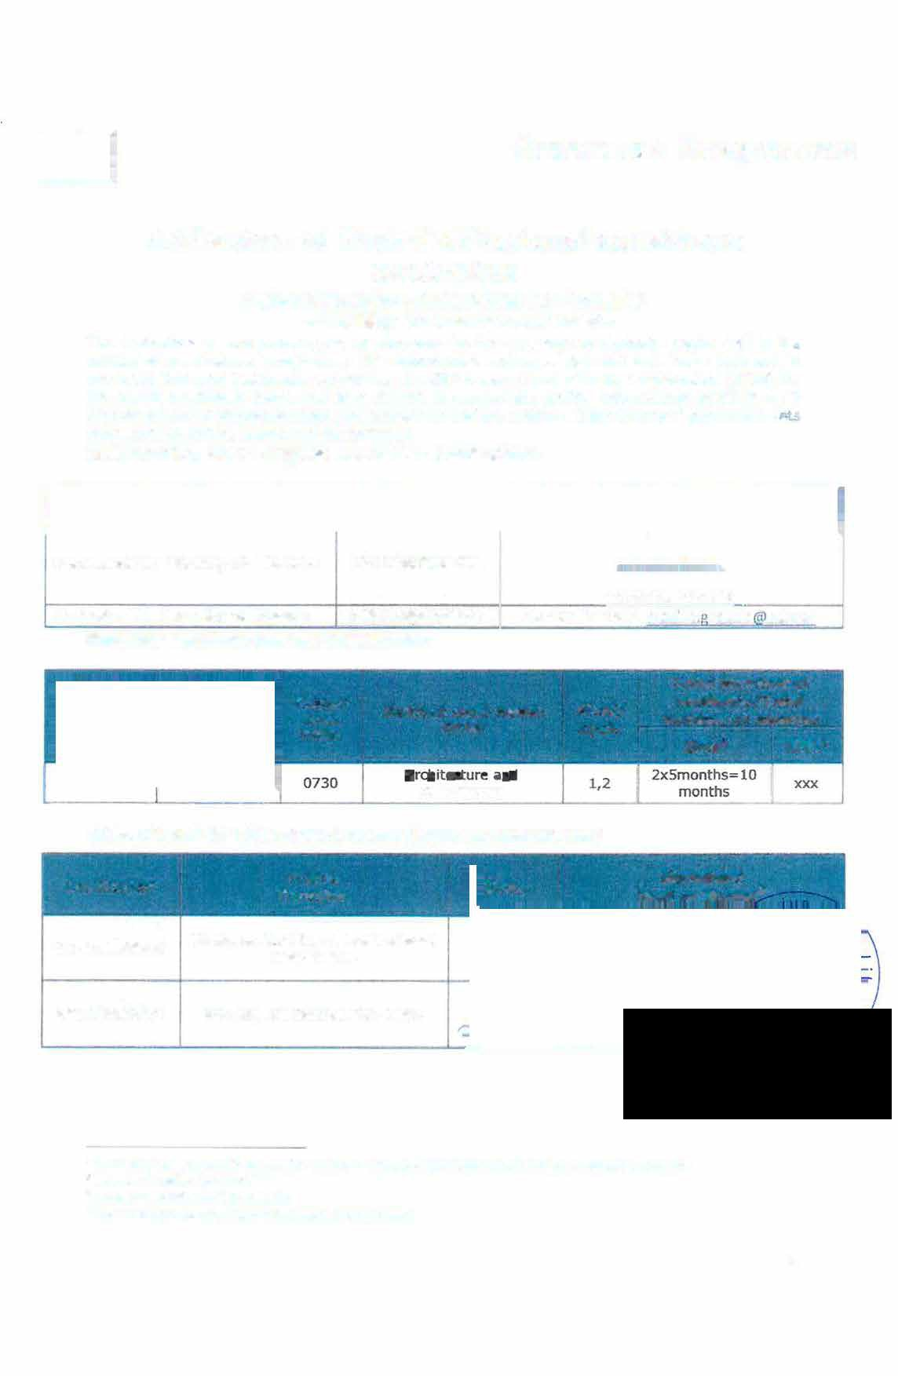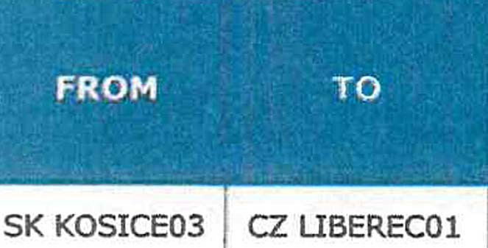

- Comact detalls to reech the senior officer ln charge of thls agreement and of its pa.$$11:1k! ulldatcs.
Stutrent MobiHty for Studles
l Student Mf.>blllty for Tralneeshlp
� Scanned slgoatures, seals and stamps are �

1

