o

O

Mzołod ołsp pnope10d

|  |  |  |  |  |  |  |  |  |  |  |  |  |  |  |  |
| --- | --- | --- | --- | --- | --- | --- | --- | --- | --- | --- | --- | --- | --- | --- | --- |
|  |  |  |  |  |  |  |  |  |  |  |  |  |  |  |  |
|  |  |  |  |  |  |  |  |  |  |  |  |  |  |  |  |
|  |  |  |  |  |  |  |  |  |  |  |  |  |  |  |  |
|  | ㈜ | 工  0 | Z  0  LD | 0  0 m | 0 卜 m | 0  卜 | 0  0  00 | 0 | 0 | 0  0 | 0  0 | 듬  D | 0 |  | 듬 |
|  |  |  |  |  |  |  |  |  |  |  |  |  |  |  |  |
|  | - |  |  | :흦1된^0㉠e」d  ,!u^04S90 e ㆍu우^0기갖0 !l.l이?PPO | | | | | | | | | | |  |
|  |  |  |  |  |  |  |  |  |  |  |  |  |  |  |  |

0

1

|  |  |  |  |  |  |  |  |  |  |  |  |  |  |  |  |
| --- | --- | --- | --- | --- | --- | --- | --- | --- | --- | --- | --- | --- | --- | --- | --- |
|  |  |  |  |  |  |  |  |  |  |  |  |  |  |  |  |
|  |  | 0  8 | O O | 8 |  |  | 8 |  |  | 8  (10 |  |  |  |  |
|  |  |  |  |  |  |  |  |  |  |  |  |  |  |  |
|  |  | 8 | 8 | 8 | 8 8 | 8 | 8  8 | 8 8  8 8 | 8  8 | 8  8 | 8 8 |  |  |  |
|  | O 0  0  O O | O |  | 0  0 | O  0  O C | O O | 8 | 0  0  8 8 |  | 8 |  |  |  |  |
|  |  |  |  |  |  |  |  |  |  |  |  |  |  |  |  |
|  |  |  |  | 8 |  |  | E |  |  | o  00 | m  00 |  | O |  |
|  |  |  |  |  |  |  |  |  |  |  |  |  |  |  |

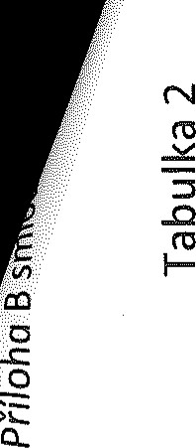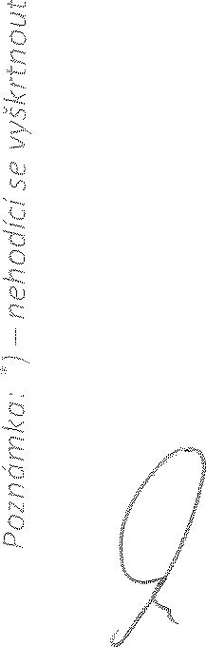R

ń)łzołod ołsp pnopąod



                                                                                                                                                                                                    
                                                                                                                                                                                                    
                                                                                                                                                                                                                                                                                      
  
  

 