|  |  |  |  |  |  |  |  |  |  |  |  |  |
| --- | --- | --- | --- | --- | --- | --- | --- | --- | --- | --- | --- | --- |
| - TÍ) |  |  |  |  |  |  | sfuon ■ | L_. - |  | ■ , — — |  |  |
| . fsaa |  | SÜCÛ... | r--- | . KMÛ ■ | V - ËÛÛÛ > : : | finm | > — firm | !. | ftj'H | ÔTJÛ | L fi«« |  |
| 1 | «i |  | f ■ |  |  |  |  | T—— |  | .f "*UJ | ■f | y-r- |

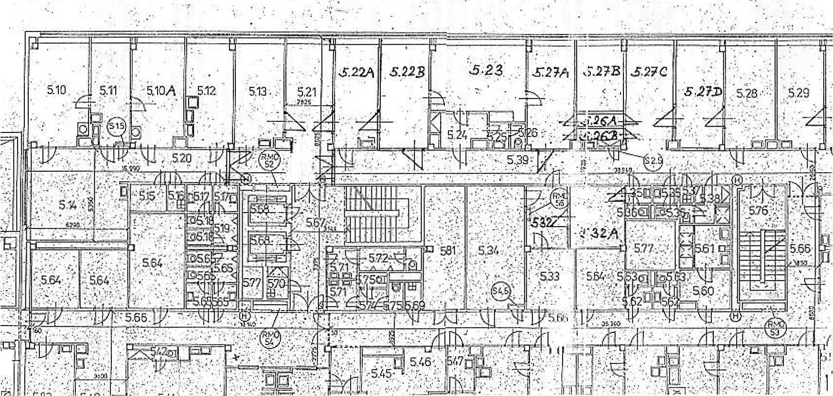

_r!|V