- **Erasmus+ Programme**

**Addendum to Inter-institutional agreement 2018-2019**

# **Higher Education Student and Staff Mobility**

**-Mobility for learners and staff....**

The institutions named below agree to cooperate for the exchange of students and/or staff in the context of the Erasmus+ programme. This Inter-institutional agreement will come into effect only in the event that both institutions are holders of valid Erasmus Charter for Higher Education (ECHE) for the period mentioned above and they cornmit to respect the quality requirements of ECHE in all aspects related to the organisation and management of the mobility. If the Erasmus+ pro gramme sets extra criteria, this Agreement will be reviewed.

# **Information about higher education institutions**

## **Name of the institution Contact details**1

**Erasmus code**

**(Name, E-mail, Phone)**

|  |  |  |
| --- | --- | --- |
| **Technical University of Liberec** | **CZ LIBEREC01** | Michaela Andělová, Institutional Coordinator [erasmus@tul.q](mailto:erasmus@tul.q)  +420 485 353 479 |
| **Firat University** | **TR ELAZIG01** | Prof. Dr. Sedat Sunter  [ssunter@firat.edu](mailto:ssunter@firat.edu) .tr  +90 4242370061 |

# **Mobility numbers per academic year**

**FROM ' TO Subject area [ISCED] Number of staff mobility periods**

**code name Teaching Training**

|  |  |  |  |  |  |  |  |  |
| --- | --- | --- | --- | --- | --- | --- | --- | --- |
| TR ELAZIG01 | CZ LIBEREC01 | 710 | Engineering and engineering trades | 1 | x | 5 | days | **X** |

## **SIGNATURES OF THE INSTITUTIONS (legal representatives)**

-

## **In5litution**

### **CZ LIBERECO 1**

**TR ELAZIG01**

## **Name function**

### **Michaela Andělová Institutional Coordinator**

**Prof.Dr. Sedat Sí.inter Institutional Coordinator**

**Oate**

*'l.!-1. oeJ.I*

***.2...o/8***

,\

## **Signature Seal or Stamp2**

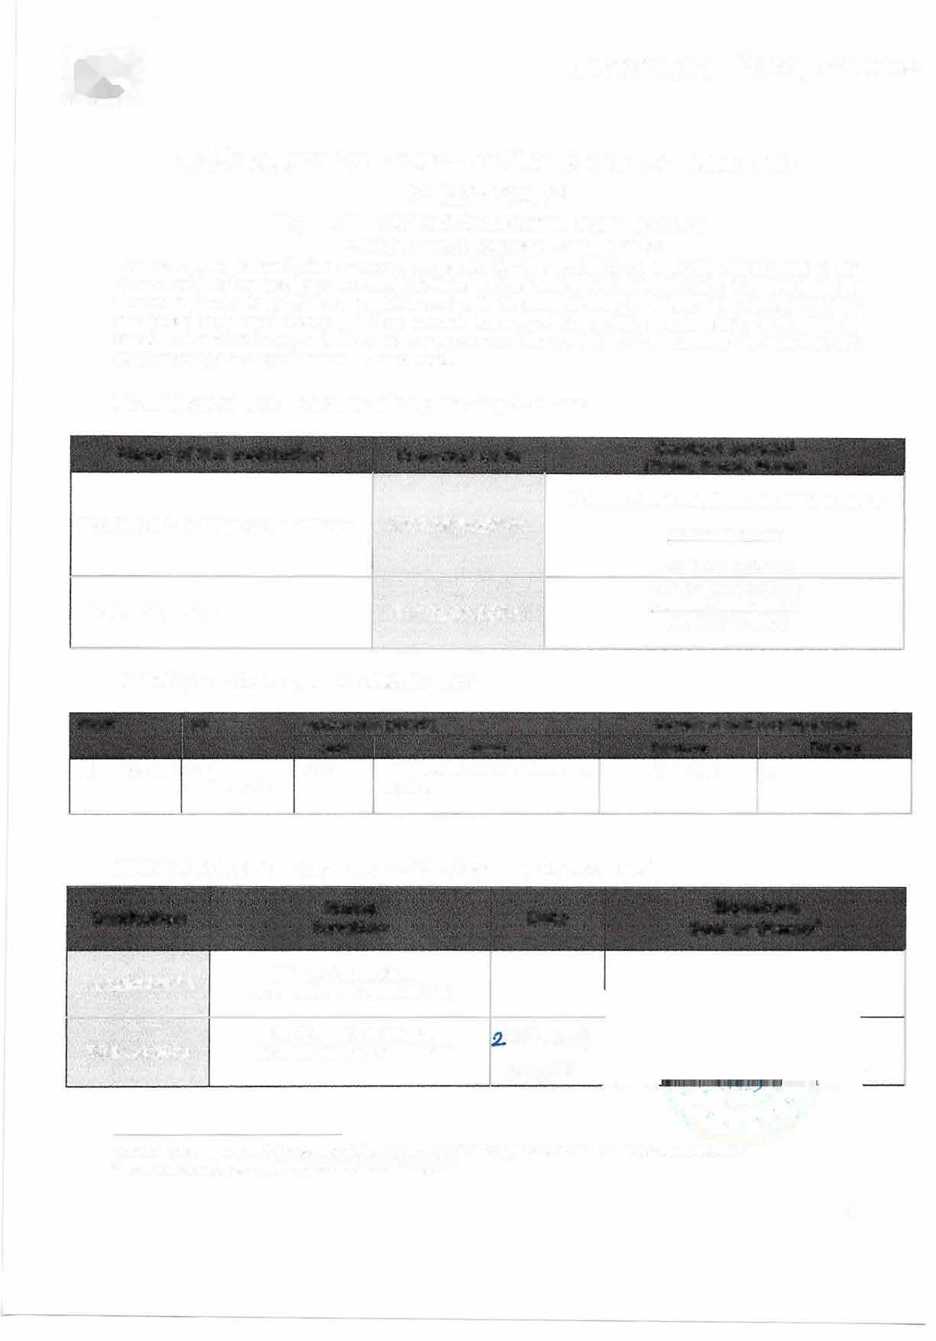

1 Contact details to reach the senior officer in charge of this agreement and of its possible updates. 1 Scanned signatures, seals and stamps are accepted

1