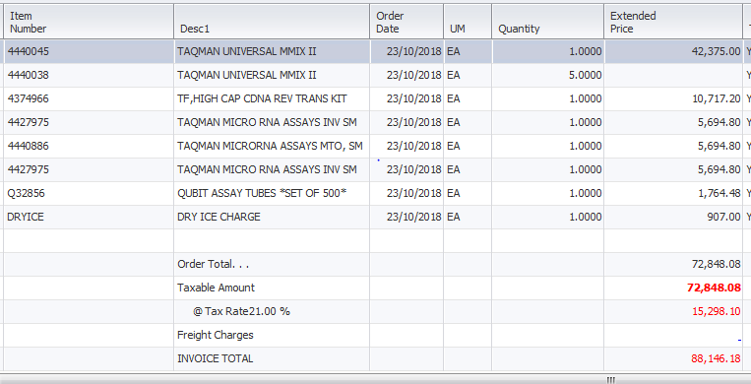

Dakujem a prajem pekny den.
Ildiko Zigraiova
Customer Care – Zákaznické Centrum

Thermo Fisher Scientific
Life Technologies Czech Republic s.r.o.
V Celnici 1031/4
11000 Praha, Czech Republic
Tel: (+420) 235-302-459
Fax: (+420) 227-204-750

czorders@thermofisher.com
www.lifetechnologies.com

