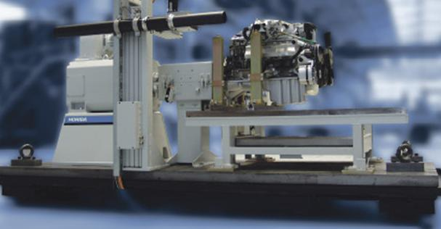
Nabídka ICZ180804
Testovací stanoviště motorů TITAN
Titan D 250

Technická univerzita v Liberci
Veřejná zakázka:
158_Ve_ERDF_Nový systém ovládání a řízení motorové brzdy (FS 008)

HORIBA GmbH, organizační složka

Technická univerzita v Liberci
Studentská 2
461 17 LIBEREC

Nabídka ICZ180804

Předkladatel nabídky HORIBA, GmbH, organizační složka
Průmyslová 1306/7
102 00 Praha 10

Odpovědná osoba: Ing. Václav Bubeník, vedoucí organizační složky

Nadřízený statutární orgán: HORIBA GmbH
Kaplan-Strasse 5
A-3430 Tulln, Rakousko

Telefon: XXXXXXXXXXXXXX
E-mail: XXXXXXXXXXXXXXXX

IČ: 49366904
DIČ: CZ49366904

Bankovní spojení: Česká spořitelna, a.s.
Číslo účtu : 845572/0800 (CZK)

Zápis v Obchodním rejstříku: Městský soud v Praze, oddíl A, vložka 7941

Datum nabídky: 8. 8. 2018

Dodací a platební podmínky

Cenové podmínky: DPA Technická univerzita v Liberci

cena bez DPH 7 779 900,- Kč
DPH 1 633 779,- Kč
cena s DPH 9 413 679,- Kč

Dodací lhůta: Do 6 měsíců ode dne účinnosti smlouvy

Platba: 100 % částky do 21 kalendářních dnů od doručení faktury kupujícímu. Platba se uskuteční na účet společnosti HORIBA, GmbH, organizační složka na základě vystavené faktury.

Záruční doba: 24 měsíců

Země původu: EU

Platnost nabídky: 90 dní

Nabídku vypracoval: Ing. Václav Bubeník

Nabídka splňuje všechny zadané podmínky výběrového řízení.

- Obsah
1 Obsah 4
2 Cenová specifikace 6
3 SCOPE OF SUPPLY / SCOPE OF SERVICES 8
3.1 Dynamometer 8
3.1.1 Load unit DYNAS3 LI 250 1000070739 8
3.1.2 Custom Frame for DYNAS3 1000013603 13
3.1.3 Measuring and control cables (Set 1a) for DYNAS3 (20m) 1300023793 14
3.1.4 Measuring and control cables (Set 2a) for DYNAS3 (20m) 1000057747 14
3.1.5 Measuring cables (Set 3) for DYNAS3 with HBM-flange (20m) 1000061305 14
3.1.6 Power cable 4G70 460V for Dynas3 LI225/250/265HP, HD255, HT250 and HS180 1000058552 15
3.1.7 Calibration unit for slotted weights for LI145/225/250 1000010997 16
3.1.8 Copper Strip for Mass Connection 1000002981 16
3.2 Dyno and Engine Controller 17
3.2.1 Digital Test Stand Controller SPARCE 1000012971 17
3.2.2 E-Gas Potentiometer Simulator 1000011123 20
3.2.3 Cable Set for E-Gas Potentiometer Simulator (20m) 1000012855 22
3.3 Measuring Equipment + Instrumentation 23
3.3.1 Voltage and Current Measuring Module SC16V 1000006843 23
3.3.2 BNC Shunt Adaptor for current measurement 1000089770 24
3.3.3 Temperature Measuring Module SDT16 1000078726 25
3.3.4 Temperature Measuring Module STh16-K 1000078727 27
3.3.5 Gauge pressure sensor ECO series 1300014752 29
3.3.6 Pressure Measuring Module SDP8 1000045153 31
3.3.7 Clean Break Coupling 1-Channel Set 1000013333 32
3.3.8 4-Channel Counter Module INC4 33
3.3.9 DSUB Connector for INC4 34
3.3.10 Wall bracket 2.5m for boom-box 1000075710 35
3.3.11 Boom Box 7U 1000012386 37
3.3.12 Cable Set Measuring Module Type D/S 0.3m 1000013434 38
3.3.13 Customized cable length for Measuring Box / Boom Box 1000013436 38
3.3.14 Analog Data Acquisition module LAM002 1000051746 39
3.3.15 Cable Set for Analogue Data Acquisition Module LAM002 1000012213 40
3.3.16 Built-in Housing for LAM002 1000007032 41
3.3.17 Weather Station with 15m cable 1000012506 43
3.3.18 Customized I/O 46
3.4 Automation System 48
3.4.1 STARS Engine Workstation 1300043538 48
3.4.2 STARS basic test stand I/O 1000004904 50
3.4.3 STARS Engine Workstation License 1000012410 52
3.4.4 STARS Device Driver License Opacimeter AVL 439 1000007055 56
3.4.5 STARS Device Driver Software License Fuel Flow Meter AVL 1000007061 58
3.4.6 STARS Device Driver AVL Indicom 1000074911 59
3.4.7 STARS Device Driver ASAM ASAP3 1000007064 61
3.4.8 Installation STARS Device Driver HORIBA MEXA ONE LAN 1000007058 63
3.4.9 Installation STARS Device Driver HORIBA MEXA 1000SPCS 1000044868 64
3.4.10 Installation STARS Device Driver HORIBA MDLT 1300T 1000007062 65
3.4.11 Installation STARS Device Driver HORIBA PTFM 1000 1000059149 66
3.4.12 Device Driver Software License Blow-By Meter 442 for STARS Test Stand Automation 1000007044 67
Technical Data 67
3.4.13 STARS RS 232 Serial Board 1300033783 67
3.4.14 STARS High Speed CAN Interface 1300033780 67
3.5 Operators Place 68
3.5.1 Measuring and Control Cabinet Type T/D 1300042242 68
3.5.2 Central Safety Module SZM light 1000112842 71
3.5.3 Emergency Stop Button (10m) 1300006412 72
3.5.4 Emergency Stop Button (20m) 1300006417 73
3.5.5 Multiple Socket Outlet EMC CEE 7-4 (8m) 1000010550 74
3.5.6 Power Cable for Measuring and Control Cabinet T/D 1000067281 75
3.6 Services 76
3.6.1 Dokumentace papírová i na CDROM 1000010462 76
3.6.2 Instalace na místě 77
3.6.3 Uvedení do provozu 77
3.6.4 STARS Software-uvedení do provozu na místě 77
3.6.5 Zaškolení min. 8 osob a předání 78

- Cenová specifikace
Pos. | Basic  Quantity | Option  Quantity | Product Number | Name | Price in  EUR | Option in  EUR
3.1 | Dynamometer
3.1.1 | 1 |  | 1000070739 | DYNAS3 LI 250 | Incl.
3.1.2 | 1 |  | 1000013603 | Custom Frame for DYNAS₃ | Incl.
3.1.3 | 1 |  | 1300023793 | Measuring and control cables (Set 1a) for DYNAS3 (20m) | Incl.
3.1.4 | 1 |  | 1000057747 | Measuring and control cables (Set 2a) for DYNAS3 (20m) | Incl.
3.1.5 | 1 |  | 1000061305 | Measuring cables (Set 3) for DYNAS3 with HBM-flange (20m) | Incl.
3.1.6 | 20 |  | 1000058552 | Power cable 4G70 460V for Dynas3 LI225/250/265HP, HD255,  HT250 and HS180 | Incl.
3.1.7 | 1 |  | 1000010997 | Calibration unit for slotted weights for LI145/225/250 | Incl.
3.1.8 | 40 |  | 1000002981 | Copper Strip for Mass Connection | Incl.
3.2 | Dyno and Engine Controller
3.2.1 | 1 |  | 1000012971 | Digital Test Stand Controller SPARCE with fixed operator panel | Incl.
3.2.2 | 1 |  | 1000011123 | E-Gas Potentiometer Simulator | Incl.
3.2.3 | 1 |  | 1000012855 | Cable Set for E-Gas Potentiometer Simulator (20m) | Incl.
3.3 | Measuring Equipment + Instrumentation
3.3.1 | 1 |  | 1000006843 | Voltage and Current Measuring Module SC16V | Incl.
3.3.2 | 8 |  | 1000089770 | BNC Shunt Adaptor for current measurement | Incl.
3.3.3 | 1 |  | 1000078726 | Temperature Measuring Module SDT16 | Incl.
3.3.4 | 1 |  | 1000078727 | Temperature Measuring Module STh16-K | Incl.
3.3.5 | 10 |  | 1300014752 | Gauge pressure sensor ECO series | Incl.
3.3.6 | 2 |  | 1000045153 | Pressure Measuring Module SDP8 | Incl.
3.3.7 | 10 |  | 1000013333 | Clean Break Coupling 1-Channel Set | Incl.
3.3.8 | 1 |  |  | 4-Channel Counter Module INC4 | Incl.
3.3.9 | 1 |  |  | DSUB Connector for INC4 | Incl.
3.3.10 | 1 |  | 1000075710 | Wall bracket 2.5m for boom-box | Incl.
3.3.11 | 1 |  | 1000012386 | Boom Box 7U | Incl.
3.3.12 | 4 |  | 1000013434 | Cable Set Measuring Module Type D/S 0.3m | Incl.
3.3.13 | 1 |  | 1000013436 | Customized cable length for Measuring Box / Boom Box | Incl.
3.3.14 | 1 |  | 1000051746 | Analog Data Acquisition module LAM002 | Incl.
3.3.15 | 1 |  | 1000012213 | Cable Set for Analogue Data Acquisition Module LAM002 | Incl.
3.3.16 | 1 |  | 1000007032 | Built-in Housing for LAM002 | Incl.
3.3.17 | 1 |  | 1000012506 | Weather Station with 15m cable | Incl.
3.3.18 | 1 |  |  | I/O Box | Incl.
3.4 | Automation System
3.4.1 | 1 |  | 1300043538 | STARS Engine Workstation | Incl.
3.4.2 | 1 |  | 1000004904 | STARS basic test stand I/O | Incl.
3.4.3 | 1 |  | 1000012410 | STARS Engine Workstation License | Incl.
3.4.4 | 1 |  | 1000007055 | STARS Device Driver License Opacimeter AVL 439 | Incl.
3.4.5 | 1 |  | 1000007061 | STARS Device Driver Software License Fuel Flow Meter AVL | Incl.
3.4.6 | 1 |  | 1000074911 | STARS Device Driver AVL Indicom | Incl.
3.4.7 | 1 |  | 1000007064 | STARS Device Driver ASAM ASAP3 | Incl.
3.4.8 | 1 |  | 1000007058 | Installation STARS Device Driver HORIBA MEXA ONE LAN | Incl.
3.4.9 | 1 |  | 1000044868 | Installation STARS Device Driver HORIBA MEXA 1000SPCS | Incl.
3.4.10 | 1 |  | 1000007062 | Installation STARS Device Driver HORIBA MDLT 1300T | Incl.
3.4.11 | 1 |  | 1000059149 | Installation STARS Device Driver HORIBA PTFM 1000 | Incl.
3.4.12 | 1 |  | 1000007044 | STARS Device Driver License BlowBy Meter AVL 442 | Incl.
3.4.13 | 1 |  | 1300033783 | STARS RS 232 Serial Board | Incl.
3.4.14 | 1 |  |  | STARS High Speed CAN Interface | Incl.
3.5 | Operators Place
3.5.1 | 1 |  |  | Measuring and Control Cabinet Type T/D | Incl.
3.5.2 | 1 |  | 1000112842 | Central Safety Module SZM light | Incl.
3.5.3 | 1 |  | 1300006412 | Emergency Stop Button (10m) | Incl.
3.5.4 | 2 |  | 1300006417 | Emergency Stop Button (20m) | Incl.
3.5.5 | 1 |  | 1000010550 | Multiple Socket Outlet EMC CEE 7-4 (8m) | Incl.
3.5.6 | 1 |  | 1000067281 | Power Cable for Measuring and Control Cabinet T/D | Incl.
3.6 | Services
3.6.1 | 1 |  | 1000010462 | Dokumentace papírová i na CDROM | Incl.
3.6.2 | 1 |  |  | Zabalení, doprava a instalace | Incl.
3.6.3 | 1 |  |  | Uvedení do provozu | Incl.
3.6.4 | 1 |  |  | Uvedení do provozu softwaru STARS | Incl.
3.6.5 | 1 |  |  | Zaškolení min. 8 osob a předání | Incl.
 |  |  |  | Celkem 7 779 900,-  bez DPH | CZK

- SCOPE OF SUPPLY / SCOPE OF SERVICES
- Dynamometer
- Load unit DYNAS3 LI 250 1000070739
This DYNAS₃ load unit consists of the AC machine and a variable frequency drive. The entire system is designed and tested to interact with any kind of engine development, performance or function test stand. The application spectrum ranges from simple steady-state test stands to sophisticated high dynamic test stands.
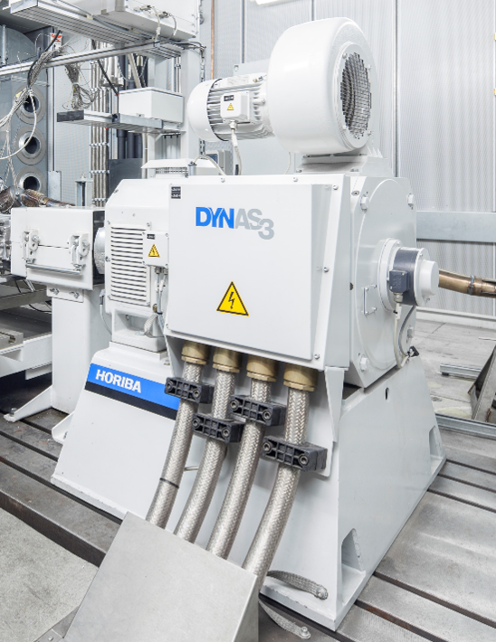
Figure 1: DYNAS₃-Asynchronous machine with measuring flange T40B
(design similar to illustration)

Benefits
- Superior dynamic characteristics such as:
- High speed torque rise time
- Low moment of inertia
- High overload capacity for high acceleration rates
- Wide range of usage such as:
- Large connectable overhung masses
- Wide speed range
- High reliability due to:
- Low wear and self-isolating hybrid bearings
- Lifetime lubricated bearings
- High-precision torque measurement because:
- Torque measured directly at the shaft connection for dynamically correct measurement
- Torque measuring flange with integrated evaluation unit
- High mechanical overload capacity
- Low-noise feed back to electrical power system through:
- Practically sinusoidal line currents
- Integrated power filter
- Compact dimensions for a smaller test cell size due to:
- Compact AC induction motor
- Compact frequency drive cabinet

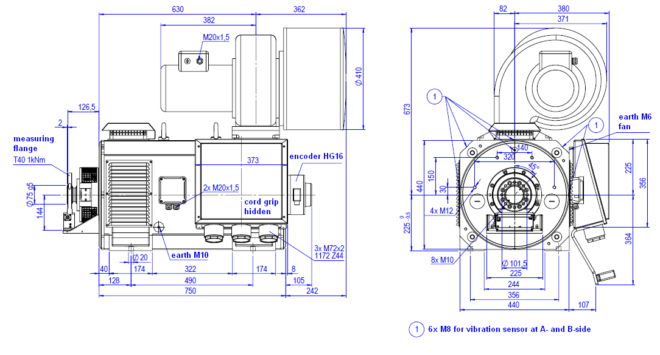
Figure 2: DYNAS₃ LI 250 with measuring flange T40B,
view without adapter flange, without protection cover
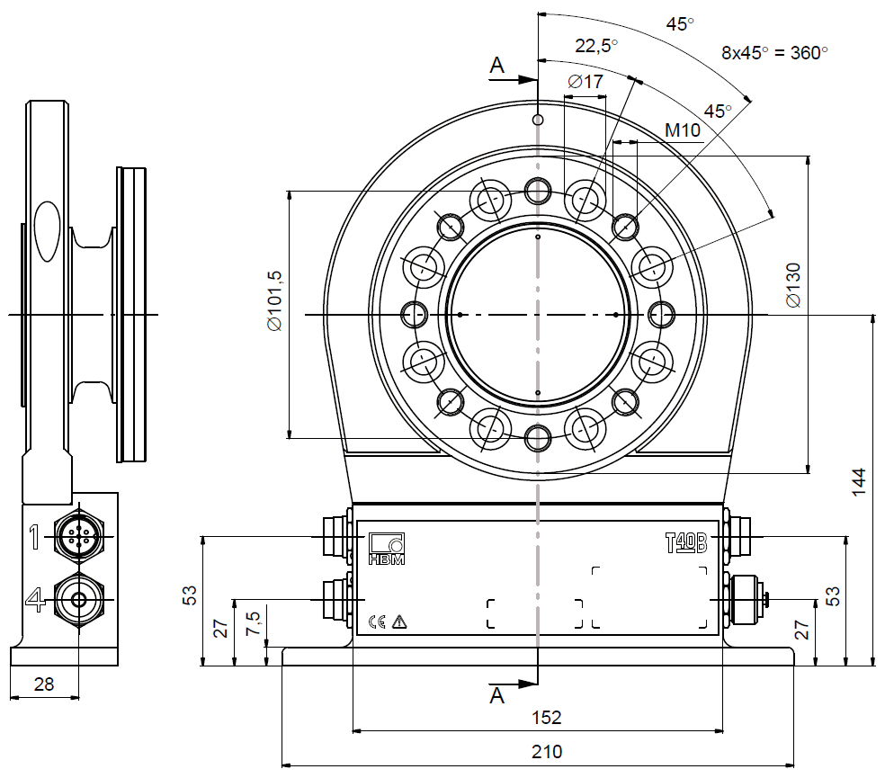
Figure 3: Measuring flange T40B, connection adapter flange

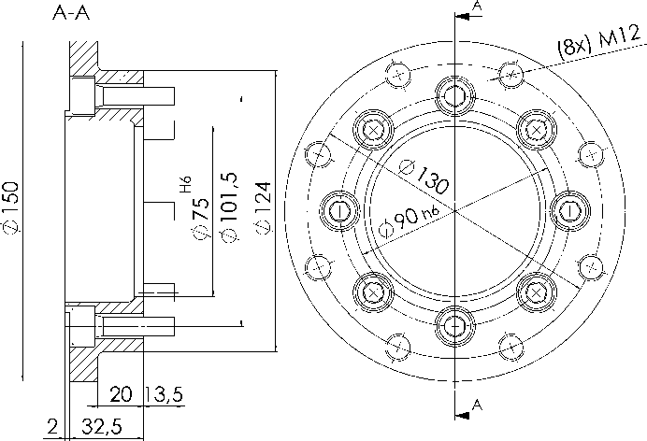
Figure 4: Adapter flange T40B

Figure 5: VFD cabinet

Scope of Supply | Quantity
Asynchronous machine DYNAS₃  - with terminal box, cable glands  - with cord grip | 1
Torque measuring flange T40B  (T12 optional) with fixture, Adapter flange and Protection cover | 1
Speed measuring unit | 1
Frequency converter consisting of:  - Supply field  - Power filter  - 4%-impedance  - Mains and machine converter  - AC-machine connection  - Power Supply for measuring cabinet | 1
Cabinet base 200 mm | 1
Set of installation material for cabinet | 1
Documentation:  - Manual  - Circuit diagram  - Factory calibration certificate | 1x CD, 1x paper

Technical Data
Directions of rotation | 2
Rated torque (absorbing /driving) [Nm] | 480/442
Rated power (absorbing /driving) [kW] | 250/225
Rated speed (absorbing /driving) [rpm] | 4980/4860
Max. speed [rpm] | 10000
Overload factor  (max. 60s every 10min) | 1.2
Max. speed gradient up to rated speed incl. overload [rpm/s] | 15600
Moment of inertia [kgm²] | 0.36
Max. deviation, speed [rpm] | ±1 for frequencies < 10 Hz
Overhung mass at n_{max} at lever arm 60mm from the torque flange [kg] | with measuring flange T40B: 10.4  optional with meas. flange T12: 9.3
Dimension of AC motor:  Overall weight [kg] | refer to figure 2  740
Dimension of cabinet  Weight [kg] | refer to figure 5  950
Approval machine / drive cabinet | CE / CE
Refer to technical specification | DYNAS₃ for Engine Test Stands

Technical Data | Measuring Flange T40B
Measuring range [Nm] | 1000
Accuracy class | 0.05
Linearity error including hysteresis, related to the nominal (rated) sensitivity [%] | < 0.03
Effect of temperature per 10 K in the nominal (rated) temperature range +10 .... +70°C  on the output signal, related to the actual value of the signal spread [%]  on the zero signal, related to the nominal (rated) sensitivity [%] | < 0.05  < 0.05
Refer to technical specification | Data sheet T40B by HBM

Figure 6: power diagram in absorbing operation

Interface
Power supply converter cabinet:  - Connected Power [kVA]  - Short-circuit power [MVA]  - Line voltage [V] AC  - Voltage tolerance [%]  - Frequency [Hz] | 289  ≥ 11.6  3/PEN 400  +10/-15  50
Converter cabinet:  - Cooling air requirement [m³/h]  - Cooling air temperature [°C]  - Max. relative air humidity  (non-condensing)  - Power loss [kW ]  - Conditions for the mains connection | 4000  +5…+40  85% at 28 °C  ≤ 15  Conditions for the mains connection for converter cabinets *)
Dynamometer:  - Cooling air requirement [m³/h]  - Cooling air temperature [°C] (non-condensing) | 900  +5…+40
Interface to test stand controller | CAN-Bus
Power supply outlet for measuring system | 1/N/PE 230V AC, 16A
interface for fixing the asynchronous machine | refer to figure 2  4 x M16
Shaft height | refer to figure 2
Threaded holes for vibration sensors  - at A-site M 8 x 10 mm  - at B-site M 8 x 10 mm | 2  2
Shaft connection | Figure 3 or 4 selectively
Cable entry mains and motor cables | from the bottom

Note:
- Depending on shaft design the adapter flange is necessary or not.
- Feeding from the top is possible as an option (additional cabinet necessary)
- *) To ensure the operating reliability of the existing mains where the drive should be connected, the requirements of the HORIBA specification "Conditions for the mains connection for converter cabinets" have to be observed.
Otherwise it is not possible to ensure:
- Compliance with rules and regulations of the responsible electric power company
- Avoidance of mains interference, mains resonance and system failures.
With unknown connection conditions or doubt we recommend to perform a power network analysis. This can be done on request by HORIBA as an additional service.

- Custom Frame for DYNAS3 1000013603
heightening of a HORIBA dynamometer DYNAS₃ LI145, LI225/250, LI350 or HT250 to a customized center height

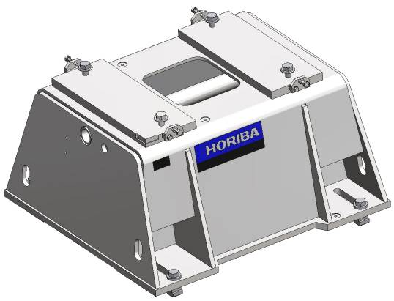
Figure 1: frame for HORIBA dynamometer DYNAS₃

Scope of Supply | Quantity
Design of a frame in 3D CAD including frequency analysis related to the speed range of the dynamometer | 1
Frame for dynamometer | 1
Set of mounting bolts for fixing the frame and the dynamometer | 1
Documentation:  - assembly drawing | 1x CD, 1x paper

Technical Data
Possible shaft height  min. / max. [mm] | 500 - 900
Possible T-Slots distance,  e.g. for mounting plate by customer  min. / max. [mm] | 500 - 1100
Color | RAL 7035 light grey
Material | steel

Interface
T Slot | DIN 650 22 H12
Customer’s data
- HORIBA DYNAS₃ type
- T-Slots distance [mm]
- Shaft height [mm]

Note:
- If the intermediate frame is purchased together with the dynamometer, the frame will be mounted.

- Measuring and control cables (Set 1a) for DYNAS3 (20m) 1300023793

Scope of Supply | Quantity
Measuring and control cable set between AC motor and VFD cabinet | 1

Technical data
Cable length [m] | 20
- Measuring and control cables (Set 2a) for DYNAS3 (20m) 1000057747

Scope of Supply | Quantity
Measuring and control cable set between SPARC and VFD cabinet with CAN-interface | 1

Technical data
Cable length [m] | 20

- Measuring cables (Set 3) for DYNAS3 with HBM-flange (20m) 1000061305

Scope of Supply | Quantity
Torque/Speed actual value cables  between ASM and meas. cabinet | 1

Technical data
Cable length [m] | 20

- Power cable 4G70 460V for Dynas3 LI225/250/265HP, HD255,
HT250 and HS180 1000058552
Power cable to pass 3-fold parallel between frequency converter and AC machine.
Delivery takes place as material sold by the meter at a cable drum.

Scope of Supply | Quantity
Power cable, drum  (material sold by the meter) | 1

Technical Data
Overall length on drum [m] | length acc. to price sheet x 3
Effective cable length (usable free length) between frequency converter and AC machine [m] | length acc. to price sheet – 3m  (approx. 3m will be needed for the electrical connection at the AC machine and inside the converter cabinet)
Approval | CE
Cable type | power cable, shielded  wire color code VDE 0293
Nominal voltage  Cross section [mm²]  Bending radius fix installed [mm]  Bending radius flexible installed  [mm]  External diameter [mm] | 460  4 x 70  260  868  44

Interface
Number of parallel to be laid cables | 3

Note:
- The power cable is especially dimensioned for the operation of this Dynas₃ machine. Only the approved cable type may be used.
- The cables have to be cut into sections, to be passed and to be lagged with cable shoes (part of the electrical installation)

- Calibration unit for slotted weights for LI145/225/250 1000010997
for calibration of the torque measuring chain (unit Nm) with radial stress free torque introduction for AC Motor LI145 / LI225 / LI250
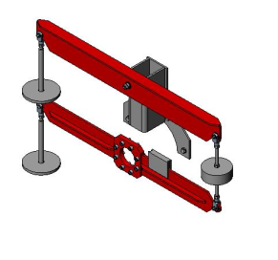
Figure 1: calibration unit for 2 direction of rotation

Scope of Supply | Quantity
Testing lever | 2
Weight tray for weight washer | 2
Documentation:  - Test certificate  - Drawing Z008941002 | 1x CD, 1x paper

Technical Data
Suitable only for shaft height [mm] | > 300

Note:
- Without weights
- The Dynas₃ load unit are equipped with a blocking system.
- Copper Strip for Mass Connection 1000002981
For potential equalization between inverter and electrical motor/frame (if not provided by local installation conditions)
Scope of Supply | Quantity
Single blank copper strip | 1

Technical Data
Dimensions [mm] | 15 x 1
Overall length [m] | length acc. to price sheet
Effective cable length (usable free length) between frequency converter and AC machine [m] | length acc. to price sheet – 3m  (approx. 3m will be needed for the electrical connection at the AC machine and inside the converter cabinet)

- Dyno and Engine Controller
- Digital Test Stand Controller SPARCE 1000012971
Controls DT, WT, Dynas₃ dynamometer or tandem applications of the engine test stand. For control of torque, speed, throttle position, or a free selectable parameter x.
Monitors speed, torque, power and additional 3 limit value contacts
(oil temperature, oil pressure, and cooling water temperature) as well as a second speed input for detection of a mechanical shaft failure by comparing speed in front and behind the shaft connection with selectable error responses.
Manual operator panel for demand value presetting of the specimen and loading device with selectable engineering units as well as operating language English, French, Spain or German.
Display of demand values, feedback values, status signals, error messages.

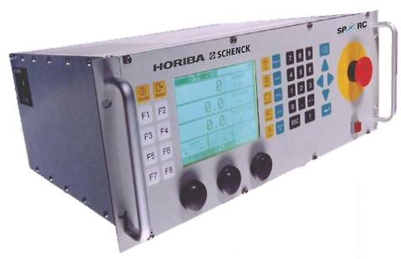
Figure 1: picture of SPARCE with control panel

Scope of Supply | Quantity
19” 4HU controller rack  with power supply unit | 1
PC 104 CPU module | 1
PC 104 power module | 1
PC 104 CAN communication module | 1
PC 104 dyno and engine I/O module | 1
Dyno interface board,  preconfigured I/O:  - 6 digital inputs  - 4 digital outputs  - 1 safety digital output  - 1 analogue input  - 3 analogue outputs  - 2 pulse inputs  - 1 bridge input | 1
Engine interface board,  preconfigured I/O:  - 6 digital inputs  - 4 digital outputs  - 1 safety digital output  - 4 analogue inputs  - 2 analogue outputs  - 1 pulse input | 1
CAN bus interfaces, intended for  - test stand automation  - throttle sensor simulation  - operator panel and additional I/O functions  - frequency converter Dynas₃  - open simulation  - not used | 6
RS232 service interface | 1
SPARC operating panel  - 7” LCD for numerical display of torque, speed, throttle position, power and control mode  - 3 digital demand value potentiometers  - 5 pre-configured function keys  - 8 available function keys (F1-F8), programmable  - emergency-stop button | 1
RS232 service interface | 1
Line cord | 1
Basis controller Software  (M, n, …) | 1
Flash card | 1
Documentation:  - Operating Manual  - Commissioning Manual (including interface diagrams)  - System Manual | 1x CD, 1x paper

Technical Data
Color | RAL 7035 light grey
Material front panel | aluminum (AlMg)
Supply voltage [V AC] | 110 / 230
Supply voltage deviation [V AC] | 100 - 240
Mains frequency [Hz] | 50 / 60
Max. mains frequency deviation [%] | ± 5
Power consumption nominal [W] | 150
Connector type | IEC 320 C14 (male)
Steady-state control deviation torque [%] | with Dynas₃:  < ± 0.17 in relation to maximum measuring value  with hydraulic brake DT-series / with eddy current dynamometer E-/ W-series:  ± 1 in relation to maximum measuring value  with eddy current dynamometer  WT-series:  ± 0,6 , in relation to maximum measuring value
Steady-state control deviation speed [rpm] | with Dynas₃:  ± 1 max. 0.25 °/oo in relation to maximum measuring value n_{max},  with hydraulic brake DT-series / with eddy current dynamometer E-/W-series:  ± 10  with eddy current dynamometer  WT-series:  ± 3
Dimension measuring rack | 4 HU / 19”  acc. to DIN 41494-1 dimensions for 19” racks
Installation depth [mm] | 360
Weight [kg] | 10
Ambient conditions
Temperature range at operation [°C] | 0..40
Relative air humidity | Class F (DIN 40050) max. 95%  at 30 days/year, no condensing
Electrical connections | details see specification
Protection class housing acc. to  EN 60529 | IP 10 (with equipped back panel)
Refer to technical specification | Test Stand Controller SPARCE

Interface
Connection to test stand automation | CAN bus, RS232 or Ethernet interface
AI, Analogue In | Voltage: +/- 10V differential  Resolution: 16 bit  Accuracy: 0.1% MBE
AO, Analogue Out | Voltage: +/- 10V  Current: +/- 20mA @ 500 Ohm  Resolution: 16 bit  Quiescent state: 0 V, 0 mA
DI, Digital In | Galvanic isolated: 10-30 V;  0-0.8 V
DO Digital Out | Relay contact: 250 VAC, 8 A  Quiescent state: Open
SO, Safety Output | Redundant relay contact: 250 VAC, 8 A  Quiescent state: Open
Dyno speed acquisition | 1 or 2-phase encoder  Max. frequency: 500 kHz  Resolution: 16 bit  Inputs: RS422, 5-24 V; open collector
Dyno torque acquisition | Max. frequency: 500 kHz  Resolution: 16 bit  Inputs: RS422, 5-24 V
Bridge input signal | DMS full bridge, 2mV/V  Excitation: 10V @ 5kHz  Resolution: 16 bit  Accuracy: 100 ppm / C° MBE
Electrical connections | Details see documentation

Note:
- If the automation system STARS is purchased, the test stand can also be operated manually by using the PC.

- E-Gas Potentiometer Simulator 1000011123
for electronic simulation of the pedal sensor potentiometer of the combustion engine by the SPARCE, SPARC^{Powertrain} or x-act digital test stand controller. The analogue and digital interface modules are completely enclosed.
Typically for installation close to the specimen on a mounting support.

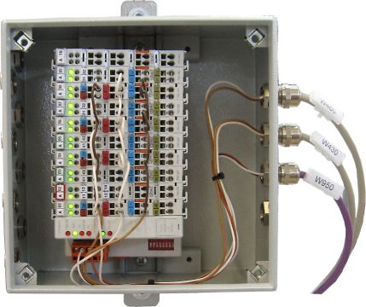
Figure 1: E-Gas potentiometer simulator hardware

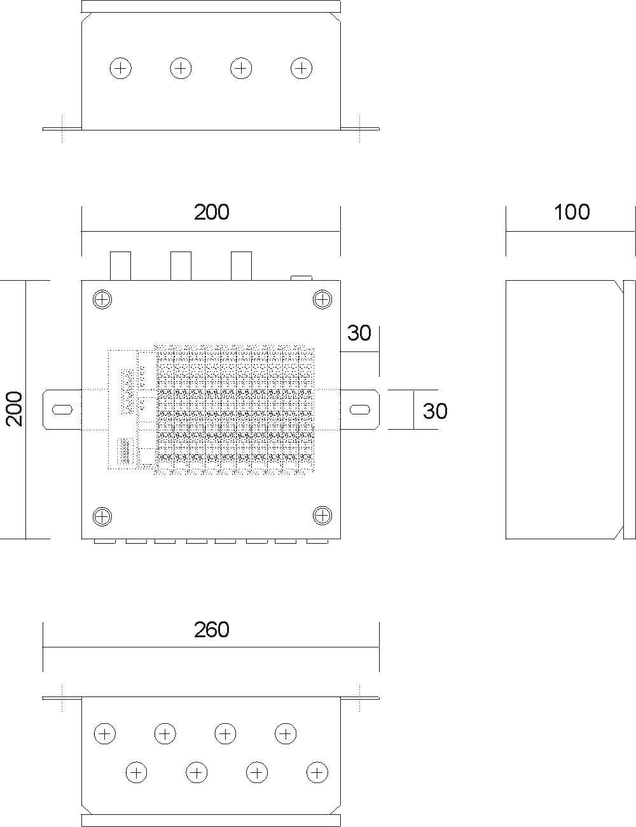
Figure 2: E-Gas potentiometer simulator hardware dimensions

Scope of Supply | Quantity
SPARCE software package E-gas simulator | 1
CAN module E-gas  2DO/4AI/4AO  - 2 AO for pre-setting the throttle position  - 2 AI for connecting the reference voltage from the ECU  - 2 Isolated DO for displaying idle and full throttle position | 1
Default setup data record | 1
E-Gas-module housing  - 1 Screw cover  - 3 EMC cable glands  - 9 Hole plugs (brass)  - 1 top hat rail (DIN)  - 2 mounting bracket (welded on) | 1
Documentation:  included in SPARC or x-act manual | 1x CD, 1x paper

Technical Data
Power supply BUS (electronics)  - Supply voltage [V DC]  - Max. supply volt. deviation [%]  - Max. current consumption [mA] | 24  -25..+30  500
Power supply field  - Supply voltage [V DC]  - Max. supply volt. deviation [%]  - Max. current feeding [A] | 24  -25..+30  10
Dimensions Housing | Refer to figure 2
Dimension of mounting bracket | Refer to figure 2
Dimension of slotted hole [mm] | 15 x 7
Protection class housing acc. to  EN 60529 | IP 66
Color | RAL 7035 light grey,  structure lacquer
Material | sheet steel
Approval housing, CAN-module | CE, UL/CSA

Interface
DO, potential-free (relais), NOC,  AC 230 V, DC 30V, max. 2A | 2
Analog outputs (0 - 10V DC) | 2
Analog inputs (0 - 10V DC) | 2
Platform | SPARCE hardware
Connection type | spring clamps
Wire cross section [mm² (AWG)] | 0.08..2.5 (28..14)
Bus type | CANopen
EMC gland size  for cable diameter [mm] | M16 x 1,5  5..9

Note:
- The later supplementation of an older controller x-act with an E-Gas Potentiometer Simulator can only be effected together with a separate order for approx. 4 to 6 hours for commissioning and upgrading of the controller.
- For simulation by x-act the „old“ Wago terminal 750-307 is necessary.

- Cable Set for E-Gas Potentiometer Simulator (20m) 1000012855

Scope of Supply | Quantity
Power supply cable DC 24V to DC power supply unit and CANopen bus connecting cable to the test stand controller SPARC | 1
ECU control and analogue cable to the connection at the specimen | 1

Technical Data
Cable length power and bus cable [m] | 20
Cable length ECU connection cables [m] | 5

- Measuring Equipment + Instrumentation
- Voltage and Current Measuring Module SC16V 1000006843
19” plug-in module for measuring voltage and current signals provided with CAN connection to test stand automation. Typical for installation in a measuring- or boom box

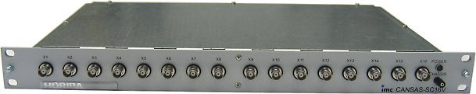
Figure 1: measuring module SC16V

Scope of Supply | Quantity
Voltage and current measuring rack SC16V with 16 BNC connectors | 1
Factory calibration certificate for the measuring module | 1
Documentation  - operating manual measuring modules type S | 1x CD, 1x paper

Technical Data
Color | RAL 7035 light grey
Material front panel | aluminum (AlMg)
Resolution | 16 bit
Operating voltage [V] | +24
Operating voltage deviation [V] | -9..+32
Sampling rate max. per channel [Hz] | 500
Voltage input range [V] | ±0.1, ±0.2, ±0.5, ±1, ±2, ±5, ±10
Current input range [mA] with shunt connector 50Ω | ±10, ±20
Input type | DC / differential
Dimension measuring rack | 1 HU / 19”  acc. to DIN 41494-1 dimensions for 19” racks
Installation depth [mm] | 285
Power consumption nominal [W] | 2.6

Interface
Bus type | CAN bus (up to 1 Mbit/s, design to ISO 11898)
Electrical Connection | CAN-Bus connection  and 24V DC supply  each with 2x D-Sub 9p connectors
Connector type -X1..-X16 | BNC (RG58 or 223 / 50Ω)

Note:
- Measurement of current requires a 50-Ohm shunt resistor per channel.

- BNC Shunt Adaptor for current measurement 1000089770
High-precision shunt resistor as a BNC gender changer for the measurement of current signals.
Able to be directly connected to the SC16V HORIBA measuring modules.

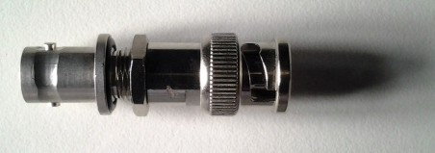
Figure 1: BNC Shunt Adaptor

Benefits:
- Confusion-proof – immediately visible from looking at the module whether a channel is used for current or voltage measurement
- Simply plug in to convert voltage measurement to current measurement – no internal changes are needed in the measurement module.

Scope of Supply | Quantity
High-precision BNC shunt adapter | 1

Technical Data
Resistance [Ω] | 100
Accuracy | 0.01 TK5
Capacity [W] | 0.25
Input Signal [mA] | ±20
Output Signal [V] | ±2

Interface
Connector | BNC f/m

- Temperature Measuring Module SDT16 1000078726
19” plug-in module for measuring temperature with 8 Pt100 RTDs and 8 type K thermocouples with CAN connection to test stand automation
Typical for installation in a measuring- or boom-box in combination with corresponding pluggable sensors

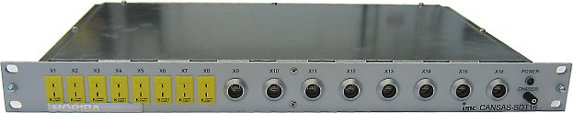
Figure 1: measuring rack SDT16

Scope of Supply | Quantity
Temperature measuring rack SDT16 | 1
4-pin Pt100 connectors | 8
2-pin female thermo connectors | 8
Factory calibration certificate for the measuring module | 1
Test certificate with the result of the functional test of all measuring channels | 1
Documentation  - operating manual measuring modules type S | 1x CD, 1x paper

Technical Data
Color | RAL 7035 light grey
Material front panel | aluminum (AlMg)
Resolution | 16 bit
Operating voltage [V] | +24
Operating voltage deviation [V] | -9..+32
Measuring rate recommended maximum for optimized noise reduction per channel [Hz] | 1
Measuring rate, adjustable up to [Hz] | 100
Measuring error, static, Pt100  -200...+850°C  - factory calibration  - on-site calibration | <1K  <1.5K
Measuring error, static, thermocouple  -200...1200°C  - factory calibration  - on-site calibration | <1K  <2.2K
Operating temperature range [°C] | -40...65
Default Measuring ranges | set to –200..+1200°C for thermocouples and 0..200°C for resistance thermometer (can be changed by customer). The accuracy applies to FS.
Input channel protective circuit [kV] | 3.5
Dimension measuring rack | 1 HU / 19”  acc. to DIN 41494-1 dimensions for 19” racks
Installation depth [mm] | 285
Power consumption nominal [W] | 2.6

Interface
Bus type | CAN bus (up to 1 Mbit/s, design to ISO 11898)
Electrical Connection | CAN-Bus connection  and 24V DC supply  each with 2x D-Sub 9p connectors
Pt100 connector type | 4p Lemo FFA.1E series
Thermocouple connector,  ANSI color code | 2p miniature thermo connector  type K, yellow

- Temperature Measuring Module STh16-K 1000078727
19” plug-in module for measuring temperature with 16 type K thermocouples with CAN connection to test stand automation
Typical for installation in a measuring- or boom-box in combination with corresponding pluggable sensors

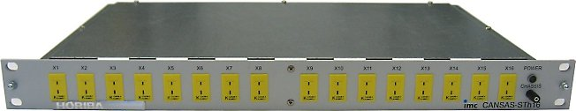
Figure 1: measuring module STh16

Scope of Supply | Quantity
Temperature measuring rack STh16 | 1
2-pin female thermo connectors | 16
Factory calibration certificate for the measuring module | 1
Test certificate with the result of the functional test of all measuring channels | 1
Documentation  - operating manual measuring modules type S | 1x CD, 1x paper

Technical Data
Color | RAL 7035 light grey
Material front panel | aluminum (AlMg)
Resolution | 16 bit
Operating voltage [V] | +24
Operating voltage deviation [V] | -9..+32
Measuring rate recommended maximum for optimized noise reduction per channel [Hz] | 1
Measuring rate, adjustable up to [Hz] | 100
Measuring error, static, thermocouple  -200...1200°C  - factory calibration  - on-site calibration | < 1K  < 2.2K
Operating temperature range [°C] | -40...65
Default Measuring ranges | set to –200..+1200°C  (can be changed by customer). The accuracy applies to FS.
Input channel protective circuit [kV] | 3.5
Dimension measuring rack | 1 HU / 19”  acc. to DIN 41494-1 dimensions for 19” racks
Installation depth [mm] | 285
Power consumption nominal [W] | 2.6

Interface
Bus type | CAN bus (up to 1 Mbit/s, design to ISO 11898)
Electrical Connection | CAN-Bus connection  and 24V DC supply  each with 2x D-Sub 9p connectors
Thermocouple connector,  ANSI color code | 2p miniature thermo connector  type K, yellow

- Gauge pressure sensor ECO series 1300014752
For measurement of the relative pressure of gaseous or fluid media in the field of engine and powertrain testing in the automotive industry.
Compatible for installation in a HORIBA measuring rack type DP, SDP8 or EP8 or separately close to the specimen.
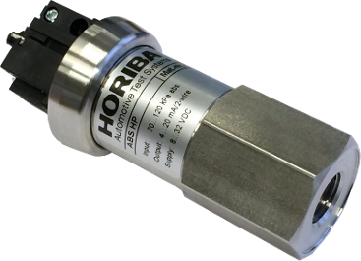 | 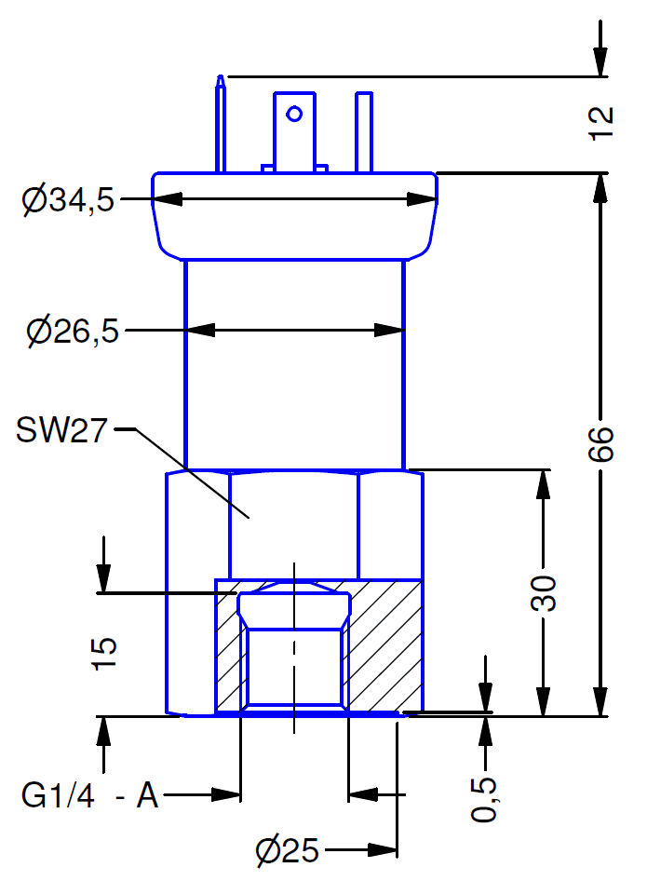
Figure 1:Pressure sensor | Figure 2: Dimensions

Typical application pressure sensors
 | engine | gearbox | meas. range [kPa] | mode
barometric pressure |  |  | 85 .. 120 | abs.
oil gallery |  |  | 0 ... +1000 | rel.
gearbox oil / automatic |  |  | 0 ... +1600 | rel.
intake air |  |  | -100 ... +200 | rel.
intake air / turbo |  |  | -100 ... +300 | rel.
fuel |  |  | 0 ... +600 | rel.
engine coolant |  |  | 0 ... +250 | rel.
charge-air |  |  | 0 ... +250 | rel.
turbo / compressor |  |  | 0 ... +250 | rel.
intercooler |  |  | 0 ... +250 | rel.
exhaust back pressure |  |  | 0 ... +100 | rel.
Figure 3: Overview typical applications and measuring ranges

Scope of Supply | Quantity
Pressure transducer ECO | 1
Connector | 1
Documentation  - datasheet with assembly instructions | 1

Technical Data
Measuring range [kPa] / quantity | Your choice:
- No. 14651 / 14652  - No. 14653 / 14654  - No. 14655 / 14656  - No. 14657 / 14658  - No. 14659 / 14660  - No. 14661 / 14662  - No. 14682 / 14683  - No. 14684 / 14685  - No. 14686 / 14687  - No. 14688 / 14689  - No. 14700 / 14701  > 1000kPa types  - No. 14650 / 14608  customized measuring range(s):  - No. 14723 | 0...+10  0...+50  0...+150  0..+250  0..+400  0..+600  -10..+10  -20..+20  -50..+50  -100..+200  -100..+400  0..+1600  [xxx]..+ [xxx] | [ ]  [ ]  [ ]  [ ]  [ ]  [ ]  [ ]  [ ]  [ ]  [ ]  [ ]  [ ]  [ ] | 0..+20  0..+100  0..+200  0..+300  0..+500  0..+1000  -15..+15  -30..+30  -100..+100  -100..+300  -100..+500  0..+2000 | [ ]  [ ]  [ ]  [ ]  [ ]  [ ]  [ ]  [ ]  [ ]  [ ]  [ ]  [ ]
Accuracy  - accuracy according to IEC 60770  - limit point adjustment (non linearity, hysteresis, repeatability) | < 40 kPa:  ≤ 0,25% FSO BFSL  ≤ ± 0,5 % FSO  ≥ 40 kPa:  ≤ 0,175% FSO BFSL  ≤ ± 0,35 % FSO
- Long term stability  - at reference conditions | ≤ ± 0,1 % FSO / year
Thermal effects (Offset and Span)  - Nominal pressure P_{N} [bar]  - Tolerance band [% FSO]  - in compensated range [°C] | -1 … 0 / < 0,40 / ≥ 0,40  ≤ ± 0,75 / ≤ ± 1 / ≤ ± 0,75  -20 ... 85 / 0 ... 70 / -20 … 85
Permissible temperatures  - medium  - electronics / environment  - storage | -40 ... 125 °C  -40 ... 85 °C  -40 ... 100 °C
Measuring signal [mA] | 4...20

Interface
Connector type | acc. to DIN EN 175301-803
Pressure connection | ¼“ inside thread

Note:
- If ordered together with a measuring module type SDP8 or EP8, the transducer will be mounted into the rack by HORIBA.
- Customized measuring ranges smaller +/-10kPa are not possible.
- The transducers are intended for stationary pressure measurement, transmitters for measuring of dynamic pressures on request.

- Pressure Measuring Module SDP8 1000045153
19” plug-in module SDP8 is a plug-in module for measuring pressures of gaseous and liquid media with CAN bus connection to test stand computer.
Typical for installation of pressure transducers type RS / RH and clean brake couplings e.g. in a measuring- or boom-box

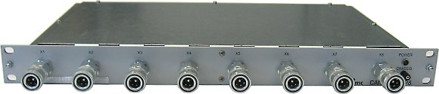
Figure 1: Measuring Module SDP8
(with installed optional pressure transducers and optional clean brake couplings

Scope of Supply | Quantity
Pressure measuring module SDP8 | 1
installation place for clean brake coupling and transducers | 8
Factory calibration certificate for the measuring module | 1
Test certificate with the result of the functional test of all integrated measuring channels | 1
Documentation  - operating manual measuring modules type S | 1x CD, 1x paper

Technical Data
Color | RAL 7035 light grey
Material front panel | aluminum (AlMg)
Resolution | 16 bit
Operating voltage [V] | +24
Operating voltage deviation [V] | -9..+32
Sampling rate max. per channel [Hz] | 500
Dimension measuring rack | 1 HU / 19”  acc. to DIN 41494-1 dimensions for 19” racks
Installation depth [mm] | 285
Power consumption nominal [W] | 2.6

Interface
Bus type | CAN bus (up to 1 Mbit/s, design to ISO 11898)
Electrical Connection | CAN-Bus connection  and 24V DC supply  each with 2x D-Sub 9p connectors

- Clean Break Coupling 1-Channel Set 1000013333
for installation in the pressure measuring rack SP8 in combination with pressure transducers type RL / RS / RH. For low leakage hose connection of gaseous and fluid media
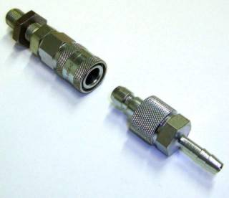
Figure 1: clean Break coupling
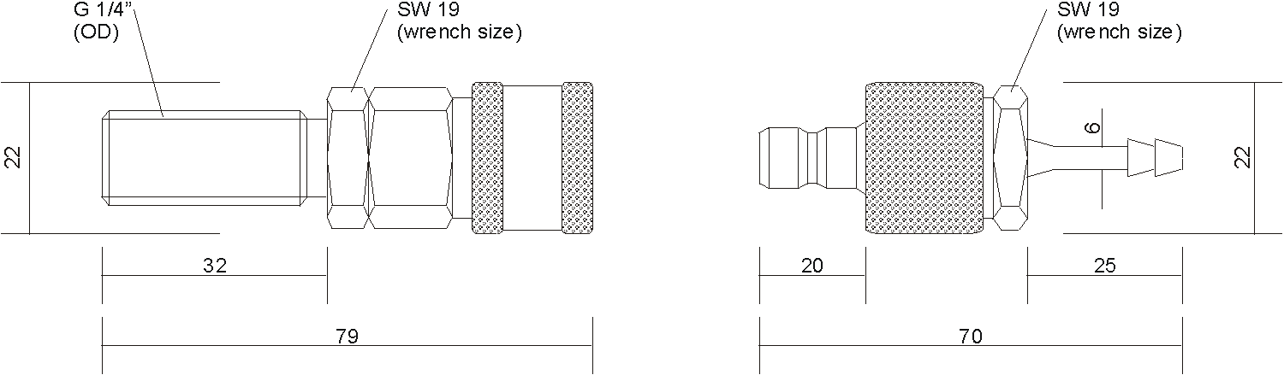
Figure 2: dimensions of clean Break coupling

Scope of Supply | Quantity
Female quick connector for panel installation | 1
Lock nut | 1
Seal ring G¼“ | 1
Male quick connector (nipple) for hose connection | 1

Technical Data
Material | steel, zinc coated
Sealing | NBR (Nitrile Butal Rubber)
Material seal ring | PVC

Interface
For installation in combination with pressure transducers recommended sealant | liquid acylate sealing;  e.g. LOCTITE 572 (M0043499.01)
Connection female connector | G¼“ external thread
Hose connection male connector; diameter [mm] | 6
Max. pressure [kPA] | 10.000

Note:
- Matching plug-in hose for e.g. mineral based hydraulic and lubricating oils and water-oil emulsions optional available.

- 4-Channel Counter Module INC4
Module for acquisition of frequency, rotation, position and angle counter signals
Parameter | Value | Remarks
Inputs | 4 + 1  ( 9 tracks ) | 4 channels with 2 tracks (X, Y) each  1 index channel  all fully conditioned  inputs isolated from CAN-Bus and supply,  but not mutually
Measurement modes | displacement, angle, events,  time, frequency;  velocity, RPMs
Sampling rate (CAN output) | 1 kHz / channel (max.)
Time resolution of  measurement  frequency stability  deterioration | 33 ns  <100 ppm  < 5 ppm / year | counter frequency 32 MHz  (primary sampling rate)
Resolution of data | 16 bits
Input configuration | differential
Input impedance | 100 kOhm
Switching threshold | -8 V to +10 V
Hysteresis | 0.3 V to 4 V
Input voltage range  (differential) | ±10 V  ±30 V | linear range  maximum, outside of linear range: max. nonlinearity  uncertainty: 300 ns
Common mode input voltage | max. ±30 V
Analog bandwidth | 500 kHz | -3 dB (full power)
Analog filter | bypass (without filter),  20 kHz, 2 kHz, 200 Hz | adjustable (globally for all channels)  Butterworth, 2nd order
CMRR | 70 dB (typ.), 50 dB (min.)  60 dB (typ.), 50 dB (min.) | DC, 50 Hz  10 kHz
Gain uncertainty | <1% | 23°C
Offset | <1% | 23°C
frequency stability | <100 ppm | deterioration < 5 ppm / year
Overvoltage protection | ±60 V | long-term
Sensor supply | +5 V, 200 mA, 20 mA | Reference: GND
Supply voltages | 10 V to 50 V DC
Sensor supply voltage at  CAN/x-INC4-xx-SUPPLY | +2.5 V to +24 V
Power consumption | 4 W (typ.) | 12 V supply, 23°C
Operating temperature | -40°C to 85°C
Dimensions (W x H x D) | 35 x 111 x 90 mm
Weight | 300 g
Terminal connection  Rear side | 2x DSUB-15  4x ITT VEAM  2x DSUB-9  2x DSUB-9  PHOENIX (MC 1,5/4STF-3,81)

- DSUB Connector for INC4
For customers sensors

Note:
Customer has to iron his sensors/cable glands himself to the connectors

- Wall bracket 2.5m for boom-box 1000075710
for the installation of a boom-box incl. installation accessories

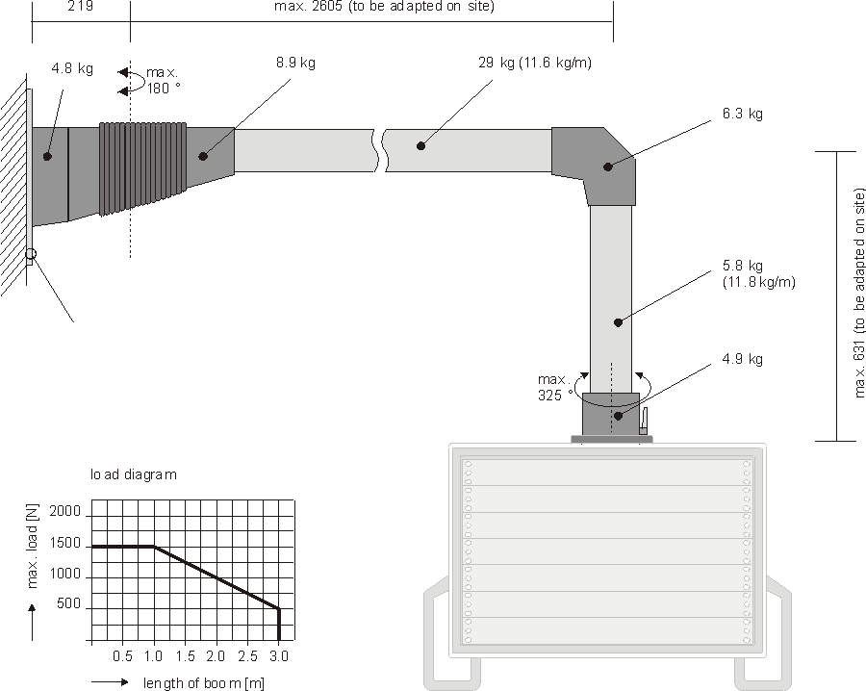
Figure 1: drawing of wall bracket
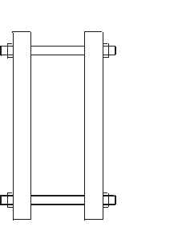
Figure 2: connecting dimensions for installation with steel plate

Figure 3: connecting dimensions for installation without steel plate

Scope of Supply | Quantity
Wall bracket 2.5m for boom-box 19" consisting of  - flange coupling  - tube section 0.5m  - angular piece  - tube section 2.5m  - wall hinge  - adapter flange | 1
Installation set consisting of  - 6x hexagon screw + nut  - 16x washer  - 1x steel plate wall support  - 4x shear connector for pure concrete wall installation  - 1x ground strap 10mm² / 4m for potential equalization | 1

Technical Data
Color | square-type tube: zinc-plated  components: RAL 7043
Material | square-type tube: steel 5mm  components: AlSi and resp. cast iron
Dimensions | see drawing
Max. load | see diagram
Overall weight [kg] | see drawing
Protection class acc. to EN 60529 | IP 65

Interface
Cable routing | inside tube
Free space for cable laying [mm] | 70 x 70
Installation with steel plate:  - Installation type  - Connecting dimensions  - Installation material | 4x through boring at wall  see drawing  with delivered threaded bolt
Installation without steel plate:  (pure concrete wall)  - Installation type  - Connecting dimensions  - Installation material  - Nominal diameter of drill [mm]  - Borehole depth [mm] | 4x borehole for screw anchor  see drawing  with delivered sheer connectors M16x 190  18  125

- Boom Box 7U 1000012386
for installation of max. 6x 1U 19” racks
Typically for wall mounting in combination with a wall bracket.

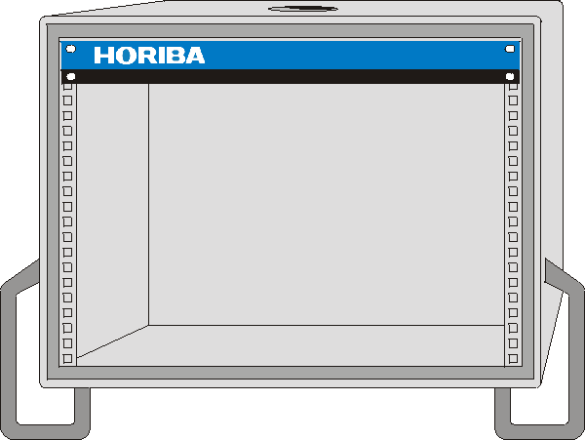 | 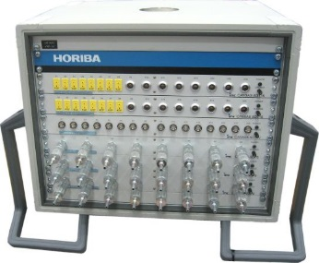
Figure 1: boom-box 7U | Figure 2: application example:  photo of an equipped boom box 7U

Scope of Supply | Quantity
Boom Box 7U complete mechanical assembled | 1
Slide bar set for 1U | 6
19” frame (front side) | 1
Hole for cable entry and wall bracket at top | 1
Ground strap for EMC potential compensation | 1

Technical Data
Max. installation depth of racks [mm] | 300
Color | RAL 7035 light grey (front),  decor/frame color :  RAL 7043 / RAL 7038
Material | AlMgSi  corner caps: AlSi
Dimension boom box  Height [mm]  Width [mm]  Depth [mm] | 422  535  435
Dimension 19” installation frame | 7U according to  DIN 41494-7 (IEC 297-2) for installation of 19”-panels and racks  1U taken for design panel  (space for circulation of air)
Overall weight [kg] | 40
Protection class housing acc. to  EN 60529 | IP 41 (equipped and with installed bracket support)
length of ground strap [m] | 4

Interface
Cable entry point | top
Note:
- Installation space of not ordered 19” racks will be covered with dummy plates.

- Cable Set Measuring Module Type D/S 0.3m 1000013434
for connection measuring modules type D/S to another measuring module with max. 1U space between

Scope of Supply | Quantity
Supply connecting cable DC 24V | 1
CANopen bus connecting cable | 1

Technical Data
Connector type power cable | D-Sub 9p male/female
Connector type bus cable | D-Sub 9p male/female
Cable length [m] | 0.3

- Customized cable length for Measuring Box / Boom Box 1000013436

Scope of Supply | Quantity
connection the measuring or boom box to test stand automation system (STARS-PC):  Power supply connecting cable DC ,  CANopen bus connecting cable | 1
CAN bus adaptor with terminating resistor 120Ω | 1

Technical Data
Cable length [m] | [length on request,  max 40 m]

- Analog Data Acquisition module LAM002 1000051746
for measuring, conditioning, converting analogue signals of Resistance Thermometer Pt100 or Pt1000, thermocouples NiCr-Ni, voltages or currents. With CAN-Bus interface for connection to STARS test stand automation. Each input can be configured for measuring range and sensor by software.

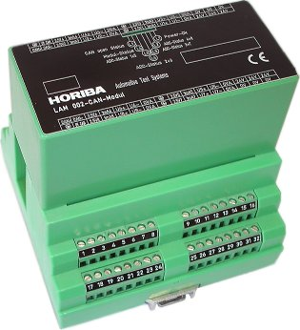
Figure 1: analogue data acquisition module LAM002

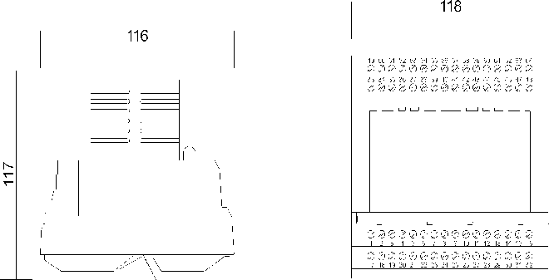
Figure 2: analogue data acquisition module LAM002 dimensions

Scope of Supply | Quantity
CAN module LAM 002 | 1
Universal analogue inputs, each with:  - Amplifiers with differential input  - Sensor feeding for Pt100 / Pt1000 and potentiometer  - Internal comparison point for thermocouples  - 32 point linearization  - Antialiasing filter coupled with measuring frequency | 8
Analogue / digital converter 16 bit | 1
Controller with CAN bus interface | 1
Diagnostics LEDs | 7
Documentation  - operating manual | 1

Technical Data
Measuring range thermocouple  type K / J [°C] | -20..+1000
Measuring range Pt100 / Pt1000 [°C] | -20..+200
Voltage [V] | 0.1 / 0.2 / 0.5 / 1 / 2 / 5 / 10
Current [mA] | 0..20 / 4..20
Potentiometer [%] | 0..100
Measuring frequency adjustable per channel [Hz] | 1..100
Operating voltage [V] | +24
Operating voltage deviation [V] | +19..+34
Dimensions | Please refer to figure 2
Weight [g] | 790

Interface
Installation type | top hat rail TS 35
Protection class housing acc. to  EN 60529 | IP 20
Bus type | CAN open 2.0
Serial service interface | RS232
Electrical connection  - CAN interface  - analog inputs  - power supply | terminal part with screw connection

- Cable Set for Analogue Data Acquisition Module LAM002 1000012213

Scope of Supply | Quantity
Connection cable DC 24V and CANopen bus cable to the test stand automation | 1

Technical Data
Cable length [m] | 20

- Built-in Housing for LAM002 1000007032
for installation of one analogue data acquisition module LAM002 or other similar top hat rail modules in heavy duty environment
Typically for installation close to the specimen on a mounting support

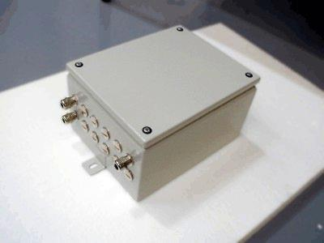
Figure 1: built-in housing for LAM

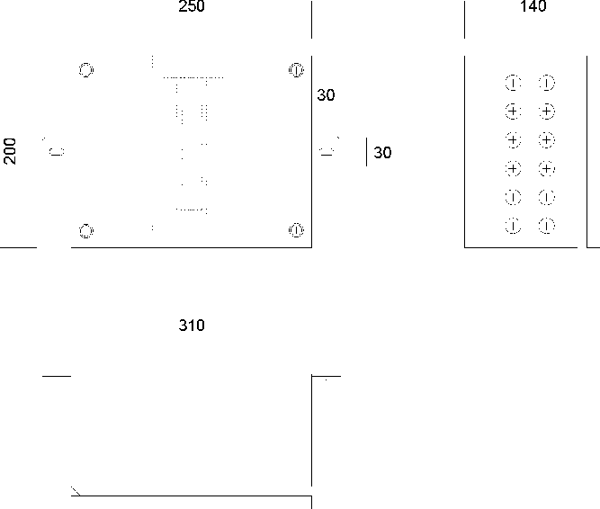
Figure 2: dimensions of built-in housing for LAM

Scope of Supply | Quantity
LAM box housing for 1 module | 1
Screw cover | 1
EMC cable glands | 3 (default)
Hole plugs (brass) | 9 (default)
Top hat rail (DIN) | 1
Mounting bracket (welded on) | 2

Technical Data
Color | RAL 7035 light grey,  structure lacquer
Material | sheet steel
Sealing (cover) | Foam gasket
Dimension of LAM box housing | Please refer to figure 2
Max. installation height [mm] of top hat rail module | 120
Dimension of mounting bracket  Length [mm]  Width [mm] | 30  30
Dimension of slotted hole [mm] | 15 x 7
Protection class housing acc. to  - EN 60529  - NF C 20-010  - Nema | IP 66  IP 669  4, 12, 13
Approval | UL, CSA, GL

Interface
Installation system | top hat rail (DIN)
EMC gland size  for cable diameter [mm] | M16 x 1,5  5..9 (default)

- Weather Station with 15m cable 1000012506
for measuring the environmental conditions (absolute pressure, relative humidity and ambient temperature) of the test cell.

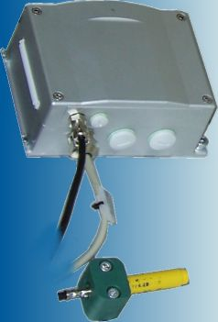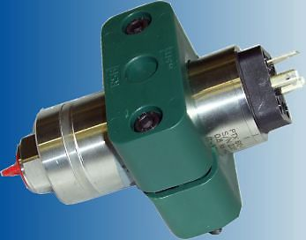
Figure 1: Humidity / temperature and absolute barometric pressure measuring unit

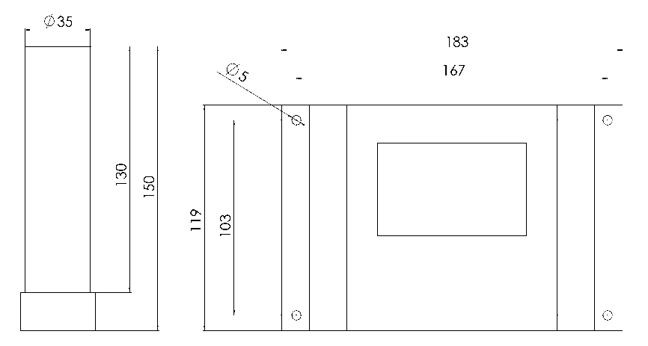
Figure 2: dimensions of weather station

Figure 3: dimensions of pressure sensor

Scope of Supply | Quantity
Absolute barometric pressure measuring unit consisting of  - pressure transducer  - connector  - wall-mounting support | 1
Humidity / temperature measuring unit consisting of  - electronic module  - combined sensor for relative humidity and air temperature in plastics housing, removable with cable (2m)  - mounting set | 1
Cable set consisting of  - measuring cable humidity / temperature measuring unit  - measuring cable pressure measuring unit  - supply cable | 1
Documentation:  - Operating manual  - Factory calibration certificate | 1x CD, 1x paper

Technical Data
Absolute barometric pressure measuring unit  - Measuring range [kPa]  - Accuracy (according to IEC 60770)  - Long term stability at reference conditions  - Thermal effects (Offset and Span)  - Compensated temperature range [°C]  - Cable type measuring cable | +70...+120  ≤ ± 0,05 % FSO BFSL  ≤ ± 0,1 % FSO / Jahr  ≤ ± 0,05 % FSO / 10K  -10 ... 50  LIYCY 2x0.5 mm², shielded  wire color code: DIN 47100
Humidity / temperature  measuring unit  - Humidity measuring range [%rH]  - Measuring accuracy humidity measuring 0...90%rH [%rH] at 20°C  - Measuring accuracy humidity measuring 90...100%rH [%rH] at 20°C  - Temperature measuring range sensor [°C]  - Operating temperature range housing [°C]  - Measuring accuracy temperature measurement [°C]  - Cable type measuring cable | 0…100  1  1.7  -20…+80  -20…+60  0.2  LIYCY (TP) 3x2x0.25 mm², shielded  wire color code: DIN 47100
Measuring signal pressure [mA] | 4..20
Measuring signal humidity [mA] | 4..20
Measuring signal temperature [mA] | 4..20
Dimension of humidity/temp. measuring unit | Please refer to Figure 2
Dimension of pressure measuring unit incl. wall-mounting support  Height [mm]  Width [mm]  Depth [mm] | 115  90  40
power supply humidity / temperature measuring unit [V DC] | 24
Cable length power and measuring cable [m] | 15
Cable length between humidity and temperature sensor and measuring unit [m] | 2
Cable type measuring cable | LIYCY (TP) 3x2x0.25 mm², shielded  wire color code: DIN 47100
Cable type power cable | LIYCY 2 x 1,5 mm², shielded  wire color code: DIN 47100

Interface
Type of installation | wall-mounted
Pressure connection | ¼“ inside thread

- Customized I/O
-Power supply for Specimen
-I/O for Specimen
-Power Supply for Sensors and Actuators of Facility
-I/O for Sensors and Actuators of Facility

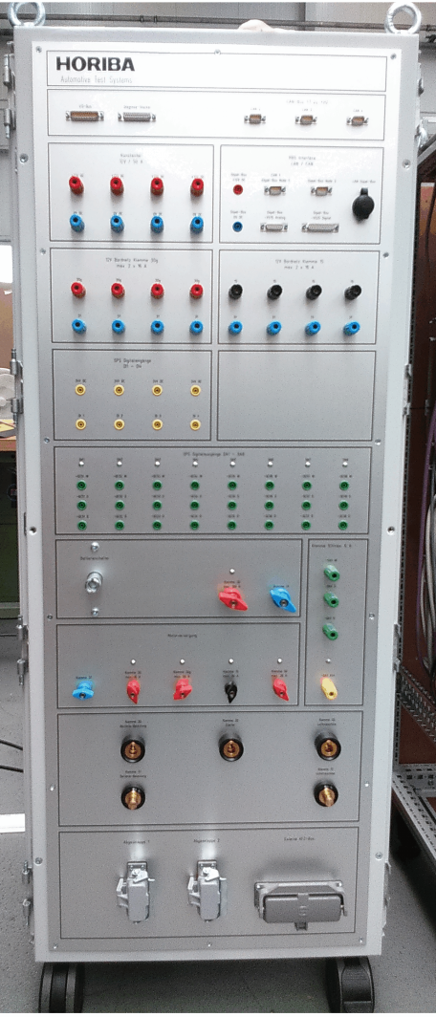
Abb.: Example of I/O Box in Test Cell
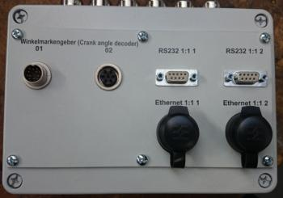
Abb.: Example I/O Panel at Operators Place

 | No. Of Channels | Where? | Connector Type
AO +/-10V | 4 | I/O Box | BNC
Frequency counter, customer wish is TTL as well as up to 24 V DC. 100 kHz | 4 | I/O Box | BNC
8 TTL 5V out | 8 | I/O Box | BNC
8 TTL 5V in | 8 | I/O Box | BNC
INC 4, 1 Module | 4 | I/O Box | BNC
Netzteil/power supply 5V 10A | 5 pairs | I/O Box | Banana
Netzteil/power supply 12V 50A | 5 pairs | I/O Box | Banana
Netzteil/power supply 24V 20A | 5 pairs | I/O Box | Banana
Ethernet Channels | 4 in front panel | I/O Box | RJ45
Ethernet Channels | 4 in front panel | TITAN Control Cabinet | RJ45
AO +/-10V | 2 | TITAN Control Cabinet | BNC
AO 4…20mA | 2 | TITAN Control Cabinet | BNC
RS232 serial interface | 1 in front panel, wired to STARS HW | TITAN Control Cabinet | DSUB 9pin
RS232 serial interface | 1 in front panel, wired to STARS HW | I/O Box | DSUB 9pin
RS232 serial interface | 6 fix on STARS HW | Backside STARS HW | DSUB 9pin
CAN interface | 2 in front panel | I/O Box

- Automation System
- STARS Engine Workstation 1300043538
Workstation Hardware for STARS Automation Software.

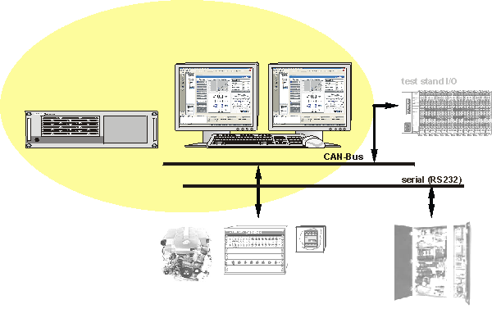
Figure 1: STARS Workstation system overview

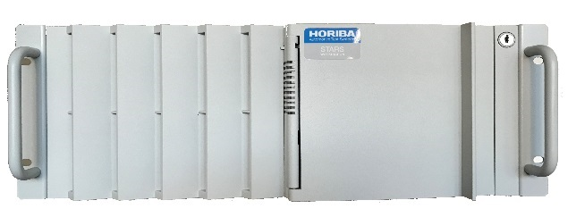
Figure 2: STARS Workstation (example picture)

Benefits:
- The STARS Workstation is specially developed, tested and released for the use with STARS Automation Software and maximizes the performance and robustness of the software.

Scope of Supply | Quantity
Process computer with Intel® Xeon® (Embedded) E3-1275 v3 (8MB Cache, 3.5GHz) or better  - 19” industrial rack  - 3 x PCI, 3 x PCIe X4, 5 x PCIe X16 slots  - Solid State Drive (SSD) > 240 GB  - Onboard Graphics Intel® HD supporting dual monitor output  - 8 GB RAM | 1
Real-time Ethernet Interface to SPARC-controller | 1
Real-time Ethernet Switch for connection to SPARC Controller | 1
2-fold CAN-card PCIe | 1
2x RS232 serial interfaces on PCI board | 1
24" TFT monitor | 2
Connecting cable for monitor 3m | 2
Optical wheel mouse | 1
Keyboard (US English revision) | 1
Extension cable for key board or mouse 5m | 2
Operating system MS W7 Prof (Multilanguage) | 1
MS Office 2016 Standard, English | 1

Technical Data
Color Front Plate | PB007H light grey
Dimension | ATX form factor,  4 HU / 19”  acc. to DIN 41494-1 dimensions for 19” racks
Protection class housing acc. to  EN 60529 | IP 41 (front)

Interface
Installation depth [mm] <  (without connected plugs) | 450
LAN / Ethernet | 2x onboard 10/100/1000 Mbit  1 x real-time via PCIe card
CAN Bus | 2x CAN bus interface via PCIe  card (for measuring devices)
Serial | 2x serial RS232 via PCI card  (for measuring / conditioning  devices)
USB 2.0 | 3
USB 3.0 | 4

Note:
- The scope of supply may change depending on the technical development

- STARS basic test stand I/O 1000004904
Peripheral test stand I/O of STARS Test Stand Automation System for communication with test stand systems or infrastructure.
Typical for installation at the back panel of a measuring- and control cabinet

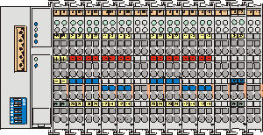
Figure 1: Drawing basic test stand I/O

Scope of Supply | Quantity
STARS basic test stand I/O  16DI/16DO/2AO | 1 *)

Technical Data
DI reserved by STARS for internal test stand control | 4
DO reserved by STARS for internal test stand control | 8
Power supply BUS (electronics)  - supply voltage [V DC]  - max. supply voltage deviation [%]  - max. current consumption [mA] | 24  -25..+30  500
Power supply field  - supply voltage [V DC]  - max. supply voltage deviation [%]  - max. current feeding [A] | 24  -25..+30  10

Interface
Free DI  24V DC, pos. logic, two- or three-wire system | 8
Free DO  24V DC, pos. logic, max. 0.5 A short-circuit proof | 8
Free digital limit contact inputs  (DI predefined by STARS)  24V DC, pos. logic, two- or three-wire system | 4
Free analog outputs  (± 10V DC) | 2
Connection type | spring clamps
Wire cross section [mm² (AWG)] | 0.08..2.5 (28..14)
Bus type | CANopen

Note:
- If the measuring and control Cabinet type S or T/D is purchased, this module will be delivered installed in the cabinet
- Direct wiring of the 24V DC supply of the test stand I/O is recommended, if the module is installed inside another cabinet.

- STARS Engine Workstation License 1000012410
The STARS Engine domain combines the STARS platform with specific functions and structures suitable for engine testing.
Gathering the real time function and user interface together in one integrated system environment greatly enhances the interaction and thus the productivity and quality of testing related activities.
STARS is a high performance, flexible automation platform with integrated automation, data acquisition and control functions that provides a broad range of application functionality in a single, powerful environment.
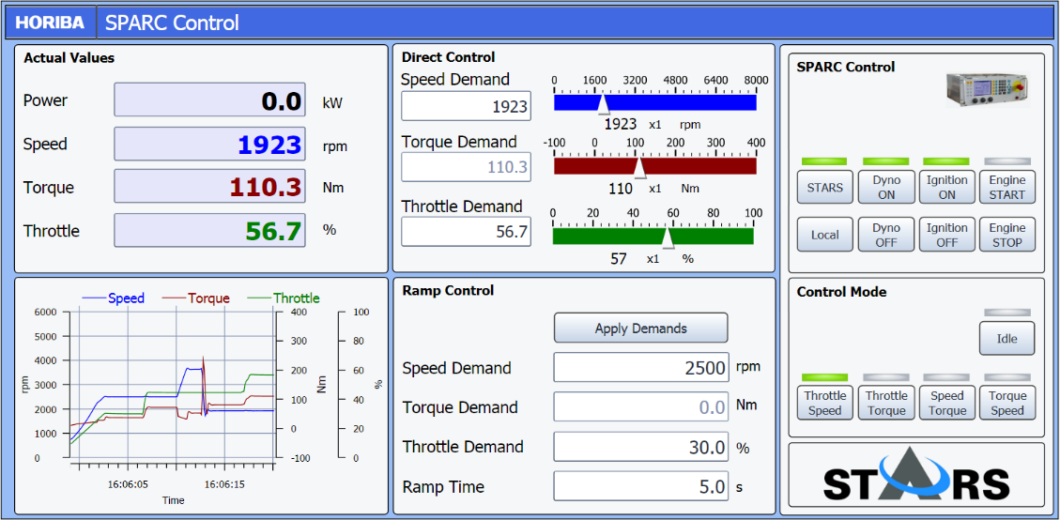
Figure 1: STARS GUI

Due to its in-build flexibility STARS Engine is especially suited for a wide range of engine testing applications supporting the whole development process from component development to certification. The range of possible applications includes:
- Durability Testing
- Performance and Emissions Development
- Quality Audit
- Mechanical Development
- Fuel and Lubricants Testing
- Noise, Vibration and Harshness
- Heavy Duty Engine Emissions
- Light Duty Engine Emissions

- STARS Automation provides:
- Defining and executing user-level tests (called Workflows in STARS) including preparation, complete test activity, data flow processes, report generation and other customer specific actions
- Test preparation and execution of manually or automatically operated tests.
- SPARC Engine controller is fully integrated into STARS Engine. Visualization, remote control, configuration and parameterization of the controller is supported via STARS
- Safe control and monitoring of the specimen in all modes of operation
- Control of test stand and test stand devices
- Data acquisition including integration of special measuring systems and intelligent instruments for engine testing, such as Fuel Meter, Combustion Analyzer, Emission Analyzer and more
- Communication with TCU via application systems like INCA or direct communication with the vehicle bus system via CAN or other bus systems
- Acquisition, monitoring, visualization and reporting of measured or derived parameter, such as speed, torque, power, fuel consumption, emissions, etc.
- Logging of events during the test, such as system messages and user entered comments.

KEY ADVANTAGES
Powerful
Execution of test schedules, monitoring, scripts in real-time with up to 1 kHz due to the in-build STARS real-time system
Data acquisition with high throughput of more than 150.000 Values/ sec and high sampling rates up to 5 kHz / channel
Future proof due to in-build flexibility
No license restrictions on the number of standard names, channels, data logger, monitoring channels, calculations, scripts etc. that can execute concurrently
Project and test stand structure can be setup to the customer requirements
STARS Resources can be used in STARS projects and in STARS test stands
Several instances of STARS resources e.g. test schedules or limit data sets can be used at the same time
Open
Open software: The STARS User can write scripts which can be executed in STARS in real time with up to 1 kHz. STARS includes a generic interface to communicate with external software via Microsoft Visual Studio Tools for Applications.
Open interfaces: Support of interface standards like CANopen and EtherCat for I/O connection, ASAM ODS Interface for evaluation tools
Due to the market presence of STARS many interfaces to commonly used devices already exist. In addition to the steadily growing number of interfaces STARS Users have the possibility to develop customized interfaces with the optional driver development framework.
Global Support
The STARS automation platform is a HORIBA core product and will continuously be extended and updated.
Continuity: It is HORIBA philosophy to be backwards compatible. Test schedules developed for the first STARS Version in 2003 can still be executed on actual STARS versions.
HORIBA has an existing global network of STARS support centers to deliver and support STARS systems in all relevant automotive markets

The system is delivered pre-configured. Its configuration is related to the delivered hardware components and to the pre-defined interfaces.
The software includes default tests and a basic setup to control engine test stands in manual and automatic mode.
In a manual test, operating points can be entered in the STARS panel and measurements can be triggered manually by clicking a button.
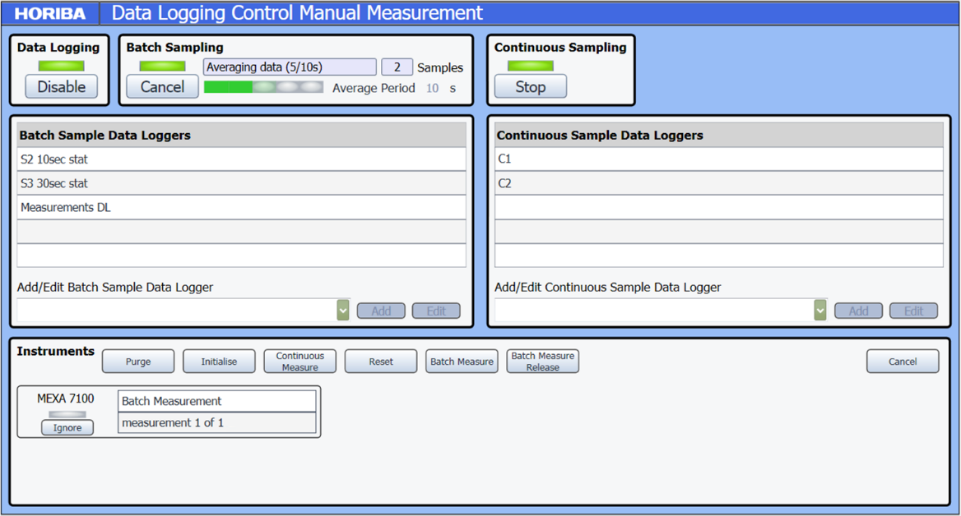
Figure 2: Manual Measurement
This allows to execute steady state tests in manual mode and to kick-off a defined measurement under stable conditions. Continuous signals and device communication are coordinated. The test consists of these elements:
- Workflow to load all necessary components
- Panel for user interaction with the test stand enabling the following functions
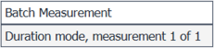
- Start/Stop of the engine
- Ignition On/Off
- Selection of control modes
- Setting demand values for the engine parameters
- Start measurement
- Live display of actual engine operation data
- Test programs for the measurement procedure
- Data logging with user definable channel list
- Excel based Report to present all measured values

In the standard configuration an example of an automated test procedure with user guidance is included. The test includes the following steps:
- Input of test parameters
- Panel for presentation of live data and for user interaction
- Automatic start and stop of the engine
- Warm up engine with steps depending on user defined cooling water temperature
- Power map test
- Engine cool-down
- Excel based report of the test result

Scope of Supply | Quantity
STARS Engine Workstation License | 1
Software license for real-time extension RTX | 1
STARS Device driver for test stand controller SPARC Engine | 1
STARS Device driver for CAN based I/O (Analogue and digital In- and output) | 1
STARS help desk for the warranty period (max.1 year) | 1

Technical Data
Functions | See Technical Specification STARS
Operating System | Microsoft Windows 7 32-bit

- STARS Device Driver License Opacimeter AVL 439 1000007055
Software Driver for interfacing the Opacimeter AVL 439. The device driver will allow remote control of the Instruments out of any STARS application. The STARS Device Driver plug-in concept will allow using this device without additional programming. Once the device driver is integrated into the test stand configuration it could be used from any STARS test schedule or display.

Scope of Supply | Quantity
Driver for Opacimeter AVL 439 | 1
Manual Control Display Page | 1
Embedded User Guide | 1 (US-English only)

Technical Data
Functions | Support commands to control the system and to transfer measured values and status information
Driver/Instrument Class | Smoke Measurement
Devices supported | AVL 439
Device Driver Capabilities | The following values are updated @ 1Hz:  - Device status  - Interface mode  - Active alarms  - Gas Temperature  - Measuring Chamber Pressure  - Gas Flow Rate  - Measuring Chamber Temperature  - Detector Temperature  - Detector Signal  - Halogen Lamp 1 & 2 Current  - Lamp Temperature  - Heat Output Window 1 & 2  - Warmup completion time  The following values are updated @10Hz:  - Opacity  - Absorption  The following values are updated at device connection and when reconfigured by the driver:  - Variable to output  - Variable to filter  - Filter type  - Rise time  - Trigger type  The following values are updated at device connection:  - Firmware version  - Device ID  The following values are updated at device connection and every 5 minutes:  - Operating time  - Time since service

Interface
Platform | STARS Version 1.6 onwards
Protocol | AK
Physical Interface | Serial RS-232

Test Schedule Plug-In Commands | Description
Connect | Connect device to STARS
Release | Disconnect device from STARS
SetMode | Sets the mode of the instrument
Measure | Starts a continuous measurement
StartPeakMeasurement | Starts peak measurements
EndPeakMeasurement | Stops peak measurements
PauseInstrument | Suspends operation of the instrument
Off | Stops all functions and turns off heaters
Zero | Initiates a warm-up phase
CheckZero | Flows clean air through the instrument
CheckLinearity | Performs a linearity check of the instrument
Purge | Performs a back flush of the probe line and sampling line

- STARS Device Driver Software License Fuel Flow Meter AVL 1000007061
Software Driver for Interfacing the Fuel Flow Meter AVL 733 and 733S. The device driver will allow remote control of the Instruments out of any STARS application. The STARS Device Driver plug-in concept will allow using this device without additional programming. Once the device driver is integrated into the test stand configuration it could be used from any STARS test schedule or display.

Scope of Supply | Quantity
License for:  Fehler! Unbekannter Name für Dokument-Eigenschaft. Device Driver | 1
Manual Control Panel | 2
Embedded User Guide | 1 (US-English only)
STARS Help desk for the warranty period (max.1 year) | 1

Technical Data
Driver/Instrument Class | Fuel Measurement
Devices Supported | AVL 733  AVL 733S
Device Driver Capabilities | - MassConsumed:  Mass of fuel consumed for the last completed measurement @ 2 Hz  - MeasurementTime:  Time interval of the last completed measurement @ 2 Hz  - InstMassFlowRate:  Instantaneous mass flow rate @ 5 Hz  - MassFlowRate:  Mean mass flow rate over the last completed measurement @ 2 Hz  - AverageMassFlowRate:  Mean mass flow rate across a number of measurements @ 2 Hz  - SDOfMassFlowRate:  Standard deviation of mass flow rate across a number of measurements @ 2 Hz  - InstantaneousMass:  InstantaneousMass @ 2 Hz  - MeasurementNumber:  Number of the current measurement @ 2 Hz  - CurrentTime:  Current time setting for time-controlled measurements @ 2 Hz

Interface
Platform | STARS Version 1.6 onwards
Protocol | AK
Physical Interface | Serial RS-232 or Ethernet

Test Schedule Plug-In Commands | Description
Set Mode | Set Mode: Mass, Time, Continuous or Manual
Measure | Start a continuous measurement
Start | Start a manual measurement
Stop | Stop manual measurement

- STARS Device Driver AVL Indicom 1000074911
Software Driver for interfacing the combustion analyser AVL Indicom via DCOM interface. The device driver will allow to remote control the Indicom and to transfer measured data to STARS.
The STARS Device Driver plug-in concept will allow using this device without additional programming. Once the device driver is integrated into the test stand configuration it could be used from any STARS test schedule or display
The device driver supports Indicom from version 1.2 and later with options R and X[D] installed.
Scope of Supply | Quantity
License for:  AVL Indicon Device Driver | 1
Manual Control Panel | 1
Embedded User Guide | 1 (US-English only)
STARS Help desk for the warranty period (max.1 year) | 1

Technical Data
Functions | Support the parameterisation and remote control of the device and the transfer of measured values and status information
Driver/Instrument Class | External Data Logging

Device Driver Capabilities
Data Rate | Update @ 1 Hz
Measured values | Maximum of 10 Hz (configurable)
Active alarms | By callback
Device status | By callback
Firmware version | Updated at device connection
Data Rate | Update @ 1 Hz

Interface
Platform | STARS Version 1.8 onwards
Protocol | Microsoft DCOM
Physical Interface | Ethernet

ULI Methods - Commands | Description
Connect | Connect device to STARS.
Disconnect | Disconnect device from STARS.
Remote | Switch device into remote controlled mode.
Local | Switch device into locally controlled mode.
StartMonitor | Start continuous measurement.
StopMonitor | End continuous measurement.
SetBatchSize | Set number of cycles for batch measurement.
AcquireBatch | Run batch measurement.
AcquireAndSaveBatch | Run batch measurement and save results.
CancelMeasurement | Stop any running measurements.
SaveData | Save measured data.
LoadConfigFile | Load device configuration from file.
GetErrorString | Convert ULI error number into text.

- STARS Device Driver ASAM ASAP3 1000007064
Software Driver for Interfacing ECU application systems via ASAP3 allows to measure data and change scalar or map data to/from an ECU application system.
The device driver supports the following devices:
- ETAS INCA (4.0.x, 5.1 to 5.x)
- ATI Vision (2.1 to 2.5)
- Gredi
- Vector CanAPE (5.x and 6.x)
- Denso Panel 3
The STARS Device Driver plug-in concept will allow using this device without additional programming. Once the device driver is integrated into the test stand configuration it could be used from any STARS test schedule or display.

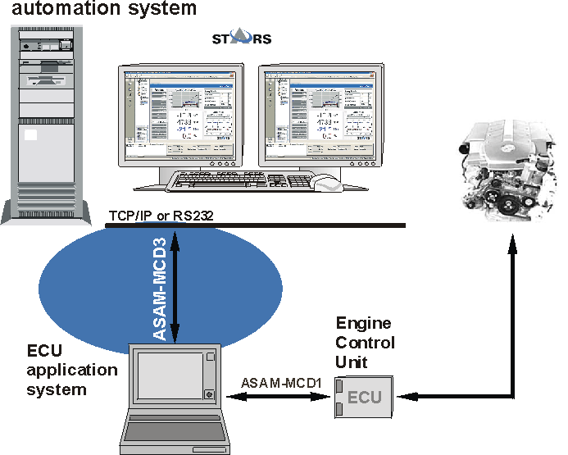
Figure 1: Schematic diagram STARS-interface ASAP3

Scope of Supply | Quantity
STARS Driver ASAP3 interface | 1
Display screen for visualisation the signals exchanged via ASAP3 | 1
Application support | Not included, will be quoted separately
STARS Help desk for the warranty period (max.1 year) | 1

Technical Data
Functions | Send and receive variables to/from ASAP3 Devices
Access speed for variables [Hz]* | 10; 5; 2; 1; 0,5; 0,2
Access speed for parameters [Hz]* | 10; 5; 2; 1; 0,5; 0,2
Max. number variables and parameters to be supported | 400

Interface
Platform | STARS Automation
Protocol | ASAP3 2.1 (without extended functions)
Physical Interface | Serial RS232 or TCP/IP

Acceptance Test
Establish Connection to Application system | Setup connection to customer’s application system.  If such system is not available, a connection to an INCA system running in Demo mode on the PC of the commissioning engineer will be established
Setup a limited number (max. 20) channels for measurement from application system, show online values in STARS variables in a display page.  Control of driver is done by use of default display page for the driver | If such system is not available, a setup of two channels from INCA in Demo mode for proof of capability will be performed

* depending on the amount of data and the performance of the ASAP3-device as well as the physical interface and the load of the STARS system.

- Installation STARS Device Driver HORIBA MEXA ONE LAN 1000007058
Installation of a software driver for interfacing the HORIBA MEXA ONE series. The device driver will allow remote control of the Instruments out of any STARS application. The STARS Device Driver plug-in concept will allow using this device without additional programming. Once the device driver is integrated into the test stand configuration it could be used from any STARS test schedule or display.

Scope of Supply | Quantity
Software license and installation of Driver for HORIBA MEXA ONE LAN | 1
Setup display screen for manual interaction with the device | 1

Technical Data
Functions | Support of the remote control commands of the HORIBA MEXA ONE series and to transfer measured values and status information

Interface
Platform | STARS Automation
Protocol | MEXA LAN
Physical Interface | Ethernet

Note:
- The scope of supply consist of the software license (free of charge) and a handling charge

- Installation STARS Device Driver HORIBA MEXA 1000SPCS 1000044868
Installation of a software driver for interfacing the HORIBA MEXA 1000SPCS series. The device driver will allow remote control of the Instruments out of any STARS application. The STARS Device Driver plug-in concept will allow using this device without additional programming. Once the device driver is integrated into the test stand configuration it could be used from any STARS test schedule or display.

Scope of Supply | Quantity
Software license and installation of Driver for HORIBA MEXA 1000SPCS | 1
Display screen for manual interaction with the device | 1

Technical Data
Functions | Support of the commands to remote control the HORIBA MEXA 1000SPCS series and to transfer measured values and status information

Interface
Platform | STARS Automation
Protocol | AK
Physical Interface | Ethernet

Note:
- The scope of supply consist of the software license (free of charge) and a handling charge

- Installation STARS Device Driver HORIBA MDLT 1300T 1000007062
Installation of a software driver for interfacing the particulate-emission measurement system HORIBA MDLT 1300T series. The device driver will allow remote control of the Instruments out of any STARS application. The STARS Device Driver plug-in concept will allow using this device without additional programming. Once the device driver is integrated into the test stand configuration it could be used from any STARS test schedule or display.
The Horiba MDLT STARS Device Driver supports the remote control commands of the models:
- MDLT-1302T
- MDLT-1303T

Scope of Supply | Quantity
Software license and installation of Driver for HORIBA MDLT 130xT | 1
Editor for device configuration and Display screen for manual interaction with the device | 1

Technical Data
Functions | - Start / Stop of the blower and the supply of dilution air  - Control of the particulate sampling  - Monitor of Instantaneous data  - Acquisition and reset of the integrated data  - Setting dilution air flow control mode and the condition  - Control of the auto filter changer  - Start / Stop of the learning of exhaust flow input signal  - Setting of the Input signal

Interface
Platform | STARS Automation
Protocol | HORIBA MetaLAN
Physical Interface | Ethernet

Note:
- The scope of supply consist of the software license (free of charge) and a handling charge
- Due to the concept of particular measurement with HORIBA MDLT the interface is used to control the device but not evaluate the particulate emission results. This is typically done with the user software of the HORIBA MDLT.

- Installation STARS Device Driver HORIBA PTFM 1000 1000059149
Installation of a software driver for interfacing the HORIBA PTFM 1000 series exhaust mass flow meter. The device driver will allow remote control of the Instruments out of any STARS application. The STARS Device Driver plug-in concept will allow using of this device without additional programming. Once the device driver is integrated into the test stand configuration it could be used from any STARS test schedule or display.

Scope of Supply | Quantity
Software license and installation of Driver for HORIBA PTFM 1000 | 1
Display screen for manual interaction with the device | 1

Technical Data
Functions | Support of the full set of remote control commands of the HORIBA PTFM 1000 series and to transfer of measured values and status information

Interface
Platform | STARS Automation
Protocol | HORIBA
Physical Interface | Ethernet

- The scope of supply consist of the software license (free of charge) and a handling charge

- Device Driver Software License Blow-By Meter 442 for STARS Test Stand Automation 1000007044
Software Driver for Interfacing the Blow-By Meter 442. The device driver will allow remote control of the Instruments out of any STARS application. The STARS Device Driver plug-in concept will allow using this device without additional programming. Once the device driver is integrated into the test stand configuration it could be used from any STARS test schedule or display.

Scope of Supply | Quantity
Driver for Blow-By Meter 442 | 1
Display screen and parameterisation for manual interaction with the device | 1

Technical Data
Functions | Support of commands to control the system and to transfer measured values and status information
Interface
Platform | STARS Automation
Protocol | AK
Physical Interface | Serial RS-232

- STARS RS 232 Serial Board 1300033783
STARS Interface for up to 8 serial connections

Scope of Supply | Quantity
Serial Connection Board | 1
Connection Cable 1 m | 1
Technical Data
Number of Serial connections | 8
Protocol | RS 232
Max. Baudrate | 921.6 kbps
Interface
Connector | 8 x DB9 male

- STARS High Speed CAN Interface 1300033780
Connection board for communication between STARS and up to 2 CAN segments

Scope of Supply | Quantity
CAN Connection Board | 1
Technical Data
Number of CAN connections | 4
CAN protocol | ISO 11898-2
Interface
Connector | 9-pin DSUB male

- Operators Place
- Measuring and Control Cabinet Type T/D 1300042242
for installation of 19” rack modules and test stand electrics
Complete assembled cabinet for engine test stands with AC machine (e.g. Dynas₃ loading unit), if purchased together with the corresponding module. Installation space of not ordered 19” racks will be covered with dummy plates.
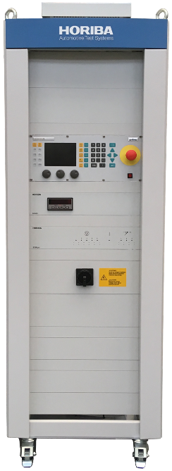 | 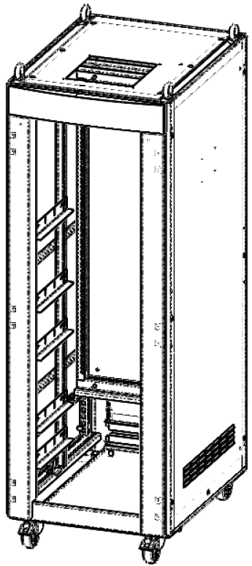
Figure 1: measuring and control cabinet type T/D fully equipped
(design similar to illustration)

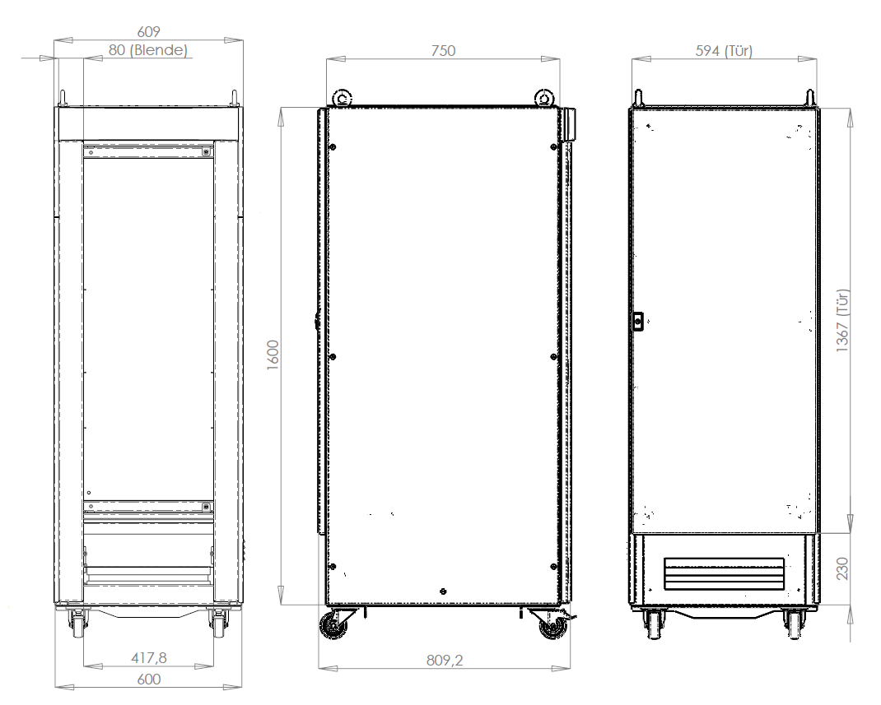
Abb. 2: dimensions of movable cabinet 19” / 31HU

Scope of Supply | Quantity
Moveable Cabinet 19” / 31HU  consisting of:  - mech. complete assembled  - 4 x cabinet roller  - 19” frame (front sided)  - subplate (back sided), swiveling  - hinge door (back sided)  - 4 x eye bolt, zinced  - 5 x slide bar set  - 8 x flat strip earthing  - shield bus  - cable feed from below / back | 1
Internal cable set + wiring with  CE cables | 1
Power supply consisting of  - 1 19” main switch front panel  - 1 1x 20A mains filter  - 1 multiple socket outlet CEE 7-4  - 1 AC terminal strip  - 1 DC terminal strip  - 2 24V DC power supply unit 10A  - 4 automatic circuit breakers | 1
Power contactor 3 N.C.C.  (forcibly guided contacts ) for remote power disconnection  e.g. for fuel consumption measuring device | 1
Installation space incl. cabling for  - STARS test stand I/O  - air flow meter  - test stand controller type SPARCE  - Central Safety Module SZM  - control and power unit throttle position type LSR2003 | 2  1  1  1  1
Documentation according to EG-machine-directives and the resulting standards  DIN EN 61000-6-2,  DIN EN 55011,  DIN EN 60204-1 | 1
Safety test report acc. to  BGV A3 / DIN EN 60204-1 | 1

Technical Data
Single wire colors acc. to  DIN EN 60204-1 (IEC 60204-1) | main circuit: black  neutral conductor: light blue  main circuit in front of main switch: orange  DC control circuits: dark blue  AC control circuits: red  protective conductor: green/yellow
Circuit fusing | acc. to DIN EN 60204-1
Wire cross section | acc. to DIN EN 60204-1
Naming electrical equipment with system, location and identification of equipment | acc. to IEC 61346-1 (1996),  DIN EN 6779-1 (1992-09),  DIN EN 61346-2 (2000-12),  DIN 61346-1 (1997-01)
Rated current [A] approx.  (full equipped cabinet) | 16
Environmental conditions | +5..+40°C rel. air humidity 5…+85%  acc. to DIN EN 60721-3-3 /  class 3K3
Terminal strip, type of clamps | spring clamps
Dimension of cabinet [mm] | Please refer to figure 2
Dimension 19” installation frame | 31 HU according to  DIN 41494-7 (IEC 297-2)
Max. installation depth of racks [mm] | 450
Color | grey RAL 7047,  powder lacquer
Material | sheet steel,
Locking mechanism | 4-point
Protection class housing acc. to  EN 60529 | IP 21

Interface
Free installation space at subplate | approx. 25%
Mains type | TN-S
Mains connection data | 1/N/PE 230V AC 50 Hz
Connected Load S [kVA] | 5
pre-fuse [A]  (in combination with Dynas3 installed in VFD cabinet) | 16
Recommended connection line  acc. to DIN EN 60204-1 | 3x2.5 mm²  (local electric regulations must be taken into consideration)
The BUS cable set has a length of 8m, it means maximum clear width between cabinet and operator desk [m] | 3
Cabinet mechanics:  - Point transmission of force  - Floor properties  - Evenness  - Air outlet B 4.1  - Air inlet B 4.2  - Cable entry point B 4.3 | over four 65mm dia. rollers mounted in the corners  floated concrete  max. 2mm/m (gauge)  louvers at cabinet top  louvers at right cabinet side  feed to rear from below.

Note:
- Installation space of not ordered 19” racks will be covered with dummy plates.

- Central Safety Module SZM light 1000112842
safety module (19“) ready for connection with emergency-stop circuit, safety circuit and display functions. Emergency stop button will be connected directly.
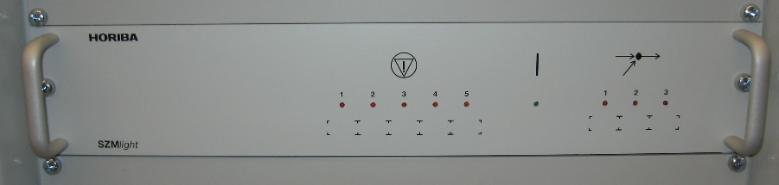
Figure 1: central safety module SZM light (design similar to illustration)

Scope of Supply | Quantity
Central safety module with  - LED display field | 1
Documentation  - operating manual central safety module SZM | 1

Technical Data
Color | RAL 7035 light grey
Material front panel | aluminum (AlMg)
Dimension measuring rack | 2 HU / 19”  acc. to DIN 41494-1 dimensions for 19” racks
Installation depth [mm] | 312
Supply voltage DC [V] | 24
Protection class housing acc. to EN 60529 | IP 20
Safety-related characteristic data in acc. with EN ISO 13849-1: 2008 | PL e  Cat. 4

Interface
Number of inputs for emergency-stop with positively driven contacts | 5
Number of outputs for emergency stop for the integration of safety-relevant switch-offs (e.g. test stand controller) | 6
Number of inputs for control circuit | 3
Number of outputs for control circuit | 1
Malfunction acknowledgement input for E-Stop´s and safety circuits | 1
Input external malfunction | 1

- Emergency Stop Button (10m) 1300006412
element for activating the emergency stop circuit of the central safety circuit module SZMlight.
Typical location for 10m version: operator desk

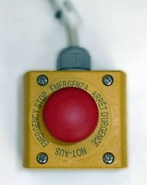
Figure 1: emergency stop button

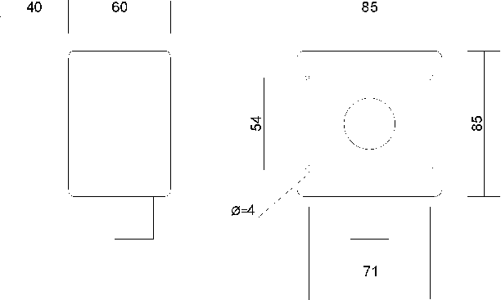
Figure 2: dimensions of emergency stop button

Scope of Supply | Quantity
Emergency stop button with labeling | 1
Electrical contacts:  Brake contact  Make contact | 2  1
Included connecting cable witch connector for central safety circuit module type SZMlight | 1

Technical Data
Tamper-proof | acc. to  ISO 13850 / EN 418, pull to release
Auxiliary contacts | safety function by positive opening to  IEC/EN 60947-5-1
Language of labeling | English, German, French, Italian
Color button / housing | RAL 3000 / yellow
Protection class housing acc. to  EN 60529 | IP66
Cable length [m] | 10

- Emergency Stop Button (20m) 1300006417
element for activating the emergency stop circuit of the central safety circuit module SZMlight.
Typical location for 20m version: beside test cell door

Figure 1: emergency stop button

Figure 2: dimensions of emergency stop button

Scope of Supply | Quantity
Emergency stop button with labeling | 1
Electrical contacts:  Brake contact  Make contact | 2  1
Included connecting cable witch connector for central safety circuit module type SZMlight | 1

Technical Data
Tamper-proof | acc. to  ISO 13850 / EN 418, pull to release
Auxiliary contacts | safety function by positive opening to  IEC/EN 60947-5-1
Language of labeling | English, German, French, Italian
Color button / housing | RAL 3000 / yellow
Protection class housing acc. to  EN 60529 | IP66
Cable length [m] | 20

- Multiple Socket Outlet EMC CEE 7-4 (8m) 1000010550
typically power supply of test stand PC (i.e. STARS-PC) and peripheral equipment at the operator desk for supply from the measuring and control cabinet

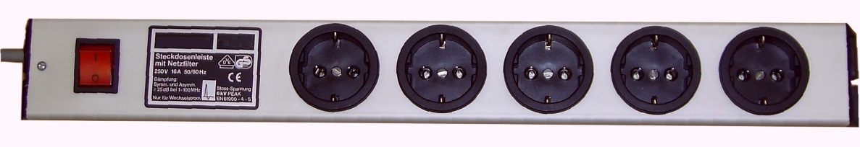
Figure 1: multiple socket outlet EMC CEE 7-4

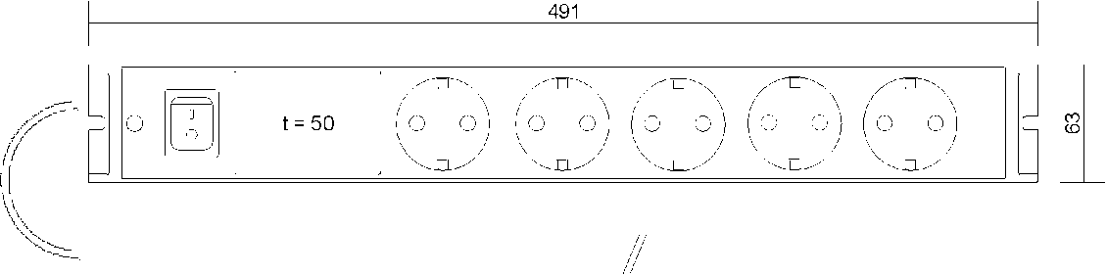
Figure 2: dimensions of multiple socket outlet EMC CEE 7-4

Scope of Supply | Quantity
Multiple socket outlet | 1
Connected power cable with free end | 1
Integrated line filter for protection against high frequency power line interference | 1

Technical Data
Cable type | 3x 1,5 mm², unshielded  numbered wire code (VDE 0293)
Cable jacket color | grey
Max. Voltage [V] | 250
Mains frequency [Hz] | 50 / 60
Dimension | Refer to figure 2
Cable length [m] | 8
Filter attenuation 1MHz/100MHz | > 25dB /25dB symm. and asymm.

Interface
Socket type | Schuko (CEE 7-4)
Number of sockets | 5

- Power Cable for Measuring and Control Cabinet T/D 1000067281
power supply cable of measuring and control cabinet T/D
Typical for power feeding from inverter cabinet

Scope of Supply | Quantity
Power supply cable AC 230V /16A | 1

Technical Data
Cable type power cable | Y-CY-JZ (Oelflex classic 110CY)  3 x 2,5 mm², shielded  wire color code: VDE 0290  black wire with white numbers;  PE-line green-yellow
Cable length power cable [m] | 20

- Services
- Dokumentace papírová i na CDROM 1000010462

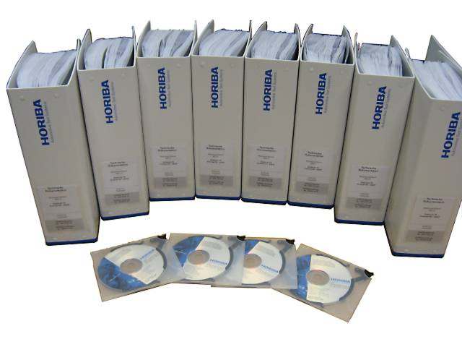

figure 1: technical documentation

Scope of Supply | Quantity
Engineering services consisting of:  - electrical drawings for the complete test stand, integration of the ordered test stand modules  - Work out a specification to support the customers on site preparations and technical interfaces of the test stand installation  - Preparation of a mechanical assembly drawing of the test stand including the ordered test stand modules  - Test stand manual and operating instructions according to the supplied test equipment | 1
Technical documentation according to EC Machinery Directive | 1x CD-ROM, 1x paper

- Instalace na místě
V ceně
- Uvedení do provozu
V ceně

- STARS Software-uvedení do provozu na místě
V ceně

Ausrüstung | Schnittstelle | Protokoll
Micro Motion Massendurchflusssensor | RS 485 / RS232
Abgasemissionsmessung - Horiba Mexa One | RJ45 | AK protokol
Abgasdurchflussmessung - Horiba PTFM-1000V2 | RJ45 | AK protokol
Opacimeter AVL 439 | RS 232 / RJ45 / 0-10V | AK protokol
Horiba MDLT-ONE | RJ45 | AK protokol
HORIBA MEXA-2200SPCS | RJ45 | AK protokol
Kraftstoffverbrauchsmessung - AVL 733S | RS 232
Lambda meter ETAS | RS 232
Festphasenspektrometer TSI EEPS 3090 | RS 232
DiagRAM Diagnosesoftwareverbindung | RS 232 / USB (vyčítání alespoň 40 kanálů)
DiagRAM Diagnosesoftwareverbindung | RS 232C
Indometer (Anzeige von dynamischen Wellenformen) | RS232
List of devices which will be integrated

- Zaškolení min. 8 osob a předání
V ceně

