Stránka č. 1 z 1

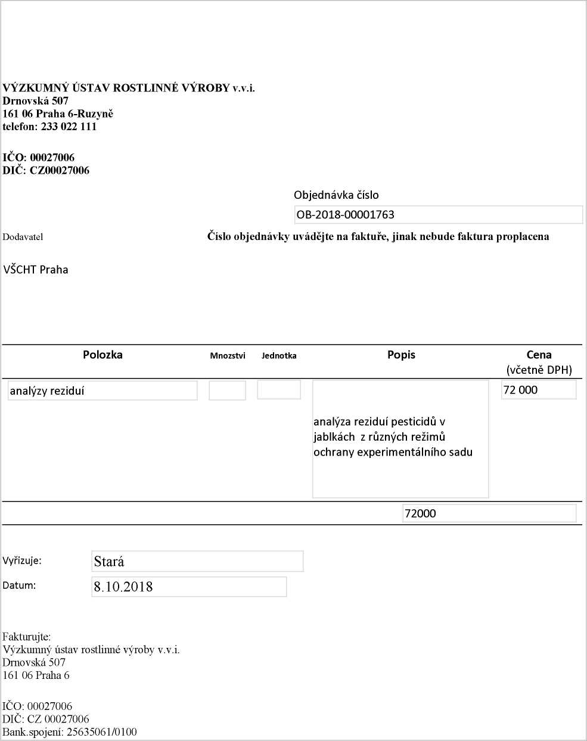

19.10.2018
http://dms/sites/Uctama/_layouts/Print.FormServer.aspx

