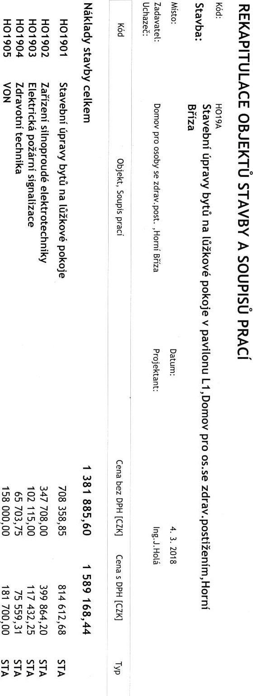

[YZ)I tua»t1ô3 euao
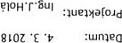 ezug yuaoH' usod•Aeapz as Kqoso Old AOwoa
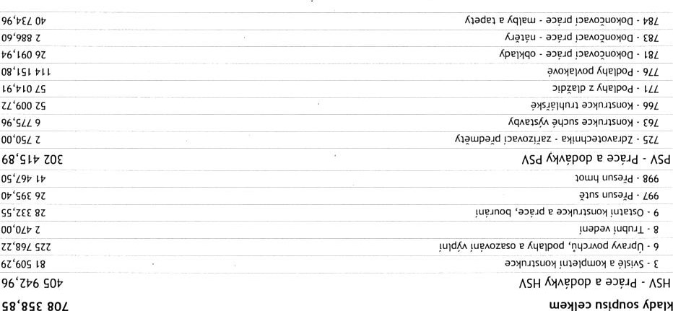
Svd0d - nup pçy
S8'8SE
.pazet_pn
:1meAepez
:OISM

amod eu 01Âq - 106 LOH
as•so oud AOWOQ' nu01!Aed A aC0*0d eu r.uKq KAeJdr.n !uqaAe1S
:eqAelS
pvud nsldnos nvnnLldVY38
I IZE
z.9'o•z.z.8'o
to LIOZ | OZ"EZE |  | 10'o |  | 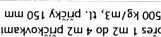  nsotnotuq ?Aoujarqo lugxouoaaqo•-pd sud Aq»old tppuns oqau p•omo evypzez | SEZ6EZOPE
 |  | nooo |  |  | PA tutu 9 x 09 x 09 'SZE g
9/09/09

10'o z.8'o.wowzr's
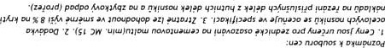
ZO LLOt Sun | 81'E6 |  |  |  | -1 oqau | n | 1 rugpz eu utusou | op oqau pop q$.ola30 yupnOZesO
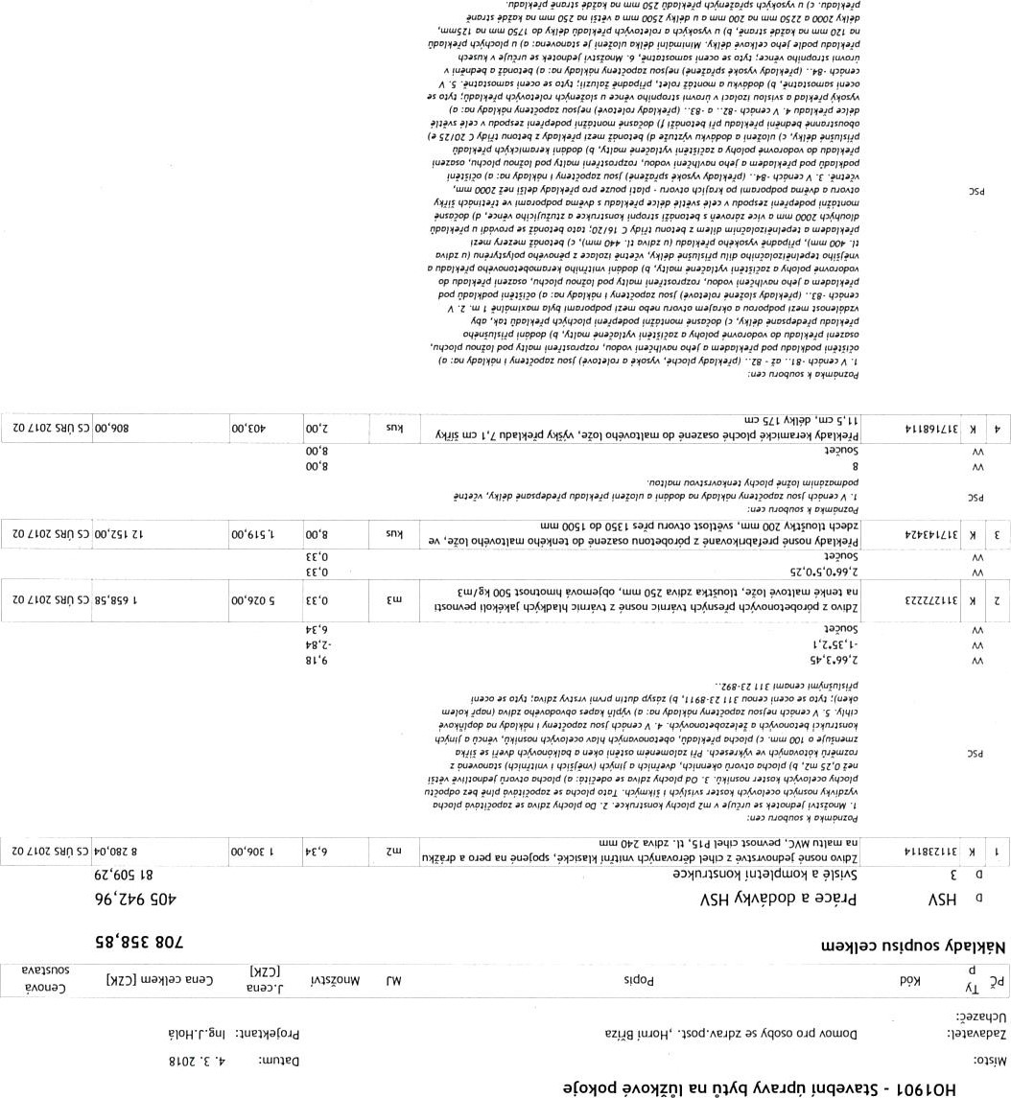
axarqo
eZ14g as•so Old Aowoa' n nu0UAPd A arowd ?AORQI eu OIÃq AAeud0 luqams
: eqAP2S
sidnos

eueas
ZO ,'LOZ | OS'EÈ# | Toss |  | og | OS sagd | pagaso•d eu | Zôq oqpasoÂ ntmaq z
1 a ?nos

F.z'z.6'o•z'z.z' 149' L.Fz+g.g'
• -02
zoaoz 91'È96 1 |  |  | leqo e pagd potd PKDfez | L '0166619

Apeptqo pod
ZO | ersss |  |  | puanezau yqruu  101 LEEt19  op •pmsnoupaÇ guayueu q.old PA01uat_ua• enguo |  | 61
ro•6sz
09'ZE
9z•S1 Z.(Z.ç6
z.z.9'o-(s•
(Z.SZE'S+SFE).S9'Z
• 19 op
zo ZIOZ SuOSO | 96'g91 61 | po'6sz |  | op  Knyu•o | Luu oqau
op
la ?nos Awpzez
zo LLOZ |  | oo•glt 1 |  |  |  |  | SZZSZEZL9
ruoqnos
PS'9LOZ | 00'L9 | OZ9'SOL |  | 01 |  |  |  | 91
zo
Z9•S01
69•rz•
L9'EZ
96 z.g6'% Z.Èf'9
 | 19'sos
OO'Eg1 | R)'6sz
1E111EZL9
guaZeaod
tp41ss•vs E op e 0 L op zo sunK8iFnOli • guagueu q•old ymuatua•ouOdPA enguo
ZO LIOZ sur.lE op q'01d
OE'ISL
 | OZ'961
ZO aoz | OS'066
op nqeszm A ' Odons u_nu op oo•rL
wold oqau eAead0
oo•sgl Odons u_Ju E tpold

ZI'89L çZZ 'u?A0zeso e Aqelpod 9
 | oo'LS9 | L9'EZ
EAUZ9PE
zul
uat_u 001 R"tpzéd a!01 eu ' EW m t0L10Z S'OOS PAO•uaCqo o z puuenpo e Kwpzed
01'0
zo os'SL | OO'SSL 01'0
01'0 z.90'o.g'o op Aufloas
01 eu 'Luelup puueasoupa( O'4gusou '_p4ue'.031PA q'KA01a30 'upAoauald
01.S9'z
o • Auan 'Z O
Âued I - o
 | oo'6LL |  | •nou?d
OS'ESL E
16 'ge
t.z. t• t1).99'Z en easnos
eua) YAIsçouw S!d0d
PAOuô)
S
md T -podo pDHpz pod •Z
ZO LIOZ | 00'9tz
S S saAd nsotnotuq nouetu wpqez as Aqopd as 'eAÇpz tp4ue*asKN op q24uapa,snau apu'( !uq-04A mptupagd q•$uqoap PIPAOZPSO
I a ?nos
Âpold tu. A as
ncup.r Du
oq.u
'Aopng md ruaqnos
ZOLLOZ SuO | OE'6ZZ 6 |  | OE•LSI
tu op gelpoa
q.pe,sozeez e q:nld e tp$uap-tsez e PKu_rn s yaap 'ua•.to e • tpnypotps e opoq.s 'opeptqo 'qagelp 'qelpod e 'uaaau•ez - KqaeJs4A
?AOMq Aopnq op tu'uppô'd
oo'os 00'01
• pa•qJp.ds
"dnols p
OO'L"Z
yuapaA yuqnal
to aoz si oo'ooo | 00'000 t |  |  | 091 1!J01d faoutuq pupq oud pA01a•o paqmpz |  | w
 |  |  |  |  |  | A T  op  d/1 | op Du •ruo.dop  uaap oqau !uqnapz  09/ "load 4aouoaq 'tppz Old pA0/a.o | Ou  oqpueq•auk•.
to sur) zoaozsun s• | ÜSES Z | OO'SES Z | S
 |  |  | oo'z
00911 ETSS
'upAOZPS0 vaqmpz
md Ou oud Kuo
 |  | apy  Z | OS'  o | n  oud  noA01uaua. eu oqau guqruyz
S op
Zaq rygulaqo z
ZO | SuO
sz
tpyugar•.p
'upwzeso
18Vy ndKi mp•p z PYS qa$ue,sogas az uguezeu• LZOZ9EIE9
to LIOZ 00'SLL 9Z
pua»po | pm | Op
ZO | sg•gL
 | u_nu og op OS sagd | noqo | Old exuald oqau
av-nz4A uqua{OlA paAd pel Auguezetu K.•as». !upods nq•aA0d 'L'avis et
 | pu.pppo | pou
6 • | • Sua) |  | oz
ss'9Et
og op OS u'ss euguezet_u ' u_quazqqagd Auguezeu• nq•nod n.seadr:l ez usuezetu t_upua• "061ELE9 u'ss
•apds un ruoqnos
as KAoprrg
q"ëDlpod A md (q ZE 5 Z ApDppz .
md *dod 'Agowod 'Aqqpod pyrrueppo
-:Ldod Cud • I naoqnos
erse Isnos d
pnouô)
9 eueas.
SOOO'O.SE' Lg
9z'o tcTo.sz•gg
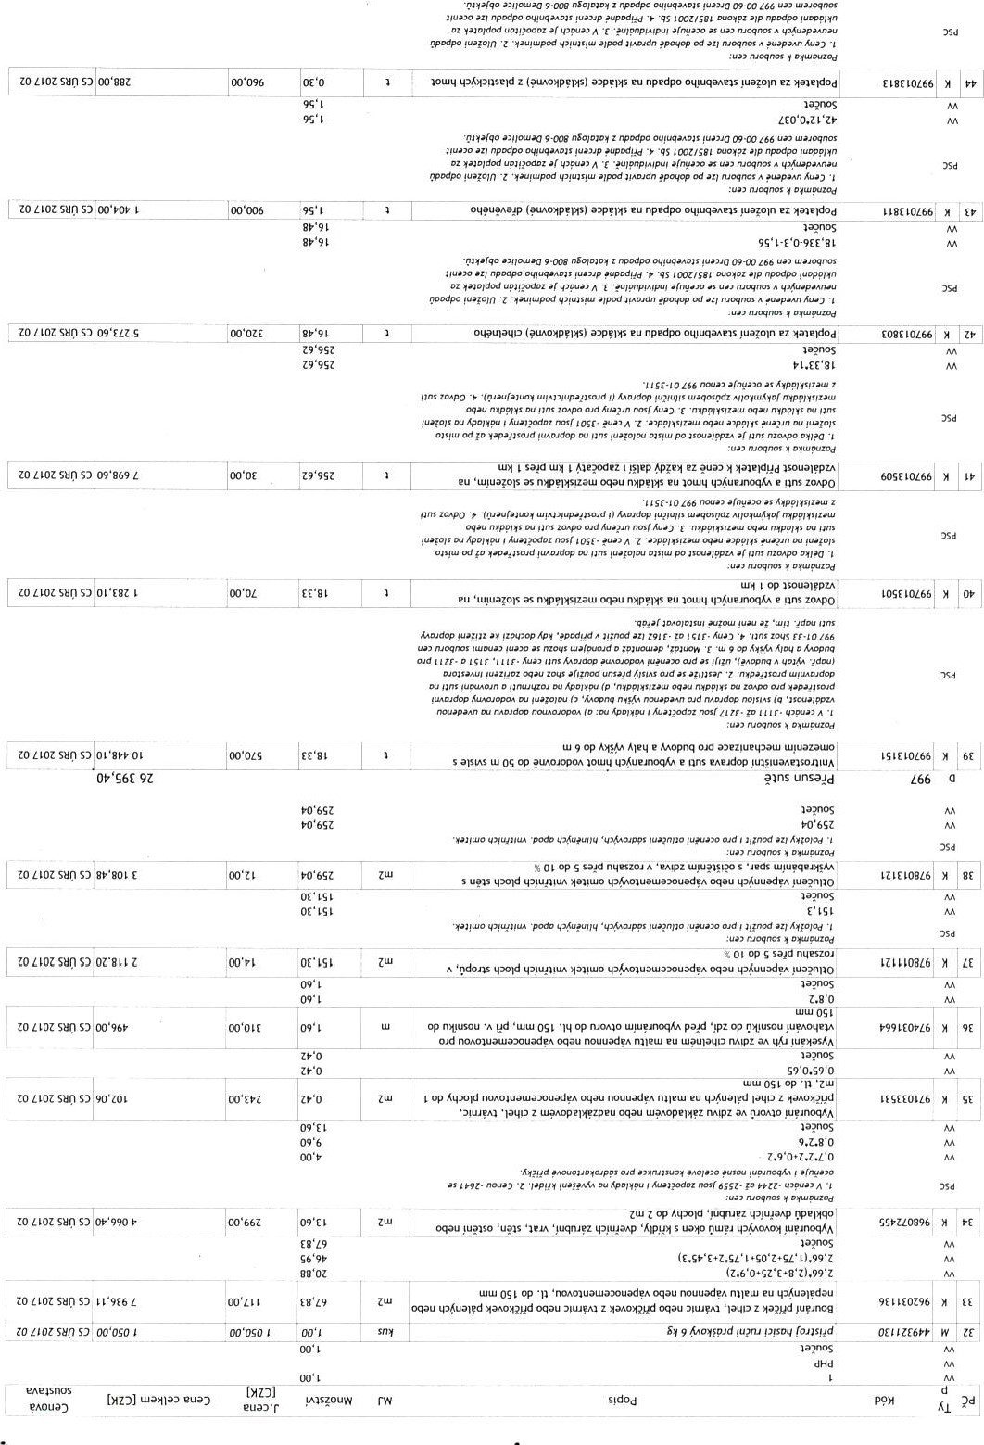
65
puqmpz
ZO LLOt zoaozsyosn | 1
 |  | CO'OOS
oog qyL•.0Jse1d oqau lapu•d qnp puld agaap
• • • | ruoqpo-s
af • mpznod o
. A eup"spu D
naoqnos
Z00099991
ZO LLOZ surn | oo^{s} osz s | oo'0SL
op up&scnseld oqau qMu?Aagp lapy*
Zi'zp a?nos aape( !upanoq
'991
zoaoz | g | oo'S61
z {nuouuaa ozgl

U '600 ZS 991
oud
•nqzos nun"4d
•Âpqa' Z o.•d
ss
oo'zoe | zo•o | nïfalqo zaq 5u?pçA0Jd unsagd ez •»taaeld"d psop z
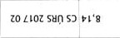
Old oqau 18EE9Z866
Old aou•q unsau
oud
pp "Z rwqzos
z md •
w
00'06#
Lu 9 op A op IsoualppzA gu.xeJdop oqpue•ounsagd nsouaouuq z 4uaAoue1S oqau 'OEE9LR66 haSap z md unsauj
009 x 009 tuawupz tu$puotuolno s guZlAaa
 | ' | n•eppop | opa
z |  | +DOwcd
 | oo•tsz  004006 |  | u_nu
ZO
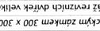
SHO009 x 009 yu?elelsul SIEZLLE9L oo'oozu4puowoanD s luze,aa 01 Izot06S
as ovppop
oeppop 5 z
: u" naoqms
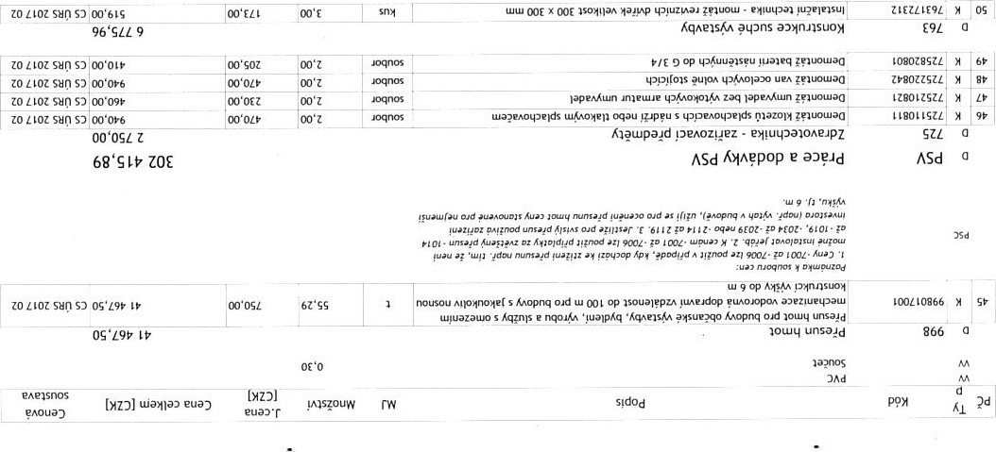
x OOE tp'uzsaa• . ZIEULE9Z

96'SLL 9 Kq,se1S4A pupns a'*nnsuoy

g
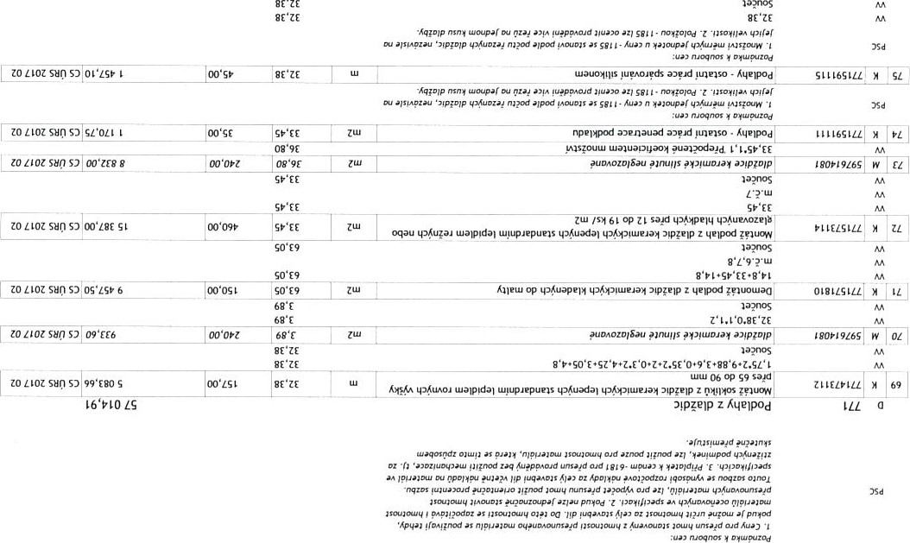
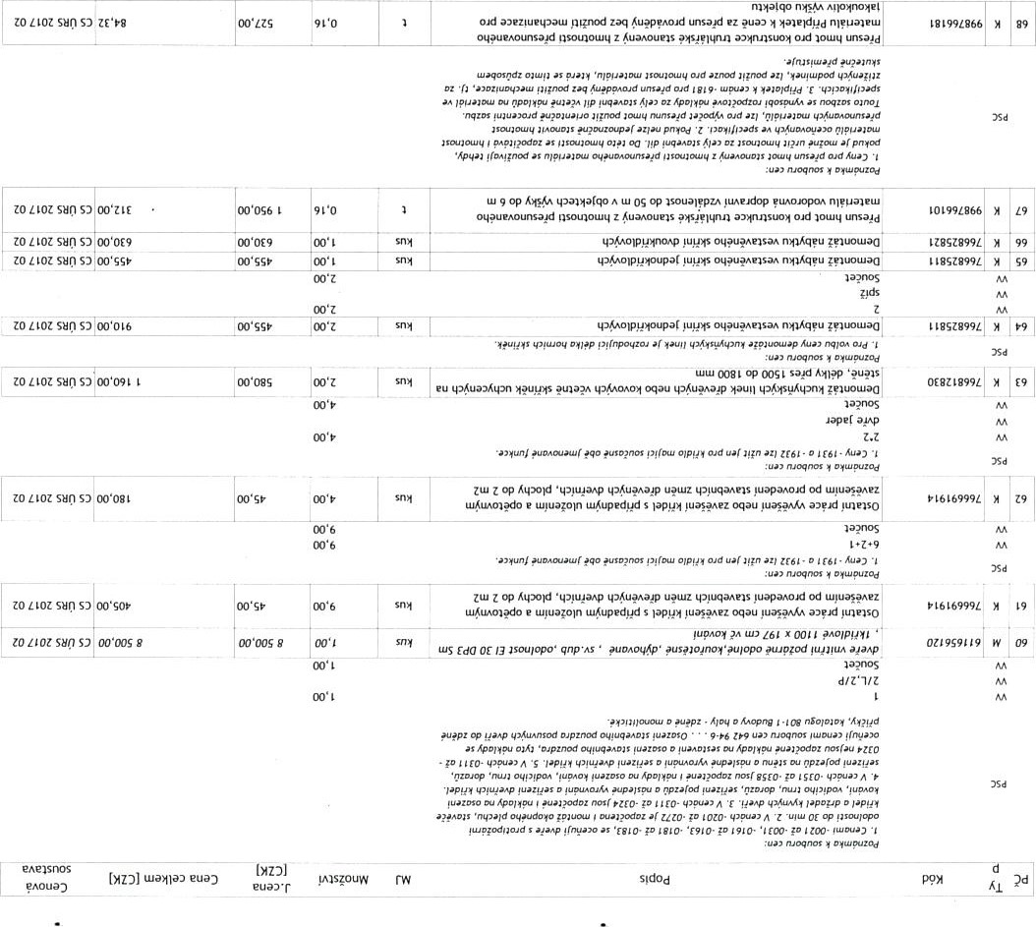
LL 6
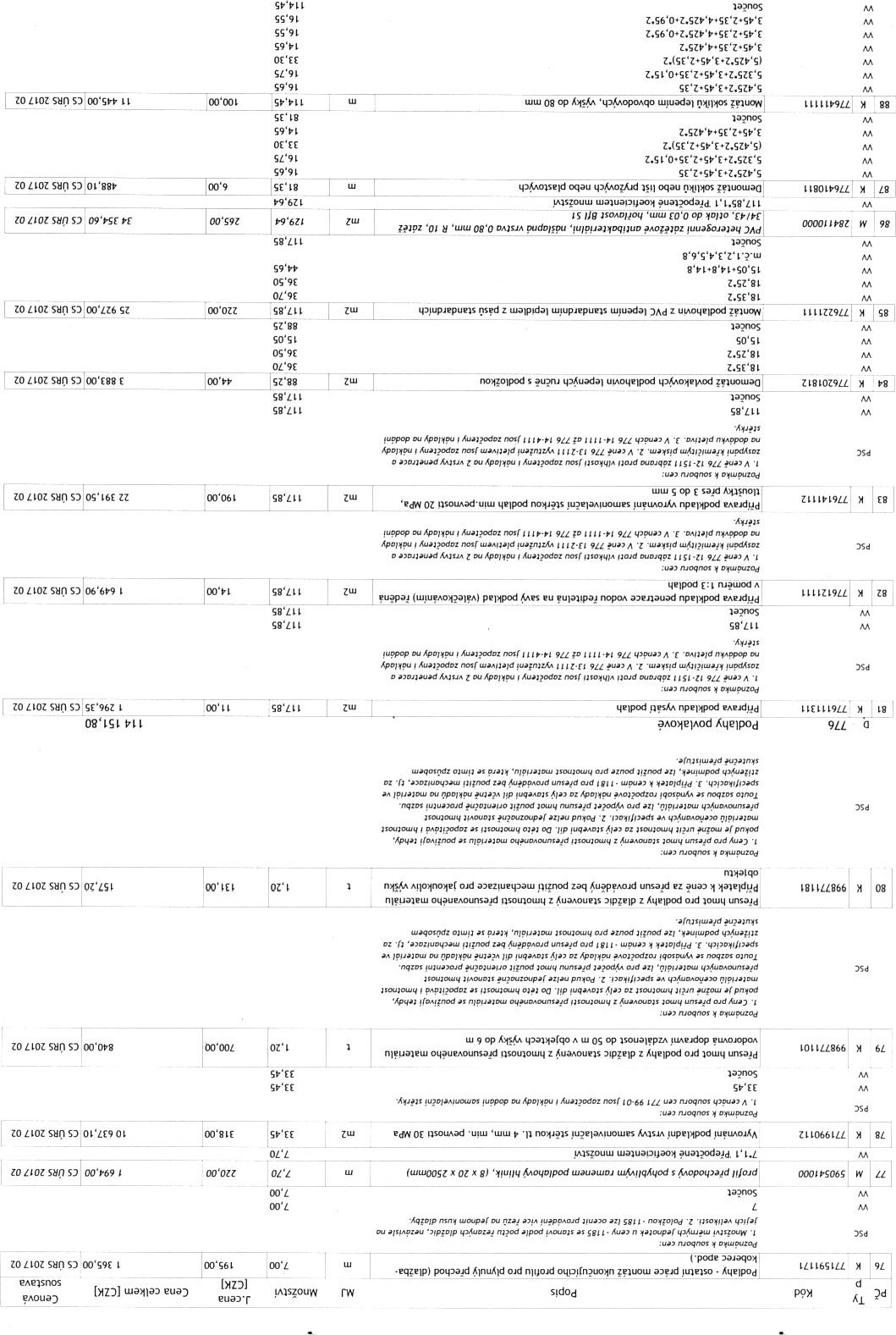
L L ZOL
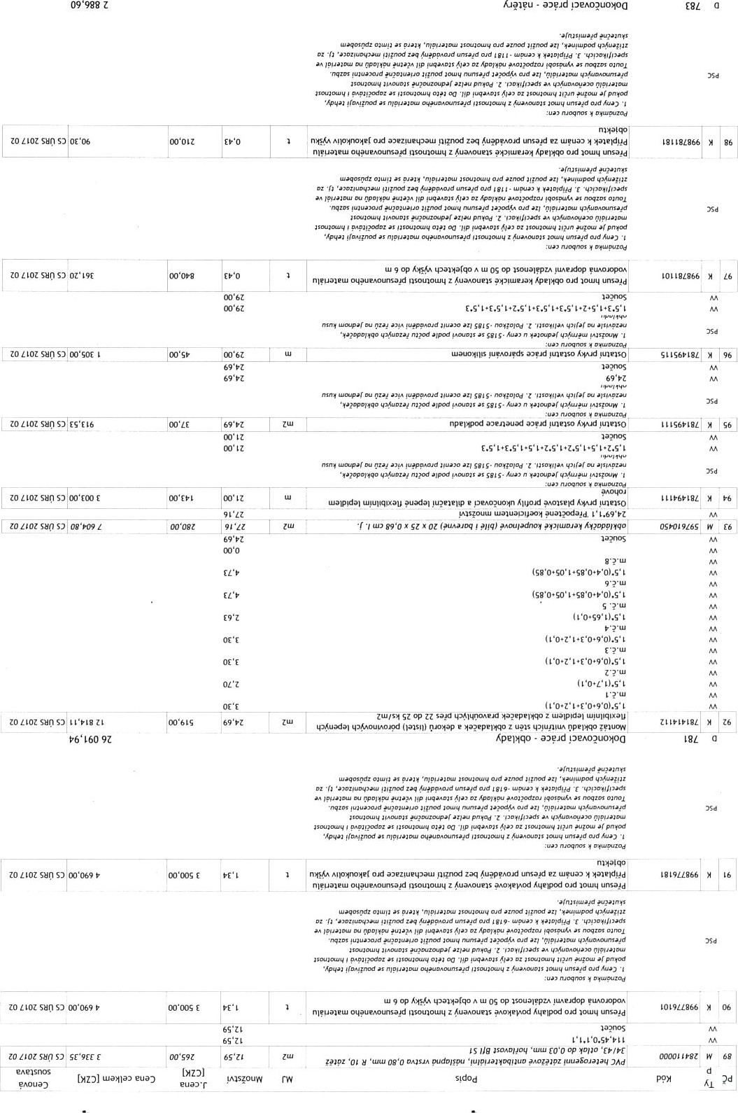

LI
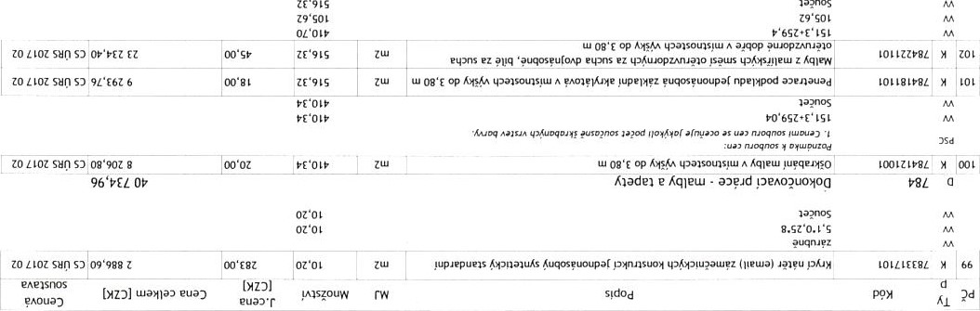
aa?nos

OE'L8L 161
00'G9E
OL'SEG

00'80L LYE
OO'80L LYE
Lue*la) euo)
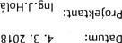
guoz
'E

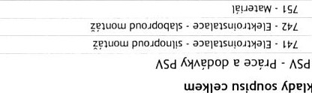
ApemeN
sgd0d . nl!p p•QY
:2azeqon

ezug yua0H' •b0d•æJpz as Åqoso oud AOwoo 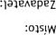
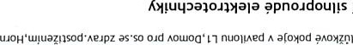
ppnoudoulys yuazæez - Z06 LOH
pzug eu cnÅq Geld') !uqaAe1S
:eqAms
PVUd nsldnos
S E
Old
.•un ruoqms
(1)'006 Z |  | OS op | !uazyez oqtaeAOP.?ASO
Käpnqo•d e K>fĺno'qz
Oud
LLOZ suti | E | OO'OOS E |  | •sn op pud e 'uazyez e | tua[qo Oid  Áxpngo•d e
ruognos
00 L op pud tuSiqóód
to IIOZ sun to ZLOZ sun  sun  to Lłoz  ZO Lłoz sun | oomg Z  Z  OO osgE  OSE | oo'oog z oo'ost  oo'ost  OO'OSE  oo'ost |  |  | JuaA0łoqKA e edpnqo•d PAO*ła' e oponzo• tpKpuuała e |  |  | LOOOłgłn  ZOOLLELH | LE  OE
VciJpi q'!udons psot.ns'tu q*ouÁq Ľvpo••, u'}uartxdez as tapuyvS Z tpłudons
oqau pvpo,•, as s loupz L tpôuazesgd usouaSÁiu oqau as u_łaiATd s Íoapz tpÔuázŔsŔd nsouasju_J oqau q*0iÁq W}uatodez as lapvvs
SOapz ti'4uazesvd oqau q*A0iÄq as lapgvs s to•pŽ
Oqau Lu}uagodez as lapnyň„s
ZO Lłoz SHO  ZO LLOZ SHO | OO'OSO I | OO'OSE oo'0SL | OO'E |  | dt• | "_ła,xoaoqz aH $ugupc»d .SZH  s as |  | 6E90EEłn | gz
ZO Sun  ZO 1LOZ | oo'0SL  OO'SEL | oo'0SL |  |  | s | E9 op uu uł"aarodez as q.$_äopnoad s v E9 op uu u.J!uarodez as |  | &OLZEłn  EllOZEłn
zo LLOZ sun | oo'09E | OO'OZL |  |  | as 'rnK1* zaq V SZ op uu as |  |  | zołoztłn
Sun  zozłoz to ZLOZ sun  to ZLOZ zozłoč  zozłoz sun  zo  ZO LLOZ  ZO sun | oo'on  s  oo'sgt  oo'ss  OO•OSZ  g | OO'OZL  oo'osł  oo'ss |  |  | as 'rnA-nt zaq SZ op uu ypoô W'uarodez as nouž?qo.d Oid Bd  'uarodgd u4ua(odez as haAnsľZ  op yułyunou  'panso.d Oid ' tu!uarodez as tp4uu?isgu oqau peu'ds  •Ľeu!dagd oqaú  Old as q'0019dnoAp Oupa( oqau ypayaso  O'd 'n?łpoa tu}uarcxiez as tp4uu.?ěsyu tp,QopdnoAp oupar ryeu!ds oqau  o.d as q*AopdnoAP oupa( peułds tppeułdez 'ĽepelA0 'ułyu_uou  OR' tu'ua(odez as oupac Peugis |  |  | ZOLOZEłn  zooołzłn
 |  |  |  |  | 02łpoA |  | OS op Rsotnou_łq tpoousełd oqau  ?ppupaz - SZH
ZO Lłoz SHO  ZO sun | OO'OS6 S  OO'OOL Z | OO'OSE  oo'OSE | oo'LL |  | ( |  | op ) e panuuqezau .SZH  oqpu2an8S a'rauauguop .SZH wałaun Qdrusoud •SZH
ZO Liot SHO ^{C}D
 |  |  |  |  |  |  | nzaggud e
ZO LLOt SHO 00'068 |  | 09'SE | oo'sz |  | q*nd |  | A oqau tp$uaěołn zaq Lp$u?pełu Olaqeä
ZO LLOt sun S3 Z  zo ILOZ sun s  Sun oo'SEE  to ZLOZ sun OO'OZO  ZO Sun S) OO'BLZ L |  | os'sz  os'st  os'st | oo'sg  oo'0LL | snä | q'4u1d  e q'$uld  e ašnuouaap |  | nzayyd  A oqau ?up,•, tp4ua4Jłn 'ua?uoän zaq tp$uep?tu nza4Jd e  Zunu 9 S • nzayyd e rn?0d  .?up,•, zaq Olaqe*  91 qa$uppo'uqo s tp4uyue1  z.q q)$ueaopzł 0?łpoA  Zunu op 0 a?łpoA Oid tpMołseld eu Etpo,•, W'uagodez as qapa•.zo• aronsud e  e Ahqnn eu zaq tunu op a a?V0A oid tpMuse
LĽoz suti sy oo'ost |  | oo'E6 | 00'91 | sru | qMuu*łsgu e aěgtuowap e aěywoułap |  | pu Q?łpo,•, uquagodez as aconsud e aľnuołu e K:tqnn eu 'uo(odeu zoq q'Mołse1d a!onsyd e A*qnn eu 'uagodeu  Luu' 09 s tppepyłv, :uqe"
zo s:) oo'złg  ZO Lłoz  ZO LLOt SHO OZ•S66 orsĺs  00'80L |  | oo•gs | oo'n  oo'os  oo'čE |  | tunnunseu s e |  | e ÄqÄqo as e unu 09 s tppepgl:ľ. | ASd
op wununseu s e Aqo• e KqAgo • Stue*ľods as e
09 op s tppep!18A tunnunseu s e Ago• e KqAqo • Stue*ľods as e zgauow pnoudoułłs -
ASd KHAgpop e

?ňoua)

OO'90L
:2azeqan ezłég as ,fqoso oad:łaueňepez
8L0t: u.łrueo
Ä*łuq'ałwuała ppnoudouus !uazyez - Z06 LOH
:uarqo ezug as 'so Old AOLuoa'L-1 nu0UAed a(0ä0d eu J.uÁq yuqaAeas
: eqAeas
DVUd Sidnos
S eueas
zo aoz syn
pqoy |  | 96
• 1 laq"
zo | 00'99#9 | OF6t |  | s'g x c (r' y •HYX) • pqt"

zo oo'oa • laqoy •/OJsuy laq"
00 'SZ pqoy
oo'm
pcxl poq POA Optadn oo•ze uzay nqolë'pqoy'wusou 00 '9e 6u0AOW'ZOd 4.•.opqo-' qolç
SO nqm•pqoy "usou oo'ZE / 4u0AOYu!Zod q0R
as a•gqb-ox$ltusu'oapp
00'91
oo•os
oo'zt
00 'z
00 'z
00 'z
00 'oz
00 'z
oo•z

zo aoz syn s) oo'szz S w €6
00'9 ooms oo'oçl S' 16
w 06
00 't/ "tsszspt
09ZSSZ9t 00"S9 016pszspt oo'zs ostççzSi•t 99 00 'zg
TSZ9 9968 lzset
w zg os'st
06 'St w 09
os'g
oo'gz 91
w
0099
oo'0S6
w 69 00 'osz w 99 oo'S' w 19
99
oo'oçz 9 SP 00'01
oo'gcz 89
oo'Z9J
00'9S/
00 'oçz 00 '059 oo'ztl oo'ztl oo'osz 1 oo•osz
00' 56e
oo•osÈ 00'09
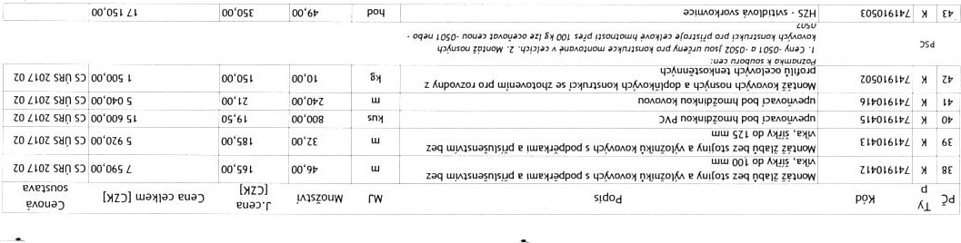
oo•osg L
ZÈL
00'S8E
pnoldoqels
-

to syn oo•otl
oo'6EZ
ZO D Z9XOS
ZO D 00'91Z oo'N9 SZ
s ' 99 dl' paoguo•o• rupçod Pd oo'goz
aoz sn OP x 09 Old zo oo•zsc OF X 09 oud
OP x 09 Old JR" •rods
S' x OF cud
x 91 zo syn 00 'oso z
ZO D oo'ogp OH op x 09 DAd
zo D oç'mz D oz FJ01dod
00'9Z g
'uaMtpn ?Luvd n/pualourlsold z ' OP dl oud PAOznOu! 01p'1!As
ZO Sb'n 91 OZ d/ M 9ZXZ npalqpod op ^{E} ipSidiv nq.ald z s apald•p'o Osal?l OIP/I!AS
00'06t 'dons
PAOlpdO ' 01p/"AS
M 9f x dons Du ' mpald z owutu•loqoaod• n/pvaaou_raso/d
ZO OO 'oor
z osapa' dl Olpm.•.s
ZO oo'sgz 9 M g 1 x Z tua?ouldAA s ' d' i apuoqJD"AlOd tua/POA.4aan pou' dl olpmas
ZO 00 'oçz •Mg' n.uoq 'pozuadu•o' s zo oo•S01
zo aoz 06 'ogp aJyqD"
OO•OSZ poaoaasaa 'PAOqDJ Luauu0/D s InpouJ aoz 00 'oz • A1 Kunspz oas•qnoJF a•uopadtug
aoz oo•zS9
Igp Z gp Z eunuo•qpo' 'zoquud•solqzoa o AYAnspz dl V 91 • 'A s•spuoupar ounspz zo syn oo:otE 'tuopoas•qnoaf as dl nmtuo a'D/DJsu' pouldagd W 19 zo aoz YS d' nog.uo ou OC/?AOPVJS ?Dtqdagd w 09 ZO D 00'99 as dl no!tuo 0u *101su' 4401?doupar pou'ds w 65 zo 00'tS1 'tuDWOAs•qr101F as dl rmytuo ow „Gowdoupar w oo•osz apep0AZ04 guaAOJoqz 4utmpod ogç' oo'osg 'A ut gus/ndtu'
oo%gc
aoz oo'6gg g/v9Jd1 zo ZIOZ syn oo'ost P'upatv•pnoad oo'osz
051 P?Od• x 'u4UuA' nou?'fndoz oud afnqnsqo a"upoAzou zo aoz 00 'gsp o ILJ?u1dop zoaoz sun OK' pull 100000 LSL
aoz Sun | 00
aoz | 00'09z

OE'LU L6L Ippmew ISL
 |  | OR' !uazeez
zo | oo'osl E | Op e oqpe10A oud yuazeez | EOmSE&L
ZO 1 Lot | E | "apen 04Lye,souuod puaçAsod pusal?l oad !uazeez
zo | •oo'0G6 | pezneubçs nospnsrue s ell?AS oqtu?ezneu8qs pusapa Old 'uaZyez
zo sru otouuaaue Aupaue pupalOds zo A aroapz oparpdeu
00 '005 8
01
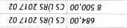
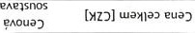
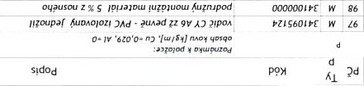
S
euaxr

E Z eueuas
ASd
OO'SLL
tua*la•
Apelh?N
eua) S!d0d nl!p pey
:2özeqon
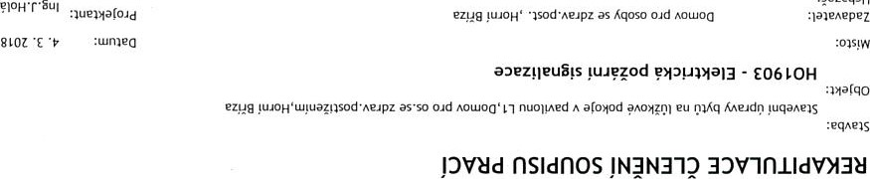
E z E euens .
ZO LIOZ sun OO•OOS E | OO•OOS E | *led x E SSO a•nuatunpa | vt0000LSL | EE
ZO sui S3 t |  | nup•sKs aznag | Lzoooossz
zo sun oo'coz z to LIOZ S) OO'OOS | oo•mz z | munsÅs e"nohz e guay-vortzpo' | ZLOOOOLSL
zonoz oo'oog z | oo'oog z | jpua;otu {uqup | 90001
zo suo 00'008 |  | oqpuqmp |  | gz
to Zlot su,^{r}p Dl 00'05>
SuO | OO'SZL 1
ZO SuO
9000m1GZ roooocnsz
oo'osp | oo•GL | Ipwaamu 90 ( uoqnos ) •uitu |  | son •pqoy 'teutuazn D yu?uu.razn e
!uarodsod yua(odsod
 |  |  |  |  | '1 tm9zSoS6S8
00*008 s to LLOZ sun S) oo'ost E | 00"911 | oo•oS |  | . | St ud nyqn_n Oid Kuulo op 'upps ud 0Jd op luptOS | Eooogzsrt EOCmoL5L
00'os9 | 00'0S9 |  | Sny |  | nuldnys oud pna,•, 'Luppd
to LLOt sun oo'ogs | Togs |  |  |  | pqe•.f | t000001SL
 | os'g | 00 |  |  | SZ ud pod omqrua | zoooocm
ZO LLOZ sun S) OO'OSO  00'080 ZE |  |  |  |  | pod ,qqnn  Yuli21SO  NV3 | 'Ooo«nsz | 61
to  ZO LIOZ SuO | so | 00'St9 | oo'st9 |  |  | paoqu,sod
 | É10000srt ELOOOOZVL | w
po,qopoqpo pujopo;uqo
to zlot  SuO SO | oo'oot  E | oo'ZJ | 00'001 |  | bd@åzoso ( ,fpqoy onp ood OV,4tpud ) oson pA0/aqoy q•4uppognp eu . Asen• | z100009t  ZIOOOOZYL
 |  | oo'tE os'sz | 00'001
zonozsyrpn | oo'sgz  00'S9L |  | 00 |  | npuJ o 0E uytu ruppd o" NS? 'Snt.u  ,qaqD1 pupu u.tuo/d 0 {nouaSqoqzaq' x t | rooooozvz
to SuO |  | IOS'sz
osgssgzsos6sg
to Zlot syrp sy zo suo | oo'09f t s | og'91 |  |  | ' | S02Zg g'o
 |  | os'sz
w
xz x p'spjq 1000tzsrf
npqeh c'90619zsos'sg NV3
to LIOZ sun | 00'oog6 |  |  |  | ( 'u.utuazn'p(ods' ndons op 'ua',4tpn pusou d S'/ XOS x09 qoß 0d gu/nuozuoq 4.•.OAOY DSO]J PAOIaqO' |  |  | 01
 | g | 00'01Z |  |  | qev 0d 'ulpuozgoq .
OO'GZE EE ?uppo ?uuP40d Åsen•pqeh.
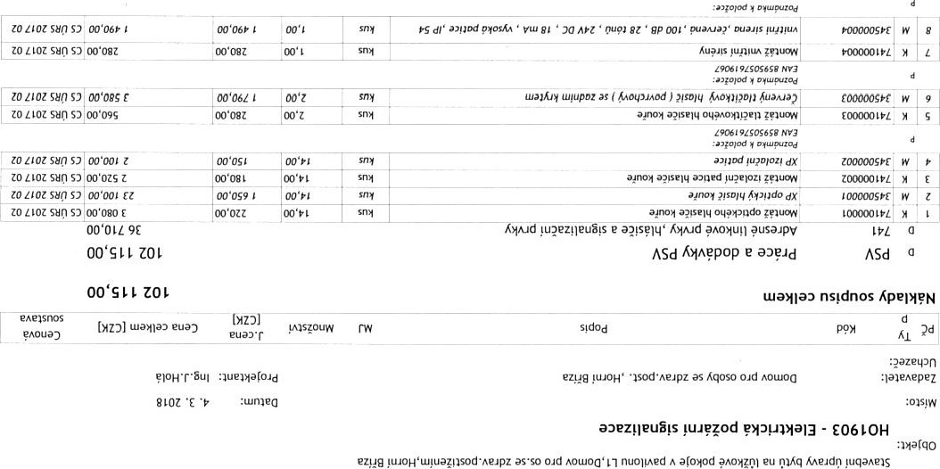
Z90619zsos65R
NV3
:eqnms
pvud sidnos

[YD] tua*lö) euaD
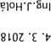
aueuaroJd ezug !uuoHas Kqoso o.d
•E
.•wmeo
S!d0d . nl!p ppy
:2azeu.n
: laienepez
.•cnsgw

oud tsouuoo• 51 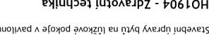
-
LOH
: eqAelS
PV8d nsldnos

z E euens
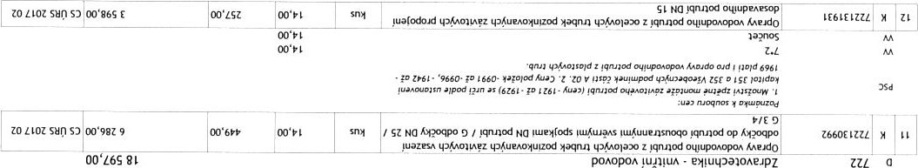oo•fl
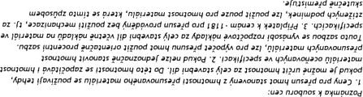
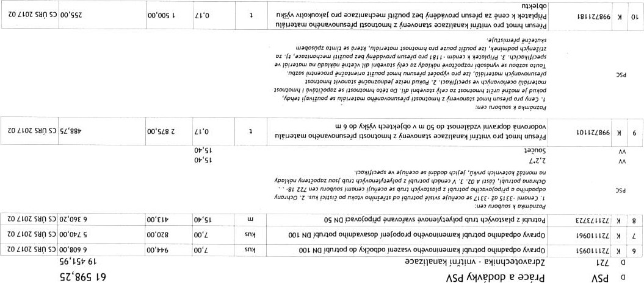ZO oz'09E 9 op'ss
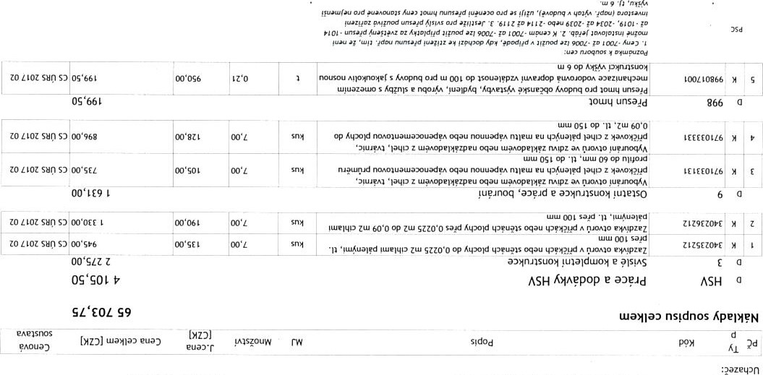
as Kqoso oud A0woa :paeaepez
eM!utpa1 IL00Ae-lPZ - LOH
:uarqo oud AOLuoa• nu01VNed A amod 01Kq KAe4dr.1 !uqaAe1S
:eqAeas
Sidnos
z euens
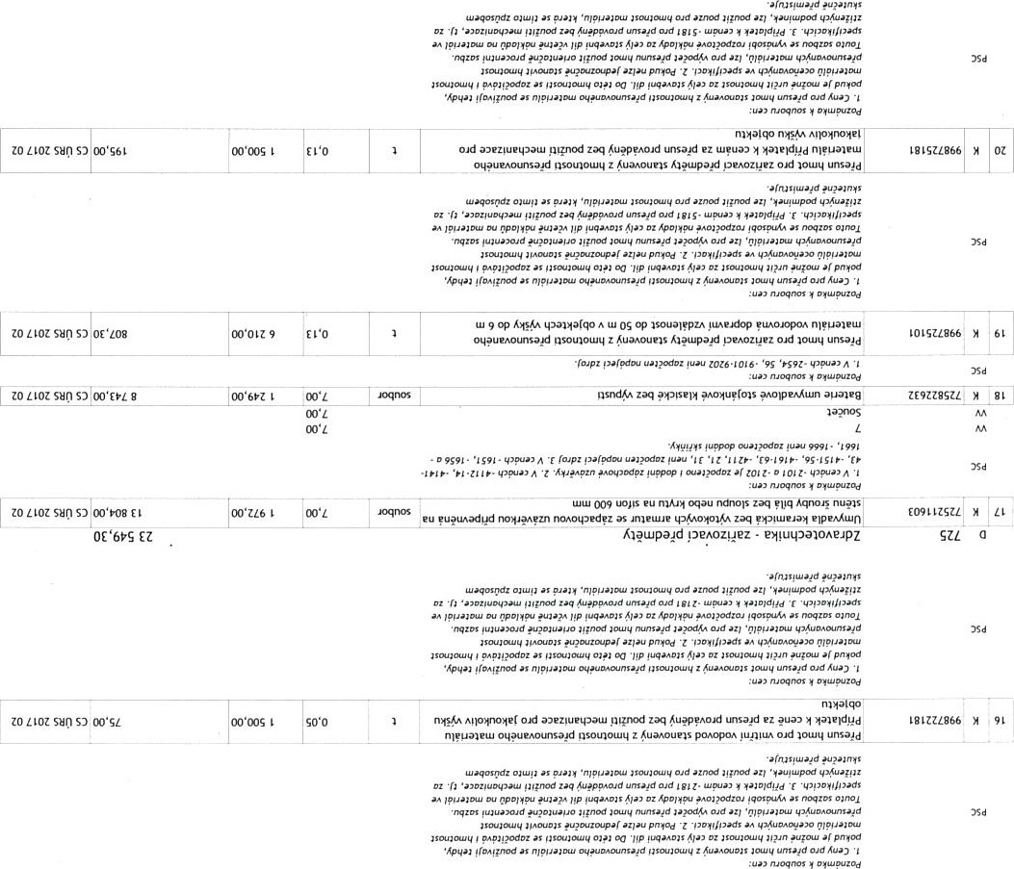91
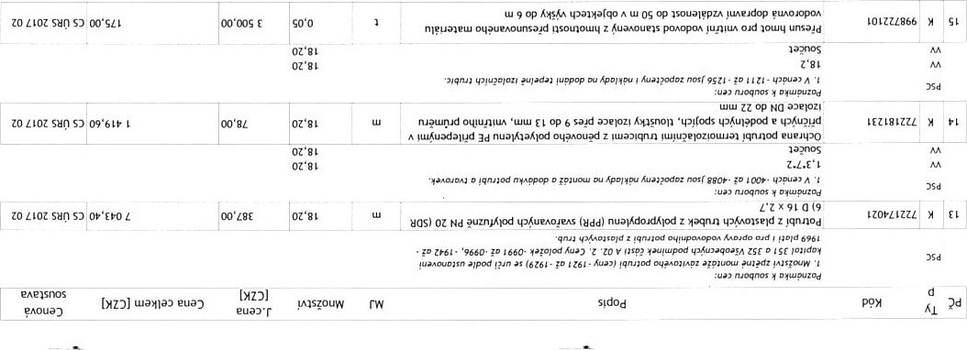
ĂpeMĘN
L

[HZ)) wanao eua) S!d0d . nup pęy
:2azeq3n
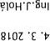
aueuacołd ezea as Ăqoso cud AOtuoa :meĄepez
8LOZ
:wmea .•ms!W
 |  | NOA - S06LOH
ezug | as•so ORI | nuołțńed A aro•80d eu rnĂq ,qeJd11
: eqAeas
DVUd nsłdnos 3)VłnLldVY3U
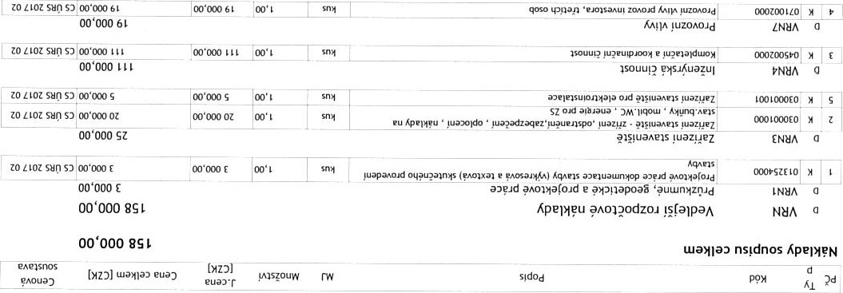
to LIOZ SuO
zo z
:2azetpn
aueua(0'd | ezue yua0H' as Kqoso oud AOwoa | :plenepez
aumea |  | :oasyw
NOA - S06LOH
ezug yua0H'wyuaznsod•.4P'pz as•so O'd AOL_uoo' aC0h0d eu r:nÅq K.AeudO !uqanms
DVBd Sidnos

