Key Action 1
- Mobility for learners and staff - Higher Education Student and Staff Mobility

Inter-institutional 1 agreement 2018-20[21] ²
between institutions from Programme and Partner Countries³

[Minimum requirements]4
The 1nstitutions named below agree to cooperate for the exchange of students and/or staff in the context of the Erasmus+ programme. They cornmit to respect the quality requirements of the Erasmus Charter for H1gher Education in all aspects of the organisation and management of the mobility, in particular the recognition of the credits (or equivalent) awarded to students by the partner institution. The institutions also commit to sound and transparent management of funds allocated to tt'em through Erasmus+.

Information about higher education institutions

Full name of the Erasmus
institution / country code !'r
Contact det'áils6 (email, phone)
Website · (eg. of the course

city catalogue)

Tech nical University of Liberec | cz  LIBERECOl | In stitutional Coordinator Studentská 2, 461  17, Liberec, Czech Republic. erasmus@tul.cz | http://www.tul .cz/en

- lnter-institutional agreements can be signed by two or more higher education lnstitutions (HEls), at least one of them must be located in a Programme Country of Erasmus+.
- Higher Education lnstitutions have to agree on the period of validity of this agreement
3 Erasmus+ Programme Countries are the 28 EU countries, the EFTA countries and other European countries as defined in the Cali for proposals. Eligible Partner Countries are listed in the Programme Guide.
- Clauses may be added to this template agreement to better reflect the nature of the institutional partnership. s Higher Education lnstitutions (HEi) from Erasmus+ Programme Countries should indicate their Erasmus code
while Partner Country HEls should mention the city where they are located. 6 Contact details to reach the senior ofíicer in charge of this agreen1ent.
1

Erasmus coordinator FT
I
--�------ I
�------- -

University of Monastir Monastir
cz
Prof. Mondher Zid1 1 '1t!Jl:JLw1:,,_w.en1n1,n1,,1.tn/ nd Director, National "ll.,RhnLr.nL
Engeneering School of

Monastir, ''101Jc::l1H�_r.zidi@enim. ífilL tn
Profossor
University of Monastir, BP 56 Taher Hadcled street Tel:+216 73 462 907- Fax:
+216 73 462 867
+L16 55063716

assoc1ate, Engeneering Monastir,
, Institutional coordinator,
National School of

- Mobility numbers7 per academic year

CZ MONASTIR
LIBERECOl

MONASTIR
cz
LIBERECOl
0710 Engineering and engineering trades, (52)
1,2,3
4x2 months

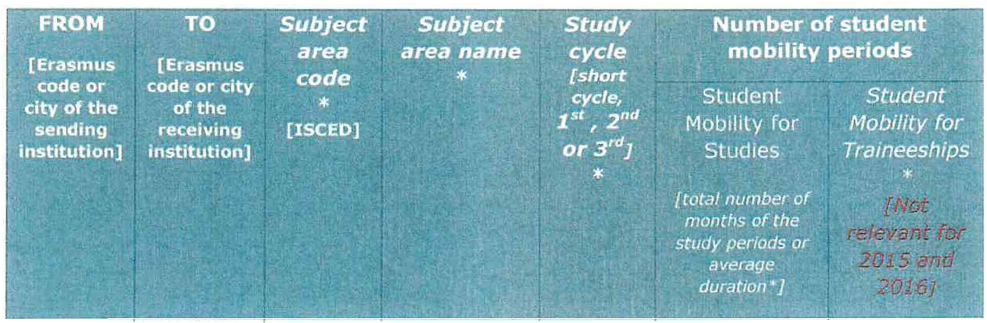

{*Optional: subject area code & name and study cyc/e are optional.]

1 Mobility numbers can be given per sending/receiving institutions and per education field (optional "': llu_p.//www.11·s.unesco.orq/Educat1on/Paqes/internarionol-standmd-clossif1cotion-of-ed11cation.a�px}

2

LIBERECOl
cz | MONASTIR | 0710 | aEndgineering | 2x5 days
MONASTIR | CZ LIBEREC01 | 0710 | aEndgineering | 2x30 days

ternagdiense,er(5in2g)

ternagdiense,er(5in2g)

r i:l"'cornrnended language skills
pTrhoevsideinginsgupinpsotrittutoonit, sfonllomwingataegdreceamndeindtatweisthsothethraetcetihveinygciannstihtuatvioen,thise rreescpoomnsmibelnedfeodr
language skills at the start of the study or teaching period:
�"��i�(�9-;�:-.:1 Op�i�"'�/t"-:.L�!1�gua���-L,29!:',;���,����'?!l]me�d�f.1angua��:ťff:rl
i�ťJ!.'�:':J.�•on .·. SubJ�ct. . · of, · ď }rlc�ii,�;r .• ·: , :\�-?instructi�n·level�.;\�>-(.\. ��
!;i,�·.:.. ·•·· ·. area mstruc- · mstruc-, .. . ..,, :, ' 1;i

- �:· ''ée.ra. Š.m· .u.s: ·: · tion 1 j,•· JiQtfl:· . ?tu9e�ť:Mobility_ StaffT.e�aocbh_lllr:tltgy•J?·
�j:i

•··_,..,•.. . ·. . . ' ,;.': . -
�íC�.\--.,:,i�.�"·-'�. ":. i��;.;� -�.�·..;;��,:-.,,',..,;',,,:::�,.ji.. · ,;·.,·::: ... '_recom'!',ended Jeve/: ď :,eco_mmende1Je��(.;�
. • ' . . ...,t

,,._;· _::·' . · • ·
, ·.-�;·, ·, [r,/inimum . [Minimum .....;::i

..:
Czech
LIBEREC01

Monastir French
.•..L��i:Y-'.•·�·-·�;J;,,:�·::ť�l_,,_,,·,:,;c;.��:li.:�{!Pl<··\'f·•)

oFof reamcohreinsdteituaitlisonon[Ltihnekslapnrgouvaidgeedoofnintshteruficrtisotnpraegceo)m.
B2
B2
Bl
Bl
English
English

mendations, see the course catalogue

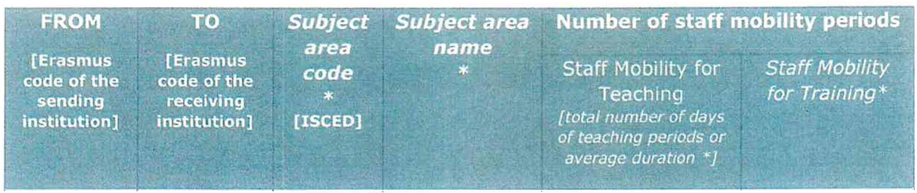

- For an easier and consistent understanding of language requirements, use of the Common European Framework of Reference for Languages (CEFR) is recommended, see http·//europa ss. cedefop.europa. eu/en/resources/eu ropean-Ianguage-levels-cefr

3

- ResoPrt nf f11nri:lm,:,nt:ll nf'inc-inlec; and other mnhilitv ri:>n11irements
The higher education institution(s) located in a Programme Country of Erasmus+ rnust respect the Erasmus Charter for Higher Education of wh,ch it must be a holder. The charter can be found here: tittQs;//P'lcea ec eu·op, .ťU/f1ds11 c1s QILs/éJJ;tion�r:ismus ct_{1_}arte_r iY
The higher education institution(s) located in a Partner Country of Erasmus+ must respect the following set of principles and requirements:
The higher education institution agrees to:
  - Respect in full the principles of non-discrimination and to promote and ensure equal access and opportunities to mobile participants from all backgrounds, in particular disadvantaged or vulnerable groups.
  - Apply a selection process that is fair, transparent and documented, ensuring equal opportunities to participants eligible for mobility.
  - Ensure recognition for satisfactorily completed activities of study mobility and, where possible, traineeships of its mobile students.
  - Charge no fees, in the case of credit mobility, to incoming students for tuition, registration, examinations or access to laboratory and library facilities. Nevertheless, they may be charged small fees on the same basis as local students for costs such as insurance, student unions and the use of miscellaneous material.

The higher education institution located in a Partner Country of Erasmus+ further undertakes to:
Before mobility

  - Provide information on courses (content, level, scope, language) well in advance of the mobility periods, so as to be transparent to all parties and allow mobile students to make well-informed choices about the courses they will follow.
  - Ensure that outbound mobile participants are well prepared for the mobility, including having attained the necessary level of linguistic proficiency.
  - Ensure that student and staff mobility for education or training purposes is based on a learning agreement for students and a mobility agreement for staff validated in advance between the sending and receiving institutions or enterprises and the mobile participants.
  - Provide assistance related to obtaining visas, when required, for incoming and outbound mobile participants. Costs for visas can be covered with the mobility grants. See the information / visa section for contact details.
  - Provide assistance related to obtaining insurance, when required, for incoming and outbound mobile participants. The institution from the Partner Country should inform mobile participants of cases in which insurance cover is not automatically provided. Costs for insurance can be covered with the organisational support grants. See the information / insurance section for contact details.
  - Provide guidance to incoming mobile participants in finding accommodation. See the information / housing section for contact details.

4

During and after mobility
  - Ensure equal academic treatment and services for home students and staff and incoming mobile particIpants and integrate incoming mobile partic1pants into Lhe inst1tution's everyday life, and have in place appropriate mentoring and suppoIt arrangements for mobile part1cipants as well as appropriate linguistic support to incoming mobile participants.

  - Accept alf activities indicated in the learning agreement as counting towards the degree, provided these have been satisfactorily completed by the mobile student.
  - Provide, free-of-charge, incoming mobile students and their sending institutions with transcripts in English or in the language of the sending institution containing a full, accurate and timely record of their achievements at tl1e end of their mobility period.
  - Support the reintegration of mobile participants and give them the opportunity, upon return, to build on their experiences for the benefit of the Institution and their peers.
  - Ensure that staff are given recognition for their teaching and training activities undertaken during the mobility period, based on a mobility agreement.

,, reqlli, r ent.

... -
I

• � ...;• -- .

cz In case of additional requirements of academic, organisational or other LIBEREC0 aspects (e.g. students with special needs), please consult our website:
1 http://www.tul.cz/en/internat,onal relat1ons/1lp•erasmus or contact the Erasmus
Office: erasmus@tul.cz.
Monastir In case of additional requirements of academic, organisational or other aspects (e.g. students with special needs), please consult our website: http://www.um.rnu.tn

F ralenctar
- Applications/information on nominated students must reach the receiving institution
by:

t· Receiving institution
�" [Er�sn1us'..code or c,ify]

301" June (15 '" June ,f the student needs a V,sa)

Spring term*
[month)
30'" November (151'' November ,f the student needs a Visa)

Monastir
- TUL will send its decision within 6 weeks
- A Transcript of Records will be issued by the respect,ve Faculty at TU Liberec before the departure of the student. The student receives a booklet, "Index", where he/she is supposed to collect signatures from the teachers to confirm passed courses and examinations. This system is parallel to the on·líne system and ensures a Fast processing of the transcript of records that the student should pick up at the student Office of the faculty before leavin TU Liberec.
September 15th January 15th

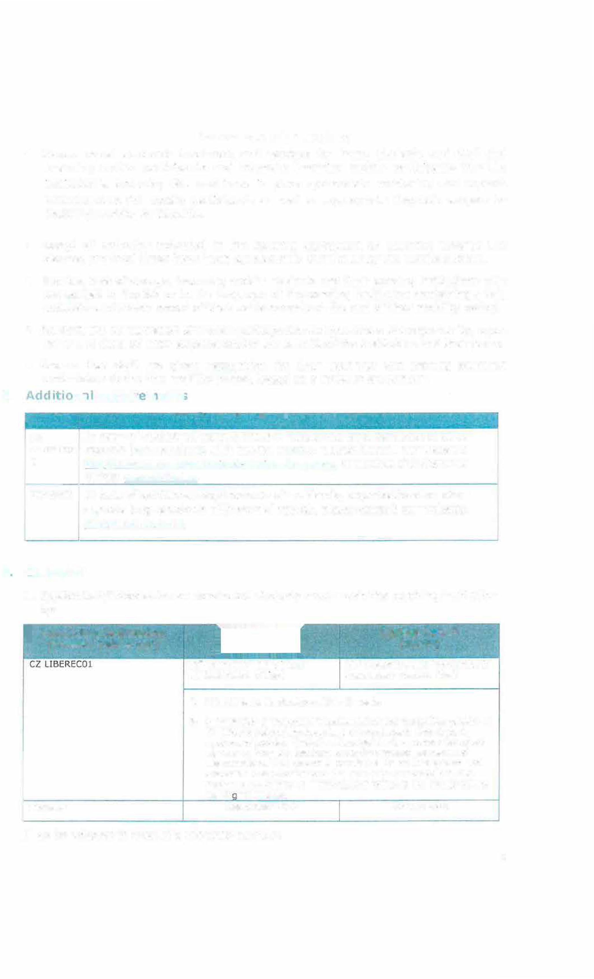
[* to be adapted in case of a trimester system]
s

- The receiving institution will send its decision wilhin [x] weeks.
- A Transcript of Records will be ,ssued by the receiv,ng inst,tution no Jater than [xx]
weeks after the assessment period has finished at the receiving HEI. {ft should norma/ly not exceed five weeks according to the Erasmus Charter for Higher Education guidelinesj
- Termination of the agreement

{ft is up to the involved 1nst1tutions to agree on lhe procecfure fo, modlfymg or term,nat,ng the ,nter-mstltutiona/ agreement HowevN, in I/Je event of unrlateral termmation, a nauce of at /east one aradem,r year should be g,ven. Ih1s means thav
a unilateral deos1on to disconUnue the exchanges nolified lo the other partY, by 1 September 20XX w1II only take effect as of 1 September 20XX + 1. The term,nat,on clauses must include the fo/lowing discla,mer: "Neilher lhe European Commission nor the National Agencies can be held responsible in case of a conflict."

G. Information
�About' ·

CZ UBERECOl
' - 1•�...., .,-----..·'"\ ..... ,,,.- ' - -...... .' . -. _;,,,.;,

,.·

Grading system
.
(for up to date contact details, see web pages)
TUL uses the ECTS credit system described at: h.J.Jp:j/ww!'\'.JIII.cz/enlects/er;_ts-credit-allocat,on 106
.. !.- �-....•_ I r�-
University of Monastir: for eac/1 exam ,s given a score on 20 to each student

The symbols of course unit duration: (Y) 1 fu/I year academic year and {S) 1 semester.
In addition to ECTS, TUL uses the local numera/
grade system as following:
(l) Excellent, (l-) Excel/ent Minus, (2) Very Good,
{2-) Very Good Minus, (3) Good and (4) Fail.
Excellent : from 18 to 20 Very good : from 16 to 1 7. 99 Good: from 14 to 15.99
Satisfactory : from 12 to 13. 99
Sufficient: from 10 to 11.99
Insufficient/failure: 10 and below

(R) SatisfactorvCompletlon of Course - No Grade.

Visa

Insurance

Housing

Special needs

Academie Calendar
Students with non-EU nationality should lnform by e- mail (erasmys@tul.cz) about the town where they have applied for the VISA in their home country.
Acceptance letters in Czech and English languages will be sent to the International Office of the home university. htt:Jl://w�_w.mvcr.cz/mvcren/articlejil visa- for-a·stav of-ovcr-90-davs-lona-tcrrn.asox
We accept EU health insurance card, students with non-EU nationality should show their insurance contract at amval. http://www.mzcr.cz/pr�ncf:/uk/uk.html

Accommodation is booked at Harcov Residence Halls by TU Liberec Erasmus Office upon acceptance of the student. There is no need to send a special application form or to register. To 1nform about the time of arrival: u<;. knleJe!fi)tul.cz
The facilit1es of the university are accessible for handicapped persons. There is also a centre for guidance and suppo1t: http://www.tul.cz/akaderrncka· nnrarlna-;i centrum-norloorv 82
Winter Semester: Beginnlng of OCTOBER - Mid FEBRUARY
Summer Semester: Mid FEBRUARY - Enci of JUNE h_rtp: //www.tul.cz/en/internat1om1 I- relal1on!>LIIQ- erasmus
Adresse Ambassade de Tunisie a Prague, République tcheque, Nad Výšinkou 1325/7 150 00 Praha 5, République tcheque
TÉLÉPHONE( +420) 244 460 652 / 3
FAX( +420) 244 460 825
EMAIL ntJ1_r(!gue@diplomatie.gov.tn amt.oraaue(á)volnv.cz
Adresse Ambassade de Tunisie a Prague, République tcheque, Nad Výšinkou 1325/7 150 00 Praha 5, République tcheque
TÉLÉPHONE{ +420) 244 460 652 / 3
FAX( +420) 244 460 825
EMA! L 1!!_,Qragu�@m�1ri_at1e.gov. tn amt. oraaue@lvolnv.cz
We guarantee assistance to find the accommodation for beneficiaríes Network projects cel!: Abdelkader.boum1i@.gmtlil.co_m i!_nQoJ<lh01ar(ruen1m.u-mona�tiL.tn bcnltouiar<i•ama1l.com

6

. SIGNATURES OF THE INSTITUTIONS (legal representatives)

doc. RNDr. Miroslav Brzezina, CSc. Rector

- 2 -10- 2018

Monc1st1r
Prof. Mondher Zidi, Oirector, National Engeneering School of Monastir,

Professor Hedi Bel Hadj Salah, President of The University of Monastir

2 5 SfP. 2018

- Scanned copies of signatures or digital signatu1·es may be accepted depending on the national legislation

7

