Key Action 1
- Mobility for learners and staff - Higher Education Staff Mobility

Inter-institutional 1 agreement From 1 September 2018- 31 August 2019 2
between institutions from Programme and Partner Countries3

[Minimum requirements] 4

The institutions named below agree to cooperate for the exchange of staff in the context of the Erasmus+ programme. They commit to respect the quality requirements of the Erasmus Charter for Higher Education in all aspects of the organisation and management of the mobility. The institutions also commit to sound and transparent management of funds allocated to them through Erasmus+.

- Information about higher education institutions

Full name of the Erasmus Contact details6 institution / code or city5 (email, phone)

country
Technical University CZ LIBERECOl Institutional Coordinator of Liberec
Studentská 2, 461 17, Liberec,
Czech Republic. erasmus@tul.cz Erasmus coordinator

Website
(eg. of the course catalogue)
httg_:LLwww. tul.czL en

Waikato Institute of Hamilton Technology

Institutional Coordinator Name:
Role: International Business Coordinator
Address: Tristram Street, Hamilton 3240,
New Zealand Email:

International Business Coordinator
www.wintec.ac. nz/ about-wintec

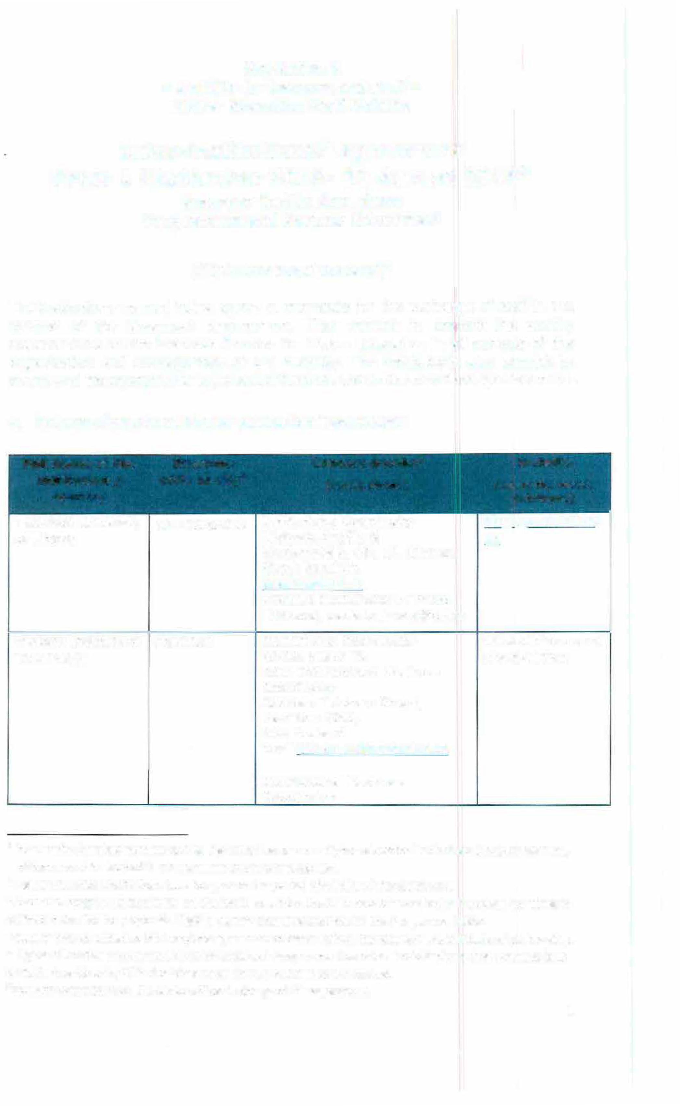
- lnter-institutional agreements can be signed by two or more higher education lnstitutions (HEls). at least one of them must be located in a Programme Country of Erasmus+.
- Higher Education lnstitutions have to agree on the period of validity of this agreement
- Erasmus+ Programme Countries are the 28 EU countries, the EFTA countries and other European countries as defined in the Cali for proposals. Eligible Partner Countries are listed in the Programme Guide.
4 Clauses may be added to this template agreement to better reflect the nature of the institutional partnership. 5 Higher Education lnstitutions (HEi) from Erasmus+ Programme Countries should indicate their Erasmus code
while Partner Country HEls should mention the city where they are located. 6Contact details to reach the senior officer in charge of this agreement.
1

- Mobility numbers 7 2018-2019

FROM TO Subjec
Subjectarea
Number of staff mobility

[Erasmus
[Erasmus
tarea
name
periods

code of the code of
sending the institution] receiving
institutio n]

---
co*de
[ISCED]
*
Staff Mobility for
Teaching
[total number of days of teaching periods or average durat,on *)

CZ UBERECOl Hamilton 0710

CZ LIBERECOl Hamilton 0710
Engineering and 28
engineering trades, (52)
Engineering and 28
engineering trades, (52)
2 (max)
2 (max)

- Recommended language skills
The sending institution, following agreement with the receiving institution, is responsible for providing support to its nominated candidates so that they can have the recommended language skills at the start of the study or teaching period:

Receiving institution
Optional: Subject
area
Language of
instruc­
Language of
instruc­
Recommended language of instruction level8

[Erasmus code or city]

tion 1

Czech

tion 2

English
Student Mobility for Studies
[Minimum recommended leve/: 81]
Staff Mobility for Teaching
[Minimum recommended level: 82)

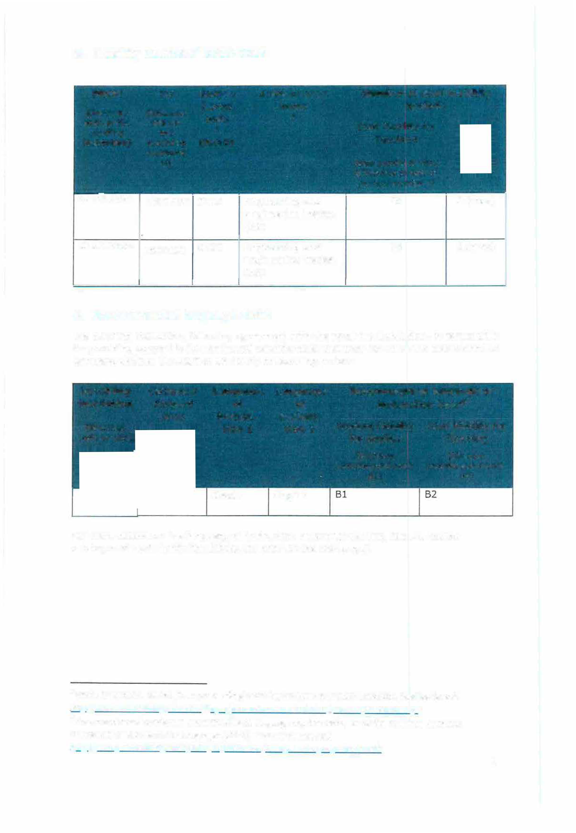

For more details on the language of instruction recommendations, see the course catalogue of each institution [Links provided on the first page].

- Mobility numbers can be given per sending/receiving institutions and per education fie/d (optiona/*:
http://www.uis.unesco.orq/Educotion/Poqes/internotionol-stondord-clossificotion-o{-educotion.ospx)
- For an easier and consistent understanding of language requirements, use of the Common European Framework of Reference for Languages (CEFR) is recommended, see http://europass.cedefop.europa.eu/en/resources/european-language-1evels-cefr
2

Respect of fundamental principles and other mobility requirements

The higher education institution(s) located in a Programme Country of Erasmus+ must respect the Erasmus Charter for Higher Education of which it must be a holder. The charter can be found here: https://eacea.ec.europa.eu/erasmus-plus/actions/erasmus­ charter en
The higher education institution(s) located in a Partner Country of Erasmus+ must respect the following set of principles and requirements:
The higher education institution agrees to:
  - Respect in full the principles of non-discrimination and to promote and ensure equal access and opportunities to mobile participants from all backgrounds, in particular disadvantaged or vulnerable groups.
  - Apply a selection process that is fair, transparent and documented, ensuring equal opportunities to participants eligible for mobility.
  - Ensure recognition for satisfactorily completed activities of study mobility and, where possible, traineeships of its mobile students.
  - Charge no fees, in the case of credit mobility, to incoming students for tuition, registration, examinations or access to laboratory and library facilities. Nevertheless, they may be charged small fees on the same basis as local students for costs such as insurance, student unions and the use of miscellaneous material.

The higher education institution located in a Partner Country of Erasmus+ further undertakes to:
Before mobility

  - Provide information on courses (content, level, scope, language) well in advance of the mobility periods, so as to be transparent to all parties and allow mobile students to make well-informed choices about the courses they will follow.
  - Ensure that outbound mobile participants are well prepared for the mobility, including having attained the necessary level of linguistic proficiency.
  - Ensure that student and staff mobility for education or training purposes is based on a learning agreement for students and a mobility agreement for staff validated in advance between the sending and receiving institutions or enterprises and the mobile participants.
  - Provide assistance related to obtaining visas, when required, for incoming and outbound mobile participants. Costs for visas can be covered with the mobility grants. See the information / visa section for contact details.
  - Provide assistance related to obtaining insurance, when required, for incoming and outbound mobile participants. The institution from the Partner Country should inform mobile participants of cases in which insurance cover is not automatically provided. Costs for insurance can be covered with the organisational support grants. See the information / insurance section for contact details.
  - Provide guidance to incoming mobile participants in finding accommodation. See the information / housing section for contact details.

3

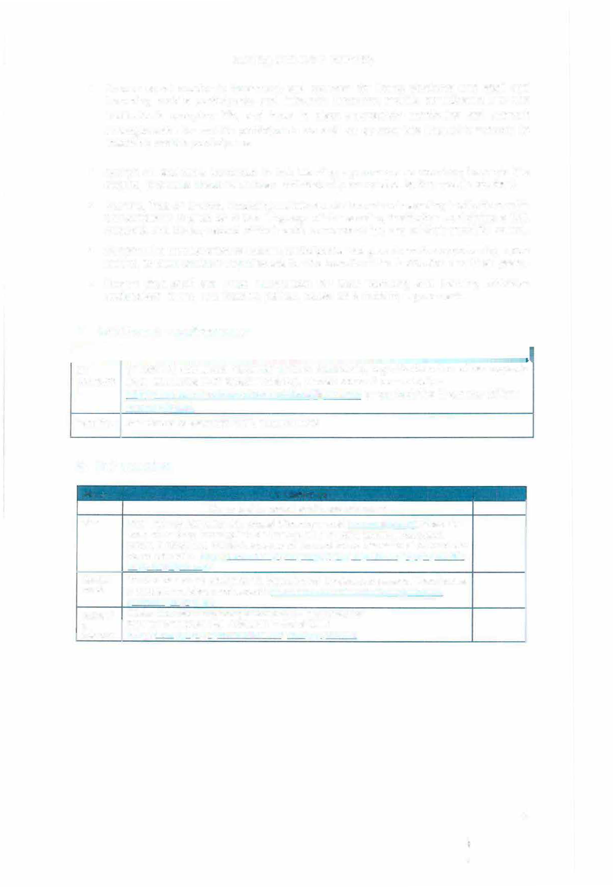During and after mobility

- Ensure equal academic treatment and services for home students and staff and incoming mobile participants and integrate incoming mobile participants into the institution's everyday life, and have in place appropriate mentoring and support arrangements for mobile participants as well as appropriate linguistic support to incoming mobile participants.

- Accept all activities indicated in the learning agreement as counting towards the degree, provided these have been satisfactorily completed by the mobile student.
- Provide, free-of-charge, incoming mobile students and their sending institutions with transcripts in English or in the language of the sending institution containing a full, accurate and timely record of their achievements at the end of their mobility period.
- Support the reintegration of mobile participants and give them the opportunity, upon return, to build on their experiences for the benefit of the Institution and their peers.
- Ensure that staff are given recognition for their teaching and training activities undertaken during the mobility period, based on a mobility agreement.

E. Additional requirements

cz In case of additional requirements of academic, organisational or other aspects LIBEREC0 (e.g. students with special needs), please consult our website:
1 http://www.tul.cz/en/internatíonal-relations/llp-erasmus or contact the Erasmus Office:
erasmus@tul.ci.
Hamilton Assistan ce to ascertain VISA requirements

G. Information
About CZ LIBEREC0l
(for up to date contact details, see web pages)
Visa Staff with non-EU nationality should inform by e-mail (erasmus@tul.cz) about the town where they have applied for the VISA in their home country. Acceptance letters in Czech and English languages will be sent to the International Office of the home university. llt1Q;_[Lwww.mvcr.czLmvcrenL2ctii;;leL2·vi�a-for-a-:;;ta:t:·Qf-Qver-90-
da:t:�·long·t�rm.asms:
Special The facilities of the university are accessible for handicapped persons. There is also needs a centre for guidance and support: http://www.tul.cz/akademicka-pQradna-a-
centrum-Qodoor:y.JU
Academi Winter Semester: Beginning of OCTOBER - Mid FEBRUARY
C Summer Semester: Mid FEBRUARY - End of JUNE Calendar bltQ.:.LLwww,tuI.cz/�n/internationa l-rel2tions[l1Q-erasmus

4

G. SIGNATURES OF THE INSTITUTIONS (legal representatives)

Institution [Erasmus code or name and city]
CZ LIBERECO

Hamilton

Name, function

doc. RNDr. Miroslav Brzezina, CSc. Rector

Paul Holloway
Chief Financial Officer

Signature9

2 -o9- 2010 .
*

- Scanned copies of signatures or digital signatures may be accepted depending on the national legislation
s

