Ill Erasmus+ Programme

� TEI of Crete
\,�......;" T�Ed.atc,r-.lllM!h.C:.:ofCi�.L
:

Key Action 1 - Mobility for learners and staff Higher Education Student and Staff Mobility

Inter-institutional agreement 2018/19 - 2020/21
between programme countries

The institutions named below agree to cooperate for the exchange of students and/or staff in the context of the Erasmus+ programme. They commit to respect the quality requirements of the Erasmus Charter for Higher Education in all aspects related to the organisation and management of the mobility, in particular the recognition of the credits awarded to students by the partner institution.
- Information about higher education institutions

Name of the institution Erasmus code Technological Educational G KRmS04
Institute of Crete

International Affairs Academie Contact

Technical University of CZ LIBEREC0l
Liberec

International Affairs
Contact details

Emeritus Academie Director of the International Relations Office

Email: incoming-international@staff.teicrete.gr Phane: +30-28210-23020

Erasmus Institutional Coordinator:

Email: incoming-euroQe@staff.teicrete.gr Phone: +30-2810-379312

Faculty Contact:

Deputy Academie Director of the IRO Office Department of Business Administration School of Management & Economics Phane: +30 2810 379647
Email:

Faculty Contact:
Academie Coordinator
Department of Accounting and Finance Email:

Faculty Contact:

Academie Coordinator Department of Social Work Phane: +30 2810 379243
Email:

Faculty Contact:
Academie Coordinator
Department of Mechanical Engineering Phane: +30 2810 256191
Email:
Institutional Coordinator Studentská 2, 461 17, Liberec, Czech Republic. erasmus@tul.cz

List of ECTS Coordinators and Course Catalogue:
Website
httQ :/[,.'-:ww. teicrete.gr/en

iro. teicrete.qr/en
httQ: //iroen.teicrete.gr/st, ,ct ents- mobil:!;y/unjergradu;:ite- students/

httQ://www.tul.cz/en

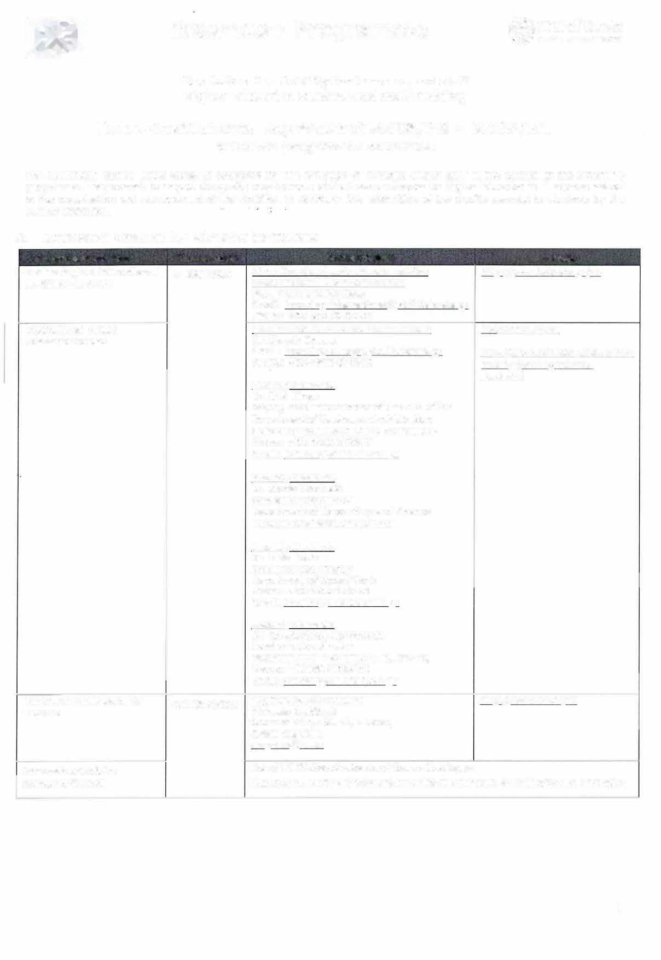Academie Contact http://www.tul.cz/en/erasmus/incoming-international-students/course-catalogue

1

- Mobility numbers per academic year
FROM TO Subject area [ISCED] Cycle Number of student mobility periods code name Studies Traineeships
�-
CZ LIBEREC0l G KRITIS04
312  041  0710 | Sociology, Social Work, Cultural Studies  Management, Finance, l5t, 2nd Accounting . , _......:::: --·...  Engineering and engineering trades | 5 | x 5  (25 | montl1s months) | =
312 | Sociology, Social Work, Cultural | 5 | x 5  (25 | months months) | -
 | Studies
041 | Management, Finance, l5t, 2nd
 | Accounting
0710 | Engineering and engineering
 | trades

G KRITIS04 CZ LIBEREC0l
FROM | TO | Subject area [ISCED] code |  | name | Number of staff mobility periods Teaching Training
CZ LIBEREC0l | G KRITIS04 | 312 | Sociology, Social Work, Cultural Studies |  | 2 stafť (8 hours each)
 |  | 041 | Management, Finance, Accounting |  | 2 stafť (8 hours each)
 |  | 0710 | Engineering and engineering trades |  | 1 stafť (8 hours) |  | 1 stafť
G KRITIS04 | CZ LIBEREC0l | 312 | Sociology, Social Work, Cultural Studies |  | 2 stafť (8 hours each)
 |  | 041 | Management, Finance, Accounting |  | 2 stafť (8 hours each)
 |  | 0710 | Engineering and engineering |  | 1 staff (8 hours) |  | 1 stafť

trades

Recommended language skills
The sending institution is responsible for providing support to its nominated candidates so that they can have the recommended language skills at the start of the study or teaching period:

Receiving institution Language (s}
of instruction
For more details Recommended language of instruction Student Mobility Staff Mobility

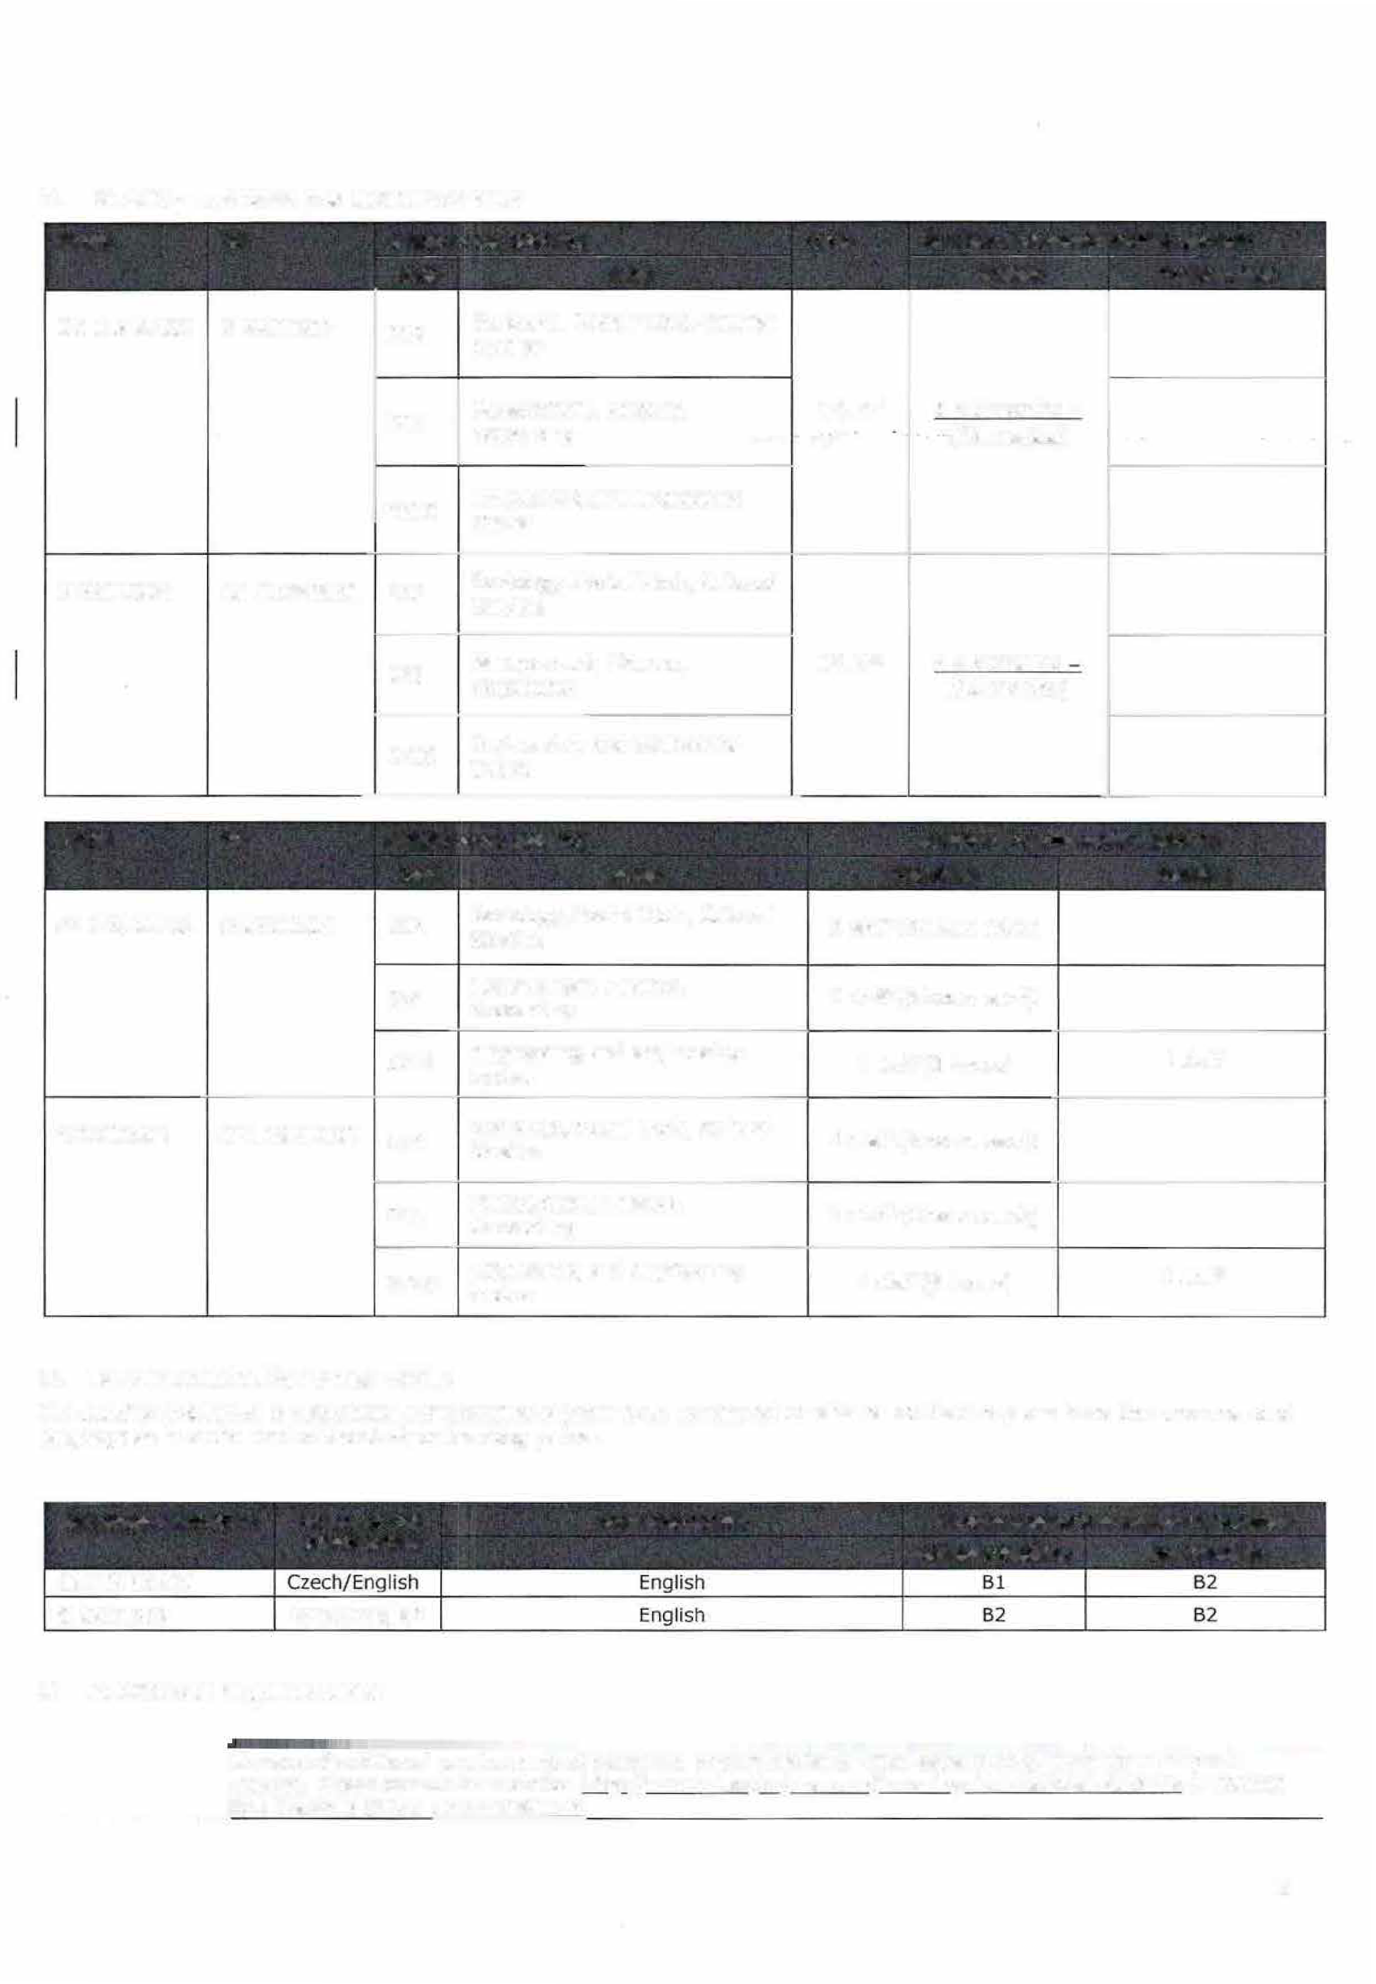CZ LIBEREC0l
G KRITIS04 Greek/English

Additional requirements

In case of additional requirements of academic, organisational or other aspects (e.g. students with special needs), please consult our website: http://www.tul.cz/en/erasmus/incominq-international-students or contact the Erasmus Office: erasmus@tul.cz.

2

� KRITIS04 In case of additional requirements of academic, organisational or other aspects (e.g. students with special needs), please consult our website: htto://ir:;en.telcrete.gr/studen�s-mobility(.mderqraduate-students/ or contact Dr. Gareth Owens, Institutional Erasmus Coordinator: international-eurooe@staff.teicrete.ge

Calendar

30th November (15th November if the student needs a Visa)

  - TUL will send its decision within 6 weeks
  - A Transcript of Records will be issued by the respective Faculty at TU Liberec before the departure of the student. The student receives a booklet, "Index", where he/she is supposed to collect signatures from the teachers to confirm passed courses and examinations. This system is parallel to the on-line system and ensures a fast processing of the transcript of records that the student should pick up at the student Office of the faculty before leaving TU Liberec.
Deadline for application 30th November
Deadline for application 30th May

    - TEi of Crete will send its decision within [4] weeks.
G KRmS04
    - A Transcript of Records will be issued by TEI of Crete no Jater than [S] weeks after the assessment period has finished. [It should normally not exceed five weeks according to the Erasmus Charter for Higher Education guidelines]

The present bilateral agreement will be valid during the academic years 2018/19 - 2020/21, unless either side terminates the agreement in writing at the latest by September 30th for activities taking placing during the next (n+1) academic year. Additional activities, cancellations or new subject areas are to be communicated by the same deadline.

Information

Grading system
(for up to date contact details, see web
TUL uses the ECTS credit system. The symbols of course unit duration: (Y) 1 fu/I year academic year and (S) 1 semester.
ECTS rade=TEI rade  A= 8.50-10.00 | Evaluation  Excellent
B = 6.50-8.49 | Very Good
C = 5.00-6.49 | Sufficient
FX/F = 0.00-4.99 | Fail

In addition to ECTS, TUL uses the local numera/ grade system as following:
- Excellent, (1-} Excellent Minus,
- Very Good, (2-) Very Good Minus,
- Good and (4) Fail.

(R) SatisfactoryCompletion of Course
- No Grade.
Visa | Students with non-EU nationality should inform by e-mail (erasmus@tul.cz) about the town where they have applied for the VISA in their home country. Acceptance letters in Czech and English languages will be sent to the International Office of the home university. http://www.mvcr.cz/mvcren/article/a­ visa-for-a-stay-of-over-90-days-lonq­  term.aspx | For information regarding VISA requirements, please visit the website: htto ://'roe n.teicrete .gr/visa/
Insurance We accept EU health insurance card, |  | For information regarding Insurance requirements, please visit the website:
students with non-EU nationality |  | http://;ro€n .teiuete.gr/visa/
should show their insurance contract
at arrival.
http://www.mzcr.cz/prevence/uk/uk.h
tmi
Housing | Accommodation is booked at Harcov Residence Halls by TU Liberec Erasmus Office upon acceptance of the student. There is no need to send a special application form or to register. To inform about the time of  arrival:us.kole·e tul.cz | For information regarding accommodation, please visit the website: http:/ / i ::;en .teic, .::te.gr/accomodation-for-st.Jden•s/
Special  needs | The facilities of the university are  accessible for handicapped persons. | Infrastructure to welcome students and staff with disabilities: only visitors  with small scale of disability - individua! support.

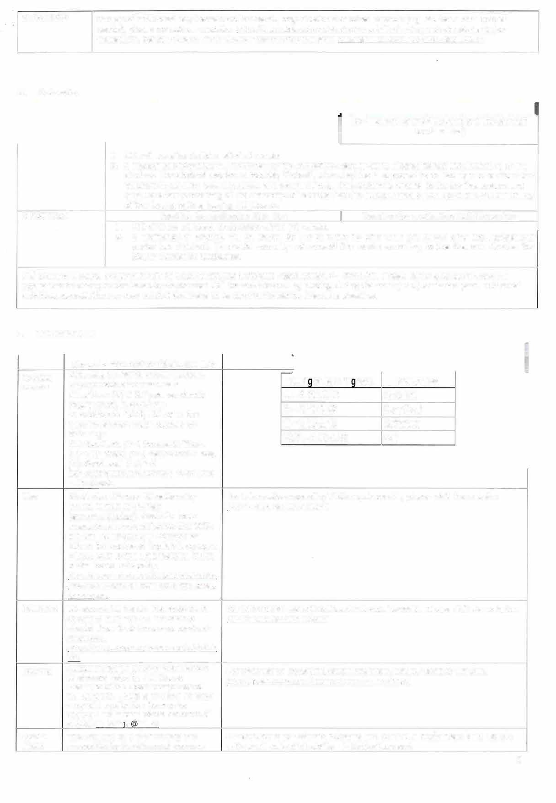3

There is also a centre for guidance and support: httQ:LLwww.tul.czLakademicka- Qoradna-a-centrum-Q0dQ0D:'. 82
Academie Winter Semester: Beginning of Winter Semester: OCTOBER 1st - Mid FEBRUARY Calendar OCTOBER - Mid FEBRUARY Summer Semester: Mid FEBRUARY - End of JUNE
Summer Semester: Mid FEBRUARY -
End of JUNE httg:LLwww.tul.czLenLerasmusLinc
oming-international- studentsLacademic-calendar

- SIGNATURES OF THE INSTITUTIONS
Institution Name, function Date Signature

CZ LIBEREC01 G KRITIS04
PhDr. Lucie Koutková, Ph.D.
Head of the International office Prof. Nikolaos Katsarakis, Ph.D. Rector - TEI of Crete

13. 09. '2.01 S

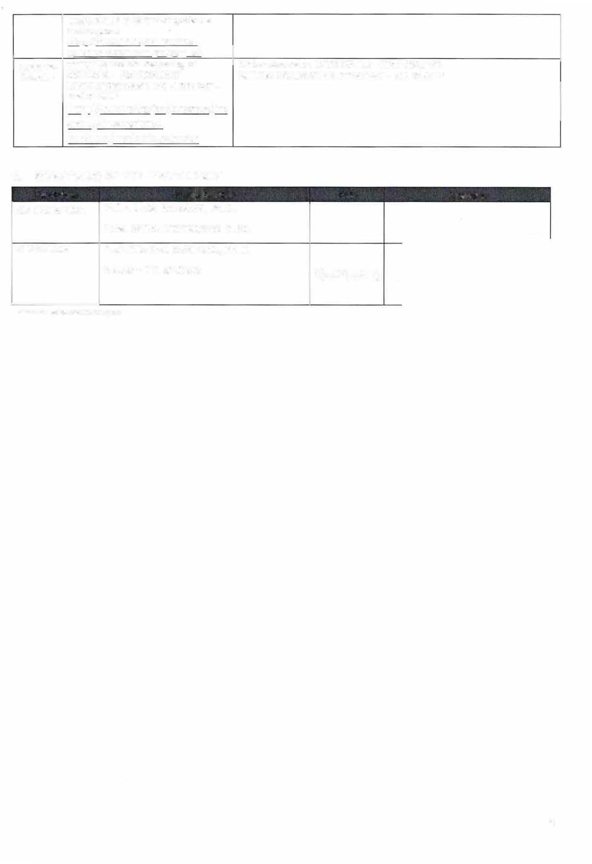
scanned signatures are accepted

4

