Page 1 of 1

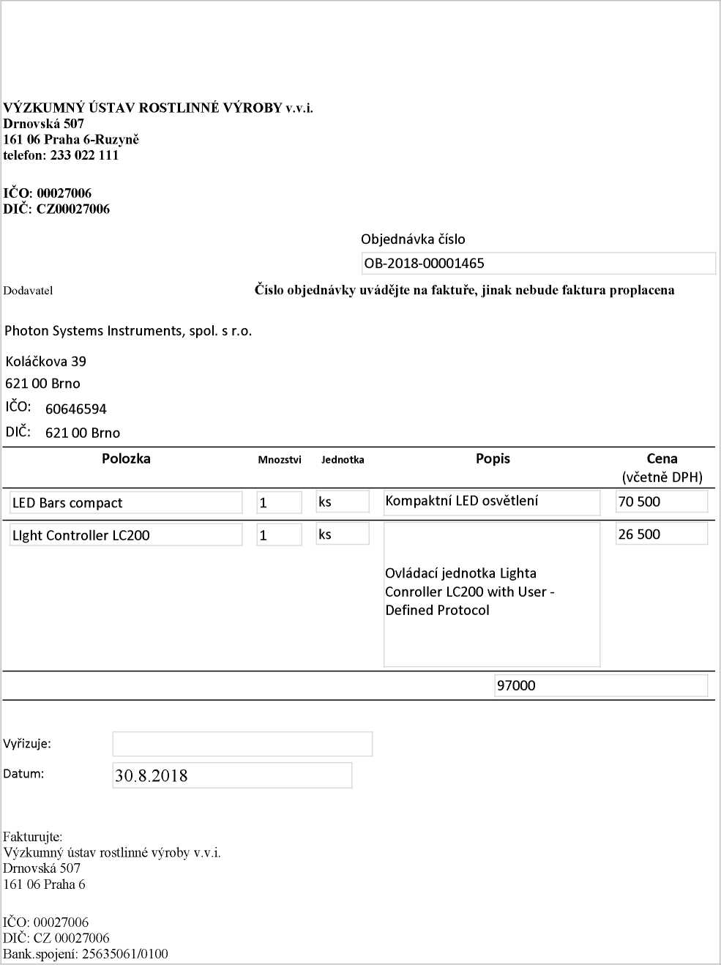

30.08.2018
http://dms/sites/Uctama/_layouts/Print.FormServer.aspx

