- Erasmus+ Programme

Key Action 1 - Mobility for learners and staff Higher Education Student and Staff Mobility

Inter-- institutional agreement 2018/ 19
between programme countries

2020/21

The lnstltutions named below agree to cooperate for the exchange of students and/or staff in the context of the Erasmus+ programrne. They cornrnlt to respect the quallty requlrements of the Erasmus Charter for Hlgher Education ln all aspects related to the organlsatlon and management of the mobility, ln particular the recognltlon of the credlts awarded to students by the partner lnstltutlon.

Information about higher education institutions
Name of the institution Erasmus code Conti<ct details Website

Luela University of Tehnology S LULEAOl

Academie contact

Erasmus Coordlnator lnternatlonal Office
SE-97187- LULEA Sweden Phone: +46-920-492224
Fax: +46-920-492957
Email:
htt1:1:l[www.jtu.se

Technlcal University of Liberec CZ LIBEREC01 Instltutlonal Coordinator http:ljwww.tul.cz/

Internatlonal Affalrs Academie Contact
Studentská 2, 461 17, Liberec, m
Czech Republic.
Tel. +420 485 353 907
erasmus@tul.cz
Erasmus Office at TUL: http;LLwww.tul.cz/en/erasmus

�LLwww.tul.cz/§J[erasmus[lncomlng-lnternatlonal-studentst:erasmus- gQQllcatlon-procedures-and·deadllnes
Intematlonal offlce, LTU: httQ.s:lt:www. Itu.set:edu/Exchange-Studles?I =en

Mobility numbers per academic year
FROM TO Subject area [ISCEOJ Cycle Number of student mobility periods code Name Studies Traineeships
Electronlcs and Automatlon | 1,2
Electronlcs and Autornatlon | 2

CZ UBEREC01 S LULEAOl 0714
S LULEAOl CZ UBERECOl 0714
2 x S months
2 x S rnonths

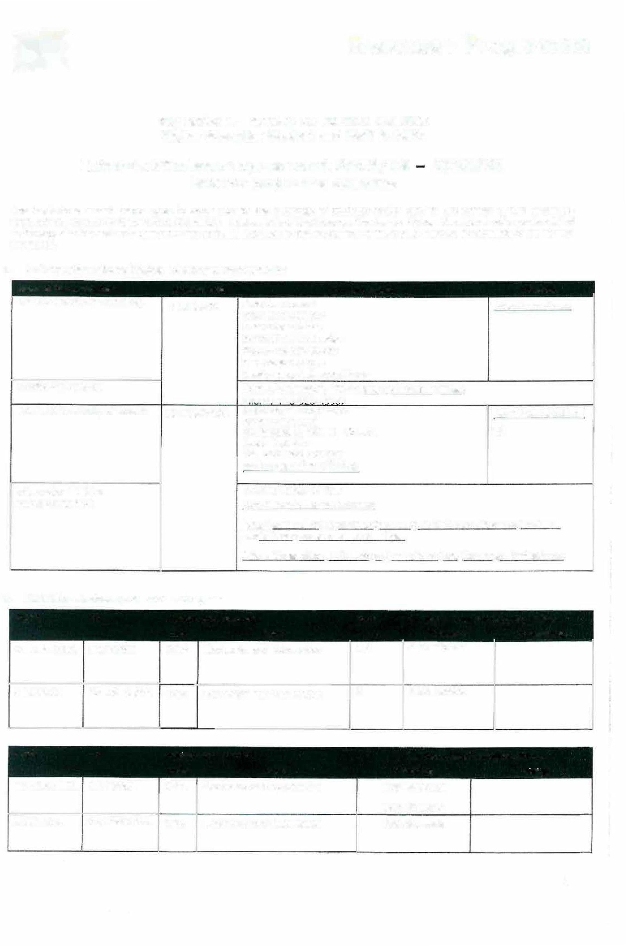

FROM TO Sub1ec:t area [ISCED] Number of staff mobility periods code Name Teaching Tra,n,ng
CZ LIBEREC01 S LULEAOl 0714 Electronlcs and Automatlon lx8=8h/week
lx8=8h/week S LULEAOl CZ LIBERECOl 0714 Electronlcs and Autornatlon 1x8=8h/week

1

c. Recommended language skills
The sendlng lnstltution is responslble for provldlng support to lts nomlnated candldates so that they can have the recommended language skllls at the start of the study or teachlng period:

Rcce,v,ng inst,tution Languagc (s) For more details Rccommended language of instruction of instruct1on Student Mobility Staff Mobility
http:/Lects.tul.czLsearch?lang-en |  | B1 | B2
htto;LLwww.ltu,se |  | 82 | B2

CZ UBERECOl Czech/English

S LULEAOl English/ Swedish

Additional requirements

CZ UBERECOl S LULEA01

Calendar
In case of additional requlrements of academic, organlsational or other aspects (e.g. students with special needs), please consult aur website: http://www.tul.cz/en/erasmus/ incoming-international-students or contact the Erasmus Office: erasmus@tul.cz.
In case of additional requirements of academic, organisationalor other aspects (e.g. students with special needs), please consult our website: http://www.ltu.se

30th November (151h November if the student needs a Visa)

l. TUL will send lts decislon wlthln 6 weeks
- A Transcrlpt of Records wlll be lssued by the respective Faculty at TU Liberec before the departure of the student. The on-line system ensures a Fast processlng of the transcript of records that the student should plck up at the student Office of the faculty before leavlng TU Liberec.
S LULEAOl Applicatlon deadline: Aprll 15 Appllcatlon deadline: October 15
  - LTU wlll send a declslon wlthin 6 weeks.
  - Students wlll have to apply for thelr transcript through LTU:s web page, lt will be sent to thelr home country

The present bllateral agreement wlll be valid during the academlc years 2017/18 - 2020/21, unless either side terminates the agreement ln wrltlng at the !atest by September 30th for activlties taking placlng durlng the next (n+l) academic year. Addltlonal activlties, cancellatlons or new subject areas are to be communicated by the same deadline.

Information

About

Grading systern

Visa

Insuranc e
CZ LIBERECOl
(for up to date contact detalls, see web pages)
TUL uses the ECTS credft system descrlbed at:

The symbols of course unit duratlon: (Y) 1 fu/I year academ/c year and (S) 1 semester.
In addition to ECTS, TUL uses the tocal numera/ grade
system as followlng:
  - Excellent, (1.-) Excellent Minus, (2) Very Good, (2-)
Very Good Minus, (3) Good and (4) Fall.
(R) SatlsfactoryCompletlon of Course - No Grade.
Students wlth non-EU natlonallty should lnform by e-mall (erasmus@tul.cz) about the town where they have applled for the VISA ln thelr home country. Acceptance letters ln Czech and Engllsh languages wlll be sent to the International Office of the home university. htto;LLwww.mvcr.cz/mvcrenLfil!l_gg/a-vlsa-for-a-stay-of­ over-90-days-long-term.asp�
We accept EU health lnsurance card, students wlth non-EU natlonallty should show thelr lnsurance contract at arrlval. http;f1www.mzcr.czLprevenceLukL.y!$._,html

http:Lfwww.ltu.seLeduLExchange­ Studies/Studlelnformation/The-Swedlsh-Credit­ System-1.1049107I-en

http:LLwww.ltu.se/edu/Exchange- StudlesLPractlcal-Gulde-for-Exchange­ StudentsLM lgratlon-lnformatlon-1.118824?I =en

http:/Lwww.Itu.se/eduLExchanqe­ StudlesLPractical-Gulde-for-Exchan.rut:_ Students/Insurance-and-health-care- 1.118820?I-en
2

Housing
Accommodation is booked at Harcov Residence Halls by TU Liberec Erasmus Office upon acceptance of the student.
There 1s no need to send a speclal applicatlon form or to reglster. To inform about the time of
htm;LL.www. ltu.seteduLExchange- Studles/Bostad?l=en

arrival:us.koleie®tul.cz

Speclal needs

Academie Calendar
The facilltles of the university are accessible for handicapped persons. There ls also a centre for guidance and support:
!:ltrn.;LLwww.tul.cz/akademlcka-i;ioradna-a-centrum-
QQ.ill2Q.!Y 82
Winter Semester: Beginning of OCTOBER - Mld FEBRUARY Summer Semester: Mid FEBRUARY - End of JUNE http://www.tul.cz/en/erasmus/incoming-international-students/ academic-calendar
https ://www.ltu.se/student/Tjanster-och- service/Funka?l=en

Autumn semester: August/September-January Spring semester: January-June

SIGNATURES OF THE INSTITUTIONS
Institut1on Name, function Date Signature

CZ UBEREC01
PhDr. Lucie Koutková, Ph.O. Head of the International Office

S LULEA01
Carin Axelsson-Grafstrom
';;',•jr ()' I v'
·

Institutional Erasmus+ Coordinator Professlonal Support
scanned sfgnatures are accept
tUJfr,-·. () 1 o

SE-971 7

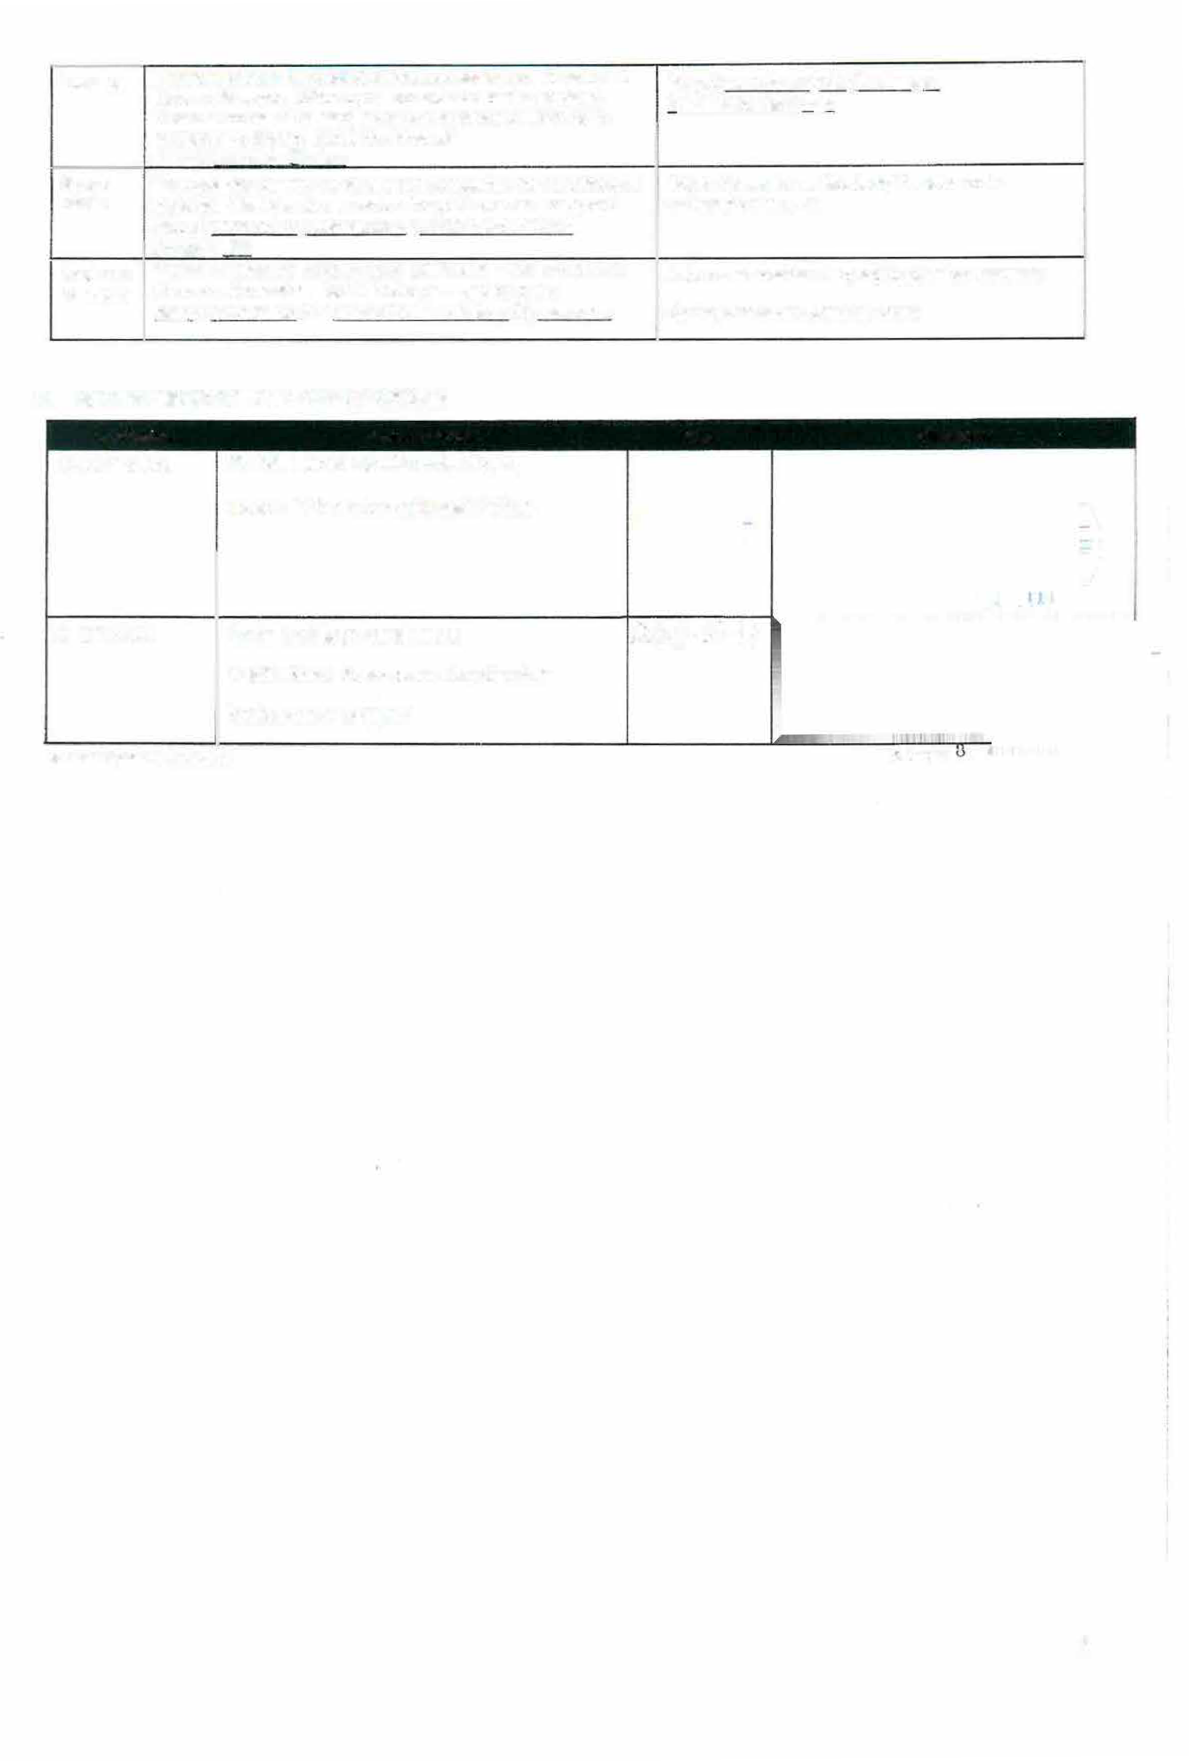

3

