Hochschule tur éiffentliche Ve�altung Kehl

**t**

-

**Erasmus+ Programme**

## **Key Action 1**

**- Mobility for learners and staff - Higher Education Student and Staff Mobility**

**Inter-institutional agreement 2017-2021**

**between programme countries**

The institutions named below agree to cooperate for the exchange of students and/or staff in the context of the Erasmus+ programme. They commit to respect the quality requirements of the Erasmus Charter for Higher Education in all aspects related to the organisation and management of the mobility, in particular the recognition of the credits awarded to students by the partner institution.

## **Information about higher education institutions**

#### **Name ofthe Erasmus institution code**

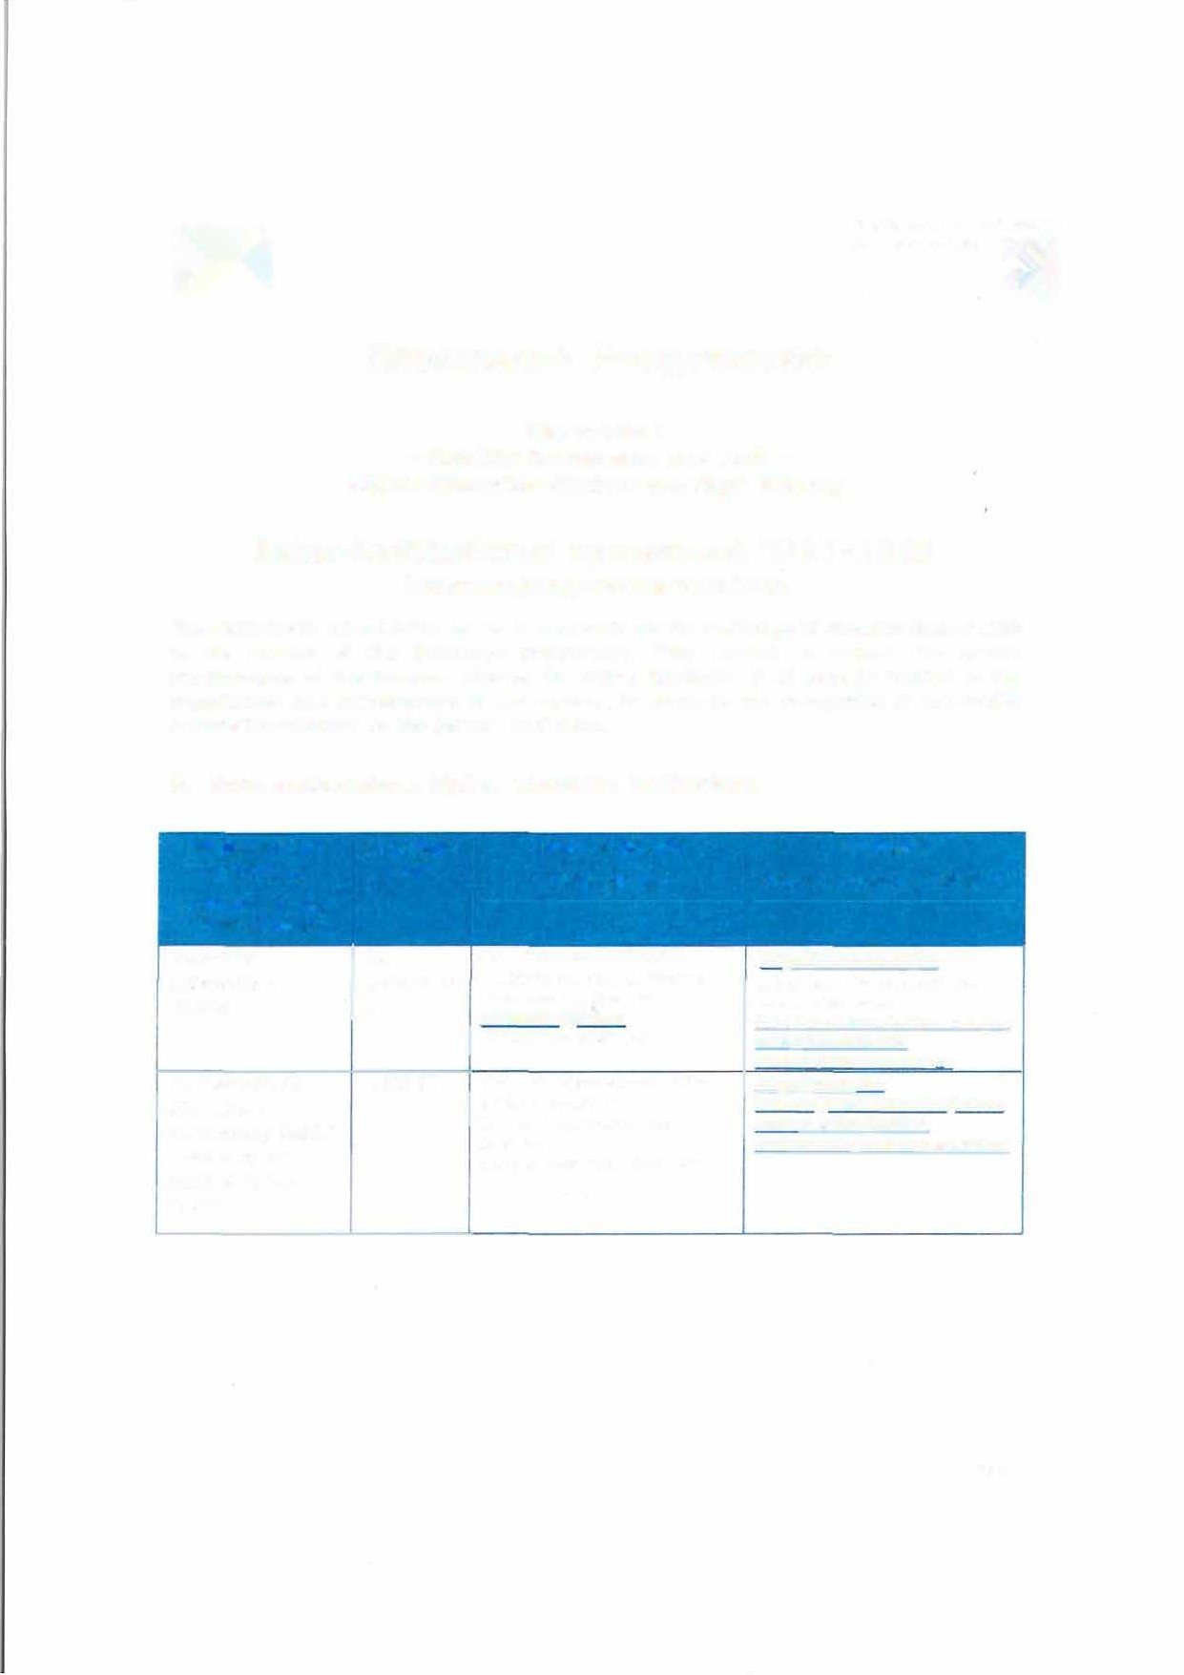

**(and depart ment, where relevant)**

Technical cz

University of LIBEREC0

Liberie 1

Hochschule fOr D KEHL0l offentliche

Verwaltung Kehl / University of Applied Sciences in Kehl

#### **Contact details**

**(email, phone)**

Institutional Coordinator of Erasmus+ at the TUL [**e rasmu**](mailto:erasmus@tul.cz) [**s@tul.cz**](mailto:s@tul.cz)

###### 00420-485353749

Head of International Office Internationa1-office@hs- kehl.de

Phone: +49 7851 894 181

#### **Website**

**(eg. of the course catalogue)**

htt12:LL[www.tul.c2ien](http://www.tul.c2ien/)

List of ECTS Coordinators and Course Catalogue: htt12:[awww](http://www.tul.czLenLerasmusLin/).[tul.czLenLerasmusLin](http://www.tul.czLenLerasmusLin/)� oming-international-

students/course-cataloaue http://www.hs-

kehI .deLinternational esLintern

ational-officeLkehler- studierendeLauslandspraktikaL

*Poge 1*

## **Mobility numbers**1 **per academic year**

The partners commit to amenci the table below in case of changes in the mobility data by no later than the end of January in the preceding academic year.

**FROM TO *Subj Subjectarea Study* Number ofstudent**

***ect name cycle* mobility periods**

#### **[Erasmus [Erasmus**

***area***

* ***[short***

#### **code ofthe code ofthe** *code*

***cycle,***

***1st ,***

Student *Student*

**sending receiving** * ***2nd Or*** Mobility for *Mobility*

**institution] institution] [ISC *3"'1***\****]*** Studies *for*

**ED] *{tatal number af***

*ps*

##### *Traineeshi*

Management

***manths afthe*** *\**

***study perlads ar average duralian*** •***J***

l**st** 2x5=10 lx3= 3

|  |  |  |  |
| --- | --- | --- | --- |
| cz  LIBEREC0l | D KEHL0l | 0413  0110 | -- - -----· --  and Administration  Education |
| D KEHL0l | cz  LIBEREC0l | 0413 | Management and  Administration |

months months

2x5=10

2nd

months

0110 Education

l**st** o 2x3= 6 months

2nd lx6=6

months

#### **FROM**

**[Erasmus**

**TO**

#### **[Erasmus**

***Subjec Subject***

***tarea area*** \****name***

**Number ofstaffmobility periods**

**code ofthe sending institution]**

**code ofthe receiving institution]**

***co***\****de***

**[ISCED]**

Staff Mobility for Teaching

***[tatal number af days af***

***teachJngperlods ar average dura!la11*** •***J***

##### *Staff Mobility* for Training



|  |  |  |  |  |  |
| --- | --- | --- | --- | --- | --- |
| cz | D KEHL0l | 0110 | Education  Education | 2x5 day=lO days  2x5 day=l0 days | 2x5 day=lO days  2 xS day=l0 days |
| LIBEREC0l |  |  |
| D KEHL0l | cz | 0110 |
|  | LIBEREC0l |  |

1. **Recommended language skills**

The sending institution, following agreement with the receIving institution, is responsible for providing support to its nominated candidates so that they can have the recommended language skills at the start of the study or teaching period:

1 Mobility numbers can be given per sending/receiving institutions *and per education field (optional": http:l/*[*www.uis.unesco.org/Educotion(Pages/intemotional-standard-classificotion-of-educotion.ospx)*](http://www.uis.unesco.org/Educotion(Pages/intemotional-standard-classificotion-of-educotion.ospx))

*Poge 2*

#### **Receiving institution**

|  |  |  |  |
| --- | --- | --- | --- |
| **[Erasmus** | ***area*** | **1** | **of instr** |
| **code]** |  |  | **uc­**  **tion 2** |

***Optiona/***

***: Subject***

**Language of instruction**

**Lang uage**

**Recommended language of instruction level2**

cz

LIBEREC0l

D KEHL0l

D Czech

KEHL0l

# cz

LIBEREC0 1

chosen course

Englis h

Student Mobility for Studies

*[Minimum recommended leve/: 81]*

B1

B1 on Bachelor Level and B2 on Master Level

Staff Mobility for Teaching

*[Minimum recommended /evel: 82]*

B2 B2

For more details on the language of instruction recommendations, see the course catalogue of each institution.

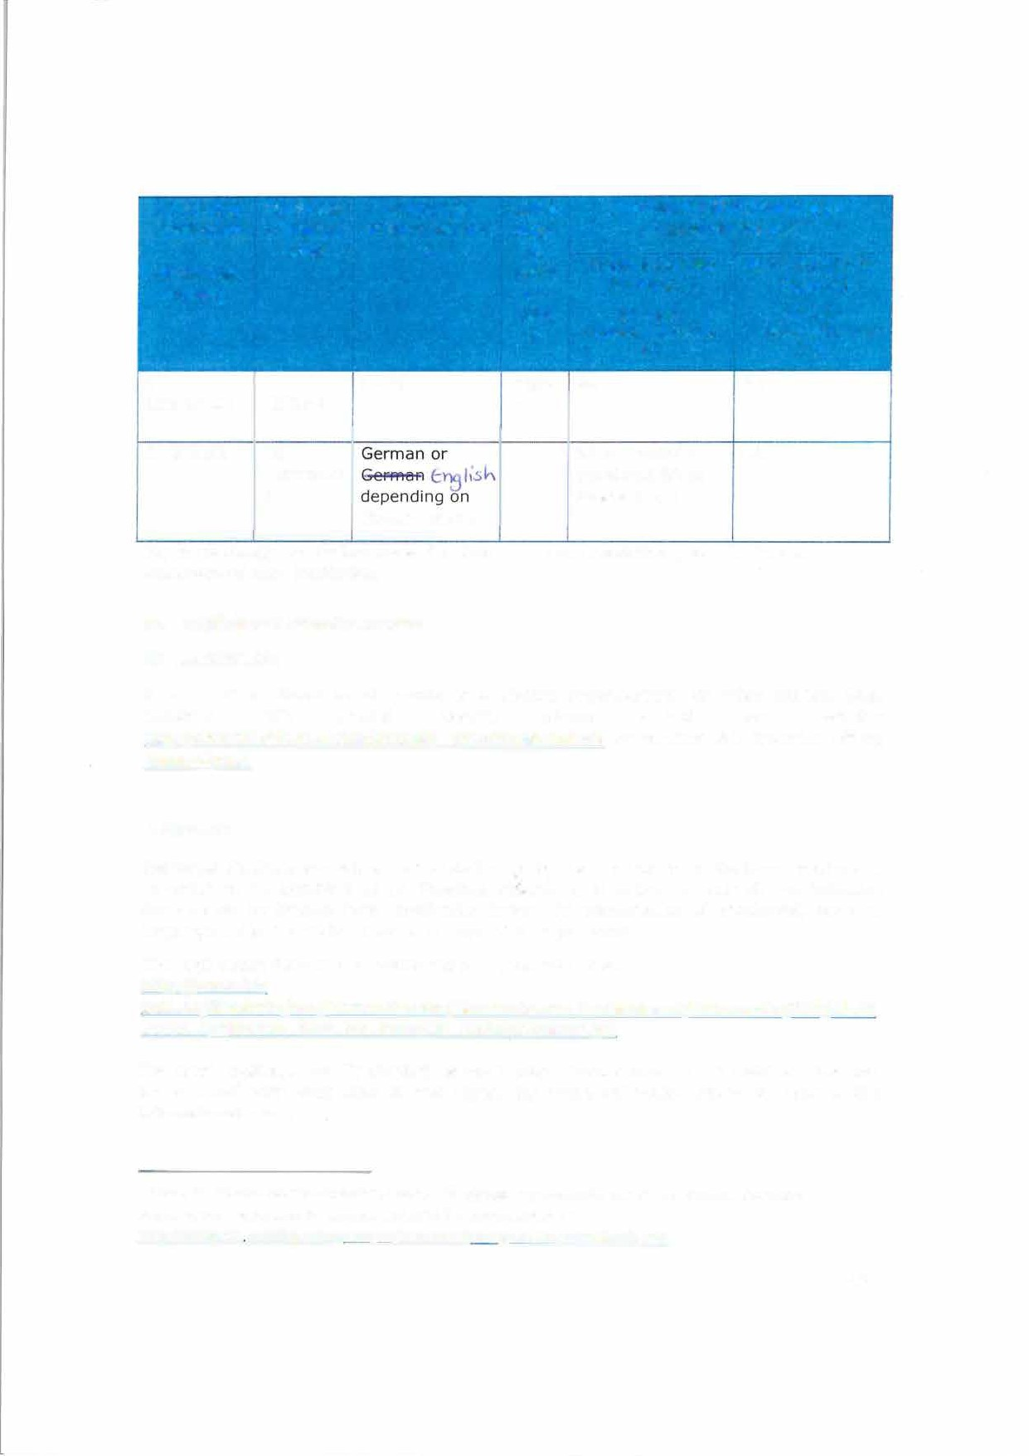

#### **Additional requirements CZ LIBERECOl:**

In case of additional requirements of academic, organisational or other aspects (e.g. students with special needs), please consult aur website: [http://www.tul.cz/en/erasmus/incoming-in ternational-students](http://www.tul.cz/en/erasmus/incoming-international-students) or contact the Erasmus Office: [erasmus@tul.cz.](mailto:erasmus@tul.cz)

#### **D KEHLOl:**

Exchange students are only accepted on the basis of a nomination by the home institution. In order to be admitted as an Erasmus student it is obliged to submit the following documents: application form, motivation letter, CV, confirmation of enrolment, proof of language skills, transcript of records, copy of ID or passport.

The Application form can be found under the following link: http://www. hs-

kehl.de/fileadmin/hsk/Internationales/Akademisches Auslandsamt/Dokumente/PDF/27. 04

..2016 Application form for Erasmus students.reader.pdf

For staff mobility, the "Individua! Work/Training Programme" or "Individua! Teaching Programme" form duly filled in and signed by home university should be sent to the international office.

2 For an easier and consistent understanding of language requirements, use of the Common European Framework of Reference for Languages (CEFR) is recommended, see hJ:tQ:LL.e.u.c.oQass cedefoQ,euroQa.euLen/resources/european-1anguage-1evels-cefr

*Page3*

For students and staff with disabilities please contact our International Office fór further information.

1. **Calendar**
   1. Applications/information on nominated students must reach the receiving institution by:

###### **Receiving institution [Erasmus code]**

**Autumn term* [month]**

**Spring term* [month]**

IBERE 1 30**1h** June ( 15 **th** June if the student

30**th** November ( 15**th** November if

needs a Visa the student needs a Visa

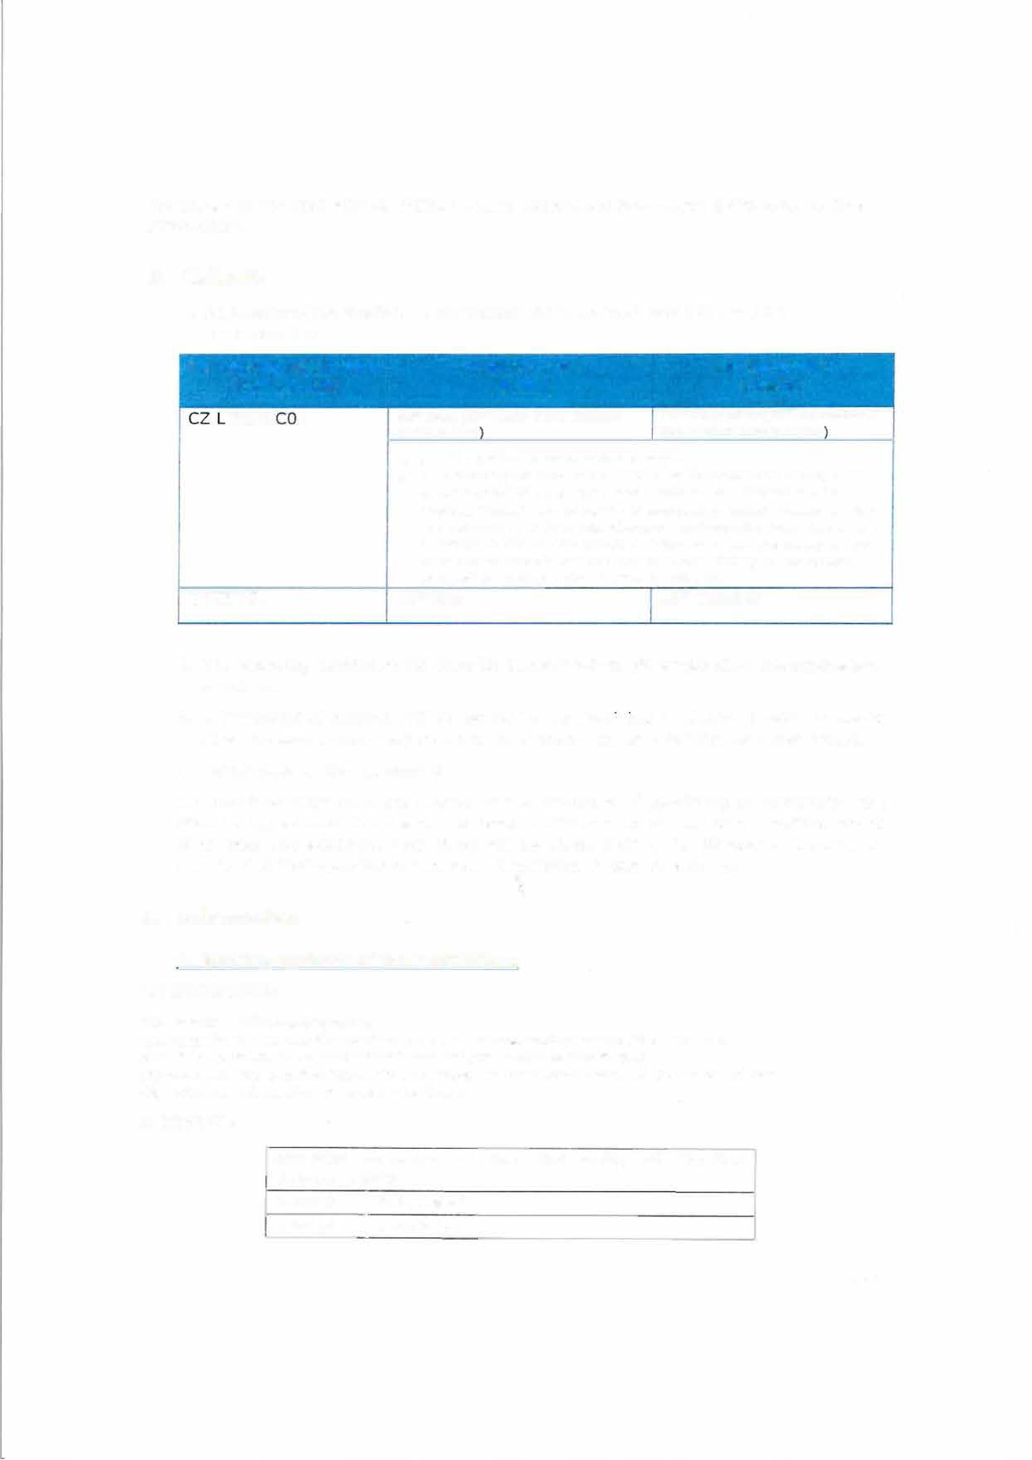

* + 1. TUL will send its decision within 6 weeks
    2. A Transcript of Records will be issued by the respective Faculty at TU Liberec before the departure of the student. The student receives a booklet, "Index", where he/she is supposed to collect signatures from the teachers to confirm passed courses and examinations. This system is parallel to the on-line system and ensures a fast processing of the transcript of records that the student should pick up at the student

Office of the faculty before leaving TU Liberec.

D KEHL0l 15th May 15th October

* 1. The receiving institution will send its decision within six weeks after the application deadline.
  2. A Transcript of Records will be issued by the rece1v1ng institution ideally six weeks after the assessment period and no later than 4 weeks after the semester ended.
  3. Termination of the agreement

The involved institutions may agree on the procedure of modifying or terminating the bilateral agreement. In case of unilateral modification or termination, a written notice of at least one academic year ahead will be given. Neither the European Commission nor the National Agencies can be held responsible in case of a conflict.

### Information

###### **Gradinq systems of the institutions CZ LIBEREC01:**

*TUL uses the* ***ECTS credit system.***

*The symbols of* ***course unit duration: (Y)*** *1 fu/I year academic year and* ***(S)*** *1 semester. In addition to ECTS, TUL uses the* ***local numera/ grade*** *system as following:*

***{1)*** *Excellent,* ***{1-)*** *Exce//ent Minus,* ***{2)*** *Very Good,* ***{2-)*** *Very Good Minus,* ***{3)*** *Good and* ***(4)*** *Fail.*

***(R)*** *SatisfactoryCompletion of Course - No Grade.*

###### **D KEHL01:**

**Grading systems of the University of Applied Sciences Kehl**

4,1-5,0 I Not passed

3,6-4,0 I Insufficient

*Poge 4*

|  |  |
| --- | --- |
| 2,6-3,5 | Average |
| 1,6-2,5 | Satisfactory |
| 1,0-1,5 | Very good, excellent |

* 1. **Visa**

The sending and rece1ving institutions will provide assistance, when required, in securing visas for incoming and outbound mobile participants, according to the requirements of the Erasmus Charter for Higher Education.

Information and assistance can be provided by the following contact points and information sources:

#### **Institution Contact details Website for information**

**[Erasmus code] (email, phone)**

CZ LIBERECOl Students with non-EU nationality httQ:[LLwww](http://www.mvcr.czLmvcrenLarticleLa-/).[mvcr](http://www.mvcr.czLmvcrenLarticleLa-/).[czLmvcrenLarticleLa-](http://www.mvcr.czLmvcrenLarticleLa-/) should inform by e-mail visa-for-a -stay_-of-over-90-day_s-long- (erasmus@tul.cz) about the town term.asQx

where they have applied for the

VISA in their home country. Acceptance letters in Czech and English languages will be sent to the International Office of the home

university.

D KEHLOl **Mrs. Kathrin Schindler** http://www.hs-

Head of lnternational Office kehI.deLinternationalesLincom*i*

ngs- internationale- l [nternational-office@hs-kehl.de](mailto:nternational-office@hs-kehl.de) studierendeL

+49 7851 894 181

#### **Insurance**

The sending and receiving institutions will provide assistance in obtaining insurance for incoming and outbound mobile pa_rticipants, according to the requirements of the Erasmus Charter for Higher Education.

The receiving institution **will** inform mobile participants of cases in which insurance cover is not automatically provided. Information and assistance can be provided by the following contact points and information sources:

#### **Institution Contact details**

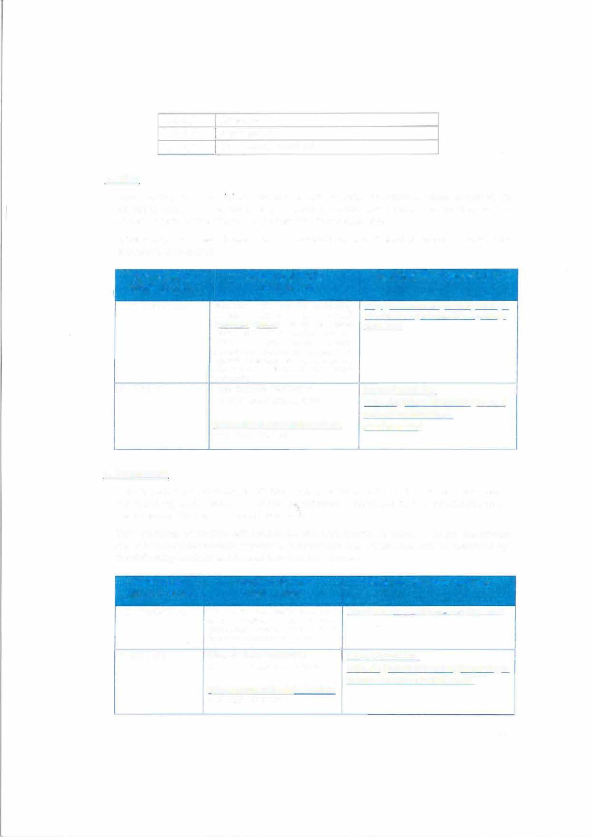

**[Erasmus code] (email, phone)**

CZ LIBERECOl We accept EU health insurance

card, students with non-EU nationality should show their insurance contract at arrival.

D KEHLOl **Mrs. Kathrin Schindler**

Head of lnternational Office

[International-office@hs-kehl.de](mailto:International-office@hs-kehl.de)

+49 7851 894 181

#### **Website for information**

httQ_;il[www.mzcr. czLQrevenceMLuk.html](http://www.mzcr.czLQrevenceMLuk.html/)

http:L(www.hs-

kehI. deLinternationalesLincomings- internationale-studierendeL

*PogeS*

#### **Housing**

The receiving institution will guide incoming mobile participants in finding accommodation, according to the requirements of the Erasmus Charter for Higher Education.

Information and assistance can be provided by the following persons and information sources:

#### **Institution Contact details Website for information**

**[Erasmus code] (email, phone)**

CZ LIBEREC0l Accommodation is booked at Harcov To inform about the time of Residence Halls by TU Liberec arrivaI: us [.kol](mailto:.koleje@tul.cz)[eje@tul.cz](mailto:eje@tul.cz) Erasmus Office upon acceptance of

the student. There is no need to send a special application form or to

reqister.

D KEHL0l **Mrs. Kathrin Schindler** http://www.hs-

Head of lnternational Office kehl.deLinternationalesLincomi

n.gs-internationale- International-office@h s-kehl. de studierendeL

+49 7851 894 181

#### **SIGNATURES OF THE INSTITUTIONS (lega! representatives)**

**Institution Name, function Date Signature3**

**[Erasmus code]**

CZ LIBEREC0l

D KEHL01

PhDr. Lucie Koutková, Ph.O.

Head of the International office

Prof. Paul WITT Rect or

o, -0,-10

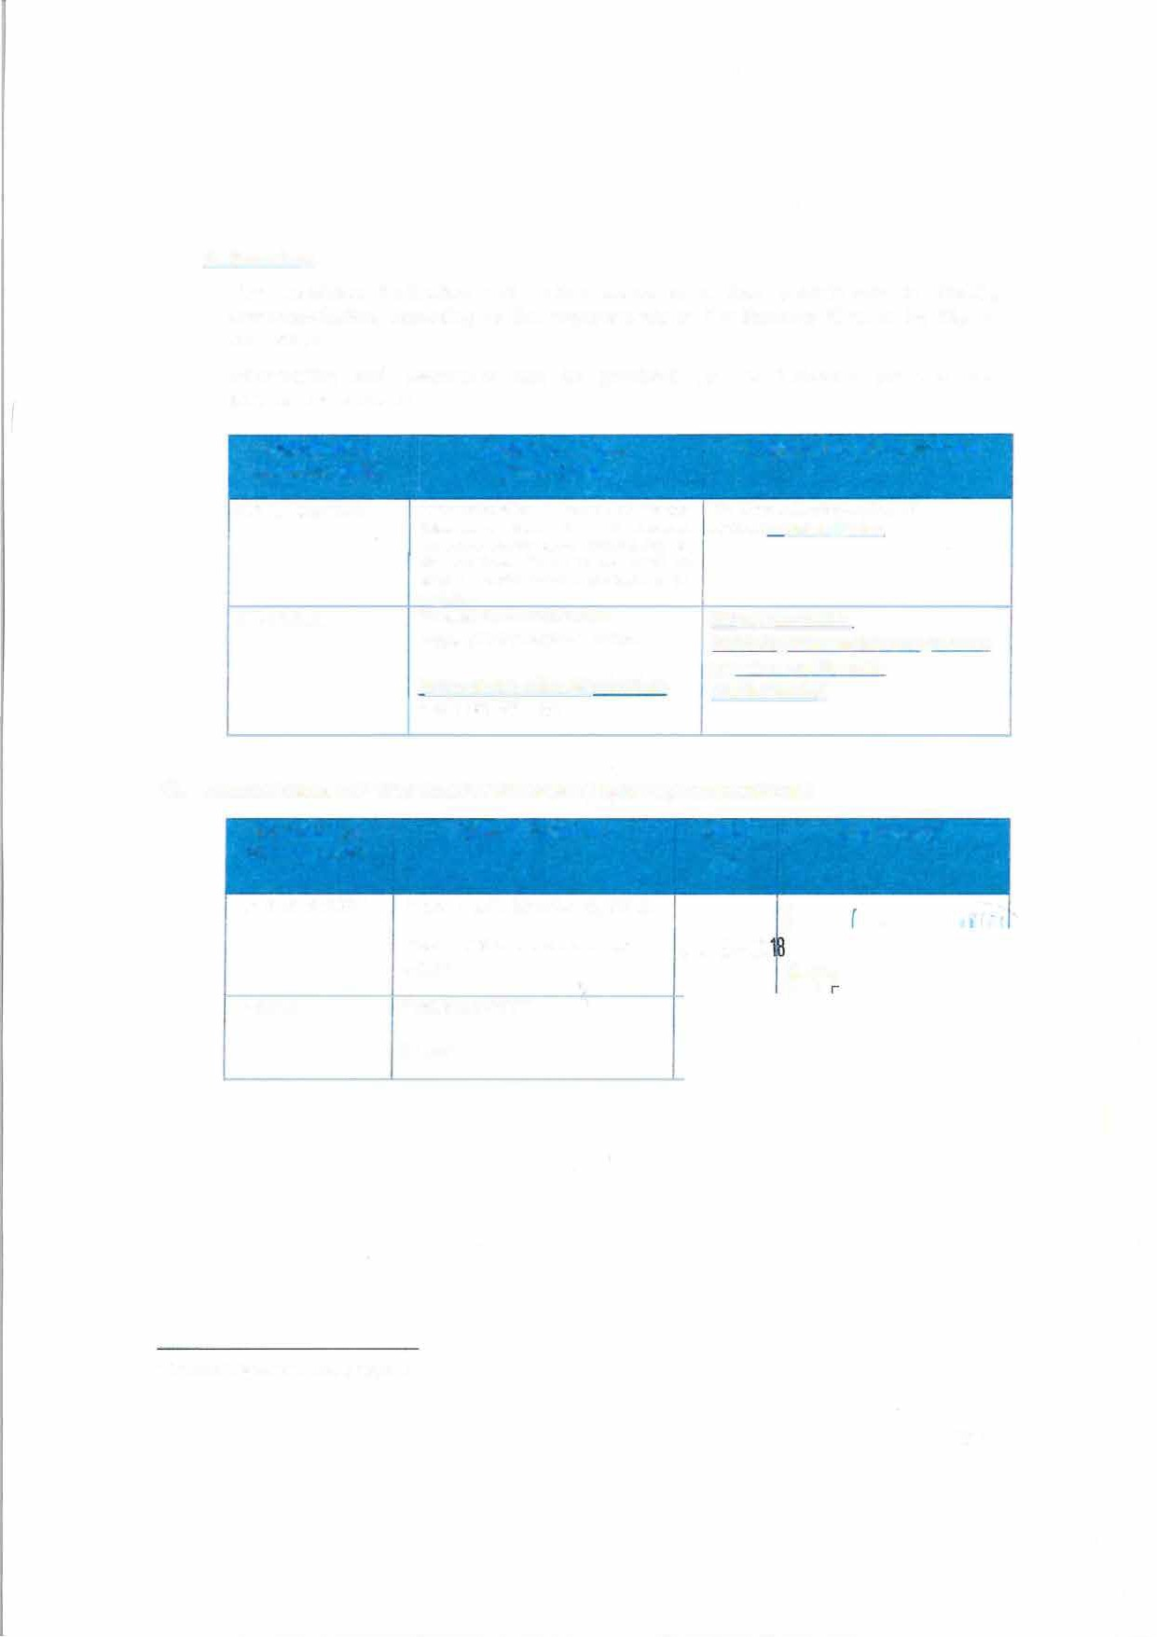

3 Scanned signatures are accepted

*Page 6*