FRAMEWORK ORDER - 4501518991
(MUST BE INDICATED ON ALL DOCUMENTS AND LABELS)
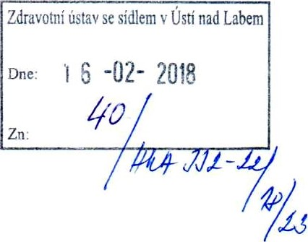
Company
Zdravotni ustav Usti nad Labem
Moskevska 15
400 01 Usti nad Labem
Validity period 25 Jan 2018 - 31 Dec 9999
Vendor: 283666

DANISCO
Fi rst you add knowledge...
Danisco Czech Republich, a.s.
Palackého 6
503 03 Smirice
The Czech Republic
Telephone (0) 495 864 1 11
Telefax (0) 495 864 129
ASC@DUPONT.COM
Date: 25 Jan 2018
Deliver to: Send invoice to:
Danisco Czech Republic a.s. Please send invoice by pdf to MULTI_EMEA@dupont.com
Palackého ul.6
503 03 Smirice
Contact person/E-maiI  Dusan Rodzinak  ASC@DUPONT.COM | Telephone/Our fax number  0034 985124910  0034 912725384
Payment terms  Net 30 Days from Date of Invoice | Delivery terms  DAP Delivery At Place Incoterms@  2010 | Currency CZK
Please send order confirmation to asc@dupont . com.
OFFER KOFI 70404256
The total value assigned to this order is indicative only and does not represent a firm commitment but an estimate. DuPont will be committed by the placement of individual service orders under this order only. This purchase order number must be referred in every invoice placed against this order .
Item Material No Description  10 medical screenings  The item covers the following services: Expected value of unplanned services . | Order qty  100.000,00 | Price per unit 100.000,00 | Net Value 100.000,00
 |  |  | TOTAL excl. tax 100.000,00

Page: 1 / 2
FRAMEWORK ORDER -4501518991
BILLING ADDRESS & RECOMMENDATIONS

DANISCO
First you add knowledge.
Date: 25 Jan 2018
Page: 2 / 2

TO FACILITATE TIMELY PAYMENT AND PREVENT INVOICE REJECTIONS, we kindly request you to:
-Ensure you are issuing the invoice to the correct DuPont Legal Entity name:
Danisco Czech Republic, a.s.
Palackého 6
503 03 SMIRICE
Czech Republic
-Address the invoice to the attention of the Accounts Payable department and NOT to the DuPont contact person which should be inside the invoice.
-Ensure the invoice matches the Purchase Order or your prior Order Confirmation statement
-Send the invoice only after delivery of goods and/or completion of services to DuPont
TWO ALTERNATIVES TO SEND YOUR INVOICES - from most efficient to least efficient:
1)To ensure on time payment, where legally accepted, please send PDF via e.mail to.
Email address:
Email title: Country of invoice + number of PDF attachments or invoices Content instructions: Only one invoice per PDF
2) As a last resort for billing, paper invoices should be sent to this address: Att: Accounts Payable department Danisco Czech Republic, a.s. c/o DuPont Asturias SL P.O. Box 865 33400 Asturias
Spain
ACCOUNTS PAYABLE CONTACT INFORMATION
For invoice status and payment information please reach our Accounts Payable on (+420) 257 414 106 or by e-mail at cz_ap_fssc@dupont.com
CONFIRMATION REQUIREMENT.
DuPont requires that all material purchase orders delivery dates and quantities be confirmed by our suppliers within 24 hours for non-overseas shipments, or within 5 days for overseas shipments. If you're not EDI connected to DuPont, please send your confirmation to one of the email addresses shown below:
-For Maintenance, Repairs and Operating Materials please send your confirmation to asc@dupont.com -For Raw Materials, Packaging or Contract Manufacturing goods:
- If you have a contract number in the line item, please send your confirmation to your usual supply chain contact person at the site
- If you don't have a contract number in the line item, please send your confirmation to asc@dupont.com
If you wish to contact Sourcing for clarifications related to prices or with general terms and conditions for the above orders, please reach contact us asc@dupont.com.
Yours Faithfully,
Danisco Czech Republic a.s.
Dusan Rodzinak

