Confidentiality Level |  | BL - Restricted for internal use | TC ID / Revision | 00158461/C
Document Status |  | Document Released | Document No. | N/A
WBS code |  | 3.3 - L3 System
PBS code |  | RA1.L3.HAPL.CMP.CMP; Compressor grating assemblies
Project branch |  | Engineering & Scientific documents (E&S)
Document Type |  | Specification (SP)
[RSD product category C,D]

G3 and G4 PW Compressor Grating Mounts
TP17_057

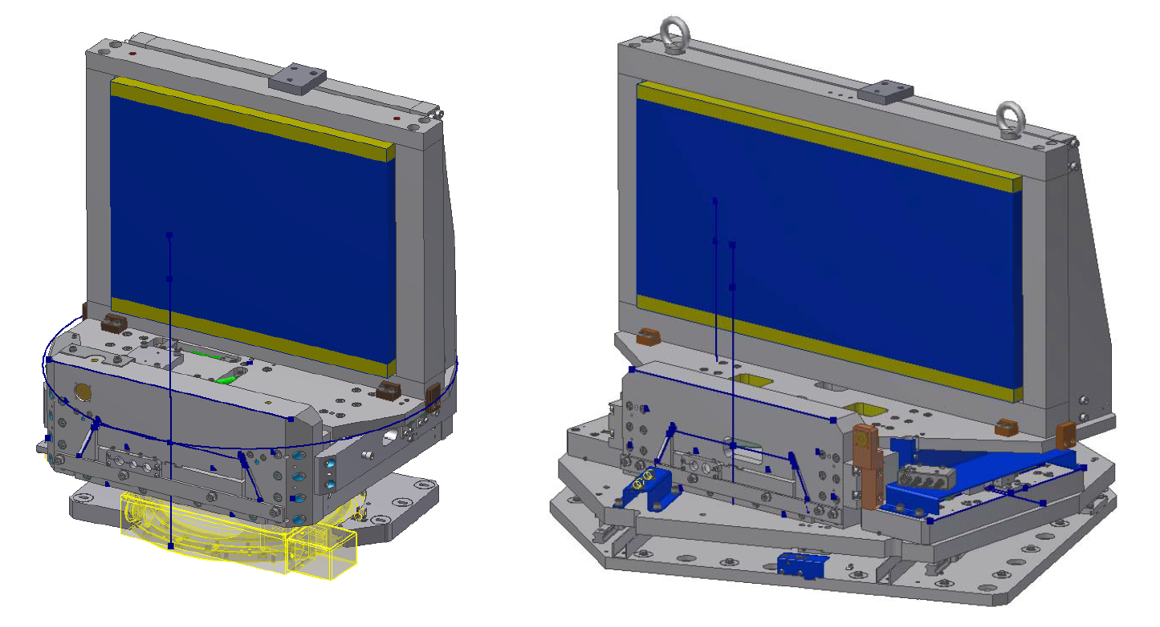

Keywords
N/A

 | Position |  |  |  | Name
Responsible person | Scientific Coordinator of Laser Technology (RP1) |  |  |  | Bedřich Rus
Prepared by | Scientific Coordinator of Laser Technology (RP1),  Senior Technology Expert |  |  |  | Bedřich Rus,  Mike Griffiths

RSS TC ID/revision | RSS - Date of Creation | RSS - Date of Last Modification | Systems Engineer
010724/A | 26.10.2017 18:02 | 28.10.2017 01:27 | Marek Malý
010724/A.001 | 28.10.2017 01:27 | 28.10.2017 01:29 | Marek Malý
010724/A.002 | 02.11.2017 15:35 | 02.11.2017 15:37 | Aleksei Kuzmenko
Reviewed By
Name (Reviewer) | Position | Date | Signature
Pavel Bakule | Deputy RP1 Leader
Lukáš Brabec | Group Leader of Vacuum and Cryogenics
Pavel Korouš | Chief Engineer
Martin Laub | Group Leader of Mechanics
Jakub Janďourek | Infrastructure Technology Coordinator | N O T I C E
Alice Hamalová | Clean room specialist | N O T I C E
Ladislav Půst | Manager Installation of Technology | N O T I C E
Veronika Olšovcová | Safety Coordinator | N O T I C E
Viktor Fedosov | SE & Planning group leader; Quality Manager


Approved by
Name (Approver) | Position | Date | Signature
Bedřich Rus | Scientific Coordinator of Laser Technology (RP1)

Revision History / Change Log
Change No. | Made by | Date | Change description, Pages, Chapters | TC rev.
1 | B.Rus | 19.10.2017 | RSD draft creation | A
2 | M.Malý | 27.10.2017 | RSD update, version for internal review | B
3 | A.Kuzmenko | 02.11.2017 | RSD update, final version for approval | C

Table of Content

1. Introduction 4
1.1. Purpose 4
1.2. Scope 4
1.3. Terms, Definitions and Abbreviations 4
1.4. Reference Documents 4
1.5. References to standards 4
2. General System Requirements 5
2.1. System Configuration 5
2.2. Interface Requirements 5
3. Functional Requirements 6
3.1. Optomechanical Arrangement 6
3.2. Grating Supporting Bezels 8
4. Performance Requirements 9
5. Design Requirements 9
5.1. General Design Requirements 9
5.2. Operational Design Requirements 10
5.3. Vacuum Design Requirements 11
5.4. Mechanical Design Requirements 11
5.5. Electrical Design Requirements 12
6. Transportation and Installation Requirements 13
6.1. General Requirements 13
7. Safety Requirements 14
8. Quality Requirements 14
8.1. General Quality Requirements 14
8.2. Documentation and Data Control 14
8.3. Non-Conformance Control System 15
9. Verification Requirements for a Supplier 16
9.1. General 16
9.2. Verification Documentation 16
9.3. Verification Control Document (VCD) 17
9.4. Verification Execution 17
9.5. Verification Close Out 19
10. Drawing Package 20

Introduction

Purpose

This Requirements Specification Document (RSD) specifies the technical requirements and constraints applicable to the design, manufacture and testing of optomechanical grating mounts G3 and G4 for the L3 laser compressor of PW pulse.
This RSD identifies the interfaces with the ELI-Beamlines L3 laser systems and acts as the originating document for the technical requirements that need to be addressed in lower level design documents.

Scope

This RSD contains all of the top level functional, performance, safety, operational and quality requirements for the design and manufacture of optomechanical mounts for the L3 compressor gratings G3 and G4 (PBS number: RA1.L3.HAPL.CMP.CMP; Compressor grating assemblies). In addition to the requirements specified in this RSD, this system shall comply completely with the requirements given in the Reference Documents [see below Section 1.4].

Terms, Definitions and Abbreviations

Abbreviation | Meaning
CA | Contracting Authority
CDRR | Critical Design Review Report
E1,2,3,4,5,6 | Experimental Hall 1,2,3,4,5,6
ELI | Extreme Light Infrastructure
L1, L2, L3, L4 | Laser Hall 1,2,3,4
NCR | Non-Conformance Report
RSD | Requirements Specification Document
VCD | Verification Control Document

Reference Documents

See Section 10 Drawing Package

References to standards

If this document includes references to standards or standardized/standardizing technical documents the CA allows/permits also another equal solution to be offered. If the Supplier offers another equal solution the CA shall not reject its bid, once the Supplier by appropriate means in the bid proves that the offered supplies, services or works meet in an equivalent manner the requirements including references to standards or technical documents.

General System Requirements

System Configuration

The optomechanical grating mounts G3 and G4, which are the subject of this specification, are part of the ELI-Beamlines L3 Laser system.

The optomechanical grating mounts G3 and G4 will be located inside the L3 Compressor vacuum chamber and will provide a support structure for large diffraction gratings, which are provided by the Supplier of the L3 laser, Lawrence Livermore National Laboratory. The optomechanical mounts will enable the gratings to be held in a precisely defined position and to be remotely steered, with very high precision and stability, whilst operating under high vacuum within the compressor chamber.

There are two versions of optomechanical grating mount used in the L3 compressor: Type G1/4 and Type G2/3. Two units of each design are required for the operational compressor. The first piece of each type was prototyped, optimized and performance verified in terms of mechanical functioning, positioning accuracy, and dimensional compactness.

Interface Requirements

The optomechanical grating mounts provide a structural supporting interface between the optical gratings and the internal optical table of the L3 compressor. Mechanical requirements are detailed in Section 5.
The optomechanical grating mounts shall be designed to accommodate the diffraction gratings specified in LLNL drawings AAA12-107042_AE and AAA12-107043. For handling and protection purposes the gratings will be mounted within bezels (frames) constructed in accordance with the design principles shown in LLNL drawing AAA07-106770_AA_S001 and related drawings (see drawing package in Section 10).

The grating/bezel units shall provide an interface to lifting equipment used to position the gratings inside the compressor. Similarly, the optomechanical grating mounts shall provide an interface to the lifting equipment used to position the mounts inside the compressor. The mounts shall never be lifted with the gratings installed.

The optomechanical grating mounts shall also have an interface with the L3 Laser control system for the function of grating positioning. The control system is being designed under a separate contract. Within the scope of this contract only the wiring connections are required from various actuators and sensors to the respective feedthrough connector mounted at the relevant vacuum chamber flange.

Functional Requirements

Optomechanical Arrangement

The optomechanical mount design for the support of gratings 1 and 4 (Type GR1/4) is shown in Figure 1 and the mount design for gratings 2 and 3 (Type GR2/3) is shown in Figure 2.

Mount Type GR1/4 is equipped with a 2-axis flexure joint unit providing roll and pitch movements (for an explanation of the principle of the flexure joint frame see Section 5.5). Alignment of the compressor also requires that these mounts are able to rotate within a range of several tens of degrees of yaw around the vertical axis. This amount of rotation exceeds that available within a flexure joint unit, so the whole assembly sits on a commercial motorized rotation stage (type Newport RV350PE V6) with accurate absolute position readout. No translation movement is required for mount Type GR1/4. Movement of the flexure joint unit is motorized using high-resolution vacuum-rated actuators (type Newport VHRU -10V6; travel range 10 mm, resolution 50 nm, absolute accuracy 2 µm, load capacity 500 N). The mount Type GR1/4 is designed to have the point of rotation, for all axes, on the centre of the front surface of the mounted grating, with an accuracy of approximately 1 mm. The required range of motion in each axis is given in Table 1.

Mount Type GR2/3 is equipped with a 3-axis flexure joint unit providing roll, pitch and rotation movements. This unit sits on a translation stage providing movement along the optical axis. Mount Type GR2/3 also uses vacuum actuators (type Newport VHRU -10V6) in the flexure joint unit.

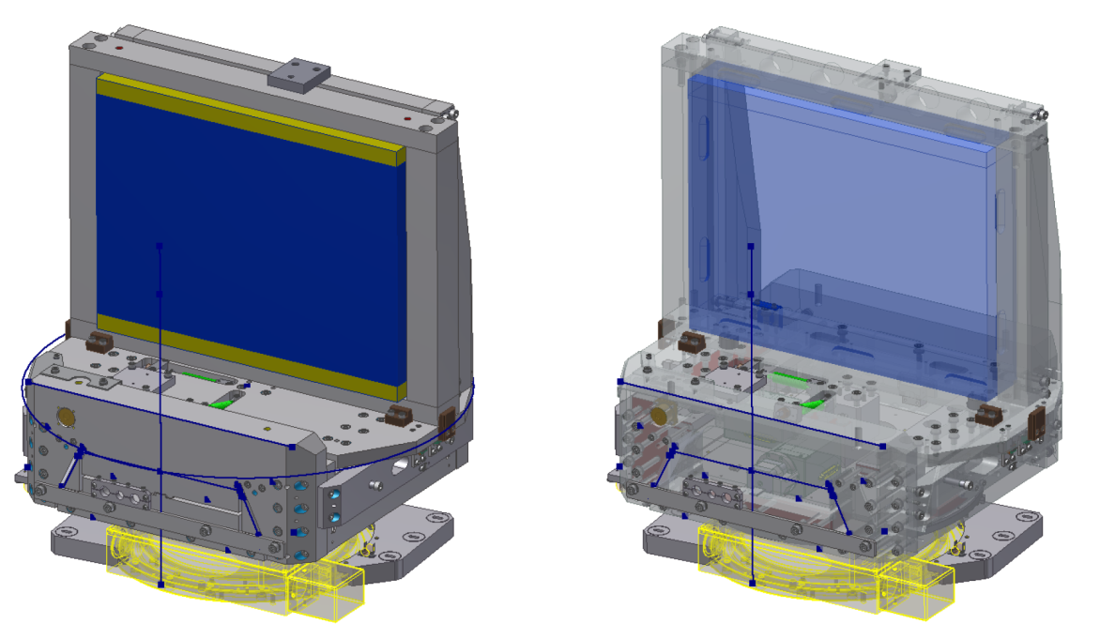
Figure 1: Overall and cutaway view of the optomechanical design of grating mount Type GR1/4.

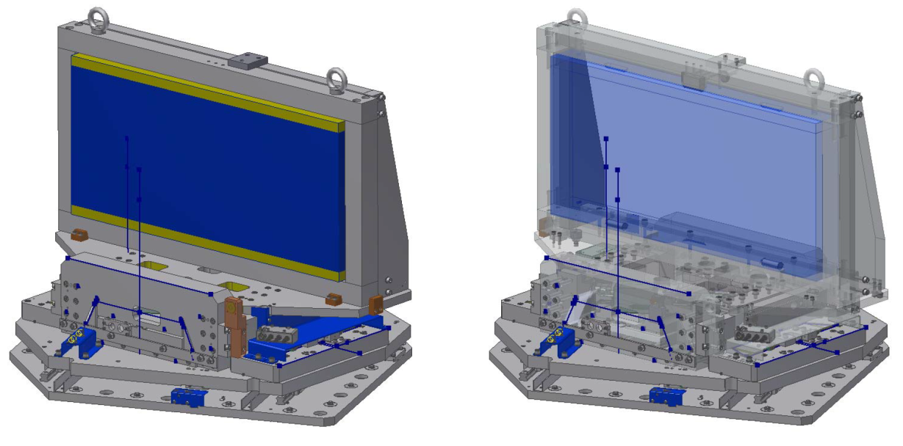
Figure 2: Overall and cutaway view of the optomechanical design of grating mount Type GR2/3.

Optomechanical mount Type | Range | Resolution | Accuracy | Actuator type
GR3
Translation | ±50 mm | 0.5 µm | 1 µm | Stepper motor
Yaw | ±0.35° | 0.5 µrad | 1 µrad | Stepper motor
Pitch | ±0.4° | 1 µrad | 2 µrad | Stepper motor
Roll | ±0.4° | 0.5 µrad | 1 µrad | Stepper motor
GR4
Yaw | ±90° | 0.5 µrad | 1 µrad | Stepper motor
Pitch | ±0.4° | 1 µrad | 2 µrad | Stepper motor
Roll | ±0.4° | 0.5 µrad | 1 µrad | Stepper motor

Table 1: Grating mount movement requirements.

Definitions relating to Table 1:

Resolution: One incremental step of motorized actuator; one graduation of fine adjustment scale for micrometric screw
Accuracy: Absolute position knowledge by encoder readout, bidirectional repeatability for motions without encoder
Yaw: Rotation around the vertical axis
Pitch: Rotation around the horizontal axis parallel to the mirror surface
Roll: Rotation around the horizontal axis perpendicular to the mirror surface

Further details including attachment of the gratings to the positioning mounts and the attachment to the optical table, can be found in the drawing package, Section 10.

Grating Supporting Bezels

The optomechanical mounts are designed to accommodate the gratings within Bezels (frames) as shown in the drawings in Section 10 - Drawing Package. Fully detailed 3D models of the grating support bezels will be provided on award of contract.

The above described units for optomechanical positioning of the gratings provide sufficient margin, as well as design flexibility, for attaching grating bezels on top of the optomechanical mount and to allow keeping the centre of rotation of the grating on the grating front surface centre (or on any other selected point at the grating). The design also provides space for implementation of grating backside cooling plates, or the heat removal system using a cooled bezel (see Figure 3).

The inherent stiffness of the flexure joint system gives the grating positioning units an extra advantage with respect to forces resulting from potential mechanical micro-oscillations due to liquid flow in the cooling panels. The flexure joint system stiffness can be further tuned by adjusting various joint design parameters (thickness of the elastic bridges, shape of the cavities forming the joint, etc.) if necessary.

The working roll and pitch position of all gratings, i.e. aligned configuration of the compressor, is designed to be precisely vertical. To this purpose the grating mounts or mounting frames will be equipped with miniature high-precision tilt gravitational sensors providing absolute information on correct vertical position of the gratings.

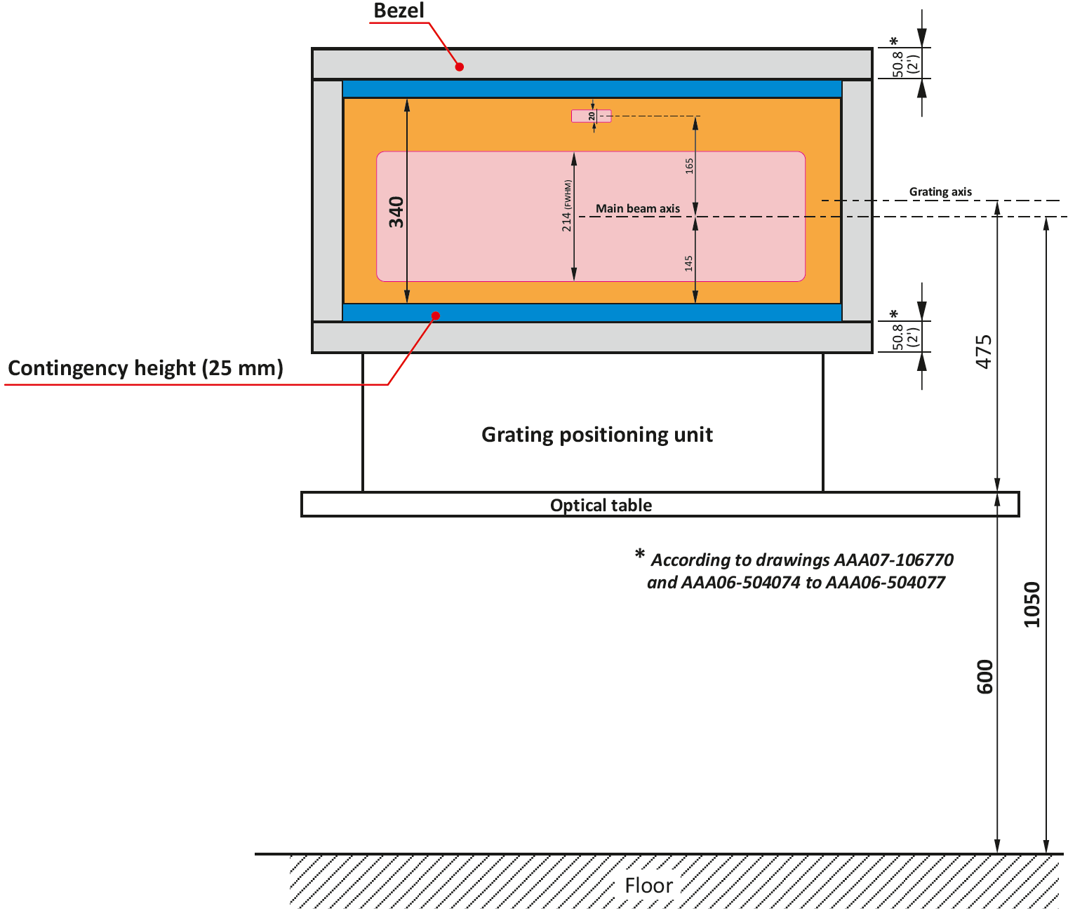
Figure 3: Major dimensions of the grating frames (bezels) incorporated in the design.

Performance Requirements

The individual movements as described in Table 1: Grating mount movement requirements, must be executable independently (free of cross talk) and with the indicated range, resolution and accuracy.

Design Requirements

General Design Requirements

REQ-022156/A
The grating optomechanical mounts shall be detail designed and manufactured according to the attached general drawings (see Section 10) and a fully detailed 3D model that will be provided following award of contract.
Verification method: R - review of design
REQ-022157/A
The grating optomechanical mounts shall be attachable to the optical table and shall be able to be pre-positioned (without engaging the actuators) with precision of ±1 mm.
Verification method: R - review of design
REQ-022158/A
Each individual optomechanical mount shall provide long-term angular mechanical stability (drift) of the optical element better than 10 µrad (in thermally stabilized environment).
Verification method: T - test
REQ-022159/A
The principal material of the mounts shall be aluminium and/or stainless steel.
Verification method: R - review of design
REQ-022160/A
The mounts design shall feature integration of electrical actuator including wiring for electrical actuators and devices up to the vacuum feedthroughs.
Verification method: R - review of design
REQ-022161/A
The detailed design will include position encoders for each movement according to Table I, allowing reading out absolute position with a precision of at least of the indicated resolution. The encoders must allow absolute position readout after switching the encoder on, without homing the movement.
Verification method: R - review of design
REQ-022162/A
The detailed design will include a precision clinometer allowing reading out absolute pitch and roll of the grating frame of both Type GR3 and Type GR4. The clinometers will have precision equal or better than 0.5 µrad for both pitch and roll.
Verification method: R - review of design

REQ-022163/A
All edges of the optomechanical mounts shall be chamfered.
Verification method: R - review of design, I - inspection
REQ-022164/A
Best practice shall be followed in the design, type choice and implementation of the vacuum electrical feedthroughs, and it shall be approved by the Contracting Authority.
Verification method: R - review of design
REQ-022165/A
Any principal documentation shall be in English language.
Verification method: I - inspection
REQ-022166/A
Only new materials and equipment shall be used.
NOTE: Recycled material and reused equipment shall not be acceptable. Material certificates shall be provided by Supplier.
Verification method: R - review of design
REQ-022167/A
Each optomechanical mount (minus grating) shall be supplied with a means of lifting that ensures the base of the mount is horizontal in both axes when the mount is lifted from a single point of suspension.
Verification method: T - test
REQ-022168/A
Each grating bezel shall be supplied with a removable grating cover made from stainless steel.
Verification method: R - review of design
REQ-022178/A
The grating mount G4 shall be equipped by a compact vacuum compatible cable tray (see also Section 10, drawing package) for guiding the cables of the pitch-roll actuators of the flexure mount located on top of the rotation platform while the yaw rotation movement is performed. The cable tray shall be designed so that it enables accommodation of two additional cables diameter 8 mm.
Verification method: R - review of design

Operational Design Requirements

REQ-022169/A
Parameters of the individual movements, i.e. range, resolution, accuracy and absence of cross talk of the mounts shall correspond to those specified in Table I.
Verification method: R - review of design
REQ-022170/A
The detailed design shall include contingency space of 25mm above and under of each grating for future implementation of the cooling bars, as specified in Figure 3 in this document.
Verification method: R - review of design

Vacuum Design Requirements

REQ-022171/A
The manufacturing design of the mounts shall avoid any trapped volumes of air, e.g. the mounting holes shall not be blind tapped.
Verification method: R - review of design, I - inspection
REQ-022172/A
All actuators used in the mounts shall be factory certified for vacuum at least 10⁻⁶ mbar.
Verification method: R - review of design
REQ-022173/A
Vacuum test of the completed mounts shall be carried out to prove that the mounts are compatible with pressures down to 10⁻⁷ mbar. The test shall include a mass spectrometer / residual gas analyser (RGA) to demonstrate that volatile organic compounds (VOCs) and other impurities are not present at the lower limit of detection of the spectrometer.
Verification method: T - test

Mechanical Design Requirements

For precise angular positioning the gratings will employ a flexure joint system constituting, in the basic configuration, the kinematic equivalent of a goniometric cradle. The flexure joint system intrinsically employs elasticity of the material and its principle is represented in Figure 4. The system is manufactured from one block of appropriate material divided into two bases (upper and lower) connected by pairs of thin elastic bridges formed by accurately separated circular holes arranged in trapezoidal geometry. With the lower plate fixed the upper plate is free to perform circular motion with the effective center of rotation determined by geometry of the trapezoid (the axis of rotation is located in intersection of arms of the trapeze). By “stacking” two pairs of flexi joints plates a two-axis system is constituted (see Figure 4) representing kinematic equivalent of a goniometric cradle, providing pitch and roll angular travel around two horizontal axes. An obvious advantage of the system is that the point of rotation, i.e. intersection point of the two flexi joint pairs of plates, can be arbitrarily determined by the design.

A system providing also rotation around vertical axis, i.e. 3-degree of freedom rotation positioning, may be obtained by adding to the block represented in Figure 4 a horizontal plate equipped with appropriate flexi joints located symmetrical by two sides of the plate. The flexi joints divide the plate into the outer fixed part and the inner part able to perform rotational movement. This arrangement is required for the mount Type GR3.

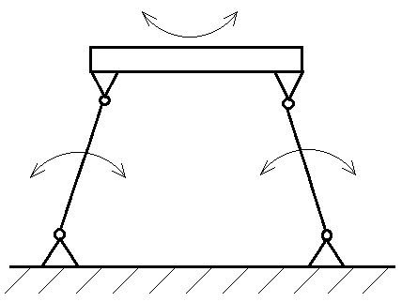
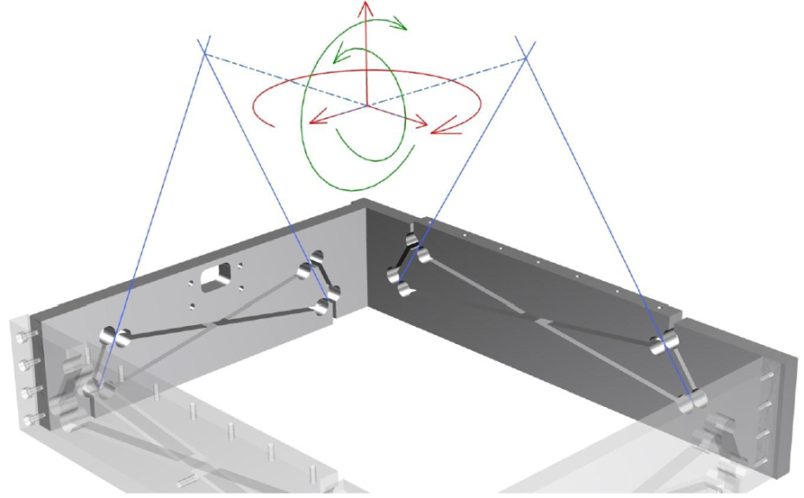

Figure 4: Principle of flexure joint and basic layout of a pitch-roll table mechanically equivalent to precise two-axis goniometric cradle. The device provides positioning indicated by the green arrows and is rigid in the third rotational degree of freedom (red arrow), i.e. rotation around vertical axis. Engineering optimization consists in obtaining maximal contrast between flexibility of the pitch-roll, maximum load support and maximal rigidity against rotation around vertical axis.

REQ-022174/A
The grating mounts shall employ the flexure joint system to enable the small angle pitch, roll and yaw movements required for the grating mounts.
Verification method: R - review of design, T - test

Electrical Design Requirements

REQ-022175/A
Only stepper motors shall be used in the actuators (see also Table I).
Verification method: R - review of design
REQ-022176/A
Vacuum compatible (10⁻⁷ mbar) electrical wiring shall be supplied from the actuators, position encoders, and signals from the clinometers up to the connectors at the feedthrough flanges on the vacuum chamber. The wiring shall be of sufficient length and flexibility to allow in-situ installation.
Verification method: R - review of design
REQ-022177/A
Electrical wires leading from the actuators, position encoders, and signals from the clinometers to the connectors shall be shielded by flexible metallic hose against scattered light in the compressor.
Verification method: R - review of design

Transportation and Installation Requirements

General Requirements

REQ-022179/A
The transportation to the final destination of the technologies and the instruments shall be conducted by the Supplier.
Verification method: R - review
REQ-022180/A
The transportation procedure shall be discussed and reviewed by the Contracting Authority.
NOTE: These regulations shall be defined by the Contracting Authority and provided to the Supplier after contract signature and before detailed design contract phase.
Verification method: R - review
REQ-022181/A
The Supplier shall allow supervising the activities related to the transportation by the Contracting Authority.
NOTE: Any acts of supervision shall not mean that the Contracting Authority assumes additional liability of any kind exceeding its liabilities according to the contract.
Verification method: R - review
REQ-022182/A
The technologies and instruments shall be delivered in protective package preventing damage and contamination and a minimum of two plies separate clean packaging. The technologies shall be cleaned and packaged complying the cleanliness of at least class 7 according to ČSN EN ISO 14644.
NOTE: Regarding the referred to standard/s or technical documents the CA allows/permits also another equal solution to be offered.
Verification method: R - review, I - inspection
REQ-022183/A
The Supplier and Contracting Authority shall agree on the cleaning method to clean devices without decreasing the devices' performance and to avoid contamination of clean space.
NOTE: The cleaning methods may use high temperatures (baking out), high gas flow (dry air) and specialised chemical cleaning liquids (alcohol, Isopropyl alcohol, demineralised water).
Verification method: R - review
REQ-022184/A
All transportation tools and equipment entering the clean rooms shall be cleaned and reviewed by the Contracting Authority's approved methods.
NOTE: Some tools can be provided by the Contracting Authority upon agreement.
Verification method: I - inspection, T – test

Safety Requirements

REQ-022185/A
The Supplier shall supply a Declaration of Conformity or any other equivalent document legally recognized and accepted in the Czech Republic for each product type if the appropriate legislation determines the Supplier's obligation to have a Declaration of Conformity (or the equivalent document) for the purposes of a Device sale in the Czech Republic to fulfil the requirements of 2001/95/EC directive or applicable Czech law.
Verification method: R – review, I - inspection

Quality Requirements

General Quality Requirements

REQ-022186/A
The Supplier shall define and document the responsibilities and the interfaces of the Quality functions, either external or internal, involved in a project.
Verification method: R - review
REQ-022216/A
The Supplier shall prepare, maintain, and implement a plan of the QA (quality assurance) activities (quality plan).
NOTE: The Contracting Authority can assist with the quality plan definition.
Verification method: R - review
REQ-022187/A
The Supplier shall provide to Contracting Authority the quality plan for agreement and approval.
Verification method: R - review

Documentation and Data Control

REQ-022188/A
The Supplier shall provide the following relevant manufacturing documents (extent as stipulated in contract):
- Full technical documentation (including manufacturing drawings);
- breakdown list as built;
- all approved “requests for deviation/wavier”(see REQ-022193/A).
Verification method: R – review

REQ-022189/A
The Supplier shall provide to the Contracting Authority the Product User Manual including procedures for safe:
- Handling and manipulation;
- Storage and Installation;
- Operation and maintenance;
- Warranty conditions.
Verification method: R - review
REQ-022190/A
Documentation shall be supplied in all following formats: hardcopy and PDF.
Verification method: Not To Be Tracked within VCD
REQ-022191/A
The Supplier shall provide following type of documents:
- 3D model (if available);
- 2D drawings;
- Text documents in printable format.
Verification method: Not To Be Tracked within VCD
REQ-022192/A
The Supplier shall use following data formats:
- *.JPG
- *.PDF/A
- CAD 2D: *.dwg
- CAD 3D: STEP type files (*.stp;*.ste;*.step)
- text processors *.doc, *.docx, OpenDocument Format
- spreadsheet processors *.xls, *.xlsx, OpenDocument Format
- presentations *.ppt, *.pptx; OpenDocument Format
- *.HTML
Verification method: Not To Be Tracked within VCD

Non-Conformance Control System

REQ-022193/A
The Supplier shall establish and maintain a non-conformance control system compatible with ČSN EN ISO 9001 (equivalent to EN ISO 9001).
Verification method: Not To Be Tracked within VCD

Verification Requirements for a Supplier

G3 and G4 PW Compressor grating mounts (product) are called in the further text of this chapter by the word Device.

General

REQ-022194/A
The verification process shall be performed by the Supplier to demonstrate that the deliverable Device meets the specified requirements of the Contracting Authority. The verification process consists of:

1. Verification execution and reporting;
3. Verification control and close-out.
Verification method: Not To Be Tracked within VCD
REQ-022195/A
The Supplier shall assign clear responsibility for the implementation of the verification process including all activities defined in REQ-022194/A.
Verification method: R - review

Verification Documentation

REQ-022196/A
The Supplier shall establish and maintain the system of verification process documentation.
Verification method: Not To Be Tracked within VCD
REQ-022197/A
Verification documentation shall consist of following basic types of documents:
- Verification Reports including: CDR Report and Tests reports.
- VCD, Verification Control Document.
Verification method: Not To Be Tracked within VCD
REQ-022198/A
The verification report shall be submitted to the Contracting Authority for the review as agreed with the Contracting Authority after corresponding verification activity completion, within the time frame agreed with the Contracting Authority.
NOTE: Verification activity can be design review, inspection and test of the final Device.
Verification method: Not To Be Tracked within VCD

Verification Control Document (VCD)

The Verification Control Document (VCD) lists the requirements to be verified with the selected methods at the defined levels. The VCD is a living document and provides traceability during contract phases (design, manufacturing, testing and deployment) how and when each requirement is planned to be verified and is actually verified.
VCD represents a formal tool of communication between the Supplier and Contracting Authority (formal record, reporting tool).

REQ-022199/A
The Supplier shall provide a Verification Control Document (VCD) for the reviews as agreed with the Contracting Authority.
NOTE 1: Guidelines for VCD preparation shall be provided by the Contracting Authority.
NOTE 2: The form of VCD will be agreed between the Contracting Authority and Supplier based on the best commercial praxis used by the Supplier.
Verification method: R - review
REQ-022200/A
In the Verification Control Document (VCD) the Supplier shall add the information about HOW and WHEN each of the technical requirements is to be verified.
NOTE 1: Since some requirements are to be verified through a review of design the VCD must be accepted by the Contracting Authority before the beginning of the Design Review.
NOTE 2: Guidelines for VCD preparation can be provided by the Contracting Authority.
Verification method: R - review

Verification Execution

REQ-022201/A
The verification execution process shall consist of following stages according to the phasing of the contract execution:

- Critical design review (CDR);
- Verification of final device (testing at Supplier’s site);
- Acceptance by Contracting Authority at customer site.

NOTE 1: CDR is intended to verify that the design meets corresponding requirements (could be accepted) and/or identify required corrective actions needed to accept the design and start manufacturing phase of the contract.
NOTE 2: Verification of final device is executed at the end of manufacturing phase by inspection and tests. This verification stage is intended for the check of product readiness to shipment to the Contracting Authority.
NOTE 3: In the acceptance stage the verification shall demonstrate that the product is free of fabrication errors and is ready for the intended operational use.
Verification method: Not To Be Tracked within VCD
REQ-022202/A
Acceptance shall be carried out on the final hardware (Device).
NOTE 1: Output of this verification stage is Verified Design and Verified Device.
NOTE 2: The results of acceptance stage shall be recorded within VCD.
Verification method: Not To Be Tracked within VCD
REQ-022203/A
Verification shall be accomplished by the Supplier through one or more of the following verification methods:
1. Review of design; Verification by Review (R) shall consist of using approved records (examples of such approved records are design documents and reports, technical descriptions, and engineering drawings, manuals and accompanying operation documentation) or evidence that unambiguously shows that the requirement is met.
2. Inspection; Verification by Inspection (I) shall consist of visual determination of physical characteristics.
3. Test (including functional demonstration); Verification by Test (T) shall consist of measuring product performance and functions under realistic operating conditions. When the test objectives include the demonstration of qualitative operational performance (functional demonstration) the execution shall be observed and results recorded.
Verification method: Not To Be Tracked within VCD
REQ-022204/A
The results of a review of design shall be documented in the Critical Design Review Report (CDRR) and tracked by the VCD.
NOTE: The Contracting Authority can provide to the Supplier the template of CDRR.
Verification method: R - review
REQ-022205/A
The parts of the VCD related to the Design of the Device shall be accepted by the Contracting Authority before manufacturing of the Device starts.
Verification method: Not To Be Tracked within VCD
REQ-022206/A
The results of the inspection shall be tracked by the VCD.
Verification method: R - review
REQ-022207/A
The results of the test shall be documented in the appropriate Test Report and tracked in the VCD.
Verification method: R – review

Verification Close Out

In case of successful acceptance stage (confirmation by inspection accordingly to REQ-022203/A) the Contracting Authority will provide to Supplier signed acceptance protocol. In case of unsuccessful acceptance stage the Contracting Authority will provide to Supplier Non-Conformance Report (NCR) and ELI non-conformance control process shall be applied (see REQ-022193/A).

REQ-022208/A
The verification process shall be considered completed when the Contracting Authority approves the VCD by confirming that:
1. Identified requirements have successfully been verified;
2. All detected non-conformances have been solved according to REQ-022193/A;
2. Documented evidence is recorded in the VCD.
Verification method: Not To Be Tracked within VCD

Drawing Package

TC Number | Number of document | Title of document
00139050 | GR14_ENG-010834 | Manipulátor rotační L3K-GR1
00139049 | GR23_ENG-012241 | Manipulátor rotační L3K-GR2

