|  |  |  |  |  |  |
| --- | --- | --- | --- | --- | --- |
| Confidentiality Level | | BL - Restricted for internal use | TC ID / Revision | | Teamcenter ID / revision |
| Document Status | | Draft | Document No. | | Specific Document code |
| WBS code | |  | | | |
| PBS code | |  | | | |
| **Report** | | | | | |
| ***Personal Safety Interlock System (Functional Concept Description)***    *Keywords*  Personal Safety Interlock, Safety, PSI | | | | | |
|  | Position | | | Name | |
| Responsible person | [VYPUŠTĚNO] | | | [VYPUŠTĚNO] | |
| Prepared by | [VYPUŠTĚNO] | | | [VYPUŠTĚNO] | |

|  |  |  |  |
| --- | --- | --- | --- |
| Reviewed By | | | |
| Name (Reviewer) | Position | Date | Signature |
|  |  |  |  |
|  |  |  |  |
|  |  |  |  |
|  |  |  |  |

|  |  |  |  |
| --- | --- | --- | --- |
| ****Approved by**** | | | |
| Name (Approver) | Position | Date | Signature |
|  |  |  |  |

|  |  |  |  |  |
| --- | --- | --- | --- | --- |
| ****Revision History / Change Log**** | | | | |
| Change No. | Made by | Date | Change description, Pages, Chapters | TC rev. |
|  |  |  |  |  |
|  |  |  |  |  |
|  |  |  |  |  |

Table of Content

[VYPUŠTĚNO]

# Purpose

The purpose of this document is to provide a functional concept description of Personal Safety Interlock System (PSI) for ELI Beamlines facility.

# Scope

PSI is a safety system that protects personnel against defined hazards. The main strategy of the system is to confine the hazard within the hazardous area and terminates the hazardous process that can lead to injury or death.

PSI shall be design to conform the most appropriate of standards IEC 62061, IEC 61511, and IEC 61508.

# Glossary of terms

**Experiment execution**

It means laser beam delivery into the experimental hall and performing the research campaign. This activity is connected with high power laser and ionizing radiation hazard.

**PSI controlled area**

It is an area which is under PSI control and is connected with concrete experimental hall operation (experiment execution) – e.g. E2 PSI controlled area is defined as an area controlled by PSI for safe E2 technology operation.

**PSI operation**

All processes and activities which are a part of operation of PSI define PSI operation.

**PSI process control**

It means process that is under PSI permitting.

**Area mode**

Area mode is a safety status of PSI controlled area which has defined rules and procedure.

**Controlled area**

Area with potential presence of ionizing radiation. Defined by Act no. 18/1997 Coll.

# Facility description

The backbone instrument of ELI Beamlines will be a large laser system delivering ultrashort pulses lasting typically a few femtoseconds (10-15s). The interaction of ultra-short and ultra-intense pulses of light with specific targets will produce pulses of radiation and particles such as flashes of XUV, X-rays and gamma-rays, bunches of accelerated electrons, protons and ions, etc., which are exploitable as qualitatively new tools in many research disciplines and in the development of new technologies.

The facility is divided into three main parts (Administrative with Multi-function Building, Laboratory Building, and Laser Building) where all experiments will be realized in Laser Building. The Laser Building accommodates the experiments within three main floors. Detailed specification of the building including environmental conditions is given in building documentation [1].

ELI Beamlines facility will operate four laser systems (L1, L2, L3, and L4) with different beam parameters. The laser beams will be distributed to the experimental halls with beam distribution. The high power beams will be distributed under vacuum. For the case of precise aligning of the high power beams, there will be alignment laser beams used. These can be distributed either under vacuum or on air.

When the laser beams are delivered to the experimental halls (E1, E2, E3, E4, E5, and E6) they will be used for the specific research program. Each experimental hall accommodates different beamlines or user stations. Fig 1 shows the arrangement inside the Laser Building.

Technology supporting the beamlines and user stations will be located mainly in plant and service rooms. Plant and service rooms will accommodate HVAC, cooling water system, vacuum pumps and other. The maintenance in these rooms shall be properly planned not to disturb the trouble-free and safe experimental technology operation.

Laser systems will be located in the floor above the experimental halls. L1, L2, and L3 lasers will occupy each one hall where L4 will be distributed in three different rooms across three floors. High voltage capacitor bank for L4 along with L4a room will be located in the first floor. The main L4 laser system will be located in L4b in the ground floor and basement will accommodate L4 optical compressor in L4c room.

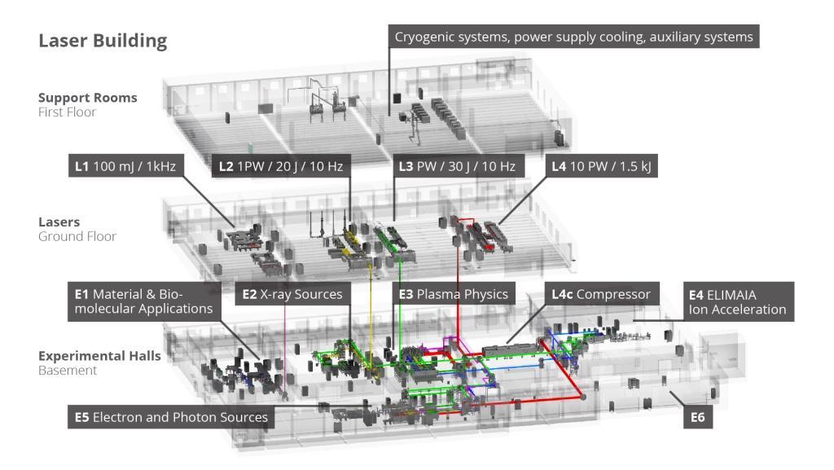***Figure 1*** **Arrangement of technology in Laser Building**

**E1 hall:**

E1 hall is dedicated for material and biomolecular applications. For this purpose following beamlines or stations are used:

* Plasma X-ray source (PXS),
* High Harmonics station (HHG),
* Raman station for stimulated Raman scattering and pulsed radiolysis,
* Ellipsometer,
* Coherent Diffraction Imaging station.

These beamlines and user stations will use L1 laser beam and local laser system.

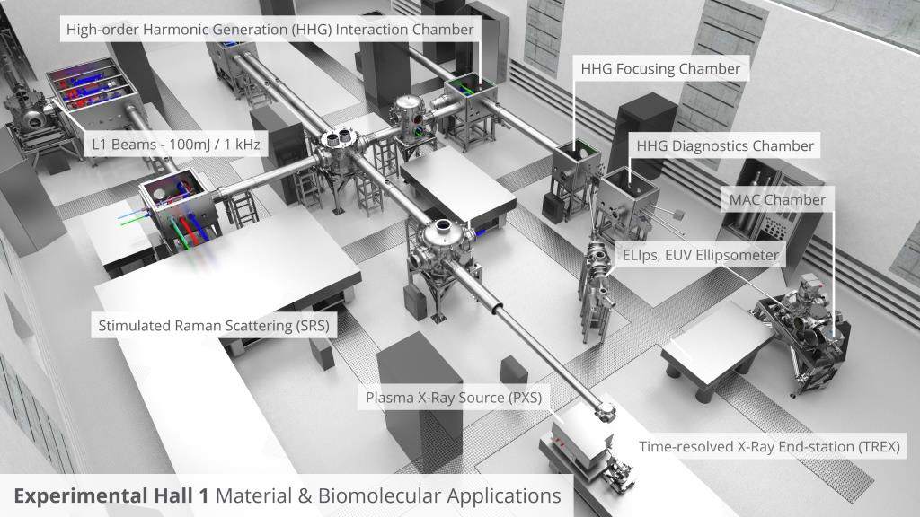

***Figure 2*** **E1 technology arrangement**

**E2 hall:**

E2 hall is dedicated for X-ray source using accelerated electrons. There will be only beamline called Betaron located.

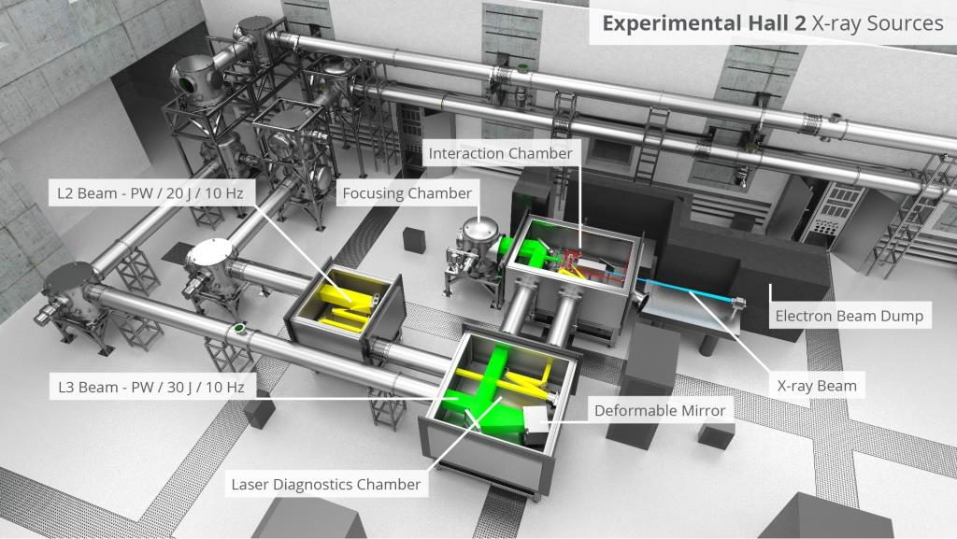

***Figure 3*** **E2 technology arrangement**

**E3 hall:**

E3 hall is dedicated for plasma physics and will accommodate so called P3 (Plasma Physics Platform). This station will use up to five different laser beams and X-ray beam from local betatron located in this hall. Different kinds of targets will be used during the experiments and therefore special attention shall be paid when operating this station (e.g. radioactive debris generation, usage of various gases etc.).

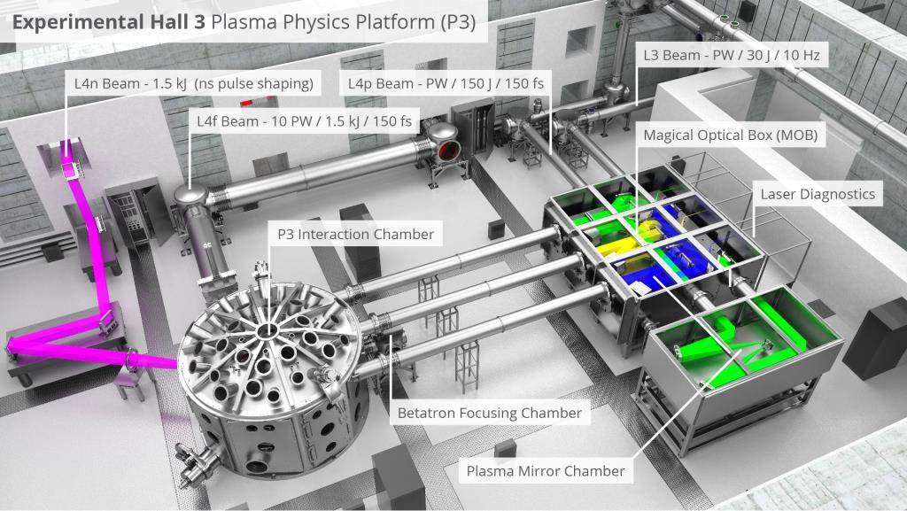

***Figure 4*** **P3 chamber in E3 hall**

**E4 hall:**

This hall is dedicated for proton and ion acceleration at beamline called ELIMAIA.

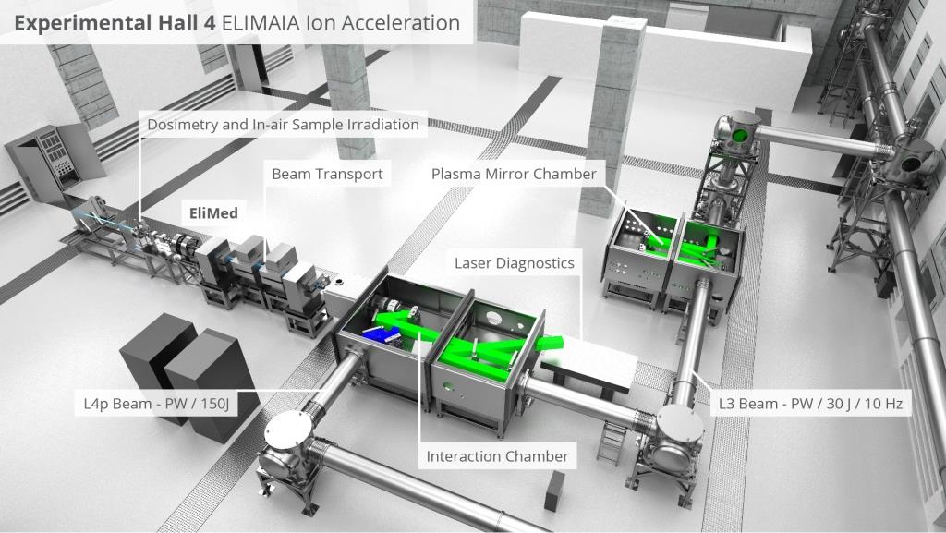

***Figure 5*** **ELIMAIA beamline in E4 hall**

**E5 hall:**

This hall will accommodate X-ray generation beamline using electron acceleration called LUX, and electron acceleration platform called HELL.

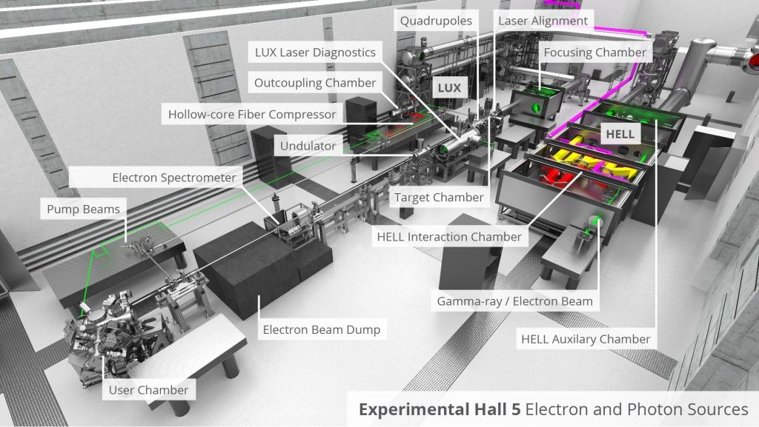

***Figure 6*** **E5 technology arrangement**

# Hazard identification

Based on the Preliminary Hazard Analysis (PHA) there were several hazards connected with laser and experimental technology identified. Those hazards significantly influence the PSI functional concept. For the design phase detailed risk assessment shall be conducted.

|  |  |  |  |
| --- | --- | --- | --- |
| **Hazard** | **Description** | **Location** | **Note** |
| Laser radiation | L1 laser system – λ=750-980 nm, *Q*=>100 mJ, pulse duration <20 fs, *F*=1 kHz. The laser is generated in L1 and is led in the beam distribution to E1. This beam is used only in E1. | [VYPUŠTĚNO] | In laser halls, this hazard is covered with local PSI units. In the beam distribution and experimental halls, “central” PSI shall manage this hazard. |
| L2 laser system - λ= ~850 nm, *Q*= ≥20 J, pulse duration 15 fs, *F*=10 Hz. | [VYPUŠTĚNO] |
| L3 laser system - 750 ≤ λ ≤ 850 nm, *Q* of the pump laser is 200 J, *Q* after compression = 20 to 50 J, pulse duration 20 to 50 fs, *F* = 10 Hz. | [VYPUŠTĚNO] |
| L4 laser system:  **Main beam -** λcentral= 800‐1200 nm, *Q*= ≥1.8 kJ in a single beam, pulse duration ≤120 fs, *F*=several per minute.  **Auxiliary beam -** λcentral= 800‐1200 nm, *Q*= ≥200 J in a single beam, pulse duration ≤120 fs, *F*=several per minute. | [VYPUŠTĚNO] |
| Ionizing radiation | There is a prompt ionizing radiation connected with experiments. Prompt radiation will be terminated with termination of laser beam delivery into the experimental halls. | [VYPUŠTĚNO] | Monitoring system shall provide the overall monitoring of ionizing radiation within affected areas. |
| There will be residual ionizing radiation. Residual ionizing radiation will be connected with material activation. | [VYPUŠTĚNO] |
| High voltage | High voltage system is used mainly in capacitor bank for laser systems. | [VYPUŠTĚNO] | Covered with local laser PSI. |
| Flammable gases | For some types of experiments there will be flammable gases used. Mainly hydrogen, deuterium, hydrogen sulfide, carbon monoxide, hydrogen cyanide, and potentially others. | [VYPUŠTĚNO] | Monitoring system shall provide the continuous monitoring of the gases in the place of their storage, usage, and manipulation. |
| Toxic gases | For some types of experiments there will be toxic gases used. Mainly hydrogen sulfide, carbon monoxide, hydrogen cyanide, and potentially others. | [VYPUŠTĚNO] | Monitoring system shall provide the continuous monitoring of the gases in the place of their storage, usage, and manipulation. |
| Oxygen depleting gases | Oxygen depleting gases like nitrogen or noble gases (Ar, Xe, Ne, Kr, He) will be used in experimental halls and laser halls. | [VYPUŠTĚNO] | Monitoring system shall provide the continuous monitoring of oxygen in the place of their storage, usage, and manipulation. |
| Cryogenic fluids | Cryogenic fluids such as liquefied nitrogen or helium will be used as a cooling media for laser and experimental technology. Manipulation will be done mostly in dewar vessels. | Not yet defined. | Monitoring system shall provide the continuous monitoring of oxygen in the place of their storage, usage, and manipulation. |
| Vacuum | Most of the laser beams will be delivered under vacuum. All experimental chambers and vacuum will be under vacuum. Vacuum is divided into central and local vacuum system. The central vacuum system must provide and distribute primary vacuum of 10-2 mbar to all laser blocks, femtosecond pulse delivery and experimental units. The turbomolecular pumps will pump down to 10-6 mbar in experimental chambers. | To be specified | Insufficient quality of vacuum in beam distribution can influence the PSI operation (shall be confirmed with risk assessment). |
| Biohazard | Biohazardous material will be used primarily for RA4 experiments. Agents belonging to risk groups 1, 2, and 3 can be handled. The main handling shall be done in special premises designed for biohazardous works (biosafety cabinets, bio-hutches etc.). The agents will be used either in liquid form (as an aerosolized sample) or crystalized as a solid sample. In the case of aerosolized sample, the agent will occur in the experimental chamber. | [VYPUŠTĚNO] | Handling of biohazardous samples will not influence the PSI operation and will be solved with biosafety management system. |
| Electromagnetic pulse (EMP) | Strong electromagnetic pulses (EMP) of hundreds of kV/m will be generated within the target chambers due to the action of the high intensity lasers on targets.  In experimental halls there is transient electromagnetic field up to 250kV/m in the frequency range 30MHz to 20GHz expected. | [VYPUŠTĚNO] | All PSI components shall be EMP resistant or shall be shielded. EMP shall not be covered with the PSI. |
| Magnetic field | The main source of magnetic field will be permanent and electromagnets used for collimation of electron, proton, and ion beams. There are also magnets in spectrometers used for measuring of the beams properties. The magnets can generate magnetic field with magnetic induction up to several T. | [VYPUŠTĚNO] | n.a. |
| Toxic substances | For some experiments, some toxic substances can be used. Some toxic substances can be used as targets or subjects of experiment (following are now identified as suspected: H2S, HCN, CO, NH3, NOx, benzene). Some X-ray beamlines will have components made of Beryllium. | [VYPUŠTĚNO] | Gases will be continuously monitored with monitoring system. |
| Ozone | The ozone will be liberalized during the high-voltage capacitors operation and during experiments execution (air ionization). | [VYPUŠTĚNO] | Ozone concetration shall be monitored. |
| Pneumatic systems | Some parts of beam distribution and vacuum system can include pneumatic systems. | To be specified. | n.a. |
| Robotic systems | There is a robotic arm planned for PXS in E1. | [VYPUŠTĚNO] | Machinery with its own safety system. |
| Radioactive materials | After the experiment, there can be some material activated and thus radioactive. Such material can cause residual ionizing radiation in the experimental halls. There can also some emitters used for calibration or similar activities (in negligible amount). | [VYPUŠTĚNO] | Some functions demanded on PSI. |
| Demineralized cooling water | The water will be used in the experimental halls for cooling of technology. The main issue is its activation. Cooling of the technology (e.g. magnets or beam dumps) is critical for the experiment execution. | [VYPUŠTĚNO] | Accident with leakage of potentially activated water or insufficient cooling supply can influence PSI operation. |

# Preliminary hazard analysis

The main aim of the Preliminary Hazard Analysis (PHA) is to address the most common failures that can cause injury or damage, and potentially influence PSI operation. This document contains only hazards demanding some requirements on PSI design and operation. Other hazards are analyzed in separate document [2].

## Laser radiation

The laser radiation occurs in the laser halls, experimental halls, and beam distribution. The beam distribution enables to deliver the beams in the scheme shown on Fig 7. The beam distribution will be installed primarily in the experimental halls but some parts will be installed also in corridor [VYPUŠTĚNO]. The service points will be installed in the experimental halls. Telescopes are planned for L3 and L4 beam and installed in [VYPUŠTĚNO] and [VYPUŠTĚNO].

During the delivery of the laser beams to the experimental chamber, there must be controls implemented in other potentially affected rooms. These are addressed in Table 1.

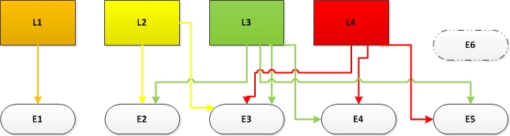

***Figure 7*** **Beam distribution scheme**

***Table 1*** **Areas affected with laser operation**

|  |  |  |
| --- | --- | --- |
| **Beam delivery** | **Affected rooms** | **Low / High Power** |
| L1 | [VYPUŠTĚNO] | Alignment and high power |
| L2 | [VYPUŠTĚNO] | Alignment and high power |
| L3 | [VYPUŠTĚNO] | Alignment and high power |
| L4 | [VYPUŠTĚNO] | Alignment and high power (small aperture, small aperture uncompressed, full aperture beam – 10PW) |

There will be also low power alignment beams either in the laser halls or in experimental halls. Those will generate laser beams for alignment procedures. All laser beams used in the process will be Class IV.

The laser beam can proliferate either from the beam distribution or laser and experimental halls. The beam distribution provides full laser enclosure except the service windows.

### PSI controlled areas

In the case of laser hazard, PSI controlled area is limited only to the halls where the laser beam is used.

#### E1 operation

[VYPUŠTĚNO]

#### E2 operation

[VYPUŠTĚNO]

#### E3 operation

[VYPUŠTĚNO]

#### E4 operation

[VYPUŠTĚNO]

#### E5 operation

[VYPUŠTĚNO]

### Preliminary hazard analysis of laser hazard

|  |  |  |  |
| --- | --- | --- | --- |
| **Failure** | **Cause** | **Consequence** | **Controls** |
| Alignment laser beam release from experimental chamber | 1. Misalignment of the beam  2. Reflection from reflective object in the chamber  3. Scattering of the beam in the distribution | 1. Eye injury  2. Thermal skin injury  3. Ignition of flammable material | - Establishment of alignment safety mode. - SOP for alignment procedures. - Safety goggles. |
| High power beam release from the beam distribution in experimental hall with occupancy (except E1) | 1. Misalignment of the beam  2. Setting of wrong path in the beam distribution  3. Beam scattering in the beam distribution  4. Failure of the control system | 1. Serious eye injury.  2. Serious thermal skin injury.  3. Material ionization and generation of ionizing radiation – mild to serious radiation damage.  4. Flammable material ignition.  5. Thermal damage to technology. | - Establishment of safety modes of experimental halls.  - Implementation of beam shutters in the beam distribution.  - Implementation of monitoring system for ionizing radiation measurement.  - Immediate process termination. |
| High power beam hits the beam distribution pipe | 1. Misalignment of the beam  2. Beam scattering in the beam distribution  3. Failure of the control system  4. Damaged mirrors | 1. Thermal damage of the pipe.  2. Beam release from the pipe. | - Establishment of diagnostic methods to monitor beam delivery.  - Proper maintenance concept.  - Immediate process termination |
| High power beam release from opened beam distribution | 1. Opened windows and covers of the beam distribution after maintenance | 1. Serious eye injury.  2. Serious thermal skin injury.  3. Material ionization and generation of ionizing radiation – mild to serious radiation damage.  4. Flammable material ignition.  5. Thermal damage to technology. | - Implementation of PSI locks of the openable covers of the beam distribution.  - Proper maintenance concept.  - Effective training for maintenance personnel. |
| Focused high power beam hits the beam distribution pipe (E3, L4c). | 1. Misalignment beam in the telescope  2. Malfunction of the telescope | 1. Material ionization and generation of ionizing radiation.  2. Thermal damage of the pipe. | - Implementation of measuring probes for monitoring of ionizing radiation dose rates.  - Proper maintenance concept.  - SOPs for alignment procedures. |
| Improper quality of the laser beam | 1. Wrong laser setting. | 1. Generation of secondary beam with unexpected parameters (e.g. high energy X-rays in PXS). | - Implementation of measuring probes for monitoring of ionizing radiation dose rates.  - Immediate process termination in the case of dose rates exceeding the preset level. |
| High power laser beam hits the target wrongly | 1. Misalignment of the beam | 1. Generation of secondary beam with unexpected parameters.  2. Ionizing radiation dose rates in control rooms, corridors, or laser halls can exceed the preset levels. | - Implementation of measuring probes for monitoring of ionizing radiation dose rates.  - Immediate process termination in the case of dose rates exceeding the preset level. |
| High power laser beam focused to air | 1. Experimental chamber or beam distribution not under vacuum. | 1. Air ionization – generation of ionizing radiation beam in the experimental halls and areas where telescopes are located. | - Implementation of vacuum meters to the system.  - Implementation of engineering control to prevent high power laser distribution to the halls if the system is not under vacuum.  - Immediate process termination in the case of vacuum loss in the system. |

## Ionizing radiation

Due to the fact that ELI Beamlines facility is intended for acceleration of particles or X-ray generation, the ionizing radiation is a hazard that cannot be eliminated. The ionizing radiation will be generated in the experimental halls. The building design does not support full ionizing radiation confining inside the experimental halls and therefore it will be proliferating operationally also to some surrounding areas. For each particular experimental hall, there is a PSI controlled area defined.

***Table 2*** **Primarily ionizing radiation generated in the halls**

|  |  |  |  |
| --- | --- | --- | --- |
| **Location** | **Primary particles** | **Max. energy** | **F [Hz]** |
| E1 | e- | 100 MeV | 1000 |
| photons | 100 keV |  |
| photons | ~1 keV |  |
| E2 | e- | 2 GeV | 10 |
| E3 | p+ | 100MeV | 1 |
| E4 | p+ | 200MeV | 1 |
| Heavy ions |  | 1 |
| E5 | e- | 2 GeV | 10 |
| e- | 50 GeV | 0.1 |
| E6 | p+ | 3 GeV | 0.1 |
| photons /e- | 2 GeV/10 GeV | 1 |

There will be primarily ionizing radiation beams generated (see Table 2) which will be in some cases stopped in the beam dump. This will generate secondary ionizing radiation consist mainly of neutron. These will operationally penetrate to surrounding areas.

### Affected areas

Note to the figures:

* Red color: areas with location of sources of ionizing radiation.
* Orange color: areas with higher dose rates where higher occupancy is expected.
* Yellow color: areas with long term occupancy and operational occurrence of ionizing radiation.

[VYPUŠTĚNO]

***Figure 8*** **Floor 098 (experimental floor)**

[VYPUŠTĚNO]

***Figure 9* Floor 098 (experimental area) – arrow shows the access to the area**

[VYPUŠTĚNO]

***Figure 10*** **Floor 100 (laser area) – arrows show access to the area**

[VYPUŠTĚNO]

***Figure 11*** **Vertical view to the building**

### PSI controlled areas

Operation in every room will influence other surrounding areas which shall be PSI controlled. These areas are mainly plant and service rooms. These areas shall have defined safety modes.

#### E1 operation

E1 will accommodate experiments with usage L1 laser beam and with generation of X-rays. Those can be shielded and the probability that the ionizing radiation will proliferate to other areas is low. [VYPUŠTĚNO]

[VYPUŠTĚNO]

[VYPUŠTĚNO]

***Figure 12*** **PSI controlled area during E1 operation (floor 098)**

[VYPUŠTĚNO]

***Figure 13*** **PSI controlled area during E1 operation (floor 099)**

[VYPUŠTĚNO]

***Figure 14*** **Doors to be PSI controlled during E1 operation (floor 098)**

#### E2 operation

E2 hall will accommodate experiments with up to 2 GeV electrons that can proliferate to surrounding areas. Therefore the PSI controlled area for E2 experiments is extended to rooms [VYPUŠTĚNO].

[VYPUŠTĚNO]

***Figure 15*** **PSI controlled area during E2 operation (floor 098)**

[VYPUŠTĚNO]

***Figure 16*** **PSI controlled area during E2 operation (floor 099)**

[VYPUŠTĚNO]

[VYPUŠTĚNO]

***Figure 17*** **Doors to be PSI controlled during E2 operation (floor 098)**

#### E3 operation

E2 hall will accommodate plasma physics experiments which will generate ionizing radiation that can proliferate to surrounding areas. Therefore the PSI controlled area for E3 experiments is extended to rooms [VYPUŠTĚNO].

[VYPUŠTĚNO]

***Figure 18*** **PSI controlled area during E3 operation (floor 098)**

[VYPUŠTĚNO]

***Figure 19*** **PSI controlled area during E3 operation (floor 099)**

[VYPUŠTĚNO]

[VYPUŠTĚNO]

***Figure 20*** **Doors to be PSI controlled during E3 operation (floor 098)**

#### E4 operation

E4 hall will accommodate proton and ion acceleration experiments which will generate ionizing radiation that can proliferate to surrounding areas. Therefore the PSI controlled area for E4 experiments is extended to rooms [VYPUŠTĚNO].

[VYPUŠTĚNO]

***Figure 21*** **PSI controlled area during E4 operation (floor 098)**

[VYPUŠTĚNO]

***Figure 22*** **PSI controlled area during E4 operation (floor 099)**

[VYPUŠTĚNO]

[VYPUŠTĚNO]

***Figure 23*** **Doors to be PSI controlled during E4 operation (floor 098)**

#### E5 operation

E2 hall will accommodate experiments with up to 50 GeV electrons that can proliferate to surrounding areas. Therefore the PSI controlled area for E5 experiments is extended to rooms [VYPUŠTĚNO].

[VYPUŠTĚNO]

***Figure 24*** **PSI controlled area during E5 operation (floor 098)**

[VYPUŠTĚNO]

***Figure 25*** **PSI controlled area during E4 operation (floor 099)**

[VYPUŠTĚNO]

[VYPUŠTĚNO]

***Figure 27*** **Doors to be PSI controlled during E5 operation (floor 098)**

[VYPUŠTĚNO]

***Figure 28*** **Doors to be PSI controlled during E5 operation (floor 099)**

#### E6 operation

E6 will not be used in the first stage. Therefore it is not possible to define the PSI controlled area for this room. It shall be defined later when the mode of operation is known. To enable the safe operation of surrounding areas room [VYPUŠTĚNO] shall be secured and M0 mode shall be applied for all the times except necessary maintenance (M1 mode to be applied). For this purpose, doors [VYPUŠTĚNO] shall be PSI controlled.

[VYPUŠTĚNO]

***Figure* 29 Doors to be PSI controlled in L.02.25 (E6) (floor 098)**

### Preliminary hazard analysis of ionizing radiation

|  |  |  |  |
| --- | --- | --- | --- |
| **Failure** | **Cause** | **Consequence** | **Controls** |
| Ionizing radiation in experimental halls (E2-E6, L4c) | 1. Intended use of laser in experimental halls. | 1. Irradiation of personnel inside the halls during the experiment.  2. Material activation. | - Halls shall be PSI controlled areas.  - Access denied into these halls during the experiments.  - Proper design of equipment in a way to minimize the activation.  - Access restricted after the experiment until the dose rates reach preset levels. |
| Ionizing radiation exceeds preset level in experimental hall E1 | 1. Wrong experiment arrangement or design.  2. Different laser been quality than requested by experiment designer.  3. Wrong alignment of the laser beam. | 1. Irradiation of personnel inside the E1 hall. | - Implementation of monitoring system in the hall.  - Immediate process termination in the case of dose rates in control rooms, corridors, and laser halls exceeding the preset level.  - Additional shielding of the most powerful ionizing radiation shielding.  - Proper laser beam diagnostics, and alignment procedures.  - Installation of E-STOP to immediately terminate the process. |
| Ionizing radiation leaks to the plant rooms (mentioned in Chapter 6.2.2) | 1. Design of the building (plant rooms are not shielded) | 1. Serious injury to death of personnel present in the plant room | - Plant rooms to be controlled by PSI and PSI area modes shall be established.  - Installation of E-STOP to immediately terminate the process. |
| Ionizing radiation leaks to Control rooms | 1. Ionizing radiation beam with parameters exceeding / are different than presumed parameters.  2. Wrong ionizing radiation beam alignment.  3. Wrong position of beam dump. | 1. Irradiation of personnel in the control rooms that can result in health damage. | - Implementation of monitoring system in the control rooms.  - Immediate process termination in the case of dose rates in control rooms, corridors, and laser halls exceeding the preset level.  - Installation of E-STOP to immediately terminate the process. |
| Ionizing radiation leaks to corridors | 1. Ionizing radiation beam with parameters exceeding / are different than presumed parameters.  2. Wrong ionizing radiation beam alignment.  3. Wrong position of beam dump.  4. Focused laser beam in the beam distribution hits the pipe and ionizes the metal. | 1. Irradiation of personnel in the corridors that can result in health damage. | - Implementation of monitoring system in the corridors.  - Immediate process termination in the case of dose rates in control rooms, corridors, and laser halls exceeding the preset level.  - Installation of E-STOP to immediately terminate the process. |
| Ionizing radiation leaks to laser halls | 1. Design of the building (celling between experimental and laser halls does not provide sufficient shielding against all types of presumed ionizing radiation).  2. Ionizing radiation beam with parameters exceeding / are different than presumed parameters.  3. Wrong ionizing radiation beam alignment.  4. Wrong position of beam dump. | 1. Irradiation of personnel in the laser halls that can result in health damage. | - Implementation of monitoring system in the control rooms.  - Immediate process termination in the case of dose rates in control rooms, corridors, and laser halls exceeding the preset level.  - Installation of E-STOP to immediately terminate the process. |
| Ionizing radiation beam parameters exceeds / differs from presumed levels | 1. Quality of the laser beam differs from requested parameters.  2. Experimental chamber not under vacuum during high power laser operation and ionization of air. | 1. Ionizing radiation beam leaks to other areas (control rooms, laser halls, corridors, plant rooms).  2. Material in experimental hall can be more activated.  3. Cooling water in the loop can be more activated.  4. Air in the experimental halls can be more activated and more ozone can be generated. | - Implementation of monitoring of dose rates in control rooms, corridors, laser halls, and plant rooms.  - Immediate process termination in the case of dose rates in control rooms, corridors, and laser halls exceeding the preset level.  - Plant rooms to be controlled by PSI and PSI area modes shall be established  - Installation of E-STOP to immediately terminate the process.  - Implementation of vacuum meters to the system.  - Implementation of engineering control to prevent high power laser distribution to the halls if the system is not under vacuum.  - Immediate process termination in the case of vacuum loss in the system. |
| Ionizing radiation activates the material inside experimental halls | 1. Interaction between presumed ionizing radiation and material used for construction of the equipment in the halls.  2. Interaction between non-presumed ionizing radiation with material. | 1. Activated material emits ionizing radiation until it decays.  2. Irradiation of personnel entering the experimental halls after the experiment. | - Access restricted after the experiment until the dose rates reach preset levels.  - Proper design of equipment in a way to minimize the activation.  - Installation of monitoring system to measure the dose rates inside the halls. |
| Ionizing radiation activates the cooling water | 1. Interaction between presumed ionizing radiation and cooling water.  2. Interaction between non-presumed ionizing radiation with cooling water. | 1. Water emits ionizing radiation in cooling water loop.  2. Leak of activated water forms open source of radiation.  3. Personnel moving around the cooling water loop can be irradiated. | - Access restricted after the experiment until the dose rates reach preset levels.  - Proper design of cooling water system in a way to minimize the irradiation.  - Installation of monitoring system to measure the dose rates at selected points of the loop.  - Regular monitoring of cooling water activity. |
| Ionizing radiation activates air inside the experimental halls. | 1. Interaction between presumed ionizing radiation and air in the experimental halls.  2. Interaction between non-presumed ionizing radiation with air in the experimental halls. | 1. Air contains activated elements and emits ionizing radiation.  2. Irradiation of personnel entering the experimental halls after the experiment. | - Access restricted after the experiment until the dose rates reach preset levels.  - Installation of monitoring system to measure the dose rates in the experimental halls. |

## High voltage

High voltage will be used to generate the laser light or charge the capacitors which will be used during the generation of laser light. All high voltage components shall be properly designed and produced in compliance with all applicable regulations and standards.

Capacitor will be located in room [VYPUŠTĚNO] and the energy pulse will be transported to room [VYPUŠTĚNO]. The final design of capacitor is not currently known and thus the PHA can be done only based on theoretical assumptions and general principles.

|  |  |  |  |
| --- | --- | --- | --- |
| **Failure** | **Cause** | **Consequence** | **Controls** |
| Capacitor explosion | 1. Improper material used for construction.  2. Charging of capacitor with voltage lower than construction limits and lowering the lifetime (short circuit).  3. Charging of capacitor with voltage higher than construction limits and subsequent short circuit. | 1. Fire with death or injury of personnel.  2. Fire with property damage.  3. Pressure wave with death or injury to personnel. | - Quality and technical control of delivered capacitor.  - Proper use and maintenance of the capacitor.  - Fire suppression system or equivalent in the capacitor room. |
| Capacitor short circuit | 1. Failure of electronic control of charging voltage level and sending of voltage higher than construction damage.  2. Construction error.  3. Improper use of the capacitor.  4. Mechanical damage of the capacitor. | 1. Capacitor explosion  2. Electrical injury to personnel.  3. Arc flash with death or injury of personnel.  4. Ozone production. | - Quality and technical control of delivered capacitor.  - Proper use and maintenance of the capacitor.  - Limitations in control of the level of voltage which the capacitor is charge with.  - Fire suppression system or equivalent in the capacitor room. |
| Capacitor sparking | 1. Wrong construction of the capacitor and connections.  2. Improper use and maintenance of the capacitor. | 1. Electrical or thermal injury to personnel.  2. Ozone production.  3. Fire with death or injury to personnel.  4. Fire with property damage. | - Quality and technical control of delivered capacitor.  - Proper use and maintenance of the capacitor.  - Administrative controls (PPEs. SOPs etc.). |
| Faulty insulation of the cabling | 1. Construction error on cabling.  2. Improper installation of the cabling.  3. Overloading of the cabling with subsequent thermal damage of insulation.  4. Mechanical damage of the insulation.  5. Improper maintenance. | 1. Cabling fire with death or injury of personnel.  2. Cabling fire with damage of property.  3. Electrical injury to personnel.  4. Toxic fumes production as a result of thermal decomposition of insulation with subsequent intoxication of personnel.  5. Ozone production. | - Quality and technical control and supervision of supplied cables and installation works.  - Proper use and maintenance of the electrical system.  - Fire suppression system or equivalent to be used in the case of cabling ignition.  - Administrative controls (Trainings, SOPs, PPEs etc.). |

## Flammable gases

Flammable gases will be used as targets during the experiments or for other experimental activities. For this purpose following were identified to be used:

* [VYPUŠTĚNO]

If the flammable gas is liberated from the closed system, it can form explosive atmosphere that can be ignited. There are several ignition sources in the experimental halls:

* [VYPUŠTĚNO]

|  |  |  |  |
| --- | --- | --- | --- |
| **Failure** | **Cause** | **Consequence** | **Controls** |
| Flammable gas liberation form the cylinder to the cabinet | 1. Improper connection of the cylinder with the valve.  2. Failure of the valve.  3. Overpressure of the cylinder. | 1. Explosive atmosphere creation inside the cabinet.  2. Explosive atmosphere liberation from the cabinet to the hall.  3. Explosion in cabinet.  4. Explosion in the hall. | - Permanent ventilation of the cabinets.  - Proper installation of the cylinders.  - Proper maintenance of the system.  - Installation of monitoring system to measure the concentration of the gases in the experimental halls and cabinets.  - Immediate experimental process termination in the case of concentration exceeds the preset level.  - Emergency ventilation of the hall in the case of detection of the gas. |
| Flammable gas liberation form the cylinder to the experimental hall | 1. Flammable gas liberation inside the cabinet.  2. Improper connection of the cylinder to the system.  3. Improper connection of the flexible supply hose to the fact connection or chamber.  4. Mechanical damage of the pipe or hose.  5. Mechanical damage of the fast connection.  6. Over pressuring of the system. | 1. Explosive atmosphere liberation from the cabinet to the hall.  2. Explosion in the hall. | - Permanent ventilation of the cabinets.  - Proper installation of the cylinders.  - Proper maintenance of the system.  - Installation of monitoring system to measure the concentration of the gases in the experimental halls and cabinets.  - Immediate experimental process termination in the case of concentration exceeds the preset level.  - Emergency ventilation of the hall in the case of detection of the gas. |
| Flammable gas pumping to the chamber which is not under vacuum | 1. Human error.  2. Hydrogen generator failure.  3. Valve failure.  4. Over pressuring of the hydrogen supply system. | 1. Explosive atmosphere creation inside the chamber.  2. Explosion inside of the chamber. | - Proper personnel training.  - Installation of monitoring system to measure the concentration of the gases in the experimental halls close to the experimental chamber.  - Immediate experimental process termination in the case of concentration exceeds the preset level.  - Engineering control to avoid chamber pumping with flammable gas when it is not under vacuum.  - Emergency ventilation of the hall in the case of detection of the gas. |
| Flammable gas leaks from the vacuum pump | 1. Failure of the pump.  2. Not all leak points closed. | 1. Explosive atmosphere creation in the area where pumps are installed.  2. Explosion in the area where the pumps are installed. | - Installation of monitoring system to measure the concentration of the gases close to the pumps.  - Immediate pumping termination in the case of concentration exceeds the preset level.  - Emergency ventilation of the area in the case of detection of the gas. |
| Flammable gas gets into contact with air during “breaking” the vacuum | 1. Experimental chamber containing flammable gas pumped with air.  2. Experimental chamber leak. | 1. Explosive atmosphere creation inside the chamber.  2. Explosion in the experimental hall. | - Implementation of safe “vacuum breaking” procedure (inertization and sequential dilution with air).  - Installation of monitoring system to measure the concentration of the gases in the experimental halls close to the experimental chamber.  - Immediate experimental process termination in the case of concentration exceeds the preset level.  - Implementation of emergency inertization for the case of explosive atmosphere creation in the experimental chamber (immediate termination of air insertion into the chamber and initiation of inert gas pumping to the chamber). |
| Flammable gas is mixed with oxygen or other oxidizer in vacuum exhaust | 1. Improper inertization of pumps.  2. Improper safe “vacuum breaking” procedure. | 1. Explosive atmosphere creation on the exhaust.  2. Explosion on the exhaust. | - Installation of monitoring system to measure the concentration of the gases on the exhaust.  - Immediate pumping termination in the case of concentration exceeds the preset level.  - Use of emergency inertization of the chamber. |
| Hydrogen in air gets into contact with platinum (Pt) components | 1. Use of Pt materials for equipment which can come into contact with hydrogen in air. | 1. Catalytic explosion of explosive atmosphere (increased speed) | - Avoidance of Pt equipment in places where a mixture of hydrogen and air can occur. |
| Flammable gas inside the vacuum pump without inertization | 1. Improper inertization of the pump.  2. No inert gas supply to the pump - inert gas not connected to the pump, blocked pipe with inert gas, failure of valve on a pipe with inert gas, valve not opened.  3. Not intended pumping of flammable gas. | 1. Explosion inside the vacuum pump | - Installation of safety control device to prevent pumping of flammable gases in vacuum without proper inertization.  - Immediate pumping termination in the case of improper or no inertization.  - SOPs for operation and maintenance.  - Training of personnel. |

## Toxic gases

Toxic gases will be used as targets during the experiments or for other experimental activities. For this purpose following were identified to be used:

* [VYPUŠTĚNO]

|  |  |  |  |
| --- | --- | --- | --- |
| **Failure** | **Cause** | **Consequence** | **Controls** |
| Toxic gas liberation form the cylinder to the cabinet | 1. Improper connection of the cylinder with the valve.  2. Failure of the valve.  3. Overpressure of the cylinder. | 1. Toxic atmosphere inside the cabinet  2. Personnel poisoning. | - Permanent ventilation of the cabinets.  - Proper installation of the cylinders.  - Proper maintenance of the system.  - Installation of monitoring system to measure the concentration of the gases in the experimental halls and cabinets.  - Immediate experimental process termination in the case of concentration exceeds the preset level.  - Emergency ventilation of the hall in the case of detection of the gas. |
| Toxic gas liberation form the cylinder to the experimental hall | 1. Toxic gas liberation inside the cabinet.  2. Improper connection of the cylinder to the system.  3. Improper connection of the flexible supply hose to the fact connection or chamber.  4. Mechanical damage of the pipe or hose.  5. Mechanical damage of the fast connection.  6. Over pressuring of the system. | 1. Toxic atmosphere inside the experimental hall.  2. Personnel poisoning. | - Permanent ventilation of the cabinets.  - Proper installation of the cylinders.  - Proper maintenance of the system.  - Installation of monitoring system to measure the concentration of the gases in the experimental halls and cabinets.  - Immediate experimental process termination in the case of concentration exceeds the preset level.  - Emergency ventilation of the hall in the case of detection of the gas. |
| Toxic gas pumping to the chamber which is not under vacuum | 1. Human error.  2. Valve failure. | 1. Toxic atmosphere inside the experimental chamber.  2. Toxic gas leak to the experimental hall.  3. Personnel poisoning. | - Proper personnel training.  - Installation of monitoring system to measure the concentration of the gases in the experimental halls close to the experimental chamber.  - Immediate experimental process termination in the case of concentration exceeds the preset level.  - Engineering control to avoid chamber pumping with toxic gas when it is not under vacuum.  - Emergency ventilation of the hall in the case of detection of the gas. |
| Toxic gas leaks from the vacuum pump | 1. Failure of the pump.  2. Not all leak points closed. | 1. Toxic atmosphere in the area where the pumps are installed.  2. Personnel poisoning. | - Installation of monitoring system to measure the concentration of the gases close to the pumps.  - Immediate pumping termination in the case of concentration exceeds the preset level.  - Emergency ventilation of the area in the case of detection of the gas. |
| Toxic gas liberation from vacuum exhaust in concentrations exceeding legal limits | 1. Improper “vacuum breaking” procedure.  2. Pumps failure. | 1. Toxic atmosphere on the exhaust.  2. Personnel poisoning.  3. Environmental issues. | - Installation of monitoring system to measure the concentration of the gases on the exhaust.  - Immediate pumping termination in the case of concentration exceeds the preset level. |

## Oxygen depleting gases and cryogenic fluids

There are following oxygen depleting gases and cryogenic fluids used:

* [VYPUŠTĚNO]

These gases deplete oxygen from the atmosphere and can cause suffocation of personnel.

|  |  |  |  |
| --- | --- | --- | --- |
| **Failure** | **Cause** | **Consequence** | **Controls** |
| Oxygen depleting gas liberation form the cylinder to the cabinet | 1. Improper connection of the cylinder with the valve.  2. Failure of the valve.  3. Overpressure of the cylinder. | 1. Oxygen depletion inside the cabinet  2. Personnel suffocation. | - Permanent ventilation of the cabinets.  - Proper installation of the cylinders.  - Proper maintenance of the system.  - Installation of monitoring system to measure the concentration of oxygen in the experimental halls and cabinets.  - Immediate experimental process termination in the case of concentration of oxygen reaches the preset level.  - Emergency ventilation of the hall in the case of oxygen depletion. |
| Oxygen depleting gas liberation form the cylinder to the experimental hall | 1. Oxygen depleting gas liberation inside the cabinet.  2. Improper connection of the cylinder to the system.  3. Improper connection of the flexible supply hose to the fact connection or chamber.  4. Mechanical damage of the pipe or hose.  5. Mechanical damage of the fast connection.  6. Over pressuring of the system. | 1. Oxygen depletion inside the experimental or laser hall.  2. Personnel suffocation. | - Permanent ventilation of the cabinets.  - Proper installation of the cylinders.  - Proper maintenance of the system.  - Installation of monitoring system to measure the concentration of oxygen in the experimental halls and cabinets.  - Immediate experimental process termination in the case of concentration of oxygen reaches the preset level.  - Emergency ventilation of the hall in the case of oxygen depletion. |
| Oxygen depleting gas pumping to the chamber which is not under vacuum | 1. Intended procedure for chamber flushing or inertization. | 1. Atmosphere with low oxygen concentration inside the experimental chamber.  2. Oxygen depleting gas leak to the experimental hall.  3. Personnel suffocation. | - Proper personnel training.  - Installation of monitoring system to measure the concentration of oxygen in the experimental halls and cabinets.  - Immediate experimental process termination in the case of concentration of oxygen reaches the preset level.  - Emergency ventilation of the hall in the case of oxygen depletion.  - Engineering control to avoid personnel access into the chamber. |
| Oxygen depleting gas leaks from the vacuum pump | 1. Failure of the pump.  2. Not all leak points closed. | 1. Atmosphere with low oxygen concentration in the area where the pumps are installed.  2. Personnel suffocation. | - Installation of monitoring system to measure the concentration of oxygen in the experimental halls and cabinets.  - Immediate experimental process termination in the case of concentration of oxygen reaches the preset level.  - Emergency ventilation of the hall in the case of oxygen depletion. |
| Cryogenic fluid leaks from closed system | 1. Human error.  2. Failure of the closed system. | 1. Atmosphere with low oxygen concentration in the area where the closed system is installed.  2. Personnel suffocation. | - Installation of monitoring system to measure the concentration of oxygen in the experimental halls and cabinets.  - Immediate experimental process termination in the case of concentration of oxygen reaches the preset level.  - Emergency ventilation of the hall in the case of oxygen depletion. |

## Vacuum

Detailed risk analysis for vacuum is elaborated in facility PHA and vacuum risk analysis.

|  |  |  |  |
| --- | --- | --- | --- |
| **Failure** | **Cause** | **Consequence** | **Controls** |
| Experimental chamber not under vacuum during the experiment | 1. Vacuum pump failure.  2. Human error.  3. Vacuum not detected.  4. Control system failure. | 1. Flammable gases can create explosive atmosphere which can be ignited.  2. High power laser is focused to air and ionize air.  3. Operation without proper vacuum measurement. | - Implementation of vacuum meters to the system.  - Implementation of engineering control to prevent high power laser distribution to the halls if the system is not under vacuum.  - Immediate process termination in the case of vacuum loss in the system. |
| Beam distribution not under vacuum when the high power laser beam is distributed | 1. Vacuum pump failure.  2. Human error.  3. Vacuum not detected.  4. Control system failure. | 1. High power laser is focused to air and ionize air.  2. Operation without proper vacuum measurement. | - Implementation of vacuum meters to the system.  - Implementation of engineering control to prevent high power laser distribution to the halls if the system is not under vacuum.  - Immediate process termination in the case of vacuum loss in the system. |
| Vacuum in experimental chamber not in requested quality during the experiment | 1. Vacuum pump failure.  2. Human error.  3. Vacuum meter failure.  4. Control system failure. | 1. Unexpected secondary beam parameters.  2. Operation without proper vacuum measurement. | - Immediate process termination. |
| Vacuum in beam distribution not in requested quality when the high power beam is distributed | 1. Vacuum pump failure.  2. Human error.  3. Vacuum meter failure.  4. Control system failure. | 1. Lowering the quality of high power laser beam.  2. Unexpected secondary beam parameters.  3. Operation without proper vacuum measurement. | - Immediate process termination. |
| Chambers (experimental, distribution etc.) pumped out when the personnel is inside or openings on chamber are opened | 1. Vacuum pump failure.  2. Human error.  3. Vacuum meter failure.  4. Control system failure. | 1. Injury or death of personnel. | - Implementation of engineering control to avoid chamber to be pumped out till the chamber is not properly secured, closed, and free of people. |
| Vacuum not detected in the vacuum system | 1. Vacuum meter failure.  2. Vacuum pump failure.  3. Control system failure. | 1. Operation without proper vacuum inside the vacuum system.  2. Operation without proper vacuum measurement. | - Implementation of engineering control to prevent operation without proper vacuum or proper vacuum measurement. |

# General PSI functions

The main function of PSI is to protect personnel against defined hazards which are connected with experimental work. This function is provided with following sub-functions:

* Confining the hazard,
* Monitoring of PSI relevant parameters and PSI status,
* Immediate process termination in the case of any kind of failure or emergency situation,
* Enabling PSI procedure.

## Confining the hazard

Based on PHA, PSI shall keep defined hazards enclosed in closed systems or PSI controlled areas. PSI shall mainly confine laser radiation, ionizing radiation, and high voltage (used in connection with experimental work – sources like e.g. capacitor bank).

**Laser irradiation** is confined within beam distribution system which is a closed system, and in PSI controlled areas.

**Ionizing radiation** is confined in PSI controlled areas only. PSI controlled areas are shielded and there is an additional shielding provided where needed.

**High voltage** is confined in areas where high voltage equipment is used.

There shall be an override procedure for emergency response. Override function shall be implemented with special care and shall be protected against misuse.

### Laser irradiation

Laser irradiation shall be confined in beam distribution system and in experimental halls.

[VYPUŠTĚNO]

Experimental halls where the laser beam (alignment or high power) is used provide confinement. To assure the confinement all access doors and covers to the halls shall be interlocked and permanently monitored. Access shall be granted only when the situation allows personnel to enter, and shall be granted only to authorized personnel.

### Ionizing radiation

Ionizing radiation shall be confined in areas where it is generated or where it leaks into (as defined in PHA). Such areas are defined as PSI controlled areas. All access doors and covers to these areas shall be interlocked and permanently monitored. Access to the areas with ionizing radiation hazard shall be restricted or granted based on the area mode. There shall be monitoring of ionizing radiation implemented (provided by [VYPUŠTĚNO]) to control areas where the ionizing radiation can leak into.

### High voltage

High voltage equipment which is directly used in connection with experimental activities will be either located inside the experimental hall or in separate room (e.g. capacitor bank in [VYPUŠTĚNO]). All access doors the areas with high voltage equipment shall be interlocked and access shall be granted only to authorized personnel.

### Confining other hazards

Some other hazards occurring in PSI controlled areas shall be confined inside these areas. In the most of the cases there is no necessity to require any special function on PSI. The confinement is provided with securing the access doors and managing of access of personnel.

In the case of flammable, toxic, and oxygen depleting gases, PSI shall confine any gas detected outside of closed system. PSI shall restrict access to this area until the gas is vented out of the area.

## Monitoring of PSI relevant parameters

PSI shall monitor different kinds of parameters which are essential for correct PSI operation. Those parameters shall be monitored with PSI as well as other systems (Chapter 13). PSI shall also continuously monitor status of its devices and subsystems.

**Parameters** that shall be monitored can be divided into following categories:

* Parameters related to hazards confinement,
* Parameters related to process performance,
* Parameters related to environmental conditions,
* Parameters related to other systems and devices.

### Parameters of hazard confinement

To monitor that hazards are well confined into hazardous areas, [VYPUŠTĚNO]. [VYPUŠTĚNO]

### Parameters of process performance

For safety reasons it will be essential to monitor certain parameters connected to experimental process. [VYPUŠTĚNO]

### Parameters of environment

Monitoring of hazards or conditions in environment is an essential step to assure safety of experiments. **Detailed risk analysis shall identify all hazards and situations which shall be monitored.** Based on PHA there are following hazards identified to be monitored (the list not limited to):

* Ionizing radiation,
* Flammable and toxic gases,
* Oxygen level,
* Fire,
* Flooding.

#### Ionizing radiation

Ionizing radiation shall be monitored in PSI controlled areas [VYPUŠTĚNO] identified in Chapter 6.2.2. [VYPUŠTĚNO]

#### Flammable and toxic gases

These hazards shall be monitored in PSI controlled areas where their sources are installed. [VYPUŠTĚNO]

#### Oxygen level

Measuring of oxygen concentration in the environment is connected with monitoring of oxygen depleting gases. It shall be monitored in PSI controlled areas where the sources of oxygen depleting gases are installed. Information about the concentration of oxygen in environment shall be provided to PSI (Chapter 13.1).

#### Fire

Fire is detected with Fire Alarm System. Any fire detected in the building [VYPUŠTĚNO] shall be reported to PSI to perform requisite emergency procedures.

#### Floods

There are flood sensors installed in PSI controlled areas. Information about any kind of flooding can be reported to PSI to evaluate the situation and take appropriate actions. Alarms from these sensors can be evaluated by operators and the action can be taken independently.

## Monitoring of PSI status

PSI shall monitor a status of its equipment and connection with other systems needed for its proper function. If any kind of failure of PSI device or other PSI relevant system is reported than immediate action shall be taken (Chapter 12.12).

## Process termination

[VYPUŠTĚNO]

## Enabling PSI procedure

[VYPUŠTĚNO]

# Specific PSI functions

Standard communication of PSI central unit with local PSI units shall be done with:

* [VYPUŠTĚNO]

PSI shall evaluate the conditions within the PSI controlled areas and results of monitoring of parameters, and thus can provide overall complex information about the conditions. Therefore [VYPUŠTĚNO]

## [VYPUŠTĚNO]

PSI shall evaluate the data related to PSI operation. Before the permission can be granted PSI shall evaluate if all relevant conditions are fulfilled. This requires information about the type of experiment that is to be executed, the laser beams that are supposed to be used, area modes of other PSI controlled areas that can be affected and possibly other types of information. **Detailed risk analysis shall indicate the information to be evaluated.**

## [VYPUŠTĚNO]

[VYPUŠTĚNO] is a function that enables experiment execution after all requisite conditions are fulfilled. Granting [VYPUŠTĚNO] means that [VYPUŠTĚNO]

[VYPUŠTĚNO]

[VYPUŠTĚNO]

[VYPUŠTĚNO]

***Fig*ure *30*** [VYPUŠTĚNO] **process diagram**

## [VYPUŠTĚNO]

[VYPUŠTĚNO] shall be applied in the case of any failure of PSI or its parts and devices, or failure of other systems which are involved in PSI process control. [VYPUŠTĚNO]

There shall be at least two outcomes [VYPUŠTĚNO]:

* [VYPUŠTĚNO]

[VYPUŠTĚNO]

# PSI logical scheme

The basic logical scheme is shown on Fig 31. [VYPUŠTĚNO]

The communication with other systems shall be done through interface (Chapter 13).

[VYPUŠTĚNO]

***Fig*ure *31* Basic logical scheme of PSI**

## [VYPUŠTĚNO]

[VYPUŠTĚNO]

## [VYPUŠTĚNO]

[VYPUŠTĚNO]

[VYPUŠTĚNO]

***Figure* *32* Model scenario of PSI communication among units and other systems**

# Critical safety devices

Critical safety devices mean hardware parts of PSI that are essential for assessment, and execution of safety functions. There can be other hardware than listed below needed to reach the scope of PSI.

|  |  |  |
| --- | --- | --- |
| **Device** | **Function** | **Approx. location** |
| [VYPUŠTĚNO] | [VYPUŠTĚNO] | [VYPUŠTĚNO] |
| [VYPUŠTĚNO] | [VYPUŠTĚNO] | [VYPUŠTĚNO] |
| [VYPUŠTĚNO] | [VYPUŠTĚNO] | [VYPUŠTĚNO] |
| [VYPUŠTĚNO] | [VYPUŠTĚNO] | [VYPUŠTĚNO] |
| [VYPUŠTĚNO] | [VYPUŠTĚNO] | [VYPUŠTĚNO] |
| [VYPUŠTĚNO] | [VYPUŠTĚNO] | [VYPUŠTĚNO] |
| [VYPUŠTĚNO] | [VYPUŠTĚNO] | [VYPUŠTĚNO] |
| [VYPUŠTĚNO] | [VYPUŠTĚNO] | [VYPUŠTĚNO] |
| [VYPUŠTĚNO] | [VYPUŠTĚNO] | [VYPUŠTĚNO] |
| [VYPUŠTĚNO] | [VYPUŠTĚNO] | [VYPUŠTĚNO] |
| [VYPUŠTĚNO] | [VYPUŠTĚNO] | [VYPUŠTĚNO] |
| [VYPUŠTĚNO] | [VYPUŠTĚNO] | [VYPUŠTĚNO] |
| [VYPUŠTĚNO] | [VYPUŠTĚNO] | [VYPUŠTĚNO] |
| [VYPUŠTĚNO] | [VYPUŠTĚNO] | [VYPUŠTĚNO] |
| [VYPUŠTĚNO] | [VYPUŠTĚNO] | [VYPUŠTĚNO] |
| [VYPUŠTĚNO] | [VYPUŠTĚNO] | [VYPUŠTĚNO] |
| [VYPUŠTĚNO] | [VYPUŠTĚNO] | [VYPUŠTĚNO] |
| [VYPUŠTĚNO] | [VYPUŠTĚNO] | [VYPUŠTĚNO] |
| [VYPUŠTĚNO] | [VYPUŠTĚNO] | [VYPUŠTĚNO] |
| [VYPUŠTĚNO] | [VYPUŠTĚNO] | [VYPUŠTĚNO] |
| [VYPUŠTĚNO] | [VYPUŠTĚNO] | [VYPUŠTĚNO] |
| [VYPUŠTĚNO] | [VYPUŠTĚNO] | [VYPUŠTĚNO] |
| [VYPUŠTĚNO] | [VYPUŠTĚNO] | [VYPUŠTĚNO] |
| [VYPUŠTĚNO] | [VYPUŠTĚNO] | [VYPUŠTĚNO] |
| [VYPUŠTĚNO] | [VYPUŠTĚNO] | [VYPUŠTĚNO] |
| [VYPUŠTĚNO] | [VYPUŠTĚNO] | [VYPUŠTĚNO] |

# Area modes

Due to the nature of the technology operation, it is necessary to define and implement several modes in which the areas can occur. Because there are different hazards and procedures in different areas, it is necessary to distinguish the modes for several groups of areas:

* Experimental halls (except E1),
* Experimental hall E1,
* Plant rooms and service rooms,
* Beam distribution.

The transitions among the modes shall be done in PSI system through Graphical User Interface (GUI). Some transitions require using of [VYPUŠTĚNO] and [VYPUŠTĚNO].

## Experimental halls (except E1)

These areas shall accommodate experiments generating the highest hazards and there shall be active presence of personnel. Therefore the modes reflect all stages of experiment process. Following modes are defined for experimental halls E2, E3, E4, and E5:

* [VYPUŠTĚNO]

[VYPUŠTĚNO]

|  |  |  |  |
| --- | --- | --- | --- |
| **Mode** | **Code** | **Characteristics** | **Requirements and rules** |
| [VYPUŠTĚNO] | [VYPUŠTĚNO] | [VYPUŠTĚNO] | [VYPUŠTĚNO] |
| [VYPUŠTĚNO] | [VYPUŠTĚNO] | [VYPUŠTĚNO] | [VYPUŠTĚNO] |
| [VYPUŠTĚNO] | [VYPUŠTĚNO] | [VYPUŠTĚNO] |
| [VYPUŠTĚNO] | [VYPUŠTĚNO] | [VYPUŠTĚNO] | [VYPUŠTĚNO] |
| [VYPUŠTĚNO] | [VYPUŠTĚNO] | [VYPUŠTĚNO] |
| [VYPUŠTĚNO] | [VYPUŠTĚNO] | [VYPUŠTĚNO] | [VYPUŠTĚNO] |
| [VYPUŠTĚNO] | [VYPUŠTĚNO] | [VYPUŠTĚNO] | [VYPUŠTĚNO] |
| [VYPUŠTĚNO] | [VYPUŠTĚNO] | [VYPUŠTĚNO] | [VYPUŠTĚNO] |
| [VYPUŠTĚNO] | [VYPUŠTĚNO] | [VYPUŠTĚNO] | [VYPUŠTĚNO] |

[VYPUŠTĚNO]

***Figure 33* Safety modes for experimental halls**

|  |  |
| --- | --- |
| **Transition ID** | **Conditions** |
| [VYPUŠTĚNO] | [VYPUŠTĚNO] |
| [VYPUŠTĚNO] | [VYPUŠTĚNO] |
| [VYPUŠTĚNO] | [VYPUŠTĚNO] |
| [VYPUŠTĚNO] | [VYPUŠTĚNO] |
| [VYPUŠTĚNO] | [VYPUŠTĚNO] |
| [VYPUŠTĚNO] | [VYPUŠTĚNO] |
| [VYPUŠTĚNO] | [VYPUŠTĚNO] |
| [VYPUŠTĚNO] | [VYPUŠTĚNO] |
| [VYPUŠTĚNO] | [VYPUŠTĚNO] |
| [VYPUŠTĚNO] | [VYPUŠTĚNO] |
| [VYPUŠTĚNO] | [VYPUŠTĚNO] |
| [VYPUŠTĚNO] | [VYPUŠTĚNO] |
| [VYPUŠTĚNO] | [VYPUŠTĚNO] |
| [VYPUŠTĚNO] | [VYPUŠTĚNO] |
| [VYPUŠTĚNO] | [VYPUŠTĚNO] |
| [VYPUŠTĚNO] | [VYPUŠTĚNO] |
| [VYPUŠTĚNO] | [VYPUŠTĚNO] |
| [VYPUŠTĚNO] | [VYPUŠTĚNO] |
| [VYPUŠTĚNO] | [VYPUŠTĚNO] |
| [VYPUŠTĚNO] | [VYPUŠTĚNO] |
| [VYPUŠTĚNO] | [VYPUŠTĚNO] |
| [VYPUŠTĚNO] | [VYPUŠTĚNO] |

Note: All conditions listed shall be true (if not “OR” is mentioned).

## Experimental hall E1

Hall E1 shall have different mode of operation than other experimental halls. According to preliminary hazard evaluation, there is no significant risk of ionizing radiation exposure (Chapter 6.2) and therefore there can be personnel present during the experiment. For this reason E1 hall shall have different area mode.

Following area modes are defined:

* [VYPUŠTĚNO]

|  |  |  |  |
| --- | --- | --- | --- |
| **Mode** | **Code** | **Characteristics** | **Requirements and rules** |
| [VYPUŠTĚNO] | [VYPUŠTĚNO] | [VYPUŠTĚNO] | [VYPUŠTĚNO] |
| [VYPUŠTĚNO] | [VYPUŠTĚNO] | [VYPUŠTĚNO] | [VYPUŠTĚNO] |
| [VYPUŠTĚNO] | [VYPUŠTĚNO] | [VYPUŠTĚNO] |
| [VYPUŠTĚNO] | [VYPUŠTĚNO] | [VYPUŠTĚNO] | [VYPUŠTĚNO] |
| [VYPUŠTĚNO] | [VYPUŠTĚNO] | [VYPUŠTĚNO] |
| [VYPUŠTĚNO] | [VYPUŠTĚNO] | [VYPUŠTĚNO] | [VYPUŠTĚNO] |
| [VYPUŠTĚNO] | [VYPUŠTĚNO] | [VYPUŠTĚNO] |
| [VYPUŠTĚNO] | [VYPUŠTĚNO] | [VYPUŠTĚNO] | [VYPUŠTĚNO] |
| [VYPUŠTĚNO] | [VYPUŠTĚNO] | [VYPUŠTĚNO] | [VYPUŠTĚNO] |

[VYPUŠTĚNO]

***Figure 34* Safety modes for E1 hall with description of remote and local control.**

|  |  |
| --- | --- |
| **Transition ID** | **Conditions** |
| [VYPUŠTĚNO] | [VYPUŠTĚNO] |
| [VYPUŠTĚNO] | [VYPUŠTĚNO] |
| [VYPUŠTĚNO] | [VYPUŠTĚNO] |
| [VYPUŠTĚNO] | [VYPUŠTĚNO] |
| [VYPUŠTĚNO] | [VYPUŠTĚNO] |
| [VYPUŠTĚNO] | [VYPUŠTĚNO] |
| [VYPUŠTĚNO] | [VYPUŠTĚNO] |
| [VYPUŠTĚNO] | [VYPUŠTĚNO] |
| [VYPUŠTĚNO] | [VYPUŠTĚNO] |
| [VYPUŠTĚNO] | [VYPUŠTĚNO] |
| [VYPUŠTĚNO] | [VYPUŠTĚNO] |
| [VYPUŠTĚNO] | [VYPUŠTĚNO] |
| [VYPUŠTĚNO] | [VYPUŠTĚNO] |
| [VYPUŠTĚNO] | [VYPUŠTĚNO] |
| [VYPUŠTĚNO] | [VYPUŠTĚNO] |
| [VYPUŠTĚNO] | [VYPUŠTĚNO] |
| [VYPUŠTĚNO] | [VYPUŠTĚNO] |
| [VYPUŠTĚNO] | [VYPUŠTĚNO] |
| [VYPUŠTĚNO] | [VYPUŠTĚNO] |
| [VYPUŠTĚNO] | [VYPUŠTĚNO] |
| [VYPUŠTĚNO] | [VYPUŠTĚNO] |
| [VYPUŠTĚNO] | [VYPUŠTĚNO] |
| [VYPUŠTĚNO] | [VYPUŠTĚNO] |

## Plant and service rooms

Certain plant and service rooms are affected with prompt ionizing radiation hazard during M4 in experimental halls (Chapter 6.2). Therefore those shall be protected against occupancy within [VYPUŠTĚNO].

These modes shall be applied to [VYPUŠTĚNO].

[VYPUŠTĚNO]

Following modes are defined:

* [VYPUŠTĚNO]

|  |  |  |  |
| --- | --- | --- | --- |
| **Mode** | **Code** | **Characteristics** | **Requirements and rules** |
| [VYPUŠTĚNO] | [VYPUŠTĚNO] | [VYPUŠTĚNO] | [VYPUŠTĚNO] |
| [VYPUŠTĚNO] | [VYPUŠTĚNO] | [VYPUŠTĚNO] | [VYPUŠTĚNO] |
| [VYPUŠTĚNO] | [VYPUŠTĚNO] | [VYPUŠTĚNO] | [VYPUŠTĚNO] |
| [VYPUŠTĚNO] | [VYPUŠTĚNO] | [VYPUŠTĚNO] | [VYPUŠTĚNO] |

[VYPUŠTĚNO]

***Figure 35* Safety modes of plant and service rooms**

|  |  |
| --- | --- |
| **Transition ID** | **Conditions** |
| [VYPUŠTĚNO] | [VYPUŠTĚNO] |
| [VYPUŠTĚNO] | [VYPUŠTĚNO] |
| [VYPUŠTĚNO] | [VYPUŠTĚNO] |
| [VYPUŠTĚNO] | [VYPUŠTĚNO] |
| [VYPUŠTĚNO] | [VYPUŠTĚNO] |
| [VYPUŠTĚNO] | [VYPUŠTĚNO] |
| [VYPUŠTĚNO] | [VYPUŠTĚNO] |
| [VYPUŠTĚNO] | [VYPUŠTĚNO] |

## Beam distribution

There are following modes defined for beam distribution:

* [VYPUŠTĚNO]

|  |  |  |  |
| --- | --- | --- | --- |
| **Mode** | **Code** | **Characteristics** | **Requirements and rules** |
| [VYPUŠTĚNO] | [VYPUŠTĚNO] | [VYPUŠTĚNO] | [VYPUŠTĚNO] |
| [VYPUŠTĚNO] | [VYPUŠTĚNO] | [VYPUŠTĚNO] | [VYPUŠTĚNO] |
| [VYPUŠTĚNO] | [VYPUŠTĚNO] | [VYPUŠTĚNO] | [VYPUŠTĚNO] |
| [VYPUŠTĚNO] | [VYPUŠTĚNO] | [VYPUŠTĚNO] | [VYPUŠTĚNO] |
| [VYPUŠTĚNO] | [VYPUŠTĚNO] | [VYPUŠTĚNO] | [VYPUŠTĚNO] |

[VYPUŠTĚNO]

***Figure 36* Safety modes of beam distribution**

|  |  |
| --- | --- |
| **Transition ID** | **Conditions** |
| [VYPUŠTĚNO] | [VYPUŠTĚNO] |
| [VYPUŠTĚNO] | [VYPUŠTĚNO] |
| [VYPUŠTĚNO] | [VYPUŠTĚNO] |
| [VYPUŠTĚNO] | [VYPUŠTĚNO] |
| [VYPUŠTĚNO] | [VYPUŠTĚNO] |
| [VYPUŠTĚNO] | [VYPUŠTĚNO] |
| [VYPUŠTĚNO] | [VYPUŠTĚNO] |
| [VYPUŠTĚNO] | [VYPUŠTĚNO] |
| [VYPUŠTĚNO] | [VYPUŠTĚNO] |
| [VYPUŠTĚNO] | [VYPUŠTĚNO] |
| [VYPUŠTĚNO] | [VYPUŠTĚNO] |
| [VYPUŠTĚNO] | [VYPUŠTĚNO] |

# PSI procedure

## PSI roles and responsibilities

Each person entering the PSI controlled zones shall have defined role and responsibility. These roles do NOT correspond to any organizational or administrative position. The roles shall be established only for purpose of PSI operation. Following roles are established:

* Shot director (master PSI user),
* Shot manager (local PSI user),
* Radiation Safety Officer,
* [VYPUŠTĚNO] technician,
* Other.

All roles shall be properly trained and assignment shall be approved by facility Radiation Safety Officer (RSO), Safety Manager, and Facility Director.

Except role “Other”, all PSI roles shall be activated with [VYPUŠTĚNO] which entitle them to act in this role.

### Shot director

Shot director acts as a master PSI user with the highest decision authority and is responsible for all PSI controlled areas. This role has a complete overview above the PSI operation. There are following rights assigned to this role:

* Full rights of Shot manager,
* Giving permission for whole PSI controlled areas operation,
* Withdrawing permission for whole PSI controlled areas operation,
* [VYPUŠTĚNO],
* Giving instructions to all other PSI roles except Radiation Safety Officer.

Shot director can also act as a Shot manager in the case of “simple” operational scheme (e.g. when only two halls are in operation).

### Shot manager

Shot manager acts as a local PSI user and is assigned to certain PSI controlled area (e.g. E1). Shot manager shall be always coordinated with Shot director. There are following rights assigned to this role:

* Giving permissions for local PSI controlled area operation,
* Withdrawing permission for local PSI controlled area operation,
* [VYPUŠTĚNO],
* Giving instructions to [VYPUŠTĚNO] technicians, Scientists, Users, Technicians, and Visitors.
* Above ACS and PSI denies access to PSI controlled areas.
* Assigning [VYPUŠTĚNO] technician roles.

### Radiation Safety Officer

Radiation Safety Officer role in PSI does not correspond to facility RSO. This role shall be always represented by either facility RSO or facility Radiation Safety Technician (RST). The main purpose of this role is to assess the ionizing radiation hazard in [VYPUŠTĚNO]. This role is activated only [VYPUŠTĚNO]. The activation of this role shall be done [VYPUŠTĚNO]. There are following rights assigned to this role:

* [VYPUŠTĚNO].
* Above ACS and PSI denies access to PSI controlled areas (valid for limited time).
* Giving instructions to all other PSI roles.

Person with this assigned role shall be qualified according to Directive no. 307/2002 Coll.

### [VYPUŠTĚNO] technician

This role plays role only in [VYPUŠTĚNO]. The main purpose is to appoint sufficient number of personnel to effectively perform the [VYPUŠTĚNO] procedure. This role is activated only [VYPUŠTĚNO]. The activation of this role shall be done with [VYPUŠTĚNO]. Following rights are assigned:

* Denying access to PSI controlled areas.
* Securing the PSI controlled areas.
* [VYPUŠTĚNO].

[VYPUŠTĚNO] technician role shall be solely assigned only to personnel who are besides other trainings properly trained on [VYPUŠTĚNO] procedure. Personnel is appointed to this role by Shot director or Shot manager.

### Other

Role Other is assigned to all other personnel entering the PSI controlled areas. This role shall not have any PSI right. Personnel with this assigned role are identified by ID card, and are always verified by Shot manager, Shot director, and Radiation Safety Officer.

## PSI procedure activation

[VYPUŠTĚNO]

## PSI procedure termination

[VYPUŠTĚNO]

## Experiment preparation

[VYPUŠTĚNO]

To assure safe experiment execution, there shall be certain safety devices or installations implemented inside the experimental halls. Those are mainly connected with ionizing radiation and laser hazard. Following shall be installed (not limited to):

* [VYPUŠTĚNO].

To avoid unauthorized manipulation with these devices or installation, there shall be an [VYPUŠTĚNO]. During the experiment preparation, responsible person shall [VYPUŠTĚNO]. The procedure [VYPUŠTĚNO].

Check list shall contain following checks (not limited to):

* [VYPUŠTĚNO].

Shot director or Shot manager shall be informed about the results from this part of PSI procedure.

## [VYPUŠTĚNO]

[VYPUŠTĚNO]

### [VYPUŠTĚNO]

#### Experimental halls in [VYPUŠTĚNO]

1. [VYPUŠTĚNO]

#### Experimental halls in [VYPUŠTĚNO]

1. [VYPUŠTĚNO]

#### E1 hall in [VYPUŠTĚNO]

1. [VYPUŠTĚNO]

#### Experimental hall, E1, and Plant rooms in [VYPUŠTĚNO]

[VYPUŠTĚNO]

### [VYPUŠTĚNO]

***Table 3* defines basic conditions** [VYPUŠTĚNO]

|  |  |  |  |
| --- | --- | --- | --- |
| **Mode** | **Conditions** | | |
| **Training** | **Medical check** | **Other** |
| [VYPUŠTĚNO] | - EHS training*  - Radiation Safety Training  - SOPs for equipment, hall, and maintenance etc. | + | Radiation worker or Person entering controlled zone*** |
| [VYPUŠTĚNO] | - EHS training*  - Radiation Safety Training  - Laser Safety Training  - SOPs for equipment, hall, and alignment procedures etc. | + | Radiation worker or Person entering controlled zone*** |
| [VYPUŠTĚNO] | - EHS training*  - Radiation Safety Training  - Laser Safety Training  - [VYPUŠTĚNO] | + | - Radiation worker***  - Person with special authority to perform [VYPUŠTĚNO] |
| [VYPUŠTĚNO] | - EHS training*  - Radiation Safety Training | + | Special qualification required** |
| [VYPUŠTĚNO] | - EHS training*  - Radiation Safety Training  - SOPs for equipment, hall, and maintenance etc. | + | Radiation worker or Person entering controlled zone*** |
| [VYPUŠTĚNO] | - EHS training*  - Radiation Safety Training  - Laser Safety Training  - SOPs for equipment, hall, and alignment procedures | + | Radiation worker or Person entering controlled zone*** |
| [VYPUŠTĚNO] | - EHS training*  - Radiation Safety Training  - Laser Safety Training  - [VYPUŠTĚNO] | + | - Radiation worker***  - Person with special authority to perform [VYPUŠTĚNO] |
| [VYPUŠTĚNO] | - EHS training*  - Radiation Safety Training  - Laser Safety Training  - SOPs for equipment, hall etc. | + | Radiation worker*** |
| [VYPUŠTĚNO] | - EHS training*  - Radiation Safety Training  - SOPs for equipment, hall, and maintenance etc. | + | Person entering controlled zone*** |
| [VYPUŠTĚNO] | - EHS training*  - Radiation Safety Training  - [VYPUŠTĚNO] | + | - Radiation worker***  - Person with special authority to perform [VYPUŠTĚNO] |

*EHS Training includes Occupational Health, and Safety, Fire Protection, Environmental Protection, Emergency Response and Procedures.

** Radiation Safety Officer (person with decision authority)

*** Defined in Directive no. 307/2002 Coll.

Every person entering to controlled areas shall have defined PSI role. The role identifies the person’s rights, duties, and position within PSI procedures. These roles do NOT correspond to any organizational or work position. The roles and their access rights are described in Table 4.

***Table 4*** [VYPUŠTĚNO] **particular PSI roles**

|  |  |  |  |  |  |
| --- | --- | --- | --- | --- | --- |
| **Mode** | **Role** | | | | |
| [VYPUŠTĚNO] | [VYPUŠTĚNO] | [VYPUŠTĚNO] | [VYPUŠTĚNO] | [VYPUŠTĚNO] |
| [VYPUŠTĚNO] | - | - | - | - | - |
| [VYPUŠTĚNO] | + | + | - | - | + |
| [VYPUŠTĚNO] | + | + | - | - | + |
| [VYPUŠTĚNO] | + | + | - | - | + |
| [VYPUŠTĚNO] | - | - | + | - | - |
| [VYPUŠTĚNO] | - | - | + | - | - |
| [VYPUŠTĚNO] | - | - | - | - | - |
| [VYPUŠTĚNO] | - | - | - | + | - |
| [VYPUŠTĚNO] | - | - | - | - | - |
| [VYPUŠTĚNO] | + | + | - | - | + |
| [VYPUŠTĚNO] | + | + | - | - | + |
| [VYPUŠTĚNO] | + | + | - | - | + |
| [VYPUŠTĚNO] | - | - | + | - | - |
| [VYPUŠTĚNO] | - | - | + | - | - |
| [VYPUŠTĚNO] | + | + | - | - | + |
| [VYPUŠTĚNO] | - | - | - | - | - |
| [VYPUŠTĚNO] | + | + | - | - | + |
| [VYPUŠTĚNO] | - | - | + | - | - |
| [VYPUŠTĚNO] | - | - | - | - | - |
| [VYPUŠTĚNO] | + | + | - | - | + |

## [VYPUŠTĚNO] procedure

Before any PSI controlled area is transmitted to “High power” mode ([VYPUŠTĚNO]) the [VYPUŠTĚNO] procedure shall be performed. The main aim of this procedure is to ensure that the area is not occupied by any person and all prescribed actions were done [VYPUŠTĚNO]. **These actions shall be addressed with performing detailed risk analysis.**

[VYPUŠTĚNO] procedure shall be performed solely by personnel who are properly trained and who know the procedure. [VYPUŠTĚNO] procedure takes place when the personnel appointed to the “[VYPUŠTĚNO] technician” role [VYPUŠTĚNO]. This key shall be used to open [VYPUŠTĚNO]. [VYPUŠTĚNO].

There shall be several “[VYPUŠTĚNO]” buttons installed in every PSI controlled area. [VYPUŠTĚNO] technician shall follow the [VYPUŠTĚNO] procedure developed for each particular PSI controlled area (to be defined in the later stages of the PSI development and implementation). Each controlled area has a different technological arrangement and thus different arrangement of [VYPUŠTĚNO] procedure can be done. [VYPUŠTĚNO] technician shall confirm with [VYPUŠTĚNO]. [VYPUŠTĚNO]

When the area barrier is violated (e.g. already secured doors are opened) the [VYPUŠTĚNO] procedure shall start again without changing of area safety mode.

1. [VYPUŠTĚNO]

[VYPUŠTĚNO]

***Figure 37* Scheme of the** [VYPUŠTĚNO] **procedure**

[VYPUŠTĚNO]

### E1 PSI controlled area [VYPUŠTĚNO]

[VYPUŠTĚNO]

[VYPUŠTĚNO]

***Figure 38*** [VYPUŠTĚNO] **procedure for E1 PSI controlled area on the floor 98** ([VYPUŠTĚNO]).

[VYPUŠTĚNO]

***Figure 39*** [VYPUŠTĚNO] **procedure for E1 PSI controlled area on the floor 99** ([VYPUŠTĚNO]).

### E2 PSI controlled area [VYPUŠTĚNO]

[VYPUŠTĚNO]

[VYPUŠTĚNO]

***Figure 40*** [VYPUŠTĚNO] **procedure for E2 PSI controlled area on the floor 98** ([VYPUŠTĚNO]).

[VYPUŠTĚNO]

***Figure 41*** [VYPUŠTĚNO] **procedure for E2 PSI controlled area on the floor 99** ([VYPUŠTĚNO]).

### E3 PSI controlled area [VYPUŠTĚNO]

[VYPUŠTĚNO].

[VYPUŠTĚNO]

***Figure 42*** [VYPUŠTĚNO] **procedure for E3 PSI controlled area on the floor 98** ([VYPUŠTĚNO]).

[VYPUŠTĚNO]

***Figure 43*** [VYPUŠTĚNO] **procedure for E3 PSI controlled area on the floor 99** ([VYPUŠTĚNO]).

### E4 PSI controlled area [VYPUŠTĚNO]

[VYPUŠTĚNO]

[VYPUŠTĚNO]

***Figure 44*** [VYPUŠTĚNO] **procedure for E4 PSI controlled area on the floor 98** ([VYPUŠTĚNO]).

[VYPUŠTĚNO]

***Figure 45*** [VYPUŠTĚNO] **procedure for E4 PSI controlled area on the floor 99** ([VYPUŠTĚNO]).

### E5 PSI controlled area [VYPUŠTĚNO]

[VYPUŠTĚNO]

[VYPUŠTĚNO]

***Figure 46*** [VYPUŠTĚNO] **procedure for E5 PSI controlled area on the floor 98:** [VYPUŠTĚNO] ([VYPUŠTĚNO]).

[VYPUŠTĚNO]

[VYPUŠTĚNO]

***Figure 47*** [VYPUŠTĚNO] **procedure for E5 PSI controlled area on the floor 98** ([VYPUŠTĚNO]).

[VYPUŠTĚNO]

***Figure 48*** [VYPUŠTĚNO] **procedure for E5 PSI controlled area on the floor 98: plant rooms and corridor** ([VYPUŠTĚNO]).

### E6 PSI controlled area [VYPUŠTĚNO]

It is not possible to clearly define [VYPUŠTĚNO] procedure for E6 PSI controlled area due to the fact that E6 PSI controlled area has not yet been marked. Thus the [VYPUŠTĚNO] procedure shall be developed at the later stages when the mode of operation of E6 is known.

## Confirmation and permission

All steps that are part of PSI procedure or PSI operation shall be confirmed and permitted by PSI system. [VYPUŠTĚNO]

Every step to be permissioned in PSI procedure (e.g. area mode transition, experiment execution, alignment laser beam delivery etc.) corresponds with a set of conditions that shall be fulfilled to permit the process. [VYPUŠTĚNO]

## Post-experimental procedure

[VYPUŠTĚNO]

### E1 post-experimental procedure

[VYPUŠTĚNO]

### E2, E3, E4, E5, and E5 post-experimental procedure

[VYPUŠTĚNO]

### Plant and service rooms post-experimental procedure

[VYPUŠTĚNO]

### Beam distribution post-experimental procedure

[VYPUŠTĚNO]

## [VYPUŠTĚNO]

After the experiment execution or for the purpose of maintenance the PSI controlled areas shall be [VYPUŠTĚNO].

### E1 [VYPUŠTĚNO]

[VYPUŠTĚNO]

### E2, E3, E4, E5, and E6 [VYPUŠTĚNO]

[VYPUŠTĚNO]

### Plant and service rooms [VYPUŠTĚNO]

[VYPUŠTĚNO]

### Beam distribution [VYPUŠTĚNO]

[VYPUŠTĚNO]

## Emergency procedures

All emergency situations (accident, injury, technical issue etc.) shall be solved with using [VYPUŠTĚNO]. It means that in the case of emergency the personnel shall push the E-Stop button and [VYPUŠTĚNO]. Only after that the emergency response can be started.

To leave the PSI controlled area safely it is possible to [VYPUŠTĚNO]

Situations such as fire or large scale [VYPUŠTĚNO] cause emergency [VYPUŠTĚNO]. The situations shall be identified in detailed risk analysis.

Rescue activity shall not be limited and in such case [VYPUŠTĚNO] in E2, E3, E4, E5, and E6 is skipped.

## E-Stop

E-Stop (Emergency stop) is a procedure of safe shut down of experimental processes (PSI operation). [VYPUŠTĚNO].

[VYPUŠTĚNO]

## Failures of PSI

Failures of PSI such as [VYPUŠTĚNO]. To release the areas [VYPUŠTĚNO] person shall investigate and document the failure and Shot manager/Shot director shall perform the [VYPUŠTĚNO]. Any other modes then shall NOT be permitted until the failure is resolved. The failures shall be identified and described into details with risk analysis and design of PSI.

## [VYPUŠTĚNO]

[VYPUŠTĚNO]

### [VYPUŠTĚNO]

1. [VYPUŠTĚNO]

### [VYPUŠTĚNO]

1. [VYPUŠTĚNO]

## Maintenance

Maintenance in PSI controlled areas [VYPUŠTĚNO]. [VYPUŠTĚNO]. Person performing maintenance shall ensure that all safety critical devices and provisions are on place and functional. It means that all devices that were maintained are in the same status as they were before the maintenance and they do not pose any additional risk to the personnel or PSI operation.

[VYPUŠTĚNO]

1. [VYPUŠTĚNO]

This process shall be documented and there shall be warning signage implemented outside as well as inside the area.

# Interfaces

PSI shall have an interface to certain defined systems that provide PSI with the data about the conditions that shall be evaluated and are essential for PSI operation. Some data will also be required e.g. [VYPUŠTĚNO].

## [VYPUŠTĚNO]

[VYPUŠTĚNO]

[VYPUŠTĚNO]

***Figure 49*** [VYPUŠTĚNO]**communication diagram**

[VYPUŠTĚNO]

## [VYPUŠTĚNO]

[VYPUŠTĚNO]

## [VYPUŠTĚNO]

[VYPUŠTĚNO]

## [VYPUŠTĚNO]

[VYPUŠTĚNO]

# Visualization and warning functions

PSI shall provide an appropriate hazard warning to inform personnel about the hazardous conditions in the PSI controlled areas. At the same time the personnel working inside the PSI controlled areas shall be informed about the status of the hazard.

Shot director and Shot manager shall be clearly informed about the PSI status; hazards in PSI controlled areas, and shall have a graphical overview of the entire PSI controlled area. This shall be provided with GUI.

## Warning signs

The warning signs shall be placed at the entrance to PSI controlled area and shall inform about the status of the hazard and area mode so that personnel clearly recognize what procedure shall be followed to enter the area. The warning statements shall be accompanied with graphical warning signage for laser and ionizing radiation hazard according to ISO 3864-1 [5].

### E1 warning signs

***Table 6* Warning signs at the entrance to E1**

|  |  |  |
| --- | --- | --- |
| **Mode** | **Warning** | **Color** |
| [VYPUŠTĚNO] | [VYPUŠTĚNO] |  |
| [VYPUŠTĚNO] | AREA CLOSED – PROSTOR UZAVŘEN ACCESS DENIED – ZÁKAZ VSTUPU | Blue |
| [VYPUŠTĚNO] | NO HAZARD – ŽÁDNÉ NEBEZPEČÍ | Green |
| [VYPUŠTĚNO] | [VYPUŠTĚNO] | Orange (blinking) |
| [VYPUŠTĚNO] | VAROVÁNÍ LASER HAZARD – VAROVÁNÍ LASER | Yellow |
| [VYPUŠTĚNO] | LASER HAZARD – NEBEZPEČÍ LASER IONIZING RADIATION – NEBEZPEČÍ RADIACE AUTHORIZED PERSONNEL ONLY | Red |
| [VYPUŠTĚNO] | LASER HAZARD – NEBEZPEČÍ LASER IONIZING RADIATION – NEBEZPEČÍ RADIACE ACCESS DENIED – ZÁKAZ VSTUPU | Red |
| [VYPUŠTĚNO] | WARNING LASER HAZARD – VAROVÁNÍ LASER MAINTENANCE - ÚDRŽBA | Yellow (blinking) |

E1 confines X-ray generating devices which shall have warning lights on or device of fail-safe design labeled with words “X-RAYS ON “ or words of similar meaning. Such warning shall be located in a conspicuous location near the radiation source housing or beams and visible from all instrument area access. The warning shall be activated when the X-ray generating device is turned on.

PSI shall inform the personnel working inside E1 hall about the status of laser and ionizing radiation generating devices. Such warning shall be placed conspicuously on a wall and shall be visible from all places in the hall. It shall be visible with all laser goggles on.

***Table 7* Warning signs inside E1 hall**

|  |  |
| --- | --- |
| **Mode** | **Warning** |
| [VYPUŠTĚNO] | [VYPUŠTĚNO] |
| [VYPUŠTĚNO] | [VYPUŠTĚNO] |
| [VYPUŠTĚNO] | [VYPUŠTĚNO] |
| [VYPUŠTĚNO] | [VYPUŠTĚNO] |
| [VYPUŠTĚNO] | [VYPUŠTĚNO] |
| [VYPUŠTĚNO] | [VYPUŠTĚNO] |
| [VYPUŠTĚNO] | [VYPUŠTĚNO] |
| [VYPUŠTĚNO] | [VYPUŠTĚNO] |

### E2, E3, E4, E5, and E6 warning signs

***Table 8* Warning signs at the entrance to experimental halls**

|  |  |  |
| --- | --- | --- |
| **Mode** | **Warning** | **Color** |
| [VYPUŠTĚNO] | [VYPUŠTĚNO] |  |
| [VYPUŠTĚNO] | AREA CLOSED – PROSTOR UZAVŘEN ACCESS DENIED – ZÁKAZ VSTUPU | Blue |
| [VYPUŠTĚNO] | NO HAZARD – ŽÁDNÉ NEBEZPEČÍ | Green |
| [VYPUŠTĚNO] | [VYPUŠTĚNO] | Orange (blinking) |
| [VYPUŠTĚNO] | WARNING LASER HAZARD – VAROVÁNÍ LASER | Yellow |
| [VYPUŠTĚNO] | LASER HAZARD – NEBEZPEČÍ LASER IONIZING RADIATION – NEBEZPEČÍ RADIACE ACCESS DENIED – ZÁKAZ VSTUPU | Red |
| [VYPUŠTĚNO] | IONIZING RADIATION – NEBEZPEČÍ RADIACE AUTHORIZED PERSONNEL ONLY | Red |
| [VYPUŠTĚNO] | WARNING LASER HAZARD – VAROVÁNÍ LASER MAINTENANCE - ÚDRŽBA | Yellow (blinking) |

PSI shall inform the personnel working inside experimental hall about the status of laser and ionizing radiation generating devices. Such warning shall be placed conspicuously on a wall and shall be visible from all places in the hall. It shall be visible with all laser goggles on.

***Table 9* Warning signs inside experimental halls**

|  |  |
| --- | --- |
| **Mode** | **Warning** |
| [VYPUŠTĚNO] | [VYPUŠTĚNO] |
| [VYPUŠTĚNO] | [VYPUŠTĚNO] |
| [VYPUŠTĚNO] | [VYPUŠTĚNO] |
| [VYPUŠTĚNO] | [VYPUŠTĚNO] |
| [VYPUŠTĚNO] | [VYPUŠTĚNO] |
| [VYPUŠTĚNO] | [VYPUŠTĚNO] |
| [VYPUŠTĚNO] | [VYPUŠTĚNO] |
| [VYPUŠTĚNO] | [VYPUŠTĚNO] |

### Plant and service rooms

***Table 10* Warning signs at the entrance to plant and service rooms**

|  |  |  |
| --- | --- | --- |
| **Mode** | **Warning** | **Color** |
| [VYPUŠTĚNO] | [VYPUŠTĚNO] |  |
| [VYPUŠTĚNO] | NO HAZARD – ŽÁDNÉ NEBEZPEČÍ | Green |
| [VYPUŠTĚNO] | [VYPUŠTĚNO] | Orange (blinking) |
| [VYPUŠTĚNO] | IONIZING RADIATION – NEBEZPEČÍ RADIACE ACCESS DENIED – ZÁKAZ VSTUPU | Red |

## Acoustic signals

Audible warnings shall be designed in compliance with ISO EN 7731 [6]. It shall be if a frequency or sound pressure level that can be heard over background noise.

Acoustic signals shall warn personnel against potential hazards. It shall be introduced when a safety barrier is violated, i.e. PSI controlled doors are opened by an unauthorized way. This warning shall be local near the door that was violated and it shall be noticeable.

The audible warning shall warn personnel that the laser beam (alignment as well as high power) is about to be introduced to the area and it shall broadcast for 30 seconds and shall contain:

WARNING LASER WILL BE DELIVERED – POZOR LASER BUDE SPUŠTĚN

The audible warning shall warn personnel that the ionizing radiation is about to be generated to the area and it shall broadcast for 60 seconds and shall contain:

WARNING RADIATION HAZARD, LEAVE THE AREA – POZOR NEBEZPEČÍ RADIACE, OPUSŤE PROSTOR

[VYPUŠTĚNO]

## Graphical user interface (GUI)

PSI shall have well-arranged GUI that will allow all Shot manager/Shot director to clear visualization of situation in PSI controlled areas and safe management of experiments.

The GUI shall contain building layouts clearly identifying individual PSI controlled areas. These areas shall be clearly signed with room number, colored visualization of area modes, and actions to be performed. The area mode shall be displayed in a way not to substitute one with another. PSI controlled areas shall have a clear indication of area mode with color distinguishing.

The graphical arrangement shall enable to recognize with certainty all alarms and failures. The alarms shall clearly identify what kind of situation occurred. There shall be a clear definition of situation to assure the fast solution of its consequences. Alarms shall obviously display in GUI so that cannot be missed. Displaying of the alarm shall always be accompanied with alerting acoustic signal.

GUI shall enable to perform the area mode transitions and thus such function shall be secured against misuse and fully in compliance with defined standards (one of the most appropriate of EN 61508, EN 61511, and EN 62061).

The GUI shall allow logging in to different accounts with defined roles and rights. GUI shall be secured against misuse.

# Data archiving and reporting

As one of the radiation control systems PSI shall enable to archive the data for at least 10 years. Data to be achieved can be (not limited to):

* Monitored parameters,
* Performed activities,
* Failures,
* Logins,
* Various reports.

PSI shall have the function to provide report of failure with unmistakable indication of failure characteristics and source. Such function shall also enable to export a report of PSI operation within selected time period. Such report shall be well-arranged to enable easy inspection. PSI shall have a function to provide a comprehensive report on selected failure with sufficient amount of information.

# Verification and validation

These requirements apply to PSI system design, development, testing, installation, and operation. They apply to PSI system performance only. PSI shall be verified and validated following these requirements:

* The verification and validation processes have to follow the Validation and Verification plan.
* The Validation and Verification plan has to be prepared at the beginning of the project. It has to be in correspondence with the Safety Management Plan (Safety Plan).
* Templates have to be prepared for the verification and validation.
* ELI-Beamlines representative/s has to be a member of verification and validation procedures.
* The verification and validation procedures and the Validation and Verification plan have to follow the corresponding (implemented) safety standards.
* The following standards (if practicable) are preferred for the design and verification and validation procedures: EN 61508, EN 61511, and EN 62061. Instead of these standards, other standards can be used if it is more practical and if it is approved by ELI-beamlines safety team.
* Other standards should be use in addition to these standards if it is needed or practical.
* If the design of the safety system is divided into safety subsystems and some of the safety subsystem are designed according to a different standard. The verification and validation procedures have to be performed for each subsystem and for the subsystems integration (i.e. it includes the verification and validation procedure for integration of the whole safety system on the top hierarchical level).
* Validation and Verification plan has to be prepared even for the modification procedures.
* Outputs of some phases of safety life cycle will be assets by external safety comity which will be nominated by ELI-Beamlines safety team. Example of assessed outputs: Risk analysis results, Safety requirements specification, Design of the safety system, Validation plan.
* Software design, verification and validation have to follow the corresponding standards.
* Software verification and validation have to be included in the Validation and Verification plan.
* Each phase of the software development has to verify (e.g. in case of V-model).
* All verification and validation procedures have to be documented by responsible persons based on the templates of Validation and Verification plan.
* Plan for the periodical proof tests has to be part of safety system documentation.
* Plan for periodical Audits has to be part of safety system documentation.
* Assessment plan has to be defined and its level of independence has to be determined. It should be part of the Safety Management Plan (Safety Plan) or Validation and Verification plan.

# Attachments

**Attachment A: PSI process flow diagram**

# Related documentation/References

|  |  |
| --- | --- |
| [1] | *ELI Beamlines Building documentation.* |
| [2] | *Preliminary Hazard Analysis (PHA) of ELI BEAMLINES Facility Operation,* 2016. |
| [3] | *Engineering Specification: ELI Beamlines facility PSI requirements,* 2016. |
| [4] | *Project documentation of the ELI monitoring system,* 2015. |
| [5] | *ISO 3864-1: Graphical symbols - Safety colours and safety signs - Part 1: Design principles for safety signs and safety markings.* |
| [6] | *ISO EN 7731: Ergonomics - Danger signals for public and work areas - Auditory danger signals.* |

# Attachment A

## PSI process flow diagram

This diagram represents a model example of PSI procedure.

[VYPUŠTĚNO]