 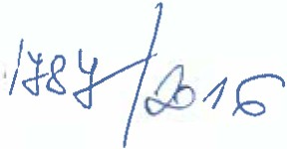 

Agricultural Association of the Czech Republic Hybernská 38



Praha 1

110 00

Czech Republic AGRI AWARE

Dear Ing. Jana Sixtová

Ihope you are well.

This letter is to confirm that Agri Aware hereby authorises you to use content from Dig ln for the purposes of printing a version to educate children on the importance cf farming and the agri-food sector in the Czech republic, on the basis that you acknowledge Agri Aware in your publication.

Kind regards,

Nora Peters



eneral Manager Agri Aware

-- ---------- -------

A n Aware Waverley Office Pari.. Old Naas Road Bluebell , Dublm I 2 D 12 CSP6 Ireland Tel t 351 1-4601103 Email mfo1lagn nwarc 1e Iwww agnawarc 1e Iwww thcfam1lyfann 1c

o o

ítctbook comlagnawate Creating Awarencs Building Undcrstanding l ducaling C'on'iumer

1'1'1ctcr c.omlagnaware

*--iJ1*

*I*