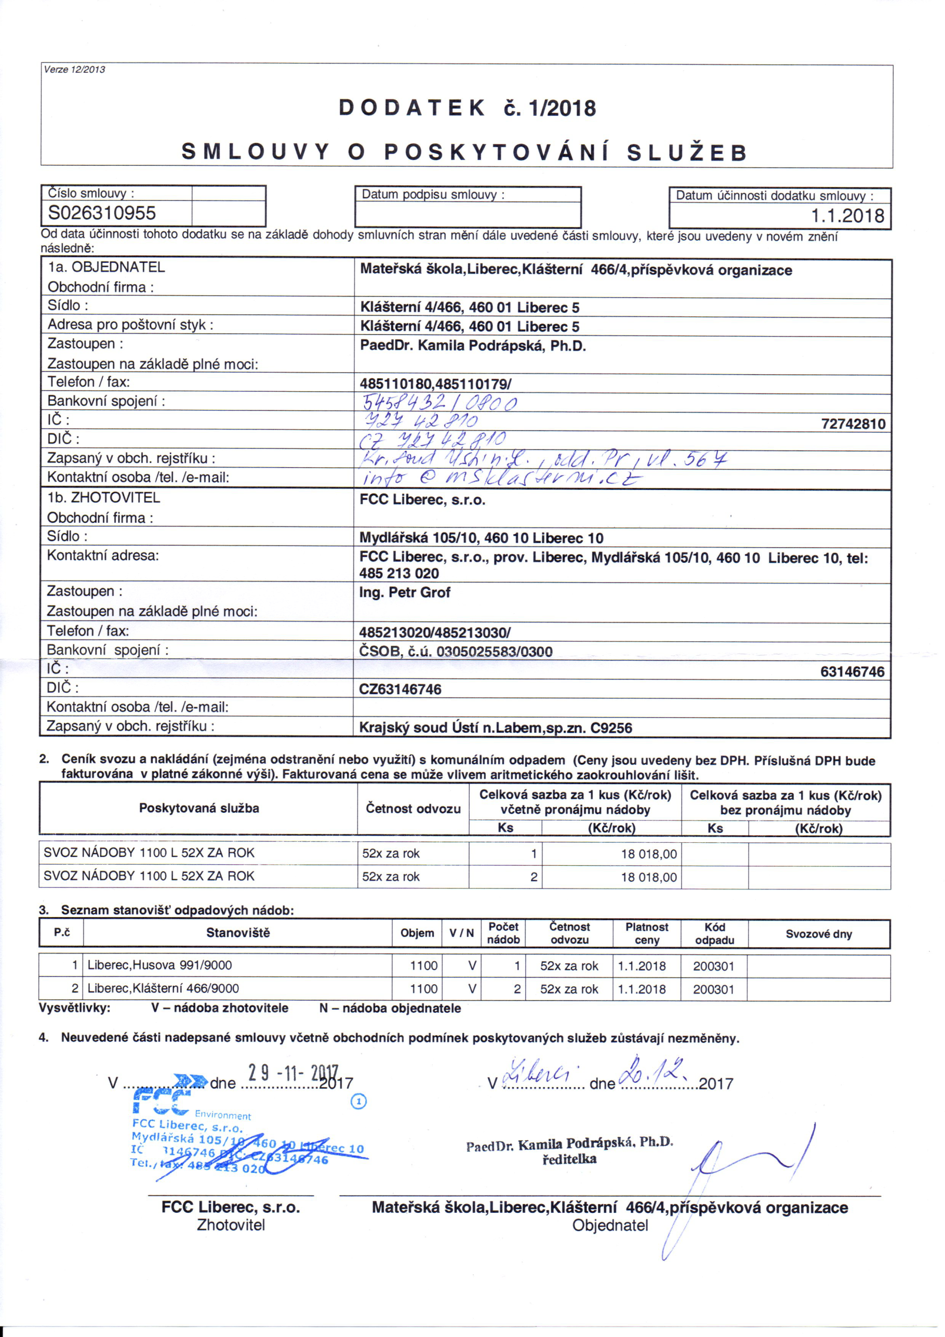

PDF-XChange Editor DEMO

PDF-XChange Editor DEMO

PDF-XChange Editor DEMO

PDF-XChange Editor DEMO

PDF-XChange Editor DEMO

PDF-XChange Editor DEMO

PDF-XChange Editor DEMO

PDF-XChange Editor DEMO

PDF-XChange Editor DEMO

PDF-XChange Editor DEMO

PDF-XChange Editor DEMO

PDF-XChange Editor DEMO