Erasmus+ Programme

Key Action 1
- Mobility for leamers and staff -
Higher Education Student and Staff Mobility

lnter-institutional agreement 2017/18-2020/21

between programme countries

The institutions named befow agree to cooperate for the exchange of students and/or staff in the context of the Erasmus+ programme. They commit to respect the quality requirements of the Erasmus Charter for Higher Education in all aspects related to the organisation and management of the mobility, in particular the recognition of the credits awarded to students by the partner institution.

- lnformation about higher education institutions

; Nilmeof itic lnún\ltlon �-Qldl!' Csmua d.t�lls Webslte I

I (&nd rfei>,;,rtJlleflt.�re ndev�otl
I

lnstitutional Coordinator
!etM1\.,ptm�I (4 or tl'le (OUC'$e I
- ď.nlo11uel
lnstltutlonal Erasmus Coordinator:

1056 Budapest, 5zerb utca 21-
23 .
+36 14116543

Ečitvos Loránd University
Faculty of Education and HU BUDAPESOl Academie
Psychology Contoct

Erasmus
Office

international@ppk.elte.hu 1075 Budapest, Kazinczy utca 23-27
+36 14614500/3468
erasmus@ppk.elte.hu
1075 Budapest, Kazinczy utca 23-27.
+36 14614500/3480
lnstltutional Coordinator
http://www.elte.hu/en/ erasmus
http://eng.ppk.elte.hu

TECHNICAL UNIVERSITY OF LIBEREC
CZ UBEREC0l
lnstJtutional Coordinator:
Studentská 2,46117, Liberec, Czech Republk erasmus@tul.cz
httrdLwww.tu1.czLen

1

Faculty Erasmus+ Coordinator:
Faculty of Sicence, Humanities and Education

I
I
I

Mobilitv numbers per academic year
list of ECTS Coordinators and Course Catalogue: http://www.tuf.a/en/erasmus/incoming- internationaf-students/course-catalogue

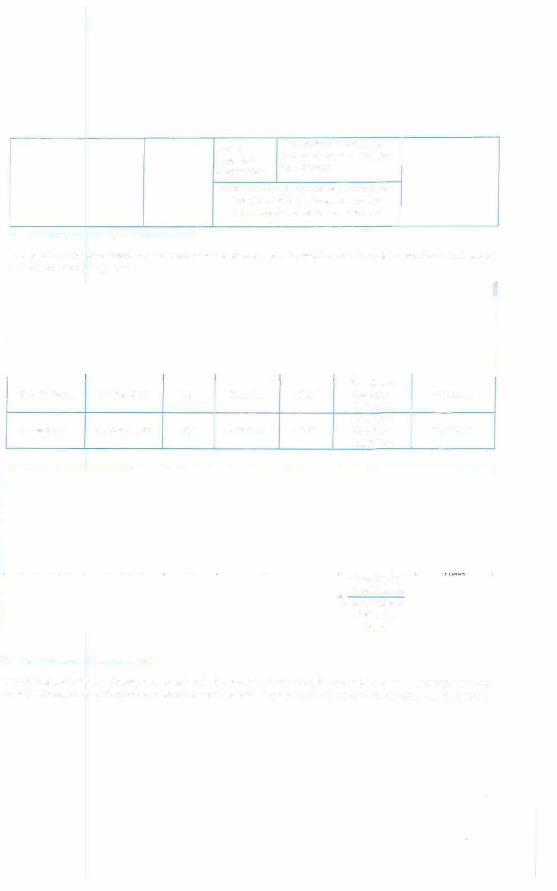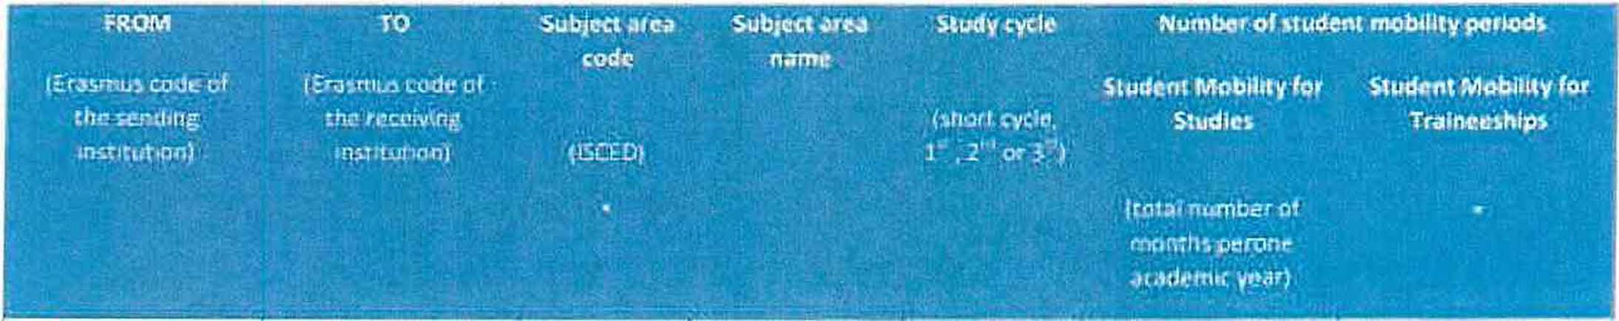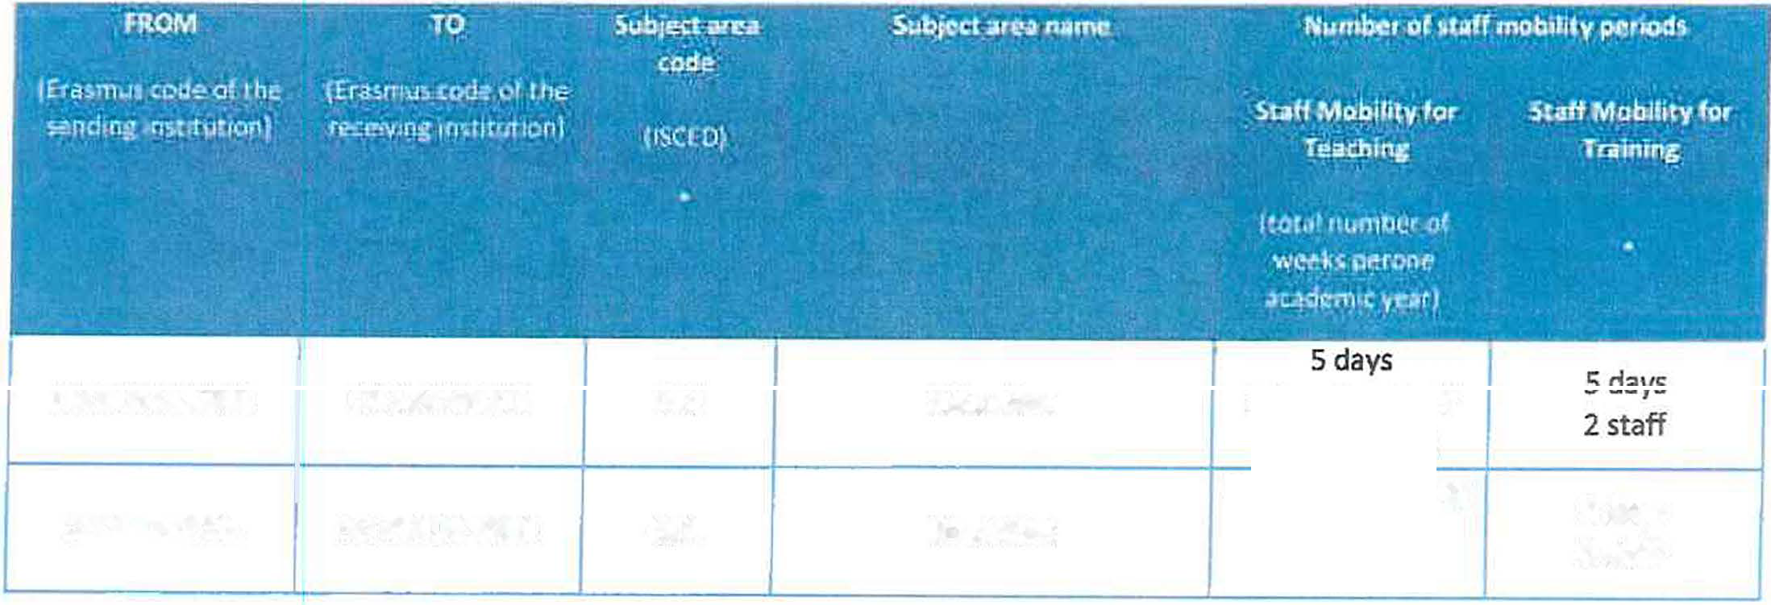The partners commit to amend the tahle below in case of changes in the mobility data by no later than the end of January in the preceding academic year.
I

2 stuaents ><
HU BUDAPESOl CZ UBERECOl 011 Education 1st, 2nd 5 months = • Optional
10 months
2 students ><
CZ UBERECOl HU BUDAPESOl 011 Educat ion 1st, 2nd S months= * Optional
10 months

2 Teaching Staff
HU BUDAPESOl | CZ LIBERECOl | 011 | Education
CZ LIBEREC01 | HU BUDAPES01 | 011 | Education

{min.8 hours)
5 days, 2 Teaching Staff {min.8 hours)
2 staff
5 days

Recommended language skllls
The sending institution, following agreement with the receiving institution, is responsibie for providing support to its nominated candidates so that they can have the recommended ianguage skills at the start ofthe study or teaching period

2

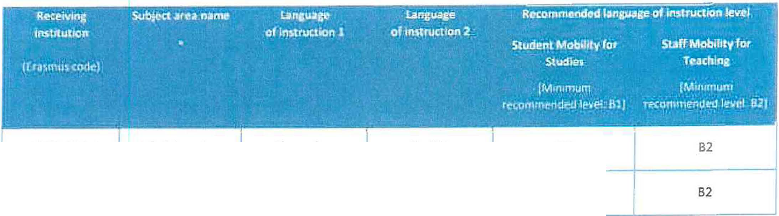

HU BUDAPESOl 011 Education Hungarian English 82
cz LIBERECo_i 011 Ed,utioa I C,�h , '"�;,� Bl
For more details on the language of instruction recommendations, see the course catalogue of each institution (links provided on the first page}.

Additional requirements
Both above mentloned lnstitutions have the conditions for the acceptance of students and staff with disabilities.

HU BUDAPESOl: Minimum requirements:

SMS (IN)

lncoming students shall apply minimum 20 ECTS/semester in their study field. Students are also allowed to take courses in other study fields to a maximum of 10 credits. (A maximum of 30 credits can be received for the courses taken.)
Selection process: the partner university is kindly requested to ensure that the language proficiency of the outgoing student(s) is a minimum 82.
Services for incoming students:

After nomination alf student shall register on: registration.elte.hu in order to enrol to the University.
- Orientation Day is organized for international students each semester where students get information about the university in general, administrative issues, student activities, the Hungarian language course, and other services. The integration of incoming students is fostered also in the areas of education and social life.
- The ESN mentor system ensures the acculturation of foreign students by organizing a series of cultural and leisure activities.
  - Hungarian language (and culture) courses are offered for incoming students in the frame of Summer University programmes as well as regular courses during the semesters (http://www.elte.hu/en/> Education > Language courses)
SMP (IN)
Traineeship is available at ELTE for interested students. ln order to receive information about available internship/apprenticeships please contact the relevant Faculty/Department/Unit of ELTE.
STA, STT (IN)
ln order to realize STA/STT-motilities, a letter of invitation - issued by an ELTE contact person - is required.

3

ELTE welcomes students and staff with disabilities and provides information and assistance. For more information please visit:www.elte.hu/en/ > University life > Equal opportunities
Faculties are authorized to extend these requirements. For more information please check Faculty website.

Calendar
    - Applications on nominated students must reach the receiving institution by:

HU BUDAPES0l
Nomination Deadline: 30 October Application deadline: 30 November
30th June (15 th June if the student needs
a Visa) l
      - TUL will send its decision within 6 weeks
Nomination deadline: 10 May;
Application deadline: 30 May

30th November (15th November if the student needs a Visa)

CTUBERECDl
      - A Transcript of Records will be issued by the respectlve Faculty at TU Liberec before the departure of the student. The student recelves a booklet, "Index", where he/she is supposed to collect signatures from the teachers to confirm passed courses and examinations. This system is parallel to the on-line system and ensures a fast processlng of the transcript of records that the student should pick up at the student Office of the faculty before leaving TU Liberec.

    - The receiving institution will send its decision within 5 weeks after deadllnes.
    - A Transcript of Records will be issued by the receiving ínstitutíon no later than 5 weeks after the assessment period has finished at the receiving HEi.
    - Termination ofthe agreement
The involved institutions may agree on the procedure of modifying or terminating the bilateral agreement. ln case of unilateral modification or termination, a written notice of at least one academic year ahead will be given. Neither the European Commission nor the National Agencies can be held responsible in case of a conflict.

HU BUDAPESOl:
Academie calendar:
Autumn semester: from lst-lOth September (usually second week of September), till 15th December spring semester: from 3rd-Sth February (usually second week of February), till 15th May
Partner institution should send nominations to erasmus@elte.hu specifying the name, field of study, academic year and semester, number of months and e-mail address of the nominated student(s).

lnformation

GradIngsvstcms of thc lnstltutions
C Z LIBERECOl:
TUL uses the ECTS credlt system.
The symbols of course unit duration: (Y) 1 fu/I year academic yeor and (S) 1 semester. fn additian to ECTS, TUL uses the local numera/ grade system as following:

4

(1) Excellent, (1-} Excel/ent Minus, (2) Very Good, (2-) Very Good Minus, (3} Good and (4) Fail.
(R) SatisfactoryCompletion ofCourse - No Grade.
HU BUDAPES01:
HU BUDAPES0l: http://www.elte.hu/en/courses
The Hungarian academic credit system following Hungarian law is an ECTS-compatíble system. The calculation of credits is based on the number of working hours of the students (one credit is 30 student working hours, on average).
At the end of the semester the studenťs study achievement is evaluated with a grade (1-faíl, 2-sufficient or pass, 3- medium or satisfactory, 4-good, 5-excellent). The ECTS conversion table ensures transfer procedures between the Hungarian academic credit system and the ECTS. The recognition of courses cornpleted abroad is based on the credit transfer regulation.
For incorning international students, a Transcript of Records, which contains the code and title of the completed courses, credits, grade, and its ECTS-cornpatible grade, wiíl be issued at the end of the semester.
ECTS conversion table - System of assessment: ELTE grade Equivalent ECTS grade
S (excellent) A, B (excellent, very good) 4 (good) C (good)
3 (satisfactory) D (satisfactory) 2 (pass) E (sufficient)
1 (Fail) FX, F (fail)

ECTS credits:
1 full academic year = 60 credits 1 semester = 30 credits
A/S EXCELLENT - outstanding performance
8/4+ VERY GOOD - above the average standard with only minor errors C/4 GOOD - generally sound work with some minor errors
D/3+ SATISFACTORY - fair but with a number of notable errors E/3 SUFFICIENT -fair but with significant shortcomings
F/2 FAIL

Visa
The sending and receiving institutions will provide assístance, when required, in securing visas for incoming and outbound mobile participants, accordlng to the requirements of the Erasmus Charter for Higher Educatíon.
lnformatlon and assistance can be provided by the following contact points and information sources:
'°'
·· :ln�lt1o1cfon·.-·-· -� - 'CDlt\.al:t<Om!tÍ " · ---- • .- - - ·w�o 1,,f� · -
Cernail. Plt;iinol
f ' • •

HU BUDAPESOl

CZ UBERECOl

lncomlng@ppk.elte.hu (-t-36) 14614592

Students with non-EU natlonallty should lnform by
e-mail ( ....u. L:) about the town where they have applied for the VISA in thelr home co_u_ntry_,_.

http:ljwww.elte.hu/en/visa

!!llPlJ.www rwcr.a.[rnvcren/artlde/a-vis�-for-.!-stay·of-over-90:<fays- ong
J
term.aspx
...._
s

AEncgcelisphtalnacneguleattgeesrswlnlllCbzeecshenatntdo the ulnntievmerasittřyo.nal Office of the home 1

lnsurance
The sending and receiving institutions will provide asslstance in obtaining insurance for incoming and outbound mobile participants, according to the requirements of the Erasmus Charter for Higher Education.
The receiving institution will inform mobile participants of cases in which insurance cover is not automatically provided. lnformation and assistance can be provided by the following contact points and information sources:
,. -lnshtution ..�.nt,ict d-:.�,,� l{l'otM.11, fo, inlorm•tlon I
l fi,"a,1. jll1ontl.
';í(,�jjr·_.,
!
HU BUDAPESOl incoming@ppk.elte.hu htm;U.www.elte.hu[en/healthinsurance W(+e36ac}c1e4pt6E1U4h5e9a2lth insurance
natlonallty should show thelr

CZ UBERECOl c d, students wfth non-EU
insurance contract at arrival.
http:ljwww.mzcr.cz/prevenm/uk/uk.hrml

Housing
The receiving ínstitution wilf guide incoming mobile participants in findíng accommodation, according to the requirements of the Erasmus Charter for Higher Education.
lnformation and assistance can be provided by the following persons and information sources;

HU BUDAPESOl
--1-'-h_ousing@elte.hu r mm;Uwww.eite.hw!:D.Lrnn&

-----

CZ LIBERECOl
Accommodation is booked baty HTaUrcLoibveRreecsiEdreanscmeuHsa lis
tOffihe csetuudpeonnt. aTchceerptance of

To inform about the time of arrival:us.koíeie@tul.cz

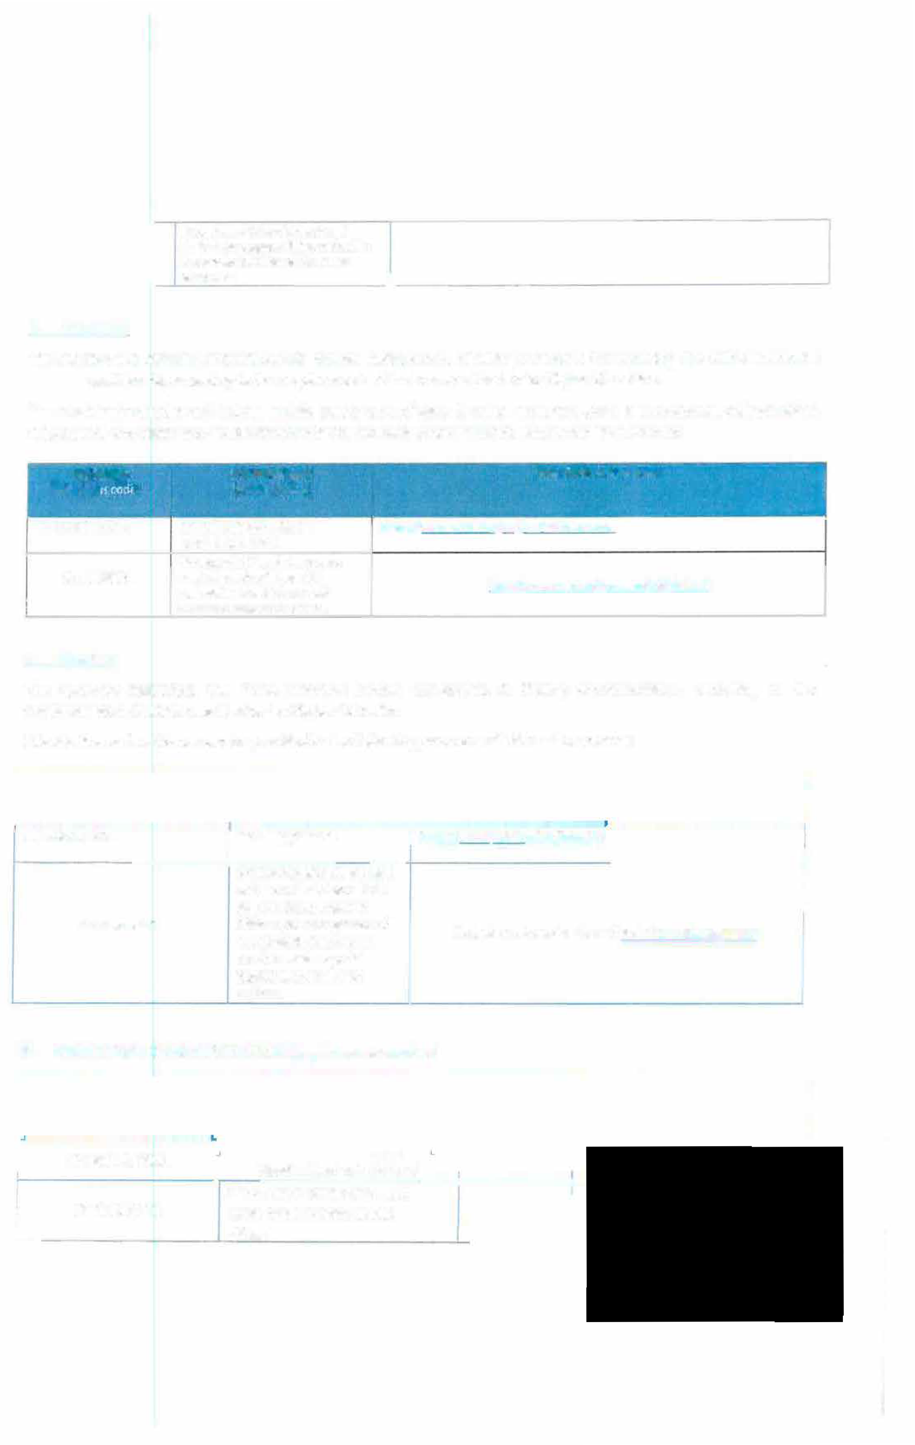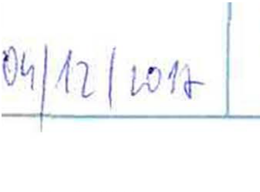n e is no
apepeldictaotisoennfdoarmspoerctiaol register.

SIGNATURES OF THE INSTITUTIONS (legal representatives)

HU BUDAPESOl Head of Rector's Cabinet
PhDr. Lucie Koutková, Ph.O. --+-------t--l
L
CZ LIBERECOl Head of the lnternational office

