Contract for the supply of LED lighting for greenhouses (hereinafter „Contract")
(within the meaning of Section 2079 et seq. of Act No. 89/2012 Coll., the Civil Code)

Institute of Experimental Botany of the CAS
CIN: 61389030
VAT ID: CZ61389030
Registered place of business: Rozvojova 263, 165 00 Prague 6
registered in the Register of Public Research Institutions maintained by MEYS
represented by: RNDr. Jan Martinec, CSc.

(hereinafter referred to as „Customer")

and

FOOD AUTONOMY KORLÁTOLT FELELŐSSÉGŰ TÁRSASÁG
VAT No: HU26218616
Registered place of business: Megyeri út 53, 1044 Budapest, Hungary
registered in the Commercial Register kept by Metropolitan Court of Registration in Budapest, file mark 01-09-308407
represented by:
e-mail:

(hereinafter referred to as „Supplier")

Customer and Supplier (hereinafter collectively referred to as „Contracting Parties“ or each individually as „Contracting Party") have entered into this contract for the supply of LED lighting for greenhouses
(hereinafter referred to as „Contract") on the date set out below:

- Introductory statement

  - The following are the representatives of the Parties authorized to act for the Parties in the performance of this Contract:

- Representatives of the Customer

in technical matters:
tel:
e-mail:

- Representatives of the Supplier

in contractual matters:

tel.:
e-mail:

in technical and software matters:
tel.:
e-mail:

  - The Customer and the Supplier are entitled to change their representatives and their substitutes at any time, provided that they notify the other party in writing in advance.

- Subject of the contract

  - Subject of this contracts is the Supplier‘s obligation to:

- deliver to the Customer LED lighting for greenhouses - FlexiGrow luminaire, which is specified in more detail in Annex no. 1 to this Contract – technical characteristics and components of the Supply (hereinafter referred to as „Equipment" or „Supply");

- arrange, at its own expense and risk, for the transportation of the Equipment to the place of performance pursuant to Article 4.1 of this Contract (hereinafter referred to as „Transportation");

- provide training to employee/s of the Customer in the operation of the Equipment and the use of its functions, in the Czech or English language and directly on the Equipment delivered under this Contract, if needed, it is possible to conduct the training online (hereinafter referred to as „Training“) including putting the control system into operation, i.e. CultiMesh commissioning (hereinafter referred to as „Commissioning“).

[Supply, Transportation, Training and Commissioning collectively also referred to as the „Matter of Subject“].

  - In connection with the Supply, the Parties agree that the Supplier shall also provide the Customer with the maintenance services to the extent specified in Articles 9 and 10 of this Contract.

  - The Parties have agreed that all parts of the Supply shall be new and unused.

  - The Customer undertakes to pay the price specified in Article 5 of this Contract for the performance of the Matter of subject of the Contract in accordance with this Contract.

- Rights and Obligations of the Contracting parties

  - The supplier undertakes by this contracts to:

- to perform the Matter of Subject according to Article no. 2.1 of this Contract without legal and factual defects and to transfer to the Customer the ownership right to the Supply;

- at the same time as the handover of the Supply, which shall take place under the terms of Article 7 of the Contract, to hand over to the Customer all the usual documentation relating to the Matter of Subject, in particular the installation/mounting instructions and maintanance and complete technical specification of the Equipment, all in electronic form, in the Czech or English language;

- at the same time as handing over the Supply, provide the Customer with declaration of conformity of the delivered Equipment with the approved standards, all in electronic form in Czech or English;

- conduct the Training and Commissioning on the terms and conditions set forth in Articles no. 2.1 (iii) of this Contract;

  - The Customer undertakes to pay for the Matter of Subject under Article 2.1 of this Contract, delivered in accordance with this Contract, the price specified in Article 5 of this Contract.

  - The Supplier declares that the Supply and its individual subparts are free from any encumbrance of third party rights (copyrights, licenses, patents, etc.) that would prevent their use by the Customer in accordance with the operating instructions and their intended use. In the event that this statement proves false, the Supplier shall be liable for damages incurred by the Customer.

- Place and dates of performance

  - The place for the handover of the Equipment and the subsequent Training is registered office of the Customer located at Rozvojová 263, Prague 6, 165 00, Czech Republic, building B3 within DAP Incoterms. The Customer agrees that the Training may also be conducted online, i.e. by remote transmission via the Internet.

  - Supply shall be made within 6 months from the conclusion of this Contract. The Supplier shall inform the Customer of the exact delivery date no later than ten (10) working days prior to delivery of the Equipment.

  - The Training and Commissioning shall be carried out no later than ten (10) working days from the date when the Customer successfully terminated installation of the luminaires, unless the Parties agree otherwise in writing. The specific date of the Training and Commissioning shall be determined in written via email by the Parties.

- Price of the Subject of Performance

  - The price for the performance of the entire Subject of Performance within the meaning of Article 2.1 of this Contract is agreed at the amount of 37.025,00 EUR excluding VAT (hereinafter referred to as the „Price“).
  - The Parties agree that the Price set forth in Article no. 5.1 of this Contract is the maximum permissible, maximum and not to be exceeded, and includes all costs of the Supply, including Transportation to the place of performance, Training, of the software that is part of the Supply, licenses to this software and other incidental costs of the Supplier.

  - The amount of costs related to the payment of value added tax, however, exclusively in relation to the Czech Republic, will be paid by the Customer on the basis of the Supplier's invoice, which will be issued with all the details corresponding to the requirements of the tax administrator and at the same time will contain all the details of the invoice agreed in this contract.

- Payment terms

  - The Customer shall pay the Price by wire transfer to the Supplier's account on the basis of a tax document issued by the Supplier and demonstrably delivered to the Customer.

  - The Supplier shall issue the invoices– tax documents under the conditions below:
- The first invoice up to 10% of the Price for the Matter of Subject as per Section 2.1. hereof as the prepayment invoice, which the Supplier shall be entitled to issue within 7 (seven) days from the date on which this Contract becomes effective;
- The second invoice up to 50% of the Price for the Matter of Subject as per Section 2.1. hereof. The Supplier shall be entitled to issue their invoice according to the preceding sentence at the moment when the Customer is notified that the Equipment has been manufactured and will be delivered (Transportation), whereby the Supplier shall also send the Customer the relevant delivery documentation with a detailed description of installing Supply;
- The third invoice up to 30% of the Price for the Matter of Subject as per Section 2.1. hereof. The Supplier shall be entitled to issue their invoice according to the preceding sentence after placing the Supply at the place of performance as per Section 4.1. hereof, about which the Parties shall make, through their authorized representatives, CMR (hereinafter as well as „proof of acceptance“) confirming the acceptance of the Suply will be signed by both contracting parties; and
- The Supplier shall be entitled to issue the fourth invoice for the remaining 10% of the Price for the Matter of Subject after Commissioning and after Training selected Customer's personnel, in accordance with the conditions stipulated in Section 7.5. hereof, about which the Parties shall make, through their authorized representatives, a certificate of the Training and Commissioning confirming that the Supply is free of any defects and backlogs acceptance of the Suply will be signed by both contracting parties.

  - The invoice will be sent by the Supplier electronically to the address of Customer. A mandatory attachment to the invoice will also be:

- proof of acceptance of the Supply by the Customer in accordance with Article 7.2 of this Contract; and

- a certificate of the Training and Commissioning issued by the Customer in accordance with Article 7.3 of this Contract.

  - The maturity of the invoice (tax document) is set by Contract of the parties to ten (10) days from the moment of their delivery, i.e. every issued invoice to the Customer. The price of the Subject of Performance shall be deemed to be paid at the moment of crediting the relevant amount to the Supplier's account.

  - In the event that the invoice issued by the Supplier does not have the appropriate elements set out in this Article, the Customer is entitled to send it back to the Supplier within the due date for completion or correction without defaulting on the due date - the due date shall start again from the delivery of the duly completed or corrected document to the Customer.

- Handover and acceptance of the Subject of Performance

- The subject of performance shall be duly and timely fulfilled by handing over the entire Supply to the Customer at the place of performance according to Article 4.1 of this Contract within the time limit set out in Article 4.2 of this Contract and by carrying out the complete Training and Commissioning within the time limit set out in Article 4.3 of this Contract.

- The handover and acceptance of the Supply shall take place by the Customer signing the Proof of Acceptance pursuant to Article 6.2(iii) of this Contract, without prejudice to Article 9.1 of this Contract.

- The Customer shall further issue the Supplier with a certificate of completion of the Training and Commissioning after the Training and Commissioning have been duly completed. By issuing this document, the Customer shall also confirm that the Equipment does not exhibit any apparent defects.

- Title to the Supplies shall pass from the Supplier to the Customer upon acceptance of the Supplies and payment of the Price. The risk of damage to the Supplies shall pass from the Supplier to the Customer at the time of acceptance of the Supplies as a whole by the Customer.

- After acceptance of the Supply, the Customer shall carry out the installation of the Equipment, itself or through a third party, in accordance with Article 9.11 of this Contract. The Supplier shall subsequently carry out the Commissioning and provide the Training to the Customer's operating personnel within the time limit pursuant to Article 4.3 of this Contract.

- Contractual penalties

  - The Customer shall be entitled to require the Supplier to pay a contractual penalty of 0.05% of the Price for each commenced day of delay in delivery of the Matter of Subject or only part thereof.

  - The Customer is entitled to demand from the Supplier payment of a contractual penalty in the amount of 0.05% of the Price for each commenced day of delay in removing the defect after the deadline for removing the defect specified in this contract or in the manner specified in this contract.

  - The Supplier is entitled to demand from the Customer payment of a contractual penalty in the amount of 0.05% of the Price for each commenced day of delay in payment.

  - The Customer is entitled to unilaterally set off its claims for contractual penalties against the Supplier's claims for payment of the Price.

- Warranties, warranty service and liability for defects

  - With regard to the nature of the performance, the Parties have expressly agreed that the Customer is entitled to reproach the Supplier for obvious defects in the Equipment until the proper completion of the Training and Commissioning within the time specified in Article no. 4.3 of this Contract.

  - The Supplier further warrants the Matter of subject of the Supply, including all components and accessories, for a period of 5 years or 20.000 burning hours (whichever expires first) from the date of fulfilment of the Matter of Subject as a whole (the „Warranty“ and „Warranty Period“). The Warranty Period shall be extended by the period of time elapsing from the date of the claim until the defect covered by the Warranty under this Contract has been remedied. For the avoidance of doubt, the Warranty Period shall not begin to run until the Training and Commissioning have been duly performed.

  - The warranty provided means that the Supply and its components will have, for the duration of the warranty under this contract, the characteristics corresponding to the technical specification set out in Annex no. 1 to this contract – technical characteristics and components of the Supply, and will be fit for use for the agreed purpose with limitations specified in Annex no. 2 (especially the clauses 4 and 5).

  - The Supplier undertakes to accept written notifications of defects covered by the warranty under this Contract, whereby written notifications of defects shall also be deemed to be notifications to the Supplier's e-mail address specified in the header of this Contract. Even notifications of defects sent by the Customer on the last day of the warranty period shall be deemed to have been sent on time.

  - The Customer is obliged to make the Equipment available to the Supplier for the purpose of servicing and to allow the Supplier access to the premises where the Equipment is installed.

  - Repair of the Equipment or its components within the warranty period shall be at the Supplier's expense, including any costs of transportation of the Equipment.

  - Unless the Parties agree otherwise in writing, the maximum time limit for the remedy of a minor defect, i.e. a defect which does not prevent the operation of the Supply, provided that no replacement part of the Supply is required to remedy the defect, shall be twenty (20) working days from the day following the date of notification of the defect. In the event that a replacement part of the Supply is required to remedy a minor defect, the time limit shall be extended to thirty (30) working days.

  - The Customer shall also be entitled to demand in the context of a claim - (i) the removal of the defect by repair, if the defect can be removed in this way and if its removal does not take more than thirty (30) working days, or (ii) the delivery of a new device in the event that after the first analysis of the defect it is already established that the defect is irremediable.

  - The remedy of a defect covered by the warranty under this contract shall be deemed to be a state in which the Supply is handed over to the Customer without any claimed defects and is fit for use for the agreed purpose without limitation.

  - The Supplier undertakes to grant the Customer consent to any assignment of the rights and obligations under this Contract relating to the warranties to the assignee of the Supplier in the event that the Customer transfers title to the Supplier to a third party during the term of the warranties under this Contract.
  - The Supplier assumes that the installation of the Equipment will be carried out by a third party selected by the Customer and this installation of the Equipment shall be provided within 30 days from the day following the date of delivery of Supply pursuant to the Article 4.2. of the Contract. The Parties agree that this fact shall have no impact on the duration of the Warranty Period pursuant to Article 9.2 of this Contract, provided that the installation is carried out in accordance with the Supplier’s instructions and documentation. The Supplier undertakes to provide the Customer and/or the third party selected by the Customer with all necessary cooperation for the purposes of carrying out the installation, including providing the relevant documentation relating to the Supply and the method of its installation.

  - For the avoidance of doubt, Annex No. 2 governs the warranty terms to the extent they are not explicitly regulated in Article 9 of this Contract. In the event of any discrepancy between Article 9 and Annex No. 2 of this Contract, the terms set out in Article 9 of this Contract shall prevail, in particular with respect to the time limits for remedying defects.

- Support

  - The Supplier undertakes to provide the following services to the Customer within the agreed Price, i.e., without any entitlement to additional payment beyond the agreed Price, during the warranty period according to Article 9.2 of this Contract:
- technical support in the form of assistance in solving functional problems in the use of the Equipment, including (i) assistance in updating the software included in the Supply, solving functional problems in the use of such software and training or instruction of the personnel of the Customer in the case of software updates.

- technological support including updating the relevant software for the Supply.

  - The Supplier undertakes to provide the Customer with spare parts for the Supply within a period of at least ten (10) years from the acceptance of the Supply.

- Withdrawal from the contract

  - The Supplier shall have the right to withdraw from this Contract with ex tunc effects if the Customer is more than fifteen (15) days in arrears with any of the payment specified in clause 6.4.

  - The Customer has the right to withdraw from this Contract with ex tunc effects, in particular if:

- The Supply will not be delivered within the time limit specified in Article 4.2 of this Contract,

- Complete Training will not be completed within the time period specified or agreed upon pursuant to Article 4.3 of this Contract,

- Upon acceptance of the Equipment, it becomes apparent that the Supply does not conform to the technical specification in Annex no. 1 to this Contract or this Contract, even in part; the Customer shall be entitled to withdraw for this reason at any time within one (1) month of delivery of the Equipment,

- The Equipment exhibits obvious defects after delivery, which shall be pointed out to the Supplier within the time limit pursuant to Article 9.1 of this Contract,

- The terms of Article 9.8 (last sentence) of this Contract shall be fulfilled,

- an insolvency petition has been filed or acts have been taken to open liquidation proceedings in respect of the Supplier, unless the Supplier proves to the Customer that such petition or act is arbitrary and unreasonable;

  - The statutory grounds for withdrawal are not affected by the above provisions.

  - Withdrawal is effective upon delivery of written notice of withdrawal to the other party. Withdrawal from this Contract shall not affect the right to payment of contractual penalties and damages

- Governing law and choice of court

  - This entire Contract shall be governed by and construed in accordance with the applicable law of the Czech Republic, in particular the provisions of Section 2079 et seq. of Act No. 89/2012 Coll., the Civil Code (as amended).

  - The Contracting parties have an interest in resolving any dispute or disagreement amicably, promptly and as cost-effectively as possible under the circumstances. In the event of litigation, the Parties agree to the jurisdiction of the courts of the Czech Republic for all disputes relating to this Contract, including any disputes concerning its validity or the consequences of its invalidity.

  - In connection with the above, the Parties further agree on the choice of the local jurisdiction of the court in accordance with Section 89a of Act No. 99/1963 Coll., the Code of Civil Procedure, so that any disputes arising out of this Contract shall be adjudicated by the District Court for Prague 1 in the event that the District Court has jurisdiction in the first instance, and by the Municipal Court in Prague in the event that the Regional Court has jurisdiction in the first instance.

- Other obligations of the Supplier

  - The Supplier is obliged to cooperate in the performance of financial control, also in relation to the Contract, within the meaning of Section 2(e) of Act No. 320/2001 Coll., on financial control in public administration and on amendments to certain acts (Act on financial control). The Supplier acknowledges that it is also obliged to contractually bind its subcontractors that it will use to provide the Matter of Subject under this Contract with a similar obligation.

- Concluding Provisions

  - In the event of a change in any of the particulars set out in the header of this Contract or in respect of the persons referred to in this Article, the Party to whom the change is made shall be has occurred, shall inform the other Party in a conclusive manner (by registered letter or electronically by e-mail, which must be acknowledged by the other Party) without undue delay.

  - The individual provisions of this contract are severable in accordance with Section 576 of the Civil Code in the sense that if the ground of invalidity relates only to a part of the contract that can be severed from the rest of its content, only that part is invalid if it can be assumed that the contract would have been concluded without the invalid part if the contracting party had recognised the invalidity in time.

  - This Contract constitutes the entire agreement of the Parties with respect to the subject matter hereof and supersedes all prior understandings between the Parties, both oral and written.

  - Unless otherwise provided in this Contract, this Contract may be amended or supplemented only by written amendments signed by authorized representatives of both parties. The addresses, names of the Parties' staff members and telephone numbers may also be changed by unilateral written notification; the Parties undertake to notify the other Party immediately of any changes to the above information and, in the event of a breach of this obligation, to reimburse the other Party for any damages and costs incurred by the other Party as a result of the breach of this obligation.

  - The Supplier agrees to the publication of the contract in the Register of Contracts established by Act No. 340/2015 Coll., on Special Conditions of Effectiveness of Certain Contracts, Publication of Such Contracts and on the Register of Contracts, as amended. The Supplier acknowledges that the publication of the contract in the Register of Contracts shall be ensured by the Customer.

  - In the event that this Contract is drawn up and signed in analogue form, it shall be drawn up in two copies, one of which shall be given to each of the Parties. In the event that this Contract is executed and signed in electronic/digital form, each Party shall have possession of the same upon its signature by the respective electronic signatures of both Parties.

  - This Contract shall enter into force upon its signing by both Parties and shall become effective upon its publication in the Register of Contracts pursuant to Article no. 14.5 of this Contract.

  - The Parties hereby declare that they have duly acquainted themselves with the contents of this Contract, that this Contract is the expression of their serious, free and certain will, free from mistake, and that it is not concluded under duress and/or on manifestly unfavourable terms, in proof of which they affix their signatures below.

Annexes:
- No. 1: Price and technical characteristics and components of the Supply
- No. 2: Warranty conditions

27.10.2026

Supplier Customer
FOOD AUTONOMY KORLÁTOLT Institute of Experimental Botany of the CAS
FELELŐSSÉGŰ TÁRSASÁG RNDr. Jan Martinec, CSc.

Annex no. 1: Price and technical characteristics and components of the Supply

FlexiGrow luminaire

Total 2 modules form 1 luminaire; 1 lumianire powered by 1 LED driver

Control:
4-channel:
- Blue
- White
- Red
- Far red

Performance per module:
Light output (300-780nm) = 901 µmol/s
Input power = 323 W
Efficacy = 2,8 µmol/J

Performance per luminaire:
Light output (300-780nm) = 1802 µmol/s
Input power = 646 W
Efficacy = 2,8 µmol/J

IP 66 provide

1 module illustrative picture:

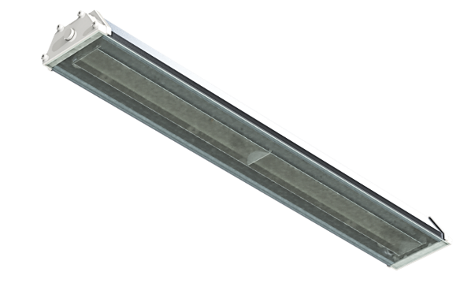

Spectrum:
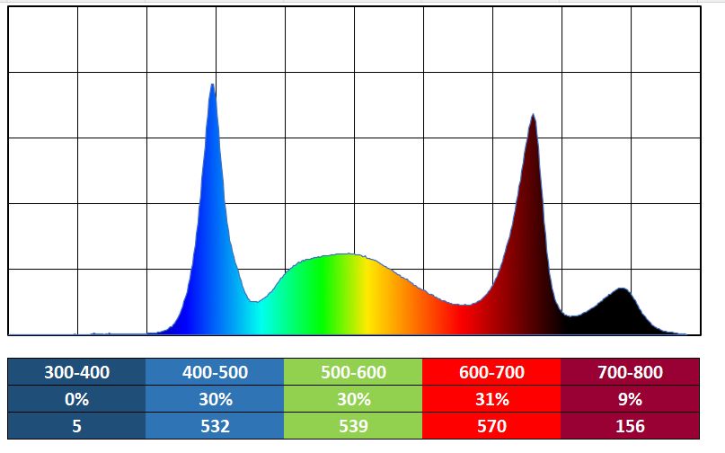

Price:

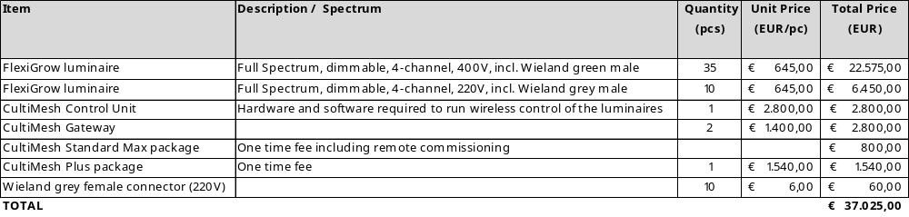

Annex no. 2: Warranty conditions

Warranty Conditions
LED Fixtures suitable for Indoor Farming

These conditions apply to Food Autonomy branded LED fixtures suitable for greenhouse indoor cultivation (hereinafter: “Products”) sold by Food Autonomy Kft.

- Food Autonomy Kft (hereinafter “Supplier”) confirms that the Products comply with the relevant IEC standards and are in accordance with the specifications set out in the provided Technical Specification of the luminaire.

- The Warranty Period is defined as follows:
Product Description |  | Warranty Period
 | FlexiGrow | 5 years or 20.000 burning hours, whichever expires first
- Customer must notify Supplier immediately and in any event within 30 days of discovering the failure of the Product informing Supplier on such data and circumstances as specified in Section 6 below, and upon request from Supplier present the following documents:
- proof of purchase
- records of operating history
- proof or receipt of these Warranty Conditions directly from Supplier.

- The Product is deemed to be defective if it is inoperative or the light degradation of the LED light source compared to the light output value and power stated in the product data sheet ± 3% * is more than 10% within 5 years.
- If a concern is raised by the Customer regarding the light degradation of the LED light sources, then a PPFD measurement shall be performed in the greenhouse with a portable PPFD measuring device based on the measurement points in line with the lighting design for which the Customer expressed their concerns. If this field measurement shows a bigger light degradation than the percentages mentioned in art. 4, then Supplier shall carry out a laboratory test to verify the failure. The laboratory test shall be performed on samples of the LED light sources selected from the measured grid. The tests will be carried out in an accredited laboratory with goniometer under the standard test conditions @ 25°C room temperature. If the results of these measurements for any of the measured light sources, accounting for the measuring tolerances declared by the laboratory, show higher light degradation than the percentage mentioned in art. 4, then the related LED light source is deemed to be defective.

* Due to the special conditions of the manufacturing processes of the semiconductor devices and the drivers, the claimed luminaire parameters can only reflect statistical figures, and do not necessarily correspond to the actual parameters of each single product.
- Supplier shall not be liable for any defective Product that has not been installed or used in accordance with Supplier’s instructions as provided to users by Supplier. Products must be used in particular in accordance with the following:
  - The Product must have been properly wired and installed;
  - The Product must have been operated at or below the rated drive current as set out in the Installation Guide;
  - The Product must have been operated in a standard greenhouse environment and within the specified parameters detailed in the Product data sheet.
Should any of the Product be disassembled or parts of the Product are dismounted or replaced without the prior written consent of the Supplier, the warranty shall cease to apply to the impacted Product and Supplier shall not be held liable for any failure or damage of the product or any direct or indirect or consequential damage or loss caused by the Product to Customer, or to any third party.
- If a Customer wishes to bring a claim against Supplier under these conditions, it must notify Supplier’s Technology Organization in writing at the contact coordinates written in Section 8 below, using the User complaint form (that is available at the Technology Organization upon request) specifying the following information:
- Precise details of the defects in the Product (failure mode description);
- Product description;
- Product individual identification code;
- Date installed;
- Total number of fixtures installed;
- Total hours of operation;
- Number of defective fixtures;
- Date failed;
- Conditions at the installation including supply voltage, type of control system if used, location of installation;
- Contact details for Customer.
- The contact coordinates of Supplier’s Technology Organization are the following:
Food Autonomy Kft.,
Technology Organization,
Csáktornya u 6, 8800 Nagykanizsa, Hungary
E-mail: quality@foodautonomy.org
For the avoidance of any doubt, the Customer shall always assert claims arising from the Supplier's liability for defects against the Supplier.
- On receipt of written notification of a defective Product, Supplier will respond within 1 working day (24 hours), providing remote support initially, if unable to resolve, Supplier will attend site to investigate the validity of the complaint. Supplier shall (at its discretion) be entitled to examine all or only samples of the failed Product to determine the cause of failure and to inspect the luminaires and installation relating to the Product which are the subject of the claim, including attending at the premises of the Customer where the Products are installed. Proof of purchase and records of operating history should be kept and made available for inspection, failure to provide these may invalidate any Warranty.
- Notwithstanding any other statement herein, Supplier’s undertaking to replace defective Products in accordance with these conditions shall not apply to:
- failure caused by incorrect installation, that did not follow the install guide;
- noncompliance of the electrical network with IEEE519-2022 and EN50160 and any defect caused by electrical network anomaly;
- failure caused by exposure to excessive physical force, vibration or direct contact with water if not supported by IP rating of fixture;
- cases where any of those in item 3 has not been observed.
- Subject to these conditions Supplier’s sole obligation hereunder shall be, at Supplier’s discretion, to provide replacements for defective Products (art. 4) of the same specification or in the case of obsolete Products, with equivalent alternative Products.
- Supplier shall have no liability for any labor, installation or to costs related to Product replacement, which may be incurred by Customer, unless expressly otherwise provided for in these Warranty Conditions. Further, Supplier shall have no liability for any indirect or consequential damage.

