

**Erasmus+**

# Erasmus+ Programme

**Key Action 1 - Mobility for learners and staff - Higher Education Student and Staff Mobility**

**Inter-institutional 1 agreement 2014-20[21] 2**

**between institutions from Programme and Partner Countries3 [Minimum requirements] 4**

##### The institutions named below agree to cooperate for the exchange of students and/ or staff in the context of the Erasmus+ programme. They commit to respect the quality requirements of the Erasmus Charter for Higher Education in all aspects of the organisation and management of the mobility, in particular the recognition of the credits (or equivalent) awarded to students by the partner institution. The institutions also commit to sound and transparent management of funds allocated to them through Erasmus+.

1. lnter-institutional agreements can be signed by two or more higher education lnstitutions (HEls), at least one of them must be located in a Programme Country of Erasmus+.
2. Higher Education lnstitutions have to agree on the period of validity of this agreement
3. Erasmus+ Programme Countries are the 28 EU countries, the EFTA countries and other European countries as defined in the Call for proposals. Eligible Partner Countries are listed in the Programme Guide.
4. Clauses may be added to this template agreement to better reflect the nature of the institutional partnership.

**A: Information about higher education institutions**

**Full name of the Erasmus Contact details Website institution / country code or (email, phone) (eg. of the course**

**city**

Technical University of cz

* 1. Institutional Coordinator of

**catalogue)**

[www.tul.cz](http://www.tul.cz/)

Liberec, Czech LIBEREC0l Republic

Erasmus+ at TUL, Univerzitní náměstí, 1410/1, Liberec I, Czech Republic,

@tul .i:z, erasmus@tuLcz

Tel: +420 485353749

2.

Erasmus+ coordinator/Faculty of Science, Humanities and Education at TUL,

@gmai.w:o.ro Tel:

+420727909469

University of Maine at UMA Augusta, USA (Erasmus+

PIC code:

###### **911615216**

1. , Dean of College of Art and Sciences, 150 Jewett Hall, Augusta Campus, ME 04330, USA,

+ 1(207)6213255

[www.uma.edu](http://www.uma.edu/)

1. **Mobility numbers5 per academic year**

*[*Optional: subject area code* & *name and study cycle are optional.J*

**FROM TO *Subject Subject* Number of staff mobility periods**

**[Erasmus [Erasmus**

**code of the code of the**

***area area name***

***code*** *

Staff Mobility for *Stdff Mobility for*

**sending recelvlng**

**institution) institution]**

*

**flSCED)**

Teaching

*ftot.1/ 1111mbc•r o/ d,l'y'S o/ I <'<1Clunq /!ťriocls or averai/•� du,alwn 'I*

I • I • I

*Traming*



**5** Mobility numbers can be given per sending/receiving institutions *and per education field (optionat·: hrtp : I Iwww,u,s. unesco. orglEducationtPogest* ,ne*ernationoHtandord-classlficac* ion *ol-edurncion.aspx)*

2

#### **Recommended language skills**

The sending lnstitution, following agreement with the receiving institution, is responsible for providing support to its nominated candidates so that they can have the recommended language skills at the start of the study or teaching period:

**Receiving institution**

**[Erasmus code or city]**

***Optional: Subject area***

**Language of instructio n 1**

**Language of instructio n2**

**Recommended language of instruction level**

Student Mobility Staff Mobility for for Stud1cs Tcaching

Psychology

*f'.'llr11111um f>.11111r11um*

*rc.--:co1111ncri(lt:'d ft.•v1.:.•I: ťec·unll1!Clh1L'"(Í lt-1 v(•I:*

81 HJ

##### :.

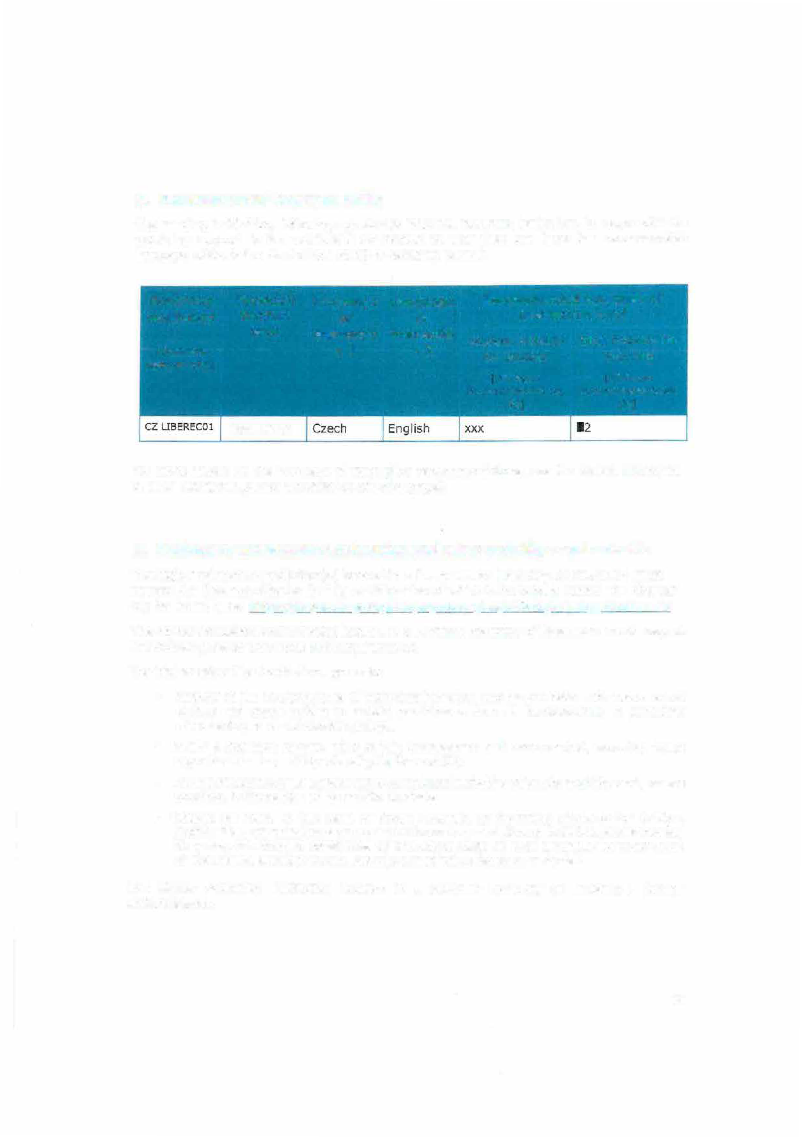

For more details on the language of instruction recommendations, see the course catalogue of each institution *[Links provided on the first page].*

#### **Respect of fundamental principles and other mobility requirements**

The higher education institution(s) located in a **Programme Country** of Erasmus+ must respect the Erasmus Charter for Higher Education of which it must be a holder. The charter can be found here: https://eacea.ec.europa.eu/erasmus-plus/act10ns/erasmus-charter en

The hlgher educatiori institution(s) located in a **Partner Country** of Erasmus+ must respect the following set of principles and requirements:

The higher education institution agrees to:

* + Respect in full the principles of non-discrimination and to promote and ensure equal access and opportunities to mobile participants from all backgrounds, in particular disadvantaged or vulnerable groups.
  + Apply a selection process that is fair, transparent and documented, ensuring equal opportunities to participants eligible for mobility.
  + Ensure recognition for satisfactorily completed activities of study mobility and, where possible, traineeships of its mobile students.
  + Charge no fees, in the case of credit mobility, to incoming students for tuition, registration, examinations or access to laboratory and library facilities. Nevertheless, they may be charged small fees on the same basis as local students for costs such as insurance, student unions and the use of miscellaneous material.

The higher education institution located in a **Partner Country** of Erasmus+ further undertakes to:

3



###### **Before mobility**

* + - Provide information on courses (content, level, scope, language) well in advance of the mobility periods, so as to be transparent to all parties and allow mobile students to make well-informed choices about the courses they will follow.
    - Ensure that outbound mobile participants are well prepared for the mobility, including having attained the necessary level of linguistic proficiency.
    - Ensure that student and staff mobility for education or training purposes is based on a learning agreement for students and a mobility agreement for staff validated in advance between the sending and receiving institutions or enterprises and the mobile participants.
    - Provide assistance related to obtaining visas, when required, for incoming and outbound mobile participants. Costs for visas can be covered with the mobility grants. See the information / visa section for contact details.
    - Provide assistance related to obtaining insurance, when required, for incoming and outbound mobile participants. The institution from the Partner Country should inform mobile participants of cases in which insurance cover is not automatically provided. Costs for insurance can be covered with the organisational support grants. See the information / insurance section for contact details.
    - Provide guidance to incoming mobile participants in finding accómmodation. See the information / housing section for contact details.

###### **During and after mobility**

* Ensure equal academic treatment and services for home students and staff and incoming mobile participants and integrate incoming mobile participants into the institution's everyday Ilfe, and have in place appropriate mentoring and support arrangements for mobile participants as well as appropriate linguistic support to incoming mobile participants.
* Accept all activities indicated in the learning agreement as counting towards the degree, providečl these have been satisfactorily completed by the mobile student.
* Provide, free-of-charge, incoming mobile students and their sending institutions with transcripts in English or in the language of the sending institution containing a full, accurate and timely record of their achievements at the end of their mobility period.
* Support the reintegration of mobile participants and give them the opportunity, upon return, to build on their experiences for the benefit of the Institution and their peers.
* Ensure that staff are given recognition for their teaching and training activities undertaken during the mobility period, based on a mobility agreement.

4

#### **Additional requirements**

cz

LIBEREC0l

In case of additional requirements of academic, organisational or other aspects (e.g. students with special needs), please consult our website: [http://www.](http://www/) tuI .cz/en/internat,ona1-relat,ons/llp-erasmus or contact

the Erasmus Office: [erasmus@tul.cz.](mailto:erasmus@tul.cz)

#### **Calendar**

1. Applications/information or:i nominated students must reach the receiving institution by:

**Receiving institution [Erasmus code or city]**

. .

##### �

**Autumn term* (month]**

30th June (15 th June if the student needs a Visa)

**Spring term* [month]**

November if the student needs a Visa)

* 1. TUL will send its decision within 6 weeks

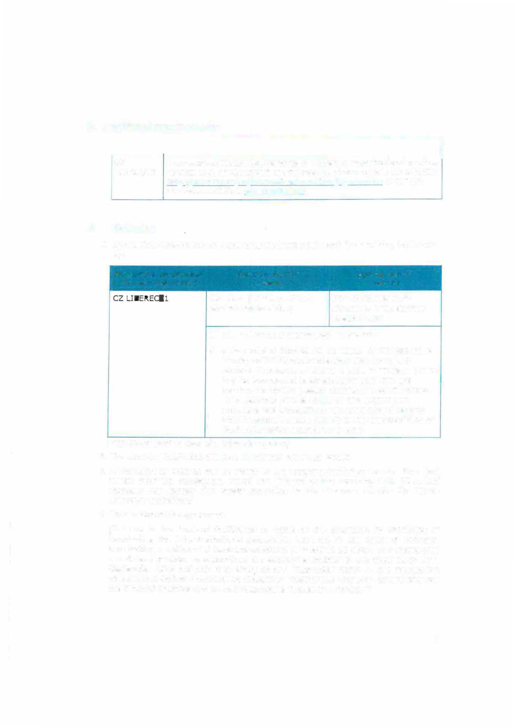

* 1. A Transcript of Records will be issued by the respective Faculty at TU Liberec before the departure of the student. The student receives a booklet, "Index", where he/she is supposed to collect signatures from the teachers to confirm passed courses and examinations. This system is parallel to the on-line system and ensures a fast processing of the transcript of records that the student should pick up at the student Office of the faculty before leaving TU Liberec.

*[* to be adapted in case of a trimester system]*

1. The receiving institution will send its decision within [x] weeks.
2. A Transcript of Records will be issued by the receiving institution no later than [xx] weeks after the assessment period has finished at the receiving HEL [It *should norma/ly not exceed five weeks according to the Erasmus Charter for Higher Education guidelines]*
3. Termination of the agreement

*[It is up to the invo/ved institutions to agree on the procedure for modifying or terminating the inter-institutional agreement. However, in the event of unilateral termination, a notice of at /east one academic year should be given. This means that a unilateral decision to discontinue the exchanges notified to the other party by 1 September 20XX wi/1 only take effect as of 1 September 20XX+l. The termination clauses must include the fol/owing disclaimer: "Neither the European Commission nor the National Agencies can be held responsible in case of a conflict. "]*

### 5



#### **Information**

**About *CZ LIBERECOl***

(for up to date contact details, see web pages) Grading *TUL uses the* ***ECTS credit system*** *described at:*

system *l1W1.,l'.L���.,1.1.l,,zLJ:.aJe,c�LJ:.,tc;-cr�dt.t·alla,amia 106*

*The symbols of* ***course unit duration: (Y)*** *1 fu/I year academlc year and* ***(5)*** *1 semester.*

*In addítion to ECTS, TUL uses the* ***/oca/ numera/ grade*** *system as fol/owing:*

***(1)*** *Excellent,* ***(1-)*** *Excellent Minus,* ***(2)*** *Very Good,* ***(2-)***

*Very Good Minus,* ***(3)*** *Good and* ***(4)*** *Fail.*

***(R)*** *SatisfactoryCompletion of Course - No Grade.*

Visa Students with non-EU nationallty should inform by e- mail (erasmus@tuLcz) about the town where they have applied for the VISA in their home country. Acceptance letters in Czech and English languages will be sent to the International Office of the home university. *h.tt+l,;Jt* w�t.Hv.mvcr,czlowca:0Lat:t11:lela-v1<;rn *f9r* 2 :m11L-Q(

Qlls:r-�Q-days·IQog-tt.:clll,alóiQX

Insurance We accept EU health insurance card, students with non- EU nationality should show their insuraAce contract at

arrival. bttp·Uw.w.w rnzcr.czlpcel.!eocelukluk btml

-

Housing Accommodation is booked at Harcov Residence Halls by TU Liberec Erasmus Office upon acceptance of the student. There is no need to send a special application form or to register. To inform about the time of arrival: us,kcleJe@tul,cz

Special The facilities of the university are accessible for needs handicapped persons. There is also a centre for

guidance and support: htto:/L[www.tul.cz/akadem,rka-](http://www.tul.cz/akadem%2Crka-)

rullildoa ·2 ,�ntrum·QQQb!QCY. .8.2

Academie Winter Semester: Beginnlng of OCTOBER - Mld Calendar FEBRUARY

Summer Semester: Mld FEBRUARY - End of JUNE bttp · llwww.,tul czleoiiotemat1ooaLcela.tia.nsLil� ecasm11s

6

###### **G. SIGNATURES OF THE INSTITUTIONS (legal representatives)**

UMA

Prof. Dr. Ing. Zdeněk K�s Tel.: +420 485 353 451

e-mail: [rektor@tul.cz](mailto:rektor@tul.cz) TUL RECTOR

Joseph Szakas,/Provost /

Tel: +1(207) 621-3360

email: szaka:;crnma1o_e� UMA PROVOST/Vice­

President of Academie

Affalrs

### 7