TECHNICAL UNIVERSITY OF LIBEREC
Identification number of an organization: 46747885 VAT number: CZ46747885
ORDER
Order number:KTT/16-4240-049 | Supplier:  CONSTRUCCIONES METALURGICAS ESPECIALES, S.A.
Paid by: 4240 – IRP 12244 | Ctra. Manresa – Solsona, km.4,2
Date: 29. 9. 2016 | Pol.Ind. “Pla dels Vinyats”
Person responsible: XXXXX | E-08250 SANT JOAN DE VILATORRADA (Barcelona)
Financial resource:
Order details:

Chain links for warp-knitted machine according the list:
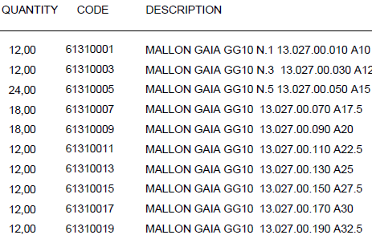

Delivery address:  Technická univerzita v Liberci – KTT  XXXXX  Studentská 1402/2  461 17 Liberec | The name and signature of the principal:  XXXXX
Phone: XXXXX  Fax: | Budget administrator: XXXXX
Delivery date: 3 weeks
Estimated price: 2000 EUR | Form of delivery:
Bank details: XXXXX  Account number: XXXXX | IBAN: XXXXX  SWIFT : XXXXX
In the invoice, please, state the number of the order, the name and the address of the bank, IBAN and SWIFT code.

