OFFER

O-11473-00001976


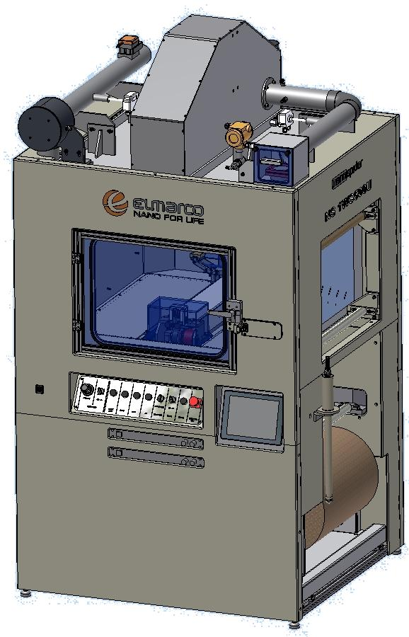

NS 1WS500U – POUŽITÝ
Nanospider™ Production Line

Date: 8. 1. 2026

Valid until: 30. 1. 2026
This Offer is provided to:

Univerzita Jana Evangelisty Purkyně (UJEP)
Pasteurova 3544/1
Ústí nad Labem, 400 96
Czech Republic

Contact:

Pavla Čapková
pavla.capkova@ujep.cz

Herein after referred to as “Buyer”.

This Offer is provided by:

ELMARCO s.r.o.
Svarovska 621
46001 Liberec XI
Czech Republic

Contact:

Kateřina Petrová
katerina.petrova@elmarco.com

Herein after referred to as “Seller”.
Table of Contents
1 Description of nanospider technology NS 1S500U 4
2 Equipment and Component Pricing 4
2.1. Pricing 4
2.1 Payment 4
2.2 Order Lead-time 5
3 scope of supply 5
4 connection points 5
5 Installation and training 5
6 Legal and Other 5
6.1 Acceptance 5
6.2 Cancellation 6
6.3 Delivery and Delays 6
6.4 Storage and Unpacking 7
6.5 Substitutes, Changes, and Improvements 7
6.6 No Reverse Engineering 7
6.7 Governing Law and Arbitration 7
6.8 Guarantee / Warranty 8
6.9 Limitation of Liability 8
6.10 Title and Remedies 8
6.11 Confidentiality 8
6.12 Force Majeure 9
6.13 General 9
6.14 Validity 9
7 Appendix - Technical specification of NS1WS500U 10
7.1 Equipment parameters 10
7.2 Process Parameters 11
7.3 Polymers 11
7.4 Equipment and Component Description 12
7.5 Included Accessories 14
7.6 Packaging description and dimensions 17
8 Appendix - Elmarco After-Sales Service Terms & Conditions 17
8.1 Service during warranty period 17
8.2 Service after warranty period 17
8.3 Hourly rates of service engineers 17
8.4 Expenses 18

Description of nanospider technology NS 1S500U
The Nanospider™ NS 1WS500U is a specialized production unit designed for the small volume production, research and development of nanofibre materials using solvent and water soluble polymers. It contains peristaltic pump and magnetic stirring inside the storage container.

The results of the NS 1WS500U can be upscaled to the Elmarco production medium and high volume production lines NS 1000 and NS 1600.

Equipment and Component Pricing
Equipment and Components for Elmarco’s NS 1WS500U production unit are as follows:

Pricing
ITEM | UNIT list price | Pc. | Price | Total
USED NS1WS500U (year of production 2011)
Nanospider UNIT NS1WS500U | 350 000 | 1 | 350 000 | 350 000
Balení | 0 | 1 | 0 | 0
Instalace v místě u zákazníka včetně výloh na cestování - jeden den instalace včetně školení | 0 | 1 | 0 | 0
Doprava a pojištění DAP Ústí nad Labem | 0 | 1 | 0 | 0
TOTAL |  |  |  | 350 000
Basic accessories are part of delivery and they are listed in Chapter 7.5

(All prices are shown in CZK, VAT is not included).

Machine fulfils the basic requirements for CE
Machine has been tested according to the Internal Acceptance Certification
Machine has been cleaned and filter for a dust particles replaced

Machine does not have following
Data computer collecting system
Relative Humidity and Temperature sensor removed from the inside of the spinning chamber, this item still displayed on the LCD panel and NOT in use

Payment
The terms of payment are:

- 100% platby (splatnost 10 dní od dodání zboží Kupujícímu)
Invoices not paid shall be subject to a late payment interest charge of 0.05% per each day overdue. Without limiting the above provisions, in the event Buyer does not pay all amounts due and owed within allowed payment terms, Seller may withhold further shipments until acceptable payment is made. Shipment holds shall not constitute Seller’s breach and Seller, in its sole discretion, may continue to perform in accordance to Buyer's purchase orders.

Order Lead-time
Stroj bude zabalen a připraven k převozu k 20. 2. 2026. Doprava a instalace bude upřesněna dle připravenosti místa v místě provozu zákazníka

scope of supply
Component |  | Cost
Small compressor to generate pressure 5-8 Bar NOT Included
Air duct piping, and compressed air tubing |  | NOT Included
Fire extinguisher bottle ( CO2 gas medium) |  | NOT Included
Packaging for all purchased accessories |  | Included
Travel expenses to the place of installation |  | Included
Construction work or any other building adjustment |  | NOT included

connection points

Electrical connection Standard IEC C14 3-pin electric plug
1,4 kW , 230 V, 50 Hz, 16A
Grounding Cable External on the earth ground of the building. Grounding wire CYA 6 mm²

Exhaust connection Nominal flow rate of the built-in exhaust fan is app. 250 m³/h. Polypropylene tube, inner diameter 110 mm (3,54””), wall 2,7 mm (0,11”), Built-in exhaust fan can regulate the airflow through the spinning chamber ONLY when connected external ventilation can be adjusted to the values similar to the given setting. The Nanospider exhaust fan provides a maximum of 80 Pa of pressure at the outlet connection point across the full operating range of 40 - 180 m3/hr. If the customer supplied exhaust ducting system has a pressure drop less than 80 Pa, no supplementary fan is required. If the customer supplied exhaust ducting system has a pressure drop of greater than 80 Pa, the customer must install a supplementary fan. The supplementary fan and related equipment must be adjustable to match the airflow from the Nanospider exhaust fan

Compressed air working pressure is 0,5 MPa (generally 5-8 bar)

Fire extinguisher CO₂ gas medium FE, min, volume of 5 kg is recommended to have connected with the machine.

Installation and training
Machine will be delivered with the training given at a customer side.

Legal and Other

Acceptance
The terms and conditions of sale contained in this quote (the "Agreement") are entered into between Buyer and Seller and govern the sale of all Seller’s equipment (the “Products”) to Buyer. Any terms proposed by Buyer, which add to, vary from, or conflict with the terms of the Agreement shall be void, and the terms of the Agreement shall govern.

All Buyer’s orders must be indicated on a written order submitted by Buyer and accepted in writing by Seller. No order is binding on Seller unless accepted in writing by Seller. Seller may at any time, without notice, change or suspend credit terms, stop shipment, or cancel unfilled purchase orders when, in Seller’s sole discretion, the financial condition of Buyer or its account so warrants, or when delivery is delayed through any fault of Buyer, or when Buyer is delinquent on any payment for invoiced Products or services.

Cancellation
Accepted purchase orders cannot be cancelled or rescheduled without Seller's written acceptance.

Delivery and Delays
    - Delivery FCA Liberec
Unless specified otherwise in chapter 2.1., the standard delivery term will be FCA Liberec (as defined by Incoterms 2010). This means the agreed point of loading of the goods to the Buyer's first carrier will be at Svárovská 621, 460 01 Liberec XI, Czech Republic. The goods have been delivered by the Seller and the Buyer assumes all responsibility for risk of loss or damage to the goods from the moment of loading the goods on the carrier's vehicle. The Seller will obtain the export license and clear the goods for export and will provide the required export documentation to the Buyer's carrier. Buyer is obliged to provide in timely manner any documents or information specified by the Seller well in advance as necessary for the export of the goods.

    - Delivery CIP "Airport"
In case the delivery term is offered as CIP "airport" (as defined by Incoterms 2010) the Seller will have the right to select the carrier and the means of transportation and will cover the cost of transportation to the named airport of the country of destination. The Seller will also contract for insurance (to 110% of the contract value) to cover against the Buyer's risk of loss of or damage to the goods during transport, from the point of loading at the Seller's premises to the point of unloading at the named airport of the country of destination. The goods have been delivered by the Seller, and the Buyer assumes all responsibility for risk of loss or damage to the goods from the moment of loading on the carrier's first vehicle at the Seller's premises. The Seller will obtain the export license and clear the goods for export. The Buyer is obliged to provide in timely manner any documents or information specified by the Seller well in advance as necessary for the export of the goods. The Buyer is obliged to obtain any import licenses or authorizations for which the Seller will provide in timely manner any documents or information as specified by the Buyer well in advance as necessary for the import of the goods.

    - Delivery DAP "Buyer's premises"
In case the delivery term is offered as DAP "Buyer's premises" (as defined by Incoterms 2010) the Seller bears the cost and the risk for loss of or damage to the goods during transport when the goods are placed at the disposal of the Buyer on the arriving means of transport ready for unloading at the named place of destination. The Buyer is obliged to obtain any import licenses or authorizations for which the Seller will provide in timely manner any documents or information as specified by the Buyer well in advance as necessary for the import of the goods. The Buyer is obliged to take the delivery and secure the unloading of the goods from the carrier's vehicle at the agreed date or within the agreed period. The Buyer must pay any additional costs incurred by the Seller if the Buyer fails to fulfill its obligations to secure the import clearance or unload the goods on time.

    - Acceptance of Delivery
Buyer is obliged to inspect the packaging of the goods while still on the vehicle of the last carrier for any signs of damage before the goods is unloaded and the delivery is accepted by the Buyer from the carrier.

      - Packaging Visibly Damaged
In case of any signs of damage of the packaging and/or the shock & tilt indicators the Buyer is obliged to make the delivery person aware, make a notation on the delivery paperwork regarding the findings, and have the delivery person also to sign and attest to the exceptions to the delivery before the Buyer signs for the acceptance. Buyer is further obliged to make a copy of the delivery paperwork with the exception notes, and to immediately send a notification e-mail with a scan of the documentation to the Seller for the insurance claim process initiation. Buyer is further obliged to inspect the contents of such potentially damaged delivery at latest in two (2) days from its receipt, while taking detailed photo-documentation from the unpacking, and in case any damage is found on the goods the Buyer is obliged immediately to send photos of the damaged goods and packaging to Seller for the insurance claim process. The Buyer’s receipt of the delivery with visible signs of damage and failure to give such written notice and damage description including detailed photos shall constitute unqualified acceptance and a waiver of all such claims.

      - Packaging Visibly Undamaged
In case the packaging and the shock & tilt indicators show no signs of mishandling during transport the Buyer secures the unloading of the goods by certified equipment and authorized personnel from the carrier's vehicle, signs the delivery paperwork and sends a scan of the delivery note to Seller at the nearest opportunity.

Storage and Unpacking
The Buyer is obliged to store the packaged goods at a roofed area with a constant temperature, and to unpack and inspect the goods within thirty (30) days after acceptance of the delivery. Failure to give a written notice for any shortages or other errors in delivery of the Products by the Buyer within this period shall constitute unqualified acceptance and a waiver of all such claims.
    - Delays and Responsibilities
Delivery dates quoted by the Seller are approximate and subject to confirmation. Delay in delivery by the Seller for any shipment shall not relieve the Buyer of its obligation to accept the remaining installment deliveries.

Seller shall not be responsible for reasonable or excusable delays, and Buyer shall not refuse to accept delivery because of any such delays. "Excusable delays" include, without limitation, delays resulting from accidents or acts of terrorism, Acts of God, strikes, fires, floods, freight embargoes or transportation delays, shortages of labor, inability to secure fuel, goods, supplies or power at current prices or on account of shortages thereof, any existing or future laws, acts, regulations, orders or decrees of any government body or agency affecting the conduct of Seller’s business and with which Seller in its judgment and discretion deems it advisable to comply.

"Reasonable delays" include, without limitation, delays to which Buyer, when notified, makes no objection. In the event of such delays, the date of delivery shall be extended for a period equal to the time lost by reason of such delays. If shipping is delayed or interrupted by the Buyer directly or indirectly, Buyer shall pay the Seller all additional charges resulting therefrom.

Moreover, if as a result of such delay or interruption the goods are not dispatched within five (5) days after notification has been made to the Buyer that the shipment is ready for dispatch, the Seller may store the goods at Buyer’s risk in a warehouse or upon the Seller’s premises, and the Buyer shall pay all handling, transportation, and storage costs at the prevailing commercial rates upon submission of invoices therefore.

Substitutes, Changes, and Improvements
Modifications that do not affect the form, fit, or function of the Products or that the Seller deems necessary to comply with the changed safety standards or governmental regulations, to make the Products non-infringing with respect to any patent, copyright, or other proprietary interest, or to otherwise improve the Products, may be made at any time by the Seller without prior notice to or consent of the Buyer and such altered Products shall be deemed fully conforming hereunder.

No Reverse Engineering
The contents and construction of the Products are proprietary to Seller. Buyer agrees not to disassemble, reverse engineer, or make any attempt to discover the contents or construction of any Products delivered to the Buyer, or any components related thereto.

Governing Law and Arbitration
This Agreement will be governed by and interpreted in accordance with the laws of the Czech Republic. If any dispute arises out of or in connection with this Agreement or the performance, breach, termination, or invalidity thereof, either party shall be entitled to serve a Dispute Notice upon the other party. The parties agree, following service of a Dispute Notice, to use their reasonable efforts to promptly negotiate in good faith to settle such dispute. Should a resolution not be possible, the parties further agree that any disputes shall be resolved definitively by an arbitration in the Czech Republic.

Guarantee / Warranty
Seller warrants that all Products shall be free in all material respects from defects in workmanship and materials for a period of 12 months commencing on the date of delivery of the Products by Seller as defined by agreed delivery condition under Incoterms 2010. The obligation of Seller and Buyer’s sole and exclusive remedy hereunder for a breach of the foregoing warranty shall be limited, and at Seller’s option shall be: (i) the repair or replacement of any defective or damaged Products FCA Seller’s place of manufacture; or (ii) a refund of the purchase price paid for the defective or damaged Products. Buyer shall not return Products unless so authorized in writing by an officer of Seller. Seller shall have the right to inspect Products at Buyer’s location. Buyer’s failure to give notice within thirty (30) days upon discovery of any alleged defect or specification inconsistency shall constitute a waiver by Buyer of all claims with respect thereto. Notwithstanding the foregoing warranties and remedies, Seller shall have no obligation hereunder if Products become defective in whole or in part as a result of improper manipulation, use, alteration, neglect, or abuse after having been delivered to Buyer, or for damage resulting from fire, flood, or acts of God. Buyer agrees to indemnify Seller against all claims arising out of or resulting from the improper operation or use of the Product. Except as set forth herein, it is expressly agreed that there is no warranty of merchantability or fitness for a particular purpose, or any other warranty express, implied, or statutory, or any affirmation of fact, or promises, by Seller with reference to the products, which extends beyond the specifications mutually agreed upon by Seller and Buyer.

Limitation of Liability
In no event shall seller be liable for anticipated or actual lost profits, for damages on account of negligence, or for incidental, special, or consequential damages. seller’s aggregate liability for any claim of any kind, for any loss or damage arising out of, connected with, or resulting from the sale of products to buyer, or from the design, manufacture, sale, delivery, resale, inspection, repair, operation, or use of any products covered by or furnished under this agreement, shall in no case exceed the price paid for the products that give rise to the claim. buyer must make all claims within one year after the cause of action has accrued with respect to any products provided hereunder.

Title and Remedies
If Buyer fails to fulfill the terms of payment, Seller may defer further shipments or may, at its option, cancel any unshipped order. Seller reserves the right, previous to making any shipments, to require from Buyer satisfactory security for performance of Buyer’s obligations. Until such time as payment in full for all Products provided hereunder is received, Seller reserves, and Buyer grants to Seller, a security interest in any Products provided under the Agreement in order to secure Buyer's obligations of payment for such Products. In the event of default by Buyer on any of its obligations to Seller, Seller will have the right to repossess such Products without liability to Buyer. This Agreement may be filed in appropriate jurisdictions to evidence Seller’s security interest in the Products. In addition, Buyer will execute any further documents as Seller may request, and cooperate in filing such documents, in order to evidence Seller's security interest in the Products.

Confidentiality
    - Definition
“Confidential Information” is any and all technical or engineering information, manufacturing processes, know-how, data, designs, diagrams, plans, computer codes, trade secrets, ideas, concepts, processes, systems, technologies, business or financial information, and other confidential or proprietary information of Buyer or Seller (including the terms of and existence of this Agreement), in any form, whether or not identified by Buyer or Seller as confidential. “Confidential Information” shall not include information that: (i) can be demonstrated by Seller or Buyer as lawfully known by Seller or Buyer prior to disclosure thereof by Buyer/Seller; (ii) is or becomes generally available to the public or Seller’s/Buyer’s industry other than as a result of a breach or violation of any obligation of confidentiality; or (iii) is specifically approved for release by the prior written authorization of Buyer/ Seller. Buyer explicitly acknowledges that “Confidential Information” of Seller shall include all technical or any other information related to the Equipment, as well as all know-how, data, designs, plans, documents, manuals, trade secrets, ideas, concepts, processes, systems, technologies, codes, diagrams, processes, etc. which are all strictly confidential and which create part of Seller’s trade secret.

    - Maintenance of Confidentiality
Each party acknowledges that the other party’s Confidential Information is a valuable and proprietary asset of the other party and shall remain its sole and exclusive property. Each party shall use the Confidential Information of the other party solely in connection with the performance of its obligations hereunder. Each party shall not disclose or cause the disclosure of any of the other party’s Confidential Information to any party other than to those employees, agents, and subcontractors with a ‘need to know’ to perform its obligations in this Agreement, provided that such employees and agents shall be advised of the existence and scope of this Section 8. Each party shall be liable for the breach of this Section 8 by its employees, agents, or subcontractors. Each party shall not copy or otherwise reproduce in any media any part of the Confidential Information of the other party, except to the extent necessary to perform its obligations hereunder.

    - Publicity
Any advertisement, solicitation, or public announcement referencing the existence of this Agreement or the relationship created hereby, must be approved in writing by Buyer and Seller prior to release.

Force Majeure
No party shall be liable for any failure to perform due to unforeseen circumstances or causes beyond such party’s reasonable control, including, but not limited to acts of God, war, terrorism, riot, embargoes, acts of civil or military authorities, fire, flood, accident, communication line failure, which failure is not the fault of the affected party.

General
The failure of Seller to insist, in any one or more instances, upon the performance of any of the terms, covenants, or conditions of this contract or to exercise any right hereunder shall not be construed as a waiver or relinquishment of the future performance of any such term, covenant, or condition or the future exercise of such rights. This Agreement and any acknowledgement or acceptance of a purchase order by Seller constitute the complete and exclusive statement of the agreement between the parties regarding the subject matter hereof and supersede all proposals, oral or written, and all other communications between the parties relating to the subject matter herein.

Validity
This offer is valid for a period as stated on cover page

Appendix - Technical specification of NS1WS500U

Equipment parameters
Operating mode: Batch system.
Either a spinning tub with a rotating spinning electrode or a moving carriage with a rigid spinning electrode is used.
Spinning tub is filled with a polymer solution and exchanged as soon as the quality of the nanofiber layer drops under acceptable level.
Carriage reservoir is filled with a polymer solution and exchanged after all polymer solution has been applied on the spinning electrode by the carriage.
Volume of solution per batch: Approx. 200 / 400 ml if a high volume spinning tub is used.
Approx. 20 – 40 ml, if one-reservoir carriage is used.

Operation staff: 1 person
Run time per batch: 30-60 min, it is strongly dependent on the stability of a particular spinning solution and chosen spinning tub/reservoir.
Start-up with the spinning tub: Up to 10 minutes, from scratch, including insertion of the spinning tub, pouring of a solution into the tub, powering the machine on, setting of electrode rotation and substrate material speed, setting of electrode distance and high voltage values.
Start-up with the carriage: Up to 30 minutes, from scratch, including insertion of the carriage, metal inserts, adjusting of the spinning electrode position, filling of a solution into the reservoir, powering the machine on, setting of carriage movement and substrate material speed, setting of electrode distance and high voltage values.
Exchange of spinning tub: Up to 2 minutes (incl. spinning electrode)
Exchange of spinning electrode: Up to 10 minutes (incl. stringing of wires)
Exchange of collecting electrode: Up to 5 minutes
Exchange of substrate fabric: Up to 15 minutes
Exchange of reservoir: Up to 5 minutes
Exchange of carriage: Up to 10 minutes
Exchange of the spinning system: Up to 30 minutes (spinning tub vs. carriage)
Cleaning and maintenance: Up to 2 hours / month regular maintenance.
Cleaning after each batch operation is necessary.
Operating environment: 20 - 50% relative humidity target for most polymer solution recipes; targets are strictly recipe dependent. Relative humidity above a polymer solution optimum restrains productivity and may lead to ineligible effects, such as arching.
Temperature range 18-30°C, target temperature 20°C.
Low dustiness, such as clean room ISO 8 (ISO 14644-1), FED 100,000 (US FED STD 209E) or better recommended. Particles in the air entering the spinning chamber may cause decrease in productivity or ineligible effects. Buyer should consult air conditions in the place of the NS Lab operation with the Seller.

Process Parameters
Linear speed of substrate material: 15-215 mm/min in low speed gear mode
0.120-1.96 m/min in high speed gear mode
Fiber diameters: 80 - 700 nm for most common polymer solutions
Available fiber diameters depend on the specific polymer and optimization of polymer solutions (molecular weight, concentration, viscosity etc.).
The fiber diameter for a particular solution can be kept only within a certain range (up to a certain value of the coefficient of variation).
Width of nanofiber coating/layer: Up to 500 mm, depending on electrode and solution used
Substrate material width: Up to 600 mm
Substrate material: Substrate materials with sufficient tensile strength and thickness should be used (e.g. high lofted or too rigid materials should be avoided).
Substrate materials should have appropriate conductivity. Volume resistivity of the substrate material should be in the range 10¹⁰ - 10¹⁶ Ohm. Spinning on metals or highly conductive materials may require special safety measures. Choice of substrate material influences productivity and morphology of nanofiber layers. Surface structure of the substrate also influences the cohesion to nanofiber layer.
Electric field intensity (strength): Up to 0.55 kV/mm, higher strength values can be set, but can not guarantee stable production and may cause arching.

Polymers

General
The machine is suitable for electrospinning of a big variety of water and non-water soluble polymers. Each polymer has unique set of parameters for optimum performance and can only be determined by research and development. The productivity of the equipment strongly depends on the used polymer and electrodes used.

Safety restrictions on polymer recipes
The following chemicals are not permitted in the machine:

- Decomposing substances producing toxic compounds (such as cyanic compounds, nitrates)
- Substances with oxidation and reduction effects (for example peroxides, peroxide, compounds, halogen oxide acid salts, etc.)
- Substances which are not chemically inactive and chemical indifferent in a reaction with contact material - PP, PE, PFA, PTFE, stainless steel (AISI 316 L) and sealing materials (EPDM, FPM).
- The system operator is obliged to carry out the balance verification of solvents released during the process using the real values (i.e., based on the particular polymer solution and the performance of the process: for example: 30 m³ / h; == > C = 64 g / h 0,5 / 30 m³ / h = 4.3 g / m³ << 54 g / m³ = LEL of isopropanol).

- For safety reasons the machine is only to be operated when a fire extinguishing system is connected to the NS 1WS500U.
- The machine requires supervision during the time when it is in operation and has to be operated in accordance with local regulations. Machine damages arising from a fire in the spinning chamber are not covered by the warranty.

Equipment and Component Description

Product: 1 main spinning unit,
2 electrode systems
Tub and rotating electrode
Moving carriage and rigid electrode
Dimensions: 2500 mm (H) + 100 mm adjustable legs x 1320 mm (W) x 1220 mm (L)
For installation: 2950 mm of height required!
Weight: 580 kg
Power consumption: 1400 W
Voltage: 230 V AC, 50 Hz (other voltages possible)

H
W

The NS 1WS500U features include:
- Based on proprietary free-surface, needle-free Nanospider™ electrospinning process.
- Specifically designed for experimental work on nanofiber layers.
- Easy control of spinning voltage, spinning distance and substrate speed.
- Interchangeable spinning electrodes/carriages for use with many polymers/substrates.
- Small volume tubs and spinning electrodes for short cycle time and small volumes.
- LCD displaying the main set and measured parameters.
- Easy setup and operation.
- Integrated unwind/rewind, reverse rewinding
- Ventilated spinning chamber, preventing the escape of solvent fumes.
- Inlet air-flow regulated by ventilator, enabling precise regulation of air-flow through the chamber
- Grounding rod for charge dissipation.
- Fire suppression system for the spinning chamber. The equipment has prepared piping for an extinguishing agent (clean agent or CO₂). Extinguisher is not included in the scope of supply.
- The equipment is produced according to CE standards.

NS 1WS500U Documentation
The following documents will be provided by Elmarco:
- Operating manual in English Language
- Wiring diagram - Circuit diagrams on paper and electronically in English.
- Manufacturer's documentation: Compilation of installed
- Training materials

Quality and Safety
Nanospider equipment fulfills the technical requirements of European Committee (EC) as defined at Declaration of Conformity, according to section § 13 of Act No. 22/1997 Col in full wording. This product is safe at the specified installation, maintenance and use. Elmarco took all precautions to guarantee conformity of marketed product with technical documentation and with required regulations. The here offered NS1WS500U machine is in this particular safety loop equipped with elements according to category PLr b, EN ISO 13849 standard.

Mechanical danger
Minimized due to qualified design and execution as per technical regulations valid in the EC for this equipment type in full compliance with European Parliament and Council Directive 2006/42/ES.

Danger from electrical fittings
Minimized due to qualified design and execution of installation of SELV, PELV, voltage supply and HV installation according to designated categories in compliance with technical regulations (Council Directive 2006/95/EHS and Council Directive 89/336/EHS as per the wording of Council Directive 91/263/EHS, Council Directive 92/31/EHS and Council Directive 93/68/EHS).

Elmarco’s Nanospider™ equipment as a whole is covered by IP 20 CH.

Chemical danger
Users are obliged to ensure the safety of operations in full compliance with the requirements of Material Safety Data Sheets of the chemicals and preparations being utilized according to the local safety operation regulations, in compliance with Council Directive 89/655/EHS as per the wording of Council Directive 95/63/ES, concerning the minimum safety and health requirements for the use of work equipment by workers at work.

Fire danger
Users are obliged to follow and ensure compliance with the safe use, transport and storage of flammable liquids as per local norms and ensure the execution of fire prevention as per ČSN EN 13 478 and/or local norms.

Environmental responsibility
As the equipment may produce solvents emissions (depending on polymers and solvents processed), all parts of the line and peripherals producing these chemical vapors need to be exhausted and the air stream treated to reduce them to a required level. Users are obliged to follow and ensure compliance with local legislation requirements and ensure the execution of environmental pollution prevention. Liquid and solid waste may also be produced by operation of the equipment, especially unprocessed chemicals or used personal protection equipment. The Buyer is required to follow local environmental regulations and treat the liquid and solid waste properly. Seller does not accept any responsibility related to environmental pollution caused by chemicals processed in the equipment.

Explosive environments
NS 1WS500U fulfills technical requirements for EX environments in accordance with the European Parliament and Council Directive 94/9/ES.
Users are obliged to follow and ensure compliance with Directive 1999/92/EC of The European Parliament and of The Council on minimum requirements for improving the safety and health protection of workers potentially at risk from explosive atmospheres and/or local norms.

Included Accessories
The following accessories are included with the standard configuration for the NS 1WS500U (the following list describes content of the Accessories Box).

Part | Picture | Nr.of items
Collecting electrode (wire collector) |  | 1
Base Plate for Rotational Electrodes Module | 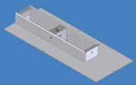 | 1
Gear Unit | 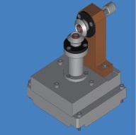 | 1
Gear Unit Cover | 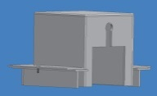 | 1
High volume spinning tub – length 500 mm |  | 1
Cylinder spinning electrode - length 500 mm |  | 1
Plastic cover for spinning tub 500 mm |  | 1
Wire spinning electrode with 12/6 wires – length 500 mm |  | 1
High volume spinning tub – length 200 mm |  | 1
Plastic cover for spinning tub 200 mm |  | 1
HV shields for high volume tubs |  | 1 pair (2 pieces)
Spinning Carriage Module | 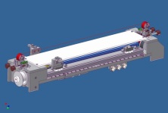 | 1
Safety HV cover for EMW module | 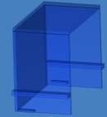 | 2
Cover for SE positioning tool | 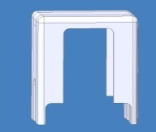 | 2
One-sided carriage (low volume 40 ml) | 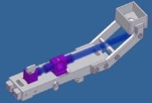 | 1
Covers for polymeric solution reservoir |  | 1
Residual polymeric solution reservoir | 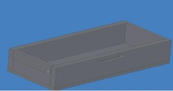 | 1
Cover for one-sided carriage | 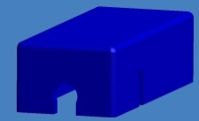 | 1
Metal insert with calibrated orifice (sizes 0,5;0.6;0.7;0.8) |  | 4
Securing rod for metal inserts | 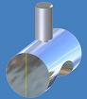 | 4
Securing clip (spare parts) |  | 3
Heavy metal shaft for substrate material core |  | 1
Light metal shaft for substrate material core |  | 2
Plastic Cone for shafts |  | 4
Substrate on the core , standard is 40 meters, if not part of contract | 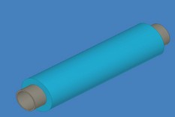 | 1
Substrate Core | 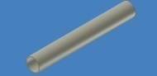 | 1
Empty coil for winding | 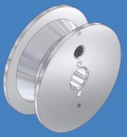 | 1
Wire Feed system coil |  | 2
Exhaust Filters | 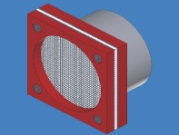 | 1
Dirak Key |  | 1
Sets of Door Keys |  | 1 pcs
Fire Extinguisher connection | 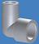 | 1

Packaging description and dimensions

- For short distances an light –less robust system of packaging is selected
- The Equipment is packed according to the best industry standards for export packaging of machines with electro-components, and in crates from OSB or plywood material that is compliant with the IPPC (ISPM 15) directive.
- The Equipment is sealed inside the crate in an Alu composite (PET/AL/PE) protective wrapping, and with desiccants to maintain a moist-free environment during transport for min. of 6 months (unless mechanically opened / perforated).
- Shock and tilt indicators with unique IDs are attached to the crate to provide immediate information at the delivery on an eventual improper manipulation by a carrier during transport.
- All sides of the crate are joined by screws for easy and safe unpacking and possible repacking.
- The crate is built for manipulation by a forklift and is non-stackable.
- The crate is built with an inspection hatch secured with a latch for possible security cargo checks or customs checks.
- The unpacked Equipment (with intact wrapping) can be stored in a roofed area with a constant temperature (fluctuation +/- 5°C). The Min. / Max. recommended storage temperature is -5°C / +35°C.
- When the protective wrapping is torn, the Equipment can be safely stored in the crate for limited period only when proper ventilation is secured (lid or one side and wrapping is removed) in order to prevent a build-up of moisture due to physical properties of the wooden material.

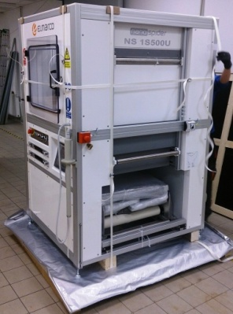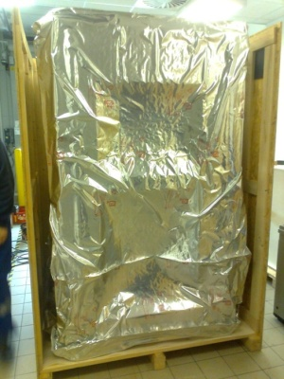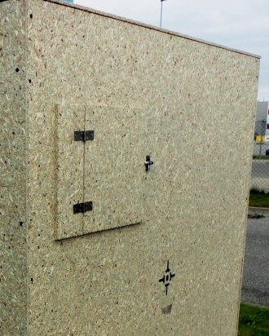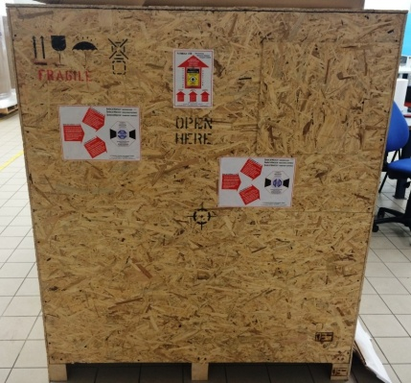

Appendix - Elmarco After-Sales Service Terms & Conditions

Service during warranty period
Costs for warranty service within the 12 month warranty period are born by Seller, including emergency support services, for covered issues.

Elmarco is not responsible for issues outside the scope of the Warranty clauses.

Service after warranty period
Seller will provide support services to Buyer after the warranty period in accordance with the following fee schedule (subject to change without notice):

Hourly rates of service engineers
- Maximum working hours are up to 10 hrs/day (incl. travel time)
Item | Day of Week | Hours  (local time) | Pricing-factor | Hourly Rate per person
 |  |  |  | technician | specialist
on site work - standard working hours | Monday – Friday | 8:00 - 16:00 | base rate | 112,00 € | 156,00 €
on site work - urgent work + not standard hours | Monday – Friday | 16:00 - 08:00 | 1,50 | 175,50 € | 234,00 €
on site work - urgent work + not standard hours | Sat, Sun & Holiday | Any | 1,50 | 175,50 € | 234,00 €
preparation work at ELMARCO + remote work | Any | Any | 2/3 | 78,00 € | 104,00 €
travel time | Any | Any | 1/2 | 58,50 € | 78,00 €

Expenses
- Travel expenses (transportation, lodging, pers. allowance) at cost
- Shipping cost (spare parts / material / service tools) at cost

