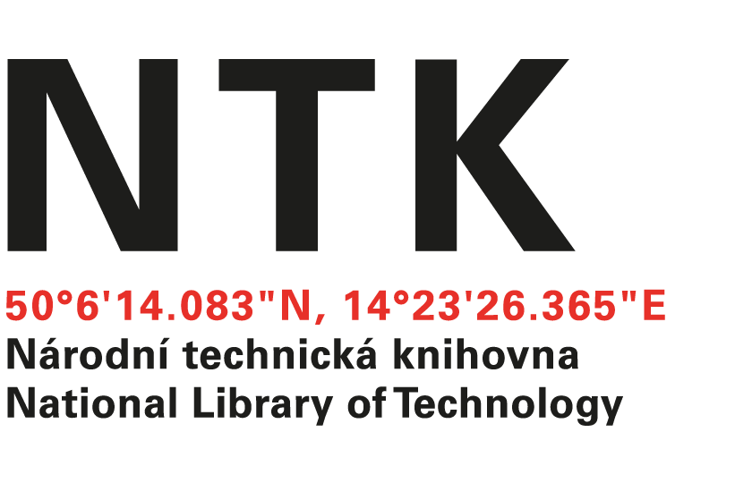
Order

No. 151/EIZ/2025/NTK

Customer: | Supplier:
National Library of Technology | McGraw-Hill  xxxxxxxxxxxxx
Technická 6/2710 | 104 Windsor Center Drive, Suite 400
160 80 Prague 6 - Dejvice | East Windsor
Czech Republic | NY 08520
ID: 61387142
VAT: CZ61387142

Dear xxxxxxxxxxx,

based on your offer from 1. 12. 2025 we order unlimited access to AccessScience for the price $ 18,395.25. Term: from 01 Januar, 2026 to 31-December, 2026.

Kind regards

xxxxxxxxxxxxxx
electronic resources librarian

Order accepted by:
Date of issue: 18. 12. 2025
Issued:
xxxxxxxxxxxxxxx
email: eiz@techlib.cz

