Technická specifikace knižního skeneru
Předmětem naší nabídky je (A2+) knižní skener BookTEK 5 V2 Archive, který splňuje všechny požadované parametry definované v Příloze č.3 zadávací dokumentace.
Ilustr. obr. :knižní skener (A2+) BookTEK 5 V2 Archive(výrobce Image Access, Německo)
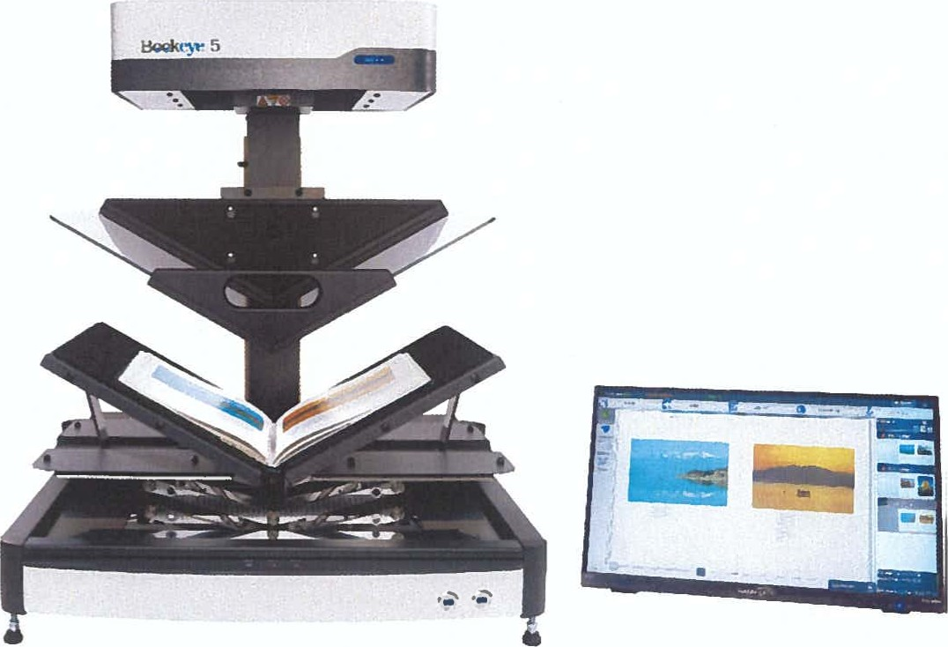
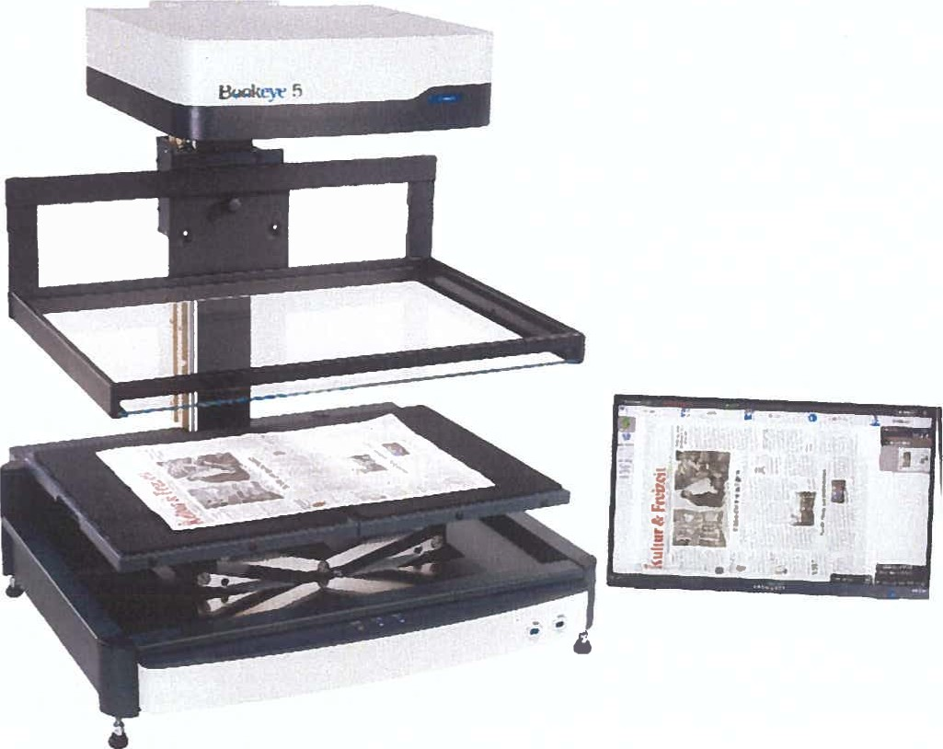

Označení skeneru | BookTEK5 V2  Archive
Snímač | Lineární CCD
Rozlišení | 600 x 600 dpi
Velikost sken. plochy | formát A2+(2 x A3) skenovací plocha  460 x 620 mm
Rychlost skenování | (A2+, 600 dpi)
Barevná hloubka | 48 bit color, 16 bit greyscale
Knižní kolébka | Manuální, samovyvažitelná ve tvaru „V” možno skenovat v úhlu 120⁰  anebo 1 80⁰
Přítlačné sklo | ANO, manuální ve tvaru „V” a „ploché”
Největší rychlost skenování | (A2+) @150 s
Nožní spínač | ANO
Zivý náhled | ANO
Laserová kontrola autofocusu | ANO
Integrované Linux PC | ANO
Profesionální ovládací SW | ANO, BatchScan Wizard
Výstupní formáty | Multipage PDF(PDF/A) a TIFF, JPEG, JPEG 2000, atd.
Standardy | ISOI 9264, Metamorphoze, FADGI
Náhledová obrazovka | Ano, 21” obrazovka

BookTEK@5

A2+ Book Scanner The production scanner for challenging digitization projects
V3 / V2 Archive
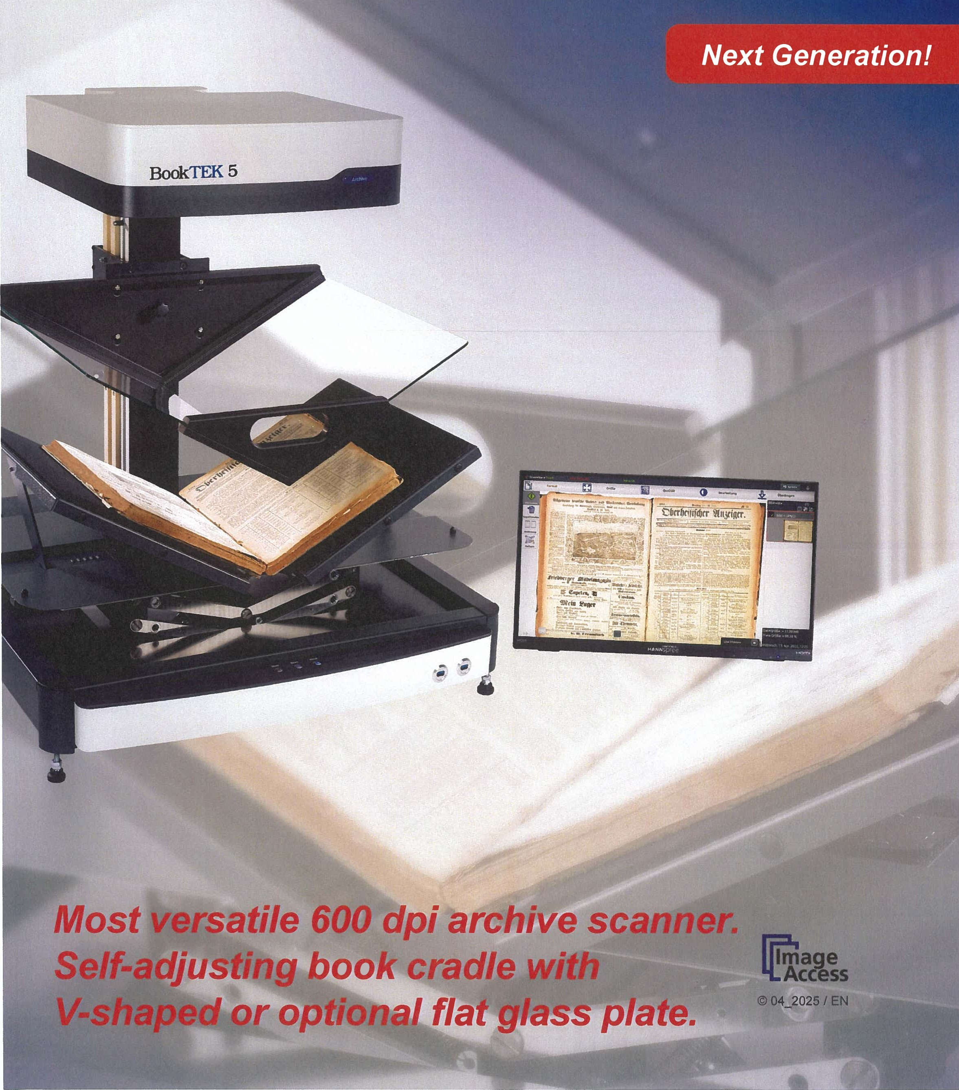
Image
Access
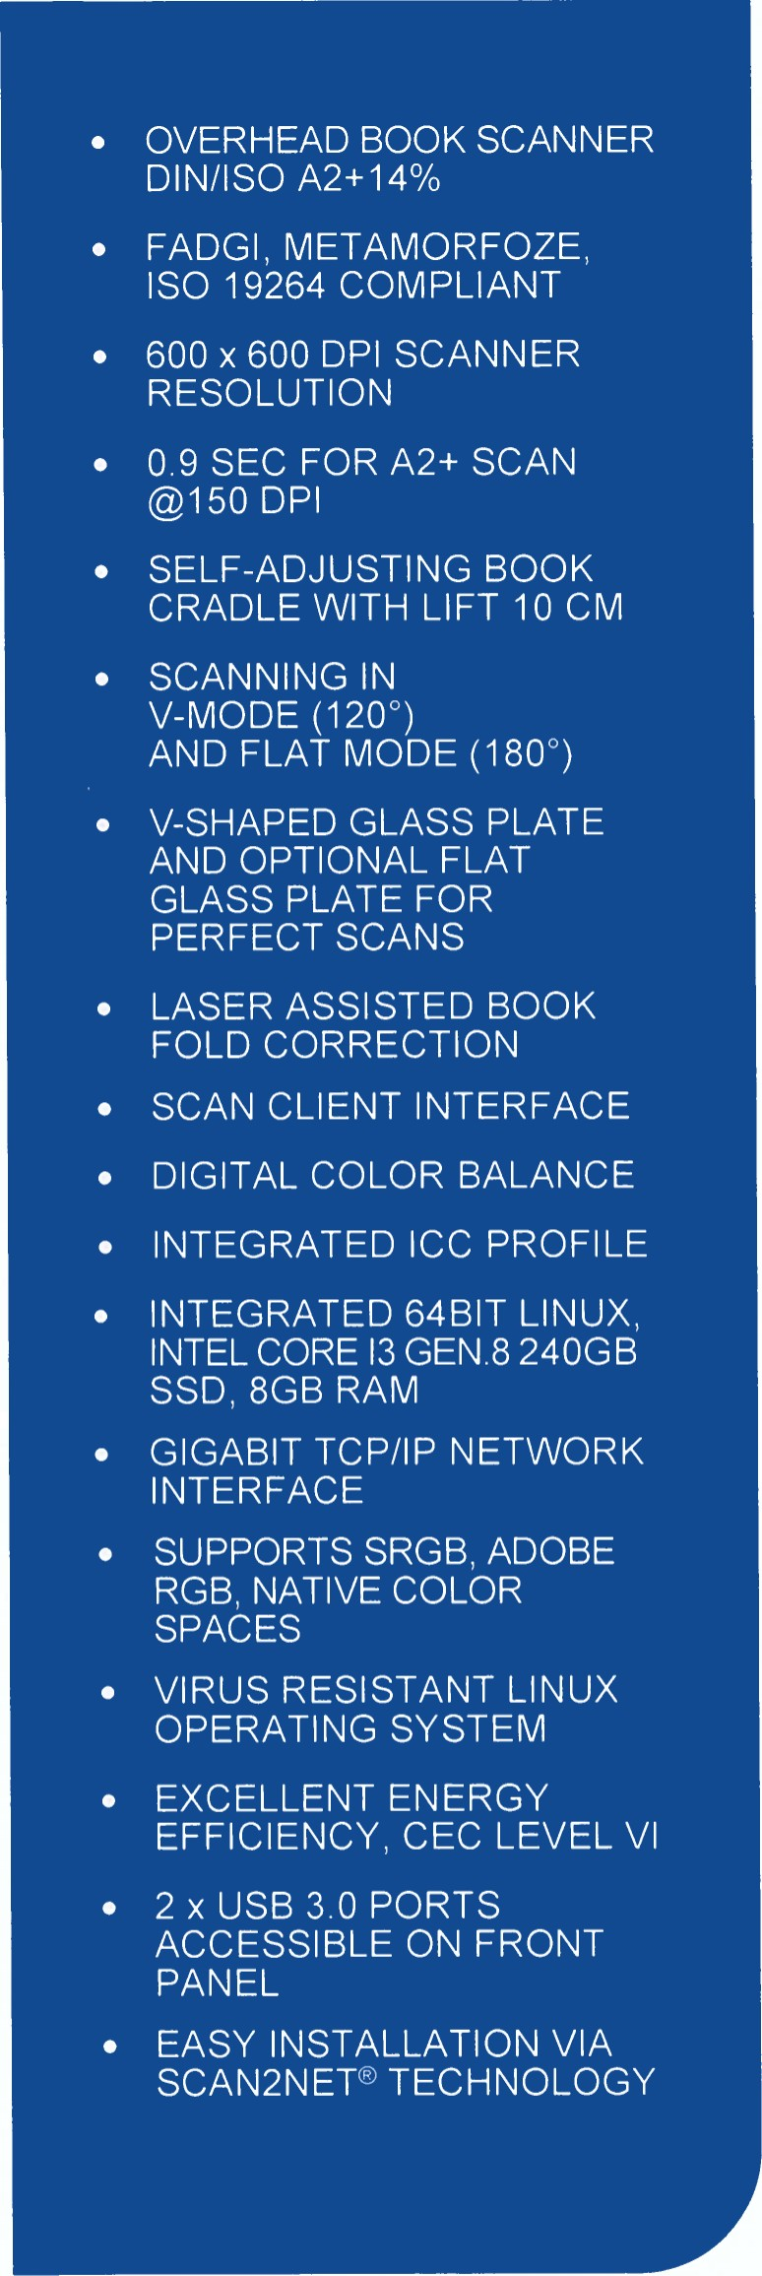
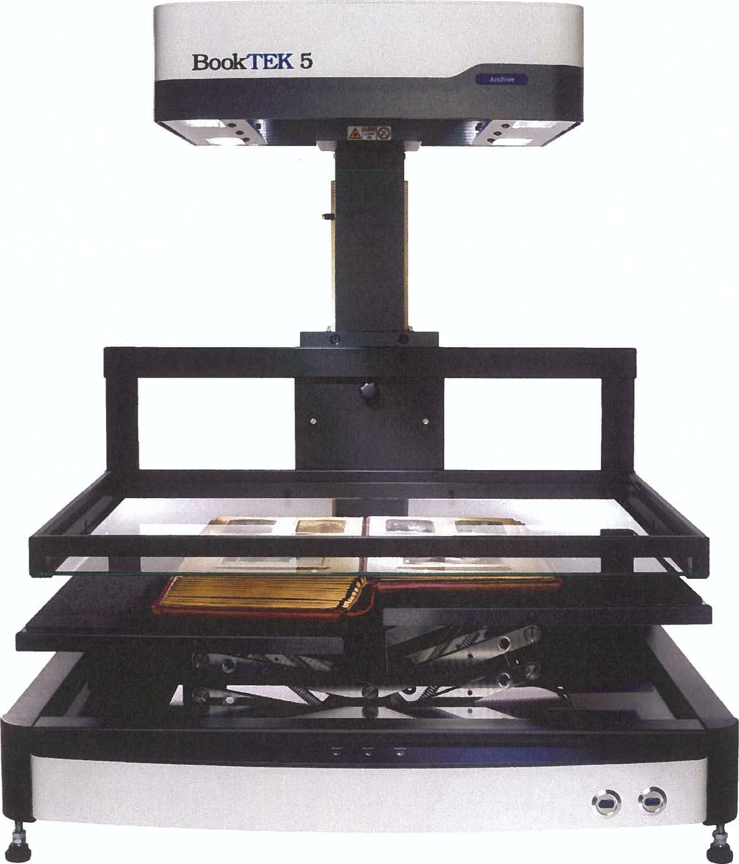
Simple operation, highest productivity.
The BookTEK@ 5 V2 Archive book scanner qualifies as a production system for all challenging digitization projects. Self-adjusting book cradle with V-shaped as well as an optional flat glass plate.
Using the latest camera technology from Image Access, this scanner meets FADGI, Metamorfoze, and ISO 19264 specifications.
PRODUCTIVITY MEETS QUALITY IN DIGITIZA TION!

The production system for digitization projects Highlights: Self-adjusting book cradle with V-shaped glass plate and optional flat glass plate
BookTEK@ 5 V2 Archive is suitable for digitization projects that require high quality and maximum productivity even in 24/7 operation. Originals up to A2+ in size such as books, magazines, posters, folders, or bound documents of all types, can be digitized at high speed and a resolution up to 600 dpi using the BookTEK@ 5 V2 Archive.
The unique self-adjusting book cradle solution allows scanning either at a 120-degree angle or in horizontal mode and lying flat with a height compensation of 10 cm.
Glass plate solutions
The book cradle enables perfect scans while protecting the book binding. The V-shaped glass plate can be removed in a few simple steps. Depending on requirements, the BookTEK@5 V2 Archive can now be used with an optional flat glass plate or without a glass plate at all.
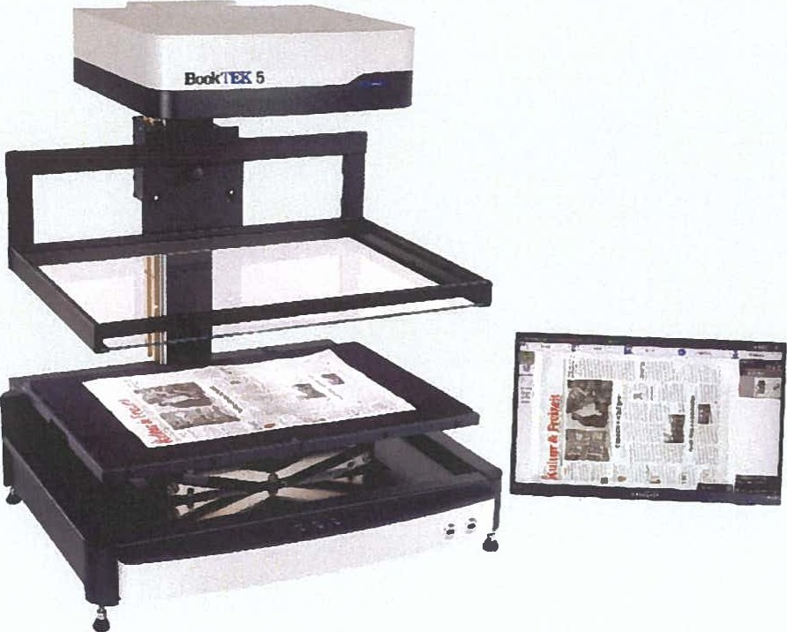
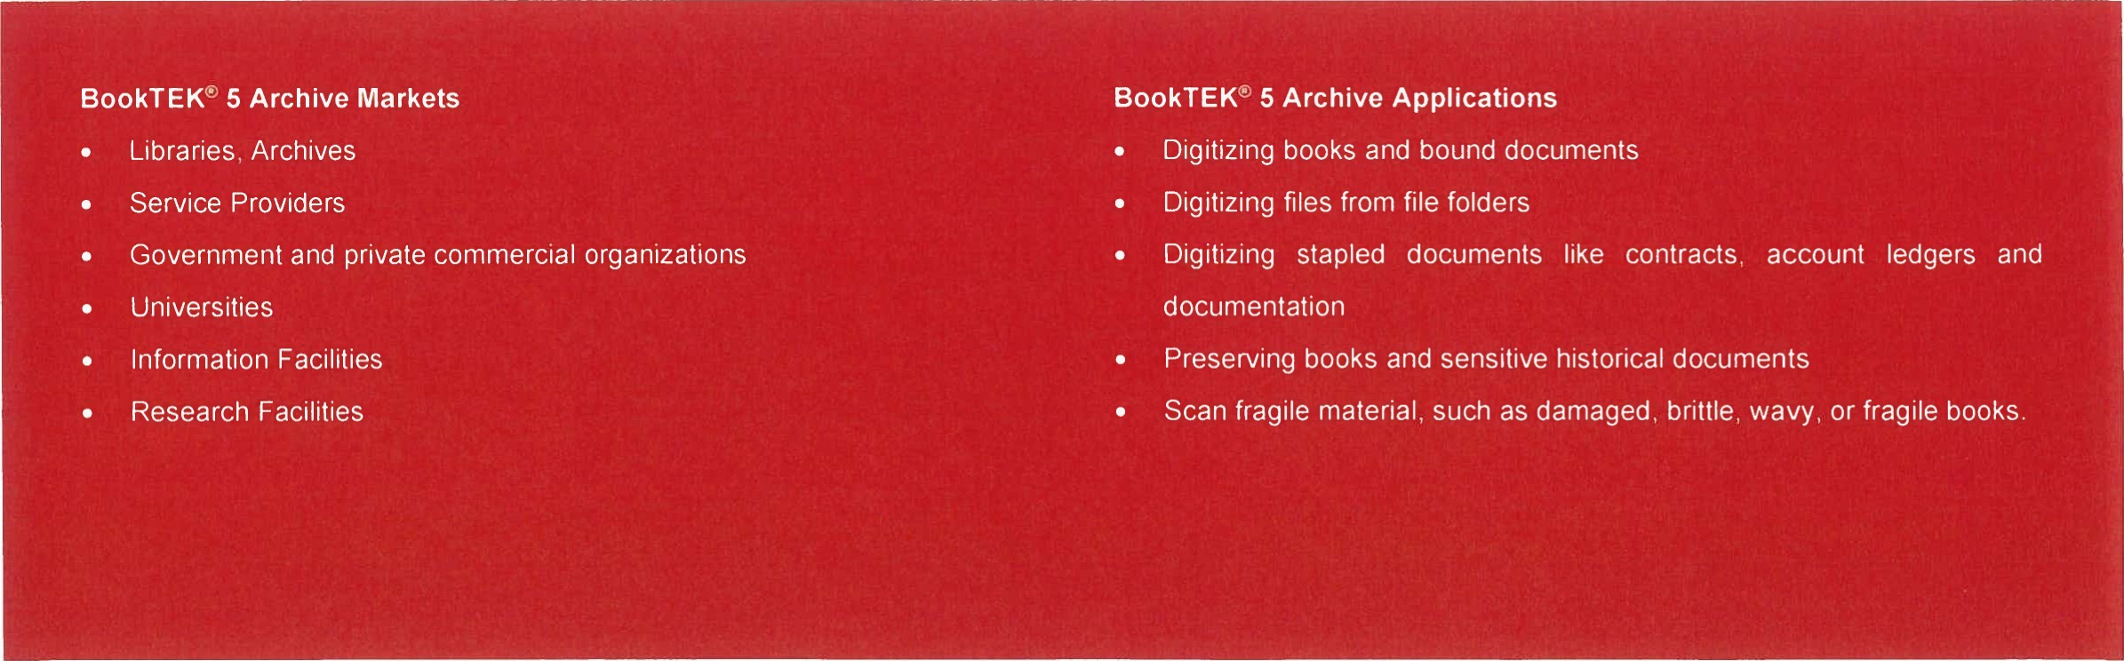
Scanning newspapers up to A2 with flat glass plate.
Highlights that make the BookTEK@ 5 V2 Archive the right choice for every application
- Large 21" full HD color multitouch screen for simplified operation, 2 ^{nd} preview screen optional Live Preview
- Self-adjusting book cradle 120 - 180 degrees can lift 10 cm V-shaped glass plate for perfect scans, optional flat glass plate is available output formats: PDF, PDF/A, JPEG, TIFF, PNM, multipage PDF and TIFF, DICOM and many more
- OS independent, runs with Windows, Linux, Mac
- Digital color balance, wide color gamut, supports sRGB, Adobe
RGB, native RGB
- FADGI, Metamorfoze, ISO 19264 compliant.
- ScanWtzard runs through any browser via network
- Remote maintenance, troubleshooting and firmware updates Full Coverage Warranty — Up to 5 years, free spare parts & consumables
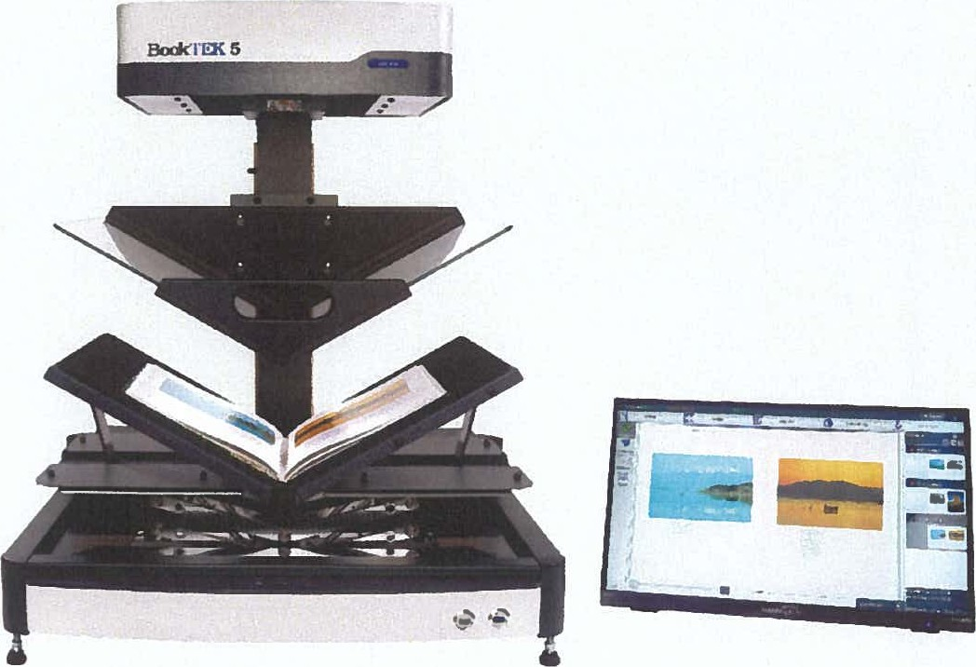
Scanning highly glossy originals with V-shaped glass plate.

- Base unit with book cradle and glass plate
- 21" full HD, 1920 ^{x} 1080p resolution touch screen
- Power supply for scanner and 21" screen including power cords
- Foot switch
- Test and calibration targets One year of Full Coverage Warranty
- Suitable for mobile applications
Easy installation (ready to use in under 1 hour)
Options
BE5-V2-GLAS-FLAT | Flat Glass Plate
BSW-P-BE5-01 | Batch Scan Wizard Pro License
SCAN20CR | Background OCR on scanner
BE5-V2-P-SP12M | Full Coverage Warranty, up to 5 years
Scan2Net@Advantages
- 64 bit Linux based computer, fast and virus protected Routable, easy integration into existing network structures Scans directly to SMB, FTP, hot folders, Email or the Cloud
- Simple, intuitive operation via full HD touchscreen

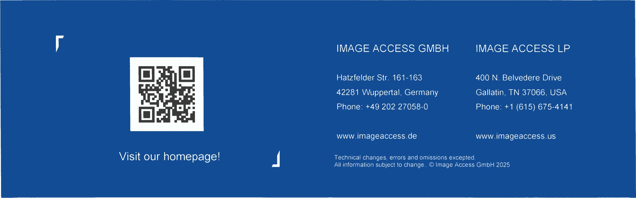
TECHNICAL DATA
Maximum Scan Area  Scanner Resolution  Scan Speed  Color Depth  Scan Output  File Formats  ICC Profiles  Quality  Camera  Live Preview Camera  Light Source Lamp Life Time  Computer  Touchscreen  USB Port  Interface  Dimension / Weight  Electrical Specification  Power Consumption  Environment  Noise  Approvals | V3 Archive = 390 x 480 mm (15.3 x 18.9 inch), more than DIN/ISO A3  V2 Archive = 460 x 620 mm (18 x 24 inch), 14% more than DIN/ISO A2  600 x 600 dpi  DIN A3+ @ 150 dpi: 0.8 s, @ 200 dpi: 0.9 s, @ 300 dpi: 1.3 s, @ 400 dpi: 1.7 s, @ 600 dpi: 2.4 s DIN A2+ @ 150 dpi: 0.9 s, @ 200 dpi: 1.1 s, @ 300 dpi: 1.6 s, @ 400 dpi: 2.0 s, @ 600 dpi: 3.0 s  48 bit color, 16 bit grayscale  24 bit color, 8 bit grayscale, bitonal, enhanced halftone  Multipage PDF (PDF/A) and TIFF, JPEG, JPEG 2000, PNM, PNG, BMP, TIFF (Raw, G3, G4, LZW, JPEG),  AutoCAD DWF, JBIG, Djvu, DICOM, pcx, Postscript, EPS, raw data and more  Embedded for sRGB, Adobe RGB and native. Individual profiling via web based Scan21CC subscription  Complies to FADGI *** guidelines, Metamorfoze Light, ISO 19264 Level B  CCD line sensor  CMOS matrix, area sensor  Mite LEDs, tested according to IEC 62471 , no IR/UV emission  50,000 h typ. Lamps are covered by the Extended Warranty Option  64 bit Linux, Intel@ Core TM i3 generation 8 processor, 240GB SSD, 8 GB memory for extra large jobs  21" full HD 1920 * 1080 multitouch screen  2 x USB 3.0 port, 4 x USB 2.0 port  1 GBit fast Ethemet with TCP/IP based Scan2Net@ interface  V3 Archive = H x w x D: 840 x 585 x 625 mm (33 x 23 x 24.5 inch) / 48.5 kg (107 lbs.)  V2 Archive = H x wx D: 870 x 730 x 670 mm (35 x 29 x 26 inch) / 53 kg (117 lbs.)  100-240 V AC, 47 - 63 Hz (external power supply, complies with ECO standard CEC level VI)  < 0.5 W (Sleep) 1 1.5 W (Standby) / 40 W (Ready to Scan) / 110 W (Scanning)  Operating temperature 5 to 40 ⁰ C, relative humidity 20 to 80% (non-condensing)  < 42 dB(A) (Scanning) / < 33 dB(A) (Standby)  IEC/EN 62368-1:2014 Ed.2, AUS/NZL 62368-1:2014 Ed.2  UL 62368-1:2014 Ed.2, CSA 62368-1:2014 Ed.2, RoHS, WE-EE
ISO
19264.i

RoHS DGI
Intertek
Image Access GmbH
Hatzfelder Straße 161 - 163
42281 Wuppertal, Germany
Image Telefon: xxx
Access Telefax: xxx
E-Mail: xxx
Internet: www.imageaccess.de
Image Access GmbH, Hatzfelder Str. 161-163, 42281 Wuppertal
To whom it may concern
October 01, 2025
Distributorship of Image Access products in the Czech Republic
Dear Sirs,
Herewith we certify that
DIGIS spol. s r.o.
VYstavni 292/13
702 00 Ostrava - Moravskå Ostrava
CZECH REPUBLIC
is our exclusive authorized distributor of Image Access' BookTEK @ products as well as service partner for the Czech Republic
DIGIS is certified to handle BookTEK@ sales, warranty and service issues in the mentioned region.
BookTEK@ Scanners which are supplied by any other company will not be covered by any manufcaturer's warranty and won't be serviced or supported in any way!

Deutsche Bank Wuppertal
BIZ xxx
Konto xxx
IBAN: xxx xxx Stadtsparkasse Wuppertal
BIZ xxx
Konto 77 42 40
WEEE: xxx Amtsgericht Wuppertal HRB 8290 Geschäftsführer:
VAT: xxx
xxx Thomas Ingendoh

