ERASMUS+ PROGRAMME
COOPERATION PARTNERSHIPS IN SCHOOL EDUCATION (KEY ACTION 220)
AGREEMENT NUMBER 2025-1-IT02-KA220-SCH-000350097

CONTRACT BETWEEN THE COORDINATOR AND OTHER BENEFICIARIES

This contract shall govern relations between:
hereafter named “ the Coordinator “, represented by ,

Mariarosaria Russo on the one hand

and

hereafter named “ the Partner “, represented by on the other hand,
Základní škola, Trutnov, V Domcích 488
IČO 641201121
Ing. Zuzana Horáková Radová

Which have agreed follows:

1 The Coordinator shall be entitled to add other classes to those indicated here

Article 1/ Subject 2025-1-IT02-KA220-SCH-000350097

- The Coordinator and the Partner commit themselves to carrying out the work programme covered by this contract.
This work programme comes under the Agreement (2022-1-IT02-KA220-SCH-000087575)
concluded between the Coordinator and the National Agency.

- The maximum grant of the contractual period referred to by the Agreement 2025-1-IT02-KA220-SCH-000350097 , is estimated at (the amount mentioned in Article 1.3.1 of the Agreement 2025-1-IT02-KA220-SCH-000350097 EUR 44.742,00

- This contract shall regulate relations between the parties, and their respective rights and obligations with regard to their participation in the project (Digital Literacy-Readiness 4 ALL) under the Agreement 2025-1-IT02-KA220-SCH-000350097 passed between the National Agency and the Coordinator.

- The subject matter of this contract and the related programme are detailed in the annexes, which form an integral part of this contract and that each party declares to have read and approved

Article 2/Duration

- The project referred to in Article 1 has a duration of 24 months. It starts 01.11.2025 and ends on 31.10.2027 at the latest.

- This contract enters into force on the date of signature by the last of both participating parties to the contract and terminates at the moment of payment of the balance of the contract.

- The period of eligibility of the costs starts on 01.11.2025 and ends on 31.10.2027 at the latest.

Article 1/ Subject 2025-1-IT02-KA220-SCH-000350097

- The Coordinator and the Partner commit themselves to carrying out the work programme covered by this contract.
This work programme comes under the Agreement (2022-1-IT02-KA220-SCH-000087575)
concluded between the Coordinator and the National Agency.

- The maximum grant of the contractual period referred to by the Agreement 2025-1-IT02-KA220-SCH-000350097 , is estimated at (the amount mentioned in Article 1.3.1 of the Agreement 2025-1-IT02-KA220-SCH-000350097 EUR 44.742,00

- This contract shall regulate relations between the parties, and their respective rights and obligations with regard to their participation in the project (Digital Literacy-Readiness 4 ALL) under the Agreement 2025-1-IT02-KA220-SCH-000350097 passed between the National Agency and the Coordinator.

- The subject matter of this contract and the related programme are detailed in the annexes, which form an integral part of this contract and that each party declares to have read and approved

- to comply with all the provisions of Agreement 2025-1-IT02-KA220-SCH-000350097 binding the Coordinator to the National Agency.

Article 4/0bligations of the Partner
The Partner shall undertake:
1. to take all the steps necessary to prepare for, perform and correctly manage the work programme set out in this contract and in its annexes, in accordance with the objectives of the project as set out in the Agreement 2025-1-IT02-KA220-SCH-000350097 concluded between the National Agency and the Coordinator;
- to comply with all the provisions of Agreement 2025-1-IT02-KA220-SCH-000350097 5 binding the Coordinator to the National Agency;

- to communicate to the Coordinator any information or document required by the latter that is necessary for the management of the project;

- to accept responsibility for all information communicated to the Coordinator, including details or costs claimed and, where appropriate, ineligible expenses;

- to define in conjunction with the Coordinator the role and rights and obligations of the two parties, including those concerning the attribution of the intellectual property rights.
Article 5/Financing
1. The maximum grant of the Partner for the period covered by this contract is estimated at EUR. The partner's detailed budget is described in the annexes co the contract (Annex a).
Article 6/Payment Arrangements
- The Coordinator commits himself to carrying out payments relating to the subject matter of this contract to the Partner according to the achievement1of the tasks and according to the following schedule:
1st payment:
An initial advance Euros 17.896,80 (40%) of the grant, within 30 days of receiving the initial paymcnt from the National Agency.
2nd payment:
A second advance Euros 17.896,80 (40%) of the grant upon receipt of claim forms with supporting documentation and agreed outcomes in the work programme. The beneficiary reserves the right to withhold this second advance if the partner's report to coordinator is submitted after the deadline mentioned in article 8 of this contract.

3th and final payment Euros 8.948,40 (20 %). The balance will be paid once the partner's contractual agreements have been fully met, all the necessary supporting documentation has been received and the National Agency has approved the final report. The beneficiary reserves the right to withhold the balance and demand a refund of the amounts already paid if the report is presented after the deadline mentioned in article 8 of this contract.

2. All payments shall be regarded as advances pending explicit approval by the National Agency of the final report including approval of the eligibility of the costs, the corresponding cost statement and the quality of the results of the project.

Article 7/Bank account

I (references of the bank account opened in the name of the Partner into which the funds allocated to the Partner will be paid)
Name of Bank: Komerční banka, s.s.
Address: Horská 634, Trutnov 541 72
Account holder:Základní škola, Trutnov, V Domcích 488
Full account number (including bank codes): 115-1088290237/100
IBAN/BIC code: CZ09 0100 0001 1510 8829 0237

Article 8/Reporting

- The Partner shall provide the Coordinator with any information and documents required for the preparation of the interim report and, where appropriate, with copies of all the necessary supporting documents completed and signed by the legal representatives by 01.12.2025 at the latest

- The Partner shall provide the Coordinator with any information and documents required for the preparation of the final report and, where appropriate, with copies of all the necessary supporting documents completed and signed by the legal representative by 01.11.2027 at the latest.

Article 9/Monitoring and supervision
- The Partner shall provide without delay the Coordinator with any information that the latter may request from him concerning the carrying out of the work programme covered by this contract.

- The Partner shall make available to the Coordinator any document making it possible to check that the aforementioned work programme is being or has been carried out.

- The obligations described in Article 11.27 (checks and audits) of Annex I of the Agreement 2025-1-IT02-KA220-SCH-000350097 - apply to the coordinator and partner.

Article 10/Liability
- Each contracting party shall release the other fron1 any civil liability in respect of damages resulting from the performance of this Agreement, suffered by itself or by its personnel, to the extent that these damages are not due to the serious or intentional negligence of the other party or its personnel.

- The Partner shall protect the National Agency, the Coordinator and their personnel against any action for damages suffered by third parties, including project personnel, as a result of the performance of this contract, to the extent that these damages arc not due to the serious or intentional negligence of the National Agency, the Beneficiary or their personnel.

Article 11/Termination of the contract

- The Coordinator may terminate the contract if the Partner has inadequately discharged or failed to discharge any of the contractual obligations, in so far as this is not due to force majeure, after notification of the Partner by registered letter has remained without effect for one month.

- The Partner shall immediately notify the Beneficiary, supplying all relevant information, of any event likely to prejudice the performance of this contract.

Article 12/ Jurisdiction clause

- Failing amicable settlement, the Courts of (National Agency in Italy) shall have sole competence to rule on any dispute between the contracting parties in respect of this contract.

- The law applicable to this contract shall be the law of Italy.

Article 13/Amendments or additions to the contract

Amendments to this contract shall be made only by a supplementary Agreement signed on behalf of each of the parties by the signatories to this contract.

Annexes

- Detailed budget relating to the activities of the Partner.
- Description of the partner´s tasks.
- Copy of Agreement
- 2025-1-IT02-KA220-SCH-000350097 between Coordinator and National Agency including Annexes

Done at Rosarno, Italy in two copies

For the Coordinator For the Partner
The legal representative The legal representative

............................................................... .......................................................
Principal Principal

Date: Date:

a, BUDGET DETAILS EACH PARTNER COUNTRY
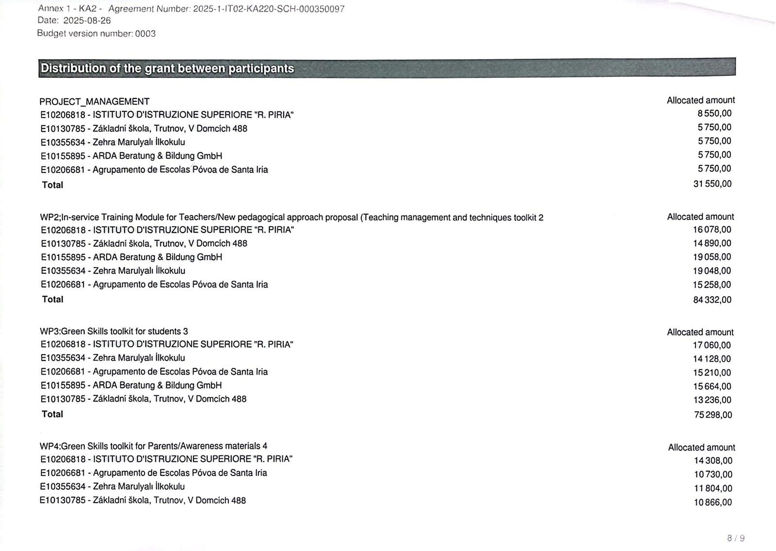
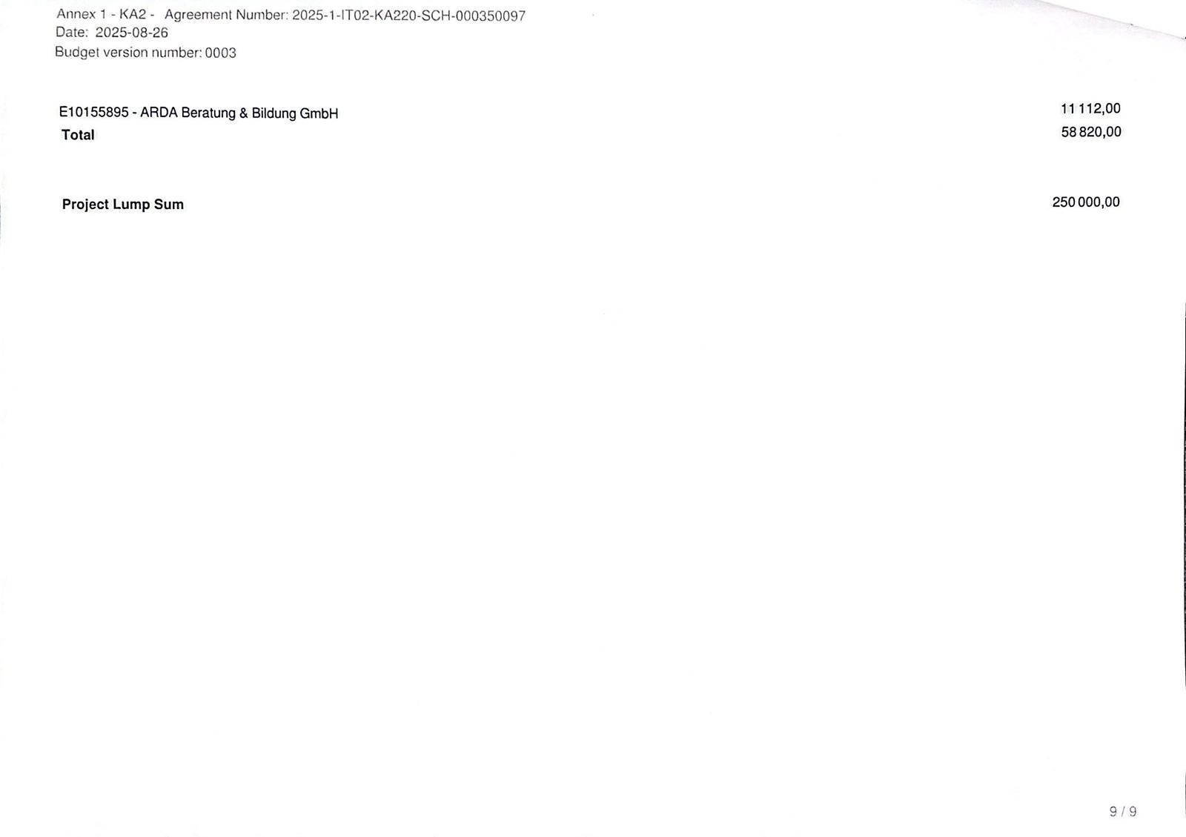

GreenArt4ALL – WP2 Task List (English Version)
This document provides a clean, presentation-free summary of WP2 with explicit WP/Ax references.

WP2 – Specific Objectives and Contribution to Project Objectives
WP2 aims to develop innovative and effective learning methods in Environmental Education (EE), based on needs identified through teacher and student feedback. By integrating STEAM with ecology-based education and ecological/digital art approaches, WP2 helps apply theoretical knowledge to real-life environmental challenges.
Specific Objectives (WP2):
- SO1 (WP2): Establish an open-access, Moodle-based e-learning platform with Teacher / Student / Parent sections.
- SO2 (WP2): Propose a new pedagogical approach emphasizing inquiry-based, project-based, and experiential learning to foster green skills, critical thinking, and creative problem-solving.
- SO3 (WP2): Design interactive online e-courses for teacher training (ecology, EE, integration of art and digital tools).
- SO4 (WP2): Provide ongoing professional development to empower teachers to implement new methodologies effectively.
Contribution to General Objectives: WP2 promotes environmental awareness, climate change education, and green skills, and strengthens active participation and critical engagement among teachers and learners.

WP2 – Main Results (Deliverables)
- D2.1 (A1): TPM in Italy (kick-off).
- D2.2 (A2): Open-Access MOOC (Moodle) with Teacher / Student / Parent sections.
- D2.3 (A3): GREENART4ALL website, YouTube channel, and social media accounts.
- D2.4 (A4): New Pedagogical Approach – interactive theory book for teachers (ecology + digital/eco-art with STEAM).
- D2.5 (A5): In-Service Training Framework for Teachers (e.g., global warming, ecosystem, renewable energy, energy conservation, environmental pollution, electromagnetic pollution, recycling, carbon footprint).
- D2.6 (A6): Online In-Service Training e-Course (interactive videos, e-learning materials, assessment).
- D2.7 (A7): eTwinning project launched and Twinspace uploads completed (≥2 schools per country).
- D2.8 (A8): Learning/Teaching/Training Activity (LTTA) for teachers – implementation of the new methods.
- D2.9 (A3/A5/A6): Project Newsletter 1 and dissemination packages.

WP2 – Qualitative and Quantitative Indicators
- TPM Evaluation (WP2): participant questionnaires, focus group insights, satisfaction levels.
- LTTA Evaluation (WP2): host-run pre/post knowledge questionnaires; counts of attendance papers and Europass Mobility certificates.
- Tangible Outputs (WP2): external evaluator report; teacher usability/relevance surveys; download/usage analytics; school pilot reports.
- Online Course (WP2): number of educators benefiting; module evaluation survey results; Sustainable Environmental Attitude Scale scores.
- eTwinning (WP2): participant opinions/satisfaction (target ≥ 85%).
- Quality Monitoring (WP2): continuous QA and time management checks by WP leaders (DE & TR); checklists; progress reports.

WP2 – Roles and Responsibilities

WP2 Leaders
P2 (Turkey – School) – Co-Leader:
- Lead the WP2 timeline; prepare activity templates; upload content to the platform (WP2/Ax).
- Set up and manage the Moodle-based e-learning platform (WP2/A2).
- Create and maintain the project website and social media accounts (WP2/A3).
- Produce and finalize activity content (WP2/A4–A6).
- Conduct dissemination activities and prepare Project Newsletter 1 (WP2/A3/A5/A6).
P4 (Germany) – Co-Leader:
- Create interactive e-learning content (WP2/A6).
- Provide technical support for the e-learning platform and digital tools (WP2/A2/A6).
- Prepare the high-quality project presentation video (WP2 dissemination package).
- Co-produce content across activities (WP2/A4–A6).
- Organise the LTTA for teachers (WP2/A8).
- Participate in dissemination (presentations, workshops, social media).

All Partners (WP2)
- Attend the kick-off in Italy and the LTTA with at least two representatives (WP2/A1 & A8).
- Produce and submit their own content on time, following project guidelines/templates (WP2/A4–A6).
- Develop a section of the teacher training programme (WP2/A5–A6).
- Create interactive content for modules and submit to the quality board (WP2/A5–A6).
- Prepare outputs in their local language and in English (WP2 deliverables).
- Promote the project locally, regionally, and transnationally (WP2 dissemination).
- Engage at least two stakeholder schools and students in the eTwinning project (WP2/A7).
- Pilot WP2 activities in their own institutions (WP2 pilots).
- Carry out activities in line with the dissemination plan (WP2 dissemination).

WP2 – Activities (A1–A8)
A1 (WP2): TPM in Italy – Kick-off project meeting; management topics and WP2 task allocation.
A2 (WP2): E-learning Platform – Open-access Moodle platform with Teacher/Student/Parent sections (led by TR, supported by CZ).
A3 (WP2): Project Website & Social Media – Set-up and content management (led by TR).
A4 (WP2): New Pedagogical Approach – Interactive e-Book – Ecology-based education + eco/digital art + STEAM; good practices and method/technique compendium; sub-sections by P1–P5.
A5 (WP2): In-Service Training Framework for Teachers – Theoretical module set (e.g., global warming, climate change, air quality, pollution, food contamination, electromagnetics, ozone hole, ecosystem, etc.).
A6 (WP2): Online In-Service Training e-Course – Transform A5 into an interactive e-course; lesson scenarios; Europass certification.
A7 (WP2): eTwinning Project – ≥2 schools per country; environment-themed STEAM applications; Twinspace uploads (TR with all partners).
A8 (WP2): LTTA for Teachers – 5-day programme (Animation; Simulation; Augmented Reality; Interactive Video; Digital Art & Serious Games).

Project Timetable and Reporting (with WP References)
- Transnational Project Meetings (TPMs): M1 – Italy (Kick-off, WP2/A1); M2 – Turkey; M3 – Germany.
- Learning/Teaching/Training Activities (C-type): WP2/A8 – Teachers (Czechia per timetable) ; WP3 – Students LTTA in Portugal.
- Online meetings: every three months.
- Reporting (R-type): partners’ financial reports (every 3 months); Progress Report; Interim Report; Final Report; Dissemination (WP2 & WP3 & WP4); Exploitation; Quality monitoring reports.

