Obsah objednávky
 | Kód | Položka | Mn. | Cena za m. j. | Cena
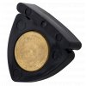 | 217112 | ALPINE MUTE black violin | 2 ks
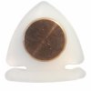 | 217111 | ALPINE MUTE white violin | 1 ks
 | 186116 | Bow Brand No.6 PEDAL Natural Gut (G1) | 3 ks
 | 186125 | Bow Brand No.12 PEDAL Natural Gut (A2) | 2 ks
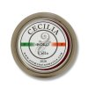 | 192229 | Cecilia SOLO Cello | 1 ks
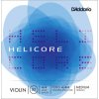 | 131500 | D'Addario HELICORE H310M set violin | 1 sada
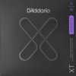 | 119720 | D'Addario XTAPB1152 | 2 sada
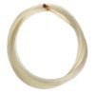 | D111022 | Dictum 111022 - Mongolian BOW HAIR viola | 2 ks
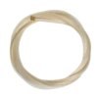 | D111103 | Dictum 111103 - Siberian BOW HAIR bass | 1 ks
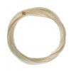 | D111113 | Dictum 111113 - Siberian BOW HAIR cello | 1 ks
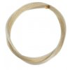 | D113020 | Dictum 113020 - Chinese BOW HAIR violin | 2 ks
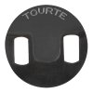 | D543511 | Dictum 543512 - TOURTE MUTE round violin | 2 ks
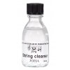 | 393019 | JOHA - String Cleaner | 5 ks
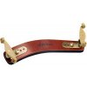 | 215155 | Kun BRAVO (housle) | 1 ks
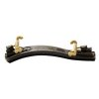 | 215154 | Kun COLLAPSIBLE (housle) | 1 ks
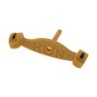 | 215176 | Kun SPARE FOOT (long) 4/4 | 2 ks
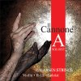 | 137192 | Larsen IL CANNONE SOLOIST (A) violin | 1 ks
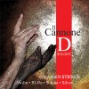 | 137193 | Larsen IL CANNONE SOLOIST (D) violin | 4 ks
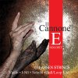 | 137191 | Larsen IL CANNONE SOLOIST (E) violin | 1 ks
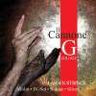 | 137194 | Larsen IL CANNONE SOLOIST (G) violin | 1 ks
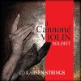 | 137190 | Larsen IL CANNONE SOLOIST set violin | 2 sada
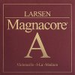 | 137381 | Larsen MAGNACORE (A) cello | 1 ks
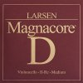 | 137382 | Larsen MAGNACORE (D) cello | 1 ks
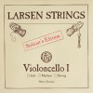 | 137311 | Larsen ORIGINAL SOLOIST (A) cello | 5 ks
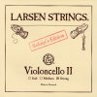 | 137312 | Larsen ORIGINAL SOLOIST (D) cello | 4 ks
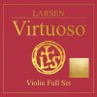 | 137170 | Larsen VIRTUOSO set violin | 3 sada
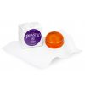 | 125029 | Pirastro EUDOXA Rosin 900200 | 1 ks
 | 122870 | Pirastro EVAH PIRAZZI set viola 429021 | 1 sada
 | 121870 | Pirastro EVAH PIRAZZI set violin 419021 | 2 sada
 | 123871 | Pirastro EVAH PIRAZZI (A) cello 332120 | 1 ks
 | 123874 | Pirastro EVAH PIRAZZI (C) cello 332420 | 1 ks
 | 123873 | Pirastro EVAH PIRAZZI (G) cello 332320 | 1 ks
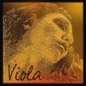 | 122892 | Pirastro EVAH PIRAZZI GOLD (D) viola 425221 | 1 ks
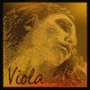 | 122890 | Pirastro EVAH PIRAZZI GOLD set viola 425021 | 4 sada
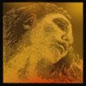 | 121890 | Pirastro EVAH PIRAZZI GOLD set violin (G gold) 415021 | 1 sada
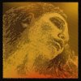 | 1218905 | Pirastro EVAH PIRAZZI GOLD set violin (G silver) 415091 | 1 sada
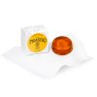 | 125039 | Pirastro GOLD Rosin 900300 | 1 ks
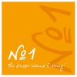 | 121181 | Pirastro No.1 (E ball) violin 311221 | 2 ks
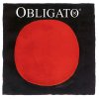 | 121850 | Pirastro OBLIGATO set (E gold) violin 411021 | 1 sada
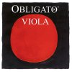 | 122850 | Pirastro OBLIGATO set viola 421021 | 2 sada
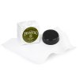 | 125019 | Pirastro OLIV/EVAH PIRAZZI Rosin 900100 | 2 ks
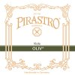 | 122194 | Pirastro OLIV STEIF (C) viola 220442 | 1 ks
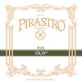 | 122193 | Pirastro OLIV STEIF (G) viola 220342 | 1 ks
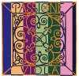 | 122151 | Pirastro PASSIONE (A) viola 229141 | 1 ks
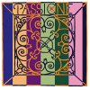 | 121152 | Pirastro PASSIONE (A) violin 219241 | 1 ks
 | 121153 | Pirastro PASSIONE (D) violin 219341 | 1 ks
 | 121151 | Pirastro PASSIONE (E) violin 311321 | 1 ks
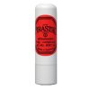 | 125411 | Pirastro PEG COMPOUND 904100 | 1 ks
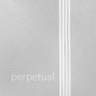 | 121820 | Pirastro PERPETUAL CADENZA set violin 41A011 | 1 sada
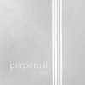 | 122830 | Pirastro PERPETUAL set viola 420021 | 2 sada
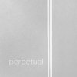 | 121832 | Pirastro PERPETUAL (A) violin 41A221 | 1 ks
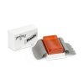 | 125079 | Pirastro PIRANITO Rosin 900700 | 1 ks
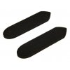 | 125422 | Pirastro RUBBER PAD (violin) for KorfkerRest - pair | 1 pár
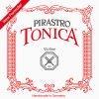 | 121740 | Pirastro TONICA set violin 412021 | 1 sada
 | 121741 | Pirastro TONICA (E) violin 312721 | 1 ks
 | 121731 | Pirastro TONICA (E 3/4-1/2) violin 312741 | 3 ks
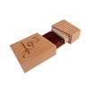 | 192269 | Sandrine Raffin rosin | 2 ks
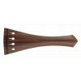 | AT11232 | Teller STRUNÍK palisandr Hill (housle) | 2 ks
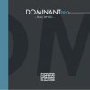 | 111550 | Thomastik DOMINANT PRO set violin DP100 | 1 sada
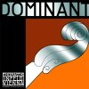 | 111100 | Thomastik DOMINANT set violin 135 | 1 sada
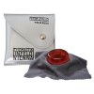 | 115219 | Thomastik PETER INFELD rosin | 1 ks
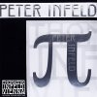 | 111700 | Thomastik PETER INFELD set violin PI100 | 1 sada
 | 111710 | Thomastik PETER INFELD set violin PI101 | 4 sada
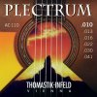 | 117600 | Thomastik PLECTRUM AC110 (010-041) | 1 sada
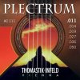 | 117610 | Thomastik PLECTRUM AC111 (011-050) | 1 sada
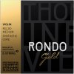 | 111920 | Thomastik RONDO GOLD set violin RG100 | 2 sada
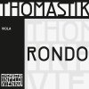 | 112910 | Thomastik RONDO set viola RO200 | 2 sada
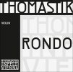 | 111910 | Thomastik RONDO set violin RO100 | 5 sada
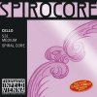 | 113234 | Thomastik SPIROCORE (C wolfram) cello S33 | 2 ks
 | 113233 | Thomastik SPIROCORE (G wolfram) cello S32 | 2 ks
 | 113200 | Thomastik SPIROCORE set cello S31 | 2 sada
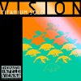 | 111610 | Thomastik VISION TITANIUM SOLO set violin VIT100 | 2 sada
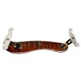 | 215307 | Viva La Musica DIAMOND No.1 (violin) | 1 ks
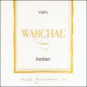 | 132150 | Warchal AMBER set violin 700B | 1 sada
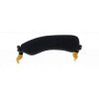 | 215127 | Wolf FORTE SECONDO (housle) 1/2-1/4 | 1 ks

