From: Order_Acknowledgement@merckgroup.com <Order_Acknowledgement@merckgroup.com>
Sent: Wednesday, October 8, 2025 9:06 AM
To:xxx@jh-inst.cas.cz
Cc: xxxx@jh-inst.cas.cz
Subject: Acknowledgement of Merck order 3011995066



Thank you for placing an order on Sigma-Aldrich.com

We will notify you once quantities and shipping dates are confirmed.

Order Number  3011995066  PO Number  001251489  Payment Terms  PI14  Order Date  Oct 08, 2025 | Customer  Ustav fyzikalni chemie  PRAHA 8  Shipping Address  xxx  Ustav fyzikalni chemie JH  Dolejskova 3  Praha 8, Praha 182 23 Czech Republic

Product | Price Qty Line Total

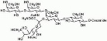 | 345724-1MG 2466.00 CZK 2 4932.00 CZK  Ganglioside GM1, Ammonium Sa 1PC X 1MG  Quote Number: 2002538437

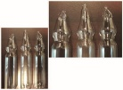 | T6513-100MG 4401.00 CZK 1 4401.00 CZK  GLYCERYL TRILINOLENATE  Quote Number: 2002538437

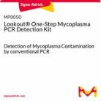 | MP0050-25TST 6273.00 CZK 1 6273.00 CZK  LOOKOUT (TM) ONE-STEP MYCOPLASMA PCR DE&  Quote Number: 2002538437

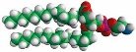 | 850705P-25MG 2277.00 CZK 1 2277.00 CZK  16:0 PE  Quote Number: 2002538437

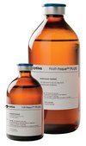 | GE17-1440-02 7074.00 CZK 2 14148.00 CZK  Ficoll® Paque Plus, liquid, sterile (en&  Quote Number: 2002538437

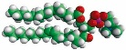 | 850457C-200MG 5670.00 CZK 1 5670.00 CZK  16:0-18:1 PC  Quote Number: 2002538437

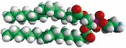 | 850757C-25MG 2286.00 CZK 1 2286.00 CZK  16:0-18:1 PE  Quote Number: 2002538437

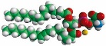 | 840034C-25MG 4095.00 CZK 2 8190.00 CZK  16:0-18:1 PS (POPS)  Quote Number: 2002538437

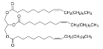 | T7140-5G 3213.00 CZK 1 3213.00 CZK  Glyceryl trioleate, Sigma Grade, >= 99 %  Quote Number: 2002538437

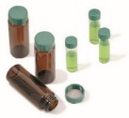 | 27134 2790.00 CZK 2 5580.00 CZK  PK100 2ML CLEAR VIAL,SCREW TOP, SOLID CA  Quote Number: 2002538437

27000 | 3798.00 CZK | 2 | 7596.00 CZK

PK100 2ML AMBER VIAL,SCREW TOP, SOLID CA

Quote Number: 2002538437

 | Subtotal  Tax  Ice Charge | 64566.00 CZK  13717.41 CZK  755.00 CZK

 | Order Total | 79038.41 CZK*

To view the status of your orders, login and access the Order Center.

For questions related to this order, contact your local customer service team at czeorders@merckgroup.com or +420
Disclaimer: Information related to price, availability and delivery dates is valid at the time of order creation but does not consider delays due to manual processing due to address changes or order comments added in the cart or additional review due to credit, compliance or dangerous goods restrictions.

The life science business of Merck KGaA, Darmstadt, Germany operates as MilliporeSigma in the U.S. and Canada.
MilliporeSigma and the vibrant M and Millipore are trademarks of Merck KGaA, Darmstadt, Germany or its affiliates. All trademarks are the property of their respective owners. Detailed information on trademarks is available via publicly accessible resources.
Copyright ©2025 Merck KGaA, Darmstadt, Germany and/or its affiliates. All Rights Reserved

