Nabídka sazenic podzim 2025
LST Trhanov 48, Trhanov 345 33; IČ: 60706805
Dřevina | Poptávané  množství Nabídka
SM
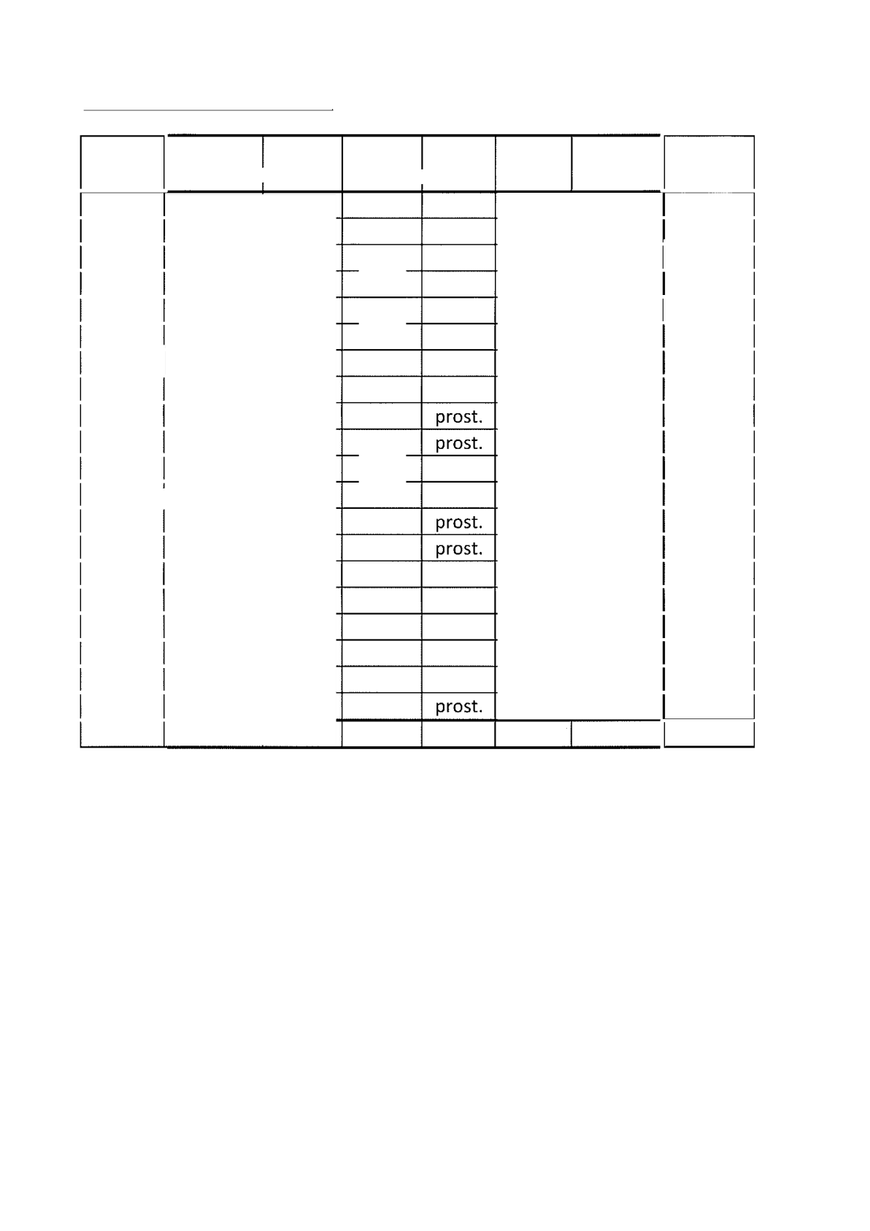
MD
DB
DBZ |
HB
BR
LP

OL
CER
DBC
JV
TR
LP
CELKEM

Cena Kč/ks | Objednáv  ka ks | celkem bez DPH
 |  | 0
 |  | 27500
 |  | |
 |  | 0
 |  | |
 |  | 0
 |  | 59400
 |  | 0
 |  | 0
 |  | 6000
 |  | 14250
 |  | 0
 |  | 6300
 |  | 0
 |  | 8500
 |  | 1900
 |  | 950
 |  | 900
 |  | 1000
 |  | 1000
 | 13 000 | 150650

10.09.2025
Ing. Milan Coufal

Velikost
26-35 36-50 36-50 51-70 26-50 36-50 26-50 36-50 26-35 36-50
36-50
26-35
36-50 36-50 51-70
81-120
81-120
81-120
81-120
81-120

Obal prost. prost. prost. prost. QP prost. QP prost.

prost. prost.

prost. prost. prost. prost. prost.

