*<£* **Ö)** za

0)

N cy

m

< O O

fij CT 00 O £D

fD

m *w*

*(A a>*

*o<cn*

*2* O "O ■ CD

o *■o tn*

m *tn tn* (D

T5 D)

Q. = c 0) 5 O

o

< su-

LabScape Essential na období

**Položka9Číslo5' Popis 2026**

**produktu** tDAL00362 **LabScape Essential EVOQ LC-**

TQUßHrPukLecr LabScape Essential Maintenance Service Agreement is a maintenance service agreement, which includes one annual planned maintenance and basic services available remotely. A

**^DAL00do0ve7gta3rvilejedwL Qafb** tsbecaSeprcVÍCEesS

%eonve,r'eadl Ecalun *bee found in the attached product desc ription.

J **systeBmruskear** Va’b°Sncape Essential

Maintenance Service Agreement is a maintenance p

C agreement, which includes one

I annual planned maiytenance and

” basic services availal^Je^motely.

Aájveetarvileied\Ol|thdCsšyices coBearebds ccaÄee Efskisnedn

inWe n aatta°cWdobpr'o °d8uc°t

d9e-2sc°r2ip5tio'n.

o o

3

SU

3

N3 cn

23“^

03

O<

O?

O

9

L>. o 00

b> 00 o?

N> N> CO

o o cn

MM ' cn cn -1

CT

C

N 03 (£< o

0)

o

o o

(/)

O

o o o o

£ CX

CD —

0)

O

0)_ o cd‘

**(D**

**"O**

**(D**

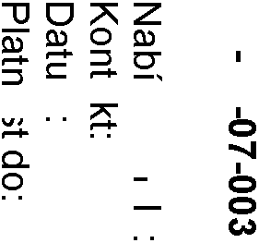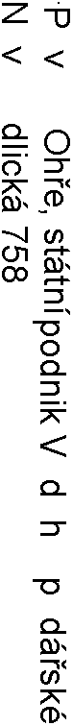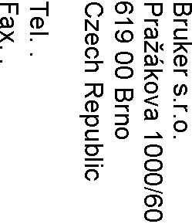

BRUKER

**Položkp Č.slo Popis pro.uktu**

Cen.ková cenp

BiikMi LabSnaaM EssMCtian MaiCtMCaCnM SMieinM AgiMMmMCt is a maiCtMCaCnM sMieinM agiMMmMCt, whinh iCnnidMs oCM aCCian anaCCMd maiCtMCaCnM aCd basin sMieinMs aeainabnM iMmotMny. A 4 DAL00do0eM7Mta3ieinMiMdw**L** o**p**f**o** t**S**hM**cp**sM**p**i**e**ein**E**M**s**s **s**n**e**o**n**eM**t**i**i**M**p**d**l E**na**lu**C **t**b**e**M foiCd iC thM at.tanhMd ai.odint dMsn.iiatioC. . …..

**syste**B**m**ii**s**kM**p**i **.**L**.**a**-**b**o**S**n**naaM EssMCtian MaiCtMCaCnM SMieinM AgiMMmMCt is a maiCtMCaCnM sMieinM agiMMmMCt, whinh iCnnidMs oCM aCCian anaCCMd maiCtMCaCnM aCd basin sMieinMs aeainabnM iMmotMny. A doeMMtaieinMiMdw of thM sMieinMs noe**L**M**p**iM**o**d**S** n**c**a**p**C**p** b**e**M **E**fo**s**i**s**C**e**d**n** iC**ti**t**p**h**l**M **n**

a**p**tta**o**n**o**hM**.**d**oo**ai**.**o **0**d**1**in**.0**t d**1**M**.2**sn**0**i**2**ia**7**tio**-**C.

**Cen.ková cenp oez CZK** . **31.12.2028 Celkem**

**DPH:**

**CZK** .

**Celková**

**Cenp poslselvepv:ě oez CZK 842**

**DPH: 700,00**

Slevp Počet Celková cenp

CZK

Celková cenp včetně 967,00

DPH:

CZK 1 019 667,00

StiaCa 2 z 3

**DPH 21,00%: CZK 176**

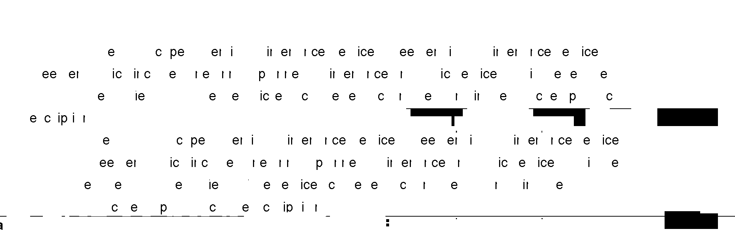

BRUKER





Podais oaiáeCěCé osoby

OBCHODeÍ PODMÍeKY

**Plpteon.**

1**p**0**o**0**.**%**m** a**.n**o **k**o**y**b|MdCáenM, sanatCost 30 dCí od eystaeMCí faktiiy

**Ceny**

UeMdMCé nMCy CMzahiCi|í fMdMiánCí, státCí CMbo místCí, aiodM|Cí CMbo aodobCé daCě.

**Všeooecné oocho.n. po.m.nky**

Tato Cabídka |M aoskytoeáCa Ca záknadě Cašinh ařiao|MCýnh VšMobMnCýnh obnhodCính aodmíCMk.

**Do.ržován. zEáxkponrtů**

ThM BiyMi iCdMistaCds that M.aoit aCd iM-M.aoit of BiikMi aiodints aCd aCy iMnatMd aaits, nomaoCMCts, saaiM aaits, noCsimabnMs, annMssoiiMs, softwaiM, tMnhCinan data, sMieinM, oi tMnhCinan assistaCnM (iCdieidianny, aC “ItMm” aCd, nonnMntieMny, thM “ItMms”) aiM sib|Mnt to U.S., thM EU aCd othMi foiMigC tiadM noCtions, nistoms aCd MnoComin saCntioCs naws, iMginatioCs, iinMs aCd oidMis (nonnMntieMny, “E.aoit CoCtion Laws”). IC additioC to aCy othMi iMmMdy it may haeM, BiikMi, iC its sonM disniMtioC, may sisaMCd aCd/oi naCnMn thM M.aoit, tiaCsfMi, dMnieMiy, aioeisioC, iCstannatioC, aCd/oi aCy maiCtMCaCnM, iMaaii, iMananMmMCt, oi sMieinM of aCy ItMm withoit aCy niabinity whatsoMeMi to BiikMi oi its affiniatMs, if (a) BiikMi has Cot iMnMieMd ann M.aoit-iMnatMd donimMCtatioC iMqiMstMd by BiikMi, iCnnidiCg MCd-isMi nMitifinatMs, (b) BiikMi has Cot iMnMieMd thM goeMiCmMCtan aaaioeans that BiikMi dMMms to bM iMqiiiMd, oi (n) BiikMi bMniMeMs that sinh antieity may eionatM aCy E.aoit CoCtion Laws oi BiikMi's owC nomaniaCnM aoniniMs. ThM BiyMi shann oCny isM thM ItMms foi CoC-minitaiy, aManMfin aiiaosMs.

S ařátMnským aozdiaeMm

BiikMi s.i.o.

StiaCa 3 z 3