
SAFIBRA, s. r. o., Černokostelecká 1621 , 251 01 Říčany tel. /fax: +420 323 601 615, e-mail: safibra@safibra.cz www.safibra.cz, IČO: 25787012, DIČ: CZ25787012

Dr. Olena Kulyk
RP4 4 group: Applications in molecular, biomedical and materials sciences Institute of Physics IoP (FZU) AS CR / ELI Beamlines
Za Radnicí 835
252 41 Dolní Brežany Czech Republic Olena.Kulyk@eli-beams.eu

Quotation: VACUUM COMPATIBLE STAGES
Quotation Number: N-358/17

No. | Part Number / Description | Unit Price | Qty | Price w/o VAT
1 | 2AB164SS  Angle Bracket | 49,00 € | 1 | 49,00 €
2 | 7T164SSV-10  Vacuum Compatible Manual Translation Stage | 378,00 € | 1 | 378,00 €
3 | 7T164SSV-10U  Translation Stage | 328,00 € | 1 | 328,00 €
4 | 7T264SSV-10  Vacuum Compatible Manual Translation Stage | 625,00 € | 1 | 625,00 €
5 | DELIVERY  and insurance to customer premises | 35,00 € | 1 | 35,00 €
 | TOTAL SUM w/o VAT 1 415,00 €
 | TOTAL SUM w/ VAT 1 712,15 €

- Delivery time: 3-4 weeks + time in transit
- Warranty: 12 months
- Quotation validity: 30 days
- Payment terms: 14 days net
• Date: 5.6.2017

Best Regards

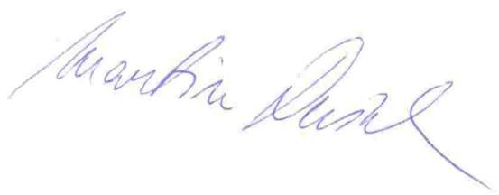
Ing. Martin Dušek martin.dusek@safibra.cz GSM: +420 777 017 304

Page 1/1

