***Buyer’s Contract No. S25/136*

## PURCHASE CONTRACT

This purchase contract (”**Contract**”) was concluded pursuant to section 2079 *et seq*. of the act no. 89/2012 Coll., Civil Code, as amended (“**Civil Code**”), on the day, month and year stated below by and between:

### Institute of Physics of the Academy of Sciences of the Czech Republic, a public research institution,

with its registered office at: Na Slovance 2, Praha 8, 182 21, Czech Republic registration no.: 68378271

represented by: RNDr. Michael Prouza, Ph.D. – director („**Buyer**”); and

### D-Ex Instruments, s.r.o.

with its registered office at: Optatova 708/37, 637 00 Brno, Česka republika registration no.: 28256468

reP.resented by: Sarka Berankova, prokurista bank account: 223387724/0300

enrolled in the commercial registered ke t by KS v Bme, odd. C, vlozka 59118 („**Seller**”). (The Buyer and the Seller are hereinafter jointly referred to as „**Parties**” and individually as “**Party**”.) **WHEREAS**

1. The Buyer is a public contracting authority and the beneficiary of a grant of the Ministry of

Education, Youth and Sports of the Czech Republic within the Johannes Amos Comenius Operation Programme. The Buyer carries out a project financed by the grant specified herein in this provision („**Project**”).

1. For the successful realization of the Project it is necessary to purchase the Object of Purchase (as defined below) in accordance with the Rules for public contracts awarding and public procurement controls within the Johannes Amos Comenius Operation Programme.
2. The Seller wishes to provide the Object of Purchase to the Buyer for consideration.

1

1. The Seller’s bid for the public procurement entitled „***Mass flow controller***”, whose purpose was to procure the object of purchase („**Public Procurement**”), was selected by the Buyer as the most suitable.
2. The Seller acknowledges that the Buyer is not, in connection to the subject matter of this Contract, an entrepreneur, and also that the subject matter of this Contract is not related to any business activities of the Buyer.
3. The documentation necessary for the execution of the Contract is
   * Technical Specification, which forms an integral part hereof as its Annex No. 1 to this Contract (hereinafter the “**TS**”); this TS also formed a part of the tender documentation for the Public Procurement in the form of Annex No. 2,

## IT WAS AGREED AS FOLLOWS:

1. **BASIC PROVISIONS**
   1. Under this Contract the Seller shall deliver to the Buyer a Multi-head galvanometric scanning system compatible with ACS Motion Control and RTC6 PCI control board and some accessories as described in detail in Annex 1 (Technical Specification) to this Contract in the required quality, and with the properties and related performance described therein („**Object of Purchase**”) and shall transfer to the Buyer ownership right to the Object of Purchase, and the Buyer shall take over the Object of Purchase and shall pay the Seller the Purchase Price (as defined below), all under the terms and conditions stipulated in this Contract.
   2. Under this Contract the Seller shall also carry out the following activities („**Related Activities**”):
2. Transport and delivery the Object of Purchase to the place of delivery (Art. 2.2 of the Contract);
3. Provide the Buyer with a certificate of conformity for CE marking;
4. Provide the Buyer with the Operating and Maintenance manuals, in English in reproducible form;
5. Cooperate with the Buyer anytime during the performance of this Contract.

## THE TIME AND PLACE OF DELIVERY

* 1. The Seller shall deliver the whole Object of Purchase and shall carry out Related Activities stated in Art. 1.2 a) within **six (6) months** from the effectiveness of this Contract, unless stipulated otherwise in this Contract. The Buyer is entitled to prolong the time for delivery Object of Purchase and for carrying out Related Activities for four

(4) more weeks, should there be important reasons for that on the side of the Buyer, such

2

as, but not only, impossibility to take over the Object of Purchase at the premises agreed in this Contract (place of delivery in Art. 2.2 of this Contract) due to reconstruction works taking place there.

* 1. The place of delivery shall be Fyzikální ústav AV ČR, v.v.i - HiLASE Centrum, Za Radnicí 828, 252 41 Dolní Břežany, Czech Republic or any other address in Dolní Břežany, Czech Republic, which the Buyer communicated to the Seller prior to the delivery of the Object of Purchase.
  2. The Seller acknowledges that the deadlines stated in this Article are of essential importance to the Buyer with respect to the timeline of the Project with respect to the deadline by which the Project are to be implemented, and that the Buyer could incur damage as a result of failure to meet the above stipulated deadlines.

## THE OWNERSHIP RIGHT

The ownership right to the Object of Purchase shall be transferred to the Buyer upon the signature of Delivery Note by the authorized representative of the Buyer.

## PRICE AND PAYMENT TERMS

* 1. The purchase price for the Object of Purchase is **2 484,26 EUR** („**Purchase Price**”) **excluding VAT.** VAT shall be set and paid in accordance with respective legislation.
  2. The Purchase Price cannot be exceeded and includes all costs and expenses of the Seller related to the performance of this Contract. The Purchase Price includes, among others, all expenses related to the delivery, the handover of the Object of Purchase and execution of Related Activities, costs of copyright, insurance, customs, warranty service and any other costs and expenses connected with the performance of this Contract.
  3. The Purchase Price for the Object of Purchase shall be paid on the basis of a tax document – invoice, to the account of the Seller designated in the invoice.
  4. The Buyer shall realize payments on the basis of duly issued invoice within thirty (30) calendar days from their receipt. If the Seller stipulates any shorter due period of an invoiced amount in an invoice, such different due period shall not be deemed relevant and the due period stipulated herein prevails. The Purchase Price shall be issued and paid only after the Handover protocol signature.
  5. The invoice issued by the Seller as a tax document must contain all information required by the applicable laws of the Czech Republic. Invoice issued by the Seller in accordance with this Contract shall contain in particular following information:
     1. Name and registered office of the Buyer,
     2. Tax identification number of the Buyer,

3

* + 1. Name and registered office of the Seller,
    2. Tax identification number of the Seller,
    3. Registration number of the tax document,
    4. Scope of the performance under this Contract (including the reference to this Contract),
    5. Date of the issue of the tax document,
    6. Date of the fulfillment of the Contract,
    7. Purchase Price,
    8. Registration number of this Contract, which the Buyer shall communicate to the Seller based on Seller’s request before the issuance of the invoice,
    9. Declaration that the performance of the Contract is for the purposes of the Project; the exact details of the Project including name and reg. number will be communicated to the Seller based on Seller´s request, which shall be sent to the Buyer to following e-mails: [joujova@fzu.cz](mailto:joujova@fzu.cz) and [svobodav@fzu.cz](mailto:svobodav@fzu.cz) before an invoice is issued,
    10. and must also comply with any double taxation treaties applicable to the given case.
  1. Seller shall issue an electronic invoice and send it to following e-mails [joujova@fzu.cz](mailto:joujova@fzu.cz) and [svobodav@fzu.cz](mailto:svobodav@fzu.cz) for preliminary check. After the preliminary check the Seller shall send the final electronic invoice to [efaktury@fzu.cz.](mailto:efaktury@fzu.cz)
  2. The last invoice in each calendar year must be delivered by the Seller to the Buyer’s no later than by December 15 of the given calendar year. In case that the invoice shall not contain the above mentioned information or the invoice does not comply with the requirements stipulated by law or the invoice is delivered to the Buyer later than by December 15 of the given calendar year, the Buyer is entitled to return it to the Seller during its maturity period and this shall not be considered as a default. The new maturity period shall begin from the receipt of the supplemented or corrected invoice to the Buyer.
  3. The Buyer’s invoicing details are set out in provision (1) hereof.

## SELLER’S RIGHTS AND DUTIES

* 1. The Seller will be required to communicate effectively (as defined below) with the Buyer at all stages of this Contract in order to resolve any technical issues or problems that arise in a timely and efficient manner.

4

* 1. The Seller shall ensure that the Object of Purchase and Related Activities are in compliance with this Contract including all its annexes and applicable legal (e.g. safety), technical and quality norms.
  2. During the performance of this Contract, the Seller proceeds independently. If the Seller receives instructions from the Buyer, the Seller shall follow such instructions unless these are against the law or in contradiction to this Contract. If the Seller, while exercising due professional care, finds out or should have found out that the instructions are for any reason inappropriate or illegal or in contradiction to this Contract, then the Seller must notify the Buyer.
  3. All things necessary for the performance of this Contract shall be procured by the Seller, unless this Contract stipulates otherwise.

## HANDOVER OF THE OBJECT OF PURCHASE

* 1. Handover and takeover of the Object of Purchase shall be realized on the basis of Delivery Note which shall be signed only after the Object of Purchase delivery and take- over is over and which shall contain following information:
* identification of the Seller, the Buyer and all subcontractors, if there are any,
* description of the Object of Purchase,
* the list of defects and deficiencies of the Object of Purchase, if there are any, and the deadlines for their removal,
* the signature of the Buyer and the date of the hand-over.
  1. Instructions and manuals related to all items of the Object of Purchase shall be included in the delivery of the Object of Purchase.
  2. If the Seller fails to duly carry out all Related Activities or if the Object of Purchase does not fully meet requirements of this Contract, the Buyer is entitled to refuse the takeover of the Object of Purchase. In such a case, the Seller shall remedy the deficiencies within forty five (45) calendar days, unless Parties agree otherwise. The Buyer is entitled (but not obliged) take over the Object of Purchase despite the above mentioned deficiencies, in particular if such deficiencies do not prevent the Buyer in the proper operation of the Object of Purchase. In such a case, the Seller and the Buyer shall list the deficiencies in the Hand-over protocol, including the manner and the date of their removal (remedy). If the Parties do not reach agreement in the Hand-over protocol regarding the date of the removal, the Seller shall remove the deficiencies within fourteen (14) calendar days.
  3. Parties hereby exclude application of section 2126 of the Civil Code.

5

## WARRANTY

* 1. The Seller hereby provides a warranty of quality of the Object of Purchase for the period of 36 calendar months.
  2. The warranty period shall commence on the day of the signature of the Hand-over protocol by both Parties. However, if the Object of Purchase is taken over with defects or deficiencies or the Seller fails to carry out any Related Activity stipulated in Art. 1.2 hereof, the warranty period shall commence on the date of the removal of the last defect or deficiency by the Seller.
  3. The Seller shall remove defects that occur during the warranty period free of charge.
  4. If the Buyer ascertains a defect of the Object of Purchase during the warranty period, the Buyer shall notify such defect without undue delay to the Seller (“**Warranty Claim**”). Defects may be notified on the last day of warranty period, at the latest; an email is considered an adequate way to initiate a Warranty Claim. Warranty Claim sent by the Buyer on the last day of the warranty period shall be deemed to be made in time.
  5. The Buyer notifies defects in writing via e-mail. The Seller shall accept notifications of defects on the following e-mail address: [info@dex.cz](mailto:info@dex.cz) and at the same time also [jveleba@dex.cz](mailto:jveleba@dex.cz)
  6. In the Warranty Claim the Buyer shall describe the defect and the manner of removal of the defect. The Parties shall agree on the manner of defect´s removal. If the Parties do not reach the agreement, the Buyer has the right to:
     1. request removal of the defect by the delivery of Object of Purchase or its individual parts, or
     2. request removal of the defect by repair, or
     3. request adequate discount from the Purchase Price.

The choice among the above mentioned rights shall be made by the Buyer, who shall take into account reasonable balance between economic perspective of the Seller and Buyer´s work planning on the Project. However, in case of a removable defect that occurs for the first time the Buyer shall not request removal of the defect by delivery of new Object of Purchase or its individual parts.

* 1. The Seller shall remove the defect within forty five (45) calendar days from the date on which the Warranty Claim was notified to the Seller, at the latest, unless the Buyer and the Seller agree otherwise.
  2. The Seller shall remove defects of the Object of Purchase within periods stated in the Contract also in the instances when the Seller is of the opinion that he is not liable for such defects. In cases when the Seller will not recognize the defect and the Buyer will

6

not agree with such conclusion, the validity of the Warranty Claim shall be ascertained by an expert, which is to be commissioned by the Buyer but with whom the Supplier also must agree. In the event the expert declares the Warranty Claim as justified, the Seller shall bear the costs of the expert’s assessment. If the Warranty Claim is raised unjustly according to expert’s assessment, the Buyer shall reimburse the Seller all reasonably incurred costs associated with removing the defect.

* 1. Parties shall execute a protocol on the removal of the defect, which shall contain the description of the defect and the confirmation that the defect was removed. The warranty period shall be extended by the time that expires from the date of exercising the Warranty Claim until the defect is removed in cases where the Buyer was prevented from using the Object of Purchase for its intended purpose.
  2. In case that the Seller fails to remove the defect within time stipulated in this Contract or if the Seller refuses to remove the defect, then the Buyer is entitled to remove the defect at his own costs and the Seller shall reimburse these costs within thirty (30) calendar days after the Buyer’s request to do so.
  3. The warranty does not cover defects caused by unprofessional handling or by the failure to follow Seller’s instructions for the operation and maintenance of the Object of Purchase.
  4. Parties exclude application of the section 1925 (the sentence behind semi-colon) of the Civil Code.

## TERMINATION, RIGHT OF WITHDRAWAL, CONTRACTUAL PENALTIES

* 1. This Contract may be terminated by completing the performance required hereunder, by agreement of the Parties or by withdrawal from the Contract on the grounds stipulated by law or in the Contract.
  2. The Buyer is entitled to withdraw from this Contract, if any of the following circumstances occur:

1. the Seller has materially breached obligations imposed by the Contract, specifically by being in delay with the fulfillment of this Contract and such delay lasts more than 4 weeks; or
2. the Seller has materially breached obligations imposed by the Contract, specifically Object of Purchase fails to meet technical parameters and qualities or other requirements defined in the Annex 1 (Technical Specification);
3. the insolvency proceeding is initiated against the Seller´s assets;

7

1. the funding body providing finances for the Project (“**Financial subsidy**”) or any other control body determines that the expenditures or part of the expenditures incurred on the basis of this Contract are ineligible;
2. the Financial subsidy for implementation of the Project is withdrawn from the Buyer, however Buyer hereby declares that there is financial subsidy in place at the time of signing the Purchase Contract; or
3. should it become apparent that the Seller provided information or documents in the Seller’s bid, which were not true and which could, therefore, influence the outcome of the Procurement Procedure leading to the conclusion of this Contract.
   1. The Seller is entitled to withdraw from the Contract in the event of material breach of the Contract by the Buyer and in case of events outside the control of the Seller (e.g. natural disasters, etc.).
   2. In the event that the Seller is more than one (1) week in delay with term of delivery as stipulated in Art. 2.1. hereof, the Seller shall pay to the Buyer the contractual penalty in the amount of 50 EUR of the Purchase Price for each, even commenced day of delay, since the first day of the delay.
   3. In the case where the Seller fails to remove defects within the periods stipulated in the Contract and the delay is more than one (1) week, the Seller shall pay to the Buyer a contractual penalty in the amount of 50,- EUR for each defect and for each calendar day of delay, since the first day of the delay.
   4. If the Buyer fails to pay the Purchase Price within the deadlines set out in this Contract, the Buyer shall pay the Seller interest on delay in the amount set forth by the law for each day of delay unless the Buyer proves that the delay with the payment of the Purchase Price was caused by late release of the Financial subsidy for the Project by the funding body.
   5. The obliged party must pay any contractual penalties to the entitled party not later than within fifteen (15) calendar days of the date of receipt of the relevant claim from the other party.
   6. Payment of the contractual penalties pursuant to this Article shall in no way prejudice the Buyer’s right to claim compensation for damage incurred by the Buyer as a result of the Seller’s breach of obligations to which the penalty applies. The Parties have agreed that the maximal amount of claim compensation for damage incurred by the Buyer as a result of the Seller’s breach of obligations to which the penalty applies shall be limited to 100% of the Purchase Price.
   7. The Parties have agreed that the maximal amount of contractual penalties shall be limited to 10% of the Purchase Price.

8

* 1. The Buyer is entitled to set off by unilateral declaration any of its receivable or part of its receivable resulting from contractual penalty against Seller´s claim to pay Purchase price.

## SOCIAL, ECOLOGICAL AND INNOVATIVE ASPECTS

The Buyer aims to conclude contracts with suppliers that take into account and implement the principles of social responsibility, ecological sustainability and innovation. Therefore, the Seller shall ensure that:

1. this Contract shall be fulfilled only by persons that are employed in accordance with the applicable legal regulations (no illegal or child workers);
2. while performing this Contract, all applicable health and safety regulations and rules at work place are observed;
3. all persons performing this Contract are employed under fair and non-discriminatory working conditions;
4. if presented with different manners of fulfilling this Contract, the Seller shall select the solution/process that is in accordance with the principles governing nature conservation and nature protection, ecological sustainability and ecological waste management; and
5. if presented with different manners of fulfilling this Contract, the Seller shall select the solution/process that is the most innovative.

## SPECIAL PROVISIONS

By signing this Contract, the Seller becomes a person that must cooperate during the finance control within the Act no. 320/2001 Coll., on finance control in the public administration, as amended, and shall provide to the Directing Body of the Operational Programme Johannes Amos Comenius or other control bodies (such as, but not only, European Commission, European Court of Auditors) access to all parts of the bid, Contract or other documents that are related to the legal relationship formed by this Contract. This duty also covers documents that are subject to the protection in accordance with other acts (business secrets, secret information, etc.) provided that control bodies fulfill requirements stipulated by these acts. The Seller shall secure that all its subcontractors are also obliged to cooperate with control bodies in the above stipulated extent. The Seller shall secure that all its subcontractors are also obliged to cooperate with control bodies in the above stipulated extent. The Seller is obliged to duly archive all written material prepared in connection with the execution of this Contract and to provide access to the Buyer to these archived documents until 2034; any finance control may also be carried out until year 2034.

## FINAL PROVISIONS

* 1. This Contract is governed by the laws of the Czech Republic, especially by the Civil Code.
  2. All disputes arising out of this Contract or out of legal relations connected with this Contract shall be preferable settled by a mutual negotiation. In case that the dispute is

9

not settled within sixty (60) calendar days, such dispute shall be decided by courts of the Czech Republic in the procedure initiated by one of the Parties.

* 1. All modifications and supplements of this Contract must be in writing.
  2. In the event that any of the provisions of this contract shall later be shown or determined to be invalid, putative, ineffective or unenforceable, then such invalidity, putativeness, ineffectiveness or unenforceability shall not cause invalidity, putativeness, ineffectiveness or unenforceability of the Contract as a whole. In such event the Parties undertake without undue delay to subsequently clarify any such provision using Sec 553(2) of the Civil Code, or to replace after mutual agreement such invalid, putative, ineffective or unenforceable provision of the Contract by a new provision, that in the extent permitted by the laws and regulations of the Czech Republic, relates as closely as possible to the intentions of the Parties to the Contract at the time of creation hereof.
  3. The Parties agree that the Seller shall not be entitled to set off any part of its receivable, or receivable of its sub-debtor against the Buyer or any of his receivables, unless this Contract stipulates otherwise. The Seller shall not be entitled to assign any receivable arising in connection herewith to a third party. The Seller shall not be entitled to assign any rights or obligations arising to him hereunder or any of its parts to third parties.
  4. This Contract shall constitute complete agreement of the Parties on the Contract subject matter including the Object of Purchase and shall substitute any and all possible previous discussions, negotiations and agreements of the Parties related to the Contract subject matter including the Object of Purchase.
  5. This Contract is executed in four (4) counterparts and each Party shall receive two (2) counterparts.
  6. The following Annexes form an integral part of the Contract:
* **Annex No. 1:** Technical Specification Document (if Annex 1 uses the term “Contracting Authority” or “contracting authority” it means Buyer. If Annex 1 uses the term “Supplier” or “supplier”, it means Seller);

In case of any discrepancies between this Contract and any of its annexes, the provisions of this Contract shall prevail.

* 1. The Parties agree to publish the full text of this Contract, including its annexes, in the Register of Contracts pursuant to Act No. 340/2015 Coll., on Special Conditions for the Effectiveness of Certain Contracts, the Disclosure of These Contracts and the Register of Contracts, as amended (Act on the Register of Contracts).
  2. This Contract shall become valid on the date of the signature of both Parties. The Contract shall become effective on the date of its publication at Register of Contracts.

10

### Representatives of the Parties

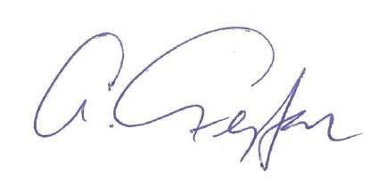

* 1. The Seller has appointed the following authorized representatives for communication with the Buyer in relation to the subject of performance hereunder:

In technical matters: Jan Veleba, tel: +420775757218, . [jveleba@dex.cz](mailto:jveleba@dex.cz)

* 1. The Buyer has appointed the following authorized representatives for communication with the Seller in relation to the subject of performance hereunder:

In technical matters: Mihai George Muresan, tel: +420314007742, [mihai@hilase.cz](mailto:mihai@hilase.cz)

**IN WITNESS WHEREOF** attach Parties their handwritten signatures:

Digitálně podepsal RNDr.

# Bc. Šárka

Beránková

Digitálně podepsal

### Buyer

Signature:

Antonín Fejfar, CSc.

Datum: 2025.07.31

18:12:57 +02'00'

### Seller

Bc. Šárka Beránková Datum: 2025.07.29

16:36:58 +02'00'

Name: RNDr. Michael Prouza, Ph.D. Position: director

|  |
| --- |
| Signature: |
| Name: Šárka Beránková |
| Position: prokurista |

11

## ANNEX 1 TECHNICAL SPECIFICATION

Minimum MFC technical requirements:

* Input/output gas feed connection: ¼’ compression
* Operating range: 0-200 sccm
* Minimal control step: 5 sccm
* Calibration gas: N2
* Compatible gasses: H2. He, Ar, Kr, Xe, O2, CO2, CO, CH4, C2H6, C3H8, C4H10, synthetic air, mixes of above gasses
* Control: compatible with Windows 11 (64 bit) if computer based; on MFC/separate control
* Ancillaries: data and power cords, power adaptors if needed Plus points:
* Display
* Gas correction factors for other than calibrated gas
* Calibration to other gasses

12



## ANNEX 2

**TECHNICAL SPECIFICATION OF THE SELLER**

13

******N A B Í D K A** *Číslo skladu:* **2**

|  |  |  |  |  |  |  |  |  |  |
| --- | --- | --- | --- | --- | --- | --- | --- | --- | --- |
| ***Dodavatel:*** D-Ex Instruments, s.r.o.  Optátova 708/37 637 00 Brno  *IČO:* 28256468 *DIČ:* CZ28256468  tel.: 00420 541 423 211 fax: 00420 541 423 219 e-mail: [info@dex.cz](mailto:info@dex.cz)  Obchodní rejstřík vedený Krajským soudem v Brně, oddíl C, vložka 59118 | | | ***Číslo nabídky:*** | | |  | | | |
| **225149** | | | |
|  | *Přijem poptávky dne: Platnost nabídky: Poptávka odběratele:*  *zakázka:*  *Popis:* | | | **09.05.2025**  **30.07.2025** | |  |
| ***Odběratel:*** Fyzikální ústav AV ČR, v.v.i.  Na Slovance 2  182 00 Praha 8 Česká republika  *IČO:* 68378271 *DIČ:* CZ68378271 | | | ***Poznámka:*** | | | | | | |
| *Ř.č. Číslo skl. karty*  *Specifikace* | | *Název* |  | *Cena za MJ* | *Množ. MJ* |  | *Cena celkem* | *Sleva v %* | *Po slevě DPH bez DPH v %* |
| Nabízíme Vám | | | |  |  |  |  |  |  |
| 01 | FG-201CV FG-201CV-AAD-22-V-DA-000 | |  | 1 792,2 | 1,00 ks |  | 1 792,25 | 0,0 | 1 792,25 21 |
| Model key: CfgID-30405-20250513-15080119 | | | |  |  |  |  |  |  |
| Product series: EL-FLOW Prestige | | | |  |  |  |  |  |  |
| Ingress protection: IP-40 | | | |  |  |  |  |  |  |
| Material: Stainless steel 316 | | | |  |  |  |  |  |  |
| Multi Fluid Multi Range: Enabled | | | |  |  |  |  |  |  |
| Control function: Flow control | | | |  |  |  |  |  |  |
| Fluid: N2 (Nitrogen)* | | | |  |  |  |  |  |  |
| Flow range: 1.6725...200 sccm | | | |  |  |  |  |  |  |
| Accuracy: ±0.5% Rd plus ±0.1% FS (At calibration conditions) | | | |  |  |  |  |  |  |
| Calibration certificate: 3-point calibration (0%, 50%, 100%) | | | |  |  |  |  |  |  |
| Inlet pressure (P1): 5...20 bar (g) (calibrated for 12.5 bar (g)) | | | |  |  |  |  |  |  |
| Outlet pressure (P2): 0...15 bar (g) | | | |  |  |  |  |  |  |
| Valve function: Normally Closed | | | |  |  |  |  |  |  |
| Orifice: 0.10 mm | | | |  |  |  |  |  |  |
| Temperature: 20 °C | | | |  |  |  |  |  |  |
| Seals: Viton 51415 | | | |  |  |  |  |  |  |
| Plunger: FFKM | | | |  |  |  |  |  |  |
| Inlet connection: 1/4" OD compression type | | | |  |  |  |  |  |  |
| Outlet connection: 1/4" OD compression type | | | |  |  |  |  |  |  |
| Output signal: RS-232 0...100 % (0...5 Vdc) | | | |  |  |  |  |  |  |
| Setpoint: RS-232 0...100 % (0...5 Vdc) | | | |  |  |  |  |  |  |
| Power supply: +15...24 Vdc | | | |  |  |  |  |  |  |
| Degreased for O2 use (QA-P-038): QA-P-038: degreased for O2 use. | | | |  |  |  |  |  |  |
| *Switchable with software to H2, He, Ar, Kr, Xe, O2, CO2, CO, CH4, | | | |  |  |  |  |  |  |
| C2H6, C3H8, C4H10, synthetic air, | | | |  |  |  |  |  |  |
| 02 | BRIGHT B1 BRIGHT local RC modul B1 | |  | 439,2 | 1,00 ks |  | 439,29 | 0,0 | 439,29 21 |
| 03 | PIPS-EL-DSUB PIPS-EL-DSUB | |  | 114,3 | 1,00 ks |  | 114,36 | 0,0 | 114,36 21 |
| 04 | 7.03.366 RS232 T-cable 3m | |  | 100,6 | 1,00 ks |  | 100,64 | 0,0 | 100,64 21 |
| 05 | 9.09.122 RS-232 to USB2.0 converter | |  | 37,7 | 1,00 ks |  | 37,71 | 0,0 | 37,71 21 |

*Vystavil:*

Jan Veleba

tel.: +420 541423218 fax.: e-mail: [jveleba@dex.cz](mailto:jveleba@dex.cz)

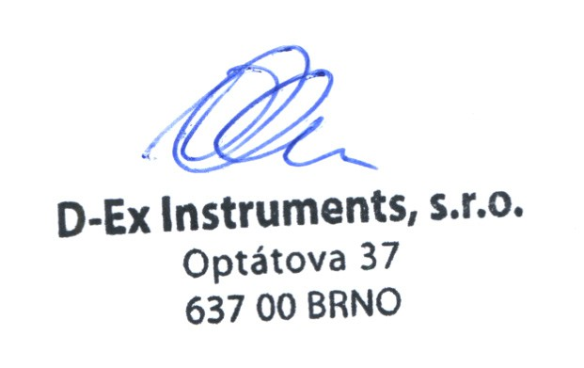

*za dodavatele za odběratele*

**N A B Í D K A** *Číslo skladu:* **2**

|  |  |  |  |  |  |  |
| --- | --- | --- | --- | --- | --- | --- |
| ***Dodavatel:*** D-Ex Instruments, s.r.o.  Optátova 708/37 637 00 Brno  *IČO:* 28256468 *DIČ:* CZ28256468  tel.: 00420 541 423 211 fax: 00420 541 423 219 e-mail: [info@dex.cz](mailto:info@dex.cz)  Obchodní rejstřík vedený Krajským soudem v Brně, oddíl C, vložka 59118 | | ***Číslo nabídky:*** |  | | | |
| **225149** | | | |
| *Přijem poptávky dne: Platnost nabídky: Poptávka odběratele:*  *zakázka:*  *Popis:* | | **09.05.2025**  **30.07.2025** |  |  |
| ***Odběratel:*** Fyzikální ústav AV ČR, v.v.i.  Na Slovance 2  182 00 Praha 8 Česká republika  *IČO:* 68378271 *DIČ:* CZ68378271 | | ***Poznámka:*** | | | | |
| *Ř.č. Číslo skl. karty*  *Specifikace* | *Název* | *Cena za MJ Množ. MJ* | | *Cena Sleva*  *celkem v %* | *Po slevě bez DPH* | *DPH*  *v %* |
| Nabízíme Vám   1. RECYKL BHT II. recyklační příspěvek kategorie 5.29.2 (nad 0,0 0,60 kg 0,00 0,0 0,00 21   0,5 kg) - 5,10 Kč/ks   1. RECYKL BHT I. recyklační příspěvek kategorie 5.29.1 (100 g 0,0 0,20 kg 0,00 0,0 0,00 21   až 0,5 kg) - 1,50 Kč/ks  2 484,26 2 484,26 EUR  **Celková hodnota nabídky po slevě bez DPH: 2 484,26 EUR**  DODACÍ PODMÍNKY:  DAP raha (Incoterms 2010). Termín dodání: 4 - 5 týdnů od obdržení objednávky.  ZÁRUČNÍ PODMÍNKY:  Záruční lhůta je 36 měsíců ode dne prodeje.  PLATEBNÍ PODMÍNKY:  30 days after the invoicing date  Ceny jsou uvedeny v EUR bez DPH. Fakturaci je možné provést v CZK - kurzem ČSOB (devizy prodej) platným v den fakturace.  **Požadavek platby v CZK je nutné uvést již při objednání.** | | | | | | |

*Vystavil:*

Jan Veleba

tel.: +420 541423218 fax.: e-mail: [jveleba@dex.cz](mailto:jveleba@dex.cz)



*za dodavatele za odběratele*

Technical specifications

Measurement & control

Type of media Gases

Flow range min. 0.014…0.7 mln/min

max. 0,4…20 ln/min

Accuracy ±0.5% Rd plus ±0.1% FS

Repeatability <±0.2% Rd (or <±0.04% FS whichever is greater)

Turndown ratio 1:150 (1:50 in analog mode)

Multi fluid capability embedded gas data for 100 unique gases plus any mixture of maximum 5 of these gases.

Settling time (in control, typical) fast: < 500 msec standard: < 1 sec slow: < 2 sec Control stability ≤ ± 0.1 % FS (typical for 1 ln/min N2)

Operating temperature -10…+70°C

Temperature sensitivity zero: < 0.02% FS/°C; span: < 0.025% Rd/°C

Leak integrity, outboard tested < 2 x 10-9 mbar l/s He

Pressure sensitivity standard: < 0.15% Rd/bar typical N2; with pressure correction: < 0.02% Rd typical N2

Max. Kv-value 6.6 x 10-2

Mounting max. error at 90º off horizontal 0.07% FS at 1 bar, typical N2

Warm-up time 30 minutes

Storage/transport conditions 0...+50°C, max. 95% RH (non-condensing)

Approvals

Electrical safety IEC 61010-1

Marking CE

Mechanical specs

Pressure rating (PN) 64

Ingress protection IP40

Material wetted parts stainless steel 316L or comparable, degreased for use on oxygen (O2)

Sealing material standard: FKM/Viton® options: EPDM, FFKM/Kalrez®, FDA and USP Class VI approved compounds

Plunger material standard: FFKM with PI foil; options: EPDM with PI foil, FDA and USP Class VI approved EPDM, FDA and USP Class VI approved FFKM/Kalrez®

Process connections compression type or face seal (VCR/VCO) couplings

Weight 0.7 kg

Electrical properties

Power supply +15…24

Power consumption 3 W typical at 24 V for fieldbus: add 0.9 W

Analog output 0…5 (10) Vdc or 0 (4)…20 mA (sourcing)

Analog setpoint 0…5 (10) Vdc or 0 (4)…20 mA (sinking)

Digital communication standard: RS232 options: DeviceNet™, CANopen®, PROFIBUS DP, Modbus RTU/ASCII, FLOW-BUS, EtherCAT®, PROFINET, Modbus/TCP,

EtherNet/IP, POWERLINK

Electrical interfaces

Power (main connector) 9-pin D-sub (male)

Function (main connector) RS232, Analog, RS485

PROFIBUS DP 9-pin D-sub (female)

CANopen / DeviceNet 5-pin M12A (male)

Modbus RTU/ASCII/FLOW-BUS RJ45

Modbus TCP / EtherNet/IP / EtherCAT®/ PROFINET / POWERLINK

2x 4 pin M12D (female)



Last modified 30-04-2025.

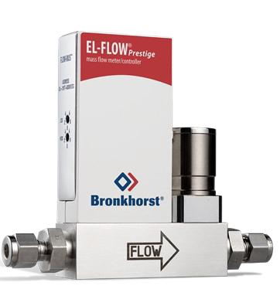

EN

EL-FLOW Prestige

FG-201CV

High Performance Mass Flow Controller for Gases

© Bronkhorst High-Tech B.V. All rights reserved.

The specifications are subject to change without notice. The products described herein and this document are subject to specific legal disclaimers as set forth on [www.bronkhorst.com/disclaimer.](http://www.bronkhorst.com/disclaimer) For more information and detailed advice, please contact the local Bronkhorst sales partner. Contact details can be found at [www.bronkhorst.com/contact.](http://www.bronkhorst.com/contact)

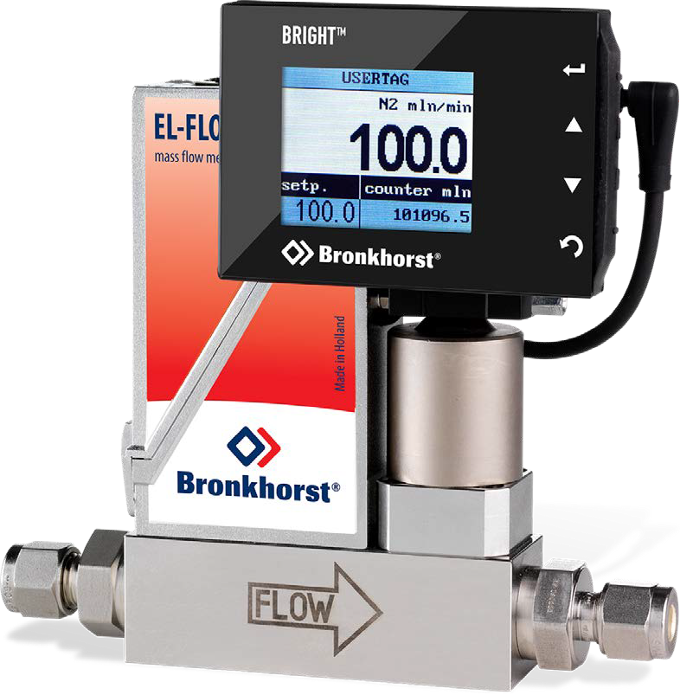

**BRIGHT**™

Compact Local Readout / Control Module for Mass Flow and Pressure Meters / Controllers



 **Introduction**

Bronkhorst High-Tech B.V., the European market leader in thermal Mass Flow Meters/Controllers and Electronic Pressure Controllers, has many years experience in designing and manufacturing precise and reliable measurement and control devices. With a wide range of instruments, Bronkhorst offers innovative solutions for many different applications in many different markets.

The instruments are made to customers’ specification, in various styles, suitable for use in laboratory, industrial and hazardous areas, in such diverse applications as semiconductor and analytical installations, to name but two. The BRIGHT series compact Readout/Control module can be used for local indication and operation of this product line.

 **Description**

The objective for the development of the R/C-module was to offer a modern, economical alternative for peripheral Readout/Control electronics with integrated power supply. Furthermore it should comply with the demand for local indication of the actual flow-rate and/or totalised fluid consumption.

Bronkhorst designed the R/C-module, fulfilling these requirements, and more! The module not only allows reading of actual and total flow,

simultaneously, but also features local operation, i.e. change of setpoint, counter reset, setting of engineering units, fluid name and tag number, etc. Four push-buttons at the right side of the device give access to a user- friendly menu. The bright 1.8” colour TFT-display is clearly visible over a wide angle.

The weatherproof (IP65) housing makes the module suitable for

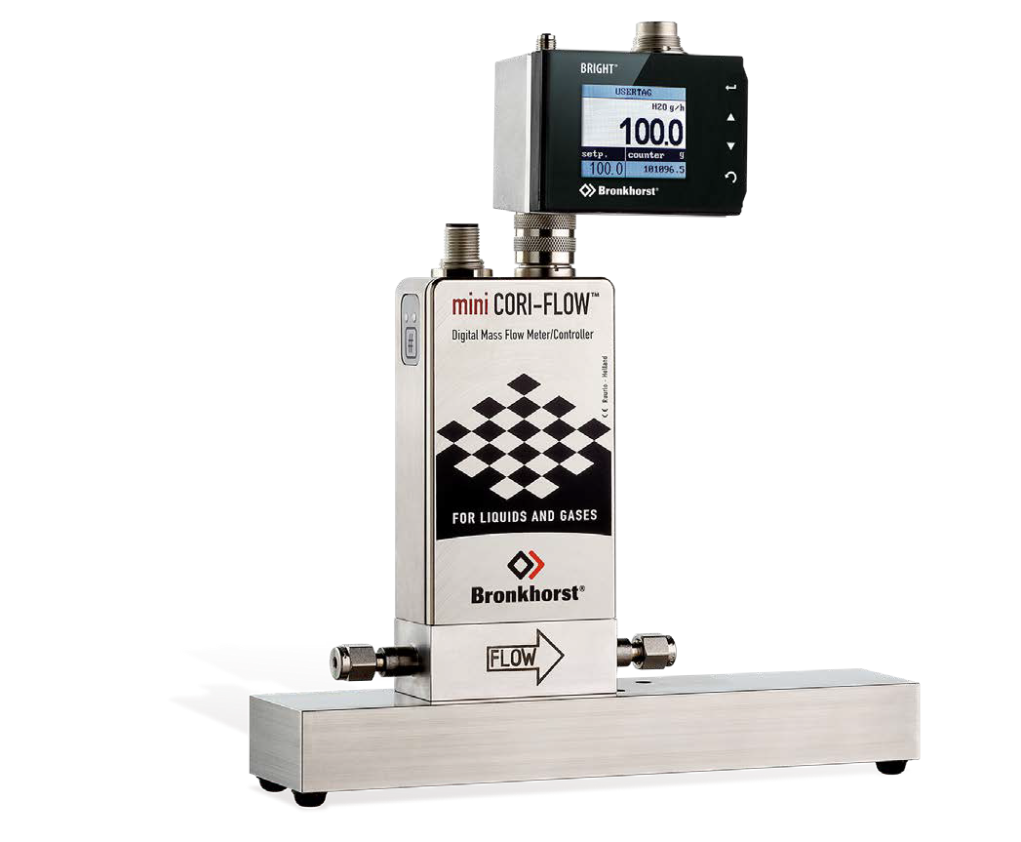use in industrial areas and the module can be mounted on the instrument or, using the mounting kit, on an adjacent wall or panel and on the pipework.

**Features**

Bright, wide-angle display (TFT-technology) Indication / operation / configuration of:

 measured value (direct or %)  setpoint

 totalised flow

 programmable alarm functions  fluid / tag number

 control characteristics  fieldbus settings

User-friendly operation

Mounting on instrument, pipework or wall

 **Specifications**

 Suitable for connection to instruments with RS232 I/O-signals  Required supply voltage 15…24 Vdc

 T-connector with 9-pin D-sockets for lab-style or 8-pin DIN sockets for industrial style instruments (1 male, 1 female), 4-pin DIN connection plus cable to R/C-module

 1,8” colour TFT-display (128x160 pixels)  4 push buttons for menu operation

 **Models**

 Bright B1: IP40 R/C-module; mounting on instrument  Bright B2: IP40 R/C-module; remote mounting

 Bright B3: IP65 R/C-module; mounting on instrument  Bright B4: IP65 R/C-module; remote mounting

 **Mounting kits**

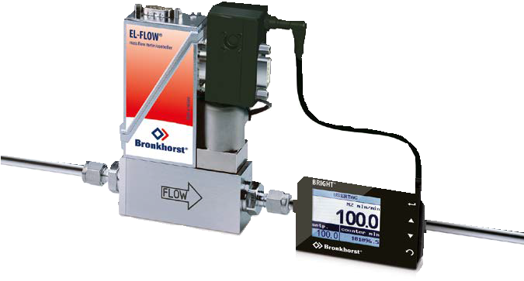

Example of pipe mounting by means of the mounting kit

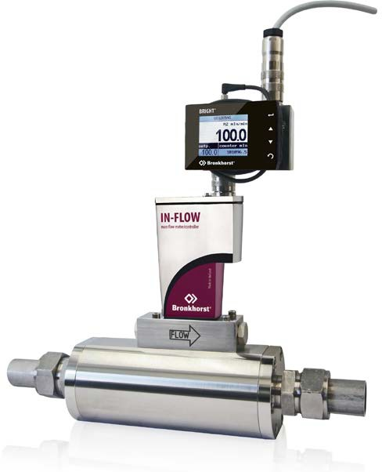

IP65 BRIGHT Module mounted on an industrial Mass Flow Meter

 **Mounting examples**

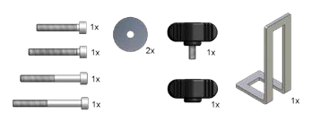**B1 B2 B3 B4 Description**

Mounting set

|  |  |  |  |  |  |
| --- | --- | --- | --- | --- | --- |
|  |  | - | - |  | IP40 T-part |

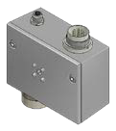- -   IP65 T-part

|  |  |  |  |  |  |
| --- | --- | --- | --- | --- | --- |
|  |  |  |  |  | Short 0.3m cable |

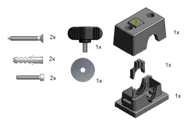-  -  Extended

|  |  |  |  |  |  |
| --- | --- | --- | --- | --- | --- |
| - |  | - |  |  | Long cable for distance mounting up to 1,0m |

 **Useful accessories**

With Bronkhorst® “PiPS” Plug-in Power Supplies the instruments with local PS/Readout can easily be hooked up to the available power sockets.

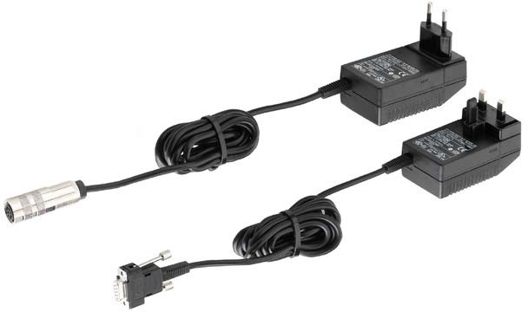

Bronkhorst High-Tech designs and manufactures innovative instruments and subsystems for low-flow measurement and control for use in laboratories, machinery and industry. Driven by a strong sense of sustainability and with many years of experience, we oﬀer an extensive range of (mass) flow meters and controllers for gases and liquids, based on thermal, Coriolis and ultrasonic measuring principles. Our global sales and service network provides local support in more than 40 countries. Discover Bronkhorst®!



[www.bronkhorst.com](http://www.bronkhorst.com/)

**Bronkhorst High-Tech B.V.**

Nijverheidsstraat 1a

NL-7261 AK Ruurlo, The Netherlands

Tel. +31 573 458800

[info@bronkhorst.com](mailto:info@bronkhorst.com)

9.60.042C P2000143 ©Bronkhorst®