|  |  |  |  |  |  |
| --- | --- | --- | --- | --- | --- |
|  | Popis práce, materiálu | m.j | množství | cena/kus | Celkem |
| 1 | Pásovina 50/8 | Kg | 123 |  | 3 321,- |
| 2 | Pásovina 40/10 | Kg | 201 |  | 5 427,- |
| 3 | Zinek | Kg | 324 |  | 8 100,- |
| 4 | Nýty 14x80 | Ks | 72 |  | 2 160,- |
| 5 | Zámek + fab | Ks | 1 |  | 870,- |
| 6 | Kované kliky + štítky |  |  |  | 3 400,- |
| 7 | Výroba |  |  |  | 41 500,- |
| 8 | Nátěr |  |  |  | 9 600,- |
| 9 | Barva Unifer Bronzo |  |  |  | 1 140,- |
| 10 | Montáž |  |  |  | 15 600,- |
| 11 | Doprava (zinek, montáž..) |  |  |  | 4 680,- |
| 12 | Madlo na branku | Ks | 2 |  | 3 730,- |
| 13 |  |  |  |  |  |
| 14 | **Cena bez DPH** |  |  |  | **99 528,-** |
| 15 | DPH 21% |  |  |  | 20 901,- |
| 16 | **Celkem vč. DPH** |  |  |  | **120 429,-** |
| 17 |  |  |  |  |  |
| 18 |  |  |  |  |  |
|  |  |  |  |  |  |
|  |  |  |  |  |  |
|  |  |  |  |  |  |
|  |  |  |  |  |  |
|  |  |  |  |  |  |

***Matouš Hujíček – Zámečnictví***

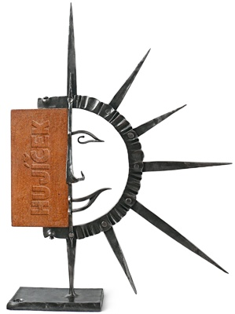

Bohuslavice č.p. 246 P.S.Č 763 51

[www.hujicek.com](http://www.hujicek.com)

IČO: 18559522, DIČ: CZ5911071573

**Cenová nabídka:**

**Brána A hřbitov - Luhačovice**

|  |  |  |  |  |  |
| --- | --- | --- | --- | --- | --- |
| 1. |  |  |  |  |  |
| 2. |  |  |  |  |  |
| 3. |  |  |  |  |  |
| 4. |  |  |  |  |  |
| 5. |  |  |  |  |  |
| 6. |  |  |  |  |  |
| 7. |  |  |  |  |  |
| 8. |  |  |  |  |  |
| 9. |  |  |  |  |  |
| 10. |  |  |  |  |  |
| 11. |  |  |  |  |  |
| 12. |  |  |  |  |  |
| 13. |  |  |  |  |  |
| 14. |  |  |  |  |  |
| 15. |  |  |  |  |  |