Installation requirements
Compressed air
The compressed air should have a pressure of minimum 5.5 bar pressure. The air consumption is 0.24 m³/min or less. The compressed air should be clean from dust particles and oil sediments and dried from water with a dew point below 3°C. The compressed air should be of class 4 or better according to ISO 8573-1.

Electricity
Required electricity outfit is 400 Volt with three phases 50 Hz, protective ground and a neutral line, with 3*16 A fuses. Earth fault breaker is mandatory to use, this can be provided as an extra option. The mean electrical effect used is 1.35 kW.

DI-water
- Clean particle free deionised water, or reversed osmosis water or similar with a conductivity of less than 5 µS.
- The water must have a pressure of min 3.5 bar and max of 4.5 bar. The pressure should be constant during consumption.
- Consumption depends on the test method.
- When raining a consumption of app. 110 litres per hour for a period of 15 minutes is necessary for the Volvo methods. Within a normal climate cycle approximately 1 litre per hour is needed. For the salt fog methods less than 15 litres per hour is needed during the downfall sections, only TC 220 v2
Drainage
A drainage point that can take the used a water, containing mainly 0.5-1% of slightly acidified sodium chloride water solution.
The drain should be placed no more than 50 mm above floor level and in connection with the Test Cabinet unit, preferably behind a line that could be described as the centre line in the longitudinal direction, see diagram below.
If drainage is not a hand nearby a drainage pump unit can be provided as an option.
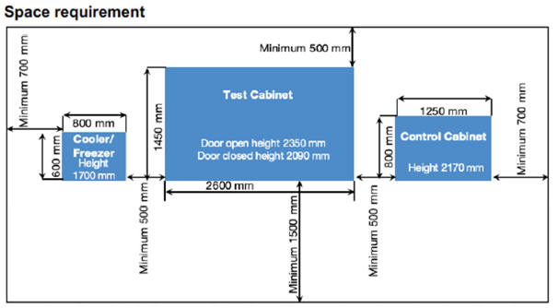
The unit can be orientated in several directions. However, the unit must be placed in such a way that doors are not blocked. Also, there must be adequate space for maintenance.
The cooling/freezing unit can be placed at a maximum of seven meters away from the Test Cabinet from a point on the right low part of the test cabinet, in the same level or higher than the Test Cabinet.


Name of document | Type of document
Capacity diagram TC 220 V2 | Specifications
Address | Issue | Issue date | Page
ControlArt AB, Tärnvägen 13 B, SE-475 40 Hönö, Sweden | 1.0 | 2025-06-05 | 1 (1)
Tel: +46 (0)700 903734

