Contro/Art AB
Cyclic Atmospheric Corrosion Test Cabinet - Specifications

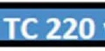
.Soecifications'
Minimum controlled temperature -18 ° C
Maximum controlled temperature |  | 65 ° C
Test cabinet volume |  | 2 m3
Test active area |  | 2 m2
Mounting format |  | Floor standing
Test cabinet weight |  | 485 kg
Control cabinet weight |  | 272 kg
Freezer weight |  | 279 kg
Cooler weight
Salt mist system according to ISO 9227 |  | Yes
Automatic salt solution mixing system |  | Yes
Salt solution tank, external
Test cabinet dimensions | w | 2600 mm
 | D | 1450 mm
Door closed | H | 2090 mm
Door o pen | H  w | 2350 mm  1250 mm
Control cabinet dimensions | D | 800mm
 | H | 2170 mm
 | w | 800mm
Freezer / Cooler dimensions | D | 600mm
 | H | 1700 mm
Electrical supply |  | Three-phase electrical
(Earth fault breaker is mandatory, provided by |  | supply, 400v, 3*16 A
customer) |  | fuses
Compressed air, dried {clean from dust, oil) |  | Min 5.5 bar pressure

DI water with conductivity less than 5 μS IS

Cabinet
Min 3.5 bar, max 4.5 bar
No more than 50 mm above floor level and in connection with the test cabinet

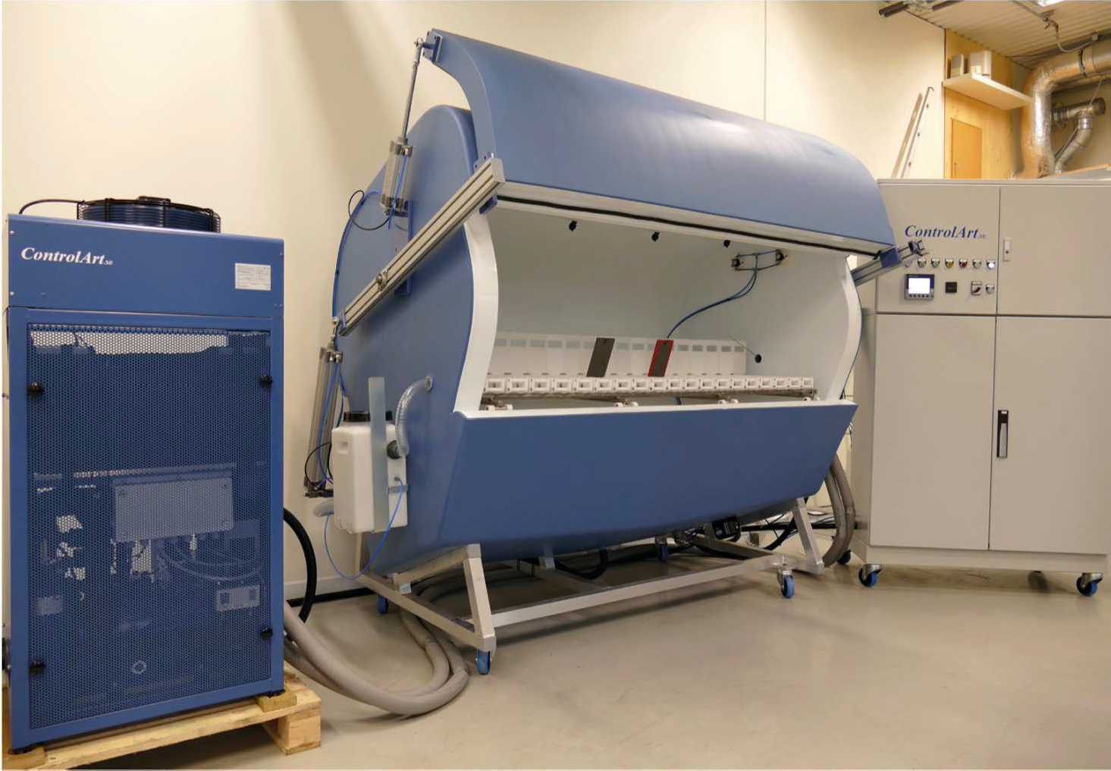
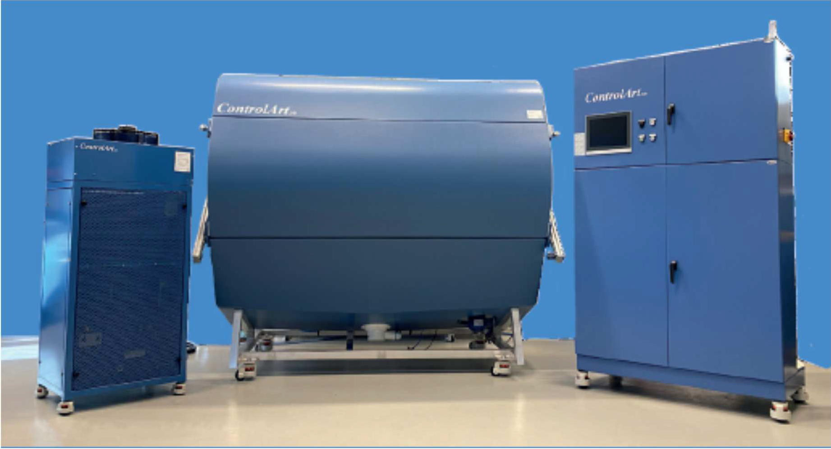

Obr. 1. Korozní komora CONTROLART TC 220 TYPE2

2

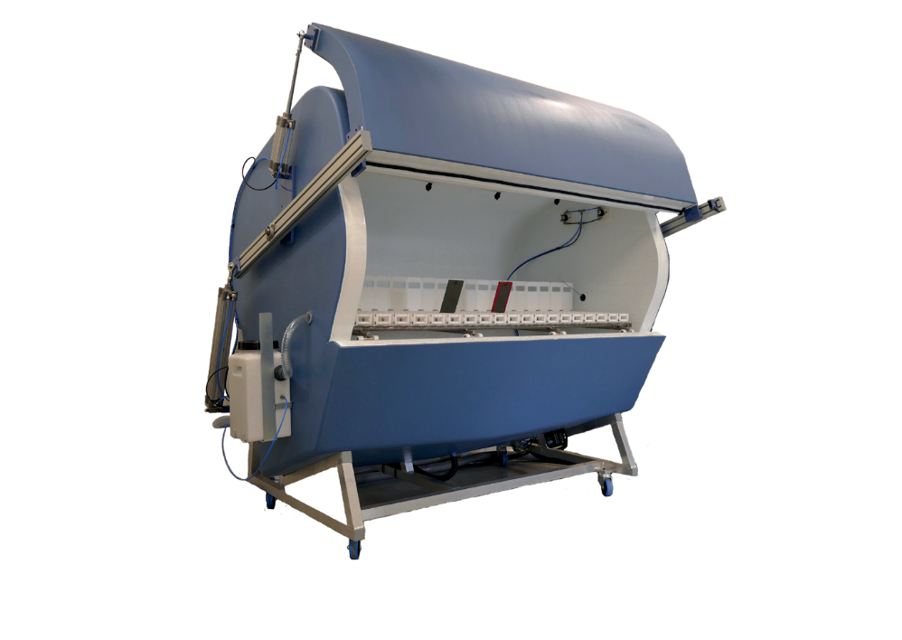

TC 210 and TC 220
have an inner volume of 2000 liters and the test plane has an area of 2 m2 (1 m x 2 m).

The equipment is user friendly designed with respect to:
- Ergonomic design for loading and unloading test samples to the test compartment, especially if the sample holders that has been designed for the equipment is being used.
- The door is not hindering the accessibility within or outside the cabinet.
- Ergonomic placement of adjuster components and touch screen.
- The “Rain solution” and “Fog solution” are automatically mixed by the equipment.
- The operation and maintenance needs are very low.
- The test space in the cabinet is homogeneous for all prescribed environmental parameters, like temperature and relative humidity.
- The cabinet temperature and relative humidity together with drying conditions are uniquely even over the whole test surface.
- Fully automated running gives easy management.
- The equipment monitors incoming media, such as electricity, compressed air and DI-water pressure. If the incoming media deviates, the equipment will issue an warning or error. If the option Alarm monitor is installed, the equipment will send SMS
or E-mail or both with the occured incident at the same time as the incident is displayed on the screen.

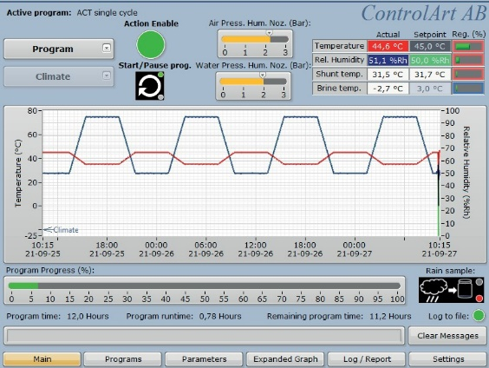
The equipment has a 12-inch touch screen where configurations, choice of test cycle and display of actual running data is shown. It is also possible to display historical data.

Apart from the test cycles that are already preprogrammed in the equipment, it is possible to change or transfer new programs to the equipment via the built in ethernet connection or via an USB memory.
The test programs are written in a software that is included with the
test equipment.
The equipment stores all running data internally, this means that a separate logging computer is not needed.
The user can export historical data from a choosen time period on the test equipment.

The ”Main” screen of the Equipment.

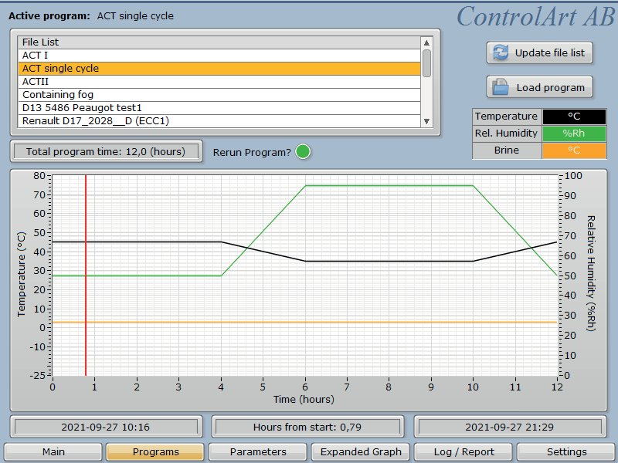
Available test programs are listed together with details of how the actual chosen test program is programmed with duration time information.
This time can be changed by the operator here so that a start somewhere in the test cycle is possible. A graphical
presentation of the programmed test curve is also shown.

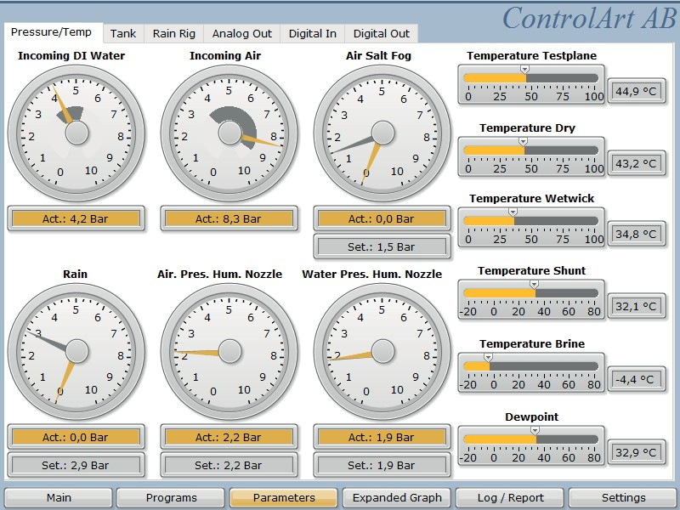

The ”Parameters” for the menu
– ”Pressure and temperatures” is shown.
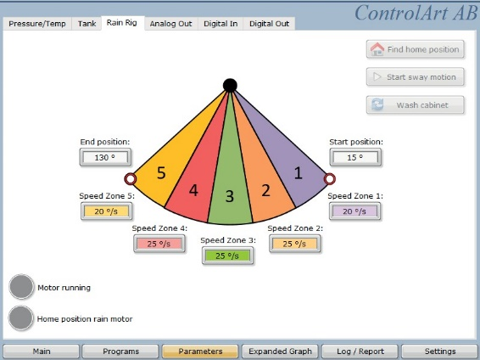
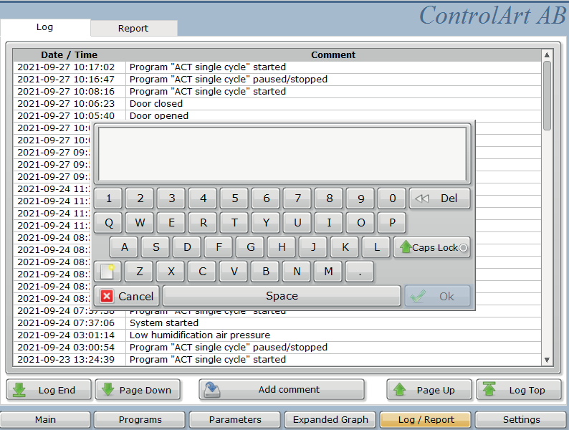

The menu ”Parameters”
- ”Rain Rig” enables extended possibilities to control the rain application. The user can control speeds in different sectors and control both start and stop angle for the rain application.
The Menu – ”Log/Report”
-”Log” is showing an actual event log for the equipment as well as actual warning- and
error-messages that has been reported.
–”Report” a possibility to create a report file for historical data is given.
The included logger program software on a computer with an ethernet connection to the test equipment can give actual running data as well as stored data as an exported file in either text format or as an Excel file.

