

G - Výpočet přitížení
Fotovoltaická elektrárna - FVE
Místo realizace: Kaplanova 1931/1, 148 00 Praha 11 - Chodov
Investor: Státní fond životního prostředí ČR, Kaplanova 1931/1, 148 00 Praha 11 - Chodov
Stupeň dokumentace: Dokumentace pro výběr zhotovitele (DVZ)
Část: D.1.4 Technika prostředí staveb / D.1.4.1 - Zařízení silnoproudé elektrotechniky
Zhotovitel dokumentace: Rostislav Štark, XXX, www.elros.cz |  | Číslo paré:
Zodpovědný projektant: XXX | Datum: 12/2024 | Číslo paré:
Vypracoval: XXX | Č. zakázky: 2024-068 | Číslo paré:



Project report

Projectname MS-HMR-Kaplanova

Project Number Wa_DE_hmRtfwnq

Project Address
1
148 00 Hlavní město Praha
Czech Republic

Creation date: 12/16/2024

Project created by:
Frankensolar Eastern Europe s.r.o. Ke Zdibsku 240


25066 Zdiby
XXX

Contents

Planning and liability notice | 3 | - | 3
Project Data | 4 | - | 4
Project Location - Google Maps | 5 | - | 5
Building: Building  3D Image - from Screenshot Roof_1 | 6 | - | 6
Roof substructure | 7 | - | 7
PV-Module | 8 | - | 8
Anchor type & model | 9 | - | 9
Racking Parameter | 10 | - | 10
Position | 11 | - | 11
Installation-Plan | 12 | - | 12
Roof coordinates CAD | 13 | - | 13
Roof coordinates | 14 | - | 14
Static CAD | 15 | - | 15
Elevation Parameter Additional Info | 16 | - | 16
Additional Information | 17 | - | 17

Climate-friendly TRIC Mounting Systems LOW CO2

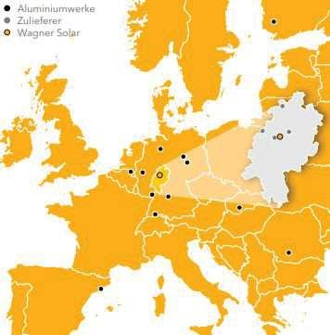
LOW CO2- Climate-friendly Mounting Systems

Sustainable and climate-friendly energy systems are our passion. Now we are taking the next step and continuously reducing our CO2 footprint

We produce our TRIC mounting systems exclusively from certified aluminum products with low CO2 emissions, manufactured in European aluminum plants.
With 4,9 kg of CO2 emissions per kg of (bright) aluminum, the production of our TRIC products generates less than a third of the global average

Regional added value

We also attach great importance to our long-standing partnerships with suppliers from the region. This guarantees not only short transportation routes but also the best product quality

Energy self-sufficient production

TRIC mounting systems are manufactured at our site in Kirchhain in our solar factory, which is 90 percent energy self-sufficient.

Minimal CO2 footprint European aluminum plants Regional added value Short transportation routes Long-term partnerships
Made in Germany
TRIC - LOW CO2

European aluminium plants, regional suppliers and optimization of energy consumption during production - the climate-friendly TRIC assembly systems impress with the lowest CO2 emissions

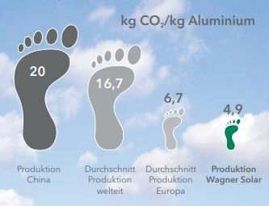

Less than a third! The low CO2 value is achieved, among other things, through highly efficient electrolysis technology and a high proportion of recycling in aluminum production as well as the consistent use of renewable energy sources.

Master data

Project Name | MS-HMR-Kaplanova
Comment
Planning Responsible
Software v.: | 11.0.33.45440
Amount Modules | 88
System Size | 40.48 kWp
Orientation [°] | 180
Roofpitch [°] | 2
Allocated Area | 175.33 m²

Project Address

Name
Street Address | 1
Postal code | 148 00
City | Hlavní město Praha
Phone
Email
Notes
Country | Czech Republic
Latitude [°] | 50.03432
Longitude [°] | 14.48788
Altitude [m] | 263

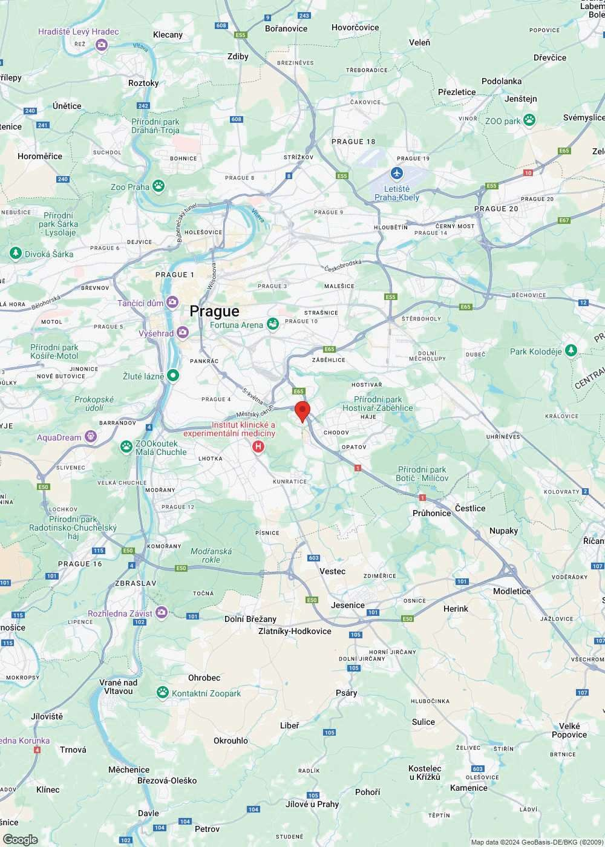

Building height h [mm] 16000
Slope of roof [°] 2
Roofing Membrane roof
Product Type: TRIC F duo East
System alignment [°] 180
Parapet height [mm]: 100
Parapet width [mm]: 250

Snow load CSN EN 1991-1-3
Custom(Elev.)
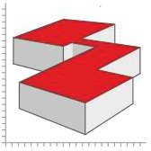

System alignment [°]*
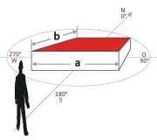

Snow load [kN/m²]*: | 0.56
Slope of roof [°]: | 2
Snow load zone: | I
Shape coefficient μi: | 0.8

Wind load CSN EN 1991-1-4 NA:2008

Wind load [kN/m²]*: | 0.791
Terrain Category: | 3
Building height h [mm]: | 16000
Reference Height [mm]: | 16000
Wind zone (see wind zone map): | Area 2

PV-Module [Roof_1]

Manufacturer: Aiko Energy Germany GmbH
Name AIKO-A460-MAH54Mb
Width [mm]: 1134
Height [mm]: 1757
Thickness [mm]: 30
Framing: Aluminum
Weight (kg) 21.5
Nominal Power [Watt]: 460
Module Type: Monocrystalline
Installation: On Both Sides
Frame color Black
Temperature coefficient [%/°C]: -0.26
Efficiency STC: 0.231
Output current MPP - STC [A]: 13.29
Output voltage MPP - STC [V]: 34.62
Short circuit current [A]: 14.25
Open circuit voltage [V]: 41.06
Temperature coefficient Current [%/K]: 0.05
Temperature coefficient Voltage [%/K]: -0.22
Max. System voltage EU: 1500
Galvanic seperation required: No

Clamps [Roof_1]

Mid Clamp: Modulklemme TRIC clip M27-31 schwarz
End Clamp: Modulklemme TRIC clip R30 schwarz

Note: Please check to see if the terminal points of the module conforms with the specifications of the manufacturer. If the access points do not match the specifications of the module manufacturer, it is recommended to contact the module manufacturer in conjunction to obtain a release planning. There is no guarantee that the proposed connection is released by the manufacturer.

Racking Parameter [Roof_1]

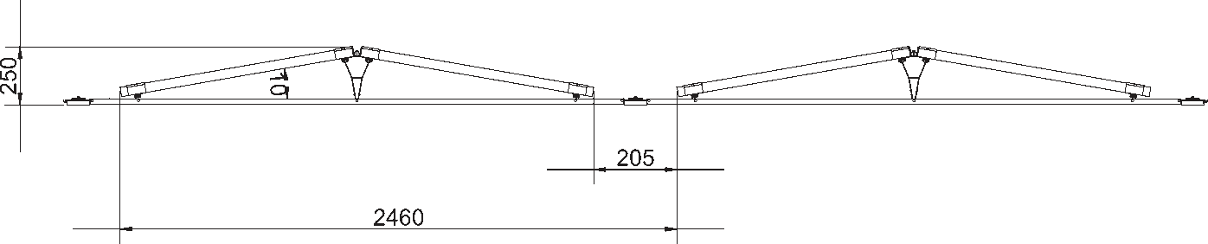

Bracket tilt α [°]: 10
Inter-row spacing a [mm]: 205 mm
Friction Constant µ 0.5
The default coefficient of friction used is 0.5 for foil sealing and 0.6 for bitumen sealing membranes and must be verified by the installer or planner. If a lower coefficient of friction is determined on site, this must be applied here for the ballast calculation. The ballast quantity to be applied increases with a lower coefficient of friction. A higher value can be applied up to a maximum of 0.7, provided this has been determined.
Gewicht Ballastierungsstein Schiene 1 kg
Gewicht Ballastierungsstein Ballastbrücke 1 kg
Distance to roof edge [mm] 300

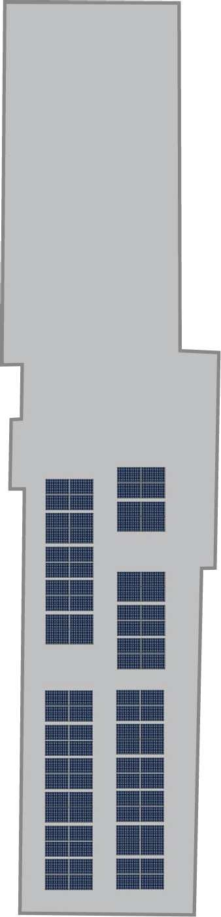

2846
16008
25354
25441
3742
31027
5315
26772
4
5
1
2
3
751
986

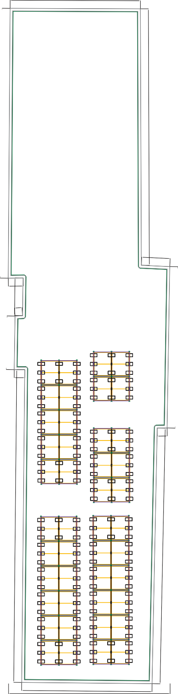
13017

1053

13028

16143

1480

2846
16008
25354
25441
3742
31027
5315
26772
751
986

13017

1053

13028

16143

1480

Coordinate 0 | X: | 0 | Y: | 6621 | Z: | 16000
Coordinate 1 | X: | 11220 | Y: | 0 | Z: | 16000
Coordinate 2 | X: | 24357 | Y: | 21685 | Z: | 16000
Coordinate 3 | X: | 25220 | Y: | 21206 | Z: | 16000
Coordinate 4 | X: | 33467 | Y: | 34927 | Z: | 16000
Coordinate 5 | X: | 31070 | Y: | 36462 | Z: | 16000
Coordinate 6 | X: | 43728 | Y: | 58531 | Z: | 16000
Coordinate 7 | X: | 32483 | Y: | 65088 | Z: | 16000
Coordinate 8 | X: | 19922 | Y: | 43736 | Z: | 16000
Coordinate 9 | X: | 18915 | Y: | 42009 | Z: | 16000
Coordinate 10 | X: | 20209 | Y: | 41289 | Z: | 16000
Coordinate 11 | X: | 18292 | Y: | 38075 | Z: | 16000
Coordinate 12 | X: | 17620 | Y: | 38411 | Z: | 16000
Coordinate 13 | X: | 14887 | Y: | 33853 | Z: | 16000
Coordinate 14 | X: | 15798 | Y: | 33325 | Z: | 16000

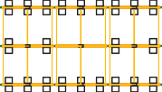
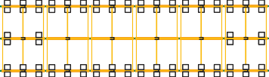
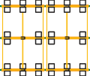
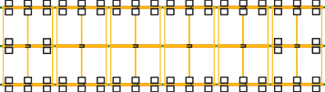
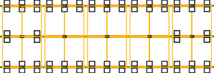
20 17 20 20 2 20 19 4 19 19 3 20 20 2 20 21 20 21

20 17 20 20 2 20 19 4 19 19 3 20 20 2 20 21 20 21
21 20 21 11 20 11 11 20 11 20 1 21 21 4 21

21 20 21 11 20 11 11 20 11 20 1 21 21 4 21
Σ S87.47 kg Σ U150.26 kg
Σ S69.72 kg Σ U83.71 kg
Σ S69.72 kg Σ U83.71 kg
4
Σ S69.72 kg Σ U83.71 kg
Σ S69.72 kg Σ U83.71 kg
Σ S87.47 kg Σ U150.26 kg
Σ S100.22 kg Σ U150.26 kg
Σ S74.13 kg Σ U83.71 kg
20

20
19

19
6

6
21

21
20

20
6

6
5
Σ S74.13 kg Σ U83.71 kg
Σ S74.13 kg Σ U83.71 kg
Σ S100.22 kg Σ U150.26 kg
21

21
21

21
Σ S87.47 kg Σ U150.26 kg
Σ S69.72 kg Σ U83.71 kg
Σ S69.72 kg Σ U83.71 kg
Σ S69.72 kg Σ U83.71 kg
Σ S69.72 kg Σ U83.71 kg
Σ S87.47 kg Σ U150.26 kg
Σ S100.22 kg Σ U150.26 kg
Σ S74.13 kg Σ U83.71 kg
Σ S74.13 kg Σ U83.71 kg
Σ S74.13 kg Σ U83.71 kg
Σ S100.22 kg Σ U150.26 kg
20 15 20 20 2 20 20 11 11 11 11 20 20 1 21 21 20 21 21 21 21 11 20 11 11 20 11 11 10 21 21 21 21
20 15 20 20 2 20 20 11 11 11 11 20 20 1 21 21 20 21 21 21 21 11 20 11 11 20 11 11 10 21 21 21 21
20 17 20 20 2 20 19 4 19 19 3 20 20 2 20 21 20 21

20 17 20 20 2 20 19 4 19 19 3 20 20 2 20 21 20 21
21 18 21 20 2 20 21 5 21

21 18 21 20 2 20 21 5 21
21 21 21 21 21 21

21 21 21 21 21 21
Σ S87.47 kg Σ U150.26 kg
Σ S69.72 kg Σ U83.71 kg
Σ S69.72 kg Σ U83.71 kg
1
Σ S69.72 kg Σ U83.71 kg
Σ S69.72 kg Σ U83.71 kg
Σ S87.47 kg Σ U150.26 kg
Σ S136.55 kg Σ U150.26 kg
2
Σ S88.92 kg Σ U83.71 kg
Σ S136.55 kg Σ U150.26 kg
Σ S165.39 kg Σ S165.39 kg
Σ U152.43 kg Σ U152.43 kg
20

20
19

19
6

6
21

21
14

14
14

14
21

21
21

21
21

21
21 21
21 21
3
21

21
Σ S87.47 kg Σ U150.26 kg
Σ S69.72 kg Σ U83.71 kg
Σ S69.72 kg Σ U83.71 kg
Σ S69.72 kg Σ U83.71 kg
Σ S69.72 kg Σ U83.71 kg
Σ S87.47 kg Σ U150.26 kg
Σ S136.55 kg Σ U150.26 kg
Σ S88.92 kg Σ U83.71 kg
Σ S136.55 kg Σ U150.26 kg
Σ S165.39 kg Σ U152.43 kg
Σ S165.39 kg Σ U152.43 kg
20 15 20 20 2 20 20 11 11 11 11 20 20 1 21 21 20 21

20 15 20 20 2 20 20 11 11 11 11 20 20 1 21 21 20 21
21 21 21 11 20 11 21 20 21

21 21 21 11 20 11 21 20 21
21 16 21 21 21 21

21 16 21 21 21 21
Total Uplift (U) 5023 kg Total Sliding (S) 4047 kg
Total Amount Stones 5094 (5,094 kg)
Static information: Ballasting [Roof_1]
MS-&shy;HMR-&shy;K... |
12/16/2024
created with
Page 15 / 17
Static V: 11.0.33.45440

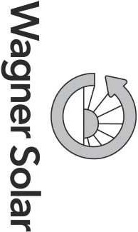

Summary of load parameters [Roof_1]

Snow load | 0.56 kN/m²
Wind load | 0.79 kN/m²
Friction Constant µ | 0.5
Factor of Safety for Uplift | 1.5
Factor of Safety for Sliding | 1.5
Load factor applied to Dead Load | 0.9
Gewicht Ballastierungsstein Ballastbrücke | 1 kg
Anzahl Ballastierungssteine Ballastbrücke | 5094
System surface area | 189.64 m²
Roof area | 907.95 m²
Total ballast weight | 5,094 kg
Weight Module/Rack | 2,423.52 kg
Total System weight | 7,517.52 kg
Surface load on system area | 0.39 kN/m²
Surface load on roof | 0.081 kN/m²

Planning and liability notice

Please check all inputs and results carefully. It must be ensured that the entries at SUNoptimo match the conditions on site. Since individual peculiarities must be taken into account for each roof, expert clarification must be carried out in advance of each installation. In case of doubt, calculations must be checked and approved by an expert (e.g.: structural engineer) before execution.

The building statics are not part of the calculation with SUNoptimo. The connection of the mounting system to the building (load-bearing capacity, roof cladding) must be assessed and checked by the installer, in cases of doubt with the help of external experts.

The technical regulations with the status used for the calculations in SUNoptimo are shown in the project report and must be checked by the executor to ensure that they are up to date. The installation instructions for TRIC mounting systems from Wagner must be observed, as well as the specifications of the module manufacturer and the relevant standards, guidelines and legal regulations.

Our General Terms and Conditions of Business apply to quotations, orders and any legal transactions arising from them in their current version. ( www.wagner-solar.com/agb)

13017

1480

1053

13028
4
1

Department Tech. Reference
- -

16143
Created by

XXX
Document type
-
Approved by
-

Title

Status
-

Project Number

1:311

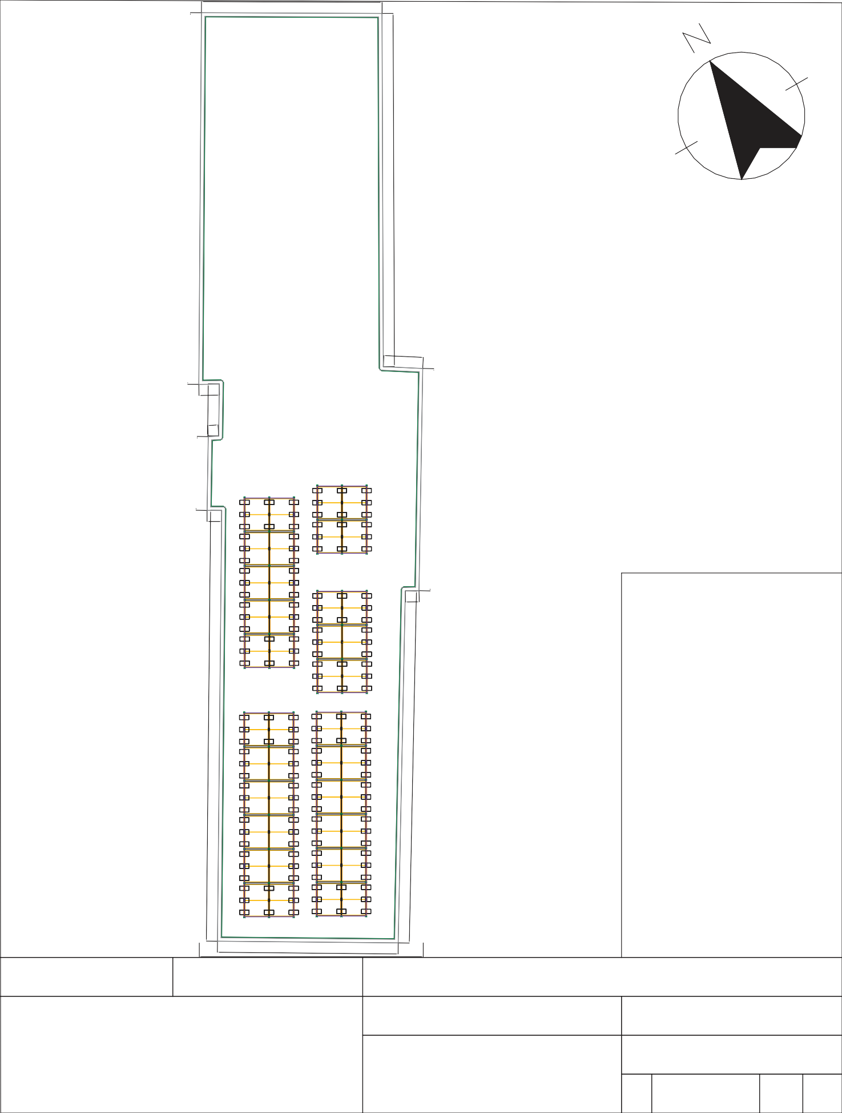
MS-HMR-Kaplanova
2846

16008

25354

25441

3742

31027

5315

26772
5
2
3
751
986

Roof_1
Wa_DE_hmRtfwnq
Vers Created Lang. Page

R1 12/16/2024 DE 1/1

20 17
Tech. Reference
-
20 17

20 20
Department
-
20 20

2 20 19
2 20 19

4 19 19
4 19 19
4

3 20 20
3 20 20

2 20 21 20 21
2 20 21 20 21

21 20
21 20

21 11 20
21 11 20

11 11 20
11 11 20
5

11 20 1
11 20 1

21 21 4 21
21 21 4 21

Σ S87.47 kg Σ U150.26 kg
20 19
20 19

Σ S69.72 kg Σ U83.71 kg

Σ S69.72 kg Σ U83.71 kg

Σ S69.72 kg Σ U83.71 kg

Σ S69.72 kg Σ U83.71 kg

Σ S87.47 kg Σ U150.26 kg
6 21
6 21

Σ S100.22 kg Σ U150.26 kg
20 6
20 6

Σ S74.13 kg Σ U83.71 kg

Σ S74.13 kg Σ U83.71 kg

Σ S74.13 kg Σ U83.71 kg

Σ S100.22 kg Σ U150.26 kg
21 21
21 21

Σ S87.47 kg Σ U150.26 kg
20 15

Σ S69.72 kg Σ U83.71 kg
20 20 2

Σ S69.72 kg Σ U83.71 kg
20 20 11

11 11

Σ S69.72 kg Σ U83.71 kg
11

20 20

Σ S69.72 kg Σ U83.71 kg
1

21 21

Σ S87.47 kg Σ U150.26 kg
20 21

Σ S100.22 kg Σ U150.26 kg
21 21

21 11

Σ S74.13 kg Σ U83.71 kg
20

11 11

Σ S74.13 kg Σ U83.71 kg
20

11 11

Σ S74.13 kg Σ U83.71 kg
10

21 21

Σ S100.22 kg Σ U150.26 kg
21 21

20 15
20 20
2 20 20
11 11 11
11 20 20 1
21 21 20 21
21 21
21 11 20
11 11 20
11 11 10
21 21 21 21

20 17

20 20

2 20 19

4 19 19

3 20 20

2 20 21 20 21

21 18

21 20

2 20 21 5 21

21 21

21 21

21 21

20 17
20 20
2 20 19
4 19 19
3 20 20
2 20 21 20 21
21 18
21 20 2
20 21 5 21
21 21
21 21 21 21

Σ S87.47 kg

Σ S69.72 kg

Σ S69.72 kg

Σ S69.72 kg

Σ S69.72 kg

Σ S87.47 kg

Σ S136.55 kg

Σ S88.92 kg

Σ S136.55 kg

Σ S165.39 kg

Σ S165.39 kg

Σ U150.26 kg

20 19
20 19

Σ U83.71 kg

Σ U83.71 kg
1 Σ U83.71 kg

Σ U83.71 kg

Σ U150.26 kg

6 21
6 21

Σ U150.26 kg

14 14
14 14
2Σ U83.71 kg

Σ U150.26 kg

21
21
21
21

Σ U152.43 kg Σ U152.43 kg

21 21 21 21
21 21 21 21

Σ S87.47 kg Σ U150.26 kg
20 15

20 20

Σ S69.72 kg Σ U83.71 kg
2

20 20

Σ S69.72 kg Σ U83.71 kg
11

11 11

Σ S69.72 kg Σ U83.71 kg
11

20 20

Σ S69.72 kg Σ U83.71 kg
1

21 21

Σ S87.47 kg Σ U150.26 kg
20 21

Σ S136.55 kg Σ U150.26 kg
21 21

21 11

Σ S88.92 kg Σ U83.71 kg
20

11 21

Σ S136.55 kg Σ U150.26 kg
20 21

Σ S165.39 kg Σ U152.43 kg
21 16

21 21
3

Σ S165.39 kg Σ U152.43 kg
21 21

20 15
20 20
2 20 20
11 11 11
11 20 20 1
21 21 20 21
21 21
21 11 20
11 21 20 21
21 16 21 21 21 21

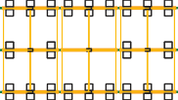
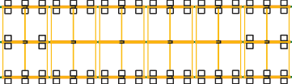
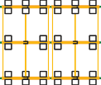
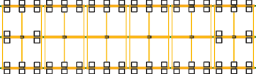
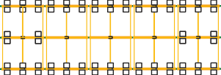
Created by
Document type
-
Title
Approved by
-
1:311
Status
-
Project Number
Wa_DE_hmRtfwnq
Vers Created
R1 12/16/2024
MS-HMR-Kaplanova
Roof_1
Lang. Page
DE
1/1

Total Uplift (U) 5023 kg Total Sliding (S) 4047 kg
Total Amount Stones 5094 (5,094 kg)

20 17
Tech. Reference
-

20 20
Department
-

2 20 19

4 19 19

3 20 20

2 20 21 20 21

21 20

21 11 20

11 11 20

11 20 1

21 21 4 21

20 50.4517kg/m² 20 20 33.252kg/m² 20 19 33.254kg/m² 19 19 33.253kg/m² 20 20 33.252kg/m² 20 21 49.9720kg/m² 21 21 49.7320kg/m² 21 11 33.2520kg/m² 11 11 33.2520kg/m² 11 20 33.251kg/m² 21 21 45.884kg/m² 21

Σ S87.47 kg
Σ U150.26 kg | Σ U83.71 kg |  |  | Σ U83.71 kg | Σ U150.26 kg | Σ U150.26 kg

20 Area : 33 19
20 49.49 kg/m² 19

Σ S69.72 kg

Area : 34

33.25 kg/m²

Σ S69.72 kg Σ U83.71 kg
Area : 35

33.25 kg/m²

Σ S69.72 kg Σ U83.71 kg

Area : 36
4

33.25 kg/m²

Σ S69.72 kg

Area : 37

33.25 kg/m²

Σ S87.47 kg
6 Area : 38 21
6 49.97 kg/m² 21

Σ S100.22 kg

20 Area : 39 6
20 50.21 kg/m² 6

Σ S74.13 kg Σ U83.71 kg

Area : 40

33.25 kg/m²

Σ S74.13 kg Σ U83.71 kg

Area : 41
5

33.25 kg/m²

Σ S74.13 kg Σ U83.71 kg
Area : 42

33.25 kg/m²

Σ S100.22 kg Σ U150.26 kg

Area : 43
21
21
21
21

54.07 kg/m²

Σ S87.47 kg Σ U150.26 kg

Σ S69.72 kg Σ U83.71 kg

Σ S69.72 kg Σ U83.71 kg

Σ S69.72 kg Σ U83.71 kg

Σ S69.72 kg Σ U83.71 kg

Σ S87.47 kg Σ U150.26 kg

Σ S100.22 kg Σ U150.26 kg

Σ S74.13 kg Σ U83.71 kg

Σ S74.13 kg Σ U83.71 kg

Σ S74.13 kg Σ U83.71 kg

Σ S100.22 kg Σ U150.26 kg

20 Are1a5: 22 20 20 Area2: 23 20 20 Are1a1: 24 11 11 Are1a1: 25 20 20 Area1: 26 21 21 Are2a0: 27 21 21 Are2a1: 28 21 11 Are2a0: 29 11 11 Are2a0: 30 11 11 Are1a0: 31 21 21 Are2a1: 32 21

20 15
20 20
2 20 20
11 11 11
11 20 20 1
21 21 20 21
21 21
21 11 20
11 11 20
11 11 10
21 21 21 21

20 17
20 20
2 20 19
4 19 19
3 20 20
2 20 21 20 21
21 18
21 20
2 20 21 5 21
21 21
21 21
21 21

20 50. 17kg/m² 20 20 33.252kg/
20 19 33.254kg/m² 19 19 33.253kg/m² 20 20 33.252kg/m² 20 21 49.9720kg/m² 21
21 49.2518kg/m² 21 20 33.252kg/m² 20 21 46.365kg/m² 21
21 54.072k1g/m² 21 21 54.072k1g/m² 21

Σ S69.72 kg
1
 | Σ S87.47 kg  Σ U150.26 kg |  | Σ S69.72 kg  Σ U83.71 kg | Σ S69.72 kg  Σ U83.71 kg
20 | Area : 11 | 19 | Area : 12 | Area : 13
20 | 49.49 kg/m² | 19 | 33.25 kg/m² | 33.25 kg/m²

Σ S69.72 kg
Σ S87.47 kg
Σ S136.55 kg
Σ S88.92 kg
Σ S136.55 kg
Σ S165.39 kg
Σ S165.39 kg

Σ U83.71 kg

Area : 14

33.25 kg/m²
Σ U83.71 kg

Area : 15

33.25 kg/m²
Σ U150.26 kg
6 Area : 16 21
6 49.97 kg/m² 21
Σ U150.26 kg

14 Area : 17 14
14 50.7 kg/m² 14
Σ U83.71 kg

Area : 18

33.25 kg/m²
Σ U150.26 kg
Area : 19 21
21
21
53.59 kg/m² 21
Σ U152.43 kg Σ U152.43 kg
21 Area : 20 21 21 Area : 21 21
21 51.66 kg/m² 21 21 54.07 kg/m² 21

Σ S87.47 kg Σ U150.26 kg
2
3
Σ S69.72 kg Σ U83.71 kg
Σ S69.72 kg Σ U83.71 kg
Σ S69.72 kg Σ U83.71 kg
Σ S69.72 kg Σ U83.71 kg
Σ S87.47 kg Σ U150.26 kg
Σ S136.55 kg Σ U150.26 kg
Σ S88.92 kg Σ U83.71 kg
Σ S136.55 kg Σ U150.26 kg
Σ S165.39 kg Σ U152.43 kg
Σ S165.39 kg Σ U152.43 kg

20 Ar1ea5: 0 20 20 Are2a : 1 20 20 Are1a1: 2 11 11 Are1a1: 3 20 20 Area1 : 4 21 21 Ar2ea0: 5 21
21 Are2a1: 6 21 11 Ar2ea0: 7 11 21 Ar2ea0: 8 21
21 Ar1ea6: 9 21 21 Are2a1: 10 21

20 15
20 20
2 20 20
11 11 11
11 20 20 1
21 21 20 21
21 21
21 11 20
11 21 20 21
21 16 21 21 21 21

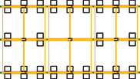
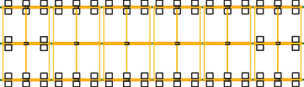
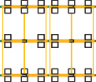
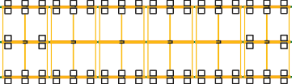
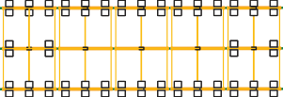
Total Uplift (U) 5023 kg Total Sliding (S) 4047 kg
Created by
XXX
Document type
-
Title
Approved by
-
1:311
Status
-
Project Number
Wa_DE_hmRtfwnq
Vers Created
R1 12/16/2024
MS-HMR-Kaplanova
Roof_1
Lang. Page
DE
1/1
Total Amount Stones 5094 (5,094 kg)

20 | 17 | 20 | 20 | 2 | 20 | 19 | 4 | 19 | 19 | 3 | 20 | 20 | 2 | 20 | 21 | 20 | 21
20 | 1750.45 kg/m² | 20 | 20 | 233.25 kg/m² | 20 | 19 | 433.25 kg/m² | 19 | 19 | 333.25 kg/m² | 20 | 20 | 233.25 kg/m² | 20 | 21 | 2409.97 kg/m² | 21

Σ S87.47 kg Σ U150.26 kg
Tech. Reference
-
20 Area : 11 19
20 49.49 kg/m² 19

Σ S69.72 kg Σ U83.71 kg
Department
-
Area : 12

33.25 kg/m²

Σ S69.72 kg Σ U83.71 kg
Area : 13
1

33.25 kg/m²

Σ S69.72 kg Σ U83.71 kg
Area : 14

33.25 kg/m²

Σ S69.72 kg Σ U83.71 kg
Area : 15

33.25 kg/m²

Σ S87.47 kg Σ U150.26 kg
6 Area : 16 21
6 49.97 kg/m² 21

Σ S87.47 kg Σ U150.26 kg
20 15Area : 0 20 20
Σ S69.72 kg Σ U83.71 kg
2Area : 1 20 20
Σ S69.72 kg Σ U83.71 kg
1A1rea : 2 11 11
Σ S69.72 kg Σ U83.71 kg
1A1rea : 3 20 20
Σ S69.72 kg Σ U83.71 kg
1Area : 4 21 21
Σ S87.47 kg Σ U150.26 kg
2A0rea : 5 21

20 15
Approved by
-
20 20
2 20 20
11 11 11
11 20
20 1
21 21 20 21

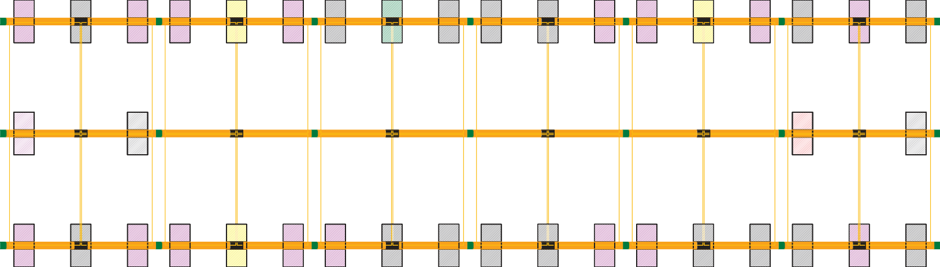
Created by
Document type
-
Title
-
Status
-
Project Number
Wa_DE_hmRtfwnq
Vers Created
R1 12/16/2024
Module area 1
Roof_1
Lang. Page
DE
2/6

21 | 18 | 21 | 20 | 2 | 20 | 21 | 5 | 21
21 | 1849.25 kg/m² | 21 | 20 | 233.25 kg/m² | 20 | 21 | 546.36 kg/m² | 21

Σ S136.55 kg Σ U150.26 kg
Department
-
Tech. Reference
-
14 Area : 17 14
14 50.7 kg/m² 14

Σ S88.92 kg Σ U83.71 kg
Area : 18
2

33.25 kg/m²
Σ S136.55 kg Σ U150.26 kg
21 Area : 19 21
21 53.59 kg/m² 21

Σ S136.55 kg Σ U150.26 kg
21 2A1rea : 6 21 11
21 21 21 11
Approved by
-

Σ S88.92 kg Σ U83.71 kg
2A0rea : 7 11 21
20 11 21

Σ S136.55 kg Σ U150.26 kg
2A0rea : 8 21
20 21

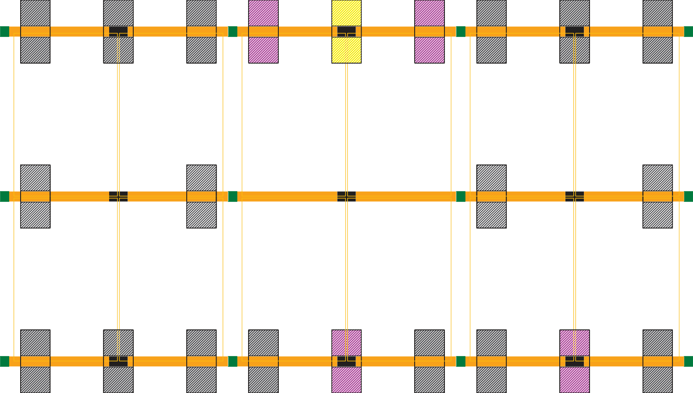
Created by
Rusin
Document type
-
Title
-
Explicit
-
Project Number
Wa_DE_hmRtfwnq
Vers Created
R1 12/16/2024
Module area 2
Roof_1
Lang. Page
DE
3/6

21
21
21
21
21
21

07 kg/m²

Σ S165.39 kg
21
21
514.
2
21
Department
-

Σ U152.43 kg
Tech. Reference
-
3

Area : 20
21
21
21

51.66 kg/m²
21
21
21

07 kg/m²

Σ S165.39 kg Σ U152.43 kg

Area : 21
21
21
514.
2

54.07 kg/m²
21







































Created by
Rusin
Document type
-
Title
-
Explicit
-
Project Number
Wa_DE_hmRtfwnq
Vers Created
R1 12/16/2024
Module area 3
Roof_1
Lang. Page
DE
4/6

Σ S165.39 kg Σ U152.43 kg

Σ S165.39 kg Σ U152.43 kg

6Area : 9 A1rea : 10
21
2
21
21
1
21
Approved by
-
21
16
21
21
21
21

20 | 17 | 20 | 20 | 2 | 20 | 19 | 4 | 19 | 19 | 3 | 20 | 20 | 2 | 20 | 21 | 20 | 21
20 | 1750.45 kg/m² | 20 | 20 | 233.25 kg/m² | 20 | 19 | 433.25 kg/m² | 19 | 19 | 333.25 kg/m² | 20 | 20 | 233.25 kg/m² | 20 | 21 | 2409.97 kg/m² | 21

Σ S87.47 kg Σ U150.26 kg
Tech. Reference
-
20 Area : 33 19
20 49.49 kg/m² 19

Σ S69.72 kg Σ U83.71 kg
Department
-
Area : 34

33.25 kg/m²

Σ S69.72 kg Σ U83.71 kg
Area : 35
4

33.25 kg/m²

Σ S69.72 kg Σ U83.71 kg
Area : 36

33.25 kg/m²

Σ S69.72 kg Σ U83.71 kg
Area : 37

33.25 kg/m²

Σ S87.47 kg Σ U150.26 kg
6 Area : 38 21
6 49.97 kg/m² 21

Σ S87.47 kg Σ U150.26 kg
20 15Area : 22 20 20
Σ S69.72 kg Σ U83.71 kg
2Area : 23 20 20
Σ S69.72 kg Σ U83.71 kg
1A1rea : 24 11 11
Σ S69.72 kg Σ U83.71 kg
1A1rea : 25 20 20
Σ S69.72 kg Σ U83.71 kg
1Area : 26 21 21
Σ S87.47 kg Σ U150.26 kg
2A0rea : 27 21

20 15
Approved by
-
20 20
2 20 20
11 11 11
11 20
20 1
21 21 20 21

Created by
Rusin
Document type
-
Title
-
Explicit
-
Project Number
Wa_DE_hmRtfwnq
Vers Created
R1 12/16/2024
Module area 4
Roof_1
Lang. Page
DE
5/6

21 | 20 | 21 | 11 | 20 | 11 | 11 | 20 | 11 | 20 | 1 | 21 | 21 | 4 | 21
21 | 2409.73 kg/m² | 21 | 11 | 2303.25 kg/m² | 11 | 11 | 2303.25 kg/m² | 11 | 20 | 133.25 kg/m² | 21 | 21 | 445.88 kg/m² | 21

Σ S100.22 kg Σ U150.26 kg
Department
-
Tech. Reference
-
20 Area : 39 6
Σ S74.13 kg Σ U83.71 kg
Area : 40
Σ S74.13 kg Σ U83.71 kg
Area : 41
5
Σ S74.13 kg Σ U83.71 kg
Area : 42
Σ S100.22 kg Σ U150.26 kg
21 Area : 43 21

20 50.21 kg/m² 6
33.25 kg/m²
33.25 kg/m²
33.25 kg/m²
21 54.07 kg/m² 21

Σ S100.22 kg Σ U150.26 kg
21 2A1rea : 28 21 11

21 21 21 11
Approved by
-
Σ S74.13 kg Σ U83.71 kg
2A0rea : 29 11 11

20 11 11
Σ S74.13 kg Σ U83.71 kg
2A0rea : 30 11 11

20 11 11
Σ S74.13 kg Σ U83.71 kg
10Area : 31 21 21

10 21 21

Σ S100.22 kg Σ U150.26 kg
2A1rea : 32 21
21 21

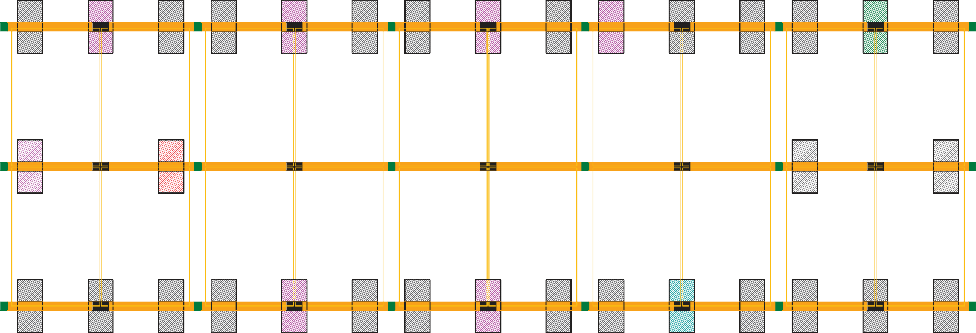
Created by
Rusin
Document type
-
Title
-
Explicit
-
Project Number
Wa_DE_hmRtfwnq
Vers Created
R1 12/16/2024
Module area 5
Roof_1
Lang. Page
DE
6/6

