|  |  |  |  |
| --- | --- | --- | --- |
| Datum zdanitelného plnëni: | 07.08.2024 | Korespondendni adresa:Smetanova 764, i(cli'ri IV |  |
| Datum splatnosti: | 18.08.2024 | KINO 99Kino 99 Kolin 280 02 |  |
| Datum vystaveni: | 08.08.2024 | Smetanova 764 IC: 00353566 |  |
| Forma ührady: | PFevodni pFikaz | Pi(spëvkové argamzaze 280 02 IV | 2 |

FAKTURA - ÙANOVY DOKLAD 4208100082

|  |  |  |  |
| --- | --- | --- | --- |
| Dodavatet:  BONTONFILM  Na 1047/26  110 00 Praha 1  Evidenën( ë(slo  Cl'slo üëtu  IBAN  BIC  3anka  ICO  DIC  Spisové znaëka | a.s. SBONTONFILM  4208100082  107-836964020710100  CZ7601000001078369640207  KOMBCZPP  Komerôni banka, a.s.  26737493  CZ26737493  OR ph MS v Praze, odd. B 7996 | Odbëratel:  C(slo kina  M (sto  Nézev  Provozovatel  léo DIC | 208100  Kolin IV  KINO 99  Kino 99 Kolin  Smetanova 764  280 02 Kolin IV  00353566  CZ00353566 |



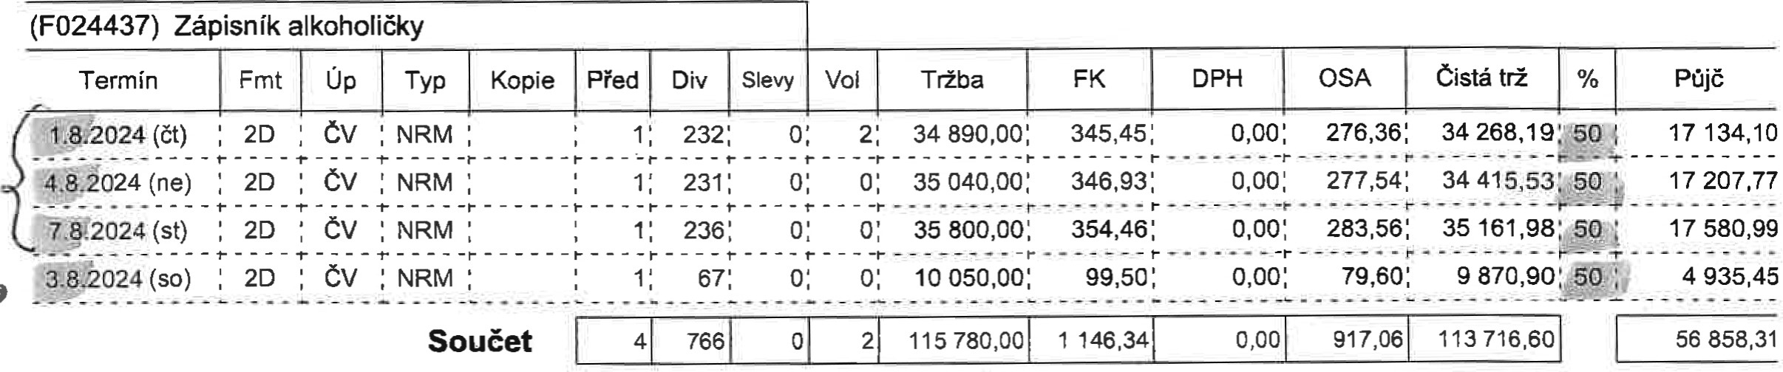

|  |  |  |  |  |  |  |  |  |  |  |  |
| --- | --- | --- | --- | --- | --- | --- | --- | --- | --- | --- | --- |
| |  |  | | --- | --- | | Odvod do FK | 1 146,34 | | Poplatek OSA | 917,06 | | |  |  | | --- | --- | | Celkem bez DPH | 56 858,31 | | DPH 21 % | 11 940,24 | | Odvod celkem s DPH na VS 4208100082 | 68 798,55 | |

QR Platba:

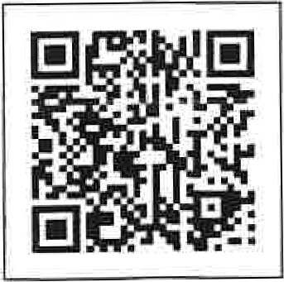BONT NF M a.s

Na Poiüi I 0001

• 79fk, DIC: (726737493; ICO: 26737493

Razitkô a podpis

Kéd: 693

IDA/ 2 VELEVA)/