#### InnoLas Laser GmbH Justus-von-Liebig-Ring 8 82152 Krailling - Germany

InnoLas Laser GmbH - Justus-von-Liebig-Ring 8 - 82152 Krailling

HiLASE Centre

Institute of Physics of the Czech Academy of Sciences

Za Radnici 828

25241 Dolni Brezany Tschechien



|  |  |
| --- | --- |
| **Sales - Quote** | |
| **Quote No.** | **VA4371 / 1** |
| Customer |  |
| Your contact | Sanin Zulić |
| Leadtime | ~ 20 weeks |
| Quote Valid until | 14. April 2025 |
| Warranty | One Year, three months for optics |
| Shipment Method | EXW |
| Payment Terms | 60 days net |
| Salesperson | Matthias Resch |
| Clerk | Matthias Resch |
| Phone No. | +49 (89) 899360-1424 |
| E-Mail | [matthias.resch@innolas-laser.com](mailto:matthias.resch@innolas-laser.com) |

Date 13.01.2025 Page 1

#### Shippingaddress

HiLASE Centre

Institute of Physics of the Czech Academy of Sciences

Sanin Zulić

Za Radnici 828

Fyzikální ústav AV ČR, v.v.i 25241 Dolni Brezany Tschechien

#### Invoiceaddress

HiLASE Centre

Institute of Physics of the Czech Academy of Sciences

Sanin Zulić

Za Radnici 828

25241 Dolni Brezany Tschechien

|  |  |  |  |  |
| --- | --- | --- | --- | --- |
| **Pos** | **No.**  **Description** | **Quantity Unit** | **Unit Price** | **Amount** |
| 10 | SL-EVOIV-100HZ  Spitlight EVO IV - 100 Hz <redacted> | 1 part | <redacted> | <redacted> |
| 20 | SL-DP  OPTIONAL, if not needed, do not order <redacted> | 1 part | <redacted> | <redacted> |
| 30 | R230  Installation and basic training in Prague flat rate incl. travel an accomodation | 1 flat rate | <redacted> | <redacted> |
| 40 | V-PAK  Packaging - Transport box for laser systems | 1 part | <redacted> | <redacted> |
| 50 | V-EXP  Export Costs - Export Declaration | 1 flat rate | <redacted> | <redacted> |
|  |  | **Total EUR** |  | **251.425,00** |

HypoVereinsbank München

IBAN DE81 7002 0270 0654 7823 42 BIC/SWIFT HYVEDEMMXXX

Web: [www.innolas-laser.com](http://www.innolas-laser.com/) Phone.: +49(89)899360-1400

Fax No.: +49(89)899360-1499

Barbara Kelnberger Talita Panhans Norbert Graf

Register: HRB 176659 VAT ID: DE263001082

Registered Office: Krailling



## Sales - Quote VA4371

Date 13.01.25

Page 2

**Specifications**

<redacted>

#### InnoLas Laser systems – Technical Properties

#### <redacted>

#### Laserhead, Oscillator and Amplifier

#### <redacted>

#### Power supply

HypoVereinsbank München

IBAN DE81 7002 0270 0654 7823 42 BIC/SWIFT HYVEDEMMXXX

Web: [www.innolas-laser.com](http://www.innolas-laser.com/) Phone.: +49(89)899360-1400

Fax No.: +49(89)899360-1499

Barbara Kelnberger Talita Panhans Norbert Graf

Register: HRB 176659 VAT ID: DE263001082

Registered Office: Krailling



## Sales - Quote VA4371

Date 13.01.25

Page 3

#### <redacted>

#### Cooling system

<redacted>

#### Control and Interface

#### <redacted>

#### InnoLas Laser - Product Support

#### <redacted>

#### Available Options

Seeder

<redacted>

Energy monitor

<redacted>

Double pulse

<redacted>

Attenuator

<redacted>

OPO

<redacted>

Pointing laser

<redacted>

External Shutter

HypoVereinsbank München

IBAN DE81 7002 0270 0654 7823 42 BIC/SWIFT HYVEDEMMXXX

Web: [www.innolas-laser.com](http://www.innolas-laser.com/) Phone.: +49(89)899360-1400

Fax No.: +49(89)899360-1499

Barbara Kelnberger Talita Panhans Norbert Graf

Register: HRB 176659 VAT ID: DE263001082

Registered Office: Krailling



## Sales - Quote VA4371

Date 13.01.25

Page 4

<redacted>

Mechanical customization

<redacted>

HypoVereinsbank München

IBAN DE81 7002 0270 0654 7823 42 BIC/SWIFT HYVEDEMMXXX

Web: [www.innolas-laser.com](http://www.innolas-laser.com/) Phone.: +49(89)899360-1400

Fax No.: +49(89)899360-1499

Barbara Kelnberger Talita Panhans Norbert Graf

Register: HRB 176659 VAT ID: DE263001082

Registered Office: Krailling

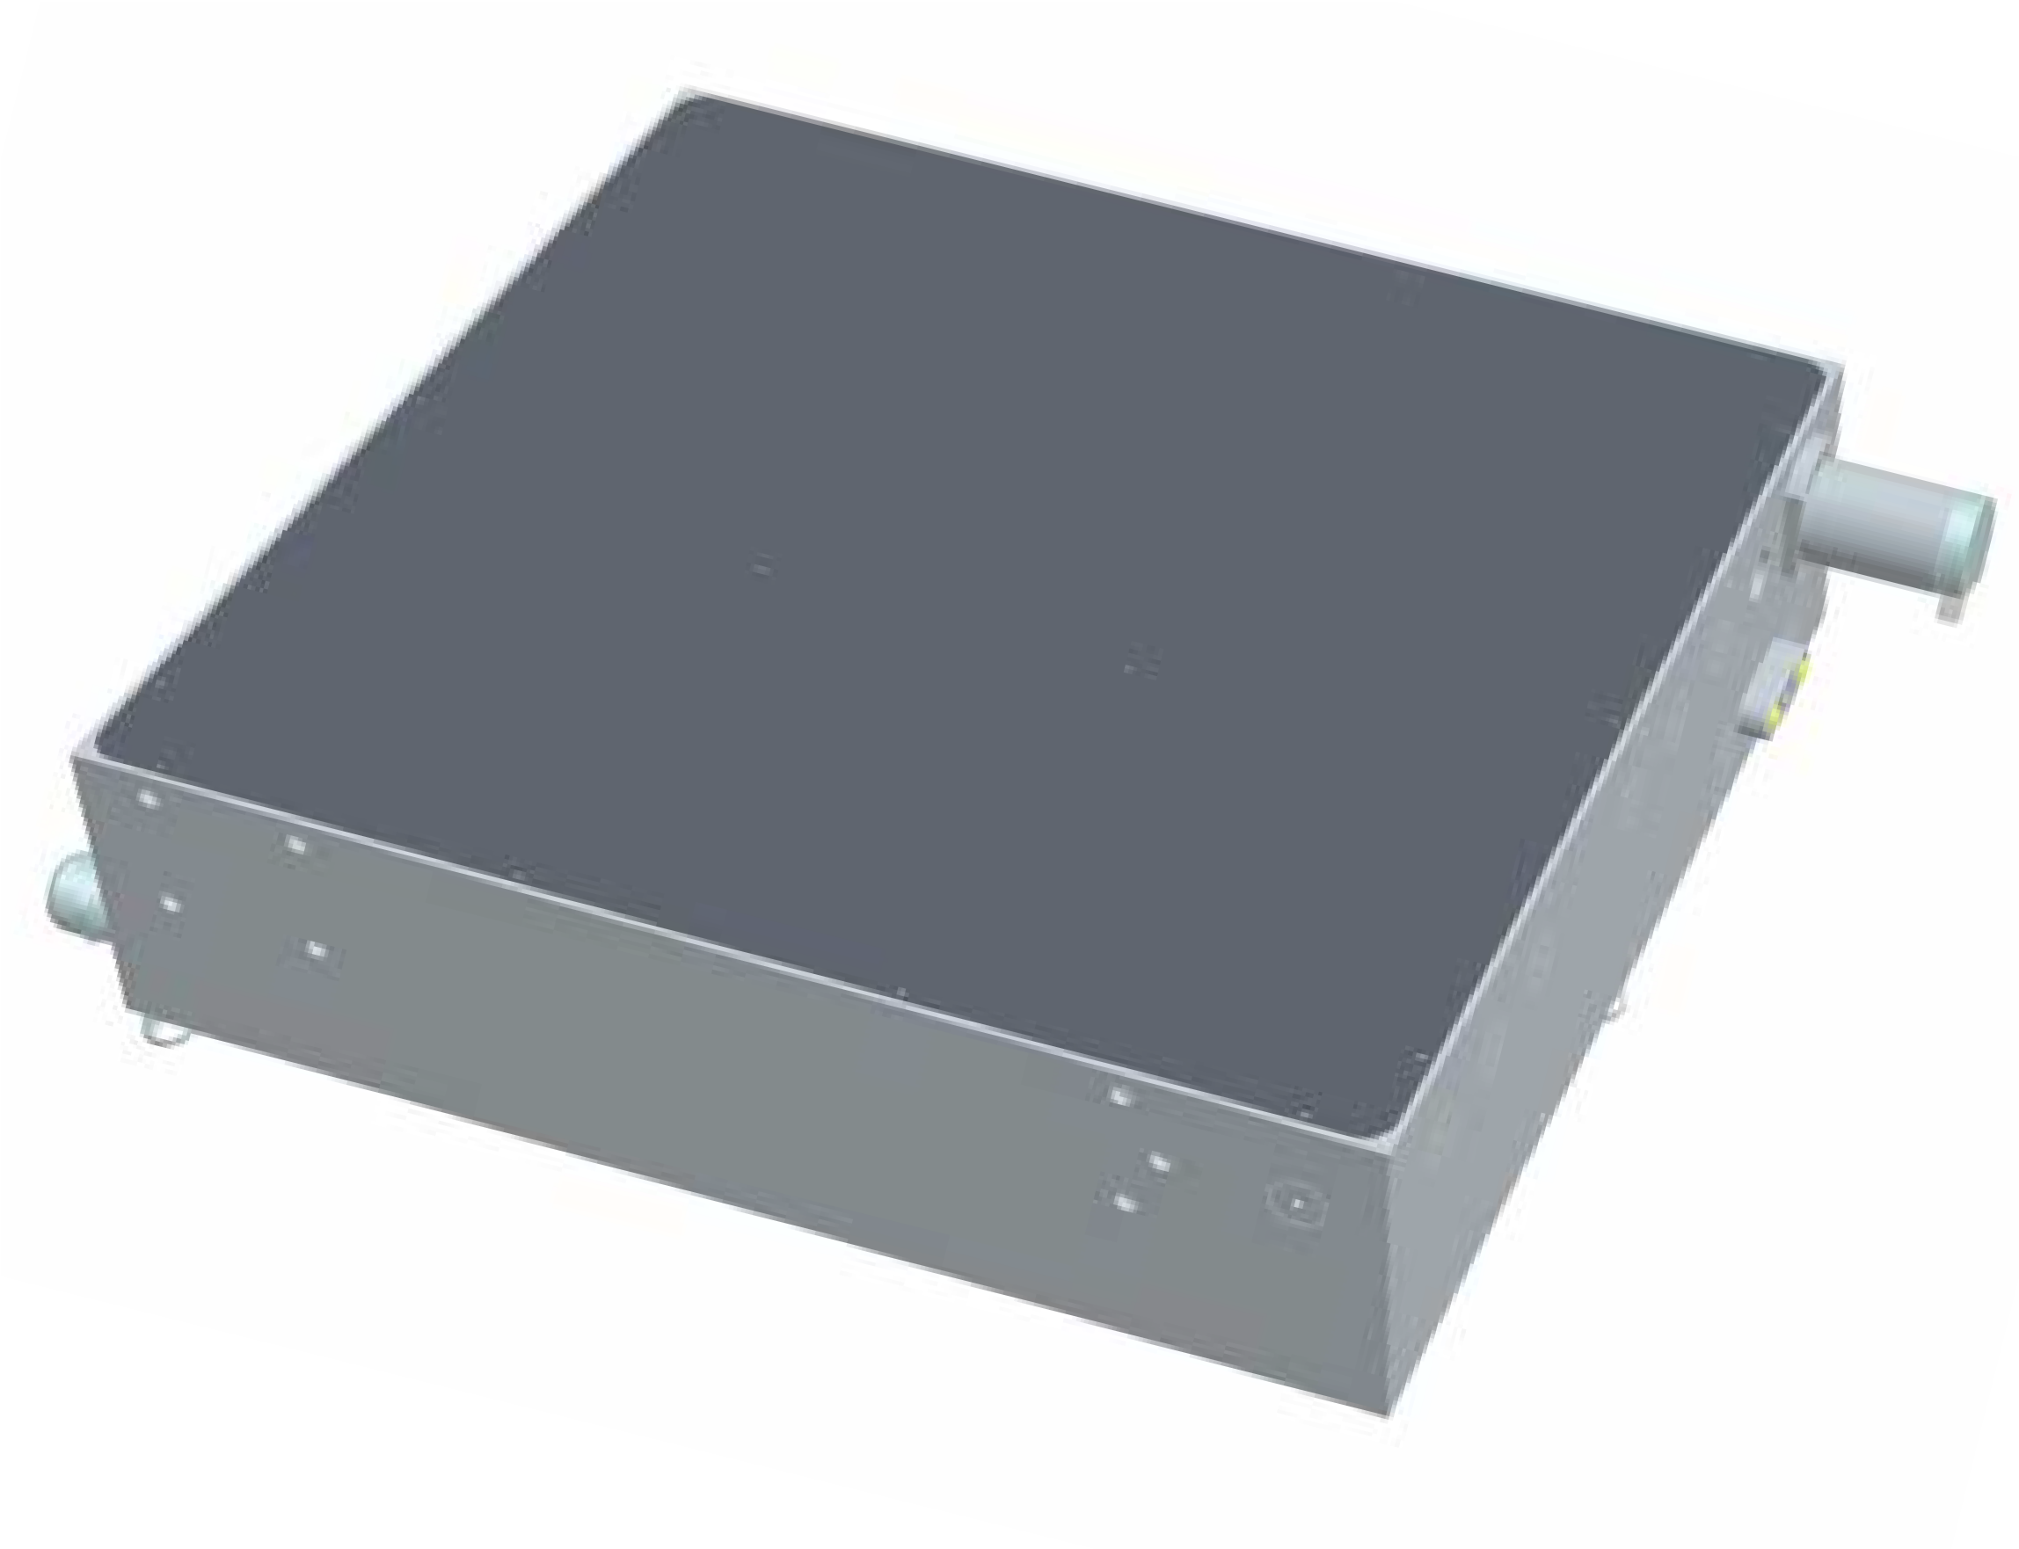

# SpitLight

HEAVY DUTY

LASERS

Heavy Duty Lasers

<redacted>