Contract

Preamble
This contract (consisting of 26 pages) is concluded between Contracting Party 1 and Contracting Party 2 and becomes legally valid upon signature by both parties.

Contracting Party 1 Komorní filharmonie Pardubice (hereinafter Organizer)
represented by MgA. Pavel Svoboda, Ph.D., director
Address Sukova tř. 1260, 530 02 Pardubice, Czech Republic
Contact svoboda@kfpar.cz, +420 608 910 461
ID No. 000 88 447
Tax No. CZ00088447
VAT No. Non-VAT payer
Bank ČSOB Pardubice
IBAN CZ33 0300 0000 0002 7189 2143
SWIFT/BIC code CEKOCZPP

Contracting Party 2 Janoska Ensemble (hereinafter referred to as the Artist)
represented by Künstlersekretariat Buchmann GmbH
(hereinafter referred to as Management)
Prof. Christian Buchmann, GF
Schachnerstraße 27, 1220 Vienna, Austria
VAT-Number ATU 16010206
Mobile +43 676 444 5555

§1 Subject Matter of the Contract
The subject of this contract is a concert of the Janoska Ensemble:
on May 4, 2025 at 19.00 (doors open at 18.00)
at the Sukova síň, Pardubice
address Sukova třída 1260, 530 02 Pardubice, Czech Republic
rehearsals May 4, 2025, 17.00–18.00, Sukova síň, Pardubice

§2 Program and performers
Details: Please refer to the Attachment C of this contract.

§3 Author’s rights
The Artist hereby affirm and warrant that they hold and will retain all necessary author rights pertaining to their performance and any related content. Should the Organizer request the inclusion of a specific piece in the program, the rights pertaining to that piece must be clarified and secured in advance. The Organizer and its associated entities shall bear no responsibility or liability in relation to securing, maintaining, or verifying said rights for pieces not specifically requested. Any claims or disputes arising from author rights shall be solely the responsibility of the Artist.

§4 Fee
The Organizer commits to a sum of € to the Artist, which covers the artistic fee, travel, and the license. The Fee is agreed upon as gross remuneration. The Organizer undertakes to pay the withholding tax of 15% (€ ) to the relevant tax authority and to transfer a net fee of € to the Artist.

The fee is indicated as a net amount, excluding value added tax (VAT), which will be added if applicable, in accordance with the applicable methods and binding legal regulations in the country where the Performance takes place. The Organizer is fully responsible for all bank charges. The Organizer expressly declares, agrees, and unconditionally accepts that it has no financial or other claims or demands (present or future) beyond the agreed lump sum/one-off remuneration.

The Payment shall be transferred to the following account:
Bank: UniCredit Bank Austria AG
IBAN: AT82 12000 00664 054 004
BIC: BKAUATWWXXX
Account holder: Künstlersekretariat Buchmann GmbH

§5 Accommodation
The Organizer provides accommodation for 4 persons for 2 nights (arrival: May 3, 2025 / departure: May 5, 2025) in a hotel of at least 4 stars and bears the associated costs. The accommodation consists of four double rooms for single occupancy including breakfast and parking. Costs for additional services such as laundry, minibar and the like are not included and must be borne by the Artist himself.

§6 Traveling / expenses
‣ Flight booking / payment responsibilities: The Organizer agrees to bear the costs of return flights between Vienna and Riga for a total of x (x) individuals. The flights shall be booked by the Artist after the costs are confirmed with the Organizer and invoiced to the Organizer for direct payment to the traveling agency.
‣ Local Transfers: The Organizer shall be responsible for organizing and covering all costs associated with local transfers, inclusive of airport transfers, for the aforementioned x (x) individuals.

§7 Technical Rider as Attachment A to the Contract
The "Technical Rider", as the Attachment A to this Agreement, forms an integral part of this Agreement. Both parties recognize the "Technical Rider" as binding and undertake to comply with all conditions and requirements set out therein.

§8 Backstage Area
Wardrobe requirements
‣ The cloakroom for the Artists must be lockable or guarded and in the immediate vicinity of the stage.
‣ The premises must be clean and air-conditioned or heated.
‣ The wardrobe should be equipped with a table, chairs, and a mirror.
‣ Ideally, the cloakrooms have private toilets with hot and cold running water and electrical sockets.

Backstage Amenities for the Artists
Please refer to the Attachment B of this contract.

§9 Autograph Session after the Concert (optional)
If the Organizer plans an autograph session after the concert, the following guidelines must be observed:
Start: 30 minutes after the end of the concert.
Duration: Maximum 45 minutes

Equipment
‣ Table: At least 4 meters wide with clean tablecloth (preferably in green, black, or white)
‣ Seating: 4 black armchairs or chairs
‣ Pens: 6 waterproof marking pens, ideally in gold and silver metallic
‣ Drinks: Cold refreshments
‣ Other: 5 small black towels

§10 Reception after the Concert (optional)
Since the concerts of the Janoska Ensemble are always a special experience, many Organizers choose to round off the evening with a fine meal in a local restaurant. This proposal is particularly appreciated by the Artists and is therefore very welcome!

§11 Recording / Photography
11.1 General prohibition
Due to the exclusive contract of the Janoska Ensemble with Deutsche Grammophon (Universal Music Group), audio and video recordings of rehearsals and concerts are prohibited.

11.2 Exceptions
11.2.1 Broadcast Recordings
Public broadcasters are allowed to record concert performances, provided they obtain prior written approval from the Universal Music Group of the respective country. Usage is limited to the following conditions:
- Maximum number of broadcasts: three (3)
- Online availability: up to seven (7) calendar days
11.2.2 Reporting
Audio and video recordings for journalistic reporting are permitted under the following conditions:
- Maximum time spent by the recording team in the room: 15 minutes
- Maximum broadcast length: 3 minutes

11.3 Further Usage Rights
Any additional usage rights for audio and video recordings must be agreed separately and directly in advance between the concert organizer and the Universal Music Group of the respective performing country.

11.4 Photography during the concert and/or rehearsals
The management allows the organizer to take photographs of the concert and/or rehearsals for promotional and informational purposes (both digital and print). No photographer is permitted to be on stage. Photography must not disturb the artist or the concert audience in any way.

§12 Advertising/PR
The Organizer undertakes to ensure sufficient advertising in the regional environment of the event. For this purpose, the Artist provides the Organizer with images, biographies, and audio recordings (if available) free of charge. The Organizer will not use those materials commercially. The Artist will, if possible, participate in PR events such as press conferences, meet & greet, etc. Such events must be communicated by the Organizer in advance to the Artist's management for approval. The Artist's management has 3 working days for this approval. The Organizer is obliged to send all published articles and reviews unsolicited to the Artist's management within one week of their publication.

§13 Levies
All fees, including those for collecting societies, performances, royalties, and sales tax and contributions to Artists' social insurance, are to be borne by the Organizer.

§14 Complimentary Tickets etc.
The Artist will receive 10 complimentary tickets in a good category, 4 evening programs and a concert poster from the Organizer.

§15 Approval of Information
The programs must be sent to management for approval before printing. The Artist has 3 working days for approval.

§16 Nondisclosure
Both contracting parties agree not to disclose the contents of the contract to uninvolved third parties.

§17 General Clauses
There are no ancillary agreements to this agreement; Changes and/or additions must be made in writing.

§18 Data Protection
Both contracting parties use data of the Artist and his employees only for the engagement (e.g. travel, visa, work permit). Any other use is not permitted. All data processors are obliged to maintain confidentiality, even after the end of their activities. Upon request, the contracting parties will inform the Artist of all data disclosures. They guarantee data protection in accordance with Art. 32 GDPR and destroy all data after the end of the contract, except for legally required retention.

§19 Force majeure / Negligence
Force majeure and termination of the contract
Events that are unforeseeable and beyond the reasonable control of the parties, such as in particular, but not exclusively, wars, epidemics, fires, or riots that hinder the execution of the concerts in accordance with the contract, may lead to the termination of the contract. If the parties decide to terminate the contract, no reimbursement of costs incurred by both parties can be reimbursed.

§20 Illness of the Artist
Should the Artist(s) be unable to fulfill their contractual obligations due to illness, the following protocols shall be adhered to:
Notification: The Organizer shall be promptly notified by either the affected Artist(s) or their management of such inability to perform.
Medical Verification: A medical certificate or appropriate documentation verifying the illness must be provided to the Organizer at the earliest opportunity.
Subsequent Arrangements: Upon receipt and verification of the medical documentation, both parties shall enter into discussions to determine the most suitable course of action, which may include:
- Procurement of a substitute artist for the scheduled performance;
- Rescheduling the concert to a mutually agreeable date; or
- Cancelling the concert. In the event of cancellation, both parties agree to share equally any expenses accrued to date and any foreseeable associated costs.

§21 Negligence or intent on the part of the Organizer
If the Artist is partially or completely prevented from fulfilling the contract due to negligence or intentional action on the part of the Organizer, the entire fee agreed in the contract will be due as if the Artist had played all the contractually agreed concerts. "Negligence" is understood to mean negligence or lack of care expected of a reasonable Organizer in the same situation, and "intent" means an intentional act or omission.

§22 Pandemic-Related Disruptions
If the concert in question is prevented due to official regulations as a consequence of a pandemic, the contracting parties will jointly try to find a new date, ideally within one year of the originally planned date. The contract remains in effect; the concert date will either be adjusted or, upon mutual agreement and with the appropriate consents and arrangements in place, the concert may be cancelled.

§23 Duration of the Contract
This contract comes into force upon signing by both parties and ends automatically upon completion of the event or upon departure of the Artists.

§24 Liability
Both parties are liable for damages caused by their fault or the fault of their representatives or vicarious agents.

§25 Intellectual Property
The rights to the music, recordings and other creative works created during the concert remain with the Artist, unless otherwise agreed in writing.

§26 Involvement of Third Parties
The Artist has the right to involve third parties (e. g. substitute musicians or technicians) to fulfill his obligations, provided that this is communicated to the Organizer in advance and approved by the Organizer.

§27 Non-Performance
In the event of non-performance of the contractual obligations by one of the parties, the other party shall be entitled to compensation, unless otherwise agreed in this contract.

§28 Dispute Resolution
In the event of a dispute in connection with this contract, the parties are obliged to go through a mediation procedure before taking legal action.

§29 Applicable Law
This contract is subject to the laws of Republic of Austria.

§30 Place of Jurisdiction
The place of jurisdiction for this contract is Vienna, Austria.

§31 Non-Transferability
This Agreement is personal in nature and may not be transferred by either party to any third party without the written consent of the other party.

§32 Changes and Ancillary Agreements
The parties hereby confirm that there are no oral or written ancillary agreements to this contract. Any amendments or additions to this contract must be made in writing and signed by both parties.

Vienna, Pardubice,

_________________________ __________________________
Prof. Christian Buchmann MgA. Pavel Svoboda, Ph.D., director
Komorní filharmonie Pardubice

_________________________
Janoska Ensemble
Attachment A
Technical Rider

Introduction
Please note that some parts of the rider and their fulfilment depend on the size of the hall, the possibilities of the Organizer, and other relevant circumstances. We ask for a detailed discussion of the possibilities with the Management in case of uncertainty. The Organizer undertakes to use the relevant components of this rider as an integral part of the underlying contract unless other agreements have been made based on local circumstances.

Definition of “Stage”
- Stage: increased, flat area without obstacles and decoration.
- Stage sizes: minimum 6 width by 4 meters depth.

Personnel and Equipment
- 1 lighting technician (from setup of the technique to the end of the concert)
- 1 sound technician (from setup of the technique to the end of the concert)
- 1 piano tuner
- 1 person for CD sale (if a CD sale takes place)
- 1 four-string double bass (4/4 or ¾) solid wood (Meisterinstrument)
- 1 concert grand piano: Steinway D (tuning 443 Hz) – freshly polished with desk lighting
- 1 piano stool made of black leather, upholstered, seat height adjustable
- 2 elegant double bass chairs, height adjustable - with footrest, without armrest
- 3 microphone stands (with a screw device at the end to attach a tablet)
- 3 professional, black music stands with desk lighting
- 1 microphone for moderation

Amplification Requirements
Unamplified / Unplugged
- Ensemble (4 members): No monitors required.
- Ensemble + Arpad: Only Arpad requires a monitor.
Amplified / Plugged without Orchestra
- Ensemble: No monitors required.
- Ensemble + Arpad: Only Arpad requires a monitor.
Amplified / Plugged with Orchestra
- Ensemble (4 members): Requires 4 monitors.
- Orchestra also requires monitors to hear the ensemble.
- PA: High-quality sound system appropriate to the size of the hall. The PAs should be aligned so that the first rows of spectators can be reached (no front fill speakers).

Sound Requirements Amplified / Plugged
Attention: Please note the variants: plugged or unplugged according to the aforementioned
Point 4 “Amplification Requirements” of this Attachment A.

Piano 2x Neumann KM 184 or 2x DPA A4099P
2 Violins each 1x DPA 4066 Lavier Omni Directional, low sense beige, compatible with wireless Sennheiser Bodyback Transmitter / Receiver / Windscreen + Transmitter
Doublebass 1x DPA 4099 B
Mixing Console High-quality digital mixing console
Monitors 4 monitors, 4-way (Wedges 10-12 inch, Nexo, Meyer, K&F, D&B)

Plugged and Unplugged Handheld microphone for moderation + microphone stand; corresponding PA for moderation.

Lighting Requirements
- Standard concert lighting: dimmable, white stage light
- Focus on the ensemble, podium: dark on the side.
- Background: red, blue, and purple light
- 5 spotlights on the pianist, on both violinists, on the bass player and the singer

Backstage Area
- Lockable or guarded dressing rooms for the artists near the stage.
- The dressing rooms must be clean and air-conditioned/heated and comfortably furnished (table, chairs, mirror).
- The dressing rooms must have private toilet facilities with running hot and cold water as well as electrical sockets.

Sound Check Requirements
- 60 minutes before doors open: Sound check / rehearsal for plugged concert
- 30 minutes before doors open: Sound check / rehearsal for unplugged concert
- Showtime: 90 minutes + 20 minutes intermission for 2-Set programs
- OR 70’ without intermission for 1-Set programs

Signing Session (optional)
- Start: 15 minutes after the end of the concert
- Duration: 30 minutes
- 1 table, min. 4 meters wide, nice clean tablecloth (e.g.: green, black, or white)
- 4 black armchairs/chairs
- 6 waterproof signing pens (Gold and Silver metallic)
- Cold drinks
- 4 small black towels

Stage Position of Artists
Janoska Ensemble alone
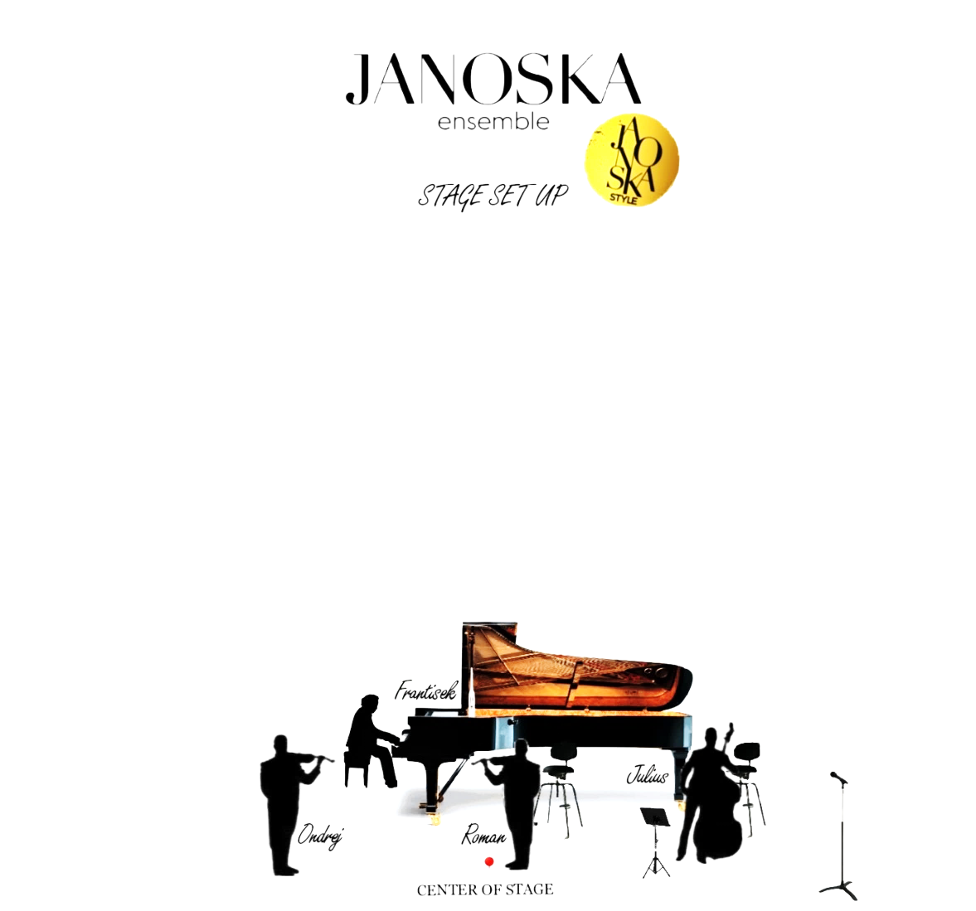

Janoska Ensemble with Orchestra

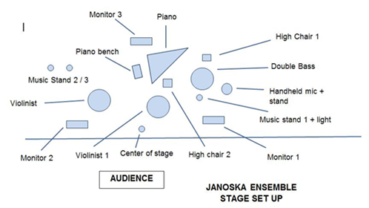

Attachment B
Optional Backstage Amenities

In the spirit of an exceptional event and creating a memorable experience for everyone (not only the audience), the Organizer is wholeheartedly invited, but not obligated, to provide the following backstage amenities for the Artist. While these amenities are optional, their provision would be a testament to the Organizer's commitment to excellence and would be deeply appreciated by the Artist.

Hydration & Refreshments
- Seven (7) bottles of chilled carbonated mineral water, each 0.5 liters, accompanied by ice.
- Five (5) bottles of chilled isotonic drinks, preferably Yellow Gatorade or an equivalent.
- Five (5) bottles of chilled Coca-Cola, each 0.5 liters.
- A variety of herbal and green teas, complemented by coffee options.
- One (1) kettle for hot water preparation.

Nourishment & Setup
- A fruit basket curated for five (5) individuals.
- A ham and cheese platter crafted for five (5) guests.
- Essential dining implements: glasses, cutlery, and plates, accompanied by one (1) table and five (5) chairs.

Comfort Amenities
- Five (5) large, pristine towels and five (5) small, equally pristine towels.
- One (1) iron, accompanied by an ironing board.

This Attachment B is incorporated by reference into the Agreement between the Artist and the Organizer dated [Insert Date]. The Organizer acknowledges that while these amenities are optional, their provision would contribute significantly to the Artist's comfort and overall experience.

Attachment C
Agreed Musical Program

This Attachment C forms an integral part of the contract between the Artist and the Organizer. The content herein outlines the proposed musical program at the time of conclusion of the contract and is subject to further discussion and potential changes. The program must be confirmed by both the Artist and the Organizer, and the final program will be mutually agreed upon by both parties.

VIVALDI – THE FOUR SEASONS IN JANOSKA STYLE
All titles are arranged by the Janoska Ensemble in their unique Janoska Style.

František Janoska Piano
Ondrej Janoska Violin
Roman Janoska Violin
Julius Darvas Doublebass

Antonio Vivaldi: Spring, Violin Concerto in E Major, Op. 8/1, RV 269
1. The Groovy Birds
2. Dreaming Soul
3. The Irish Wedding

Antonio Vivaldi: Summer, Violin Concerto in G Minor, Op. 8/2, RV 315
1. Caribbean Vibes
2. Silence before the Storm
3. Storm in Janoska Style

[ intermission ]

Antonio Vivaldi: Autumn, Violin Concerto in F Major, Op. 8/3, RV 293
1. 7/8 Balkan Journey
2. Blind Improvisation
3. The Hunter and the Jazzy Fox

Antonio Vivaldi: Winter, Violin Concerto in F Minor, Op. 8/4, RV 297
1. Dancing in the Snow
2. Sweet Home
3. Peace and Love Forever

Total length: approx. 40 + 40 minutes

