EQUIPMENT BORROWING AGREEMENT

Agreement No.: KW-JC-202503E01

Supplier ("Party A"): D'exForce Technology Co., Ltd. Address: [Insert Party A's Registered Address] Authorized Representative: [Name/Title]

Borrower ("Party B"): Czech Technical University in Prague, CllRC, CZ68407700 Address: Jugoslavskych partyzanu 1580/3,

Authorized Representative:

RECITALS

WHEREAS, Party A possesses proprietary equipment for temporary loan purposes; WHEREAS , Party B desires to borrow said equipment under mutually agreed terms; NOW, THEREFORE, the parties hereby agree as follows:

- -- ---- -- ·-· -·

1. BORROWING PERIOD
   1. Party A grants Party B a 90-calendar -day trial period commencing from the date of equipment receipt.
   2. If Party B fails to initiate return shipment of the Equipment within five (5) business days following the expiry of the trial period, Party B agrees to purchase the Equipment.;
   3. Party A shall provide remote technical support during the trial period.
2. BORROWED PRODUCT DETAILS

No. Product Name Specificat ion Quantity

1. DexSense 3D Industrial Camera XEMA-LCW 1
2. 3D Camera Ethernet Cable 10 meters 1
3. 3D Camera Power Cable 10 meters 1



•..;.:_::.=---· --- -- · --· - ---- -- --- -- - -- ...



Ill. BORROWING GUIDELINES

* 1. Custody Responsibility:
     + Party B shall safeguard equipment integrity. Serial/model labels must remain intact.
  2. Logistics Costs:
     + Party B bears all shipping costs and insurance fee. Party A warrants the accuracy and completeness of all export and return customs documentation it provides.
  3. Extension Request:
     + Party B must request extensions in writing 3 days prior to expiry.
  4. Damage Liability:
     + Party B assumes full liability for non-quality-related damage.
  5. Shipping Damage Protocol (New):
     + Party B must report any damage reasonably attributable to transit within three (3) business days of the delivery date, providing timestamped photographic or video evidence

o Party A manages insurance claims; Party B preserves original packaging.

* 1. Party A shall declare the Equipment as "Temporary Export Goods" under HS Code [XXXX.XX.XX] and provide ATA Carnet or equivalent temporary · export

documentation.

* 1. If Party B exercises the purchase option under Section 1.2:
     + a) Party B shall be solely responsible for completing import formalities in the destination country and paying applicable duties/taxes.

o b) Party A shall provide revised commercial invoices and export declarations reflecting the sale within 5 business days.

1. TECHNICAL CONFIDENTIALITY 1. IP Rights:

o Reverse engineering, disassembly, or decompilation is strictly prohibited.

1. Confidentiality :
   * Party B shall not disclose technical data, trade secrets, or customer/vendo r lists.
2. Breach Penalties:
   * Unauthorized disclosure entitles Party A to terminate the Agreement and claim damages.
3. FAULT DETERMINATION
   1. Quality-related defeCts shall be resolved by Party A through product improvements.
   2. Non-quality issues arising from Party B's misuse, negligence, or failure to follow operating guidelines after acceptance of the Equipment are Party B's sole responsibility. Damage occurring during transit is subject to the insurance claim process outlined in Sections 111.5 and Vl.2.
4. SHIPPING CLAUSES *(New)*
   1. Courier Selection:
      * Shipments via SF Express(https://www.sf-international.com) with prior written confirmation.

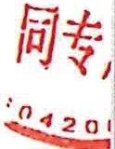

2. Insurance:

o Insures equipment for 100% of market value during transit.

1. Customs Documentation:
   * Party A provides HS codes, technical specs, and export paperwork.
2. Shipment deadline:
   * Party A shall ship the Equipment within seven (7) business days of receiving the Security Deposit specified in Section VII. Should Party A fail to ship the Equipment within this period, Party B shall have the option to terminate this Agreement, whereupon Party A shall refund the Security Deposit in full within five (5) business days.
3. SECURITY DEPOSIT
   1. Deposit Amount: USD $3,000, payable within 7 days via bank transfer. 2. Refund Conditions:
      * Full refund within 15 working days if:

./ Equipment is returned undamaged ;

./ No outstanding obligations exist.

1. Deductions:

o Party A may deduct reasonable, documented costs for repair of damage exceeding normal wear and tear from the Secur ity Deposit. Party A shall

provide Party B with itemized invoices or repair quotes justifying such deductions within ten (10) working days of receiving the returned Equipment.

1. Documentation (New):

o Party A issues a Pro Forma 1.nvoice within 3 days (see Attachment A). o A Credit Memo is issued upon compliant return.

·--- - --

1. DISPUTE RESOLUTION *(New)*
   1. Arbitration:
      * Disputes resolved under Singapore International Arbitration Centre (SIAC).

2. Governing Law:

o The governing law of this agreement shall be the law of China

1. GENERAL TERMS
   1. Amendments :
      * Modifications require written agreement by both parties.
   2. Severability :
      * Invalid clauses shall not affect the remainder of the Agreement.
   3. Electronic Signatures:
      * Scanned signatures and emails hold full legal validity.

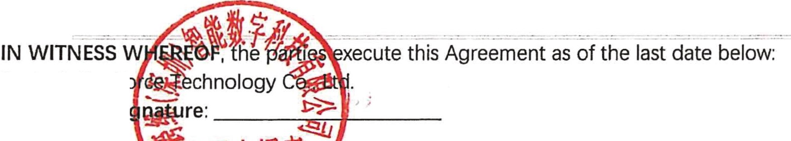

Party A: DexFnlrlroLIb Authorized Si

Name/Title:--l ....-f='d--f.1--.!o!o. __

Date: -- ..,,,... :-i>Jll -,....-r

Party B: Czech

## 1580/3, CZ68407700

ague, CllRC, Jugoslavskych partyzanu

Authorized Signature:



Name/Title: Date: _

ATTACHMENTS

* Attachment A: Pro Forma Invoice Template

# DexForce Technology Co., Ltd.

## Address: Room 511, Building 4, Software Industry Base, No. 19, 17, 18, Haitian First Road, District, Shenzhen

Binhai Community, Yuehai Street, Nanshan District, Shenzhen email : Tel:

**PROFORMA INVOICE**

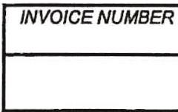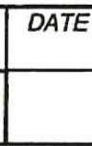





Name:

Institution: Czech Institute of Informatics, Robotics, and Cybernetics, Czech Technical University in Prague

Address: Jugoslavskych partyzanu 1580/3, Dejvice (Prague)

Country: Czech Republiq Zip code: 160 00

*TRANSPORTAT/ON IPACKING IMARKING DETALES*

*QUANTITY*

*UNIT TOTAL*

*PRICE AMOUNT*

*(FOB (USD)*

*ShenZhen)*

total

0.00

**NOTE:**

Above samples for evaluation only and no commerial value.

*Ship from*

Company Name:DexForce Technology Co., Ltd.

Add:

Room 511, Buil iin n ll Software

*SH/P TO*

lnd.u.stry ·

Ha1t1an Nansh

Tel:O?

*TERM*

:t, Sheni:

26732

,.. v *: ,et,*

*Vr*

..Ell

*DELii ERj*

*'>#'*

·-

*3*

2

*,<\ J((*

*CLE /*

*CR/PT/ON*

HS CODE :