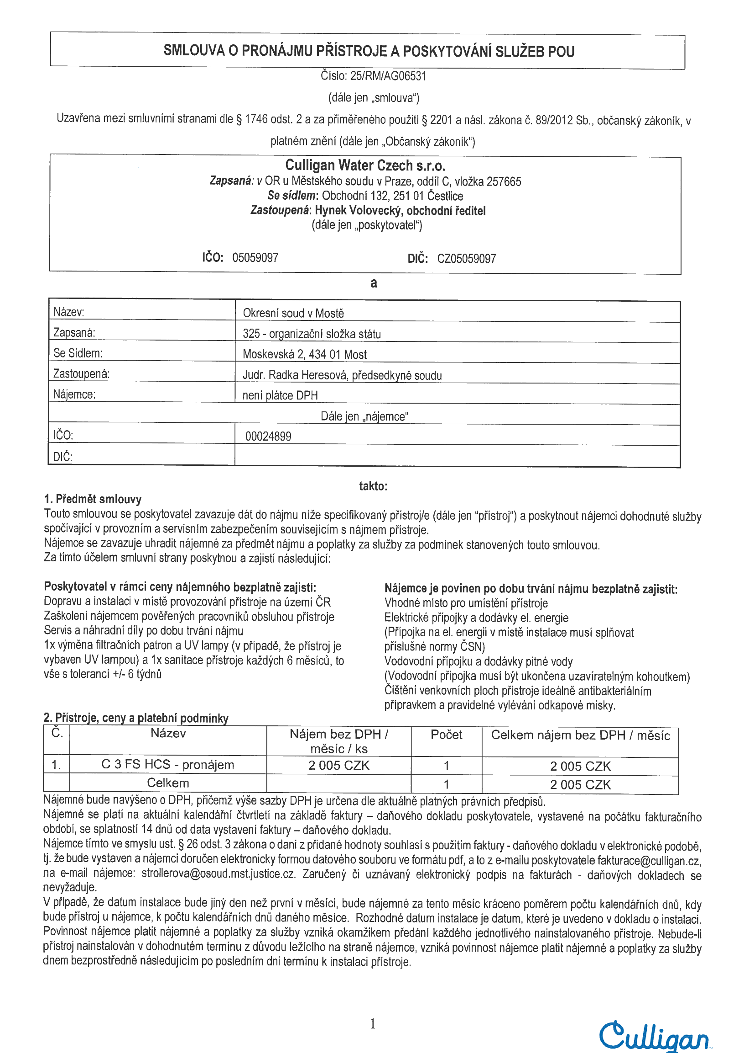Envelope ID DigiSign.org: 0196d5f5-e7e4-72ab-bfe6-80a81dcf1d7d

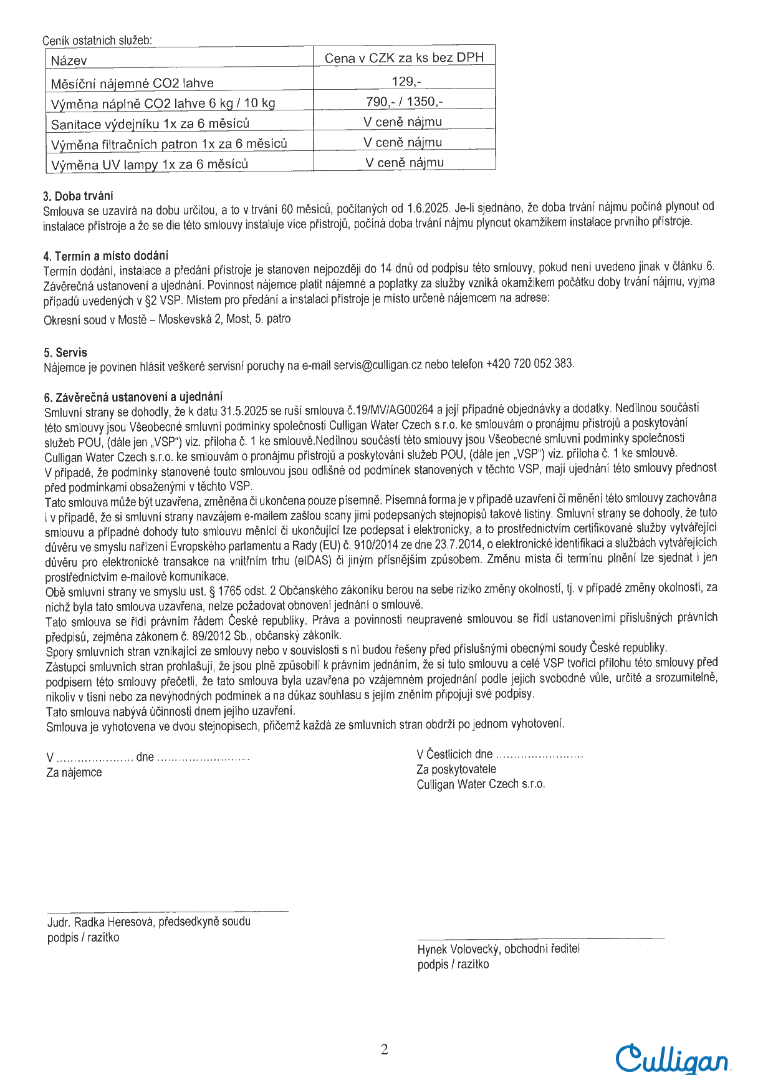CABADAJMART210191 1Envelope ID DigiSign.org: 0196d5f5-e7e4-72ab-bfe6-80a81dcf1d7d

XXXXXXXXXXXXXXXXXX

XXXXXXXXXXXXXXXXXXXXXXXXXXXXXXXXXXXXXXXXXXXXXXXX

Digitálně podepsal   
JUDr. Radka Heresová   
Datum: 2025.05.14   
09:58:16 +02'00'

ID: 0196e7fe-4129-7071-b53b-16d7d6b08ee0

19.5.2025 12:02:01

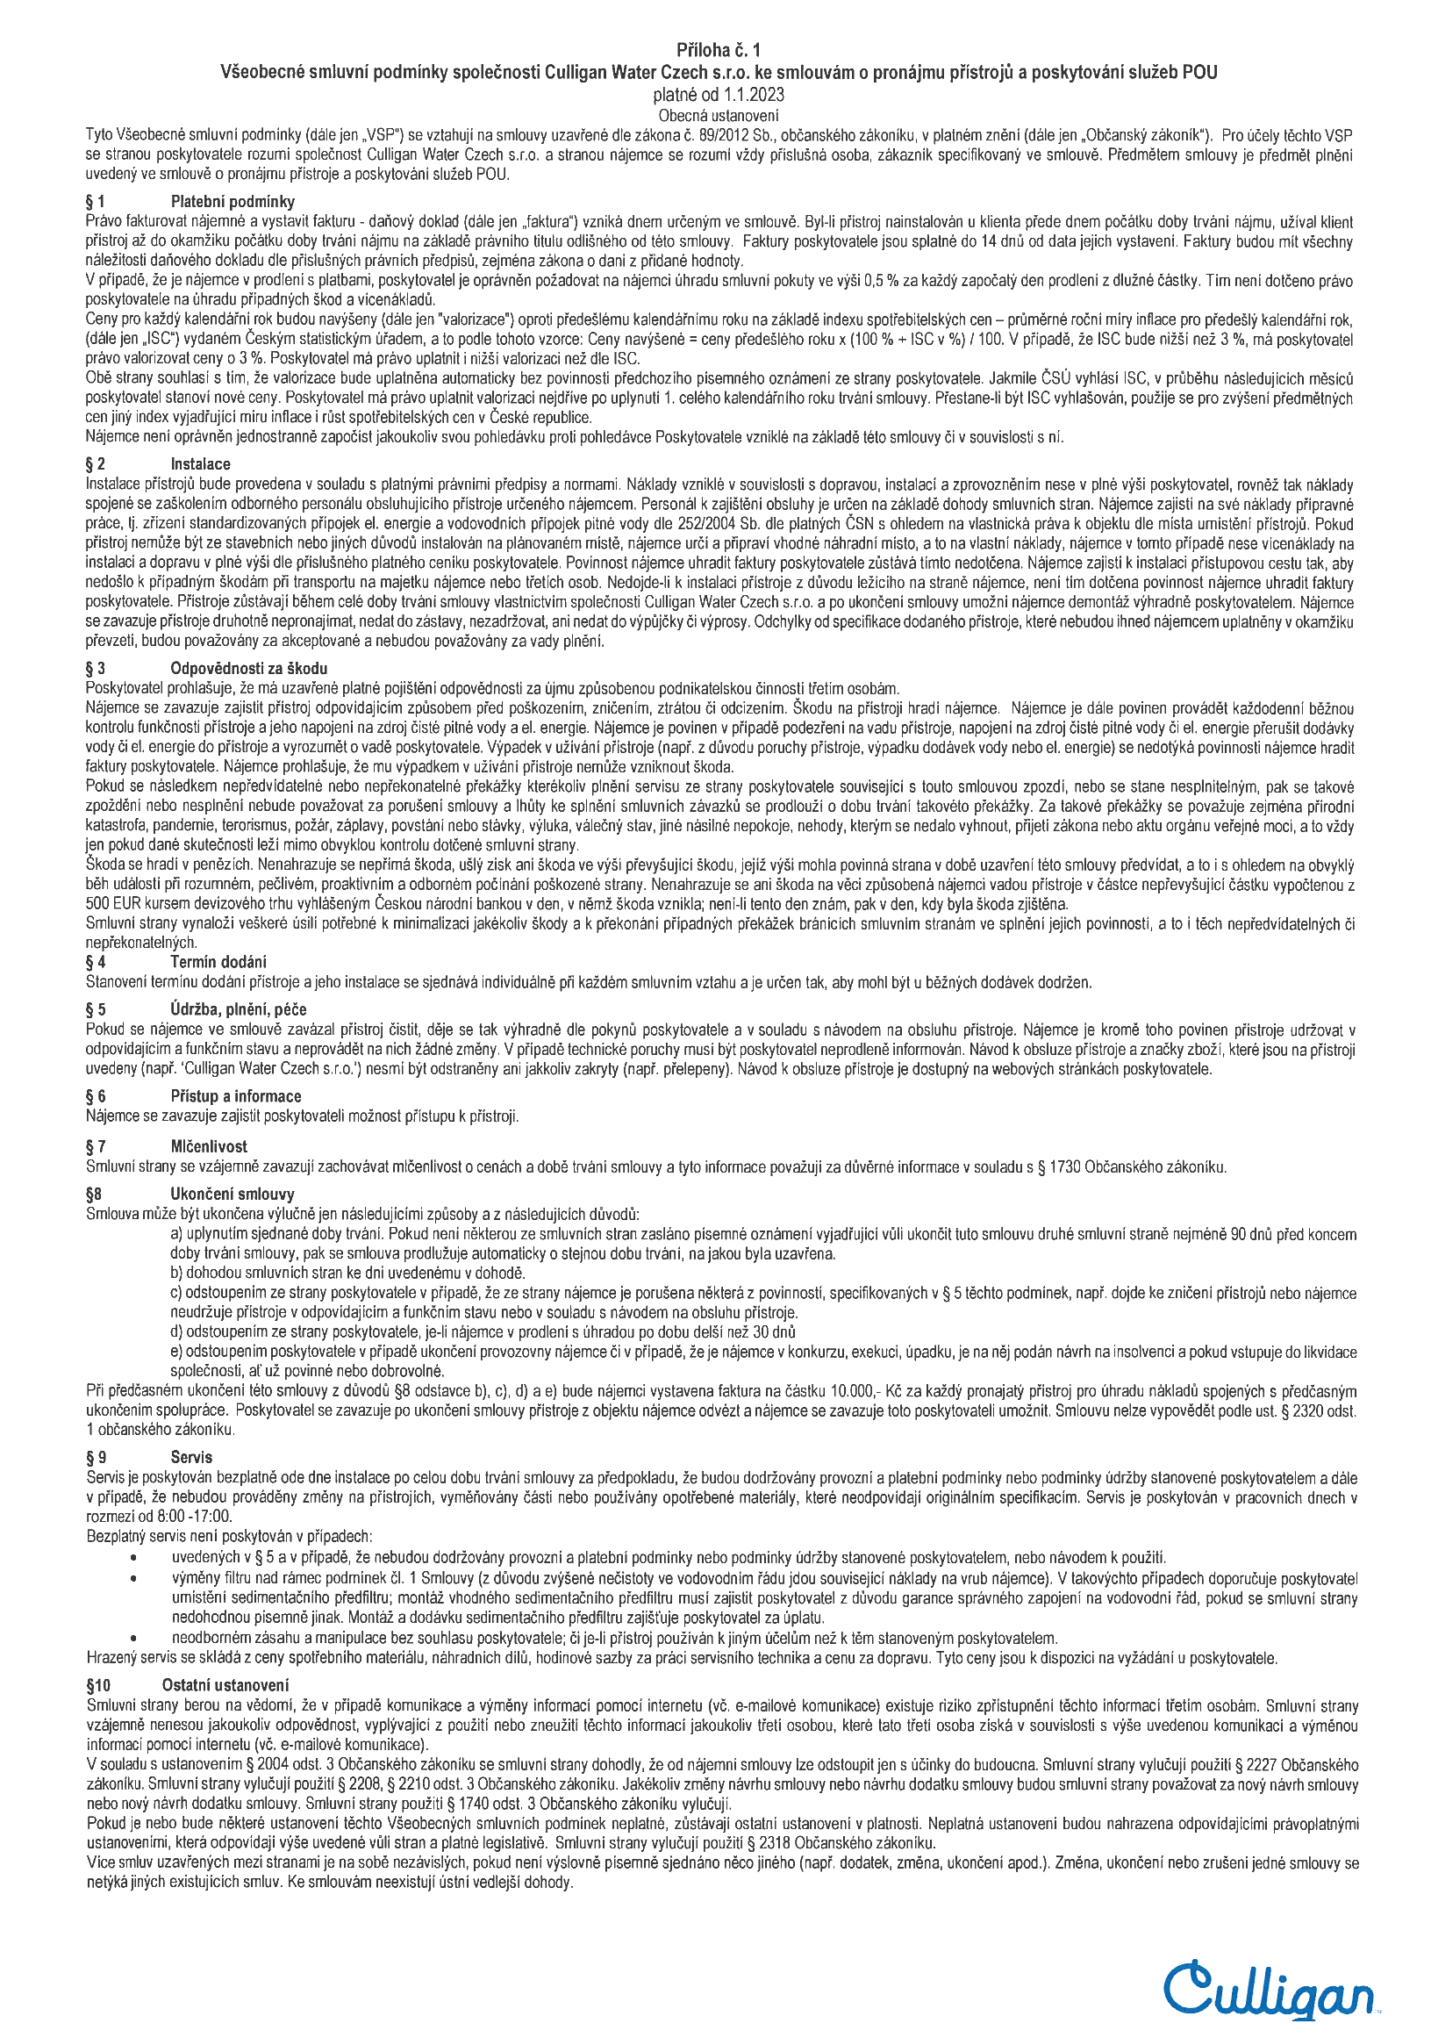Envelope ID DigiSign.org: 0196d5f5-e7e4-72ab-bfe6-80a81dcf1d7d