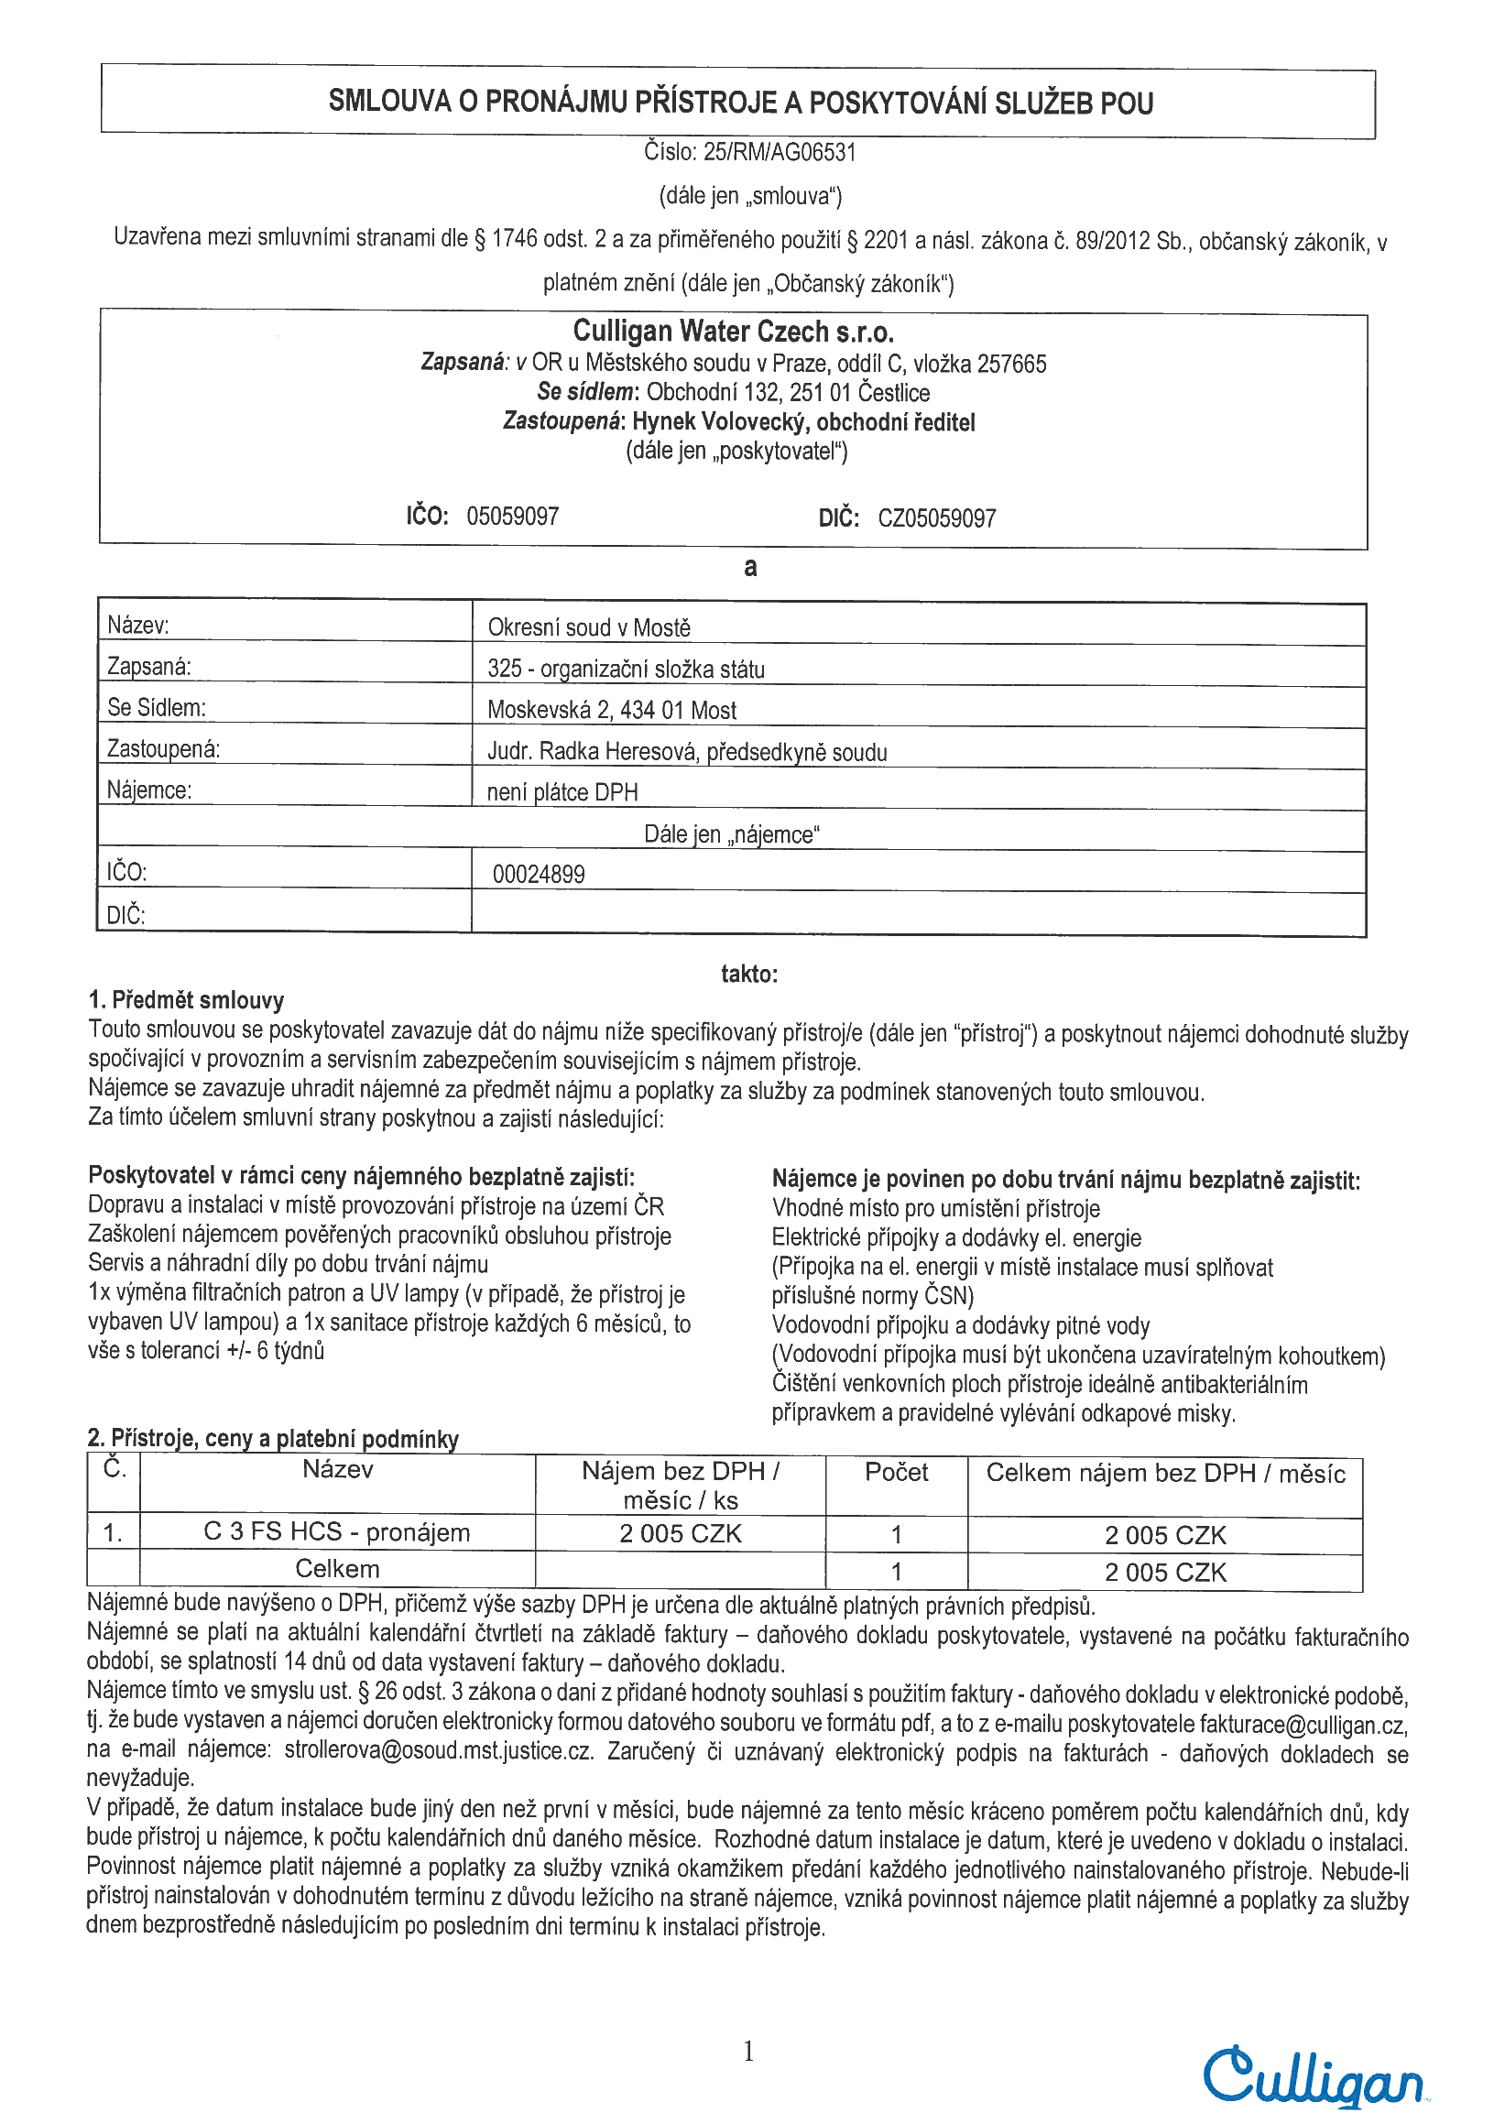
Envelope ID DigiSign.org: 0196d5f5-e7e4-72ab-bfe6-80a81dcf1d7d
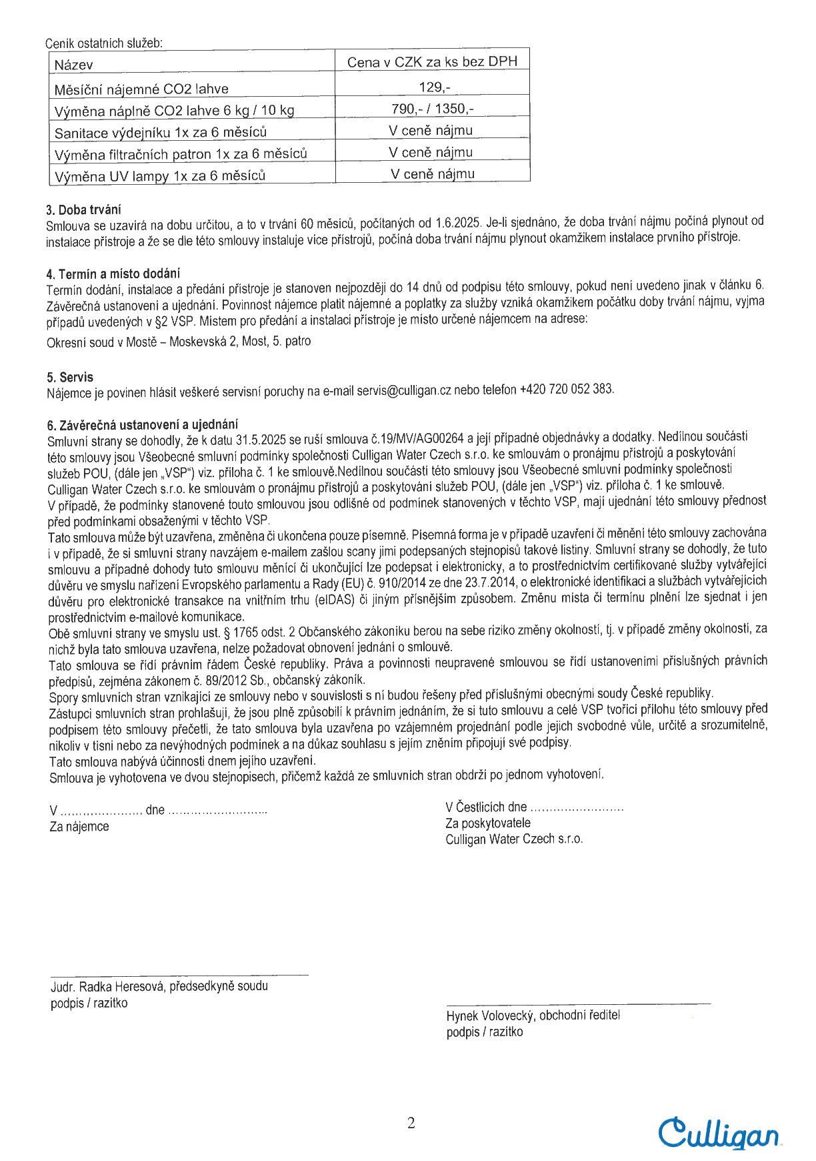


CABADAJMART210191 1Envelope ID DigiSign.org: 0196d5f5-e7e4-72ab-bfe6-80a81dcf1d7d
XXXXXXXXXXXXXXXXXX
XXXXXXXXXXXXXXXXXXXXXXXXXXXXXXXXXXXXXXXXXXXXXXXX
Digitálně podepsal
JUDr. Radka Heresová
Datum: 2025.05.14
09:58:16 +02'00'
ID: 0196e7fe-4129-7071-b53b-16d7d6b08ee0
19.5.2025 12:02:01
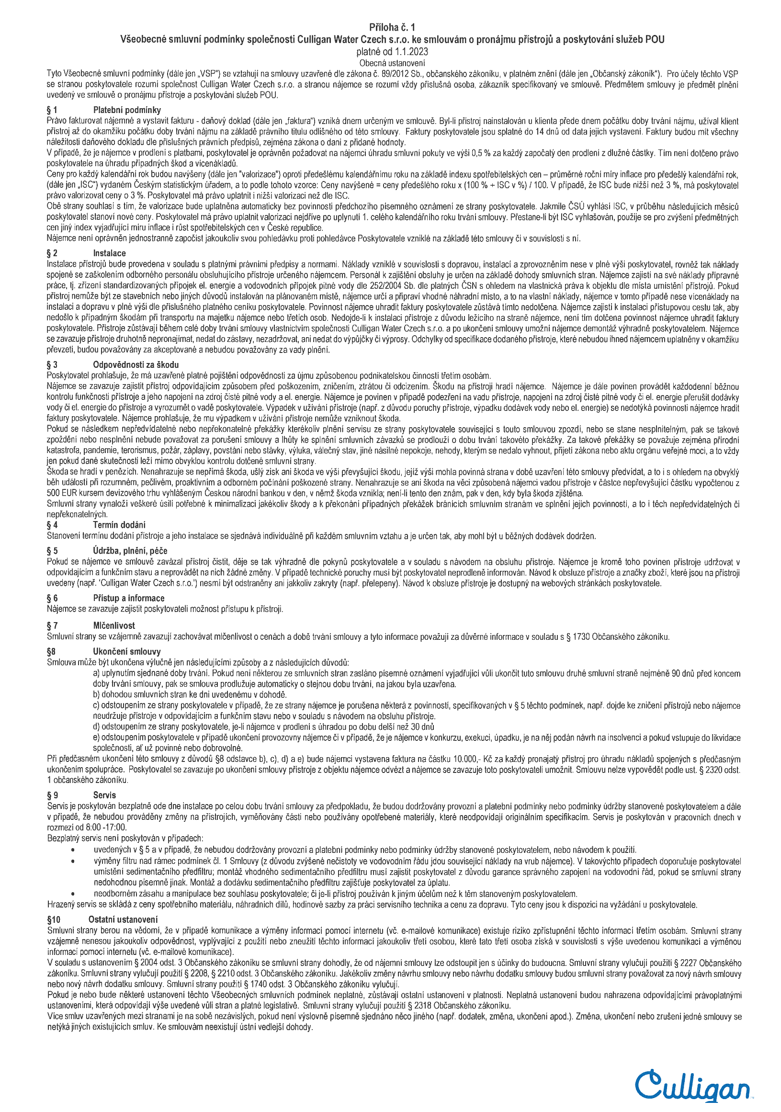
Envelope ID DigiSign.org: 0196d5f5-e7e4-72ab-bfe6-80a81dcf1d7d

