GGM Gastro International GmbH, Weinerpark 16, 48607 Ochtrup

Sportovní centrum Radostova Luhačovice, příspěvkov

Miroslav Talaš

Hradisko 1029

**Order Confirmation**

76326 LUHAČOVICE

CZECH REPUBLIC

Commercial advisor:

Order number:

Customer number:

VAT number:

Date:

Vesile Ilbay

142912531

D1449846

CZ70974942

28.04.2025

Phone number:

E-Mail:

Customerref.no.:

reditel@radostova.cz

142912531

Deviating delivery address:

Sportovní centrum Radostova Luhačovice, příspěvkov

Miroslav Talaš

Hradisko 1029

76326 LUHAČOVICE

CZECH REPUBLIC

CZ70974942

Page

1

of

4

Please state your customer or order number in the bank transfer as the intended purpose.

For payments from abroad we only accept payments by SEPA in EURO. Please note that GGM Gastro International GmbH

does not assume bank charges. The customer pays all fees and external commissions.

Our bank details:

Bank institute: Volksbank Gronau-Ahaus eG

IBAN: DE10 4016 4024 0207 9672 02

BIC (SWIFT): GENODEM1GRN

Please note that the adherence to the delivery date depends on the receipt of payment, since we work exclusively with

prepayment.

With your payment you confirm our current GTCs, which we sent to you in advance by e-mail.

Please check your address data for correctness, as later changes on the invoice are not possible!

Net price Discount

EUR

Price Total price TC

EUR EUR

Position Description

Quantity

%

%

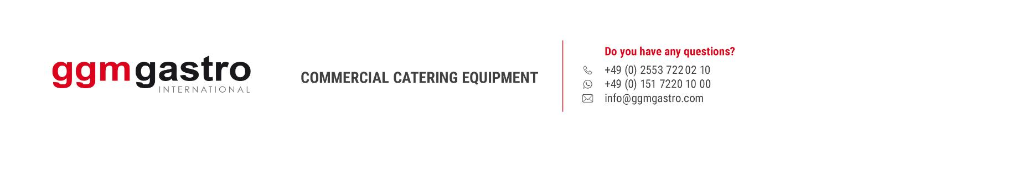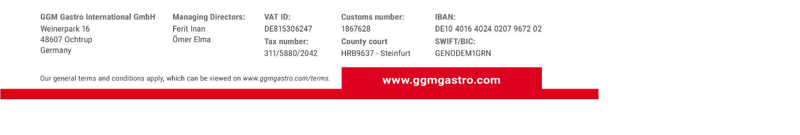

Order number: 142912531

Position Description

Date: 28.04.2025

Quantity

Page

2

of

4

Net price Discount

EUR

Price Total price TC

%

EUR

EUR

%

0

Pos: 1

GLS320ME

1 1.023,99

0,00 1.023,99 1.023,99

Gläserspülmaschine - Manuell - 2,97 kW - mit

Reiniger-, Klarspüler- & Laugenpumpe

Einschubhöhe: 320mm

B465xT510xH645mm

Customs tariff number: 84221900

Pos: 2

Pos: 3

Pos: 4

EWBH356-N

1

1

1

356,99

239,99

782,99

0,00

0,00

0,00

356,99

239,99

782,99

356,99

239,99

782,99

0

0

0

Ice cube maker - 28kg / 24h

Container capacity: 7kg

B 398 x T 572 x H 675 mm

Customs tariff number: 84186900

WEHM840TD

Wasserenthärter - automatisch - Leistung: 840 Liter

besonders geeignet für Kaffeemaschinen

B210xT430xH460mm

Customs tariff number: 84212100

TSH600

Tiefkühlschrank Edelstahl ECO - 600 Liter - mit 1 Tür

-

Innentür aus Kunststoff

Temperatur: -18 bis -22 °C

B680xT710xH2010mm

Customs tariff number: 84184080

Pos: 5

KDCTE612

1 2.787,99

0,00 2.787,99 2.787,99

0

Kombidämpfer KOMPAKT - Touch - 6x GN 1/1 - inkl.

Waschsystem & Temperaturfühler

Multi-Level-Garen - max. 270 °C

B500xT930xH700mm

Customs tariff number: 84198180

Pos: 6

Pos: 7

VS-UV

uninsured shipping

1

1

1

0,00

0,00

0,00

0,00

0,00

0,00

0,00

0,00

0,00

0,00

0,00

0,00

0

0

0

ZZ-UE

prepayment

Pos: 8

DSV

GAR1

1

year warranty on spare parts 0 % charge

Total price netto

Tax 0,00%

5.191,95

0,00

**Total price**

**5.191,95**

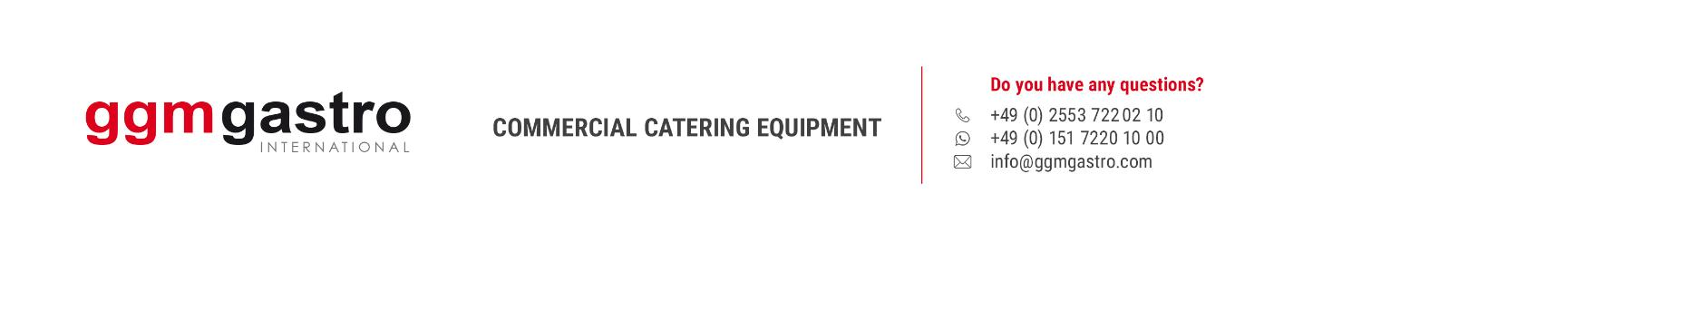

Order number: 142912531

Returns and warranty

Date: 28.04.2025

Page

3

of

4

To provide peace of mind when you buy from us, we offer a range of warranties and a straightforward returns service in the

event of a product being damaged etc.

Conditions for all types of warranty:

a) Plugless and gas-operated devices must be connected by a specialist

b) For refrigerators and freezers, the parameters must be set by a specialist during initial start-up

c) The technician's invoice must be kept within the warranty period

d) Non-compliance with the aforementioned conditions will void the warranty

Types of warranty

1. Replacement parts warranty

1

year manufacturer's warranty on spare parts from date of invoice.

The warranty claim does not apply to: Glass materials, seals, sealing material, ceramics, fire clay, and wear parts such as

thermal elements.

There is no additional charge, the spare parts warranty is free of charge!

2. Full warranty for 1 or 2 years

The selected full warranty is valid from the invoice date.

The full warranty includes the assumption of the technican's costs for the technican who was commissioned by GGM Gastro

International GmbH within the warranty period.

The warranty claim does not apply to: Glass materials, seals, sealing material, ceramics, fire clay, and wear parts such as

thermal elements.

1

2

-year full warranty: Surcharge on the net value of goods + VAT

-year full warranty: Surcharge on the net value of goods + VAT

The following countries are excluded from the full warranty: Sweden, Russia, Poland, Switzerland, Denmark, Norway,

Finland, and countries outside of Europe.

Returns

With GGM Gastro you have the right to return the purchased products within 14 days after receiving the goods.

Please note that the return is a voluntary service of GGM Gastro. A 14-day legal right of withdrawal applies only to

consumers and not to commercial buyers.

You can also easily exchange your device in our help center.

Conditions for Returns

a) The return takes place at the latest 14 days after receipt of the goods (reklamation@ggmgastro.com or by telephone via

customer service).

b) The return has been approved (in written form) by a service employee of GGM Gastro.

c) The goods are unused, undamaged and complete.

d) The goods must be packed safely for transport in the original shipping packaging.

e) The goods must not be special designs, B-goods, items procured individually at the customer's request, or spare parts.

f) The customer bears the costs and the transport risk of the return transport.

g) Transactions based on a leasing contract (e.g., through the ALBIS Leasing Group) are excluded from the right of return.

Order items/custom-made/special orders

When ordering items that are specially ordered for the customer, specially made (to measure) or specially produced, a

deposit of 30% of the gross value must be paid in advance. The remaining amount must be paid before delivery. In the event

of non-delivery, the customer has no right to claim for changes or replacement.

Special right of withdrawal

In the case of contracts for goods with special dimensions or other special features that are not part of GGM's standard

range, the customer has a special right of withdrawal under the following conditions: The customer may withdraw from the

contract at any time up until receipt of the payment confirmation from GGM; the withdrawal must be declared in writing. GGM

reserves the right to charge the customer a cancellation fee of 30% (thirty percent) of the gross order value or, in the case of

payment already made, to deduct this from the amount to be refunded.

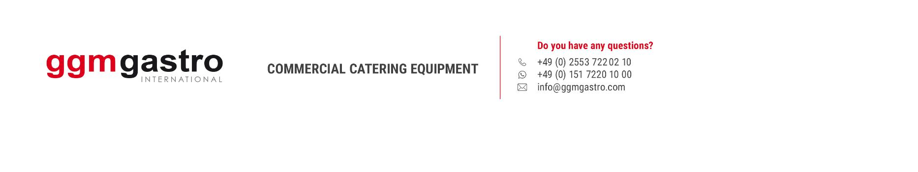

Order number: 142912531

Date: 28.04.2025

Page

4

of

4

(1) The [Importer/Buyer] shall not sell, export or re-export, directly or indirectly, to the Russian Federation or Belarus or for

use in the Russian Federation or Belarus any goods supplied under or in connection with this Agreement that fall under the

scope of Article 12g of Council Regulation (EU) No 833/2014.

(2) The [Importer/Buyer] shall undertake its best efforts to ensure that the purpose of paragraph (1) is not frustrated by any

third parties further down the commercial chain, including by possible resellers.

(3) The [Importer/Buyer] shall set up and maintain an adequate monitoring mechanism to detect conduct by any third parties

further down the commercial chain, including by possible resellers, that would frustrate the purpose of paragraph (1).

(4) Any violation of paragraphs (1), (2) or (3) shall constitute a material breach of an essential element of this Agreement, and

the [Exporter/Seller] shall be entitled to seek appropriate remedies, including, but not limited to:

(i) termination of this Agreement; and

(ii) a penalty of [XX]% of the total value of this Agreement or price of the goods exported, whichever is higher.

(5) The [Importer/Buyer] shall immediately inform the [Exporter/Seller] about any problems in applying paragraphs (1), (2) or

(3), including any relevant activities by third parties that could frustrate the purpose of paragraph (1). The [Importer/Buyer]

shall make available to the [Exporter/Seller] information concerning compliance with the obligations under paragraph (1), (2)

and (3) within two weeks of the simple request of such information.

**Our Terms and Conditions are valid. This offer is valid for 14 days.**

**I hereby declare that I am a Commercial Customer. / Avec cela, je déclare, que je suis un client professionnel.**

**Advance payment: Please transfer the full amount with information of the offe number, customer number and commercial advisor**

