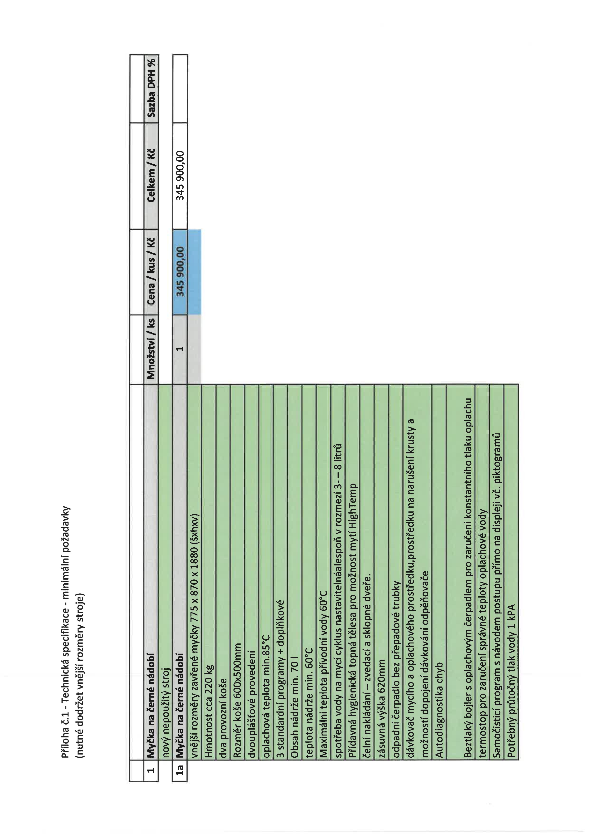

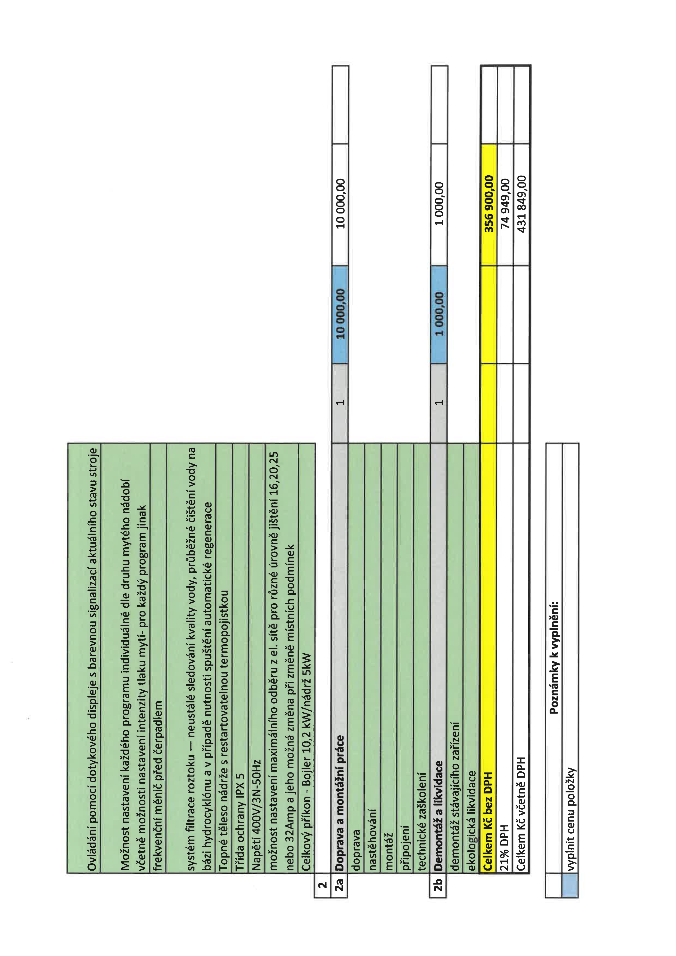

|  |  |  |  |  |  |  |  |  |  |  |  |  |  |  |  |  |  |  |  |  |  |  |  |  |  |  |  |  |  |  |  |  |  |  |  |  |  |  |  |  |  |  |  |  |  |  |  |  |  |  |  |  |  |  |  |  |  |  |  |  |  |  |  |  |  |  |  |
| --- | --- | --- | --- | --- | --- | --- | --- | --- | --- | --- | --- | --- | --- | --- | --- | --- | --- | --- | --- | --- | --- | --- | --- | --- | --- | --- | --- | --- | --- | --- | --- | --- | --- | --- | --- | --- | --- | --- | --- | --- | --- | --- | --- | --- | --- | --- | --- | --- | --- | --- | --- | --- | --- | --- | --- | --- | --- | --- | --- | --- | --- | --- | --- | --- | --- | --- | --- |
|  | |  |  |  |  |  |  |  |  |  |  |  |  |  |  |  |  |  |  |  | | --- | --- | --- | --- | --- | --- | --- | --- | --- | --- | --- | --- | --- | --- | --- | --- | --- | --- | --- | |  |  |  |  |  | | | | | | | | | | | | | | | |  |  |  | |  |  |  | |  |  |  | |  |  |  |  | `> | 0 |  | E | 噏 |  | ° E | 경    > | 8 | E |  |  |  |  |  | |  |  |  |  |  | | | | | | | | | | | | | | | |

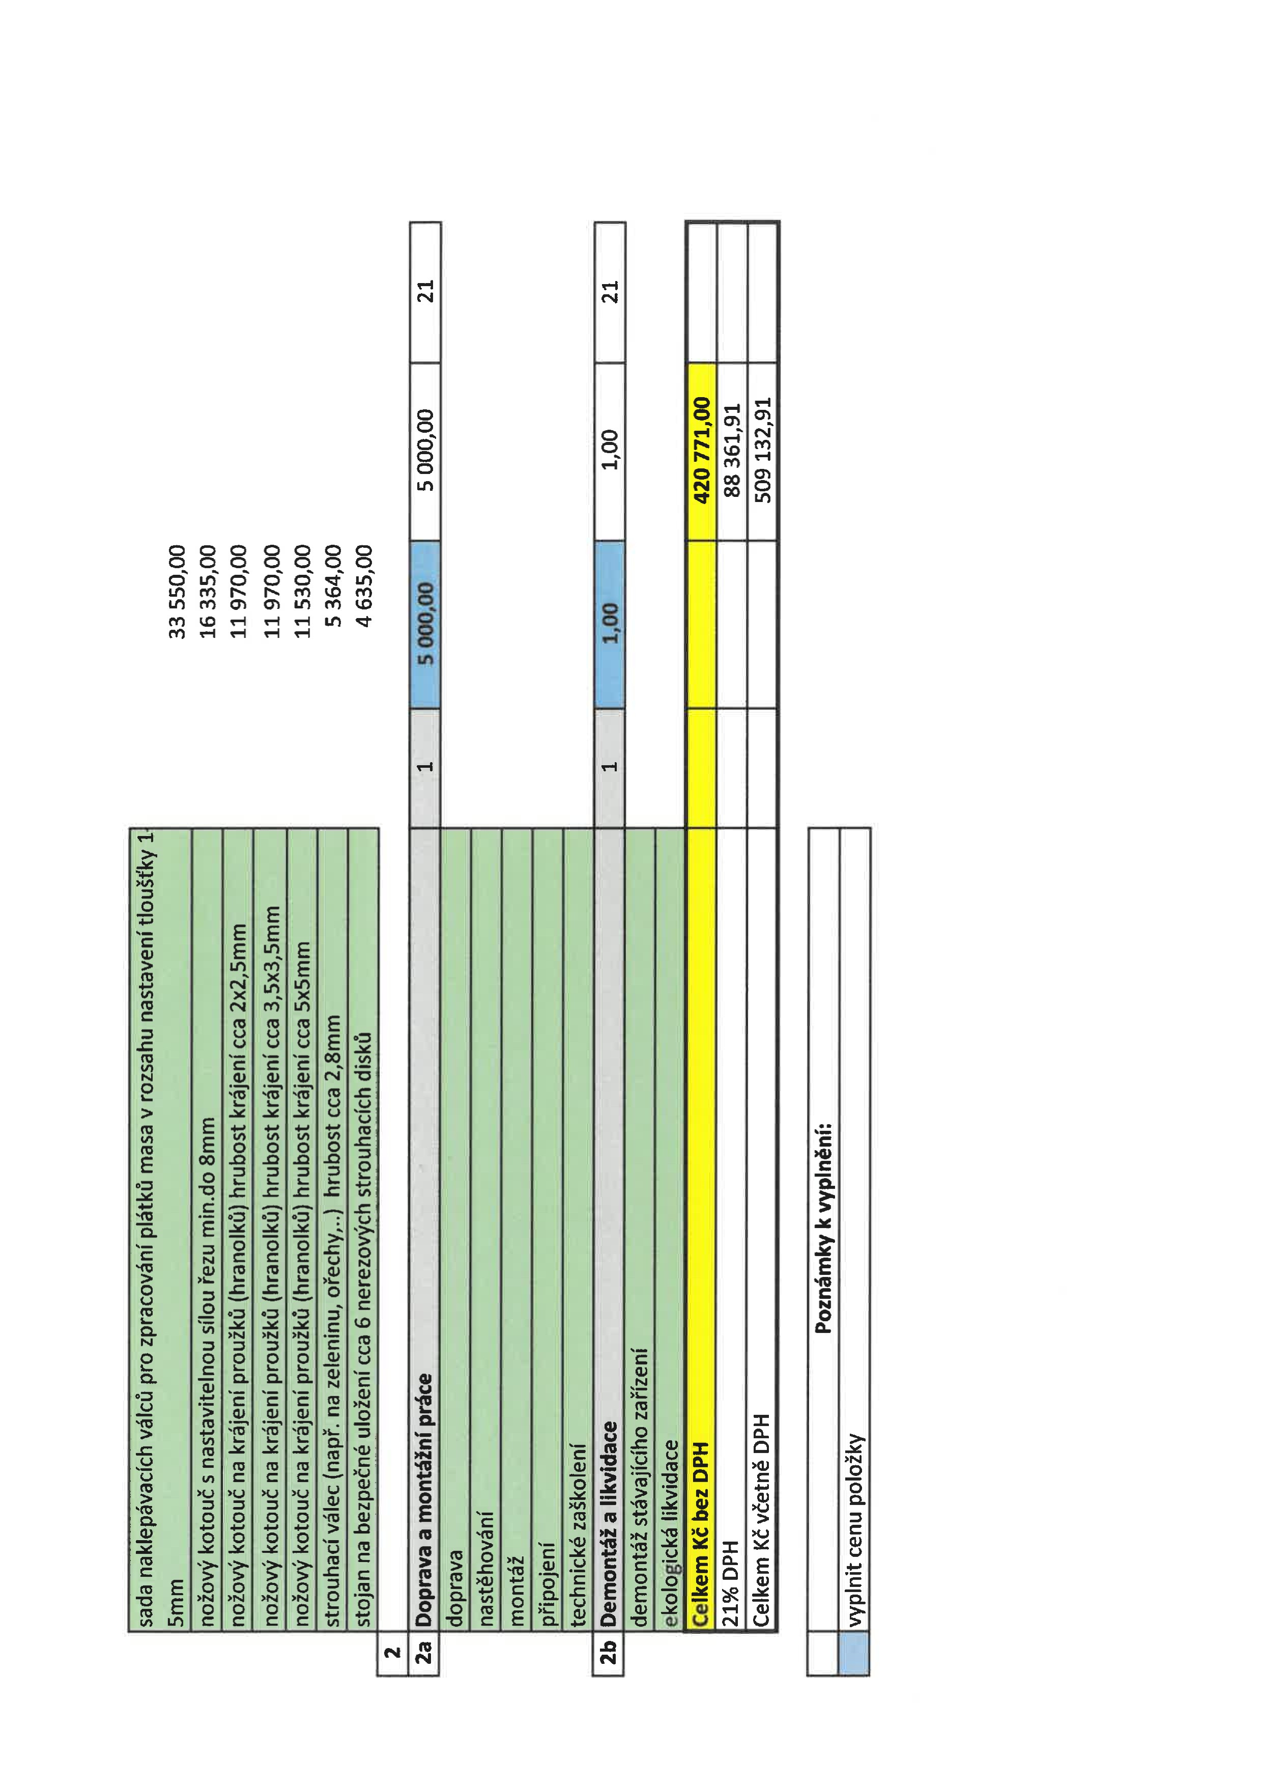

|  |  |  |  |  |  |  |  |  |  |  |  |  |  |  |  |  |  |  |  |  |  |  |  |  |  |  |  |  |  |  |  |  |  |  |  |  |  |  |  |  |  |  |  |  |  |  |  |  |  |  |  |  |  |  |  |  |  |  |  |  |  |  |  |  |  |  |  |  |  |  |  |  |  |  |  |  |  |  |  |  |  |  |  |  |  |  |  |  |  |  |  |  |  |  |  |  |  |
| --- | --- | --- | --- | --- | --- | --- | --- | --- | --- | --- | --- | --- | --- | --- | --- | --- | --- | --- | --- | --- | --- | --- | --- | --- | --- | --- | --- | --- | --- | --- | --- | --- | --- | --- | --- | --- | --- | --- | --- | --- | --- | --- | --- | --- | --- | --- | --- | --- | --- | --- | --- | --- | --- | --- | --- | --- | --- | --- | --- | --- | --- | --- | --- | --- | --- | --- | --- | --- | --- | --- | --- | --- | --- | --- | --- | --- | --- | --- | --- | --- | --- | --- | --- | --- | --- | --- | --- | --- | --- | --- | --- | --- | --- | --- | --- | --- | --- |
|  | |  |  |  |  |  |  |  |  |  |  |  |  |  |  |  |  |  |  |  |  |  |  |  |  | | --- | --- | --- | --- | --- | --- | --- | --- | --- | --- | --- | --- | --- | --- | --- | --- | --- | --- | --- | --- | --- | --- | --- | --- | |  |  |  |  |  | | | | | | |  |  |  | | | | |  |  | |  |  |  | |  |  |  |  |  |  |  |  | |  |  |  |  |  |  |  |  | |  |  |  |  |  |  |  |  | |  | N  혊  0 | `흐    c | N    0 | 0  > | E | ℃ |  | E | 0 |  | 0 |  |  | `儁 | .똋 | 으 | 0 | ℃ |  | u | N | 0 | |  |  |  |  |  | | | | | | |  |  |  | | | | |  |  | | | | | |  |

