TECHNICKÁ UNIVERZITA V LIBERCI
l!i'M'Mffilffi •

Dated

1st July 2016

THE BRITISH COUNCIL
- and -
TECHNICAL UNIVERSITY OF LIBEREC

AGREEMENT FOR SUPPLY OF SERVICES

THIS AGREEMENT is dated

PARTIES
(1) THE BRITISH COUNCIL, incorporated by Royal Charter and registered as a charity (under number 209131 in England and Wales and number SCO37733 in Scotland), with its principal office at 1O Spring Gardens, London, SW1A 2BN operating through its local office at Politických vězňů 13, Prague, Czech Republic 11O 00 (the "British Council"); and
(.2) TECHNICAL UNIVERSITY OF LIBEREC., � r-etJi.,w.,,vulv� w
o.4-- S� :1-402/2, 4�:1- :1- 7 Li.he,vu,, C.zUÁ-v R�, Ret}. No:
4�747885„ VAT "'-O': GZ-4�747885, r-epv-� b-y p-vof Dr-. l""-fJ.
� KL½', r-eofor (fi,,.h "�).

BACKGROUND
ln response to the increase in numbers of higher education degree courses in Europe being taught in English, the British Council has developed a week-long training course for lecturers who are non-native speakers of English and who teach their subjects through the medium of English, Academie Teaching Excellence - English as the Medium of lnstruction. The training course has been co-developed by the University of Oxforďs Department of Education.
The British Council and the Client, hereby agree the delivery of an Academie Teaching Excellence course for higher education teaching staff to take place at the Technical University of Liberec from 11th July 2016 to 15th July 2016 under the terms and conditions set out below.

Agreed terms
- lnterpretation
  - The definitions and rules of interpretation in this clause apply in this Agreement.
"Deliverables", all documents, products and materials: (i) developed by the British Council or its agents, subcontractors, consultants and employees in relation to the Services in any form, or (ii) provided by the British Council rel.?ting to the Services which existed prior to the commencement of this Agreement.
"lntellectual Property Rights", all patents, rights to inventions, utility models, copyright and related rights, trademarks, service marks, trade, business and domain names, rights in trade dress or get-up, rights in goodwill or to sue for passing off, unfair competition rights, rights in designs, rights in computer

3

software, database right, topography rights, moral rights, rights in confidential information (including know-how and trade secrets) and any other intellectual property rights, in each case whether registered or unregistered and including all applications for and renewals or extensions of such rights, and all similar or equivalent rights or forms of protection in any part of the world.
"Services", the training services to be provided by the British Council under this Agreement as set aut in Schedule 1, together with any other services which the British Council provides or agrees to provide to the Client.
  - Any headings shall not affect the interpretation of this Agreement.
  - A person includes a natural person, corporate or unincorporated body (whether or not having separate legal personality) and that person's legal and persona! representatives, successors and permitted assigns.
  - The Schedules and background form part of this Agreement and shall have effect as if set out in full in the body of this Agreement. Any reference to this Agreement includes the Schedules.
  - A reference to a statute or statutory provision is a reference to it as it is in force for the time being, taking account of any amendment, extension, or re­ enactment and includes any subordinate legislation for the time being in farce made under it.
  - A reference to writing or written includes faxes but not e-mail.
  - Where the words include(s), including or in particular are used in this Agreement, they are deemed to have the words without limitation following them. Where the context permits, the words other and otherwise are illustrative and shall not limit the sense of the words preceding them.

Commencement and duration
  - The British Council shall provide the Services to the Client on the terms and conditions of this Agreement from 11th July 2016 unless this Agreement
terminated in accordance with clause 1O.

British Council's obligations
  - The British Council shall:
    - provide the Services, and deliver the Deliverables to the Client, in accordance with Schedule 1 in all material respects, save that any dates and times for performance can be changed in agreement with the Client.
    - observe all health and safety rules and regulations and any other reasonable security requirements that apply at the Clienťs premises and that have been communicated to it under clause 4.1.2, provided

4

that it shall not be liable under this Agreement if, as a result of such observation, it is in breach of any of its obligations under this Agreement.

Clienťs obligations
  - The Client shall:
    - co-operate with the British Council in all matters relating to the Services;
    - inform the British Council of all health and safety rules and regulations and any other reasonable security requirements that apply at any relevant Client premises; and
    - ensure that any and all equipment, systems, cabling or facilities provided by the Client and used directly or indirectly in the supply of the Services is in good working order and suitable for the purposes for which it is used in relation to the Services and conforms to all relevant United Kingdom standards or requirements.
  - lf the British Council's performance of its obligations under this Agreement is prevented or delayed by any act or omission of the Client, its agents, subcontractors, consultants or employees, the British Council shall not be liable for any costs, charges or losses sustained or incurred by the Client that arise directly or indirectly from such prevention or delay.

Charges and payment
  - The Client shall pay the charges as set aut in, and in accordance with, Schedule 2.
  - The Client shall pay each invoice submitted to it by the British Council, in full and in cleared funds, within 15 days of receipt to a bank account nominated in writing by the British Council and time for payment shall be of the essence of this Agreement.
  - Without prejudice to any other right or remedy that it may have, if the Client fails to pay the British Council on the due date, the British Council may:
    - suspend all Services until payment has been made in full
  - Ali sums payable to the British Council under this Agreement shall become due immediately on its termination, despite any other provision. This clause 5.4 is without prejudice to any right to claim for interest under the law, or any such right under this Agreement.
  - The British Council may, without prejudice to any other rights it may have, set off any liability of the Client to the British Council against any liability of the British Council to the Client.

5

lntellectual property rights
  - As between the Client and the British Council, all lntellectual Property Rights and all other rights in the Deliverables and the Pre-existing Materials shall be owned by the British Council. Subject to clauses 5.1 and 6.2, the British Council grants the Client the right to use those lntellectual Property Rights owned or licensed by the British Council and used to provide the Services or existing in the Deliverables on a non-exclusive basis and solely to such extent as is strictly necessary to enable the Client to make use of the Deliverables and the Services in accordance with Schedule 1. lf this Agreement is terminated, this licence will automatically terminate.
  - The Client acknowledges that, where the British Council does not own any of the lntellectual Property Rights used to provide the Services or existing in the Deliverables, the Clienťs use of such lntellectual Property Rights is conditional on the British Council obtaining a written licence (or sub-licence) from the relevant licensor or licensors on such terms as will entitle the British Council to license such rights to the Client.

Confidentiality and the British Council's property
  - The Client shall keep in strict confidence all technical or commercial know­ how, specifications, inventions, processes or initiatives which are of a confidential nature and have been disclosed to the Client by the British Council, its employees, agents, consultants or subcontractors and any ether ·, confidential information concerning the British Council's business or its products which the Client may obtain.
  - The Client may disclose such information:
    - to its employees, officers, representatives, advisers, agents or subcontractors who need to know such information for the purposes of carrying aut the Clienťs obligations under this Agreement; and
    - as may be required by law, court order or any governmental or regulatory authority.
  - The Client shall ensure that its employees, officers, representatives, advisers, agents or subcontractors to whom it discloses such information comply with this clause 7.
  - The Client shall not use any such information for any purpose ether than to perform its obligations under this Agreement.
  - Ali materials, equipment and tools, drawings, specifications and data supplied by the British Council to the Client shall, at all times, be and remain, as between the British Council and the Client, the exclusive property of the British Council, but shall be held by the Client in safe custody at its own risk and maintained and kept in good condition by the Client until returned to the British

(ó

Council, and shall not be disposed of or used other than in accordance with the British Council's written instructions or authorisation.

Limitation of liability
  - Nothing in this Agreement shall exclude or restrict the liability of either party to the other for death or persona! injury resulting from negligence or for fraudulent misrepresentation or in any other circumstances where liability may not be limited under any applicable law.
  - Subject to clause 8.1:
    - the British Council shall not be liable for:
      - loss of profits; or
      - loss of business; or
      - depletion of goodwill and/or similar losses; or
      - loss of anticipated savings; or
      - loss of goods; or
      - loss of contract; or
      - loss of use; or
      - loss of corruption of data or information; or
      - any special, indirect, consequential or pure economic loss, costs, damages, charges or expenses; and
    - the British Council's total liability in contract, tort (including negligence or breach of statutory duty), misrepresentation, restitution or otherwise arising in connection with the performance or contemplated performance of this Agreement shall be limited to 170.000,- CZK (one hundred and seventy thousand Czech crowns).

Data protection
  - The Client acknowledges and agrees that details of the Clienťs name, address and payment record may be submitted to a credit reference agency, and persona! data will be processed by and on behalf of the British Council in connection with the Services.
  - ln t-his clause 'persona! data', 'persona! data processing', 'persona! data filing system' 'persona! data filing system controller' and 'processing official' shall have the meaning set out in the Act No. 101/2000 Coll. Persona! Data Protection as amended or any superseding legislation.

7

The British Council and the Client acknowledge that in relation to any persona! data processed under this Agreement (the 'Persona! Data') the Client is the data controller and the British Council is the data processor.

The British Council shall:

    - process the Persona! Data only for the purposes of this Agreement and in accordance with the instructions of the Client;
- not disclose any of the PersonaI Data to any third party except for the purposes of this Agreement or to comply with a court order or statutory duty on the British Council;
- implement appropriate technical and organisational measures against unauthorised or unlawful processing of the Persona! Data and against its accidental destruction, damage or loss so as to ensure a level of security appropriate to the harm that might result therefrom;
- not subcontract the processing of the Persona! Data or transfer any of the Persona! Data outside the European Economic Area without the prior written consent of the Client
- notify the Client if it receives any complaint or access request by an individua! in respect of his or her persona! data and comply with the reasonable directions of the Client in regard to such complaint or request;
- comply with all relevant data protection legislation in force in the Czech Republic.

Termination
  - Without prejudice to any other rights or remedies which the parties may have, either party may terminate this Agreement without liability to the other immediately if:
    - the other party commits a breach of any of the material terms of this Agreement and (if such a breach is remediable) fails to remedy that breach within 1O days of that party being notified in writing of the breach; or
    - the other party becomes (or, in the reasonable opInIon of the terminating party, is at serious risk of becoming) insolvent or unable to pay its debts as they fall due; or
�10.1.3 there is a change of control of the other party.

1-0.2 Ovv fe,v� of � A9v� for � v� other than those governed by 10.1 and 10.2:

8

    - the Client shall be liable for paying to the British Council f/Ah fo-fvJ., p-r-Uh l,,11\..1 ftM.L t1.'.Y ýť,f- 01).;f- l,,11\..1 po.,y-j- 2 of s� 2.
    - the accrued rights and liabilities of the parties as at termination and the continuation of any provision expressly stated to survive or implicitly surviving termination, shall not be affected.
  - Termination of this Agreement, however it arises, shall not affect or prejudice the accrued rights of the parties as at termination or the continuation of any provision expressly stated to survive, or implicitly surviving, termination.

Force majeure
  - Neither party shall be in breach of this Agreement if it is prevented from or delayed in carrying on its business by acts, events, omissions or accidents beyond its reasonable control.

Assignment
  - The Client shall not, without the prior written consent of the British Council, assign, transfer, charge, mortgage, subcontract or deal in any other manner with all or any of its rights or obligations under this Agreement.
  - The British Council may at any time assign, transfer, charge, mortgage, subcontract or deal in any other manner with all or any of its rights or obligations under this Agreement.

Governing Law and Dispute Resolution Procedure
This Agreement and any dispute or claim (including any non-contractual dispute or claim) arising out of or in connection with it or its subject matter, shall be governed by, and construed in accordance with, the laws of the Czech Republic.
  - Subject to the remainder of this clause 13, the parties irrevocably agree that the courts of the Czech Republic shall have exclusive jurisdiction to settle any dispute or claim (including any non-contractual dispute or claim) that arises out of or in connection with this Agreement or its subject matter.
  - ln the event that any claim or dispute arises out of or in connection with this Agreement, the parties shall, following service of written notice by one party on the other, attempt to resolve amicably by way of good faith negotiations ar:1d discussions any such dispute or claim as soon as reasonably practicable (and in any event within 1O working days after such notice or by such later date as the parties may otherwise agree in writing). lf the parties are unable to resolve the dispute or claim in accordance with this clause 13.2, either party may commence proceedings in accordance with clause 13.1.

q

  - Nothing in this clause 13 shall prevent either party from applying at any time to the court for injunctive relief on the grounds of infringement, or threatened infringement, of the other party's obligations of confidentiality contained in this Agreement or infringement, or threatened infringement, of the applicanťs lntellectual Property Rights.

General
  - No variation of this Agreement shall be valid unless it is in writing and signed by or on behalf of each of the parties.
  - A waiver of any right under this Agreement is only effective if it is in writing and it applies only to the party to whom the waiver is addressed and the circumstances for which it is given.
  - Nothing in this Agreement is intended to, or shall operate to, create a partnership between the parties, or to authorise either party to act as agent for the other, and neither party shall have authority to act in the name or on behalf of or otherwise to bind the other in any way (including the making of any representation or warranty, the assumption of any obligation or liability and the exercise of any right or power) and neither party shall incur any expenditure in the name of or for the account of the other.
  - This Agreement and any documents referred to in it constitute the whole agreement between the parties and supersedes any previous agreement, understanding or agreement between them relating to the subject matter of this Agreement.
  - This Agreement does not create any rights or benefits enforceable by any person not a party to it.
  - Notice giv�n under this Agreement shall be in writing, sent for the attention of the person, and to the address, given on the front page of this Agreement (or such other address or person as the relevant party may notify to the other party) and shall be delivered either personally, by courier, by pre-paid, first­ class post or by recorded delivery. A notice is deemed to have been received: if delivered personally, at the time of delivery; in the case of recorded delivery or courier, 48 hours from the date of posting. lf deemed receipt under this clause is not within working hours, the notice will be deemed to be received at the commencement of norma! working hours on the first working day following delivery. To prove service of notice, it is sufficient to prove that the envelope s;ontaining the notice was properly addressed and posted or handed to the courier.
  - This Agreement has been entered into on the date stated at the beginning of it.

1-0

Schedule 1 - Services

The British Council will deliver the Academie Teaching Excellence course to a group of 14 course participants, who have been selected by the Technical University of Liberec
The course will be delivered by a training member of staff who has previously received the week-long train-the-trainer induction by the University of Oxforďs Department of Education for teaching the Academie Teaching Excellence course.
The Academie Teaching Excellence course will be delivered at the premises specified and provided free of charge by the Client
The course will take place from 11th July 2016 to 15th July 2016 according to the following schedule:
- Monday to Thursday from 9 am to 5.30 pm
- Friday from 9 am to 3 pm.
The training provided will be based on the course book 'Academie Teaching Excellence - Participant Handbook', of which the British Council will provide a hard copy per participant as part of this Agreement.
The ATE lecturer will enable two observation sessions for two representatives of the lnternational and Erasmus+ Office.
The British Council will provide refreshments for the participants in a form of one morning and one afternoon coffee break each day of the training.
A British Council Certificate of Completion will be given to each participant at the end of the course. Participants must complete all lessons of the course.
The schedule of the 5-day course is as set out below:

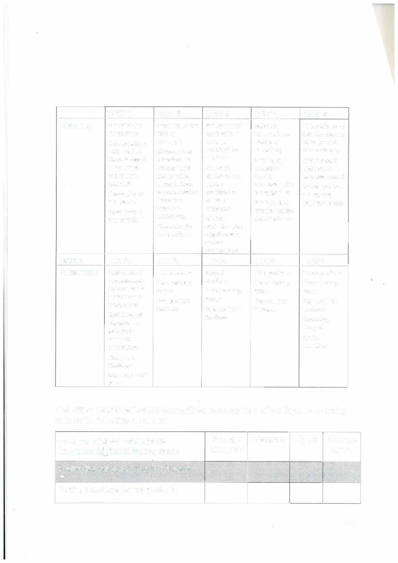

DAY 1 |  | DAY2 | DAY3 | DAY4 | DAYS
Morning | Welcome and | Debrief on article | Setting up brief group tasks in lectures; reducing tutor talk time  Assessing student needs: student participation culture or language?  Student elicitation: what might impede  student contributions? | Seminars (observation or reading of transcripts)  Creating an interactive learning community; rules of engagement  Brainstorming; collating; feeding back; moving on | Supervisions and tutorials: observe video (or read two transcripts)  Oral feedback strategies & language needed  Written feedback strategies & language needed
 | lntroductions | read for
 | Conceptualizing | homework.
 | EMI: what are | Observation of
 | the challenges? | online lecture:
 | What are the | NS tutor; NNS
 | different EMI | tutor to mixed
 | settings? | students. Focus
 | Observation of EMI lecture  Observation of EMI seminar | on pronunciation;  intonation; discourse markers etc.  Preparation for
 |  | first practicum
Break Lunch Lunch Lunch Lunch Lunch
Afternoon | Modification of | First practicum | Second | Third practicum  Micro teaching: lecture  Peer and tutor feedback | Fourth practicum  Micro teaching: lecture  Peer and tutor feedback  Concluding thoughts  Course evaluation
language input:  focus on lexical items; focus on explanations  Modification of interaction: in |  | Micro teaching: | practicum
 |  | lecture  Peer and tutor feedback | Micro teaching: lecture  Peer and tutor feedback
lectures; in
seminars; in supervisions
Marshmallow Challenge
Seif-study: article on EMI

The British Council will collect anonymised feedback from all participants including data on the following questions:
Agree | Strongly agree

I feel my English skills have improved in the following areas | Strongly disagree | Disagree
Presenting subject matter to students
'w>;�
Posing questions for my students

1-2

Moderating díscussíons in class
Elíciting / reactíng to student contríbutíons
Giving appropriate (positive/negative)
feedback to students
Adapting my choice of language to the students
Pronunciation
,,
Vocabulary
Grammar •
Finding my persona! teaching style
Overal!, I feel my skills have improved
As part of this Agreement the British Council will províde the Client with a summary of the ínformation provided by the particípants after the delívery of the course.

1-3

Schedule 2 - Pricing Part 1 - Price
The agreed fixed price for the delivery of the course is 173.000,- CZK (one hundred and seventy three thousand Czech crowns).

Part 2 - Payment
The agreed fixed price as set out in Part 1 will be paid by the Client in two instalments, according to the schedule below:
P1 instalment - 86.500,- CZK (eighty six thousand and five hundred Czech crowns) 2nd instalment - 86.500,- CZK (eighty six thousand and five hundred Czech crowns)
The full amount of the instalment shall be paid within 15 days of the receipt of an invoice issued by the British Council.

Signed by Justin Spence
for and on behalf of THE BRITISH COUNCIL

Signed by y:wof. Dr-. I�.� Kt4-
for and on behalf of TECHNICAL UNIVERSITY OF LIBEREC
DIRECTOR R...E..C...T..O...R.....
*

o on

