Bid Cover Note

BASIC DATA:

Public Tender Title: Positioning Systems for EEl ndstations 2

Contracting Authority: Institute of Physics of the Czech Academy of Sciences, public research institution

Registered Office:
l d.No.:
Person Authorized
Na Slovance 2,182 21Prague 8
68378271

to represent the Contracting Authority: RNDr. Michael Prouza, Ph.D.,Director

Participantl Registered office: ld.No.(if any):
Tax ld.No.(if any):
MIT,spol. s r.o.

Klanova 71/56, 147 00 Prague 4

46348395

CZ46348395

Small I Medium-sized enterpri ses (in accordance with the Recommendation 2003/361/ES):

YES

Person authorized

to represent the participant: Contact person:
Contact address:

Tel: +420 777 708 930

Martin Moser, Managing Director

Martin Moser

Klanova 71/56,147 00 Prague 4

E-mailof the Contact Person: moser@mit-laser.cz

Totalbid price: 124.950,· EUR without VAT In Prague On 26.5.2017

··
MIT,spo . s r.o.
.............
Martin Moser
•T La sc ry, foton1ka
MI
a jcmnll mcchanika

MIT spaar.o, Klt:1nova o6, 14 r 00 Praha 4

;(

Strana 1 z 2 vypis ze seznamu kvalifikovanych dodavatelu vygenerovany informaaJim systemem o verejnych zakllzkllch
Vypis ze seznamu kvalifikovanych dodavatelu
vedeneho podle § 226 a nasled. zakona c. 134/2016 Sb., o zadavani verejnych zakazek

Udaje o dodavateli zapsane v seznamu k 17.05.2017
rf\_1. Identifikacni udaje 0 dodavateli
1.1. Obchodnifirma/Nazev
MIT, spol. s r. o.

1.2. Sidlo
Klimova 71/56
14700 Praha
Ceska republika
1.3. ICO
46348395

1.4. Statutarni organ

Jmeno a prijmenistatutarniho organu nebo jeho clenu | Funkce ve statutarnim organu
Martin Moser | jednatel

Zpusob jednani
Spolecnost zastupuje jednatel samostatne.

1.5. Ostatni osoby opravnene jednat jmenem dodavatele

Jmeno a prijmeni osoby | Pravni titul jednanijmenem dodavatele | Zpusob jednimi | Datum platnosti do
Iva Matu na | prokurista

2. Zakladni zpusobilost, jejiz splnenidodavatelprokazal

Dodavatel prokazal Ministerstvu pro mistnirozvoj, ze sph"luje podminku podle:
• § 74 odst. 1 pism. a)
nebyl v zemi sveho sidla v poslednich 5 letech pravomocne odsouzen pro trestny cin uvedeny v priloze c. 3 zakona nebo obdobny trestny cin podle pravniho radu zeme sidla dodavatele; k zahlazenym odsouzenim se neprihlizi, (tento pozadavek splnily i vsechny fyzicke a pravnicke osoby uvedene v bodech 1.1. - 1.5. tohoto vypisu),
• § 74 odst. 1 pism. b)
nema v Ceske republice nebo v zemi sveho sidla v evidenci danizachycen splatny dariovy nedoplatek,
• § 74 odst. 1 pism. c)
nema v Ceske republice nebo v zemi sveho sidla splatny nedoplatek na pojistnem nebo na penale
na vei'ejne zdravotni pojisteni,
• § 74 odst. 1 pism. d)
nema v Ceske republice nebo v zemi sveho sidla splatny nedoplatek na pojistnem nebo na penale
na socialnizabezpeceni a pi'ispevku na statni politiku zamestnanosti,
• § 74 odst. 1 pism. e)
neni v likvidaci, nebylo proti nemu vydano rozhodnuti o upadku, nebyla vuci nemu nai'izena nucena sprava podle jineho pravniho predpisu nebo neni v obdobne situaci podle pravniho radu zeme sidla dodavatele.

2

Strana 2 z 2

3. Profesnizpusobilost, jejiz splneni dodavatel prokazal

Dodavatel prokazal, ze splriuje podminku podle:

3.1. § 77 odst. 1 - profesni zpusobilost

vypis z obchodniho rejstriku

3.2. § 77 odst. 2 pism. a)- opravneni k podnikani

Nazev dokladu | Vystavil | PredmeH podnikanf | Obory cinnosti | Datum vystaveni | Datum platnosti
Vypis z tivnostenskeho rejstrlku | M stska Mst  Praha 4 | Vyroba, obchod a slutby neuvedene v prlloMch 1 at 3 tivnostenskeho zakona | Viz.poznamka 1 za tabulkou | 29.10.2013

Pozn. 1
Vyroba, rozmnozovanf, distribuce, prodej, pronajem zvukovych a zvukove-obrazovych zaznamu a
vyroba nenahranych nosicu udaju a zaznamu
vyroba elektronickych soucastek, elektrickych zal'fzenf a vyroba a opravy elektrickych stroju, pristroju
a elektronickych zaffzenf pracujicich na mahm napeti
Velkoobchod a maloobchod
Poskytovanisoftware, poradenstvi v oblasti informacnich technologii, zpracovani dat, hostingove a souvisejici cinnosti a webove portaly
Vyzkum a yYvoj v oblasti prfrodnich a technickych ved nebo spolecenskych ved
Opravy a udr.Zba potreb pro domacnost, predmetu kulturnipovahy, vyrobku jemne mechaniky,
optickych pristroju a meridel
Vyroba, obchod a sluzby jinde nezarazene

4. Datum podani zadosti o zapis do seznamu a jimrozhodne informace

Rozhodnutio zapisu dodavatele do seznamu nabylo pravnimoci dne 31.12.2013.
Posledni aktualizace zapisu v seznamu byla provedena dne 13.02.2017.

Spravnost tohoto vypisu se potvrzuje

Ceska republika- Ministerstvo pro mistnirozvoj

Datum: 17.05.2017
Evidencnicislo: CP2017004610

Elektronicky podepsano certifik,etm IS VZ eservice 2017
=
dne 17.5.2017 J

.. ...
' ... ....

EUROPEAN UNION
European Structural and Investing Funds
Operational Programme Research.
Development and Education MINISTR'I - JUCATIOf\:
v .JTtt ""·D" orn..,

Purchase Contract

entered into pursuant to Section 2079 et seq. of Act No. 89/2012 Coli., the Civil Code (hereinafter the
"Civil Code")

I. CONTRACTUAL PARTIES:

1. Buyer:

Fyzikalnlustav AV tR,v.v.i.
(Institute of Physics of the Czech Academy of Sciences, a public research institution)
with its registered office at Na Slovance 2
PSt 182 21Praha 8,
represented by: RNDr. Michael Prouza,Ph.D.- Director
Registered in the register of public research institutions of the Ministry of Education, Youth and
Sports of the Czech Republic Account number: 2106551053/2700 ld.No.: 68378271
Tax ld. No.:CZ68378271 (hereinafter the "Buyer")

and
2. Seller: MIT,spol. s r.o.

with its registered office at Praha 4,Klanova 71/56, PSC 14700
registered in commercial register kept by the Municipal court of Prague,item C 10259 represented by Martin Moser,the statutory representative
Bank: CSOB,a.s.
Account number: (EUR) 576978853/0300 ld. No.: 46348395
Tax ld. No.:CZ46348395

(Hereinafter the "Seller"; the Buyer and the Seller are hereinafter jointly referred to as the
"Parties" and each of them individually as a "Party").

enter, on the present day, month and year, into this Purchase Contract (hereinafter the
"Contract")

1

.. ...
. .
.....

EUROPEAN UNION
European Structural and Investing Funds
Operational Programme Research.
Development and Education MIN STAY- UCATION
O.JTtt AND S 0 T.,

II. INTRODUCTORY PROVISIONS:

1. The Buyer is the beneficiary of a subsidy from the Ministry of Education, Youth and Sports of the Czech Republic for the project "Ell: EXTREME LIGHT INFRASTRUCTURE, phase 2", reg. No. CZ.02.1.01/0.0/0.0/15_008/0000162, within the Operational Programme "Research, Development and Education (hereinafter the "ELI-Beamlines Project").

2. The objective of the ELI-Beamlines Project is to build and operate an international research laboratory (research facility) utilising the latest generation of laser technology with subsequent implementation of a series of projects in basic and applied research.

3. For successful implementation of the ELI-Beamlines Project, it is also necessary to purchase the
Devices (as defined below).

4. The Seller was selected as the winner of a public procurement procedure announced by the Buyer in accordance with the Act No. 137/2006 Coli.,on Public Procurement, as amended (hereinafter the "Act''), for the public contract called "Positioning systems for ElEndstations 2" (hereinafter the "Procurement Procedure").

5. The Seller acknowledges that the Buyer is not,in connection to the subject matter of this Contract, an entrepreneur, and also that the subject matter of this Contract is not related to any business activities of the Buyer.

6. The documentation necessary for the execution of the Contract is
a) Requirements specification Document for the engagement hereunder, which forms an integral part hereof as its Annex 1 (hereinafter the "RSD" ); this RSD also formed a part of the tender documentation for the Procurement Procedure in the form of Annex No. 4,
b) The Seller's bid submitted for the Procurement Procedure, (hereinafter the "Sellers's Bid"); the
Sellers's Bid forms form Annex 2 to this Contract and an integral part hereof

7. The Seller represents that it has all the professional prerequisites required for the supply of the Devices under the Contract,is authorised to perform the Contract and there are no obstacles on the part of the Seller that would prevent the Seller from fulfilling the Contract. The Seller is aware that the Buyer considers the participation of the Seller in the Procurement Procedure as a confirmation of the fact that the Seller is within the meaning of section 5(1) of the Civil Code capable of acting with due care and diligence that is connected with its profession and that, if the Seller does not act with the due care and diligence,it shall be to its disadvantage. The Seller shall not exploit its status as a professional nor its market position to the disadvantage of the Buyer and to achieve obvious

2

.......
.....

EUROPEAN UNION
European Structuraland Investing Funds
Operational Programme Research,
Development and Education MINISTRY f UCATION
1'0 Tt-l 111'>;0 SPOT..

and unreasonable imbalance in the mutual rights and duties of the Parties.

8. The Parties declare that they accept the "risk of changed circumstances" within the meaning of Sec
1765(2) of the Civil Code.

9. The Parties declare that they shall maintain confidentiality with respect to all facts and information they learned in connection with the Contract or during the performance of the Contract, and the disclosure of such facts or information could cause damage to the other Party. This confidentiality provision does not affect duties of Parties with respect to applicable legislation.

Ill. SUBJECT OF THE CONTRACT:

1. The subject matter of this Contract is the obligation of the Seller to deliver to the Buyer positioning systems for EEl ndstations 2 which consists of:

a) XYZ Sample positioner b) Camera positioner
c) two SO positioners d) 60 OAP positioner e) 40 positioner
f) Three Liner positioners
g) Two Rotation positioners
RSflor high vacuum
RS2 for ultra-high vacuum h) 40 "dark" positioner
i) Motion controllers for positioners in c)- h)
with qualities and technical parameters described in the RSD (hereafter the "Devices") in accordance with the terms and conditions of the Contract.

2. The following activities form an integral part of the performance to be provided by the Seller:

a) final suggestion of the complete positioning systems configuration approved by Buyer before manufacturing starts in the extent specified in the RSD,
b) packing and transportation of the Devices to the place of delivery in the extent specified in the
RSD,
c) preparation of and the handover of the instructions and manuals and other documents in the extent specified in the RSD.

(The Devices and the activities required under para 2 above are hereinafter referred to as the
"Delivery'').

3. The Buyer shall take over properly and timely delivered Devices and shall pay the Seller the

3
(

.....
. .
.....

EUROPEAN UNION
European Structural and Investing Funds
Operational Programme Research.
Development and Education MINISTR'W _t -UCATION
YOUTH AI',[) •ORTS

Purchase Price under the terms and conditions of the Contract.

4. The Seller hereby undertakes, under the terms and conditions hereof, to deliver to the Buyer, properly and in timely manner the Devices, to hand over the Devices to the Buyer and to carry out activities specified in paragraph 2 above. The Seller shall ensure the compliance of the Devices with the Seller's Bid and with all valid legal, technical and quality standards in the extent specified in the RSD, and the Seller shall ensure that the Devices shall have a properly issued and valid CE certificate,if applicable.

5. During the performance of the Contract,the Seller shall cooperate with the Buyer and shall follow the instructions of the Buyer unless such instructions contravene the Contract.

IV. OWNERSHIP TITLE:

The ownership right passes to the Buyer upon the signature of the Handover protocol (as is defined below).

V.PURCHASE PRICE AND PAYMENT TERMS

1. The Purchase Price for the Delivery is the maximum price that cannot be exceeded and is
124.950,- EUR without value added tax,(hereinafter the "Purchase Price").

2. Unless provided otherwise in this Contract, all the prices in this Contract are exclusive of value added tax, which shall be paid according to the applicable regulations or international agreements.

3. The Purchase Price includes all the costs related with the performance of the Contract, including the cost of transport of the Devices to the place of delivery, the costs of Verification, the costs of insurance including unloading until the Delivery,licenses, taxes and fees,etc. The Purchase Price
is fixed and shall not be changed regardless of the changes of prices or changes in the foreign exchange rates.

4. The Purchase Price shall be paid after the signature ofthe Handover protocol.

5. The Buyer shall pay the Purchase Price on the basis of an invoice issued by the Seller.

6. Invoices shall be payable within thirty (30) days of the date of their delivery to the Buyer. Payment of the invoiced amount means the date of its remitting to the Seller's account. In conformity with the applicable tax regulations of the Czech Republic, the tax documents - invoices issued by the Seller hereunder shall include the following details:

the business name/designation and registered office of the Buyer the tax identification number of the Buyer
the business name/designation and registered office of the Seller

4

.. ...
. .
.....

EUROPEAN UNION
European Structural and lnvesling Funds Operational Programme Research. Development and Education
------------- --


MINISTR'I' ..- UCATIOI',
VOUTH M-.0 S OIHS

the tax identification number of the Seller the registration number of the tax document the scope and object of the Delivery or Services the date of issue of the tax document
the date of the supply or the date of acceptance of the consideration,whichever is earlier, if it differs from the date of issue of the tax document
the price
the registration number of the Contract,which the Buyer shall communicate to the Seller at his request before the invoice is issued
a declaration that the charged price is provided for the purposes of the "Ell: EXTREME LIGHT INFRASTRUCTURE" project phase II,reg. No. CZ 02.1.01/0.0/0.0/15_008/0000162

must also comply with any double taxation treaties applicable to the given case.

7. The last invoice in each calendar year must be delivered by the Seller to the Buyer's no later than by December 15 of the given calendar year. If a tax document- invoice does not comply with the payment terms stipulated by the Contract or if it does not comply with the requirements stipulated by law or if it is not delivered to the Buyer by the aforementioned date, the Buyer is entitled to return the tax document - invoice to the Seller as incomplete, or incorrectly issued, for supplementation or issue of a new invoice,as appropriate, within five (5) business days of the date of its delivery to the Buyer. In that case, the Buyer is not in delay in payment of the Purchase price or part thereof or the Price for Services and the Seller shall issue a corrected invoice with a new identical Maturity Period, which shall commence on the date of delivery of the corrected or newly issued tax document- invoice to the Buyer.

8. The Buyer's invoicing details are set out in Art. I hereof.

VI.TIME OF PERFORMANCE OF THE THE CONTRACT:

1. The Seller shall deliver the Devices to the place of delivery within 4 months from the signature of this Contract.

2. The Seller acknowledges that the deadlines stated in this article are of essential importance to the Buyer with respect to the timeline of the ELI-Beamlines Project and with respect to the deadline by which the ELI-Beamlines Project is to be implemented,and that the Buyer could incur damage as a result of failure to meet the above stipulated deadlines.

VII.PLACE OF DELIVERY

The place of delivery shall be Ell 2, Prumyslova 838, Dolnf Bi'ezany in the Central Bohemian

5

.......
.....

EUROPEAN UNION
European Structural and Investing Funds
Operational Programme Research.
Development and Education MINISTRY _. L UCATION
VO Ht II.NO OfHS

Region in the Czech Republic.

VIII. HANDOVER OF THE DEVICES

1. The Devices shall be at the place of delivery handed over on the basis of handover protocol, which shall contain the following information:

identification of the Seller,the Buyer and all subcontractors,if there are any, description of the Devices including the list of individual items of the Devices,
the list of defects and deficiencies of the Devices, if there are any, and the deadlines for their removal,
the signature and the date of the handover

{hereinafter the "Handover protocol").

2. Instructions and manuals and other documents in the extent specified in the RSD shall be attached to the Handover protocol.

3. The delivery of the Devices marks the passage of the risk of damage to the Devices from the Seller on the Buyer.

4. The Buyer shall not be obliged to take over the Devices with defects or deficiencies, regardless of the fact that such defects or deficiencies may not compromise the functionality and use of the Devices. Should the Buyer not exercise its right not to accept the Devices even when manifesting defects or deficiencies, the Parties shall list these in the Handover Protocol,including the manner and deadline for their removal. Should the Parties not specify a deadline for the removal of defects or deficiencies in the Handover protocol, then these must be removed within 14 days from the date of the handover.

IX.WARRANTY AND POST-WARRANTY SERVICE

1. The Seller shall provide the warranty for the Devices for a period of 12 months.

2. The warranty period shall commence on the date of the signature of the Handover Protocol.
However, if the Devices are taken over with defects or deficiencies, the warranty period shall commence on the date of the removal of the last defect or deficiency by the Seller.

3. If the Devices which contains its own warranty documents then the warranty period shall be the period specified in such documents, unless does not exceed the warranty period stipulated in the Contract.

4. The Buyer shall raise a claim for removal of a defect of the Devices without undue delay after

6 q

... ....
.. . ..

EUROPEAN UNION
European Structural and Investing Funds
Operational Programme Research.
Development and Education MINIS TRY f _ UCATION
YOUnt A-.;!) S ORTS

discovering the defect, but not later than on the last day of the warranty period, by means of a written notice sent to the Seller's authorised representative for technical matters set out herein (hereinafter the Warranty Claim"). An email is considered to be an adequate way to initiate a warranty claim. Warranty Claim sent by the Buyer on the last day of the warranty period shall be deemed to have been made in time.

5. In the Warranty Claim the Buyer shall describe the defect and the manner in which the defect is to be removed. The Buyer is entitled to:

request the removal of defects by substitute delivery, or request that the defects are repaired,or
request an appropriate discount on the Purchase Price.

The choice among the above specified claims shall be made by the Buyer.

6. The Seller agrees to remove the defects of the Devices free of charge.

7. Defects must be removed within the period of fourteen (14) days from the date, on which the Warranty Claim was notified to the Seller, at the latest, unless the Buyer and the Seller agree otherwise.

8. The Seller shall remove defects of the Devices within periods stated in the Contract also in the instances when the Seller is of the opinion that he is not liable for such defects. In cases when the Seller will not recognize the defect and the Buyer will not agree with such conclusion,the validity of the Warranty Claim shall be ascertained by an expert, which is to be commissioned by the Buyer but on which the Seller also must agree. In the event the expert declared the Warranty Claim as justified, the Seller shall bear the costs of the expert's assessment. If the Warranty Claim is raised unjustly (according to expert's assessment), the Buyer shall reimburse the Seller all reasonably incurred costs associated with removing the defect.

9. The Parties shall execute a record on removal of the defect, in which they shall confirm that the defect was removed. The warranty period shall extend by the time that expires from the date of exercising the Warranty Claim until the defect is removed.

10. In case the Seller fails to remove the defect within the time period set out in the Contract, or within other period as may be agreed by the Parties, or in case the Seller refuses to remedy the defect, the Buyer shall be entitled to have the defect removed at his own cost, and the Seller shall be obliged to compensate the Buyer for all reasonably incurred costs associated with removing the defect within 30 days of the Buyer's request to do so. Under the condition that the repair was

7

... ....
.....

EUROPEAN UNION
European Structural and Investing Funds
Operational Programme Research,
Development and Education MINISTRY' I _ UCATION
VOUT"ti AND OHTt;

professionally done,the scope and length of the warranty remains unaffected by this provision.

11. The warranty shall not cover defects caused by unprofessional handling, non-compliance with the manufacturers' rules of operation and maintenance of equipment accepted by the Buyer from the Seller upon handover, or those of which the Seller advised the Buyer in writing. The warranty shall also not apply to defects caused by intentional conduct.

12. Parties exclude application of the section 1925 (the sentence behind semi-colon) of the Civil Code.

13. The Seller shall provide a post warranty service for the Devices for a period of 60 months. Defects must be removed within the period of fourteen (14) days from the date, on which the claim was notified to the Seller, at the latest, unless the Buyer and the Seller agree otherwise. The price of a post warranty service will be in the amount of the time and place usual.

14. The Seller shall provide to the Buyer technical support (consultation of operational, maintenance and other issues regarding the Devices) free of charge on the phone no.: +420 241712 548 .

X. CONTRACTUAL PENALTIES

1. In the event the Seller is in delay with performance as stipulated by Art. VI para 1 of this Contract by more than 30 days, the Seller shall pay to the Buyer the contractual penalty in the amount of
0.05% of the Purchase Price for each,even commenced day of delay and for every individual case of delay.

2. In the case where the Seller fails to remove defects within the periods stipulated in the Contract, the Seller shall pay to the Buyer a contractual penalty in the amount of 500.00 CZK for each defect and for each day of delay.

3. If the Buyer fails to pay the Purchase Price within the deadlines set out in this Contract, the Buyer shall pay the Seller interest on delay in the amount set forth by the law for each day of delay unless the Buyer proves that the delay with the payment of the Purchase Price was caused by late release of the funds by the provider of the support.

4. The obliged party must pay any contractual penalties to the entitled party not later than within 15 calendar days of the date of receipt of the relevant claim from the other party.

5. Payment of the contractual penalties pursuant to this article shall in no way prejudice the Buyer's right to claim compensation for damage incurred by the Buyer as a result of the Seller's breach of obligations to which the penalty applies.

6. Total amount of contractual penalties, which the Buyer is entitled to enforce pursuant to this

8

.. ...
. .
.. ...

EUROPEAN UNION
European Strvcturaland Investing Funds
Operational Programme Research.
Development and Education MINISTA'I -

_ _,UCATION

VOUTH J\NO S ORT.,

Contract, shall not exceed 10% of the Purchase Price.

XI. TERMINATION OF THE CONTRACT

1. This Contract may be terminated by completing the performance required hereunder,by agreement of the Parties or by withdrawal from the Contract on the grounds stipulated by law or in the Contract.

2. The Buyer is entitled to withdraw from the Contract without any penalty if any of the following events occur:

a) The provider of the subsidy or any other control body determines that the expenditures or part of the expenditures incurred on the basis of this Contract are ineligible; or
b) The financial subsidy for implementation of the ELI-Beamlines Project is withdrawn from
the Buyer;
c) The Seller has materially breached the obligations imposed thereon by the Contract, specifically i) by being delayed with the performance hereunder by more than 2 months, or ii) Devices fail to meet technical parameters and qualities or other requirements defined in the RSD;
d) Insolvency proceedings are initiated against the Seller's assets,
e) should it become apparent that the Seller provided information or documents in the Seller's bid, which are not true and which could, therefore, influence the outcome of the Procurement Procedure leading to the conclusion of this Contract (Section 82(8) of the Act).

3. The Seller is entitled to withdraw from the Contract in the event of material breach of the Contract by the Buyer and in case of events outside the control of the Seller (e.g. natural disasters,etc.).

XII. REPRESENTATIVES OF THE PARTIES

1. The Seller has appointed the following authorised representatives for communication with the
Buyer in relation to the subject of performance hereunder:

In technical matters: Thomas Meier,tel.: +420 777 708 930,e-mail:meier@mit-laser.cz

2. The Buyer has appointed the following authorised representatives for communication with the

9

.....
. .
.....

EUROPEAN UNION
European Structural and lnvesling Funds
Operational Programme Research,
Development and Education MINISTRY - UCATION
vount A ;o s ORT&

Seller in relation to the subject of performance hereunder: In technical matters: Mgr. Eva Klimesova, Ph.D.

XIII.CHOICE OF LAW

1. This Contract and all the legal relationships arising out of it shall be governed by the laws of the
Czech Republic.

2. Any disputes arising out of this Contract or legal relationships connected with the Contract shall be resolved by the Parties amicably. In the event that a dispute cannot be resolved amicably within sixty (60} days, the dispute shall be resolved by the competent court in the Czech Republic based on application of any of the Parties.

XIV.FINAL PROVISIONS

1. The Contract with all annexes represents the entire and complete agreement between the Buyer and the Seller.

2. The Parties agree that the Seller shall not be entitled to set off any part of its receivable, or receivable of its sub-debtor against the Buyer or any of his receivables, unless this Contract stipulates otherwise. The Seller shall not be entitled to assign any receivable arising in connection herewith to a third party. The Seller shall not be entitled to assign any rights or obligations arising to him hereunder or any of its parts to third parties.

3. The Seller shall:

duly archive all written material prepared in connection with the execution of this Contract and to provide access to the Buyer to these archived documents until 2021. The Buyer shall be entitled to take possession of these documents after ten years from the completion of the Contract from the Seller free of charge;
cooperate during financial inspections carried out in accordance with Act 320/2001 Coli.,
on Financial Inspections, as amended, i.e. to allow the Managing Authority of the Operational Program Research, Development and Education (hereinafter the "Sponsor") to access also those portions of the bid submitted within the Procedure, the Contract, Orders and related documents which may be protected by special legal regulation, given that all requirements set forth by legal regulation with respect to the manner of executing such inspections will have been observed; the Seller shall bind any of its sub-contractors to comply with this obligation accordingly.

10

.......
.....

EUROPEAN UNION
European Structuraland Investing Funds
OperationalProgramme Research.
Development and Education MINISTRY vf- .......UCATION
VOUHl /,>.;0 S OIHS

4. In the event that any of the provisions of this contract shall later be shown or determined to be invalid, putative, ineffective or unenforceable, then such invalidity, putativeness, ineffectiveness or unenforceability shall not cause invalidity, putativeness, ineffectiveness or unenforceability of the Contract as a whole. In such event the Parties undertake without undue delay to subsequently clarify any such provision using Sec 553(2) of the Civil Code,or to replace after mutual agreement such invalid, putative, ineffective or unenforceable provision of the Contract by a new provision, that in the extent permitted by the laws and regulations of the Czech Republic,relates as closely as possible to the intentions of the Parties to the Contract at the time of creation hereof.

5. This Contract becomes valid and effective as of the day of its execution by the authorised persons of both Parties.

6. This Contract may be changed or supplemented solely in writing.

7. This Contract is drawn up in English language in four (4) counterparts, each of which is deemed to be the original. Each Party to the Contract shall receive two (2) counterparts.

8. The following Annexes form an integral part of the Contract: Annex No. 1: Requirements Specifications Document (RSD); Annex No. 2: The Seller's Bid;

In case of any discrepancies between this Contract and its annexes, the provisions of this Contract shall prevail. In case of any discrepancies between Annex No. 1 and the other annexes of this Contract, the provisions of Annex No. 1shall prevail.

9. The Parties,manifesting their consent with the entire the Contract,affix their signatures below.

In Prague,On 24.5.2017
Seller:
In
Buyer:

Position: Statutory representative
Name: Position:

M•I
T Lasery,foton1 a

.....-....... 'k

--..._......--
a jomna mechanika

MIT _.., , Klanova 56, 147 00 Praha 4

11

1))))))
Eii
beamlines

Institute of Physics ASCR. v. v. I Na Slovance 2,182 21 Praha 8

n·J(aah beam... eu I \ o vw e 1 beamG.eu

Confidentiality  Level |  | BL - Restricted for internal use | TC ID I Revision |  | 00148864/C
Document Status |  | Document Released | Document No. |  | N/A
WBS code |  | 5.3. - RP4 Applications in molecular, biomedical, and material sciences
PBS code |  | E.El.HXRS.POSS- Positioning Systems for El Endstations 2- X-rays
Project branch |  | Engineering & Scientific documents (E&S)
Document Type |  | Specification (SP)
[RSD product category B)

Positioning systems for El Endstations 2

TP16_138

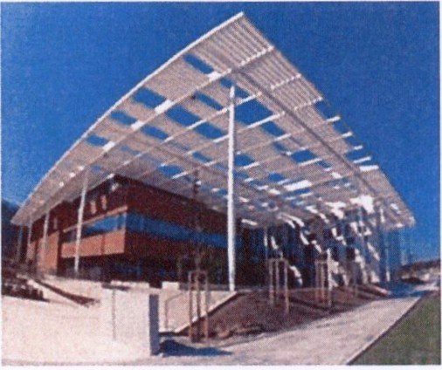

Keywords

N/A
 | Position |  |  | Name
Responsible person | RP4 Team Leader |  |  | Jakob Andreassen
Prepared by | Researcher I Postdoc RP4 |  |  | Eva Klimesova

q •· •
' CJ

European Structural and lrr....tmg Funds
EUROPEANUNION
OperaUonalProgramme Research,
•
FzlJ I Dl! ""'t'"',_'and Educallon u•"ilh t c-' • OUt •a-. .
'>e""'"'l
Tfilt/IC trOfl1'a



1 )))))) Institute of Physics ASCR. v. v. I , Na Slovance 2, 182 21 Praha 8
Eii'

beamlines
nfJ@'al1 Oe3ms.eu I \WvW e 1 b :arn'J.eu

RSS TC ID/revision | RSS - Date of Creation | RSS - Date of Last  Modification | Systems Engineer
011973/A.OOO | 11.04.2017 01:20 | 13.04.2017 21:30 | Marek Maly
011973/A.001 | 13.04.2017 21:32 | 13.04.2017 21:33 | Marek Maly
011973/A.002 | 24.04.2017 15:02 | 24.04.2017 15:04 | Marek Maly
011973/A.003 | 02.05.2017 12:02 | 02.05.2017 12:03 | Aleksei Kuzmenko

Reviewed By
Name (Reviewer) | Position | Date | Signature
Jakob Andreassen | Group Leader RP4 | NOTICE (RSD product category B)
Christopher Brooks | Researcher RP4 | NOTICE (RSD product category B)
Martin Laub | Team Leader of Mechanics | NOTICE (RSD product category B)
Alice Hamalova | Clean Room Specialist | NOTICE (RSD product category B)
Ladislav PBst | Manager installation of  technology | NOTICE (RSD product category B)
Lubas Nims | Head of Electrical engineering | NOTICE (RSD product category B)
Tomas Lastovicka | Group Leader BIS and C&C | NOTICE (RSD product category B)
Veronika Olsovcova | Safety coordinator | NOTICE (RSD product category B)
Viktor Fedosov | SE & Planning group leader; Quality Manager | NOTICE (RSD product category B)

Approved by
Name (Approver) | Position | Date |  | Signature
Georg Korn | Science and Technology Manager, Scientific coordina tor of RP2-6 | t)1logl-z.o' | \lf- | I

Revision History I Change Log
Change  No. | Made by | Date | Change description, Pages, Chapters | TC rev.
1 | E.Kiimesova | 28.03.2017 | RSD draft creation | A
2 | M.Maly | 13.04.2017 | RSD update, addition of standard chapters | A
3 | E.Kiimesova | 24.04.2017 | RSD update, version for internal review | B
4 | E.KIImesova,  A.Kuzmenko | 28.04.2017 | RSD update, final version for approval | c

page: 2/14 EUROPEANUNION
[{I
TC# 00148864 Europe<lrl SIJu::ll,raland lrr..-t.ng Funds
Operallonal Programme Research,
,
FZtJ DIM'Ioprnentend EducaiKln """ ':..' ...... ... w ...c•• '"

1))))))
beamlines
Institute of Physics ASCR. v. v. I Na Slovance 2, 182 21 Praha 8 nf:J@eh beams eu I www.e 1 beams.eu

Table of Content

1. ntroduction .................................................................................................4

1.1. Purpose .................................................................................................. 4
1.2. Scope..................................................................................................... 4
1.3.Terms, Definitions and Abbreviations .........................................................4

1.3.1. Definition of translation and rotation axes .............................................5

2. Functional, Performance and Design requirements.............................................5
2.1. General Requirements on Positioning systems ............................................. s
2.2. XYZ Sample positioner .............................................................................6
2.3. Camera positioner ...................................................................................6
2.4. SD positioners .........................................................................................7
2.5. 60 OAP positioner....................................................................................8
2.6. 40 positioner ..........................................................................................9
2.7. Linear posltioners ..................................................................................10
2.8. Rotation posltioners ...............................................................................10
2.9. 40 "dark" positioner...............................................................................11
2.10. Motion controllers ................................................................................12

2.10.1. General Requirements.....................................................................12
2.10.2. Motion controller(s) MC1.................................................................12
2.10.3. Motion controller(s) MC2 .................................................................12
2.10.4. Motion controller(s) MC3 .................................................................13

3. Operational conditions .................................................................................13
4. Delivery Requirements.................................................................................13
5. Safety Requirements ...................................................................................14
6. Quality Requirements ..................................................................................14

6.1. General Quality Requirements ................................................................. 14
6.2. Specific Quality Requirements .................................................................14



1)))))) Institute of Physics ASCR. v. v. I Na Slovance 2, 182 21 Praha 8
beamlines
nfo@eh beams eu I wwwe t beams.eu

1. Introduction

1.1. Purpose
This Requirements Specification Document (RSD) lists the technical requirements and constraints on positioning systems for RA4 experiments in experimental hall El. The positioning systems will be used for various purposes, e.g. to hold and position a solid sample, align a focusing mirror, hold a camera, microscope, etc.

1.2. Scope
This RSD contains all of the technical requirements: functional, performance, operational, transportation,safety and quality requirements for the following product: Positioning systems for ElEndstations 2 (PBS number : E.El.HXRS.POSS).

This product Is a product Category B.

Category 8 Is an Off-the-shelf Product with customization (e.g., product performance) that does not require any design modifications of the product. If there is no need in conducting specific tests regarding the product's performances the Supplier shall verify all requirements defined by appropriate RSD within own outgoing Inspection and testing procedure. All non-conformances (If any) must be addressed by the Supplier in a timely manner.

1.3. Terms, Definitions and Abbreviations
For the purpose of this document, the following abbreviated terms are applied:

Abbreviation | Meaning
ASCII | American Standard Code for Information Interchange
CA | Contracting Authority
ELI | Extreme Light Infrastructure
RA4 | Research Activity 4  (Applications in molecular, biomedical and materials sciences)
El | Experimental hall 1
OAP | Off-axis parabola
PBS | Product Breakdown Structure
RSD | Requirements specification document
W X Lx H | Width X Length X Height

;(I

1))))))
beamlines
Institute of Physics ASCR, v. v. i Na Slovance 2, 182 21 Praha 8 nfo@eli beams eu I www.e 1 beams eu

1.3.1.Definition of translation and rotation axes

a) b)

Z/J.
I
I
_..... .... .....

H
' ..l....... - H
-
' -
X y 0x
w L w
L

Figure 1: The schematic drawing for definition of translation and rotation axes.

2.Functional,Performance and Design requirements

2.1.General Requirements on Positioning systems

REQ-020688/A

REQ-020690/A

REQ-020691/A

The delivery of Positioning systems shall consist of;
1. XYZ Sample positioner
2. Camera positioner
3. two SO positioners
4. 60 OAP positioner
5. 40 positioner
6. three Linear positloners
7. two Rotation positioners:
a. RSlfor high vacuum
b. RS2 for ultra-high vacuum
8. 40 "dark" positioner
9. Motion controllers for positloners ln 3. - 8.
NOTE: All positioning systems shall be vacuum-compatible.
Required level of vacuum compatibility for each system is defined Individually In sections bellow.

Cables (with connectors) between the positioners and the vacuum feedthroughs shall have length at least 600 mm.
NOTE: Preferred connectors are either Sub-D 15 pin or
connectors for LEMO feedthroughs. Feedthroughs shall
NOT be Included in the delivery.

Cables shall have the same vacuum compatiblllty as positloners.

page: 5 1 14 -- - euROPEAN IJNIO'
Mr
TC# 001488fi4 Ewnllf'•"'Slruc:rural ar cll,.,.,,:or'll Funob
Oocr tKJnlPI'Oo,jra·nrne <e5!!:!rch.
,
FZ\J
Dovelopmonttmct EdUC:lhon \ll'.,u;·rc,"'' t..J. G'' ")...
'J• II ,..•' ·.;"t o

1))))))
beamlines
Institute of Physics ASCR. v. v.I Na Slovance 2.182 21 Praha 8 nfo@ell beams.eu I wwwe1 beams.eu

REQ-020692/A

All positioners shall have metric holes to mount a sample/device on
the positioner.

2.2. XYZ Sample positioner

REQ-020693/A

REQ-020694/ A REQ-020695/A

REQ-020696/ A

The XYZ Sample positioner shall be a stepper motor based positioner with 3 linear mutually orthogonal axes (x and y - horizontal, z - vertical).

The XYZ Sample positioner shall have integrated limit switches to detect minimum and maximum positions of travel on each axis.

Brackets and/or adapter plates to assemble the XYZ Sample positioner and mount it on a flat surface shall be included in the delivery.

The XYZ Sample positioner shall have parameters listed in table n°1.

Travel In x direction | 50± 1 mm
Travel in y direction | 100 ± 1 mm
Travel In z direction | 50± 1 mm
Load capacity | 2:: 1kg
Resolution in full step (x and y direction) | s 2.5 IJffi
Resolution in full step (z direction) | s 1.25 IJffi
Total dimensions (xyz), including motors | less than 235 mm x 325 mm x 245 mm
Vacuum compatibility | 10> mbar or better
Table n°1: Requtred parameters of the XYZ Sample positioner.

2.3. Camera positioner

REQ-020697IA

REQ-020698/A REQ-020699/A

REQ-020700/A
The Camera positioner shall be a stepper motor based linear translation positioner.

The Camera positioner shall have integrated limit switches to detect minimum and maximum positions of travel.

It shall be possible to mount the Camera positioner on a standard optical breadboard.
NOTE: An adapter plate can be used for mounting.

The Camera positioner shall have parameters listed In table n°2.



1)))))) lnstiMe of Physics ASCR. v. v. I. Na Slovance 2,182 21 Praha 8
beamlines
nfo@leli beams.eu I www.e r beams.eu

Travel range | 150 ± 2 mm
Load capacity | 2: 7 kg
Resolution in full step | 2.5 J.lm
Total dimensions (xyz), including motors | Less than 325 mm x 80 mm x 45 mm
Vacuum compatibility | 10>· mbar or better
Table n°2: Required parameters of the Camera positioner.

2.4. 50 positioners

REQ-020701/A REQ-020702/A REQ-020703/A

REQ-020704/A

Two Identical 5D positloners shall be delivered.

Each 5D positioner shall be a piezo based positioner.

Each SD positioner shall have 3 linear and 2 angular motorized axes:
• x and y - horizontal axes
• z - vertical axis
• ex - rotation around x axis
• ey - rotation around y axis

Each SD positioner shall have parameters listed in table n°3

Travel in x direction | 2:3mm
Travel in y direction | 2:3mm
Travel In z direction | 2:3mm
Angular travel ex | 2: 8 deg
Angular travel ey | 2: 8 deg
Load capacity | 2: 1.2 kg
Minimum incremental motion (for linear axes) | :S 30 nm
Angular resolution | :S 0.7 f..lrad
Total dimensions (xyz) | less than 120 mm x 85 mm x 42 mm
Vacuum compatibility | 10 11 mbar or better
Table n°3: Requrred parameters of the SD posltloners.

paqc: I I 14 - - --- EUI<OPEANIJ'ltON 1
\.!J.:.:
TC# 00148fl64 ; •. !;u'll\lf!.lll Stroct<.rl and ''M<>IITlQ rurnl. l\7f.
,
•
• Opt:raltO'l:tl Pr(.)rta; mrr•t: r ese3rch

FZlJ - ·• : _
_ nev,.loprrnlnnr1 Euc:\hon ,.·..· : !-;, -::: --.
2j

1))))))
beamlines
Institute of Physics ASCR. v. v. I Na Slovance 2, 182 21 Praha 8 nfo@eli beams eu I www.e 1 beams.eu

2.5. 60 OAP positioner

REQ-020705/A REQ-020706/ A

REQ-020707/A REQ-020708/A

REQ-020709/ A REQ-020710/A REQ-020711/A

REQ-020712/A
The 60 OAP positioner shall be a piezo based positioner. The 60 OAP positioner shall consist of:
• 3 linear positioners: x and y- horizontal axes, z- vertical axis
• 2 goniometers: ex and ez- rotations around x and z axes
• 1rotation positioner (360 deg): ey- rotation around y axis

The two goniometers shall have a common center of rotation.

The 60 OAP positioner shall be equipped with sensors on all 6 axes to allow closed-loop operation.

Brackets and/or adapter plates to assemble the 60 OAP positioner and mount it on a flat surface shall be included in the delivery.

Proposed layout of the 60 OAP positioner shall be approved by the
CA (see REQ-020753/A).

System assembly with cabling and final testing shall be performed by the Supplier (within outgoing check of the Product, see REQ-
020751/A).

The 60 OAP positioner shall have parameters listed in table n°4

10"6 mbar or better
. .
Table n°4: Required parameters of the 60 OAP pos1t1oner.
Travel in x direction | 2: 39 mm
Travel In y direction | 2: 44 mm
Travel in z direction | 2: 29 mm
Angular travel ex | At least ± 5 deg
Angular travel ey | 360 deg
Angular travel ez | At least ± 5 deg
Load capacity | 2: 150 g
Sensor resolution (for linear axes) | s 2 nm
Repeatability measured over the complete travel range (for linear axes) | Better than ±70 nm
Angular sensor resolution (ex and ez) | s 0.05 llrad
Angular sensor resolution (ey) | s 0.3 llrad
Total dimensions (xyz) | less than 98 mm x 120 mm x 115 mm
Vacuum compatibility

page. 8/14 I
·-T EUF<OPf:A'lll lON

TC # 00148864 EuroiJti"'' Struc•,.r;l nrl•n·,..,;:,r.g Fun\l•
Mr
- ' | :!-

Operallomtl Pro-Jramrne Rese3rch,
•
FZlJ
DevPi o))(n nl nnc1 Etlur.:ltton \.t•·,,•:;""

_:.'',



1))))))
Eii
beamlines

Institute of Physics ASCR. v. v. I Na Slovance 2, 182 21 Praha 8 nfo@eli beams eu I www.e i beams eu

2.6. 40 positioner

REQ-020713/A REQ-020714/A

REQ-020715/A REQ-020716/A REQ-020717/A REQ-020718/A

REQ-020719/A
The 4D positioner shall be a piezo based positioner. The 40 positioner shall consist of:
• 3 linear positioners: x andy- horizontal axes, z -vertical axis
• 1rotation positioner (360 deg): ez- rotation around z axis

The 40 positioner shall be equipped with sensors on all 4 axes to allow closed-loop operation.

Brackets and/or adapter plates to assemble the 40 positioner and mount it on a flat surface shall be included In the delivery.

Proposed layout of the 40 positioner shall be approved by the CA (see REQ-0207S3/A).

System assembly with cabling and final testing shall be performed by the Supplier (within outgoing check of the Product, see REQ-
0207S1/A).

The 40 positioner shall have parameters listed in table n°S

Travel in x direction | 2:: 100 mm
Travel in y direction | 2:: 100 mm
Travel in z direction | 2:: 40mm
Angular travel 9z | 360 deg
Load capacity | 2:: 300 9
Sensor resolution (for linear axes) | s 2 nm
Repeatability measured over the complete travel range (for x and y axes) | Better than ± 1SS nm
Repeatability measured over the complete travel range (for z axis) | Better than ± 80 nm
Angular sensor resolution (for rotation  positioner) | s 0.3 wad
Total dimensions (xyz) | less than 155 mm x 1S5 mm x 140 mm
Vacuum compatibility | 10"6 mbar or better
Table n°S: Required parameters of the 40 sample positioner.

page: 9 I 14 r·-
TC# 00148864 I
,
'
;;-- EllROPEAUNION
•• Europedll s·ruct Jitl.orKJ lr·=""'l fun<Js M(-
- --
:.
•

• Oper:thon:.l Pro;mmrne Re arch.

FZlJ I • "_"'_ . Dtt'.JCinpl'1e"'ll'!n<f l:::.uc;1:t0n .1•, r .' c . L.' c- 1 .:•
• " "' l • '·) • •

 1)))))) Institute of Physics ASCR. v. v. I Na Slovance 2, 182 21 Praha 8
beamlines nfo@el1 beams eu I www.e 1 beams.eu

2.7. Linear positioners

REQ-020720/A REQ-020721/A

REQ-020722/A

REQ-020723/A

Three identical Linear positioners shall be delivered.

Each Linear positioner shall be a piezo based linear translation positioner.

Each Linear positioner shall be equipped with a sensor to allow closed-loop operation.

Each Linear positioner shall have parameters listed In table n°6.

Travel range | 49 ± 1 mm
Load capacity | 2: 3 kg
Sensor resolution | :52 nm
Repeatability measured over the  complete travel range | Better than ± 80 nm
Total dimensions (xyz) | Less than 76 mm x 25 mm x 11mm
Vacuum compatibility | 10·c. mbar or better
Table n°6: Requ1red parameters of the Linear pos1tloners.

2.8. Rotation positioners

REQ-020724/A REQ-020725/A

REQ-020726/A

REQ-020727/A REQ-020728/A

REQ-020729/A

Two rotation positloners - RS1and RS2 - shall be delivered.

The RS1 positioner shall be compatible with vacuum level 10·6 mbar or better.

The RS2 positioner shall be compatible with vacuum level 10·8 mbar or better.

Each Rotation positioner shall be plezo based.

Each Rotation positioner shall be equipped with a sensor to allow closed-loop operation.

Each Rotation positioner shall have parameters listed In table n° 7.

Less than 58 mm x 58.mm x 14 mm
.
Table n°7: Required parameters of the Rotation pos1t1oners.
Angular travel range |  | 360 deg
Load capacity |  | 2: 2.5 kg
Sensor resolution |  | :5 0.3 1-1rad
Total dimensions (xyz)

page: 10 / 14 1-------:-;;---; EUROPEAN UNIOf\ -
1"
TCl: 00148864 I ; : Eumpt!dllStru·.tl al ancltn·;est"''j Fufl<JS 1\7 1
,

fZ(J
.. • •
'
• • • , Operatu.:nttlPH.)(jlmnmRcsHar::r.
fmvPiopmr..ll.1nct '=du.:-1hon \' · ·rr - ;. Ctl :r•.

---- 'J•
l<;L,
:..•;1•!0:

1))))))
beamllnes

Institute of Physics ASCR. v. v. I. Na Slovance 2. 182 21 Praha 8

nto@eli beams eu I www.e r beams eu

2.9. 40 "dark" positioner

REQ-020730/A REQ-020731/A

REQ-020732/A REQ-020733/A
REQ-020734/A REQ-020735/A
The 40 "dark" positioner shall be a piezo based positioner. The 40 "dark" positioner shall consist of:
• 3 linear positioners: x and y - horizontal axes, z - vertical axis
• 1 rotation positioner (360 deg): 9z- rotation around z axis

The 40 "dark" positioner shall be equipped with sensors on all 4 axes to allow closed-loop operation.

The sensors on the 40 "dark" positioner shall not use light with wavelength below 1.2 m to detect the position.
NOTE: Other types of sensors, e.g. resistive or Inductive, can be used.

Brackets and/or adapter plates to assemble the 40 "dark" positioner and mount it on a flat surface shall be included in the delivery.

The 40 "dark" positioner shall have parameters listed in table n°S.

Travel In x direction | 20 mm
Travel In y direction | 20 mm
Travel in z direction | 12 mm
Angular travel 9z | 360 deg
Encoded angular travel | 310 deg
Load capacity | 140 g
Sensor resolution (for linear axes) | s 250 nm
Repeatability (for linear axes) | Better than 3 m
Absolute accuracy (for linear axes) | Better than 1.5% of travel range
Angular sensor resolution (for rotation positioner) | s 0.11 mrad
Absolute accuracy (for rotation) | Better than 2% of travel range
Total dimensions (xyz) | less than 4S mm x 4S mm x 74 mm
Vacuum compatibility | 10-8 mbar or better
Table n°S: Required parameters of the 40 "dark" positioner.

, l ••
-
r-
I
page: | 11 | 1 11\
TC# 00148864

- EJHOt'EAN vJtON
. Ew e·nStructural itll<lln.l!s:.rgFund
:--
••
.-
 | -
: | -

r
.r. '-.1:. :
-

FZ\J _ ·-
OperCJIIon:-11 Pr0o rummc Reso: rc!l.
Devr.loptf\c 1 .1nc1 !:dUC:'J!!{)n '' -; ,.. 1 ro.



.-J.· I
t\l l

1))))))

beamUnes

Institute of Physics ASCR, v. v. I Na Slovance 2,182 21 Praha 8

nfo@elr beams.eu I wwwe beams.eu

2.10. Motion controllers

2.10.1. General Requirements

REQ-020736/A

REQ-020737IA REQ-020738/A

REQ-020739/A

The delivery of motion controllers shall consist of:
• MCl- motion controller (or controllers) for 50 positioners
• MC2 - motion controller (or controllers) for 60 OAP positioner, 40 positioner, Linear positioners and Rotation positioners
• MC3 - motion controller (or controllers) for 40 "dark" positioner
NOTE: 19H rack-mounted controllers are preferred,

The motion controllers shall be delivered with EU compatible power supplies.

The motion controllers shall be delivered with cables between vacuum feedthroughs and the controller.

The motion controllers shall have RJ45 or RS232 socket that allows communication and control from a remote host computer. This control shall be possible through one of the following protocols:
• ASCII based command protocol (protocol is documented);
• Llnux 64bit compatible C++ libraries (libraries are part of the delivery).
NOTE: The RJ45 socket can be provided by extender/convertor
or by mounting on a DIN rail.

2.10.2. Motion controller(s) MCl

REQ-020740/A

REQ-020741/A

The MClshall have at least 10 channels to control two 50 positioners.

The MClshall operate In open-loop.

2.10.3. Motion controller(s) MC2

REQ-020742/A

REQ-020743/A

The MC2 shall be compatible with these posltioners:
• 60 OAP positioner
• 40 positioner
• Linear positioners
• Rotation positioners

The MC2 shall have 15 channels to control 15 motion axes.



efi ;I

1))))))

beamUnes

Institute of Physics ASCR. v. v. i Na Slovance 2.182 21 Praha 8 nfo@ell beams.eu I www e 1 beams.eu

REQ-020744/A

The MC2 shall use feedback from the positioner's sensor to control the position (closed-loop operation).

2.10.4. Motion controller(s) MC3

REQ-020745/A REQ-020746/A

The MC3 shall have at least 4 channels to control the 4D "dark" positioner.

The MC3 shall use feedback from the positioner's sensor to control the position (closed-loop operation).

3. Operational conditions

REQ-020757/A

REQ-020758/A

The Supplier and the CA shall agree on the cleaning method to clean devices that are not placed In vacuum (e.g. controllers) without decreasing the devices' performance and to avoid contamination when used In a Class 7 clean environment according to ISO 14644.

All elements of the positioning systems shall be suitable for operation at temperature 18 - 25 °C.

4. Delivery Requirements

REQ-020747/A REQ-020748/ A

The transportation to the final destination shall be conducted by the
Supplier.

The technologies and Instruments shall be delivered in protective package preventing damage and contamination and a minimum of two plies separate clean packaging.



1)))))) Institute of Physics ASCR. v. v. i Na Slovance 2, 182 21 Praha 8
beamUnes
nfo@eli beams.eu I wwwe 1 beams.eu

5. Safety Requirements

REQ-020749/ A

The Supplier shall supply a Declaration of Conformity or any other equivalent document legally recognized and accepted In the Czech Republic for each product type if the appropriate legislation determines the Supplier's obligation to have a Declaration of Conformity (or the equivalent document) for the purposes of a Device sale In the Czech Republic to fulfil the requirements of
2001/95/EC directive or applicable Czech law.

6. Quality Requirements

6.1. General Quality Requirements

REQ-020750/A

REQ-020751/A

REQ-020752/A

The Supplier shall provide the Product User Manual as part of the delivered Device (positioning systems). The Manual shall include the Instructions and descriptions regarding the following procedures:
• transport, handling,storage, installation and cleaning;
• safe operation and maintenance procedures.

The Supplier shall provide information on execution of outgoing check of the Product. At least this information shall comprise declaration about execution of outgoing check and declaration of conformity with technical requirements defined by the product RSD and completeness of the Product.
NOTE: Alternatively the Supplier might provide theCA with information (e.g.: catalogue/technical data sheets, product manuals or other similar documentation) subject to the condition that such documentation is detailed enough to prove meeting all requirements stipulated herein.

The Supplier shall establish and maintain a non-conformance control system compatible with CSN EN ISO 9001.

6.2. Specific Quality Requirements

REQ-020753/A

REQ-020754/A

The Supplier shall provide a final suggestion of each positioning system configuration that is to be accepted by the CA before manufacturing starts.

The unit system of the mounting holes, sizes and layout shall be SI
base units (metric) or other units derived from them.

p<Jgc: 141 14 - ---:- . --· ELJRO >EA'Ill'IION
M'f
TC# 00148864 ; ". ;:'·"Ill""''Struct<.ral.ma """"''"ll fUt•ro
,
• Operahonal Pro.r,J•nrntJ Resftarch
•

FZlJ --•-
1
Oevfl!lopmt-nt ctn<ltc.tucahon
•.· ·:•..: ..
!.. -- : J'".

MiT Lasery, fotonika a jemna mechanika

Bid price
Positioning Systems for El Endstations 2

Item Qty Description Offered price in EUR
w/o VAT/pc VATZI" Unit price incl.
VAT

I I set Positioning systems for RA4 experiments in experimental 1 24.950,00 26.239,50 151.1 89,50
ball El
Containing:
I. XYZ Sample positioner consist ing of
Ipc. 8MT17SV-100 (Standa) Ipe. 8MT17SV-SO (Standa) Ipe. 8MT30V-SO (Standa)
incl. mounting material and cables with connectors for vacuum
2. Camera positloner consisting of
I pe.8MT17SV-ISO (Standa)
incl. cables with connectors for vacuum
3. Two SO positioners consisting of
2 pes. 8081M-UHV (Newport)
4. 60 OAP positioner consisting of
I pe. SLC-1770-W-0-S-HV (SmarAct)
Ipc. SLC-1760-0-W-D-S-HV (SmarAct)
Ipc. SLC-1750-W-0-S-HV (SmarAct)
Ipe. SLC-1750-W-0-HV (SmarAct)
I pe.SG0-77.5-Z-D-S-HV (SmarAct) I pe. SG0-60.5-Z-0-S-HV (SmarAct) Ipc.SR-5714-D-S-HV (SmarAct)
incl. mounting and connecti ng materia l and cables with connectors for vacuum
5. 40 positioner consisting of
2 pes. SLC-24150-0-S-HV (SmarAct) I pe. SLC-2475-0-S-HV (SmarAct)
Ipe. SR-5714-0-S-HV (SmarAct)
i ncl. mounting and connecting material and cables with connectors for vacu um
6. Three Linear positioners consisting of
3 pes.SLC-2475-0-S-HV (SmarAct)
i ncl. cables with connectors for vacuu m
7. Two Rotation positioners consisting of a. RSI for high vacuum consisting of
I pe. SR-5714-D-S-BV (SmarAct)
b. RS2 for ultra-high vacuum consisting of
I pc. SR-5714C-S-UBV (SmarAct)
8. 40 "dark" positioner consisting of
2 pes. ANPx341/RESIHV (Attocube)
I pe. ANPx321/HURES/HV (Attocube) I pc. ANR240/RES/HV (Attocube)
incl. mounting material and cables with connectors for vacuu m
9. Motion controUers consisting of
I . MC I - motion controllers for 50 positioner
I pc.8742-12-KJT (Newport), 12 axis
2. MC2- motion controllers for 60 OAP posit ioner, 40 positioner, linear positioners and rotation positioners
I pe. MCS control system (SmarAct), 15 axis
3. MC3 -motion controllers for 40 "dark" positioner
2 pes. ANC350/31RES/Vac (Attocube), 6 axis
(technical performance specified i n Technical Specifications)
Total price without VAT 124 950,00 EUR
21% VAT 26 239,50 EUR
Total price incl. VAT 151 189,50 EUR

MIT spol. s r.o
Klanova 56, CZ-14700 Praha 4
tel.:+420 241 712 548, fax:+420 241 710 252 info@mit-laser.cz.www.mlt-laser.cz
CSOB,a.s.
BIC: CEKOCZPP CZK 576978503/0300
IBAN CZ86 0300 0000 0005 7697 8503
M stsky soud v Praze oddil C, vlotka 10259
tC: 46348395
DIC: CZ46348595

MiT Lasery, fotonika ajemna mechanika

The bid price is the maximum price that cannot be exceeded and include all costs that the participant shall incur during performing the Public Contract. The bid price include also any costs not explicitly specified but about which the bidder knew or should and could have known considering its professoi nal knowledge,exercising all professionalcare.
The price may only be modified in connection with any changes to tax regulations regarding the VAT.

Time and place of delivery
The delivery period is 4 month from the signature of the Contract.
The place of delivery shall be the ELI Beamlines facility, Dolni Bfezan y, district Prague-West, Czech Republic.

ProhhiSeni uchazece

::: :
0:: : bidpo celou dobu b•hu zod;vaci lhOcyA. W';V-----

UchazeMIT spol. s r.o. se sidlem Klanova 56, 147 00 Praha 4, zastoupeny Martinem Moserem, prohla uje, ze

6
rn Moser
Managmg Director
MIT, spot. s r.o.
•T l.n'lery, fotomka
MI
!I JO!'MII mochan!ka

ova 56, 147 00 Prat1<1 4

MIT spot. s r.o
Kliinova 56, CZ-14700 Praha 4
tel· +420 241 712 548, fax: +420 241 710 252
info@mit-laser.cz.www.mit-laser.cz
CSOB,a.s. BIC:CEKOCZPP
CZK 576978503/0300
IBAN CZ86 0300 0000 0005 7697 8503
MAstsky soud v Praze oddll C, vloika 10259 tC: 46348395
DIC:CZ46348595
J o

....t.sand a

8MT175V - Vacuum Compatible Motorized Stages

• Narrow
• Compact design
• Resolution 0.31 IJm (1/8 step)
• H1gh guide way accuracy
• Lead screw p1tch 0 5 mm
• X-Y-Z configurations available
• Non vacuum version

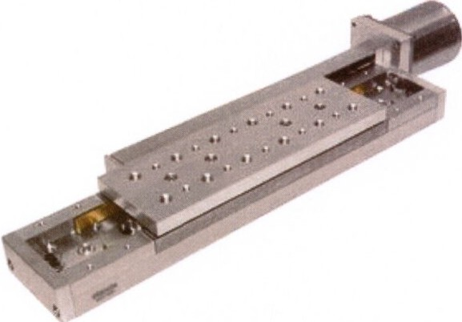Vacuum compatible Motorized Stages are equipped with vacuum compatible stepper motor. Stages stack 1n X-Y configurations directly using M6 screws. Angle Bracket 2AB175V is used to mount stages for vertical translation; 1t is also used for X-Y-Z configurations. To mount stages on a flat surface you will need 3UBP175V base plate.

H1gh vacuum compatible Sub-D. male or female, 9 or 15 pin connectors can be ordered separately The connectors are made of glass filled polymer with a stainless steel outer and suitable for High Vacuum (1o-6
mbar) and temperatures up to 11ooc

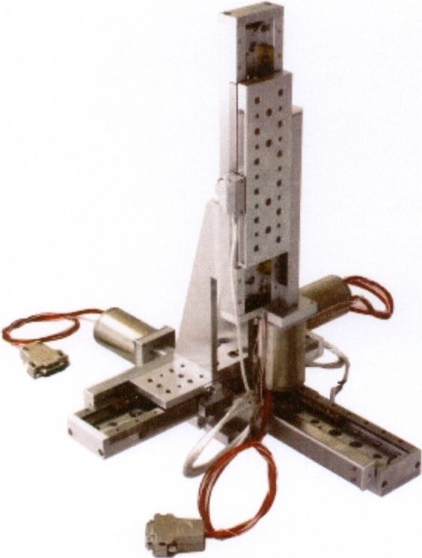
XYZ assembly

:J1

Vacuum multi-axis linear stage



Specification of HV Sub-D Connectors. Vacuum. 1o·6 mbar
Body material: DEP
Temp. range -55 'C to 110°C
Pin matenal: Gold plated copper alloy

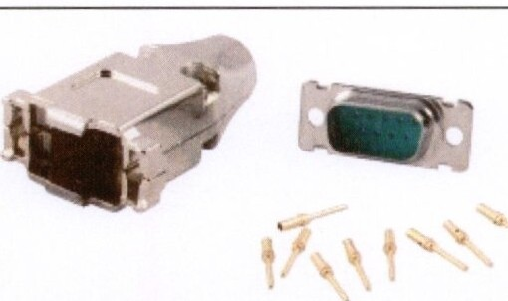Connectors of other sizes and vacuum feedthroughs are available on request.

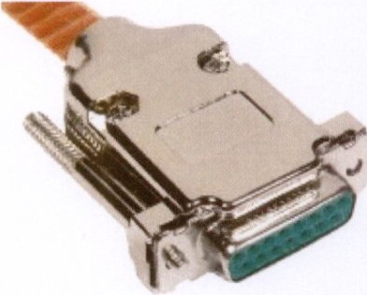

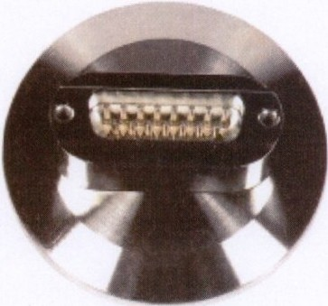Specifications

Lead screw pitch Resolution in full step Max.speed
Load capacity Horizontal Vertical
Vacuum, Torr Motor connector Stepper motor Assemblies
X-Y
z

0.5 mm
2.51-Jm
5 mm/s

8 kg
3 kg
10-6
DB9(M) VSS42

directly
2AB175V
Ordering Information

Model Travel range, Weight, mm kg
8MT175V-100-VSS42 Qty. 1 5
8MT175V-150-VSS42 150 1.5
8MT175V-200-VSS42 200 1 6
8MT175V-50-VSS42 50 1
2AB175V 0.45
3UBP175V 03

Ultra High Vacuum Motorized

Five-Axis Tilt Aligner

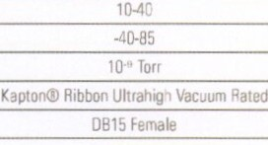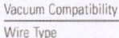

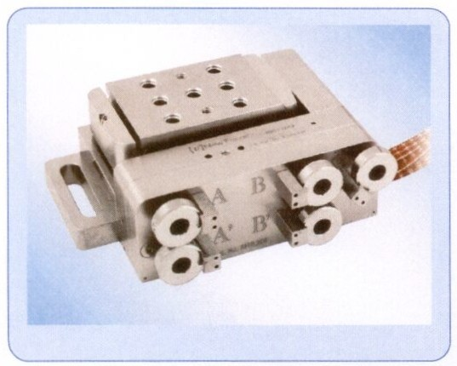

Model 8081(M)-UHV Features:

• Ultra H1gh Vacuum Compatible (10 Torrl
• Outgas less than 5 ppm of volatile mass at as• C over 3 hrs

• X, Y,Z, Bx, By adJustments

•M1mmum IncrementalMot1on < 30 nm

•Maxtmum Load of 13N

[ V ]New Focus

The BOB1-UHV IS our motorized Five-ax1s aligner that allows high remote and prec1s1on aJ,gnment m UHV (10 9 Torrlenvironments as well as for VUV/EUV appltcat>ons. The PicomotorTM actuators to each stage allows better than <30 nm of various comb1nat1ons of X, Y. Z, 9x, and 9y. The BOB1 -UHV has been tested and measured to outgas levels less
than 5 ppm of volatile mass at B5 oc over three hours. Mass Spectrograms detailing the
exact outgassmg compounds are ava1lable upon request Also available in metric vers10n.

Specifications

Specifications a1-UHV (a iM·UHV)
Motonzed Axes
Axos of Travel X. Y.Z ex. 9y

Tra | vel Ra1QB lmml X,S Y&3l
Travel. Angu |  | lar 1"1
Mm1mum lrcre,ental Mot1on (X. Y, Zl (nm) <30
Resolution·Angular h,rad)
load Capacity lb!Nil 3(131
Tlvtad Type 8-11and 1/4-20 IM4 ard M6)
Operat1ng TempErature I"CI
Surv,val Temperature Range lnon-operat,cg) !"CI

Co!V·ector Type

Ultra High Vacuum Motorized Five-Axis Tilt Aligner

Dimensions

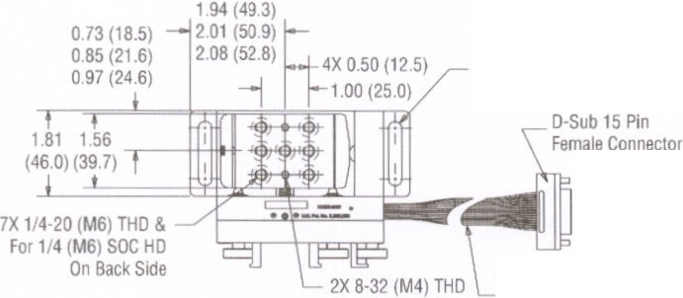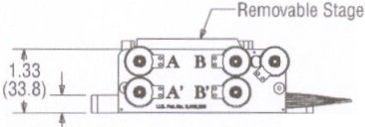2X Slot for 1/4 20 (M6) Screw 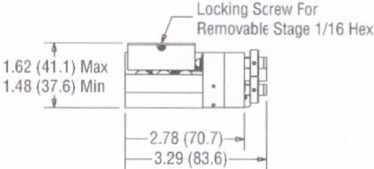

15 Conductor Ribbon Cable
With Kapton Insulation ---=®3
I--1700NOM-.j

2X 037 (93)
(431 8)

Ordering Information

Model Descrilion
8081-UHV Ultra High Vacuum Motorized )f;(Z ex ey Tilt Aligner. 1/4-20
8081M-UHV Ultra Hogn Vacuum Motor redZ ex ev th Aligner,M6
8081-LIHV-C 8081-UHV ca le,1.83m.0815 Female tl6-p1r RJ25 Connector
8725 Muh1·AX1S Adapter
8742-4-KIT FJur·AxiS 8742 Pw:cmotor Controller/Dnver K1t
8766-(IT Nf S1x-Ax1$ Pw:orrotor DrT'Il!r Module K.t,,p,to

www.newport.com/newfocus

363Peterson Way,Santa Clara,CA 950 4. USA
PHONE. 1-800-222-6440 1-408-980-4300 FAX:1-408-919-6083 EMAIL: salesO ewfocus.com

 | PHONE | EMAIL |  | PHONE | EMAIL
Belgium | +32-{0)0800-1' 257 | belg umOnewport.com | Irvine,CA.USA | +1-800-222-6440 | sales newport.com
China | +86-10-6267-0065 | chinaOnewport.com | Netherlands | +31-(0)30 6592111 | netner ands@newport.com
France | +33-(0)1-60-91-68-68 | france@newport.com | United Kingdom | +44-1235-432-710 | ui<Onewoort.com

Japan +81-3-3794-5511 spectra-phys.csesp·asers co.,p
Ta1wan +886 -{0)2-2508-4977 salt-$0newport.com.tw
Germany I Austria I Switzerland
+49 (0)6151 708-0

ger.,anyOnewoort.com

1\Jowpor t CDfpUfdtJ:;)r,, rv r·e. Cll k -a nd Frankllu, M ssa(..hus<•tls, E.vry 1nd
Seaune ..a R •rd<: France and Wu.o (Ina '><vn all been cc: t tl(!(j :orrphar t "t
50Q00' bytheB ushSt ..mds s tuton SantaO• Cnltforna s O:Wcert1f eO

Newport Corporation,GlobalHeadquarters PHONE· 1-800-222-6440 1-949-863-3144
1791 Deere Avenue, Irvine CA 92606, USA EMAIL. salesOnewpert com
Complete tSt•ng5 k Jll gl-owl vf', _e ..........,th.n:;, v:e avuluble O"'l ne at WNNnewport com/contact

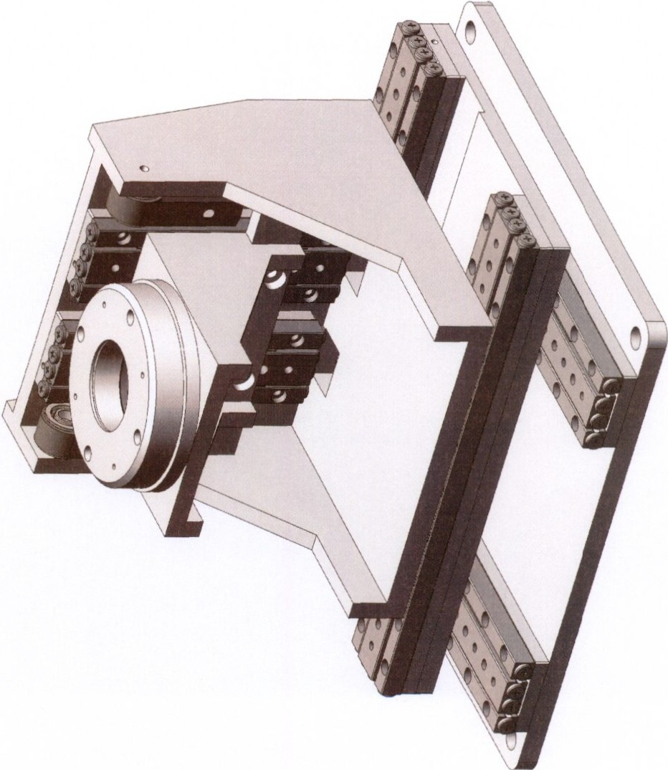

.1/

Linear Positioners

SLC-1750
Nanometer Precision Linear Positioner



< 1nm


30 N (3 kg)

down to



31 mm



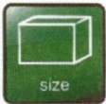available

50x17x8.5

10,·
mbar
mm3

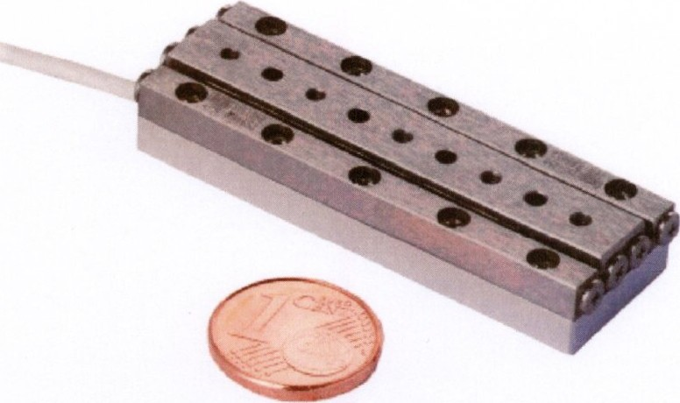

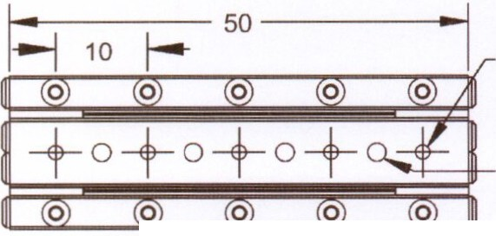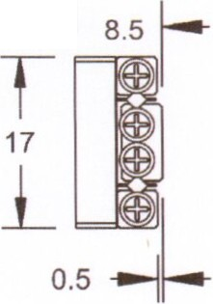4x M2
3.5

¢2H7
3.5

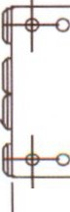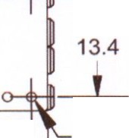0 0 0 l

0 0 0

._.
46 ----

._,.__ 50---- -- 4x M1.6
3.5

Linear dimensions are given in mm.

- 52-

SLC-1750

Mechanical Properties Positioning

blocking force F8  max. normal force F N | > 3.5 N  30 N | travel  step width | ± 15.5 (31) mm  1 - 1,500 nm<D
max. lift force FL  positioner dimension | > 1.5 N  50 x 17 x 8.5 mm3 | scan range  scan resolution | > 1.5 m  <1nm
weight | 32 g | velocity | > 20 mm/s
pitch torque Mp | 4.6 Nm | max. frequency | 18.5 kHz
yaw torque My | 4.6 Nm
roll torque MR | 1.2 Nm

Closed-Loop with -8

sensor resolution 1nm
Materials and Vacuum Options®

steel base (-ST), titanium base (-TI}

repeatability
± 50 nma>
non magnetic materials (-NMG>)

Closed-Loop with -La>

sensor resolution 4nm
black anodized (-BK)

integrated connecting elements (-0)

external support for increased My, MR (-W)

closed loop resolution

repeatability
50 nm (H)CU
4 nm MCS

± 1m (H)CU
± 100 nm MCS
high precision bearing (-P)

increased blocking force (-0, +1.5 N)

-HV (10-6 mbar), -UHV / -UHVT (10-11

mbar)

Closed-Loop with -Ma> 
sensor resolution 100 nm

500 nm (H)CU
closed loop resolution
100 nm MCS

± 2.5m (H)CU
repeatability
± 0.5m MCS

<D for low-vibration mode (-LV), for scan-mode < 1 nm, otherwise 50 -1,500nm
0 measured over the complete travel range, for shorter travelmuchbetter
<l> with mechanical endstops, 3mm reduced travel
@ positioner dimensions,mount1ng holes and travelrange may vary andcanbe customized
<S> all holes M1.6, no dowel holes, screwing depth: min.
3 mm,max. 3.5 mm



-53-

Goniometers
SGO -60.5

SGO- 60.5

MechanicalProperties

Positioning

Nanometer Precision Piezo Goniometer

< 2l·
blockmg torque M0
20 Ncm travel
± 5 0

(< 0.03wad) 60.5 mm
max.verticalload F•
5N stepw1dth 0.7-7 wad

5N (500g)

:±: so
totoraltorquo M. pos111oner dimension center of rotat1on
we1ght
1.2 Nm

50 x 50 x 17 mm'

60.5 mm

.. 140 g
scan range 10.51Jrad scan resolution 0.01 wad velocity 4 "Is
max.frequency 18.5 kHz

.::.
,...,..

10 mbar

50x50x17 mm

Closed-Loop with -M

Closed-Loop with -5

t! tm
sensor resolution

closed-loop resolution
1.5 1J rad

4.5 Jrad (H)CU
1.51Jrad MCS
sensor resolution
0.03 1Jrad

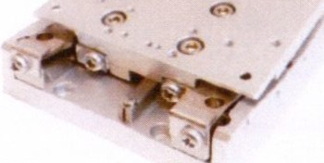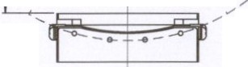Closed-Loop with -L Materials and Vacuum Options

I() ci lO

1;,

sensor resolution closedloop resolution

0.12 wad

1.5 wad (H)CU
0.1211rad MCS

steelbase (-ST)

1ncreased life lime (-Z)

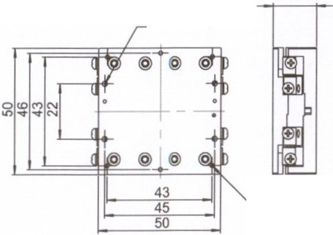-HV (10..mbar), -UHV / -UHVT (10 mbar)

4x ¢ 2 -;- 5
u¢4 -;- 2.5

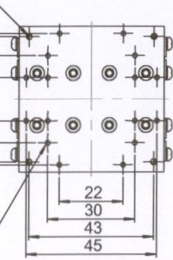17 4x ¢ 22 v¢4.4x90"

f::\
.r.:-.• -

l lgl

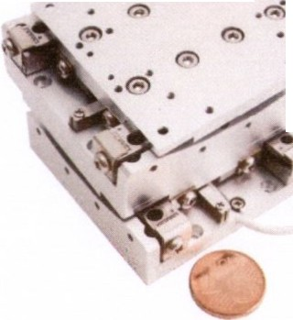,.,

6x M24.5

- 102 -

16x M2 x3.5

Linear dmi ensionS are given '" mm.

- 103 -

SG0-77.5-60.5
20 eut... gonoomotw

- t) SmerAct -

Rotary Positioners

SR-5714
High Precision Rotary Positioners

MechanicalPropert es Positioning
SR-5714

(
0.5 1J" | oo | blocking torque M1  max. normal force F. | 5Ncm  25 N | travel  step width | 00  0.2-2.0 m•
 |  | posotioncr dimensoon | 57x57x14mm | scan range | > 2.3 m•
 |  | stage doameter | 0 57mm | scan resolution | < 0.51J"
25 N  2.5 kg) |  | aperture  weoght | 0 25mm  110 g | angular velocoty  max.frequency | " 9 "/s  18.5 kHz

.,._

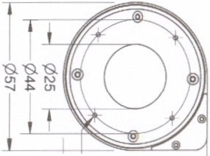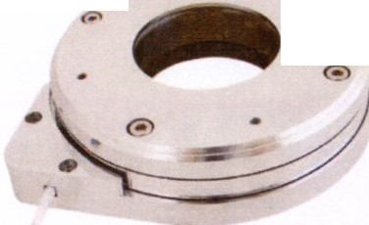

- -5' - a;-
down to 57x57x14
10mbar mm'

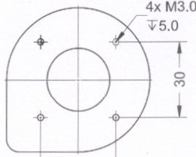30 -

Closed-Loop with -S Materials and Vacuum Options sensor resolution 1511" steel base (-ST), titanium base (-TI)
higher blocking force (-D)

-HV (10.. mbar)

Designed with an aperture of 25 mm, the robust SR-5714 can be used for a broad range of applications.

4x M2.0
5.0
Aperture 25 mm

G
14 .-

Linear dimensions are given in mm.

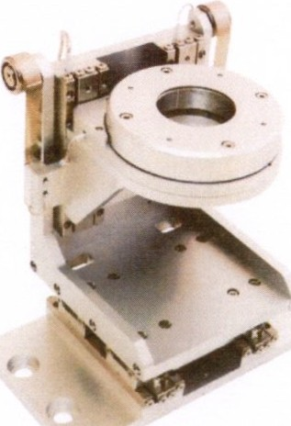40 Positioner
30 stage w•lh one SR-5714
rotary pos•honer and oonstanl
_forcesp,n,nSg•mfor h.eghrefAload. -

- 124 -
- 125 -

ANPx341

Technical Specifications

Technology
travel mechanism positioner type
Size and Dimensions footprint; height
max installation space weight
Materials
positioner body actuator connecting wires bearings
Options
environmental options Compatibility with Electronics ANC300 piezo positioning controller load(@ ambient conditions) maximum torque on the axis
maximum load
maximum dynamic force along the axis
Coarse Positioning Mode in put voltage range
typical actuator capacitance@ 300 K typical actuator capadtance@ 4 K travel range (step mode)
maximum drive velodty@ 300 K Fine Positioning Mode
fine positioning resolution
fine positioning range@ 300 K fine positioning range@ 4 K input DC voltage range@ 300 K input DC voltage range@ 4 K

inertial piezo drive linear

45x40; ll.Smm
40x53.3; ll.Smm
76 g

titanium
PZT ceramics
insulated twisted pai r, copper ceramics

/HV./LT./LT/HV./LT/UHV, / RT, /UHV ANM150, ANM300
10Ncm
20N
2N

0 - 60V
1.6 F
0.22 F
20mm
approx. 3 mmfs

sub-nm
7.5 m
1.2 m
0 - 100 v
0-150V
Accuracy of Movement repeatability of step sizes
typ. forward I backward step asymmetly
Working Conditions mounting orientation magnetic field range minimum pressure (/RT) minimum pressure (/HV) minimum pressure (/UHV) temperature range (/RT) temperature range (/LT)
Connectors and Feedthroughs
cable
connector type
electrical feedthrough solution
High load Option (/Hl)
/Hl/RT- maximum dynamic force
/Hl/(U)HV- maximum dynamic force
/Hl/LT- maximum dynamicforce
Versions
/RTversion
/HVversion
/UHV version
/LTversion
/LT/HV version
/LT/UHV version
/ Hl/RT version
/ Hl/HV version
/ Hl/UHV version
/ Hl/LTversion
/Hl/LT/HV version
/Hl/LT/UHV version

typica lly 5% over full range typically 5"'

axis horizonta l
0 • 31T
1E-4 mbar
1E-8mbar
5E-11mba r
273K 00 373K
10rrK oo 373K

30 em cable with connector
2-pole pin plug, e 0.5 mm, d • 2 mm
VFT/LT

3N
2N
1.5N

1006750
1006751
1006752
1007261
1007262
1007263
1008361
1008349
1008362
1008351
1008352
1008353

Technical Drawings

4xM25 2
10xM2 3 cntlbr.f."12

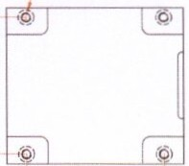Oo 0 0 oO
f I ' e e e
40 35 20 35
" " "

I t co-
0 oo
11 35
35
40
45

533 c;-n

115
A
'I
o

lho 'R
I

AU rights, including rights created by p. tent gr1nt or registration of a utility model or design as weU IS rights of technical modifiationsart reserved. Oetiv subject to avoilobitity.O.Signotions moy be tnd•morlcs, th• use of which by thinl portiesfor their own purposes moyvioloU. the rights ofth• tndemork owneB. Oottocube systems AG 2001-2017.

ANPx321

Technical Specifications
IattoMOTION

Technology
travel mechanism positioner type
Size and Dimensions footprint; height
max installation space weight
Materials positioner body actuator
connecting wires bearings
Options
environmentaloptions Compatibility with Electronics ANC300 piezo positioning controller load(@ ambient conditions) maximum torque on the axis
maximum load
maximum dynamic force along the axis
Coarse Positioning Mode input vo!Dge range
typical actuator capacitance@ 300 K typical actuator capadtance@ 4 K travel range (step mode)
maximum drive velodty@ 300 K
Fine Positioning Mode
fine positioning resolution
fine positioning range@ 300 K fine positioning range@ 4 K input DC voltage range@ 300 K input DC voltage range@ 4 K

inertial piezo drive linear

41.6x40; 11.5mm
40x56.6; 11.5mm
74g

titanium
PZT ceramics
insulated twisted pair, copper ceramics

/HV, /LT. /ll/HV, /ll/UHV, /RT, / UHV ANM150, ANM300
lONcm
20 N
2N

0-60V
1.6 F
0.22 F
15mm
approx. 3 mmfs

sub-nm
7.5 m
1.2 m
0-lOOV
0·150V
Accuracy of Movement repeatability of step sizes
typ.forward I backward step asymmetry
Working Conditions mounting orientation magnetic field range minimum pressure (/RT) minimum pressure (/HV) minimum pressure (/UHV) temperature range (/RT)
temperature range (/lT) Connectors and Feedthroughs cable
con nectar type
electrical feedthrough solution
High load Option (/Hl)
/HL/ RT- maximum dynamic force
/HL/(U)HV - maximum dynamic force
/HL/lT- maximum dynamic force
Versions
/RT version
/HVversion
/U HV version
/llversion
/lT/HV version
/lT/UHVversion
/HL/RT version fHL/HV vemon
/ HL/UHV version
/ HL/lTversion
/HL/lT/HV version
/HL/lT/UHVversion

typically 5 Of. over full range typically5%

axis horizontal
0-31T
lE-4 mbar
1E-8mbar
5E-11 mbar
273K oo 373K
tOm< oo 373K

30 em cable with connector
2-pole pin plug. e 0.5 mm, d-2 mm
VFT/LT

3N
2N
1.5 N

1006724
1006725
1006726
1007258
1007259
1007260
1008325
1008326
1008327
1008328
1008329
1008330

Technical Drawings

10xM2 ;r 3 35

35
0 () | 0 0 | I
() | 0 | 11 35 41.6

0 t i)
0

20
35

xM2.5
O'ltlbr.f.M2

40

49.1
t

0 (nj

-1.8 I 11t .5
49.1

H o I
I

Lnl

All rights, including rights crtltecl by patertgr nt Of registrJtion of a utility model or design IS well as rights of technial modifiations are rH6Yed. Delivery
subj<ct ID ovaillbility. Designations may bt trJd..,..rb, the useoh•hich by third partiesfor their own purposes may viobte the rightsof the trJdemark owners.
.., 0!1
L attocube

() attocubt systems AG 2001-2017.
P"O
\ Of lf't<'I\IOn

ANR240

Technical Specifications
IattoMOTIO N

Technology
travel mechanism positioner twe
Size and Dimensions
footprint; height aperture
weight
Materials positioner body actuator
connecting wires
Options
environmental options Compatibility with Electronics ANC300 piezo positioning controller
load(@ ambient conditions)
maximum load
maximum dynamic torque around axis maximum torque perpendicular to axis Coarse Positioning Mode
input voltage range
twical actuator capacitance@ 300 K twical actuator capadtance@ 4 K travel range (step mode)
maximum drivevelodty@ 300 K Fine Positioning Mode
fine positioning resolution
fine positioning range@ 300 K fine positioning range@ 4 K input DC voltage range@ 300 K input DC voltage range@ 4 K

Technical Drawings

inertial piezo drive rotator

35x35;13.5mm
12.7 mm
68g

beryllium copper and titanium
PZT ceramics
insulated twisted pair, copper fHV,/LT./LT/HV, /LT/UHV, /RT,/UHV ANM150, ANM300
2N
2 Nan
20Nan

0-60V
2.1 F
0.3 F
360" approx.30 • fs
·
4om•
6 m•
0 -100V
0 -150V
Accuracy of Movement repeatability of step sizes
IW· Forward I baclcward step asymmetry
wobble
Worlcing Conditions mounting orientation magnetic field range minimum pressure (/RT) minimum pressure (/HV) minimum pressure (/UHV) temperature range (/RT)
temperature range (/LT) Connectors and Feedthroughs cable
connectortwe
electrical feedthrough solution
Versions
/RTversion
/HVversion
/U HV version f LTversion
/LT/HVversion
/LT/UHV version

twicaUy 5% over full range twicaUy5%
:t 0.1 mrad

axis horizontal or vertical
0-31T
1E-4 mbar
1E-8 mbar
5E-11mbar
273K .. 373K
10mK ..373K

30 em cable with connector
2-pole pin plug, e 0.5 mm, d •2 mm
VFT/LT

1004092
1004093
1004094
1004095
1004096
1004097

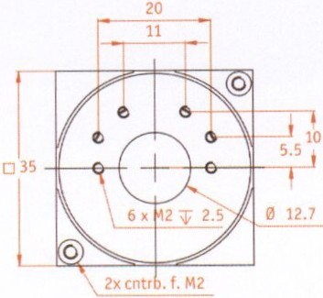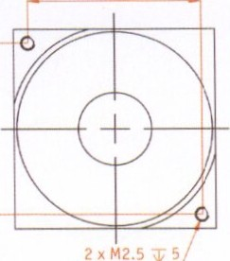30

l
l

0 34
2 ... ...,,c. <.s

":'
±\ iG::t=

irl

AU rights, including rights crtited by patert grant or registntion of 1utility model or design as well as rightsoftec-hnkll modifiations are reserved. Ofl.ivery subject to 1willbility. Designations may bf trademarks, the use ofwhkh by third pJrties for their own purposes mayviollte the rights of the tndemark owners. OottDcubesy>tems AG 2001·2017.
L attocube

MiT Lasery, fotonika a jemna mechanika

,., , v 0 ,
PROHLASENI 0 POCTU LISTU NABIDKY

Prohlasuji, ze tato nabidka obsahuje 43 listu.

Toto prohlaseni podepisuji jako jednatel finny MIT, spol. s r.o., K.lanova 56, 147 00 Praha 4, IC : 46348395, opnivneny za spolecnost jednat.

Martin Moser jednatel

MIT spo.l &r.o.
Klanova 56,CZ·14700 Praha 4
tel.:+420 241 712 548, fax: +420 241 710 252
lnfo@mit·laser.cz.www.mit-laser.cz
CSOB. a.s. BIC:CEKOCZPP
CZK 576978503/0300
IBAN CZ86 0300 0000 0005 7697 8503
M stsky soud v Praza oddII C. vlo:tka 10259
IC: 46348395
DIC;CZ46348595

