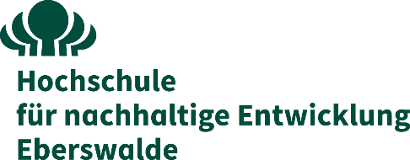

**Supplementary Agreement**

to the

**Cooperation Agreement**

for the project

# Transformational Learning Network for Resilience - Enabling Ukrainian higher education to ensure a sustainable and robust reconstruction of (post-war) Ukraine (TransLearnN)

between

# the Eberswalde University for Sustainable Development

Schicklerstraße 5, 16225 Eberswalde, Germany

represented by the President, Prof. Dr. Matthias Barth Project responsibility: xxxxxxx

- hereinafter referred to as "**HNEE**" or "**Coordinator**" -.

and

# the Technical University of Liberec

Studentská 1402/2, 461 17 Liberec 1, Czech Republic

Represented by the Rector, Prof. Dr. Miroslav Brzezina Project responsibility: xxxxxxx

- hereinafter referred to as "**TUL**" or “**Beneficiary**”.

For the purposes of signature of this Agreement both parties are represented by their legal representatives, according to the Mandates previously signed.

The above-named parties agree on the following amendments to the cooperation agreement dated 05 December 2023:

In accordance with the amendment agreement between the coordinator and NA DAAD dated 26 September 2024, the partner Odessa State Environmental University left the consortium on 31 August 2024, as this institution was incorporated into Odesa I. I. Mechnikov National University and no longer exists from September 2024. As a new partner, Odesa I. I. Mechnikov National University joined the consortium on 1 September 2024 and took over its responsibilities.

Annex I of the Grant Agreement (‘Annex I’) was therefore updated as of 01.09.2024. The amounts specified in the above-mentioned cooperation agreement remain unchanged.

All other provisions and annexes of the agreement remain unchanged and continue to apply.

We, the undersigned, declare to have read and accepted the terms and conditions of this Agreement.

|  |  |
| --- | --- |
| **For the Coordinator** | **For the Beneficiary** |
| The legal representative | The legal representative |
| Prof. Dr. Matthias Barth | Prof. Dr. Miroslav Brzezina |
| Signature and stamp | Signature and stamp |
| Done in Eberswalde | Done in Liberec |
| Date: Feb. 24, 2025 | Date: Jan. 15, 2025 |