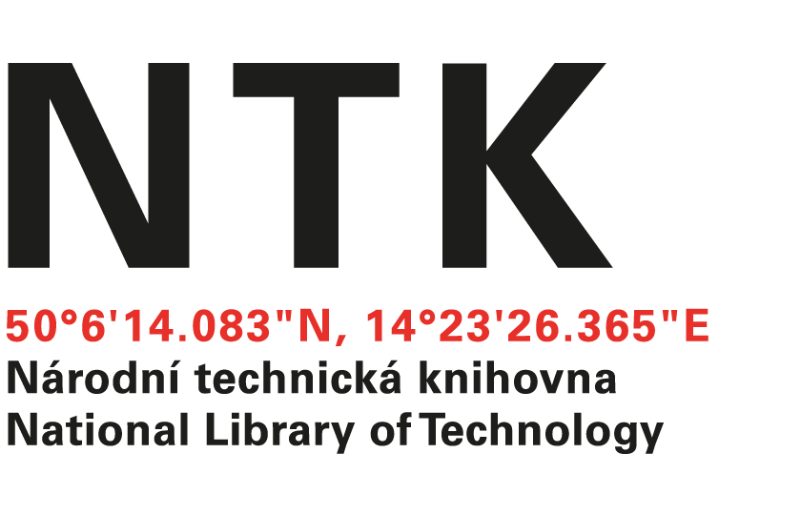
Order

No. 162/EIZ/2024/NTK

Customer: | Supplier:
National Library of Technology | McGraw-Hill  xxxxxxxxxxxxx
Technická 6/2710 | 104 Windsor Center Drive, Suite 400
160 80 Prague 6 - Dejvice | East Windsor
Czech Republic | NY 08520
ID: 61387142
VAT: CZ61387142

Dear xxxxxx,

based on your offer from 20. 11. 2024 we order unlimited access to AccessScience for the price $ 17,191.82. Term: from 01 Januar, 2025 to 31-December, 2025.

Kind regards

xxxxxxxx
electronic resources librarian

Order accepted by:
Date of issue: 18. 12. 2024
Issued:
xxxxxxxxxxxxxxxx
email: eiz@techlib.cz
tel.: +420 232 002 xxxx

