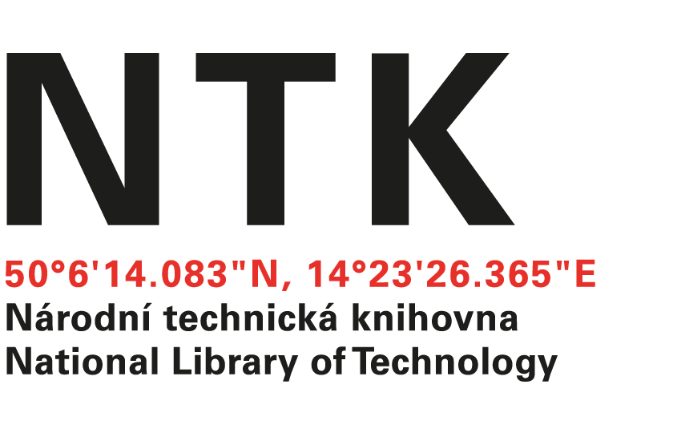
Order

164/AČ/2024/NTK

Customer: | Supplier:
National Library of Technology | The Optical Society OSA  Alison Taylor
Technická 6/2710 | 2010 Massachusetts Avenue, NW
160 80 Prague 6 - Dejvice | Washington DC 20036
Czech Republic | USA
ID: 61387142
VAT: CZ61387142

Dear Alison,

based on your offer (Pro Forma Invoice) from 7. 11. 2024 we order access to the collection e-journals OSA - Electronic Combination 1 for the price $ 16.148,00 USD started from 1-January 2025 ended 31-December 2025.

Kind regards

Jitka Marhoulová
electronic resources librarian

Order accepted by:
Date of issue: 18.12.2024
Issued:
Jitka Marhoulová
email: eiz@techlib.cz
tel.: +420 232 002 409

